Research proposal
Jake Davies (P151889)

Proposing a standardised method for microplastic sampling.
Table of Contents
Table of figures: 2
Table of tables: 2
Introduction 3
Literature review: 4
Sampling Method 1: 6
Sampling Method 2: 7
Sampling Method 3: 8
Methodologies: 9
Evaluation: 10
Cited work: 11

Table of figures:
Figure 1: Suggestion of plastic debris nomenclature based on size, as proposed by the European MSFD technical subgroup on Marine Litter (MSFD GES Technical Subgroup on Marine Litter, 2013). 4
Figure 2:Sampling locations on islands in the Hawaiian Archipelago (McDermid & McMullen, 2004). 6
Figure 3:Location of Singapore and the sampling locations (Ng & Obbard, 2006). 7
Figure 4: Location of sampling sites on the Sothern Baltic sea (Graca et al., 2017) 8
Figure 5: South Beach Tenby, where the case study will take place (http://www.newoverlander.co.uk/tenby-south-beach-10/). 10

Table of tables:
Table 1: Worldwide amount of microplastic (Van Cauwenberghe, 2015). 5

Introduction

Microplastic is a vast global issue, affecting various ecosystems and natural processes. These plastics are prevalent in most marine debris, they’re defined as microplastics by being less than 5mm in length (NOAA, 2017). This report aims to provide a standardised method for sampling microplastics within the marine environment, this is a vital step to combating microplastic pollution.
Within the field of research, it’s been found that there are multiple methods of collecting microplastic samples, therefore this provides data that can cause inaccurate comparisons between samples (L Van Cauwenberghe, 2015). The community could benefit from this study by bringing together multiple sampling methods and defining one as extremely reliable and accurate, developing a method for rapid assessment within the field is also an essential factor. Studies of a similar stature have been undertaken previously, these studies have mainly focused on microplastics within a body of water. There are two categories of microplastics, firstly primary microplastics are plastics manufactured in small pieces. These primary microplastics are generally used as an abrasive in cleaning, they’re used to blast rust from things such as ships, aircraft, buildings and cars (Derriak,2002). Although the plastics are reused they’re eventually discarded, containing hazardous chemicals such as lead, chromium and cadmium (GESAMP, 2015) (Cole, 2011). Secondly, within the marine environment plastics can be mechanically broken down into smaller pieces such as UV radiation, wind, waves or animals. This physical weathering produces secondary microplastics (UNEP, 2016) (NEA, 2014). Microplastics can be split into five categories which are; fibre, pellet, foam, film and fragment (San Francisco Estuary Institute , 2015). The proposed sampling method will have to collect each of these microplastics to be effective. There is a great worry throughout the scientific community about microplastic pollution, this is due to the nature of the problem. As microplastics generally can’t be seen with the naked eye, they’re easily consumed. Microplastics have been found within the stomachs of various marine animals spanning from zooplankton to whales and everything between. The fear for humans is the plastic that bio-accumulates within sea creatures that are consumed by humans. This has led to the global concern about microplastics within the hydrosphere, microplastics was one of the major taking points within the UNEP frontiers 2016 report on emerging environmental concerns.

This report will include a literature review of some existing microplastic sampling methods and provide an outline of the methodologies to be used within the research project. when the research is undertaken, a new method for rapid assessment of microplastics will be proposed from all of the data brought together within the literature review. This method will then be put to the test on a trial run on South beach, Tenby. To provide feedback on how the method works in practice. The method developed will be for sampling microplastics on land predominantly sand, there are multiple variables having an impact on the proposed experiment. In any microplastic sampling experiment the independent variable will be different locations. In this case the dependant variable will be the amount of microplastics collected at each location. There will be multiple controlled variables in the experiment including, sample size and depth, microplastic size, equipment used. The final methodologies cannot be discussed within this report, as they’re entirely dependent on the findings within the literature review of the research project.

Literature review:
The development of microplastic sampling in the scientific world was extremely quick, thus resulting in a lack of consistency in sampling methods. Van Cauwenberghe states, “The majority of these method inconsistencies can be related to;
- Differences in the lower and upper size limit implemented.
- The sensitivity of the applied extraction technique.
- Differences in sampling technique leading to a wide variety of reporting units.
(L Van Cauwenberghe, 2015).
The lack of a clear size-based definition of microplastic has resulted in the documenting of multiple different size divisions in literature, all using the same term: microplastics. In practice, this means that the results of a substantial body of microplastic literature cannot be compared directly (C. Arthur, 2009).
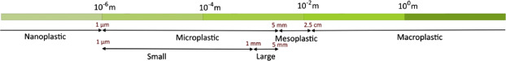
Figure 1: Suggestion of plastic debris nomenclature based on size, as proposed by the European MSFD technical subgroup on Marine Litter (MSFD GES Technical Subgroup on Marine Litter, 2013).
The overall term “microplastic” is composed of small microplastics (SMPs, smaller than 1 mm) and large microplastics (LMPs, 1–5 mm), to differentiate between two commonly used definitions of microplastics. There needs to be a clear difference in definitions between, Nano, Micro, Meso and Macro plastics.

Table 1: Worldwide amount of microplastic (Van Cauwenberghe, 2015).
Continent | Location | Location specification | Particle size | Measured abundance | Reference
Africa | Canary Islands | Beach | 1 mm–5 mm | <1 – >100 g/L | Baztan et al., 2014
America | Hawaii | Beach | 1 mm–15 mm | 541–18,559 items/260 L | McDermid and McMullen, 2004
America | Brazil | Beach | 2 mm–5 mm | 60 items/m² | Ivar do Sul et al., 2009
America | Brazil | Beach | 0.5 mm–1 mm | 200 items/0.01 m² | Costa et al., 2010
America | Brazil | Beach | 1 mm–20 mm | 100 items/0.01 m² | Costa et al., 2010
America | Hawaii | Beach | 250 μm–10 mm | 0.12%–3.3% plastic by weight | Carson et al., 2011
America | Chile | Beach | 1 mm–4.75 mm | <1–805 items/m² | Hidalgo-Ruz and Thiel, 2013
America | Nova Scotia | Beach | 0.8 μm–5 mm | 20–80 fibres/10 g | Mathalon and Hill, 2014
Asia | Singapore | Beach | 1.6 μm–5 mm | 0–4 items/250 g dry | Ng and Obbard, 2006
Asia | India | Beach | 1 mm–5 mm | 10–180 items/m² | Jayasiri et al., 2013
Asia | South Korea | Beach dry season | 1 mm–5 mm | 8205 items/m² | Lee et al., 2013
Asia | South Korea | Beach rainy season | 1 mm–5 mm | 27,606 items/m² | Lee et al., 2013
Asia | South Korea | Beach | 50 μm–5 mm | 56–285,673 items/m² | Kim et al., 2015
Europe | UK | Beach | 1.6 μm–5 mm | 0.4 fibres/50 mL | Thompson et al., 2004
Europe | UK | Subtidal | 1.6 μm–5 mm | 5.6 fibres/50 mL | Thompson et al., 2004
Europe | Sweden | Subtidal | 2 μm–5 mm | 2–332 items/100 mL | Norén, 2007
Europe | UK | Beach | 1.6 μm–1 mm | <1–8 items/50 mL | Browne et al., 2010
Europe | UK | North Sea beach | 38 μm–1 mm | 0.2–0.8 fibres/50 mL | Browne et al., 2011
Europe | UK | English Ch. beach | 38 μm–1 mm | 0.4–1 fibres/50 mL | Browne et al., 2011
Europe | Belgium | Beach |  | 92.8 items/kg dry | Claessens et al., 2011
Europe | Portugal | Beach | 1.2 μm–5 mm | 133.3 items/m² | Martins and Sobral, 2011
Europe | Germany | Urban beach | 1 mm–15 mm | 5000–7000 items/m³ | Ballent et al., 2012
Europe | Germany | Rural beach | 1 mm–15 mm | 150–700 items/m³ | Ballent et al., 2012
Europe | Belgium | High tide line | 38 μm–1 mm | 9.2 items/kg dry | Van Cauwenberghe et al., 2013
Europe | Belgium | Low tide line | 38 μm–1 mm | 17.7 items/kg dry | Van Cauwenberghe et al., 2013
Europe | Italy | Subtidal | 0.7 μm–1 mm | 672–2175 items/kg dry | Vianello et al., 2013
Europe | Germany | Beach | <1 mm | 1.3–2.3 items/kg dry | Dekiff et al., 2014
Europe | Slovenia | Beach | 0.25–5 mm | 177.8 items/kg dry | Laglbauer et al., 2014

As displayed in table 1 measured abundance unit is different in most countries around the world, thus making comparisons difficult. To gauge the scale of worldwide plastic contamination, calculations into a single unit need to occur but this can cause problems with the data making comparisons inaccurate. Standardising this area is essential to combating microplastic pollution, as the problem can be easily compared between locations. This would intern indicate where the highest levels of pollution are and lead to methods to mitigate against it. Below are three randomly selected sampling methods from researchers respected within the field. The literature review for the research project would have a larger amount of methods to bring comparisons between them, this would aid the construction of a new method understanding the strengths and weaknesses of existing methods.

Sampling Method 1:
This method was developed by K J McDermid and T L McMullen in Hawaii, 2004. Through the time between September 2001 and February 2003 nine remote locations within the Hawaiian island were sampled. None near commercial, residential, nor densely populated areas. A sediment sample was taken from each beach, at the high tide and low tide mark. Each sample consisted of sand scooped with a small shovel from a 61 × 61 cm² quadrat to a depth of approximately 5.5 cm, to fill a 20L bucket. These residues were sieved through a set of nested sieves: 4.75, 2.8, and 1 mm. Only particles 1–15 mm in size were retained from each sieve tray and placed in separate labeled plastic bags (McDermid & McMullen, 2004). Sorting proceeded through the following steps (Moore et al., 2001.);
- Dry sort- “Each sample was placed on a sheet of white paper. Materials were sorted into major categories: plastic, plant, and “other” (i.e. shell, paper and ceramic matter), placed in separate containers, and labeled with sieve size, location and type” (McDermid & McMullen, 2004).

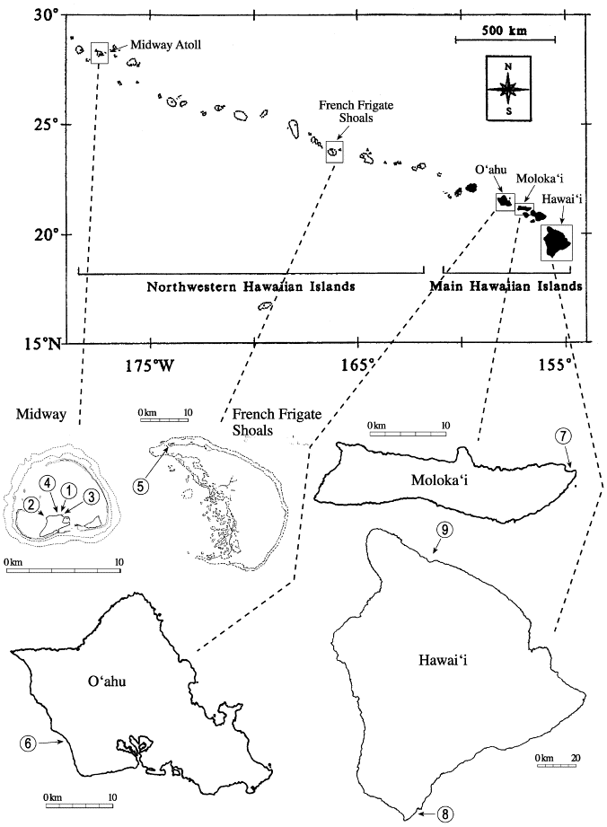
- Wet sort- “Each sub-sample of plastics was rinsed to remove soil and sand, and to pick out non-floatable objects that may be mistaken for plastics (glass). Small amounts of sample were poured into a container of freshwater. The container was swirled for 1 min and floating particles (mostly plastic) then sieved out. Some sub-samples required rinsing several times to remove all of the clinging sand or soil. The samples were then dried in an oven for 1 h at 65 °C” (McDermid & McMullen, 2004).

- Classification- “each size class was then separated by type of plastic (film, line, pellet, fragment, foam), counted and placed in separate containers. Each size class was weighed to 0.01 g on an Ohaus top-loading balance. Plant material and “other” non-plastic, non-plant material from each sample was sorted and weighed” (McDermid & McMullen, 2004).

Figure 2:Sampling locations on islands in the Hawaiian Archipelago (McDermid & McMullen, 2004).

Sampling Method 2:
The second method shown was used by Ng and Obbard in 2006 to sample for microplastics on the beaches around Singapore. 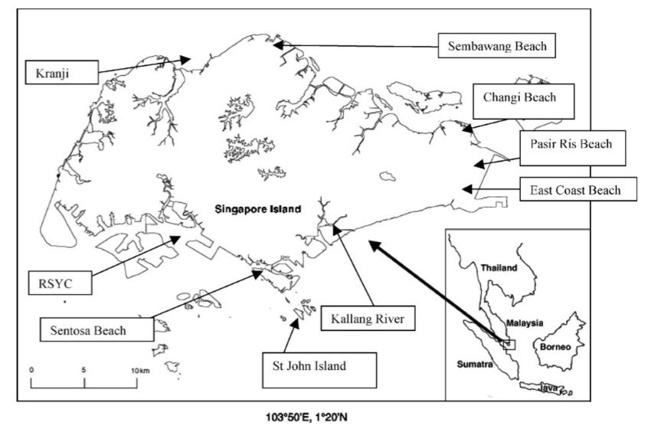
Figure 3:Location of Singapore and the sampling locations (Ng & Obbard, 2006).
All sediment samples in Ng and Obbards experiment were collected 0.5 m away from the ocean tideline. “In total, 16 kg of sediments were collected from St John’s and this included 2 kg samples taken from eight separate points, four of which were at the beach surface (top 1 cm) and four at a depth of 10– 11 cm. Subsequently, 3 kg sediment was collected from Changi, Pasir Ris, East Coast, Kallang River, Sembawang and Sentosa beaches, where 1 kg of sediment was taken from three separate points at the beach surface (top 1 cm) and homogenised” (Ng & Obbard, 2006).

Sampling Method 3:
Graca published a third method in 2017 varying from the others displayed, it was put into practice around the Southern Baltic sea. “At each studied beach, sediments were collected at 3 km (GD and KA) or 1 km distance (GA) with a subsample every 200 m. Surface (0–2.5 cm) beach sediment was taken using metal ring (10 cm in diameter), plate, and spoon. Then subsamples from the entire distance were integrated in a metal container and stored in a glass jar. Samples were collected from December 2014 to April 2015” (Graca et al., 2017).

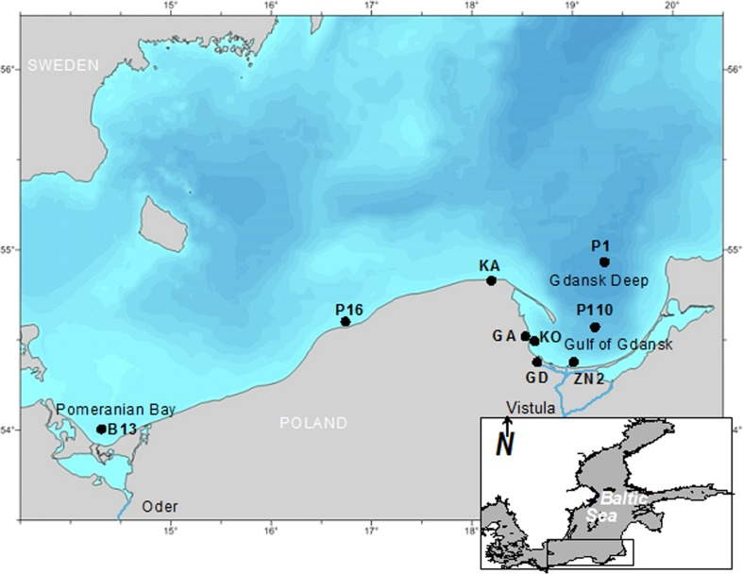
Figure 4: Location of sampling sites on the Sothern Baltic sea (Graca et al., 2017)
All three methods displayed in the review are along vast geographical areas, with different researchers with different amounts of funding. There can be multiple constraints on any research project at one time. The three methods all have contrasting amounts sample size, depth also beach zonation and microplastic size. Thus, showing the variation is sampling method, method 1 by McDermid collected 20L of sediment from a quadrat, retaining a sediment size of between, 1-15mm and at a depth of up to 5.5mm. samples were taken from the high water and low water zones. Method 2 developed by Ng and Oddard took sediment from 0.5m away from the high tide line and 16kg of sediment was collected in total from just the top 1cm of the collection zone. Method 3 by Graca varies again sediment was taken from up to 2.5cm depth in the collection zone with an unknown sample size or overall quantity. The 3 methods displayed within this report start to exhibit the scale of the problem within the literature, and the lack of cohesion between research.

Methodologies:
The proposed research project would incorporate multiple methods, including context analysis, experimentation and official statistics.

Firstly, analysis of the most current methods of microplastic sampling will be undertaken, then conclusions will be drawn about the state of the literature and what can be improved. Analysis of method variability will be undertaken, this will include clarification of microplastic size, beach zonation, sample size and depth.

Secondly, a method will be proposed incorporating elements of some previous methods and also new elements, to try to produce a more effective way of rapidly and reliably collecting data at a site.

Thirdly, the new method will be tested at South beach, Tenby to gauge its strengths and weakness’. The method used in the case study will be entirely dependent on the findings within the literature review, the sample size, beach zones, sample depth will all be included within the research projects methodologies. A second method will be selected from the literature review to compare against, comparisons will include, ease of use, equipment required, sample size and depth. This will help determine whether the new method is effective.

Finally, the method will be proposed as an effective and reliable method of collecting microplastic samples. Presented with the findings from the case study at South Beach, Tenby.
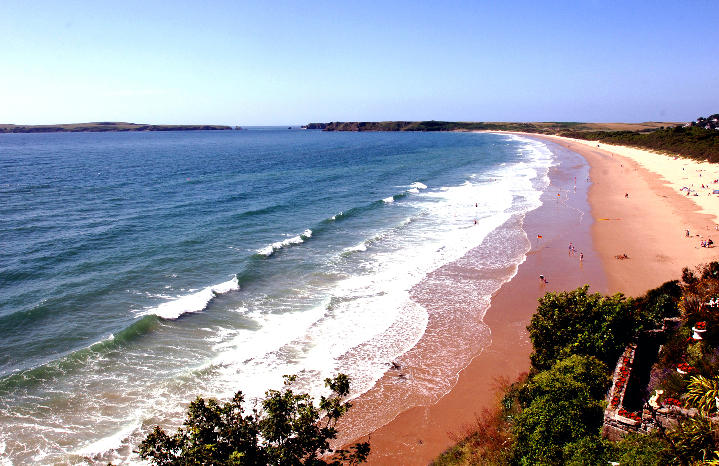
Figure 5: South Beach Tenby, where the case study will take place (http://www.newoverlander.co.uk/tenby-south-beach-10/).

Evidence from the case study will be imputed into the results section of the research project. Variables such as sampling depth, sample size, and sampling location will be assessed within the discussion of the research project. Sample depth and size will be controlled variables, with sampling location being independent as mentioned in the introduction. This will keep the investigation fair and results accurate and reliable. The methods selected for the research project are the most reliable and appropriate. With the method for the case study entirely dependent on the literature review, the methodologies within the research proposal aren’t as precise as would usually be expected. There are huge social, economic and of course environmental impacts related to microplastics.

Evaluation:
The research could be extremely beneficial to the worldwide scientific community, standardisation of methods is essential within this field. The calibration of functioning method could be achieved through this research project. The research proposal is within the early development stage thus leading to some constraints. Such as sourcing the equipment needed to undertake the case study, the equipment for the collection method will be influenced by financial implications. Some equipment may not be available when the research project is being undertaken, leading to less accurate and reliable equipment being used. The equipment will be sourced early to avoid this occurring, in turn not effecting the accuracy or reliability of the project. Within the field there has to also be a call for standardisation of extraction techniques. Collecting samples is only half the issue, without a unified method for extracting microplastics from sediment only half the battle is complete. The standardisation of extraction techniques could be a separate research project. The chosen solution to combat microplastic pollution is through legislation, in June 2014 the United Nations Environment Assembly chose to address the problem thorough legislation, improved waste disposal, efficient and sound use of plastics, international agreements and education. In September 2015, world leaders agreed on a special target to “prevent and significantly reduce marine pollution of all kinds, particularly from land-based activities, including marine debris and nutrient pollution” by 2025 (Target 14.1) of the Sustainable Development Goals (UNEP, 2015).

Cited work:
Ballent, A., Purser, A., de Jesus Mendes, P., Pando, S., & Thomsen, L. (2012). Physical transport properties of marine microplastic pollution. Biogeosciences Discussions, 9(12), 18755–18798. https://doi.org/10.5194/bgd-9-18755-2012
Baztan, J., Carrasco, A., Chouinard, O., Cleaud, M., Gabaldon, J. E., Huck, T., … Vanderlinden, J.-P. (2014). Protected areas in the Atlantic facing the hazards of micro-plastic pollution: First diagnosis of three islands in the Canary Current. Marine Pollution Bulletin, 80(1), 302–311. https://doi.org/https://doi.org/10.1016/j.marpolbul.2013.12.052
Browne, M. A., Crump, P., Niven, S. J., Teuten, E., Tonkin, A., Galloway, T., & Thompson, R. (2011). Accumulation of microplastic on shorelines woldwide: Sources and sinks. Environmental Science and Technology, 45(21), 9175–9179. https://doi.org/10.1021/es201811s
Browne, M. A., Galloway, T. S., & Thompson, R. C. (2010). Spatial patterns of plastic debris along estuarine shorelines. Environmental Science and Technology, 44(9), 3404–3409. https://doi.org/10.1021/es903784e
Carson, H. S., Colbert, S. L., Kaylor, M. J., & McDermid, K. J. (2011). Small plastic debris changes water movement and heat transfer through beach sediments. Marine Pollution Bulletin, 62(8), 1708–1713. https://doi.org/10.1016/j.marpolbul.2011.05.032
C. Arthur, J. B. (2009). Proceedings of the international research workshop on the occurence, effects and fate of microplastic marine debris. NOAA Technical Memorandum, 49.
Claessens, M., Meester, S. De, Landuyt, L. Van, Clerck, K. De, & Janssen, C. R. (2011). Occurrence and distribution of microplastics in marine sediments along the Belgian coast. Marine Pollution Bulletin, 62(10), 2199–2204. https://doi.org/10.1016/j.marpolbul.2011.06.030
Cole M., Lindeque P., Halsband C. and Galloway T.S. 2011. Microplastics as contaminants in the marine environment: A review. Marine Pollution Bulletin, 62(12), 2588-2597. http://www.sciencedirect.com/science/article/pii/S0025326X11005133
Costa, M. F., Ivar Do Sul, J. A., Silva-Cavalcanti, J. S., Araújo, M. C. B., Spengler, Â., & Tourinho, P. S. (2010). On the importance of size of plastic fragments and pellets on the strandline: A snapshot of a Brazilian beach. Environmental Monitoring and Assessment, 168(1–4), 299–304. https://doi.org/10.1007/s10661-009-1113-4
Dekiff, J. H., Remy, D., Klasmeier, J., & Fries, E. (2014). Occurrence and spatial distribution of microplastics in sediments from Norderney. Environmental Pollution, 186, 248–256. https://doi.org/10.1016/j.envpol.2013.11.019
Derraik, J.G.B. (2002). The pollution of the marine environment by plastic debris: a review. Marine Pollution Bulletin, 44, 842–852. http://www.sciencedirect.com/science/article/pii/S0025326X02002205
GESAMP (2015). Sources, fate and e ects of microplastics in the marine environment: a global assessment. (Kershaw, P. J., ed.). IMO/FAO/ UNESCO-IOC/UNIDO/WMO/IAEA/UN/UNEP/UNDP Joint Group of Experts on the Scienti c Aspects of Marine Environmental Protection. Rep. Stud. GESAMP No. 90. http://www.gesamp.org/data/gesamp/ les/media/Publications/ Reports_and_studies_90/gallery_2230/object_2500_large.pdf
Graca B, Szewc K, Zakrzewska D, Dołęga A, Szczerbowska-Boruchowska (2017)
M. Sources and fate of microplastics in marine and beach sediments of the Southern
Baltic Sea—a preliminary study. Environmental Science and Pollution Research
International. 2017;24(8):7650-7661. doi:10.1007/s11356-017-8419-5.
Ivar do Sul, J. A., Spengler, Â., & Costa, M. F. (2009). Here, there and everywhere. Small plastic fragments and pellets on beaches of Fernando de Noronha (Equatorial Western Atlantic). Marine Pollution Bulletin, 58(8), 1236–1238. https://doi.org/10.1016/j.marpolbul.2009.05.004
Jayasiri, H. B., Purushothaman, C. S., & Vennila, A. (2013). Quantitative analysis of plastic debris on recreational beaches in Mumbai, India. Marine Pollution Bulletin, 77(1–2), 107–112. https://doi.org/10.1016/j.marpolbul.2013.10.024
Kim, I. S., Chae, D. H., Kim, S. K., Choi, S. B., & Woo, S. B. (2015). Factors Influencing the Spatial Variation of Microplastics on High-Tidal Coastal Beaches in Korea. Archives of Environmental Contamination and Toxicology, 69(3), 299–309. https://doi.org/10.1007/s00244-015-0155-6
KIMO Sweden. (2007). Small plastic particles in Coastal Swedish waters. N-Research, (0), 11.
Laglbauer, B. J. L., Franco-Santos, R. M., Andreu-Cazenave, M., Brunelli, L., Papadatou, M., Palatinus, A., … Deprez, T. (2014). Macrodebris and microplastics from beaches in Slovenia. Marine Pollution Bulletin, 89(1–2), 356–366. https://doi.org/10.1016/j.marpolbul.2014.09.036
Lee, J., Hong, S., Song, Y. K., Hong, S. H., Jang, Y. C., Jang, M., … Shim, W. J. (2013). Relationships among the abundances of plastic debris in different size classes on beaches in South Korea. Marine Pollution Bulletin, 77(1–2), 349–354. https://doi.org/10.1016/j.marpolbul.2013.08.013
Martins, J., & Sobral, P. (2011). Plastic marine debris on the Portuguese coastline: A matter of size? Marine Pollution Bulletin, 62(12), 2649–2653. https://doi.org/10.1016/j.marpolbul.2011.09.028
Mathalon, A., & Hill, P. (2014). Microplastic fibers in the intertidal ecosystem surrounding Halifax Harbor, Nova Scotia. Marine Pollution Bulletin, 81(1), 69–79. https://doi.org/10.1016/j.marpolbul.2014.02.018
McDermid, K. J., & McMullen, T. L. (2004). Quantitative analysis of small-plastic debris on beaches in the Hawaiian archipelago. Marine Pollution Bulletin, 48(7–8), 790–794. https://doi.org/10.1016/j.marpolbul.2003.10.017
Moore, D. Gregorio, M. Carreon, S.B. Weisberg, M.K. LeecasterComposition and distribution
of beach debris in Orange County, California. Marine Pollution Bulletin, 42 (3) (2001),
pp. 241-245
MSFD GES Technical Subgroup on Marine Litter. (2013). Monitoring Guidance for Marine Litter in European Seas, Draft Report. Brussels: European Commission.
Ng, K. L., & Obbard, J. P. (2006). Prevalence of microplastics in Singapore’s coastal marine environment. Marine Pollution Bulletin, 52(7), 761–767. https://doi.org/10.1016/j.marpolbul.2005.11.017
NEA. (2014). Sources of microplastics to the marine environment . Retrieved from Norwegian Environment Agency: http://www.miljodirektoratet.no/
NOAA. (2017, 10 10). What are microplastics? Retrieved from National Ocean Service : https://oceanservice.noaa.gov/facts/microplastics.html
San Francisco Estuary Institute . (2015). Microplastic Contamination in San Francisco Bay - Fact Sheet. Retrieved from San Francisco Estuary Institute : http://www.sfei.org/sites/default/ les/biblio_ les/MicroplasticFacts.pdf
Thompson, R. C., Olson, Y., Mitchell, R. P., Davis, A., Rowland, S. J., John, A. W. G., … Russell, A. E. (2004). Lost at Sea: Where Is All the Plastic? Science, 304(5672), 838. https://doi.org/10.1126/science.1094559
UNEP. (2016). Marine plastic debris and microplastics – Global lessons and research to inspire action and guide policy change . Nairobi: United Nations Environment Programme.
V. Hidalgo-Ruz, M. T. (2013). Distribution and abundance of small plastic debris on beaches in the SE Pacific (Chile): a study supported by a citizen science project. Marine Environmental Research, 87, 12–18.
Van Cauwenberghe, L., Claessens, M., Vandegehuchte, M. B., Mees, J., & Janssen, C. R. (2013). Assessment of marine debris on the Belgian Continental Shelf. Marine Pollution Bulletin, 73(1), 161–169. https://doi.org/10.1016/j.marpolbul.2013.05.026
Van Cauwenberghe, L., Devriese, L., Galgani, F., Robbens, J., & Janssen, C. R. (2015). Microplastics in sediments: A review of techniques, occurrence and effects. Marine Environmental Research, 111(Supplement C), 5–17. https://doi.org/https://doi.org/10.1016/j.marenvres.2015.06.007
Vianello, A., Boldrin, A., Guerriero, P., Moschino, V., Rella, R., Sturaro, A., & Da Ros, L. (2013). Microplastic particles in sediments of Lagoon of Venice, Italy: First observations on occurrence, spatial patterns and identification. Estuarine, Coastal and Shelf Science, 130, 54–61. https://doi.org/10.1016/j.ecss.2013.03.022

