

Changemakers: Creativity and Value Creation
Module code: BMHP5014
Component 2: Assignment (Report)
Student name: Estera M Mihalescu
Student number:2416449
Lecturer name: Soban Sadiq

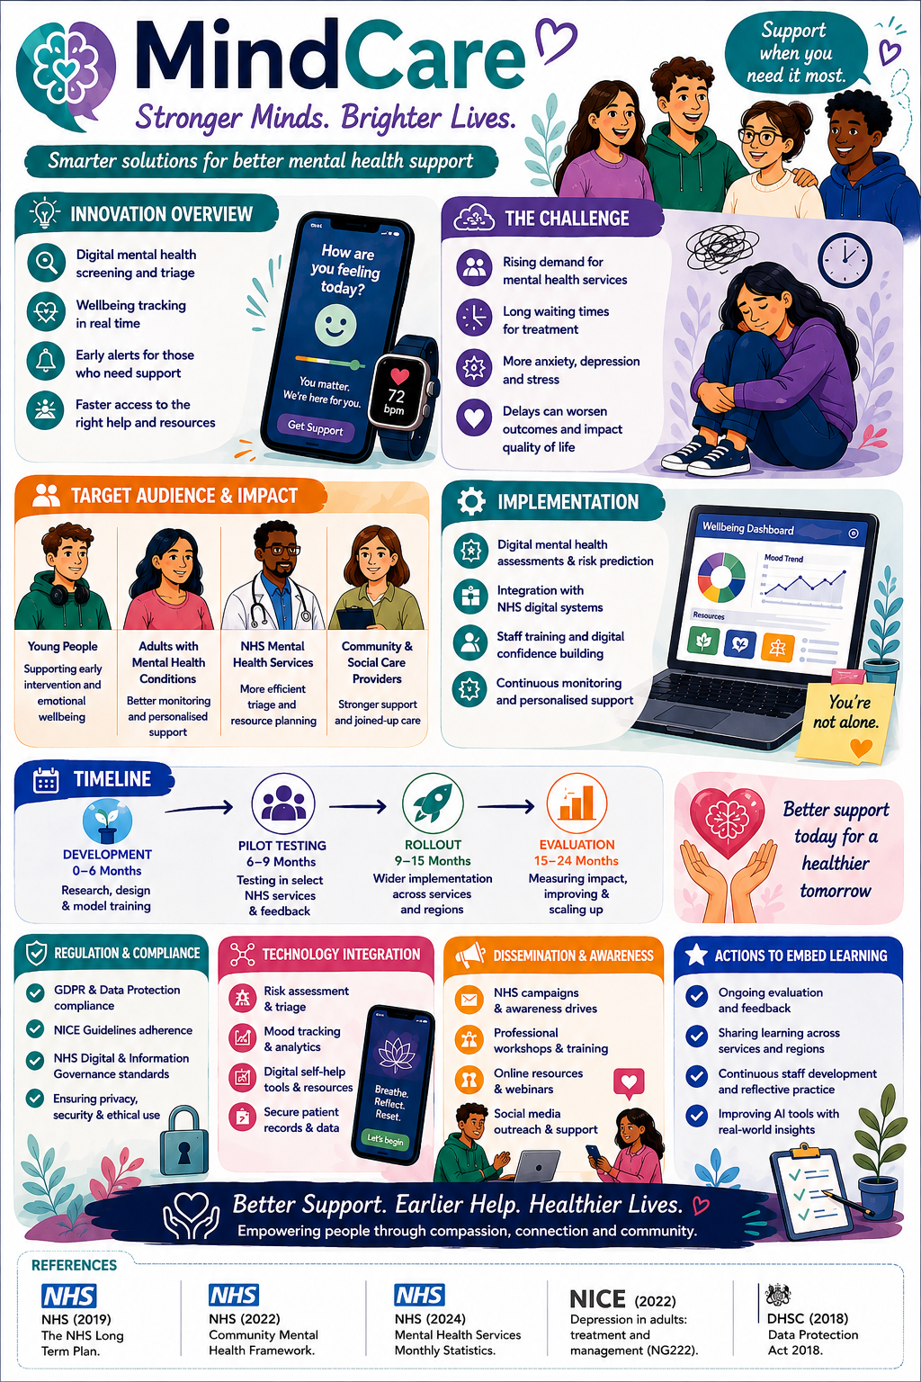
Introduction
Mental health has become an increasingly significant public health concerns in the UK, affecting millions of people regardless of age, background or circumstance. Although awareness has improved, many individuals continue to experience difficulties accessing timely support due to increasing demand, workforce shortages and lengthy waiting lists.
MindCare is digital metal health support platform developed to complement existing NHS and social care services by promoting early intervention, personalised wellbeing support and stronger collaboration between professionals. Rather than replacing face-to-face care, MindCare provides individuals with continuous access to wellbeing resources, mood monitoring and personalised guidance while helping professionals identify concerns earlier. By encouraging presentative care and improving communication across services, the platform aims to enhance, mental wellbeing, reduce pressure on healthcare services and improve outcomes for individuals, families and communities.
Background
Mental health remains one of the fastest growing healthcare challenges in the UK. Rising levels of anxiety, depression and emotional distress, particularly since the COVID-19 pandemic and the ongoing cost-of-living crisis, have significant increased demand for NHS mental health services. As referrals continue to rise, services are struggling to meet demand, resulting in long waiting lists that often delay assessment and treatment. For many people, these delays mean living with worsening symptoms, affecting relationships, education, employment and overall wellbeing.
According to NHS England (2024), record numbers of people are-funded now accessing NHS-funded mental health services each year, demonstrating both increased awareness of mental health and growing pressure on existing services. Despite the progress, workforce shortages and limited clinical capacity continue to make timely access to support difficult. NICE (2022) highlights that early identification and prompt treatment improve recovery and reduce the likelihood of mental health conditions becoming more severe. However, when support is delayed, individuals are most likely to require intensive treatment or emergency intervention, placing additional strain on health and social care services.
The NHS Long Term Plan (2019) identifies digital technologies as a key priority for modernising healthcare and improve access to mental health support. Digital innovations can help people receive guidance earlier while enabling clinicians to prioritise those most in need. MindCare has been developed in response to these challenges by offering an accessible, secure and person-centred approach that complements existing NHS services rather than replacing them.
Innovation Description
MindCare is an integral digital platform that supports individuals throughout their mental health journey, from the first signs of emotional distress to accessing professional care. Unlike many existing wellbeing applications that primarily focus on self-help, MindCare combines digital assessment, wellbeing monitoring and intelligent triage within one integrated system linked to NHS services.
The platform begins with a confidential mental health screening that evaluates symptoms of anxiety, depression and emotional wellbeing. Based on the results, users receive personalised recommendation tailored to their individual needs. They may include self-help resources, wellbeing activities, educational materials or referral to NHS Talking Therapist, GPs or specialist mental health services where appropriate.
A key feature of MindCare is it continuous wellbeing monitoring system, allowing users to track changes of the mood, stress levels and emotional health over time. This information helps individuals better understand their mental wellbeing while providing clinicians with valuable insights that support more informed treatment decision.
MindCare also incorporate intelligent triage technology to identify individuals who may require urgent intervention. By securely integrating with NHS digital system, the platform enables healthcare professionals to review assessment data before appointments, improving clinical efficiency and helping services prioritise patients according to risk. Rather than replacing healthcare professionals, MindCare strengthens existing care pathways by supporting earlier intervention and more effective use of available resources.

Impact on Health and Social Care
MindCare has the potential to transform the way mental health services are accessed and delivered across health and social care. For service users, quick access to assessments and personalised support can lead to earlier intervention, preventing mental health conditions from becoming more severe. Receiving support while waiting for formal treatment can also reduce feelings of anxiety, uncertainty and social isolation.
The platform offers particular benefits for young people, students, working adults and individuals living in rural or underserved communities, where access to face-to-face services may be more limited. Flexible digital access allows people to receive support at a time and place that suits them, improving inclusivity and reducing barriers to care.
Healthcare professionals also benefits from more efficient assessment and referral process. Mental health nurses, psychologists, GPs and social worker can use digital screening information to identify those requiring urgent care, improving prioritisation and reducing unnecessary delays. This enables clinicians to spend more time supporting individuals with complex needs while making better use of available resources.
At a wider level, earlier intervation can reduce demand for emergency mental health services, lower healthcare cost and improve long-term health outcomes. Better mental wellbeing also contributes to improved educational achievement, employment opportunities and stronger community participation. By combining digital technology with professional expertise, MindCare supports a more sustainable, equitable and person-centred mental health service.
Public and Stakeholder Involvement
Developing an effective digital healthcare platform requires ongoing collaboration with the people who will use and deliver the service. Individuals with lived experience of mental health conditions should be involved throughout the planning, accessible and responsive to user’s needs. Feedback can be collected through focus groups, pilot studies and user satisfaction survey to support continuous improvement.

Healthcare professionals, including GPs, psychologist, mental health nurses and social workers, should contribute to developing referral pathways and clinical guidance. Collaboration with charities such as Mind and Rethink Mental Illness can also strengthen public awareness, improve engagement and encourage early access to support through community-based partnership.
Policies, Services and Professional
MindCare supports national healthcare priorities by promoting early intervention, integrated care and equal access to mental health services. The Care Act 2014 emphasise the importance of preventing needs from escalating and promoting individual wellbeing, while the Equality Act 2010 requires healthcare services to be inclusive and accessible to all members of society. The platform also complies with the Data Protection Act 2018 and UK GDPR by ensuring that personal information is managed securely and confidentiality.
Successful implementation relies on partnership working between GPs, NHS Talking Therapies, psychologists, mental health nurses, social workers and voluntary organisations. This collaborative approach enables coordinated care, improves communication between services and supports better outcomes for individuals requiring mental health support.
Conclusion
MindCare represents a practical and forward-thinking approach to addressing increasing demand for mental health services across the UK. By providing early screening, continuous wellbeing monitoring and intelligent referral pathways, the platform helps people access the right support sooner while assisting healthcare professionals in managing resources more effectively. Working alongside existing NHS services, MindCare had the potential to reduce waiting times, improve patient experience and deliver a more accessible, efficient and person- centred mental health service for the future.

References:
• Care Act (2014) Care Act 2014. Available at: https://www.legislation.gov.uk/ukpga/2014/23/contents (Accessed: 6 August 2026).
• CQC (2022) Care Quality Commission. Available at: https://www.cqc.org.uk/ (Accessed: 6 August 2026).
• GOV.UK (2012) Mental health condition. Available at: https://www.gov.uk/when-mental-health-condition-becomes-disability (Accessed: 6 August 2026).
• GOV.UK (2018) Data Protection Act 2018. Available at: https://www.legislation.gov.uk/ukpga/2018/12/contents (Accessed: 6 August 2026).
• National Institute for Health and Care Excellence (2022) Depression in adults: Treatment and management (NG222). Available at: https://www.nice.org.uk/guidance/ng222 (Accessed: 6 August 2026).
• NHS Digital (2023) Mental Health Services Monthly Statistics. Available at: https://digital.nhs.uk/data-and-information/publications/statistical/mental-health-services-monthly-statistics (Accessed: 6 August 2026).
• NHS England (2022) Digital and Technology. Available at: https://www.england.nhs.uk/mat-transformation/matrons-handbook/digital-and-technology/ (Accessed: 6 August 2026).
• NHS England (2024) Mental Health Services. Available at: https://www.england.nhs.uk/mental-health/adults/cmhs (Accessed: 6 August 2026).
• UK Government The NHS Long Term Plan. Available at: https://webarchive.nationalarchives.gov.uk/ukgwa/20250511091243/https://www.longtermplan.nhs.uk/ (Accessed: 6 August 2026).
• World Health Organization (2021) Guidance on community mental health services. Available at: https://www.who.int/publications/i/item/9789240025707 (Accessed: 6 August 2026).
•World Health Organization (2022) Mental health. Available at: https://www.who.int/news-room/fact-sheets/detail/mental-health-strengthening-our-response (Accessed: 6 August 2026).

