Concurrent client/server application, design, and build
Contents
Socket Programming 1
Design statement 1
Justified choice of technologies and frameworks 2
Application logic planning 2
Data requirements analysis and design 3
Application flow and page layout design 4
Test programme 5

Socket Programming
Socket allows communication between two different processes on the same machine or different. It is a way to talk to other computers using standard file descriptors. [1] It is a way of connecting two nodes on a network to communicate with each other. One socket listens on a particular port at an IP. While the other socket reaches out to form a connection. A socket is used in a client-server application. [1] A server is a procedure that performs some functions request from a client. Application-level protocols like FRP, POP3 make use of sockets to establish a connection between client and server.

Design statement
What is my project – the project that I will be developing is going to be a JavaScript online quiz which will relate to different questions about Computing. This quiz is for anyone to have a go, both male and female. However, it would be more aimed at teenagers and adults as kids will not be able to know the answers to my questions. But they could still attempt to do my quiz. They would use my quiz to test their knowledge to see if they would know the answers to it. It would also be good to support my quiz and they could give feedback on what they think of it. Any positive or negative feedback would help, as I know what I can do to improve it next time. For the hardware aspect, I will be using my DELL laptop with 8GB RAM to develop the project, as well as using a software application called Visual Studio code to develop the quiz. I would need to understand the aspect of what I need to do, as well as having a clear mind for me to achieve the project. Being determined will bring a positive mind when making a start on the project. A teenager might use it for fun or develop their understanding of computing. They could also use it because they are bored and just want to use it for fun. I would attempt a quiz when I am bored or have nothing to do as it is a good way to pass through time. However, an older adult would not want to do this as they might not understand the quiz. For example, if I would share my application out on social media. I do not think that there would be many people attempting to do it. More teenagers of any genders take part over older adults. They would not be able to understand the technology and be able to use a computer as they would not use it when they been bought up.
I have picked an online quiz because I think that this is the most entertaining to do. This project type would be computing related. This would be a better option than the others as the other suggest project types do not satisfy me. The intended functionality is meant to work as an online quiz, the functionality will be working and needs to alert the user if they have got the answer right or wrong. The quiz would need to have simple questions as if the questions are hard, this would not attract the users to do my quiz. In terms of accessibility, this would suit the audience doing the quiz as it is fit for purpose. I will need to do a lot of learning as this would be a difficult job in developing the application. Having a poor knowledge of coding is not going to be good. This means that I will not do well with a vague understanding of the work.

Justified choice of technologies and frameworks
For this assignment, I will be using my laptop to develop a quiz. This quiz will be IT related for people that know about computing and will be for both genders. I will be using visual studio code to develop the coding aspect as this application seems fairly straightforward to use. JavaScript would be used on the client and server-side that allows web pages to be interactive. Common examples of JavaScript include the search box on Amazon. JavaScript improves the user experience of the web page by converting it from a static page to an interactive one. I have just based this quiz on a client and have not included any server related. I have just focused on the client-side of the application, which has not included any server related. For example, storing the questions over the server and connecting this to a client when the user answers the question.

Application logic planning
The input of the application would be the user using my quiz, they would need to click on specific buttons for it to work. When the question is displayed, they would need to click on the right button in which they think is right. If the answer is wrong, they would get a red colour next to the box. The output would be the code behind it which would make it perform. By coding the program correctly, the application should be able to run. The output of this would be by notifying the user if they have a specific question right. The number of questions would also be shown, this is to make sure the user will know what question they are on and how many lefts. The process will be a JavaScript website where it would be displayed on the internet. This would be followed up with CSS, this is the language used to style an HTML document. For the process of CSS, this would be the background colour, the text aligns, the font used and the size of the font. This process will then be processed in the quiz, having a bigger and darker font colour on a lighter background will make it easier to read. This is especially for adults who struggle to read in small text.

Data requirements analysis and design
The identified stakeholders would mainly be adults who like computing and likes quizzes. This is because a person that does not like a quiz would not attempt my quiz. The overall goals and objectives need to be identified. To do this, it is necessary to review the project scope, documents, requirements, design, and testing documentation. Constrains affects the implementation of the system functionality. This means that there could be some issues when working towards the application. For example, the lack of experience in coding will result in poor writing of the code as well as the lack of asking for help which will result in a bad project. The information will be asked in JavaScript, and the information would just be stored on the web. Security will be important as the data for the application needs to be safe. Although private data will not be used, such as their details. However, the application would not cause any issues or do anything bad. The use of security data is important as it means protecting the digital data, the use of cyberattack or a data breach. On other websites, the data in the company will collect and store data which would create a carbon footprint. A website with HTTPS means that the website is secured and that it is encrypted. The importance of data security will help protect the data. There are many different security technologies and processes to support the company’s productivity while safeguarding data. The data is important as data allows organisations to establish baselines, and goals to keep moving forward. Data allows to measure and establish the baselines, set performance goals, and find benchmarks. Web data is important as it is a way for businesses can access information that is not generated. Web data can be used to monitor competitors, keep track of channel partners. There are other data, such as personal data, transactional data. Personal data is covered by the person. This covers their location, email address. Lots of companies collect personal data, such as social media sites where the user would input their email address or credit card details. That is a way to get targeted ads and content from companies. Every website collects transactional data of some kind.

Application flow and page layout design

Start

This will be a simple quiz to make it simple to understand for the user. The user would start the quiz by clicking on the start button. There would be no message box or alerts on this as there is no user feedback. A user will click on the start button, thus would not need an alert.

(Question)

Answer
Answer
Next

The question will be displayed on the screen once the user selects the start button. Once they have done that, there will be a question that would show up. then there would be multiple answers and one of the answers will be correct. The answer will then be green which would alert the user if they got it right. Below the answer button, there would be a next button which the user would click on to proceed to the next question.
The questions would be different, for example, a question with more than 2 multiple choices. I could add in an alert on when the person would skip a question out and press the next button without answering. This would alert the user in answering the question. A message box could be generated on behalf of this. This would be the same layout for the other questions asked in the application.

Test programme
The importance of testing is essential. Few things have been skipped; therefore, the product might suffer. Having testing in the project can save money. For example, if I had downloaded an app to sign up and an error message showed up. [2] Due to that issue, many other users cannot sign up and use the product. This means that the users will go find a different app that works. Testing essentially helps to save time and money in the long run because issues are resolved before a bigger issue occurs. [2] The goal for a product owner is to give the best satisfaction. This is why apps and software should be tested to bring the best user experience possible. Customer satisfaction is important as the product would not want to see a glitchy and is functional application. An example of this is British Airways, a major IT software failure that led to the cancellation of flights and delays on flights. According to NPR.org, this took over three days to resolve the problems.
Test plan
Test | User Requirement Addressed | Expected Result | Actual Result | Pass / Fail | Corrective Action
Sign up for the quiz | The website would want a sign-up form | User to sign up | Not expected | Fail | Could add in a sign up for users to use. However, I do not want it to be complex
Buttons | The buttons work | User be able to click on it | Expected | Pass | None
The button lights up when answered right? | Buttons light up | The user should be able to know if the answer is correct | Expected | Pass | None
Does the quiz start? | Quiz starts | The user would want the quiz to start | Expected | Pass | None
Scoreboard | The website would want a scoreboard to see their score | User be able to see a scoreboard | Not expected | Fail | I could add in a scoreboard feature for users to see
Server connecting | The questions could be stored on a server |  | Not expected | Fail

User acceptance test
User Story | As a user, I want to be able to go on the website
Acceptance Criteria | The user will type in the URL of the website
Critical | Yes
Test result | Successful
Comments | The user can be able to go on

User Story | As a user, I want to be able to log in or sign up
Acceptance Criteria | The user will be able to log in to the website
Critical | Yes
Test result | Await result
Comments | There is no login or sign up

User Story | As a user, I want to be able to click on the buttons
Acceptance Criteria | The user will be able to click on the buttons to navigate
Critical | Yes
Test result | Successful
Comments | The user can be able to click on the buttons, this is working well

User Story | As a user, I want to see if I had the answer correct
Acceptance Criteria | The user will want to see if they have got the answer right or wrong
Critical | Yes
Test result | Successful
Comments | The answer will show red for incorrect answer and green for the correct answer

User Story | A user would want to see their score
Acceptance Criteria | The user would want to see or know which answers they got right and to see their score
Critical | Yes
Test result | Unsuccessful
Comments | I have not got a scoreboard in the quiz

User Story | A user would want to change the difficulty
Acceptance Criteria | The user will want to change the difficulty as one set of difficulty might be too easy
Critical | Yes
Test result | Unsuccessful
Comments | I have not got different difficulty
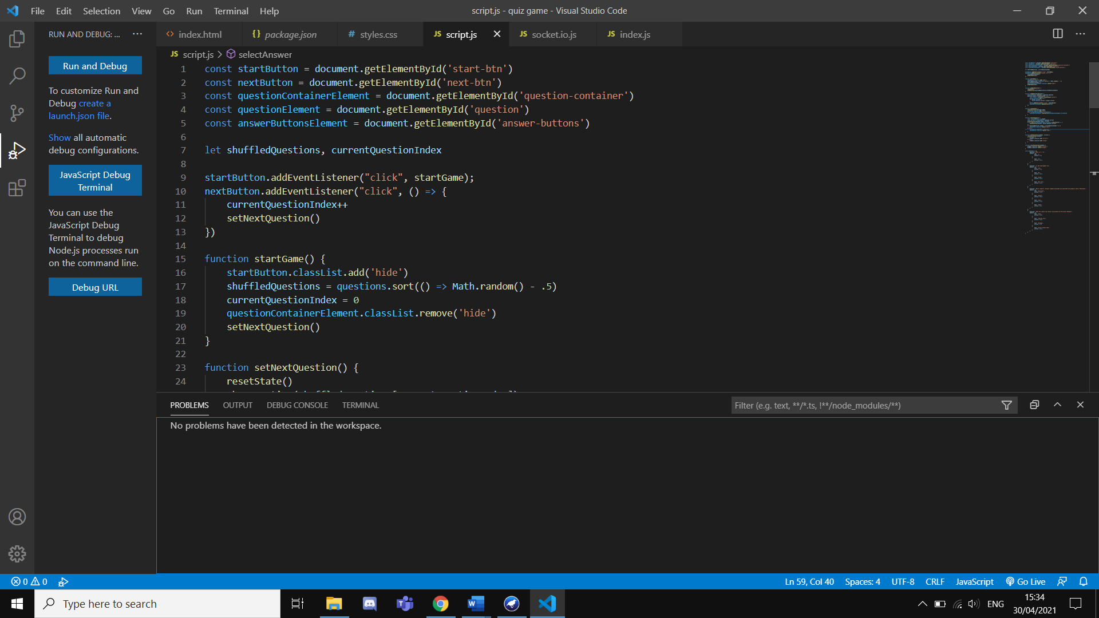
I have run the application and it shows that I have got no problem that has been detected in the workplace. However, this might be different if I run this on Google Chrome.
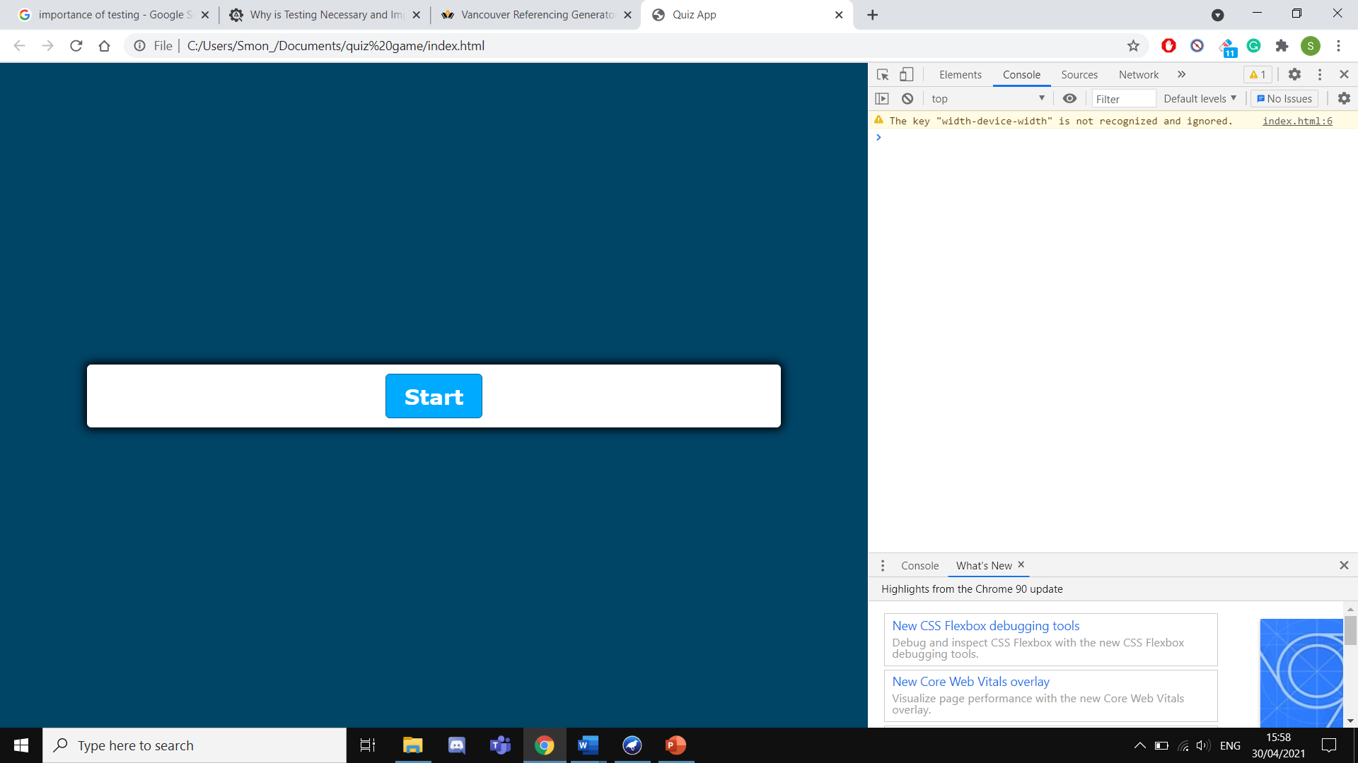
This shows that I have no errors on the application as only have got 1 warning shown.
References
[1] Tutorialspoint. What is a Socket?. [Online]. Available from: https://www.tutorialspoint.com/unix_sockets/what_is_socket.htm [Accessed 30 April 2021]
[2] Sharma, L.S. Why is Testing Necessary?. [Online]. Available from: https://www.toolsqa.com/software-testing/istqb/why-is-testing-necessary/#:~:text=The%20testing%20is%20important%20since,and%20high%2Dperformance%20software%20operation. [Accessed 30 April 2021]

