Rhiannon Thomas
P149985
BSc Games Development
Indie Games Development
13th December 2017

Contents

Introduction…………………………………………………………………………………………………………………....3
Design…………………………………………………………………….……………………………………………………....3
Implementation…….……………………………………………………………………………………….……………....5
Evaluation…….………………………………………………………………………….…………………….……………....8
Appendix…….………………………………………………………………………….…………………….……………....10
References…….………………………………………………………………………….…………………….….…….……11

Introduction
This report provides a specification report containing relevant documentation of a maze game that has been produced. This report includes a ‘Design’ section, An ‘Implementation’ section and an ‘Evaluation’ section.

Design
The game that has been created is a Maze based on a Science Fiction Horror genre that has been inspired by the game Space Invaders. The game is called “Alien Invasion” where Aliens are scattered across the Maze which the player must avoid and find the finishing point to complete the game, this includes three levels, and the higher the levels the more aliens there are.

How to win the game
To win the game the player must avoid the aliens which move in and out of walls, the player must get to the finishing point before losing all their lives. The player will start off with 10 lives. The player must complete three levels before winning the game.

How to lose the game
To lose the game the player must lose all their lives before its Game over. However, there will be a menu available to restart the game.

How to play the game

Controls: | Buttons:
Forward | W and Top Arrow
Back | S and Back Arrow
Left | A and Left Arrow
Right | D and Right Arrow
Look around | Mouse Cursor
Pause | M

Challenges and Actions
There are enemies which will be in the game:
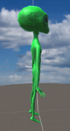  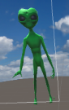  Alien: | What does the enemy do?  - Jump in and out of walls  - If the player collides with an Alien, then the player will lose a life  Specification:  - 3D object  - Green material used for the skin

Also, there is a main menu where the player will be able Continue, Restart or Quit the game:

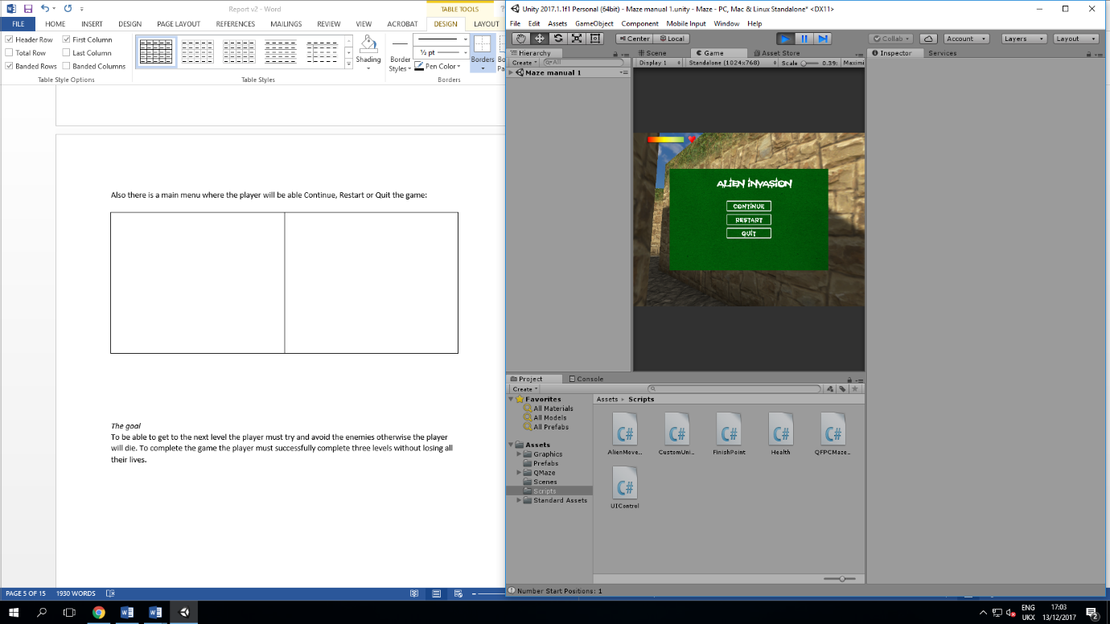  Main Menu: | What does the main menu do?  - The main menu allows the user to click on any of the three buttons which are Continue, Restart and Quit  - The title is at the top of the Main Menu  Specifications:  - Text has been downloaded online called “Spooky Light”  - The background image was downloaded online  - UI Buttons  - UI Text

There is a Health bar which allows the user to know how much life left:

Health bar: | What does the health bar do?  - This lets the player know how much life they have left  - The player should lose a life when they hit into the enemy.  Specifications:  - Health Bar and heart was downloaded online

The goal
To be able to get to the next level the player must try and avoid the enemies otherwise the player will die. To complete the game the player must successfully complete three levels without losing all their lives.

Implementation
The game that has been created has 6 scripts which is AlienMovement, CustomUnityEvent, FinishPoint, Health, QFPCMazeGame and UIControl.

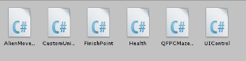

AlienMovement
This script was used to move the aliens back and forth in the maze. This was created by using transform.position which will allow the gameobjects to move in a certain direction, the function “PingPong” is used so that the aliens would move back and forth constantly. I also used min and max variables so the aliens will only move in that distance range.

A collision was also created so that when the player bumps into the aliens then the player will lose a life. This was created by using the OnTriggerEnter method and a Unity Event. When the QFPSController collided with the alien the player will lose a life, a unity event called HurtPlayer is used to take a life away from the player and a float was used to take the life away (-1).

A method called OnDestroy() was used to remove all the event listeners when the player is destroyed.

CustomUnityEvents
This script is used so the UnityEvent allows floats, this will be needed for the health to work. To decrease health then numbers must be used (health -1). UnityEvent will not accept floats if this script was not included in the game.

FinishPoints
This script is used so when the player collides with the finish point then the player should go to the next level. To do this an OnTriggerEnter method was used so when the QFPSController collides with the QFinishFX then the player will go to the next level.

Health
This script controls the health of the player, two UnityEvents has been created in this script to tell the programme when the health has been changed and when the health has been expired. The health changed event lowers the player’s health, this was done by passing it the HealthPercentage method where the value will be changed. The health expired event checks if the health value has dropped to zero, if so then player is destroyed.

A method called OnDestroy() was used to remove all the event listeners when the player is destroyed.

QFPCMazeGame
This is the main script used to run the game. A method called GenerateNewMaze() was used to generate a new maze, also setStartRandomPositionCount was used to position the player randomly when a new maze is generated.

A method called AddFinishPoints() was used to position the finish point in the maze. Also, a method called PositionPlayer() was used to position the player in random points across the maze.

A method called OnGUI() was created so the player can play the game without seeing the cursor, however to be able to use the main menu the method has been commented out otherwise players were unable to click on the buttons in the main menu.

A method called onHurt() was created to be able to decrease the player’s health. This was done by finding the GameObject tagged as “Player” which is QFPSController, get the health script component which should be attached to player and then decrease the player’s health value by the damage and ensuring it doesn’t go beyond zero, a parameter has been created called damage so the float number will be stored in that variable.

UIControl
This is script which manages with the main menu and player interaction. A GameObject variable has been created called menu which will connect with the Main Menu gameObject, this was done by initialising the menu variable and finding the HUDCanvas which is the parent of the Main Menu gameObject.

In the update() method code has been used so when the player presses the letter “M” then the game should be paused.

A method called onPlayerhealthChanged has been used to be able to resize the health bar by using the RectTransform component. Also, if no health point bar game object exists, there is no need to continue.

A method called PauseGame has been used so when the player pressed M then the game will be paused and the menu will be showing. A ResumeGame method was used so when the game is paused the player can press the continue button to continue with the game. Also, a QuitGame method was used so when the player can exit the game when they press the Exit button. A RestartGame method has also been used so players are able to restart the game when they press the Restart button.

A method called DoGameOver() is used so when the player dies then the main menu will display and players are able to restart the game to play again.

Screenshots of the completed game
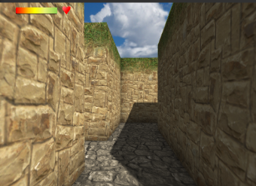  Main Screen: | This is what the player will mainly see when walking through the maze. The health bar is located at the top left corner of the screen.
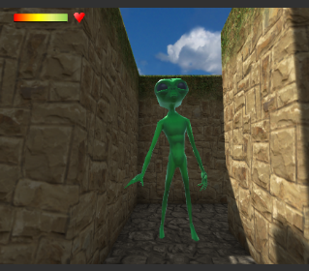  Enemies: | This is what the player will see when an Alien has come out of the walls.
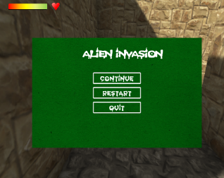  Main Menu: | This is what the player will see what they press “M” which will bring up the main menu where the players will be able to click either the Continue, Restart or Quit button.
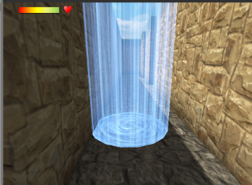  Finish Point: | This is what the player will see when they have reached the end point.

Evaluation
There have been many errors that have been encountered during the implementation. Such as, Finishing point, spawn point, Collision with enemies and Health.

Finishing Point
When the player collides with the finishing point it does not do anything, the player can go through it. Also, the finishing point sometimes randomizes in walls so the player is unable to reach the finishing point. Unfortunately, this has not been fixed. However, the method that was attempted was the OnTriggerEnter function which should have worked. The finishing point was also set as “Is Triggered” so when the QFPSController collides with the prefab the player should have moved to the next level.

Spawn Points
Sometimes the player’s starting point is off the maze grid, so the player is continuously falling through a black hole, however restarting the game the player is spawned inside the maze. This could possibly be because the code is set for the player to spawn in random places.

Collision with enemies
When the player collides with the enemies nothing happens. Unfortunately, this hasn’t been fixed. However, the method that was attempted was the OnTriggerEnter function which should have worked, when the QFPSController collides with the GameObject the player should have lost a life.

Health
When the player collides with the enemies the player does not lose a life and also the health bar does not move. Unfortunately, this hasn’t been fixed. However, many UnityEvents and UnityEventFloats have been used to attempt to fix the problems.

Evaluation of the completed game
There are many features which is in the game that was created such as a Graphical User Interface. There is a main menu for players which gives them the option to Continue, Restart or Exit the game. Also, users are able to pause the game. The users are able to walk around using the controls provided and look around the maze with the cursor. Also, third person players are included in the game.

Reflection
Overall, the game that was created was not truly finished. If there were any changes to be made the errors will have to be solved to make a fully successful functioning game. Recommendations for further improvements could be for the player to have a gun and be able to shoot and destroy aliens, also making levels so that the game can be harder for players to finish and create more aliens.

References

[1] Moving an object back and forth on a single azis automatically, Unity Community, https://forum.unity.com/threads/moving-an-object-back-and-forth-on-a-single-axis-automatically.235033/

Appendix

AlienMovement:

using System.Collections;
using System.Collections.Generic;
using UnityEngine;
using UnityEngine.Events;

public class AlienMovement : MonoBehaviour {

[SerializeField, Header("Player Hurt")]
private UnityEventFloat HurtPlayer;
[SerializeField]
float damage = 1f;

public float min = 2f;
public float max = 3f;
// Use this for initialization
void Start() {

min = transform.position.x;
max = transform.position.x + 3;

}

// Update is called once per frame
void Update() {
// [1] Moving an object back and forth on a single azis automatically, Unity Community, https://forum.unity.com/threads/moving-an-object-back-and-forth-on-a-single-axis-automatically.235033/
transform.position = new Vector3(Mathf.PingPong(Time.time * 2, max - min) + min, transform.position.y, transform.position.z);
}

private void OnTriggerEnter(Collider other)
{
if (other.gameObject.name == "QFPSController")
{
if (HurtPlayer != null)
HurtPlayer.Invoke(damage);
Debug.Log("Hit finish point");
}

}
private void OnDestroy()
{
// Remove all the event listeners when the game object is destroyed
HurtPlayer.RemoveAllListeners();
}
}

CustomUnityEvents:
using System.Collections;
using System.Collections.Generic;
using UnityEngine;
using UnityEngine.Events;

// Custom unity event that accepts a single float parameter (argument)
[System.Serializable]
public class UnityEventFloat : UnityEvent<float> { }

[System.Serializable]
public class UnityEventInt : UnityEvent<int> { }

[System.Serializable]
public class UnityEventInt2 : UnityEvent<int, int> { }

public class CustomUnityEvent : MonoBehaviour {

// Use this for initialization
void Start () {

}

// Update is called once per frame
void Update () {

}
}

FinishPoint:

using System.Collections;
using System.Collections.Generic;
using UnityEngine;
using UnityEngine.Events;

public class FinishPoint : MonoBehaviour {

// [SerializeField, Header("Next Level!")]
// private UnityEvent NextLevel;

// Use this for initialization
void Start () {

}

// Update is called once per frame
void Update () {

}

private void OnTriggerEnter(Collider other)
{
if (other.gameObject.name.Equals("QFPSController"))
{
Debug.Log("Hit finish point");
GameObject.Find("QMazeGame").GetComponent<QFPCMazeGame>().needtoGenerateNewMaze = true;

// NextLevel.Invoke();
}

// Debug.Log("Hit finish point");
// NextLevel.Invoke();
}
}

Health:
using System.Collections;
using System.Collections.Generic;
using UnityEngine;
using UnityEngine.Events;

public class Health : MonoBehaviour {

float maxValue;
[SerializeField]
float _value = 10f;

[SerializeField, Header("Register to know when my health changes")]
private UnityEventFloat HealthChanged;

[SerializeField, Header("Register to know when I run out of health")]
private UnityEvent HealthExpired;

// Use this for initialization
void Start () {

Value = 10f;
}

// Update is called once per frame
void Update () {

}

public float Value
{
get { return _value; }
set
{
_value = value;

// Check that an event listener for the HealthCHanged event exists
// invoke the event (call on the listener method) and pass it the new health percentage
if (HealthChanged != null) HealthChanged.Invoke(HealthPercent);

// Check if the health value has now dropped to zero
// Check that an event listener for the HealthExpired event exists
// invoke the event (call on the listener method)
if (_value <=0f)
{
if (HealthExpired != null) HealthExpired.Invoke();
}

}
}

public float HealthPercent
{
get { return Value / maxValue * 100; }
}

private void OnDestroy()
{
// Remove all the event listeners when the game object is destroyed
HealthExpired.RemoveAllListeners();
HealthChanged.RemoveAllListeners();
}
}

QFPCMazeGame:

using System.Collections;
using System.Collections.Generic;
using UnityEngine;
using qtools.qmaze;
using qtools.qmaze.example1;

public class QFPCMazeGame : MonoBehaviour {

[SerializeField]
private QMazeEngine mazeEngine;
[SerializeField]
private GameObject finishPrefab;
[SerializeField]
private GameObject player;
[SerializeField]
private int numberLevels = 3;
public bool needtoGenerateNewMaze = true;
private int currentLevel = 0;

// Use this for initialization
void Start () {

}

// Update is called once per frame
void Update() {
if (needtoGenerateNewMaze == true)
{
needtoGenerateNewMaze = false;
GenerateNewMaze();
}

}

void GenerateNewMaze()
{
// Check that the maze engine has been specified, if not return and exit early
if (mazeEngine == null) return;

// Randomly generate a number of start positions between 1 and 5
mazeEngine.setStartRandomPositionCount(Random.Range(1, 5));

// Destroy any exisiting maze
mazeEngine.destroyImmediateMazeGeometry();

// Generate new maze
mazeEngine.generateMaze();

// Add the finish points
AddFinishPoints();
PositionPlayer();

// Increase the level counter
currentLevel++;

}

private void AddFinishPoints()
{
// The maze engine provides a method called getFinishPositionList, which returns a list of finish points
// get the list of finish points from the mazeEngine and store them in the variable finishPoints
List<QVector2IntDir> finishPoints = mazeEngine.getFinishPositionList();

// Loop through the finish points and instantiate them
foreach (QVector2IntDir finishPoint in finishPoints)
{
// Instantiate a new game object
GameObject goFinish = Instantiate(finishPrefab) as GameObject;

// set the object's parent to the maze so it is correctly positioned within the maze
goFinish.transform.parent = mazeEngine.transform;

//Position the finish object relative to its parent (local position_
// Scale the x and z position according to the maze's width and height
// The y-position is fixed at 0.01f;
goFinish.transform.localPosition = new Vector3(finishPoint.x * mazeEngine.getMazePieceWidth(), 0.01f, -finishPoint.y * mazeEngine.getMazePieceHeight());

}
}

private void PositionPlayer()
{
// Check if there is a FPC in the scene and position it
// Get the QFPSController component attached to the player
QFPSController fpsController = player.GetComponent<QFPSController>();

// Get the list of start points from the mazeEngine and store them in the variiable startPoint
List<QVector2IntDir> startPoints = mazeEngine.getStartPositionList();

// Check Start Position Count
Debug.Log("Number Start Positions: " + startPoints.Count);

// Check that the fpsController is not null
if (fpsController != null)
//Check if start list count is zero
if (startPoints.Count == 0) // no start points specified
{
// Set the start point to a fixed position
fpsController.transform.position = new Vector3(0, 1, 0);
}
else
{
// Set it to the first start position in the list
QVector2IntDir startPoint = startPoints[0];

// Position the player object rand scale the x and z position according to the maze's width and height
// the y-position is fixed at 0.01f;
fpsController.transform.position = new Vector3(startPoint.x * mazeEngine.getMazePieceWidth(), 0.9f, -startPoint.y * mazeEngine.getMazePieceHeight());

// Rotate the player
fpsController.setRotation(Quaternion.AngleAxis((int)startPoint.direction * 90, Vector3.up));
}
}

private void OnGUI()
{
/*
// When uset starts playing, lock and hide the cursor
if (Input.GetMouseButtonDown(0))
{
Cursor.visible = false;
Cursor.lockState = CursorLockMode.Locked;
}

// When user presses escape key, renable the cursor
if (Input.GetKeyDown(KeyCode.Escape))
{
Cursor.lockState = CursorLockMode.None;
Cursor.visible = true;

}*/
}

private void OnTriggerEnter(Collider other)
{
if (other.gameObject.name == "QFPSController")
{
Debug.Log("Hit!");
}
}

public void FinishPoints()
{
Debug.Log("Hit Finish Point");
}

public void GameOver()
{
Debug.Log("GameOver!");
}

public void onHurt(float damage)
{
// Find the real player object in the active scene
GameObject player = GameObject.FindGameObjectWithTag("Player");

// Get the health script component attached to the player
Health = player.GetComponent<Health>();

//Decrease the player's health value by the damage, but limit the decreased health so it does not go beyond zero
// Mathf.Maz will return the largest of health.Value
health.Value = Mathf.Max(health.Value - damage, 0);

}

}

UIControl:

using System.Collections;
using System.Collections.Generic;
using UnityEngine;
using UnityEngine.UI;
using UnityEngine.SceneManagement;

public class UIControl : MonoBehaviour {

[SerializeField]
GameObject healthPoint;

GameObject menu;
float hpBarFullWidth;
bool isMenuShowing = false;
bool isGameOver = false;

// Use this for initialization
void Start () {

isGameOver = false;
isMenuShowing = false;

// Initialise the menu variable
// First find the HUD convas game object, then find the child Main Menu game object
menu = GetHUDCanvas().transform.Find("Main Menu").gameObject;

// if the health point object has been specified
if(healthPoint !=null)
{
// Get the rectangle transform component
RectTransform hpRectTransform = healthPoint.GetComponent<RectTransform>();

// Get the size of its width
// Full width means 100% health

hpBarFullWidth = hpRectTransform.rect.width;
}
}

// Update is called once per frame
void Update () {

// Check if the user is pressing the M key and it is not yet game over
if (Input.GetKeyDown(KeyCode.M) && !isGameOver)
{
// Pause game
PauseGame(!isMenuShowing);
}

}

private GameObject GetUIControl()
{
//GameObject UIControl = GameObject.FindGameObjectWithTag("UIControl");
return GameObject.FindWithTag("UIControl");
}

private GameObject GetHUDCanvas()

{
// menu = GetHUDCanvas().transform.Find("UI Control").gameObject;
return GetUIControl().transform.parent.gameObject;
}

public void onPlayerHealthChanged(float value)
{
// if no health point bar game object exists, there is no need to continue
if (healthPoint == null) return;

// Get the rectangle transform component
RectTransform hpRectTransform = healthPoint.GetComponent<RectTransform>();

// Calculate the new width based on the health percentage passed to the method
float newWidth = (value / 100f) * hpBarFullWidth;

// Resize the health point bar to give the illusion of decreasing health
hpRectTransform.sizeDelta = new Vector2(newWidth, hpRectTransform.rect.height);

}

private void PauseGame(bool paused)
{
// Set is menu showing based on whether game is paused or not
isMenuShowing = paused;
if (paused == true)
{
Time.timeScale = 0;
}
else
{
Time.timeScale = 1;
}

menu.gameObject.SetActive(paused);
}

public void ResumeGame()
{

PauseGame(false);

}

public void QuitGame()
{
// if UNITY_EDITOR
UnityEditor.EditorApplication.isPlaying = false;
Application.Quit();
}

private Button GetMenuButton(string buttonName)
{
GameObject goButton = menu.transform.Find(buttonName).gameObject;

Button button = goButton.GetComponent<Button>();
return button;
}

private void DoGameOver()
{
// Set is game over to true
isGameOver = true;

// Pause Game
PauseGame(true);

Button continueButton = GetMenuButton("Continue");
continueButton.enabled = false;

// Get child text game object of the Continue Button
// Then get text component attached to the child text game object
Text buttontext = continueButton.transform.Find("text").gameObject.GetComponent<Text>();

// Change the text colour so it stands out
buttontext.color = Color.black;

}

public void OnPlayerhealthExpired()
{
DoGameOver();
}

public void RestartGame(bool paused)
{
// Get current active scene
Scene scene = SceneManager.GetActiveScene();

// Reload the scene, so that game play can restart from the beginning
SceneManager.LoadScene(scene.buildIndex);
}

}

marking criteria and Student FEEDBACK

This section details the assessment criteria. The extent to which these are demonstrated by you determines your mark. The marks available for each criterion are shown. Lecturers will use the space provided to comment on the achievement of the task(s), including those areas in which you have performed well and areas that would benefit from development/improvement.

Common Assessment Criteria Applied (Assignment 1) | Marks available | Marks  awarded
1. Research-informed Literature
Extent of research and/or own reading, selection of credible sources, application of appropriate referencing conventions.
A very limited list of references has been provided. Expand the scope of references consulted to help you improve the quality of your work. (Grade mark: 20.00%) | 5 | 1
2. Knowledge and Understanding of Subject
Extent of knowledge and understanding of concepts and underlying principles associated with the discipline.
Demonstrates a basic understanding of implementing a game from a dynamically generated game world. Although you have attempted to reuse some of the scripting concepts learnt in class, you have not really been able to integrate these together to create a functioning game. The main areas for improvement are getting the basics right and understanding game object interactions, improving your understanding of events and how they can be used to link object interactions, triggers and events. (Grade mark: 47.50%) | 20 | 9.5
3. Analysis
Analysis, evaluation and synthesis; logic, argument and judgement; analytical reflection; organisation of ideas and evidence
The discussion of the challenges faced is detailed and clearly outlines the current limitations of the implemented game. The evaluation and recommendations are satisfactory. (Grade mark: 66.67%) | 15 | 10
4. Practical Application and Deployment
Deployment of methods, materials, tools and techniques; application of concepts; formulation of innovative and creative solutions to solve problems.
A fair attempt, but there is generally room for improvement. The main area for improvement is getting the basic mechanics right. As already mentioned, although you have attempted to implement a few features, many of them do not work. Some of them also require a bit more thought to provide a satisfying and challenging experience for the player. Aim to complete the class tutorial exercises to help you improve your understanding (do not wait till a week before submission to try and understand the tutorials) and also start your next assignment on time. You may also want to restrict the player character's rotation on the y-axis. Please see your report for additional comments. Nonetheless, a satisfactory attempt. Well done. (Grade mark: 45.45%) | 55 | 25
5. Skills for Professional Practice
Attributes in professional practice: individual and collaborative working; deployment of appropriate media; presentation and organisation.
The report is of a good standard. See your report for suggested improvements. (Grade mark: 60.00%) | 5 | 3

Assignment Mark (Assessment marks are subject to ratification at the Exam Board. These comments and marks are to give feedback on module work and are for guidance only until they are confirmed. ) | Late Submission Penalties (tick if appropriate) |  | 48.5%
 | Up to one week late |  | 48.5%
 | 1st/2nd/3rd attempt? |  | 48.5%

