

How effective are current ‘positive action’ procedures in dealing with victimless cases of domestic violence, and could they be causing trust issues in the UK Police?

Sarah Warriner
Student ID: 2029482

Bsc (Hons) Professional Policing Practice
Word Count 8405 (Including Ethics Review and Proposal of 1500 words)

Acknowledgments:
I’d like to take this opportunity to thank my parents, friends and family for their support throughout the first three years of my career within policing, and encouraging me throughout the completion of my degree in policing.
I would also like to thank my supervisors Jordan Woosnam and Steve King for their support throughout my career to this time, without this I would not have been inspired to progress in policing to the level I have today.
I would also like to thank all colleagues, family and friends who are members of the police service, who have given their thoughts and views on this topic. Without their views, opinions and discussions surrounding the topic, I would not have found the inspiration to explore this.

Declaration:

Declaration - This work has not previously been accepted in substance for any degree and is not being concurrently submitted in candidature for any degree. Signed: Date:
Statement 1 - This dissertation is being submitted in partial fulfilment of the requirements for the degree of BSc. Signed: Date:
Statement 2 - This dissertation is the result of my own independent work/investigation, except where otherwise stated. Other sources are acknowledged by footnotes giving explicit references. A bibliography is appended. Signed: Date:
Statement 3 - I hereby give consent for my dissertation, if accepted, to be available for photocopying and for interlibrary loan, and for the title and summary to be made available to outside organisations. Signed Date:
Statement 4 - I hereby give consent for my dissertation, if accepted, to be available on the university’s IT system to those who have consent to use the system. Signed: Date:

Abstract
This paper examines and compares existing policies and procedures surrounding Domestic violence incidents, specifically where the cases are ‘victimless’ prosecutions.
It examines how successful these policies are in not only convicting offenders, but also safeguarding the victims who do not wish to support convictions against their perpetrator, therefore establishing if changes or training are required in how these crimes are managed.
It explores the victims’ perception and views of how these crimes are dealt with, both through news articles, and through the research study completed with police officers in UK police forces. This helped to elaborate on whether victims’ trust police and whether they are more or less likely to report these crimes to the police in future. Most officers who completed the study portrayed that there is a clear mistrust and anger from victims who do not wish for the perpetrator to be prosecuted, which in turn can create a mistrust in the police and criminal justice system. It also portrayed that most officers disagreed in the current policies surrounding ‘positive action’ in victimless cases.

Contents
- Introduction…………………………………………………………………………………………………………………………7
- Literature Review…………………………………………………………………………………………………………………8
  - Introduction…………………………………………………………………………………………………………….8
  - Priorities of Positive Action in Domestic Abuse Cases from Police…………………………….8
  - Why do victim’s often not support police action?.......................................................9
  - Considerations by police when victim is not in support…………………………………………….10
  - Outcome for victims………………………………………………………………………………………………..10
  - Conclusion……………………………………………………………………………………………………………….11
3.0 Methodology of Study………………………………………………………………………………………………………….12
3.1 Introduction………………………………………………………………………………………………………………….12
3.2 Ethical Practice………………………………………………………………………………………………………………12
3.3 Informed consent and participant confidentiality…………………………………………………………..13
3.4 Research Method and Tools……………………………………………………………………………………………13
3.5 Participant Sample and Technique………………………………………………………………………………….13
4.0 Systematic presentation of the findings, discussion, and analysis
4.1 Introduction……………………………………………………………………………………………………………..14
4.2 Police Opinion on ‘Positive Action’ Approaches………………………………………………………..14
4.2.1 ‘What do you deem to be ‘positive action’ in a domestic related incident where any offence has been disclosed?’…………………………………………………………………………………………..14
4.2.2 Officers’ disagreement with arrest policy and reasoning………………………………………..15
4.3 Success rates of victimless prosecution…………………………………………………………………….16
4.4 Victims’ trust and Opinion………………………………………………………………………………………..17
4.4.1 Victims less likely to call police for future crimes……………………………………………………17
4.4.2 Victims’ reaction to current ‘positive action’ policies…………………………………………….18
4.6 Victim’s Code within Victimless Cases……………………………………………………………………….18
5.0 Findings, Conclusion and Recommendations…………………………………………………………………………20
5.1 Introduction……………………………………………………………………………………………………………..20
5.2 Summary of Primary Findings…………………………………………………………………………………...20
5.3 Objectives…………………………………………………………………………………………………………………20
5.3.1 Evaluate the effectiveness of current methods of ‘positive action’ and arresting perpetrators in victimless domestic violence offences……………………………………………………..20
5.3.2 To determine and identify victims’ views and perceptions of current victimless ‘positive action’ practices in policing and explore the likelihood of victims’ trusting the police in future instances…………………………………………………………………………………………………21
5.3.3 To explore whether current policies regarding victimless prosecutions in domestic abuse cases contradict other policies regarding being victim led, as per the victims’ code.21
5.4 Recommendations…………………………………………………………………………………………………….22
5.5 Final Thoughts…………………………………………………………………………………………………………..22
6.0 Bibliography………………………………………………………………………………………………………………………….23
7.0 Appendix……………………………………………………………………………………………………………………………….25
7.1 Appendix One – Questionnaire………………………………………………………………………………….25
7.2 – Appendix Two – Results From Questionnaire……………………………………………………..27
7.3 – Appendix Three – Ethics Review…………………………………………………………………………40
7.4 – Appendix Four – Research Proposal Sheet………………………………………………………….56

- Introduction
This research will examine the current policies and procedures in place regarding victimless prosecution in domestic violence cases, and specifically whether the current safeguarding actions in place – known as ‘positive action’- are successful in prosecuting perpetrators and gaining the trust of victims.
The Domestic Abuse Act (2021) states that
‘Behaviour of a person (“A”) towards another person (“B”) is “domestic abuse” if—
(a)A and B are each aged 16 or over and are personally connected to each other, and
(b)the behaviour is abusive.
(3)Behaviour is “abusive” if it consists of any of the following—
(a)physical or sexual abuse;
(b)violent or threatening behaviour;
(c)controlling or coercive behaviour;
(d)economic abuse;
(e)psychological, emotional or other abuse’
Domestic Violence cases are one of the most prominent incidents that are dealt with by UK police forces daily, with a domestic abuse related call being made to the police every 30 seconds. Additionally, there is often a stigma surrounding domestic abuse related calls whereby the victim will often not report these incidents and instead hide them from police, with only 24% of cases being reported. When considering that in the year ending March 2022 there were 1.5 million cases reported, and these only accounting for less than a quarter of cases that have occurred, it reflects that there is a possible issue with the trust victims have in their issues being dealt with correctly (National Centre for Domestic Violence, 2023).
These statistics clearly reflect the importance of dealing with domestic violence cases thoroughly and correctly, however the low number of reports made is a main reason why the current UK police force policies of ‘positive action’ including arrest when an offence has been committed and investigating without relying on evidence from victims who often do not support conviction, needs to be explored thoroughly (Wiltshire Police, 2021). By doing this in this study, it will not only give explanation for these low figures of reporting to police but establish what changes may need to be made to policies.
This study will do this by looking at the following objectives:
- To evaluate the effectiveness of current methods of ‘positive action’ and arresting perpetrators in victimless domestic violence offences’

- To determine and identify victims’ views and perceptions of current victimless ‘positive action’ practices in policing and explore the likelihood of victims’ trysting the police in future instances.

- To explore whether current policies regarding victimless prosecutions in domestic abuse cases contradict other policies regarding being victim led, as per the victims’ code.
2.0 - Literature Review
2.1 – Introduction
The purpose of this chapter is to review current literature relating to ‘positive action’ and victimless prosecution within the policing of domestic abuse related crime, with a particular focus on how successful these methods are for the victim in the long run. It will examine how much of a focus the strategy of arresting the perpetrator in these situations is, as well as how often this strategy is utilised. In addition to this the literature review will focus of the victim’s feelings of why domestic abuse is often not reported, and what positive action is put in place when a victim does not support the conviction and why. Lastly the literature review will look at the gaps in the positive outcomes in victimless prosecutions and present possible questions on how these cases should be handled alternatively.
The literature review contains a wide range of sources including articles from official organisations such as the CPS(2017), HMICFRS (2019) and the College of Policing (2015), as well as articles from journalists who have conducted existing primary research in the topic area of ‘domestic abuse’. Most consistently searched terms include ‘Victimless Prosecutions’, ‘Positive Action in Domestic Abuse’, ‘Success rates for victimless prosecutions’ and ‘Reasons for Victims not supporting police’.

2.2 - Priorities of Positive Action in Domestic Abuse Cases from Police
In the year ending March 2022, 1,500,369 domestic abuse-related incidents were recorded in England and Wales, not all these incidents were deemed a crime. Additionally, of all crimes committed in the same year, 17.1% of these were domestic abuse related (Office for National Statistics, 2022). Showing that there is a significant demand for police with a high percentage of their crimes being related to domestic abuse.
A report carried out by HMICFRS (2019) discusses the importance of making domestic violence cases a priority within policing. It found that most forces are continuing to do this and that when speaking with 350 domestic abuse practitioners, the feedback was extremely positive in how police deal with these incidents. With almost two-thirds stating there had been an improvement since 2014, and a fifth stating that there had been a large improvement.
One of the reasons for this improvement explained is due to taking effective and timely ‘positive action’ in dealing with these incidents. The College of Policing (2015) explained that in dealing with domestic abuse incidents, some form of ‘positive action’ should always be taken to safeguard the victim. In the majority of these cases it involves arresting the perpetrator and an officer must be able to justify the reasoning for not arresting the perpetrator if the decision is made not to. This includes if the victim is not supporting the arrest, unlike with other offences that are not domestic abuse related.
In contrast to this, although multiple agencies state that the most beneficial action in dealing with these incidents is to arrest the perpetrator, this is quite frequently not the case across the entire of England and Wales. The Office for National Statistics (2022) also stated in their report at the year ending March 2022, that the police made 31.3 arrests per 100 domestic-abuse related crimes. Although the decision to not arrest may have been justified as the College of Policing explained, it is still a relatively low figure when considering the positive action policy on this.
In fact, HMICFRS also explore this in their report, where they explain that although most officers understand the importance to arrest the offender in cases of domestic abuse but found that the arrest rate in these cases is still falling. 23 forces in the 12 months prior to 30 June 2017 saw a decrease in the number of arrests for domestic abuse-related offences. When considering this, and the limited percentage of arrests in 2022, this demonstrates that there may be a lack of positive action being taken with regards to arresting suspects for these offences.

2.3 – Why do victim’s often not support police action?
The difficulty with the ideology of positive action in all cases of domestic related crime is that in most cases, the victim does not wish for the perpetrator to be arrested and therefore does not support a conviction against them. This can be for various reasons and Gurm and Marchbank (2020) explain that over 70% of victims do not report these incidents to police for various reasons. They discuss that the victim often will want to ‘make-up’ with their partner, the victim may be dependent on the perpetrator, or they may simply fear of the repercussions if their partner is arrested and then released.
Another article written by Scott (2021) discusses why it is often the case that victims do not report these cases of domestic abuse. She explains that it is often the case that the victim has been so isolated by the perpetrator that they feel that they have no other person to turn to other than them. This then leaves them in a vulnerable position after reporting this, financially, socially, and then opening them up to more potential physical danger. Scott explains that the victims often do not have financial independence from their partner and less access to a healthy income, and in addition to this, little to no support system from family and friends due to the abuse they have faced.
Children in the relationship are also a key factor in why victims’ will often avoid reporting the abuse. Scott (2021) spoke with a victim in her article (who remained anonymous) who explained that she felt that reporting the situation to the police would only cause her children ‘more suffering’ and that she “didn’t want to bring any unnecessary pressure on the children from what they were already witnessing”.
In addition to this, multiple sources explain that when a victim makes the decision to leave the perpetrator, or report the abuse to police, this is when it leaves them at their most vulnerable. Scott (2021) again explains this in her article whereby she explains that a lot of victims feel that they will not be kept safe when the abuse is reported and that the most dangerous time for female victims’ in these cases is when they go to the police.
An article by the National Coalition Against Domestic Violence (No Date) expands on this by explaining that in a lot of cases when a victim leaves, the abuser may follow through with the threats they have made during the relationship. A lot of these threats relate to them hurting or killing them, hurting or killings the children, retaining custody of the children, amongst many other threats. They explain that there are also societal barriers to the victim reporting, even though they believe the threat is real. One of the main societal barriers is the fear of not being fully supported by law enforcement agencies, which would then result in the victim not being safeguarded and these threats becoming reality.

2.4 – Considerations by police when victim is not in support
The CPS (2017) produced a trouble shooting guide for officers when dealing with domestic abuse cases with part of this guide discussing cases where the victim may become obstructive in the perpetrator being arrested for various reasons. It discusses that often victims either just want support from third party organisations instead of arrest, or they will on occasion try to disrupt the process of arresting the perpetrator to prevent this altogether. In this situation it is clearly stated that regardless of the support of the victim in these cases, officers should be arresting the suspect if there is a power of arrest.
The CPS (2017) go on to explain that the reasoning for ‘extending the investigation beyond the victim’ is due to the possibility that they have been controlled or coerced in these situations and that deciding to report is often a very complex process for them, which is why the decision should remain with the police.
In all cases when dealing with a victim, the College of Policing (2021) states that the police and the CPS should be following the ‘Victims Code for Policing’ which is a set of rights that all victims’ are entitled to when involved in crime. This policy includes that the victims’ have a right to ‘make informed choices that are fully respected’ and that ‘police personnel are not responsible for the crime and the harm this has caused to the victim, but they are responsible for not making the victims situation any worse’. The difficulty with this is that in victimless prosecutions, the decision the victims’ choice is not always considered in the result of the report to police.
Due to this, a different power is utilised and considered in victimless prosecutions which the CPS (2017) discuss in their guide. The power used in these cases is stated in The Criminal Justice Act (2003), and this explains that a statement made by a victim can be admissible if the person is in fear of giving the statement orally to the courts and the courts allows the statement to be used. This further solidifying that police do have the power to act on the victims’ behalf if they believe this necessary for safeguarding purposes, even if this contradicts the victims’ code.

2.5 – Outcome for victims
Ultimately, it must be considered if the positive action policy within Domestic Abuse is successful for the victims themselves. In a report conducted by HMICFRIS (2019) they assessed 554 cases where a victim had withdrawn support from the case, finding that only 215 of these cases could then be progressed without the support of the victim, and of those 215, only 152 were progressed by the police. This means that the perpetrators in these cases had all conditioned imposed on them withdrawn after they were arrested, allowing them to return to the victim where applicable and the fears discussed by Gurm and Marchbank (2020) may then become a reality for these victims.
The other difficulty in confirming if the policy is successful for the victims, is that there is currently no way of measuring the outcomes officially in this area. Gibbs (2019) explains that there is currently no study exploring reoffending trends when a person has been arrested for a domestic abuse offence. In her article, she explains that the policy appears to be more to do with risk aversion for the police themselves rather than for the victim. Although she discusses that the police will often use arrest to create a window of opportunity to make referrals to other agencies and apply for restrictions on the perpetrator, she points out that applications can still be made for orders such as a Domestic Violence Protection Order without the arrest having to take place.
In addition to this a Criminal Justice Joint Inspection (2020) was carried out surrounding Evidence led prosecutions in Domestic Abuse cases. It found that both the police and the CPS are missing out on improving their best practices in dealing with these cases without the support of the victim, as they are no effective systems in place which record the outcomes of the cases. The inspection found very few results of success stories surrounding these cases, as they had not been recorded or documented. This resulted in performance not being able to be evaluated for future use or improvement and again not being informative on whether the victim had a successful outcome in their case.
On the other hand, there have been successful cases reported whereby victimless prosecutions have led to convictions and ultimately long-term safeguarding of the victim. One of the most prominent of these was the case against Steven Saunders which secured a sentencing against him of coercive control and an indefinite restraining order protecting his victim. Herald (2018), discusses this case which was the first case of coercive control whereby a perpetrator was convicted of the offence without the support of the victim. The article quotes David Munro who was the Police and Crime Commissioner at the time of the case, where he explains how important of a milestone this case was in the future of battling with domestic abuse and how this case would send a message to perpetrators who believe that fear from their victims will not prevent them from being prosecuted.
2.6 – Conclusion
In conclusion to this literature review, it is obvious that there is a clear focus from agencies such as the College of Policing (2015), the HMICFRS (2019) and the CPS (2017) on dealing with domestic abuse cases by use of positive action, with all these agencies focusing on arresting the perpetrator as the most beneficial outcome for the victim. They all focus on taking the decision out of the victims’ hands and are of the opinion that this is the safest option for the victim in these cases, and when reviews have been made on police forces, it is said that officers understand the focus on this and the importance for this.
However, it is also apparent that there are obvious disparities between this opinion and the success rates of dealing with domestic abuse cases in this manner, especially when considering that although the view is to arrest the perpetrators less than a third of cases result in arrest (HMICFRS, 2019).
In addition to this it can be concluded that even when a suspect is arrested, there is very little evidence of success stories in dealing with cases via victimless prosecution and therefore very little room to offer constructive criticism in dealing with these (CJJI, 2020). There are also currently no studies surrounding whether these types of investigations and positive action work with regards to safeguarding victims (Gibbs, 2019). When also considering that reviews shows that less than half of cases can often be progressed to a prosecution, and that less three quarters of these cases get progressed (HMICFRIS, 2019), it could be concluded that the positive action that is deemed so important, is not necessarily fit for purpose.
The conclusion could also be made that the fears victim have regards to police involvement (Scott, 2021) could become a reality based on the lack of examples of positive outcomes, and that although there are policies in place to take the decision out of the victim’s hands (Criminal Law Act, 2003), there needs to be further study into whether this is the most beneficial option for the victim.

3.0 – Methodology of Study
3.1 – Introduction
Throughout this chapter of the dissertation, it will offer a synopsis of the methods that have been utilised in conducting research in this topic. It will provide confirmation of the ethical practices that have been followed in conducting the research and the informed consent provided by the participants. Additionally, it will explore the approaches used to obtain the data for the research, and the reasons behind choosing those methods.
Research can be defined as ‘a process of systematic inquiry that entails collection of data; documentation of critical information; and analysis and interpretation of that data/ information, in accordance with suitable methodologies set by specific professional field and academic disciplines. (Hampshire College, 2022).
As discussed in the previous chapter, there are currently limited results from the CPS and the police on the success rates of ‘positive action’ in domestic abuse cases, especially those where the case is a victimless prosecution. To help assist with obtaining information surrounding this, research is to be conducted and data collected in the form of primary data, which is original data collected by the researcher first hand (Study Smarter, 2023).
3.2 – Ethical Practice
Prior to conducting any primary research, ethical approval should be sought by the relevant bodies who will be assessing the results. This is done to protect the participants and the researcher when the research is carried out and proves that the researcher has adhered to ethical guidelines (UWE Bristol, 2023).
This ensures that the researcher will be paying attention to possible ethical issues that could occur when collecting the data, and discussing how they will overcome these issues. Bhandari (2022) defines ethical considerations as ‘a set of principles that guide your research designs and practices’. She also explains that there are several ethical issues that should be considered prior to conducting the research which are: Voluntary participation, informed consent, anonymity, confidentiality, potential for harm and results for communication.
To guarantee that this research complies with those standards, an application was submitted to an ethics committee which has been approved. This form included explained to the ethics committee the goals of the research, the methods which would be used to collect the data such as surveys, and explained how the researcher had considered the ethical issues that could be produced and how these had been negated.
Additionally, the application form discusses what participants would be targeted for the research and the reasoning for choosing this sample of participants, how their answers would be stored and accessed, as well as confirming how the participants information would be kept confidential, therefore demonstrating compliance with the ethical issues that Bhandari (2022) discusses.

3.3 – Informed consent and participant confidentiality
As stated previously, there is an ethical obligation to ensure that the participant’s information is kept confidential and to ensure that the participants are not exposed to any harm that could be accrued because of the research. It is the responsibility of the researcher to ensure that all measures are put in place to comply with this successfully (University of Sunderland, No date).
Due to this, all responses provided in the study were stored on a secure website with the researcher having to enter a username and password to access the information. Additionally, the researcher would only access this website from password protected devices which were only accessible by them, therefore protecting the participants in line with data protection laws such as the Data Protection Act (2018).
Before completing the survey, participants were provided with a disclaimer. This disclaimer explained they should only complete this if they are a serving police officer who deals or has dealt with domestic violence cases. There was no requirement to confirm the participants were over the age of 18, as all serving police officers are aged 18 or over. The participants were informed their answers were confidential, and that the survey was not compulsory, and they could exit at any time. Finally, the participants were informed that by completing the survey they were giving written informed consent for their answers to be used in this research, and that their answers would then be deleted upon submission of the research. (University of Oxford, 2021).
3.4 – Research Method and Tools
When collecting data, it was necessary to conduct a mixed method approach and utilise both quantitative and qualitative research. Each method has a unique approach and has different methods for gathering the data, with qualitative research focusing more on open-ended and detailed questions, and quantitative data emphasising instead on the number of responses retrieved (Daniel, 2016).
The decision was made to utilise an online survey including both methods. Online surveys have many benefits in obtaining research data in that they are more accurate as the researcher cannot misinterpret the answers given, results can be obtained quickly and conveniently, and the researcher is able to reach more people online than they may be able to in person (Communications for Research, 2021).
The survey used some closed questions which were more quantitative in nature, but then followed up by asking the participants to provide more reasoning to their answers if they selected certain answers, thereby encouraging a more qualitative approach. These more detailed responses from participants allows the researcher to gain an in-depth response as to whether positive action in policing is working, and where participants believe it does not work, ‘how’ and ‘why’ this should be changed (Cleland, 2017).
3.5 – Participant Sample and Technique
Initially it was considered to utilise the charities that deal with victims of domestic abuse to conduct the research required, this was discussed as it would not be ethical to consider using the victims of the crimes themselves. However, due to the difficulties in obtaining a large sample of responses from these charities, and the time restraints on shift patterns, the decision was made to obtain responses from serving police officers in the UK.
By collecting responses from police officers who have or currently deal with domestic abuse victims daily, they would ideally be able to provide an accurate response on how many cases get progressed via victimless prosecution, because of positive action. It also would allow the researcher to gain answers as what victims’ have told them directly in these cases, and whether the current policies are successful, need improvement, and what could be done differently.
The survey aimed to have at least 25 responses and was posted on internal policing websites to ensure that this could only be accessed by police officers and not the public. The survey was open for one month between July 2023 and August 2023 and on closure had a total of 32 participants.

4.0 - Systematic presentation of the findings, discussion, and analysis
4.1- Introduction:
The purpose of this chapter is to analyse the results of the questionnaire disseminated to various police officers of a variety of ranks, police forces and service level. There were 32 respondents, all of which completed all compulsory questions. Some questions only required a response to give further detail based on answers to previous questions, and of all questions where a further response was required were answered.
This questionnaire has gathered both qualitive and quantitative data from officers who deal with domestic abuse incidents on a regular basis, focusing on addressing all objectives for the study.
Some results may include abbreviations such as PPN (Public Protection Notification), DASH (Domestic abuse, stalking and harassment assessment), NFA (No further action) and VA (Voluntary attendance interview).
Additionally, although question a question was posed with regards to the rank of the contributors within the police force, this has been omitted from the presentation of findings. This is due to their being limited range of ranks who completed this, and it also having little to no effect on the outcome of the survey.
4.2 Police opinion on ‘Positive Action’ approaches
To cover this section, three questions were posed to the contributors. The purpose of these questions was to establish how police officers dealing with domestic abuse offences defined ‘positive action’, as well as exploring their views on whether they agreed with the policy on arresting a perpetrator in any domestic related offence, and establishing if they believe other methods of dealing with the situation would be more effective.
4.2.1 - ‘What do you deem to be ‘positive action’ in a domestic related incident where any offence has been disclosed?’
This question allowed the contributor to provide multiple responses, which was important as there are various scenarios in domestic violence scenarios. The results were as follows:
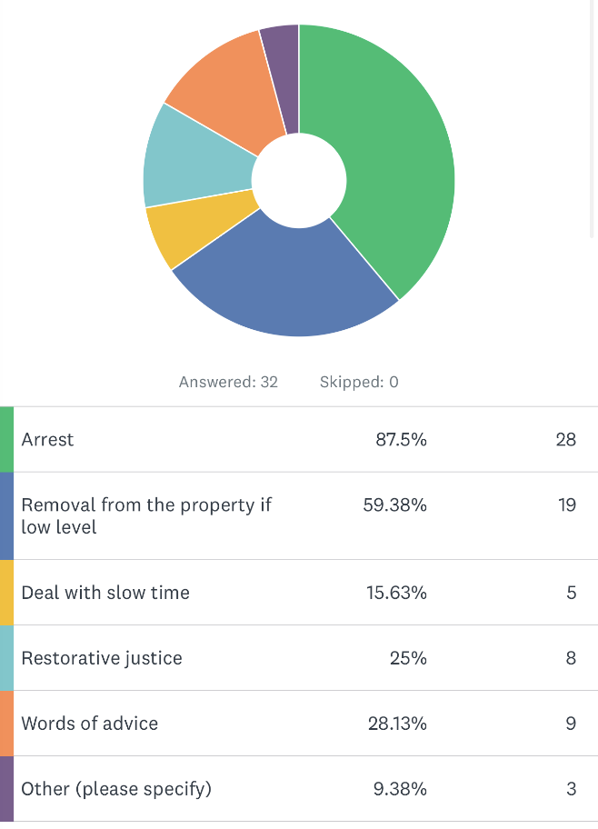
The results show most officers agreed that arresting an individual would be deemed to be ‘positive action’ at a domestic related incident, therefore corroborating guidance from the College of Policing (2015) as previously stated in the literature review chapter of this study. There is however a discrepancy with other responses, as 59.38% of officers deem removing a person from the property where the offence is low level, to be positive action taken, as well as various other responses.

4.2.2 – Officers’ disagreement with arrest policy and reasoning
Question 3 posed the below question to contributors:
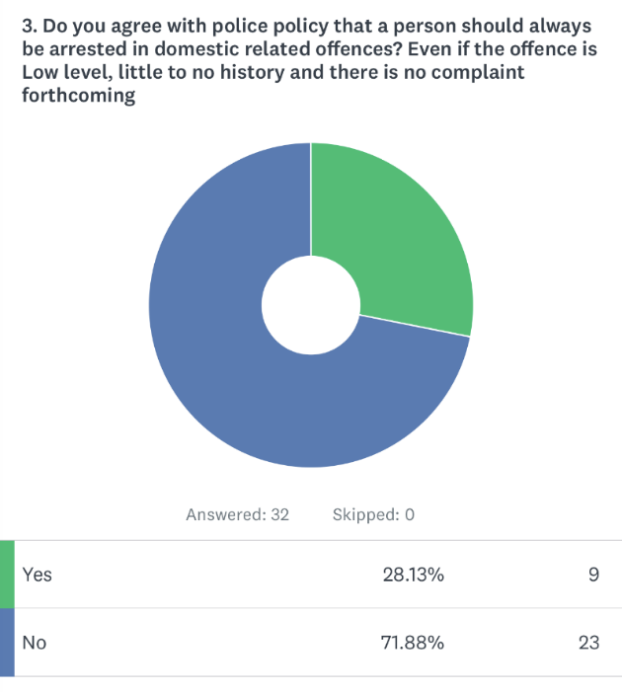
This ratifies that officers disagree with current guidelines in place, with an overwhelming majority of 71.88%.
To explore participants’ thoughts on this and establish better solutions in managing these incidents, Question four was posed: ‘If answered ‘no’ to question 3 what other methods would you potentially use in dealing with these cases?’.
Much like Gibbs (2019) who wished for the use of outsource agencies to assist in creating safe space between the victim and the perpetrator, responses such as ‘‘Removal from address and referrals to other agencies. Also, can look to place on courses such as drink and drug course and anger management through VA and court’’ and ‘‘People involved to be separated and safeguarding measures to be put in place as well as DASH and PPN referrals’, reflect similar themes. Responses from participants appeared to follow the ideology that it is more beneficial overall to deal with these incidents with out of court methods instead of arrest.
Upon reflection, it would have been beneficial to allow respondents who agreed with the arrest policy to have the opportunity to give their views on why, posing a more balanced view of the topic.
4.3 – Success rates of victimless prosecution
Although officers disagree with the policies in place regarding arrest in all domestic cases, it is important to consider the success rates of these cases. By arresting a perpetrator, this results in an investigation and either a positive outcome by form of conviction or out of court disposal, or a negative result whereby no further action is taken. Question five details how successful the outcomes of these cases are according to the officers who deal with them.
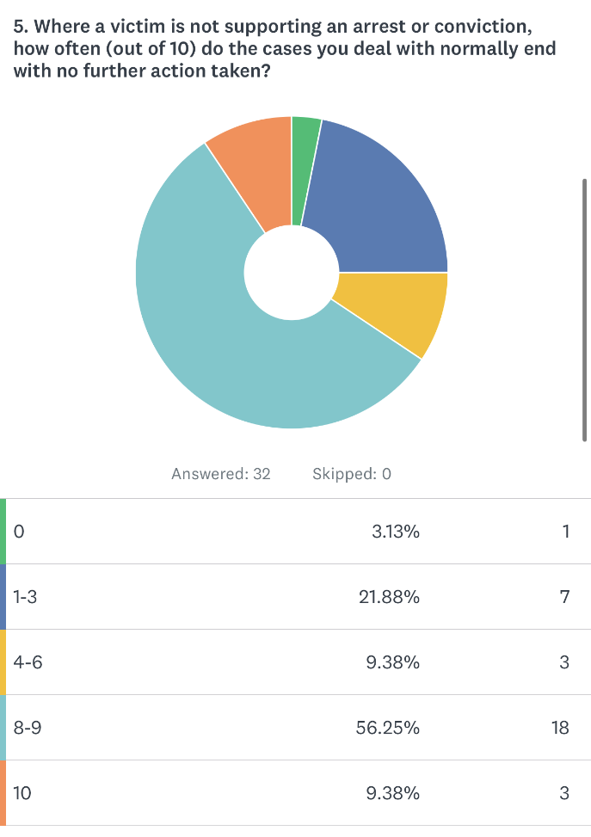

Although some officers stated that 0-3 cases resulted in a NFA result, 56.25% of officers stated that 8-9 of incidents resulted in a NFA result, which indicates that officers have little faith in the success of victimless cases.
These results are not official statistics and are only experiences of officers, however it could be stated that these officers are most experienced in giving answers on success rates due to regular dealings in the area. The feedback obtained is also corroborated by earlier information obtained from HMICFRIS (2019) where only 27% of cases, where a victim had withdrawn support, were pursued by police. Although this may be slightly more than the amount stated by participants, it is not a drastically different number, and evidences that there are a significant number of cases that are not pursued as victimless cases.
4.4 – Victim’s trust and opinion
To understand the feelings of victims not supporting the positive action of arrest, three questions were posed to participants. The goal was to determine the victims’ perceptions after this action was taken, as well as exploring the likelihood of victims’ having trust in the police and making future reports of a similar nature.
4.4.1 – Victims less likely to call police for future crimes
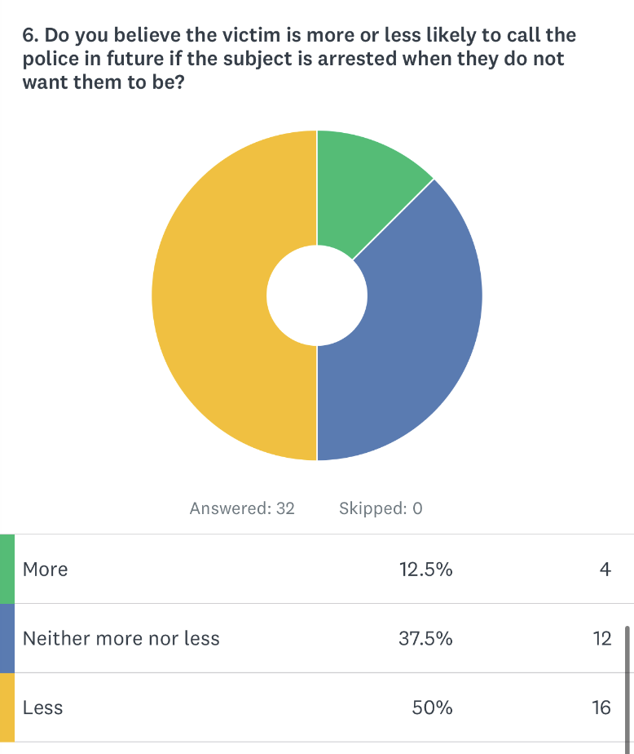

The results show most participants believe a victim is less likely to contact police in future if positive action in the form of arrest is taken against their wishes. This gives a perception that officers believe that the victim is less likely to trust police in future due to their wishes not being taken into consideration.
To explore the reasoning for this, participants were asked ‘If you answered more or less to Question 6, please explain your reasoning for this.’
Many responses had similar views of Gurm and Marchbank (2020), with participants stating that ‘‘Repeat victims learn quickly what not to say to avoid their partner being arrested’’ and that ‘‘They will think they are to blame for the arrest and will suffer the repercussions from the suspect. It doesn’t keep them safe; it can put them at further risk. Should be judged case by case not a blanket policy’’.
Additionally, some comments such as ‘‘A large aspect of policing by consent is developing trust in Police. If it appears that we are not observing the wishes of the victim, we risk alienating them which often results in them not engaging when required.’’ and ‘‘Less likely to trust police as their views and wishes have been overlooked’’ echo the views of The National Coalition Against Domestic Violence (No Date), who are of the opinion that victims’ often do not feel fully supported by law enforcement agencies and lack trust in them. And although some responses which were of the belief that the victim ‘will have confidence that positive action will be taken’, however in these responses carried little detail, and therefore struggled to provide a strong opposition to the argument posed.
4.4.2 – Victims’ reaction to current ‘positive action’ policies
The third question utilised to further investigate the victims’ viewpoint was Question 10: ‘When a victim hasn’t supported an arrest and the suspect is arrested, how does the victim normally react to this news and what did they ask for as a resolution instead?’
This question allowed the participants to provide a more detailed account on the full feelings of victims’ from their experience, with the majority of responses from participants expressing that victims’ normally respond in a negative manner. Again, both Gurm and Marchbank (2020) and Gibbs (2019) points were reaffirmed from comments made such as “Typically the victim will be upset or angry if they are adamant they do not want the offender arrested and usually they just want the offender removed from the address” and “Upset, annoyed, fearful or repercussions. They often ask for a NFA and frequently beg us to tell the suspect they didn’t make a complaint/ provide a statement”.
4.6 – Victim’s Code within Victimless Cases
One focus area of this study was to explore how compliant victimless policing is within the victims’ code of practice. Questions 8 and 9 focus on this, whereby participants were asked the question and to explain their response:
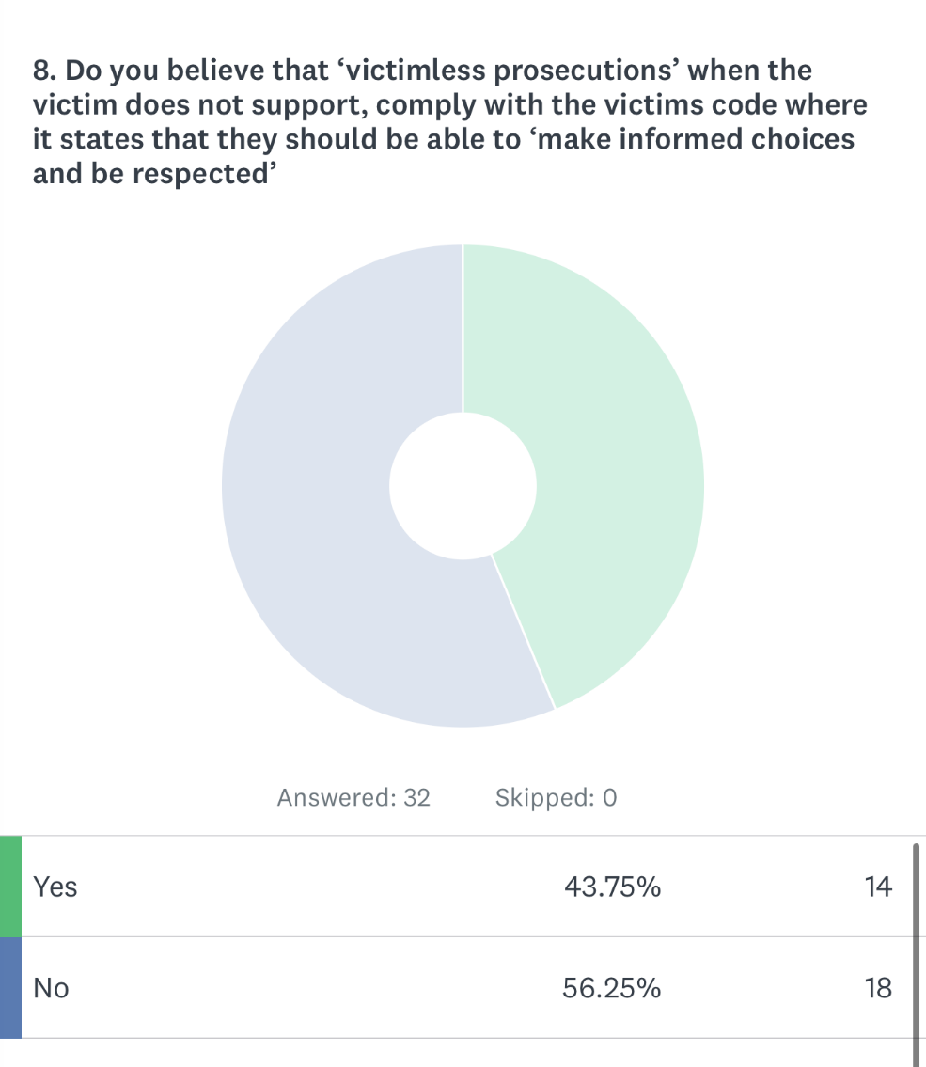
Results in this section show there is a small majority who do not believe that victimless prosecutions comply with this section, with responses as to why they have stated this explaining that by ignoring their wishes we are “essentially saying ‘we know what’s best for you’”. Another response stated “I do not believe that it does comply with being victim lead. DV also appears to be one of the very few incidents that are treated like this. Rape victims have a choice in this, and it has always confused me that one violent crime would be treated differently to others’’.
Additionally, although multiple persons stated they do not believe the policy complies with the victims’ code, they stated that for safeguarding purposes, a victimless prosecution should be pursued, reiterating the guide from the CPS (2017) on utilising the Criminal Justice Act (2003) guidance instead.

5.0 – Findings, Conclusion and Recommendations
5.1 Introduction
This chapter will focus on summarising the research findings, as well as returning to the objectives detailed in the introduction. This will help decipher whether the objectives set out in this dissertation have been met, as well as exploring if the research findings mirror or undermine the results considered in the literature review. The chapter will then conclude with its recommendations.
The objectives of this dissertation were as follows:
- To evaluate the effectiveness of current methods of ‘positive action’ and arresting perpetrators in victimless domestic violence offences.

- To determine and identify victims’ views and perceptions of current victimless ‘positive action’ practices in policing, and explore the likelihood of victims’ trusting the police in future instances.

- To explore whether current policies regarding victimless prosecutions in domestic abuse cases contradict other policies regarding being victim led, as per the victims’ code.
5.2 Summary of Primary Findings
The aim of this dissertation is to explore whether current methods of ‘positive action’ and victimless prosecution in domestic abuse cases are effective, and how victims perceive these methods, as well as confirming if these methods comply with the victims’ code. To obtain this, participants were asked surrounding whether they agreed with current victimless prosecution methods and if they believed victims’ trusted the current methods. An online questionnaire was disseminated to these participants, with most participants agreeing with Gibbs (2017) in opposing this policy and wishing the pursue alternate methods, as well as mirroring opinions of Gurm and Marchbank (2020) and Scott (2021), which portray a lack of trust from victims when these policies are used.
5.3 Objectives
5.3.1 Evaluate the effectiveness of current methods of ‘positive action’ and arresting perpetrators in victimless domestic violence offences.
When respondents were asked their opinions surrounding ‘positive action’ in policing, over seventy percent disagreed with the College of Policing’s (2015) policy on arresting domestic violence perpetrators in most cases.
In fact, although over 80% of participants stated that arresting an offender is a form of positive action, multiple participants also selected several other outcomes as methods of positive action. Over 50% of respondents stated that a removal of the perpetrator from the property would be a potential solution, and over 25% opting for words of advice to be given to the perpetrator, or to consider restorative justice measures where appropriate. These responses could therefore evidence why police only had a thirty-one percent arrest rate in March 2023 (National Statistics, 2023), and why HMICFRIS (2019) document a decline in the number of arrests by officers in these cases.
Additionally, over 55% of participants who reflected on their experiences of dealing with such cases, believed that only 10-20% of victimless cases resulted in a case having the ability to be pursued against the perpetrator. When considering this, along with a similar figure from HMICFRIS (2019) of 27% of cases being pursued, it could explain why participants may wish to preference other methods instead of arrest and sheds a very negative view on the whole victimless process promoted by the CPS (2017) currently in place. These alternative measures corroborated Gibbs (2017) and prioritised the safeguarding of the victim, such as referrals to support agencies, as well as separating parties to create distance.
Furthermore, Gibbs (2017) also explored the lack of evidence on the success rates of victimless prosecutions, specifically how few results there are on the reoffending rates where the stance of the College of Policing were used. When reviewing the lack of results of success rates in this area, as well as considering the Criminal Justice Joint Inspection’s (2020) findings that the CPS currently have no method of reviewing these outcomes, it once again backs up participants appeared lack of faith in the number of cases that proceed to a prosecution.
5.3.2 To determine and identify victims’ views and perceptions of current victimless ‘positive action’ practices in policing and explore the likelihood of victims’ trusting the police in future instances.
To meet this objective, participants were asked questions to establish how the victims would feel about their wishes not being addressed, and instead a case being pursued regardless of opinion. The results from this portrayed a clear opinion that victims are likely to develop a lack of trust in the police and criminal justice system. This is due to 50% of participants portraying the view that a victim would be less likely to report further incidents of domestic abuse to the police in future when their needs and wishes were not met initially.
Many participants expressed concern that victims often feel fearful of the repercussions from the offender of the arrest, and therefore could potentially be put at further risk because of reporting the incident to the police in the first place. When considering these results, it shows a direct reflection of findings from both Gurm and Marchbank (2020) and Scott (2021).
Additionally, when again considering points made by Gibbs (2019) regarding lack of evidence on the success rates of reoffending in these cases this could indicate further factors of why victims may have little to no trust in the process.
5.3.3 To explore whether current policies regarding victimless prosecutions in domestic abuse cases contradict other policies regarding being victim led, as per the victims’ code.
To meet the final objective of the dissertation, participants were asked whether they believed victimless prosecutions were compliant with the Victims’ code of Policing (College of Policing, 2021), with 56.25% of participants believing it is non-compliant. Some participants also expressed concern that similar serious offences, such as rape, do not have the same process of being victimless, even though the crime is just as violent. This potentially contradicts the idea that breaching this policy is done as a matter of safeguarding.
The difficulty with comparing this is there is little detail on where victimless prosecutions fit into the Victims’ Code, and therefore no opposing view that it is compliant. This is even the case hen looking at the opposing participants’ feedback, with these participants focusing on victimless prosecutions being used for safeguarding purposes and not detailing any explanation on why they believe the process to be compliant. This furthermore provides the weighted argument that the CPS (2017) are potentially ignoring the Victims’ Code, in favour of utilising powers from the Criminal Justice Act (2003) instead.
5.4 Recommendations
Upon completing this dissertation, the following recommendations have been made:
- To gain a more detailed and in-depth opinion surrounding this topic and be more representative of police opinion, it is recommended that future research should be conducted on a larger scale, including equal amounts of time in service, as well as ranks. By doing this, it would allow for a more representative view from the police as whole.
- The second recommendation would be for the CPS and the police to work with victims’ who have experienced these situations, to gauge opinion on what has worked well within victimless cases, and what has not been successful. By doing this, it will allow for a potential re-evaluation on what methods are working when dealing with domestic violence, instead of a blanket policy on arresting in these cases. It could also mean that although the Victims’ Code is not utilised in victimless cases, by incorporating the views of victims in the process of dealing with these incidents, it would be much more aligned.
- The final recommendation is regarding how these cases are reviewed by the CPS. As discussed, there are currently no results on the success or reoffending rates of victimless prosecution, meaning there is no knowledge on if these methods truly safeguard victims, or if they have positive results. It is recommended that the CPS and individual police forces provide figures annually on how many victimless prosecutions are pursued through arrest, as well as the number of times the perpetrator reoffended, and in doing so will allow performance to be evaluated and reflect where improvements need to be made.
5.5 Final Thoughts
Although sometimes it is appropriate to use arrest as a method of positive action, and there should be instances where victimless prosecution is utilised, from the findings from literature and research in this dissertation, there needs to be a re-evaluation on the suitability of this in other cases of domestic related crime. Additionally, it is evident that current processes of reviewing the success rates of these methods are either posing negative results or are non-existent in certain areas, which is turn is resulting in a lack of trust in the system from police officers dealing with domestic abuse and more importantly, trust from the victims themselves. Evidently, without intervention and feedback from victims on how they wish to be treated, reports to police from victims are likely to fall, therefore endangering them from future incidents, and ultimately negating the premise of victimless prosecutions being a safeguarding purpose.

6.0 – Bibliography
Bhandari, P (2022). Ethical Considerations in Research / Types & Examples. Available At: https://www.scribbr.co.uk/research-methods/ethical-considerations/#:~:text=These%20principles%20include%20voluntary%20participation,when%20collecting%20data%20from%20others (Accessed 23rd August 2023)
Cleland, J. (2017) ‘The qualitative orientation in medical education research’ Korean Journal Medical Education, 29(2), Available At: https://www.ncbi.nlm.nih.gov/pmc/articles/PMC5465434/#:~:text=Conclusion-,Qualitative%20research%20is%20very%20important%20in%20educational%20research%20as%20it,numbers%20to%20understand%20human%20experience (Accessed 24th August 2023)
The College of Policing (2018). Arrest and other positive approaches. Available At: https://www.college.police.uk/app/major-investigation-and-public-protection/domestic-abuse/arrest-and-other-positive-approaches#:~:text=Police%20officers%20have%20a%20duty,a%20necessary%20and%20proportionate%20response. (Accessed 4th August 2023).
The College of Policing (2021), Victim’s Code for Policing. Available At: https://www.college.police.uk/guidance/victims-code/victims-rights-policing (Accessed 17th April 2023).
Communications for Research (2021). 6 Advantages of Online Surveys. Available At: https://www.cfrinc.net/cfrblog/6-advantages-of-online-surveys (Accessed 24th August 2023)
CPS (2017), Domestic Abuse Referrals from the Police to CPS – Troubleshooting Guide. Available At: https://www.cps.gov.uk/sites/default/files/documents/legal_guidance/Troubleshooting-Guide-Domestic-Abuse-Referrals.pdf (Accessed 4th August 2023)
Criminal Justice Act 2003. Available At: https://www.legislation.gov.uk/ukpga/2003/44/section/116 (Accessed 4th August 2023)
Criminal Justice Joint Inspection (2020) Evidence Led domestic abuse prosecutions. Available At: https://www.transformjustice.org.uk/news-insight/should-all-domestic-abuse-suspects-be-arrested/ (Accessed 4th August 2023)
Daniel, E (2016) ‘The Usefulness of Qualitative and Quantitative Approaches and Methods in Researching Problem- Solving Ability in Science Education Curriculum’. Journal of Education and Practice, 7(15), pp92-98. Available At: https://files.eric.ed.gov/fulltext/EJ1103224.pdf (Accessed 24th August 2023)
Wiltshire Police (2021) ‘Domestic Abuse’. Wiltshire Police Force Policy and Procedure, 5. Pp3. Available At: https://www.wiltshire.police.uk/SysSiteAssets/foi-media/wiltshire/2021/07-september-2021/foi-2022-196-policy-documents-domestic-abuse-policy-and-procedure.pdf (Accessed 30th December 2023).
Data Protection Act 2018. Available At: https://www.legislation.gov.uk/ukpga/2018/12/contents/enacted (Accessed 23rd August 2023).
Domestic Abuse Act 2021. Available At: https://www.legislation.gov.uk/ukpga/2021/17/part/1/enacted (Accessed 30th December 2023)
Farham Herald (2018) Domestic abuser jailed in ‘legal first’ on hearsay. Available At: https://www.farnhamherald.com/news/999/domestic-abuser-jailed-in-legal-first-on-hearsay-187532
Gibbs, P (2019). Should all domestic abuse suspects be arrested? Available At: https://www.transformjustice.org.uk/news-insight/should-all-domestic-abuse-suspects-be-arrested/ (Accessed 31st July 2023).
Gurm, B and Marchbank, J. (2020, Chapter 8) ‘Chapter 8: Why Survivors Don’t Report’ Available At: https://kpu.pressbooks.pub/nevr/chapter/why-do-survivors-not-report-to-police/ (Accessed 18th May 2023)
Hampshire College (2022) What is Research? Available at: https://www.hampshire.edu/what-research (Accessed 23rd August 2023).
HMICFRS (2019). The police response to domestic abuse, An update report. Available At: https://www.justiceinspectorates.gov.uk/hmicfrs/wp-content/uploads/the-police-response-to-domestic-abuse-an-update-report.pdf (Accessed 3rd August 2023)
National Coalition Against Domestic Violence (2023). Domestic Abuse Statistics UK. Available At: https://www.ncdv.org.uk/domestic-abuse-statistics-uk/ (Accessed 30th December 2023)
National Coalition Against Domestic Violence (No Date). Why do Victims Stay? Available At: https://ncadv.org/why-do-victims-stay (Accessed 9th August 2023).
Office for National Statistics (2022) Domestic abuse in England and Wales overview: November 2022. Available At: https://www.ons.gov.uk/peoplepopulationandcommunity/crimeandjustice/bulletins/domesticabuseinenglandandwalesoverview/november2022#:~:text=Of%20all%20crimes%20recorded%20by,ending%20March%202020%20(15.1%25) (Accessed 3rd August 2023)
Scott, K. (2021) Why victim- survivors don’t report domestic violence Available At: https://www.abc.net.au/everyday/reasons-why-victim-survivors-dont-report-domestic-violence/100035002 (Accessed 9th August 2023)
Study Smarter (2023) Primary and Secondary Data. Available At: https://www.studysmarter.co.uk/explanations/psychology/cognition/primary-and-secondary-data/ (Accessed 23rd August 2023).
University of Oxford (2021) Informed Consent. Available At: https://researchsupport.admin.ox.ac.uk/governance/ethics/resources/consent#collapse281091 (Accessed 23rd August 2023)
University of Sunderland (No Date). Participant and Researcher Safety and Well-Being. Available At: https://www.sunderland.ac.uk/more/research/research-governance-integrity/ethics/apply-ethical-review/participant-and-researcher-safety-and-well-being/ (Accessed 23rd August 2023)
UWE Bristol (2023) Why you need ethical approval. Available At: https://www.uwe.ac.uk/research/policies-and-standards/research-ethics/why-you-need-ethical-approval (Accessed 23rd August 2023)

7.0 – Appendix
7.1 – Appendix One – Questionnaire

Effectiveness of positive action and victimless prosecution in DV cases

This survey is completely anonymous and should be undertaken by serving police officers only who have dealt or deal with domestic abuse cases. The results of this survey will be used as primary research in a dissertation on the topic detailed and the research may be published by University of Trinity St David to view. The full results of the survey will be deleted after the dissertation has been submitted.

There is no obligation to complete this survey and you may stop answering questions at any time.

By completing the survey, you confirm you are a serving police officer and therefore are over the age of 18 and you consent for your answers to be used in research for this dissertation.

* 1. What rank are you?
Constable
Sergeant
Inspector or above

* 2. What do you deem to be ‘positive action’ in a domestic related incident where any offence has been disclosed ?
Arrest
Removal from the property if low level
Deal with slow time
Restorative justice
Words of advice
Other (please specify)

* 3. Do you agree with police policy that a person should always be arrested in domestic related offences? Even if the offence is Low level, little to no history and there is no complaint forthcoming?

Yes
No

4. If answered ‘no’ to question 3 what other methods would you potentially use in dealing with these cases?

* 5. Where a victim is not supporting an arrest or conviction, how often (out of 10) do the cases you deal with normally end with no further action taken?
0
1-3
4-6
8-9
10

* 6. Do you believe the victim is more or less likely to call the police in future if the subject is arrested when they do not want them to be?
More
Neither more nor less
Less

7. If you answered more or less to question 6, please explain your reasoning for this

* 8. Do you believe that ‘victimless prosecutions’ when the victim does not support, comply with the victims code where it states that they should be able to ‘make informed choices and be respected’
Yes
No

* 9. Please explain your answer to question 8

* 10. When a victim hasn’t supported an arrest and the suspect is arrested, how does the victim normally react to this news and what did they ask for as a resolution instead?

7.2 – Appendix Two – Results from Questionnaire
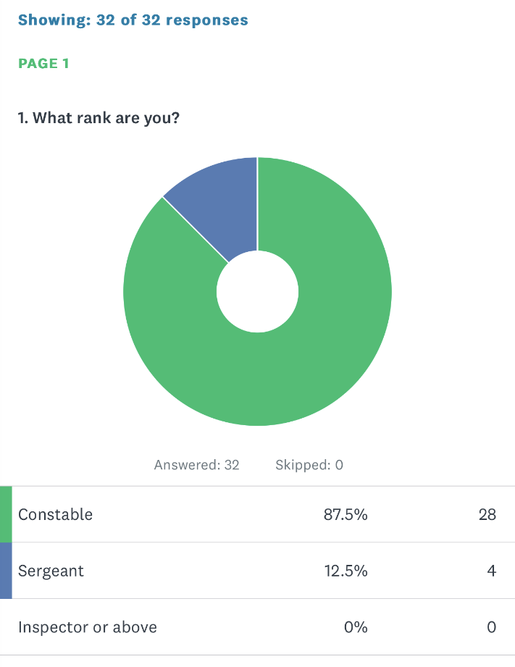
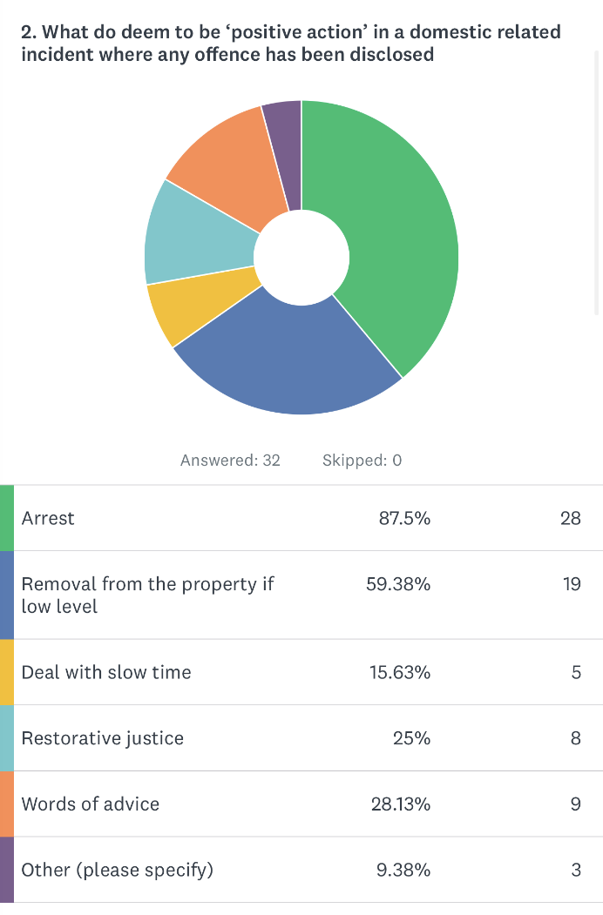
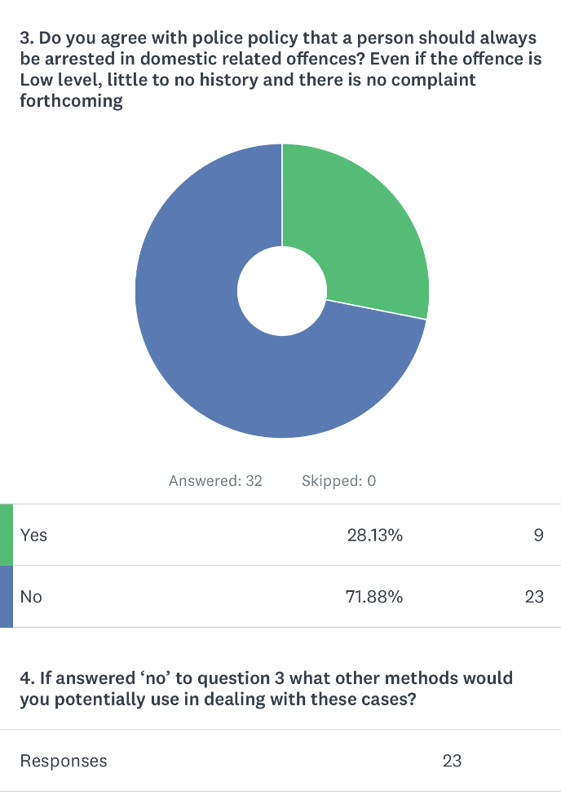
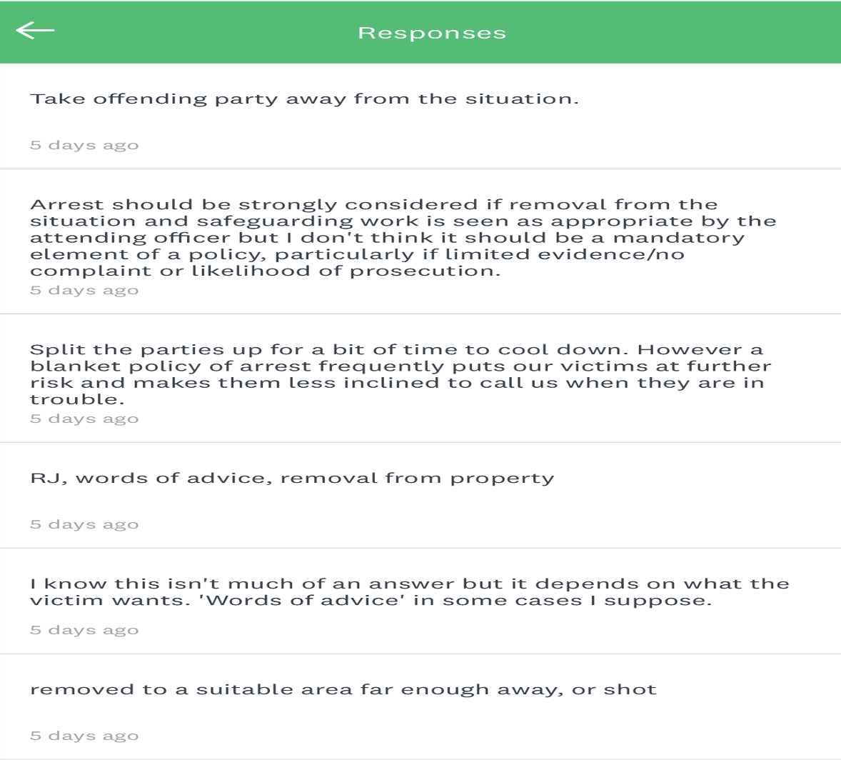
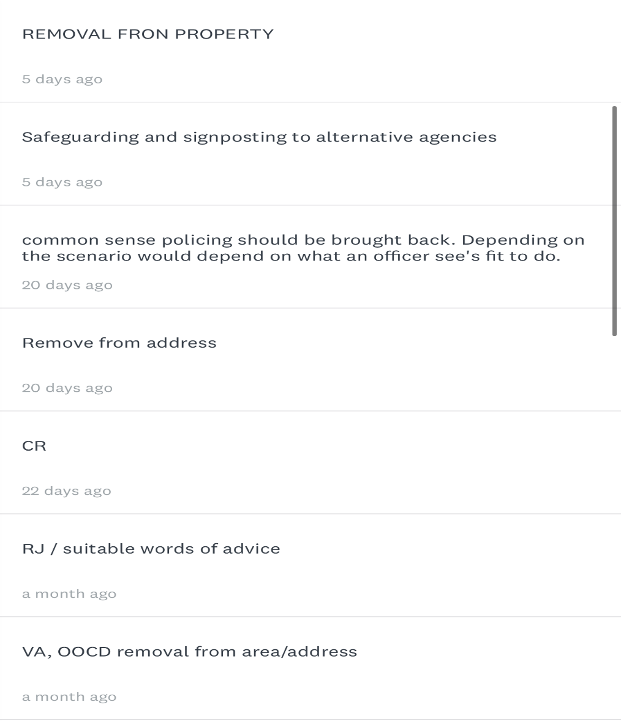
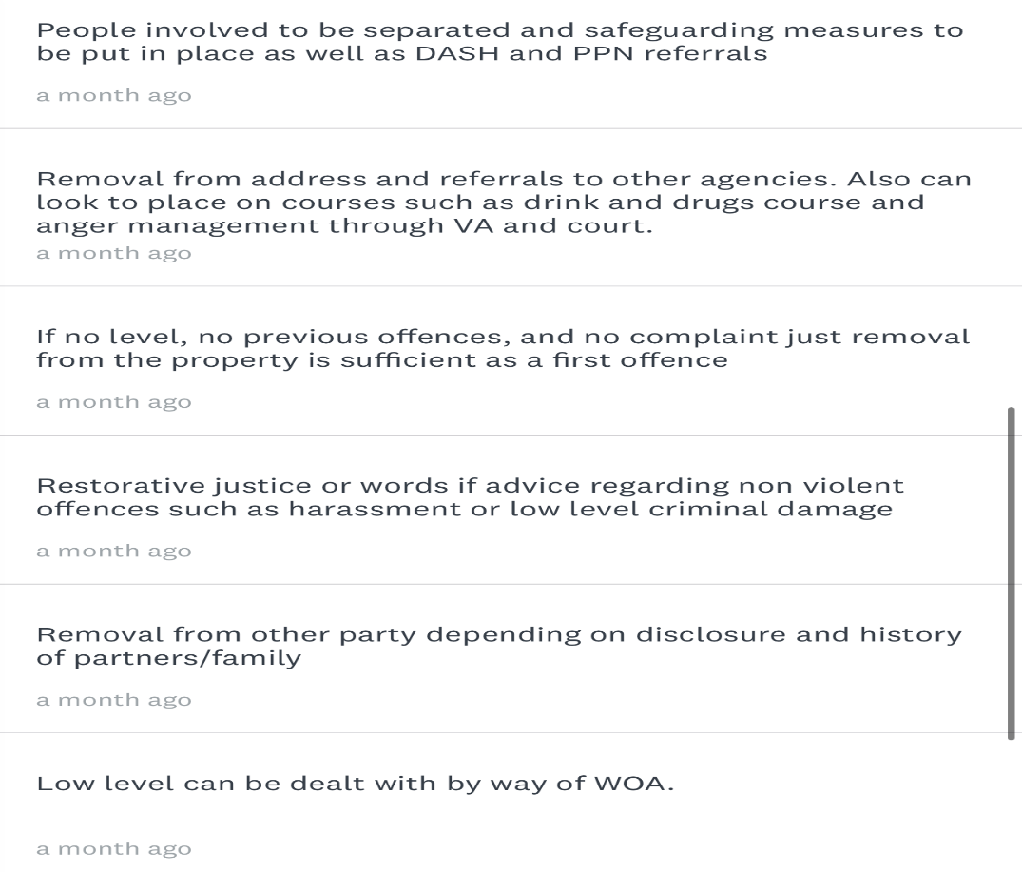
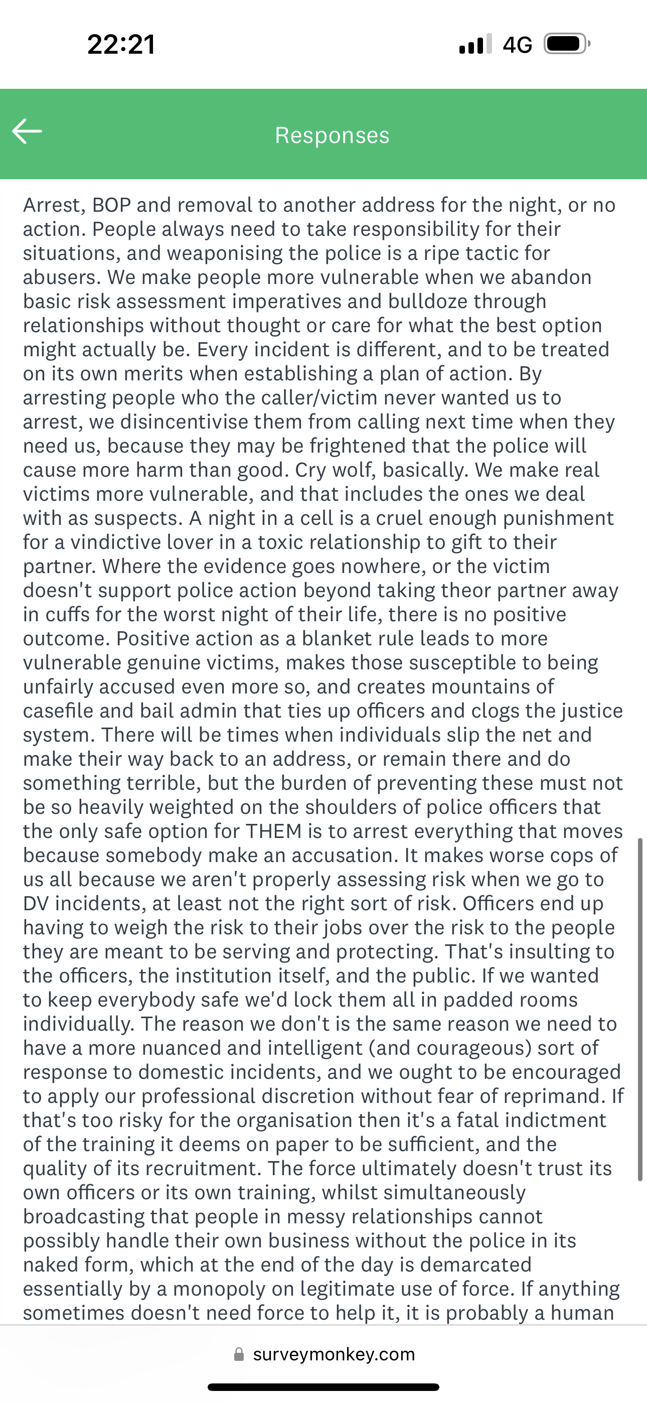
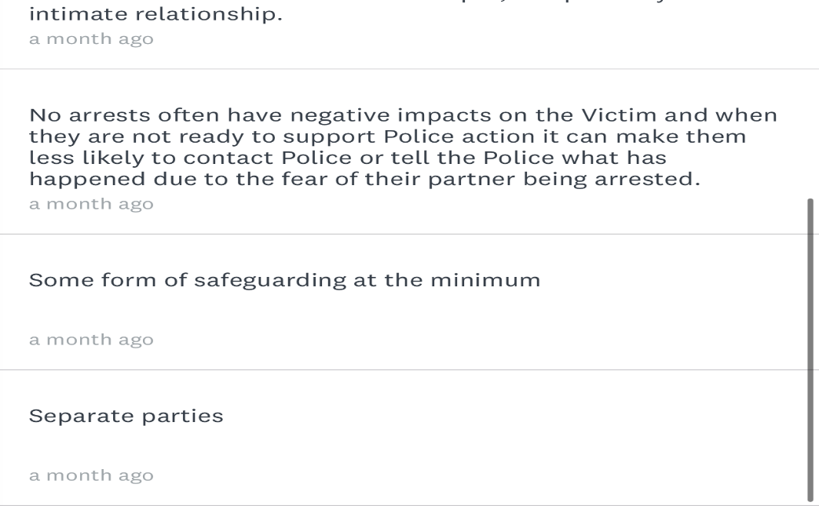

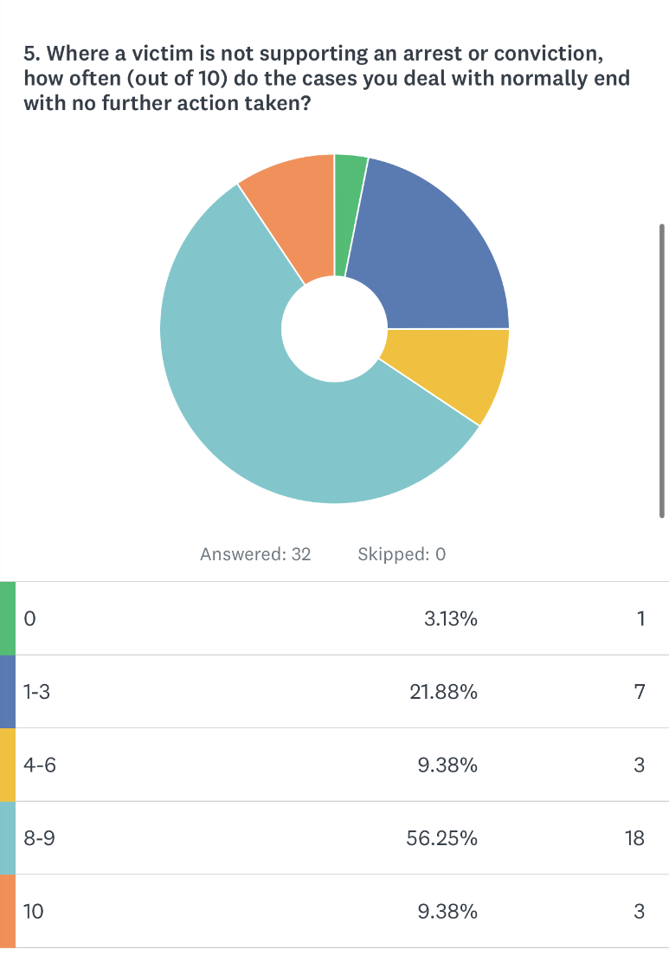
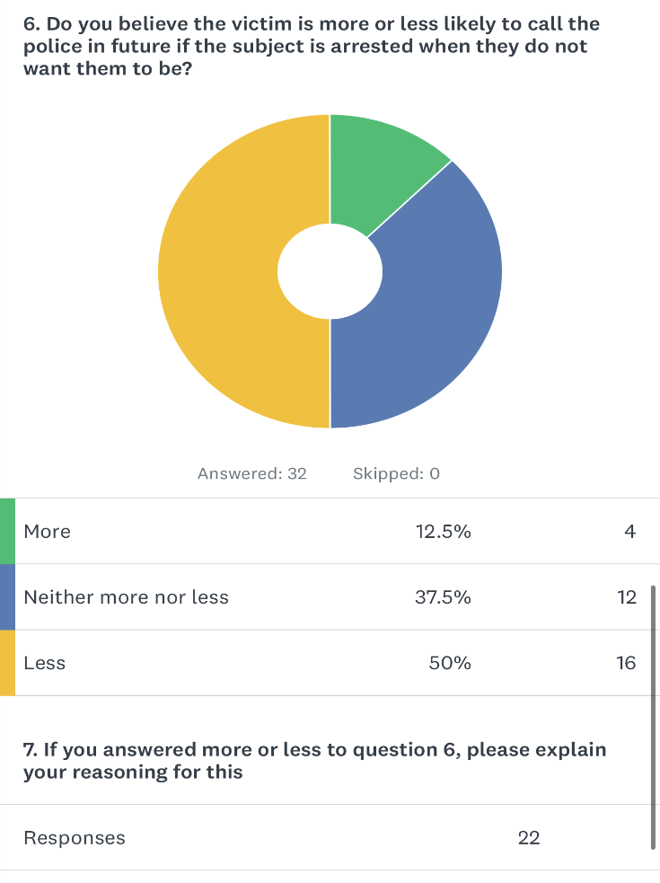
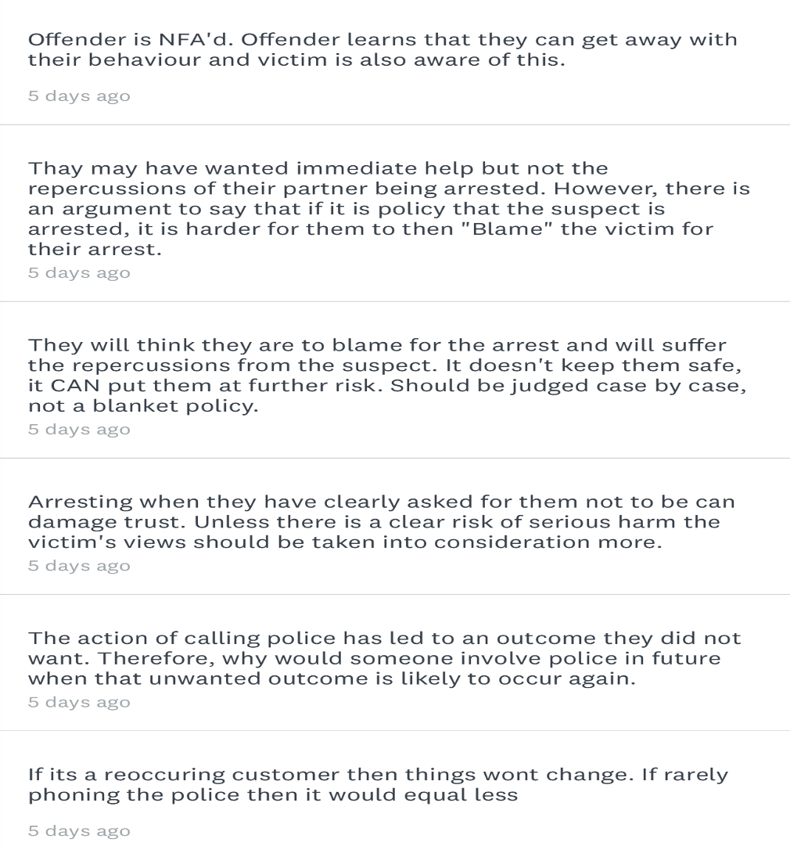
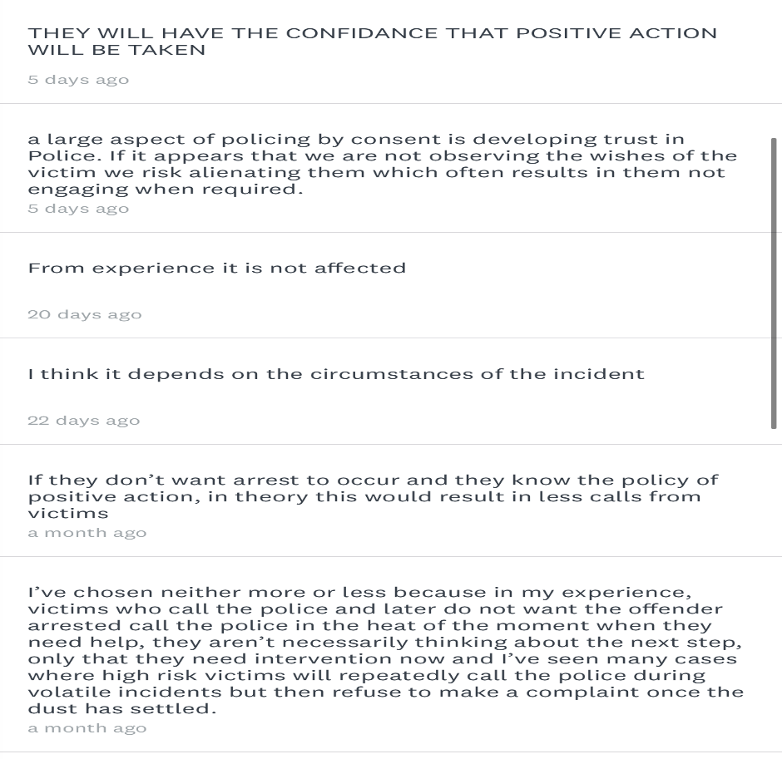

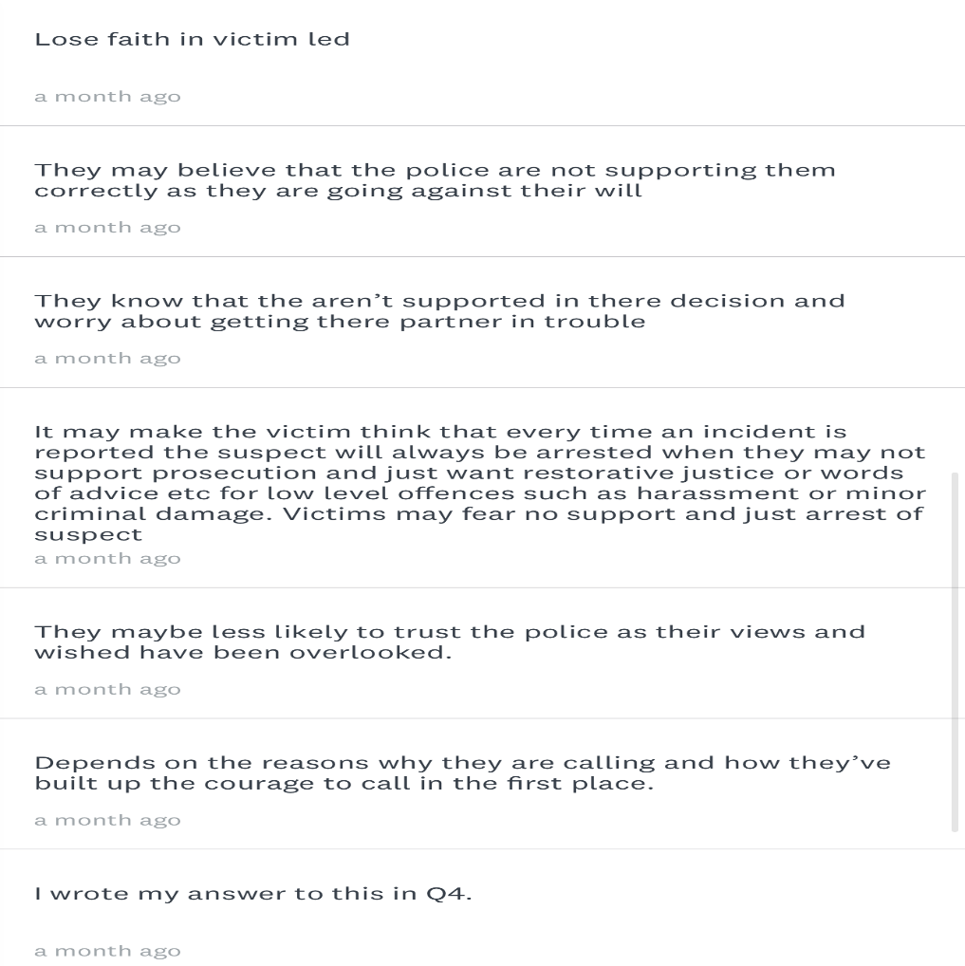
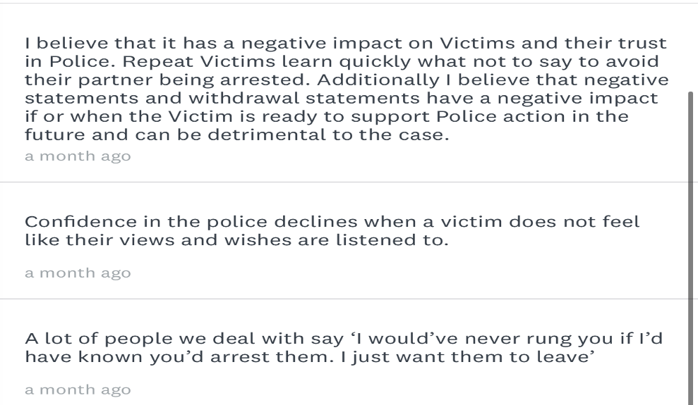
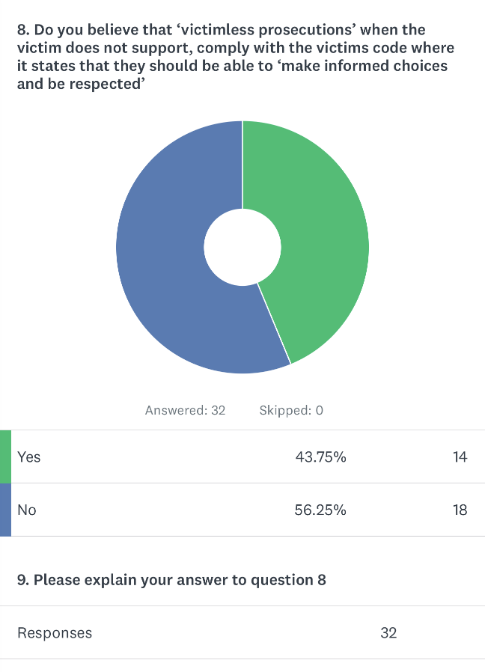

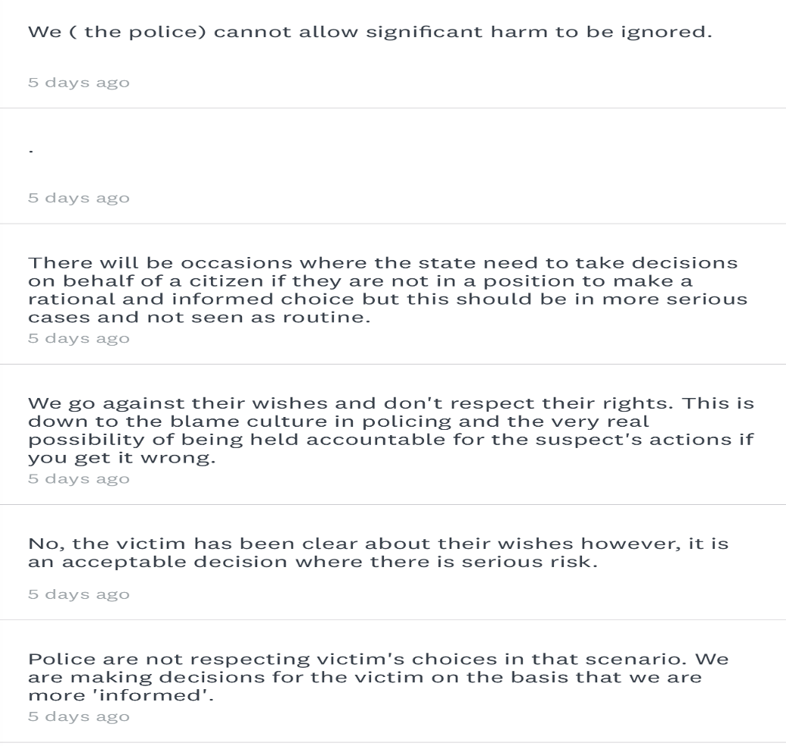
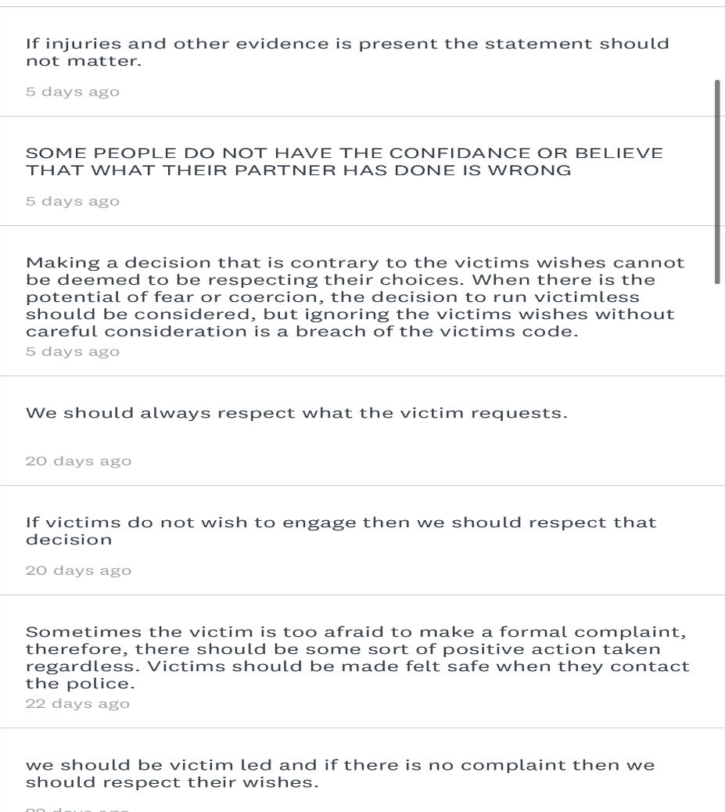

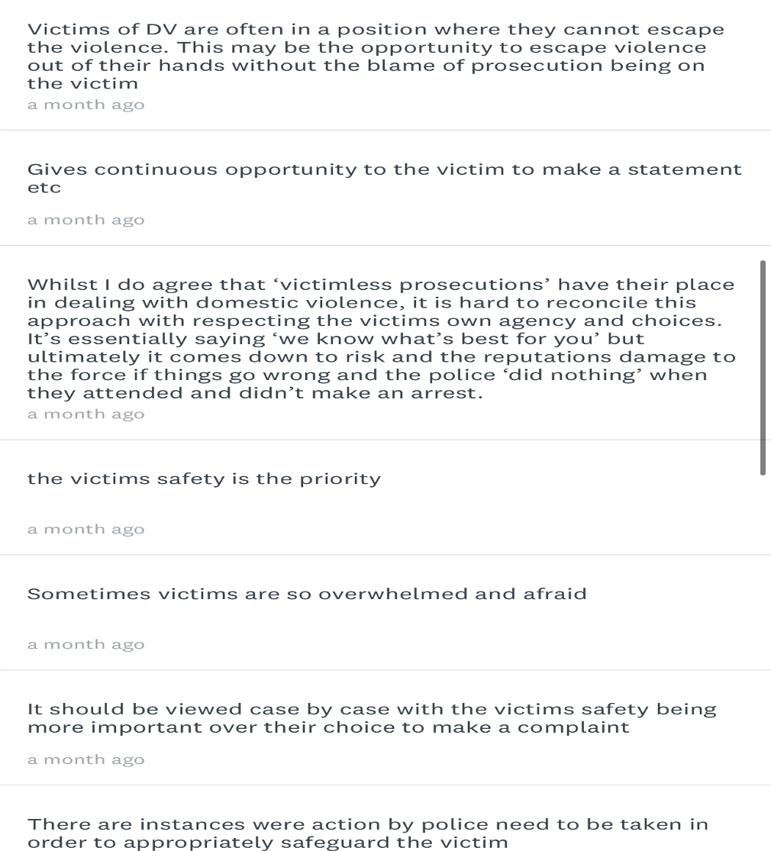
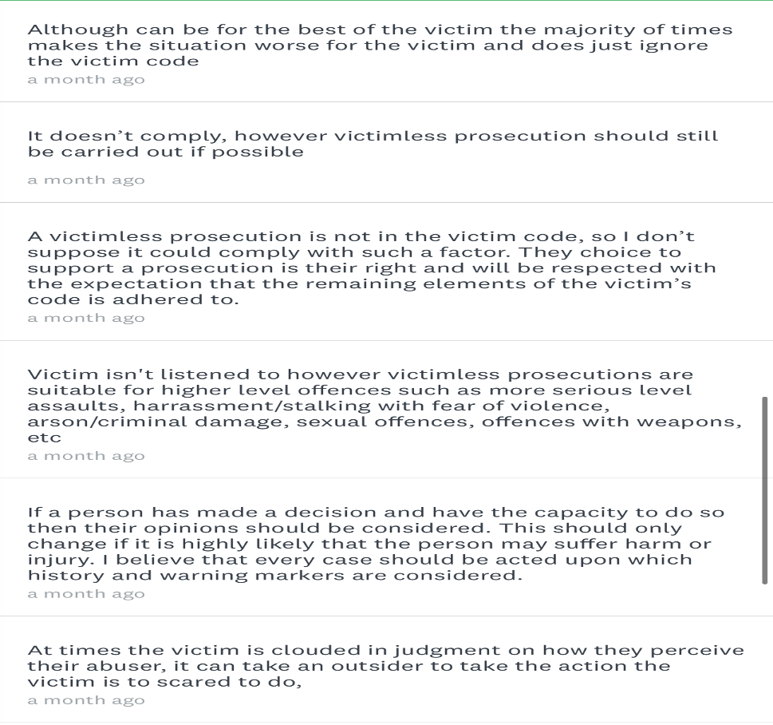

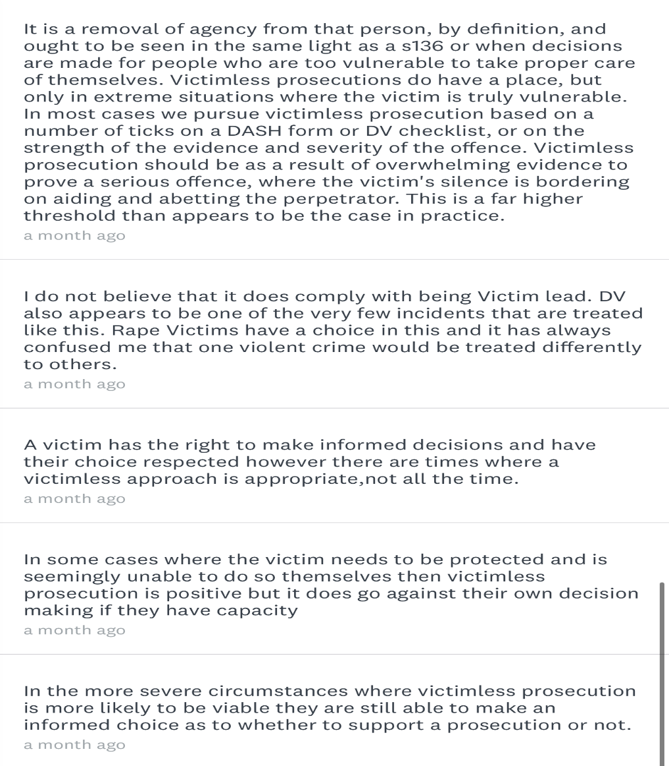
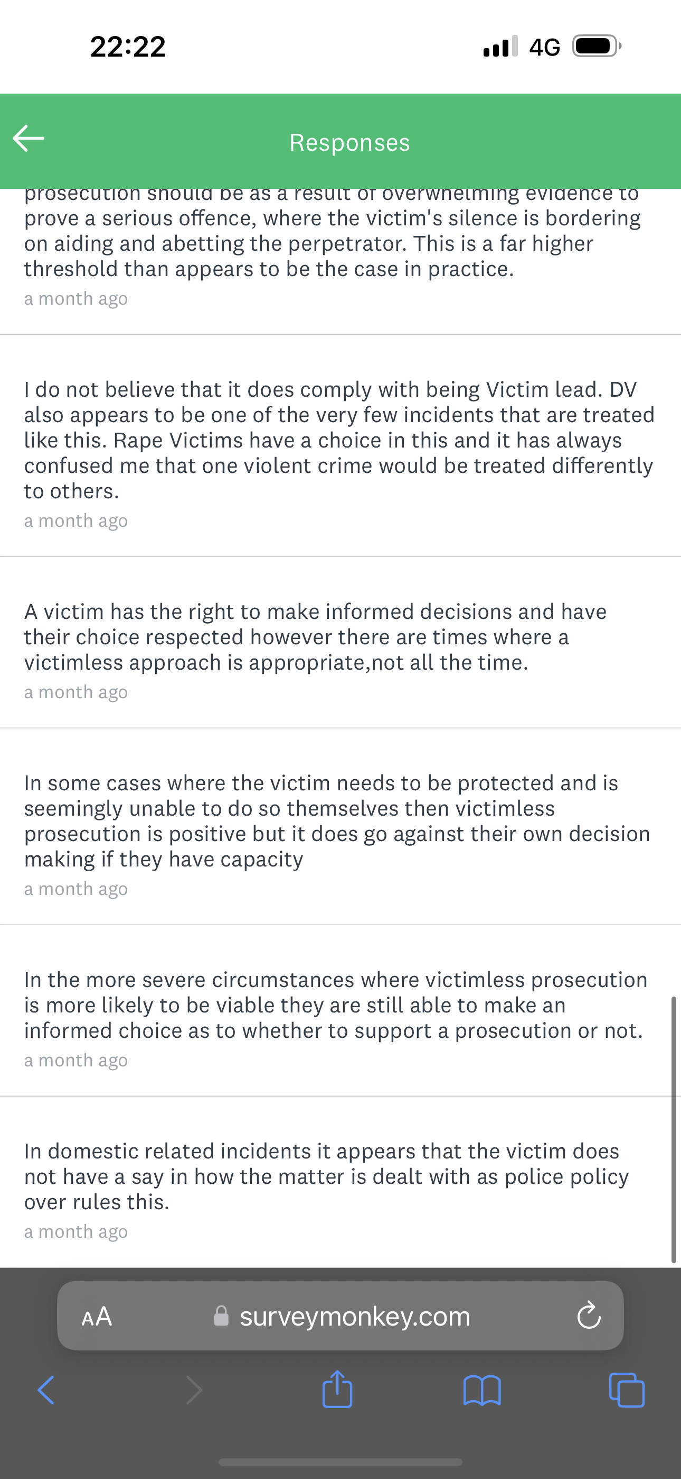

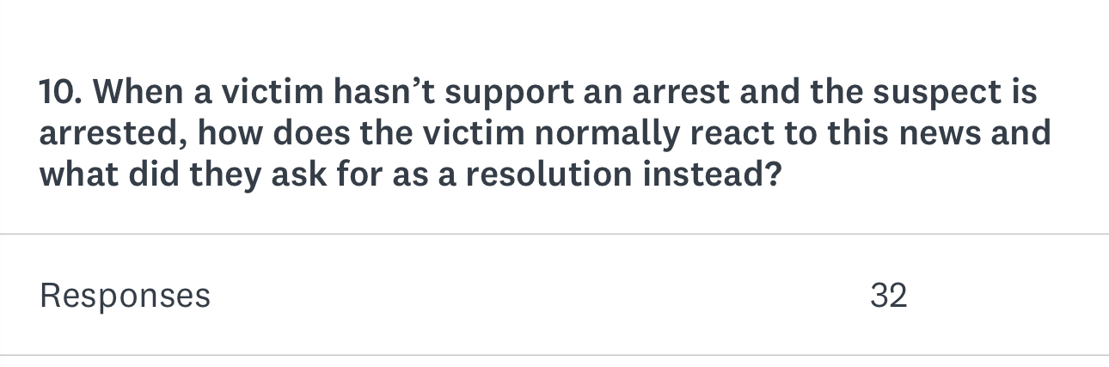

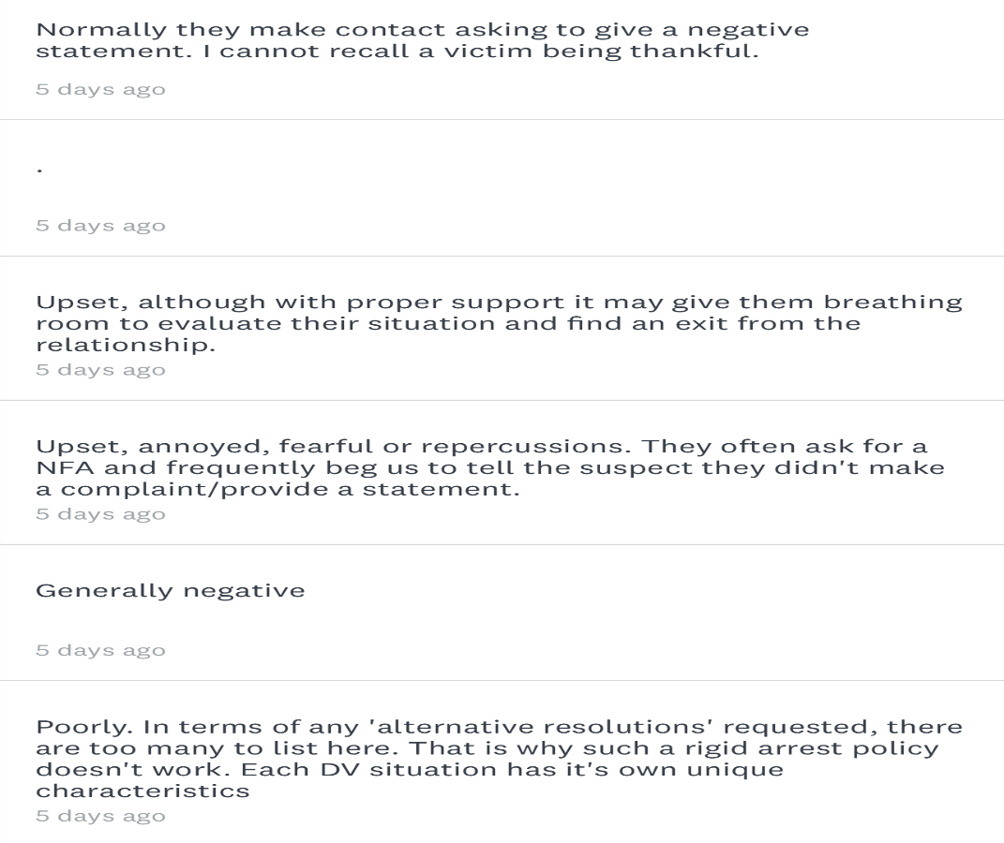
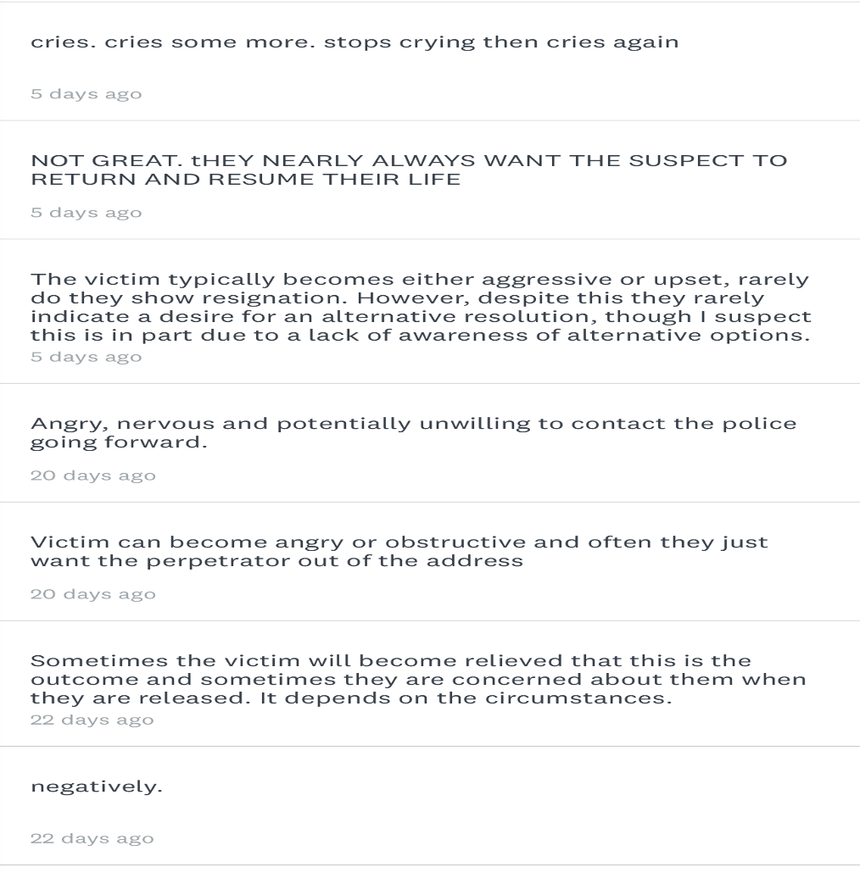

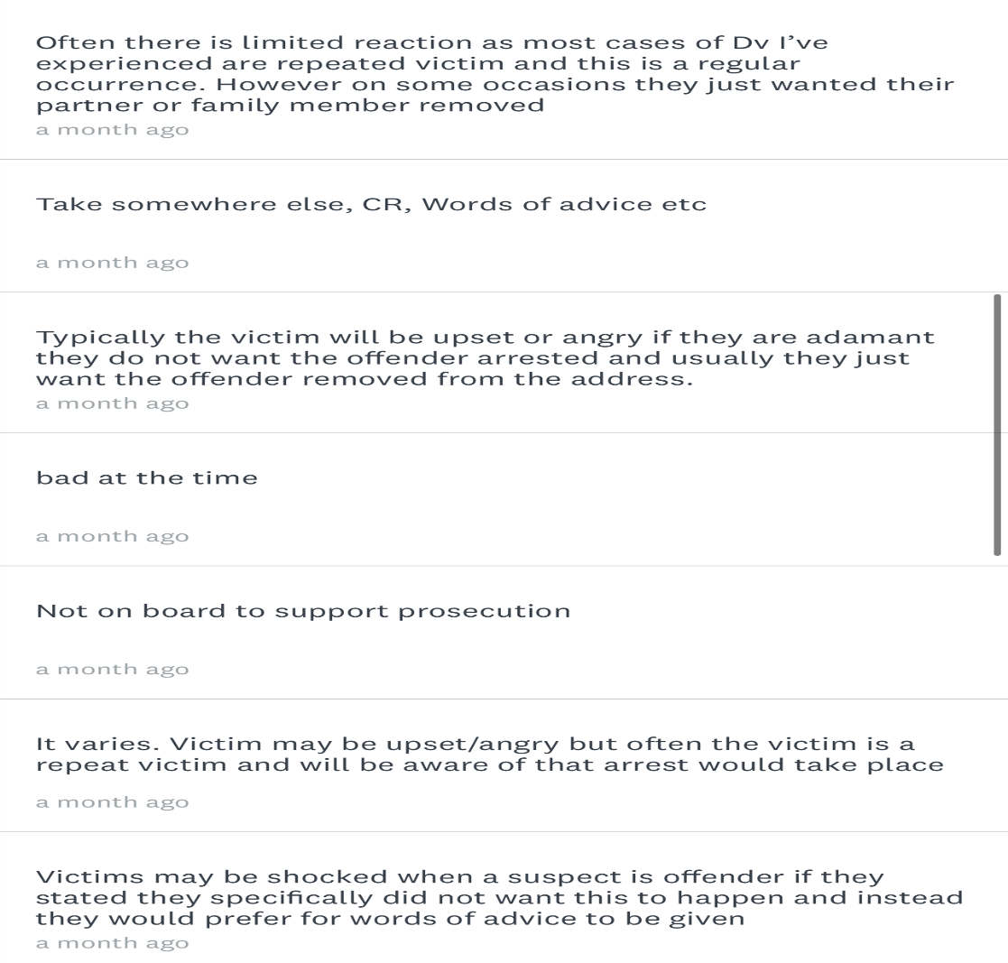
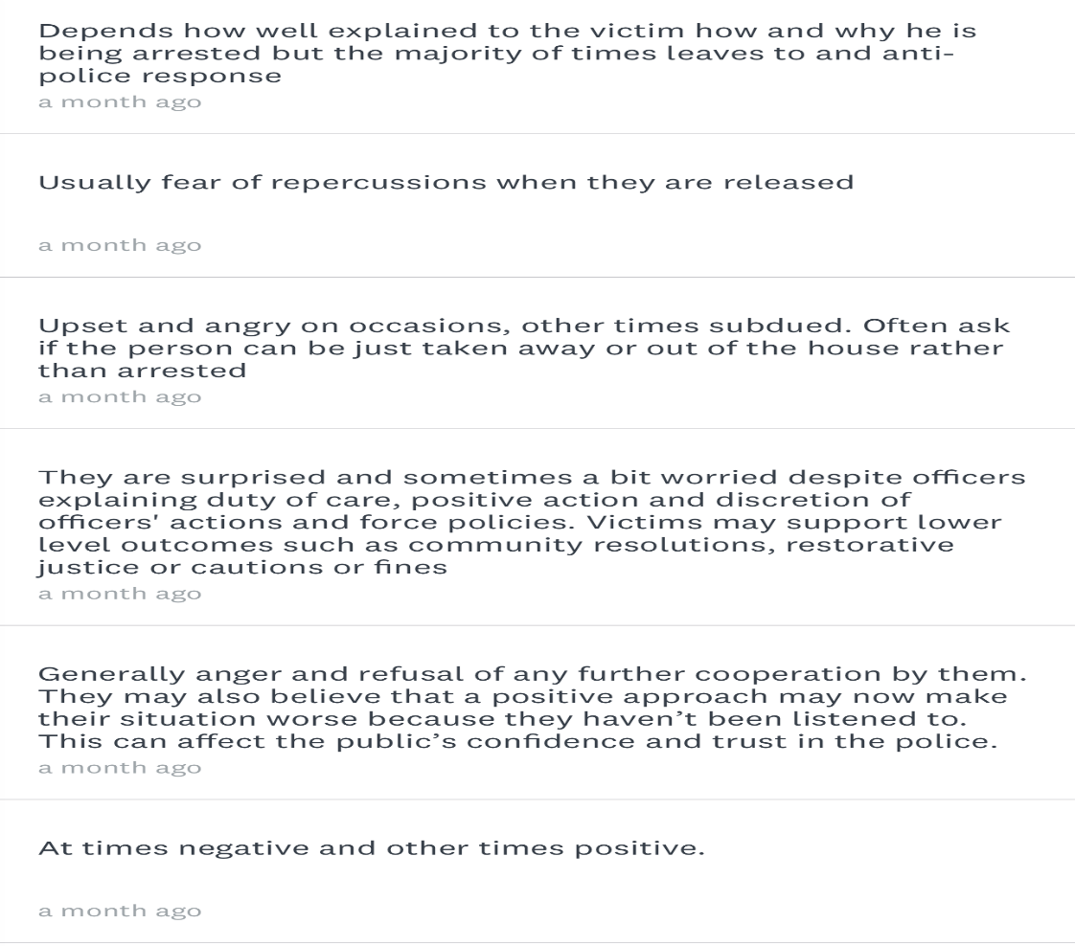
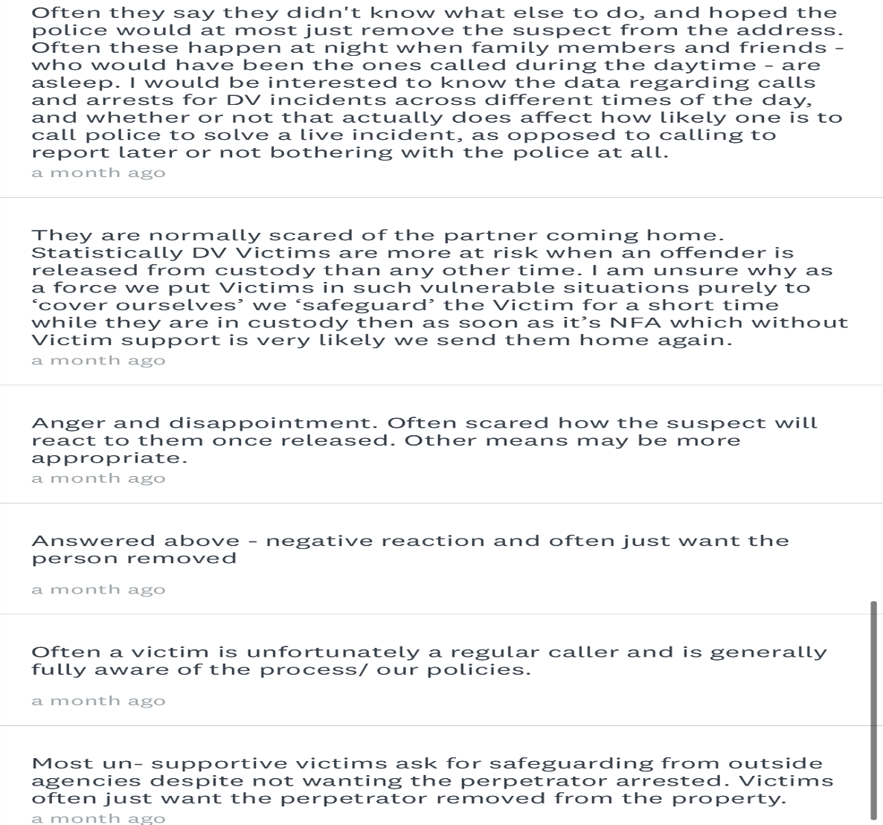

7.3 – Appendix Three – Ethics Review
APPLICATION FOR ETHICAL APPROVAL

RESEARCH STUDENTS
This form is to be completed by the student within SIX months for full-time students and TWELVE months for part time students, after the commencement of the research degree or following progression to Part Two of your course.

Once complete, submit this form via the MyTSD Doctoral College Portal at (https://mytsd.uwtsd.ac.uk).

This document is also available in Welsh.

RESEARCH STAFF ONLY
All communications relating to this application during its processing must be in writing and emailed to pgresearch@uwtsd.ac.uk , with the title ‘Ethical Approval’ followed by your name.

STUDENTS ON UNDERGRADUATE OR TAUGHT MASTERS PROGRAMMES should submit this form (and receive the outcome) via systems explained to you by the supervisor/module leader.

In order for research to result in benefit and minimise risk of harm, it must be conducted ethically. A researcher may not be covered by the University’s insurance if ethical approval has not been obtained prior to commencement.

The University follows the OECD Frascati manual definition of research activity: “creative work undertaken on a systematic basis in order to increase the stock of knowledge, including knowledge of man, culture and society, and the use of this stock of knowledge to devise new applications”. As such this covers activities undertaken by members of staff, postgraduate research students, and both taught postgraduate and undergraduate students working on dissertations/projects.

The individual undertaking the research activity is known as the “principal researcher”.

Ethical approval is not required for routine audits, performance reviews, quality assurance studies, testing within normal educational requirements, and literary or artistic criticism.

Please read the notes for guidance before completing ALL sections of the form.

This form must be completed and approved prior to undertaking any research activity. Please see Checklist for details of process for different categories of application.

SECTION A: About You (Principal Researcher)
1 | Full Name: |  | SARAH LOUISE WARRINER
2 | Tick all boxes that apply: |  | Member of staff: | ☐ | Honorary research fellow: | ☐
 | Undergraduate Student | ☒ | Taught Postgraduate Student | ☐ | Postgraduate Research Student | ☐

3 | Institute/Academic Discipline/Centre: | UNIVERSITY OF WALES
4 | Campus: | UNIVESITY OF WALES TRINITY SAINT DAVID
5 | E-mail address: | Sarah.warriner@south-wales.police.uk
6 | Contact Telephone Number: | 07494893028
 | For students:
7 | Student Number:
8 | Programme of Study:
9 | Director of Studies/Supervisor:

SECTION B: Approval for Research Activity
1 | Has the research activity received approval in principle?  (please check the Guidance Notes as to the appropriate approval process for different levels of research by different categories of individual) |  | YES | ☒ | NO | ☐
 |  |  |  |  | Date
2 | If Yes, please indicate source of approval (and date where known): Approval in principle must be obtained from the relevant source prior to seeking ethical approval | Research Degrees Committee |  | ☒ | 29.3.2023
2 |  | Institute Research Committee |  | ☒ | 29.3.2023
2 |  | Other (write in) |  | ☐

SECTION C: Internal and External Ethical Guidance Materials
 | Please list the core ethical guidance documents that have been referred to during the completion of this form (including any discipline-specific codes of research ethics, location-specific codes of research ethics, and also any specific ethical guidance relating to the proposed methodology). Please tick to confirm that your research proposal adheres to these codes and guidelines. You may add rows to this table if needed.
1 | UWTSD Research Ethics & Integrity Code of Practice | ☒
2 | UWTSD Research Data Management Policy | ☒
3 | [List any other relevant documents here] | ☐

SECTION D: External Collaborative Research Activity
If there are external collaborators then you should gain consent from the contact persons to share their personal data with the university. If there are no external collaborators then leave this section blank and continue to section E.
1 | Institution
2 | Contact person name
3 | Contact person e-mail address
4 | Is your research externally funded? |  | YES | ☐ | NO |  | ☐
5 | Are you in receipt of a KESS scholarship? |  | YES | ☐ | NO |  | ☐
6 | Are you specifically employed to undertake this research in either a paid or voluntary capacity? | Voluntary | YES | ☐ | NO | ☐
7 |  | Employed | YES | ☐ | NO | ☐
8 | Is the research being undertaken within an existing UWTSD Athrofa Professional Learning Partnership (APLP)? | If YES then the permission question below does not need to be answered. | YES | ☐ | NO |  | ☐
9 | Has permission to undertake the research has been provided by the partner organisation? | (If YES attach copy)  If NO the application cannot continue | YES | ☐ | NO |  | ☐

Where research activity is carried out in collaboration with an external organisation
10 | Does this organisation have its own ethics approval system? | YES | ☐ | NO | ☐
 | If Yes, please attach a copy of any final approval (or interim approval) from the organisation (this may be a copy of an email if appropriate).

SECTION E: Details of Research Activity
1 | Indicative title: | The Police Service and the CPS state they are victim focused in cases of domestic violence. To what extent is this the case?
2 | Proposed start date: | 22nd May 2023 | Proposed end date: | 2nd January 2024
Introduction to the Research (maximum 300 words per section)
Ensure that you write for a Non-Specialist Audience when outlining your response to the points below:
- Purpose of Research Activity
- Proposed Research Question
- Aims of Research Activity
- Objectives of Research Activity
Demonstrate, briefly, how Existing Research has informed the proposed activity and explain
- What the research activity will add to the body of knowledge
- How it addresses an area of importance.
3 | Purpose of Research Activity  This research activity will focus on three main points:  ‘To evaluate the effectiveness of current methods of ‘positive action’ and arresting perpetrators in victimless domestic violence offences’  ‘To determine and identify victims’ views and perceptions of current victimless ‘positive action’ practices in policing, and explore the likelihood of victims’ trysting the police in future instances.  ‘To explore whether current policies regarding victimless prosecutions in domestic abuse cases contradict other policies regarding being victim led, as per the victims’ code.  The purpose of completing this research, is to identify if the current policies and procedures are fit for purpose, or if the police are doing more harm than good by taking a no nonsense approach, and arresting DV perpetrators no matter the situation. By completing this research, it will allow the ideology to be explored, that potentially the current procedures are causing victims’ to trust the police less, rather than solidifying trust as hoped.  (this box should expand as you type)
4 | Research Question  ‘How effective are current ‘positive action’ procedures in dealing with victimless cases of domestic violence, and could they be causing trust issues in the UK Police?’  (this box should expand as you type)
5 | Aims of Research Activity  The objectives of the research activity are as follows:  To evaluate the effectiveness of current methods of ‘positive action’ and arresting perpetrators in victimless domestic violence offences’  To determine and identify victims’ views and perceptions of current victimless ‘positive action’ practices in policing and explore the likelihood of victims’ trysting the police in future instances.  To explore whether current policies regarding victimless prosecutions in domestic abuse cases contradict other policies regarding being victim led, as per the victims’ code.  (this box should expand as you type)
6 | Objectives of Research Activity  The objectives of the research activity are as follows:  Complete research into studies on success rates of positive action when arresting in victimless situations, by considering how many cases are going to the CPS for victimless prosecutions, if officers believe other methods would be more effective in handling these cases, and looking into the effectiveness of other methods.  To complete research into articles and studies completed who have researched the victims’ views on how the police deal with domestic related incidents. This research will include finding out reasons why the victim does not report to the police initially and if there is a lack of trust in the police. Additionally, research will be done into the feedback officers have received in these procedures; how the victim feels after action is taken against their wishes, whether the victim is likely to contact police in future and what action the victim wanted taking other than arrest.  Determine if not following the victim’s wishes of not prosecuting and instead arresting for lower level DV cases is having a negative impact on the victim’s experience and therefore is not victim led, as per the victims code. This will be done through research conducted to see if there are other methods that instead used to override the victims’ code, as well as assessing officers’ opinions on whether victimless prosecutions are compliant with the victims’ code of practice.  (this box should expand as you type)
Proposed methods (maximum 600 words)
Provide a brief summary of all the methods that may be used in the research activity, making it clear what specific techniques may be used. If methods other than those listed in this section are deemed appropriate later, additional ethical approval for those methods will be needed. You do not need to justify the methods here, but should instead describe how you intend to collect the data necessary for you to complete your project.
7 | The methods utilised in obtaining the information and material needed for this study will be collated from two main outlets:  Literature Review – Research will be completed online and through studies to obtain details on the success rates of victimless prosecutions, as well as articles from charities and government organisations who specialise in domestic abuse cases. This will allow me to gain varied opinions from a variety of sources.  Questionnaire – Although it would be ideal to gain opinions on the current policies and procedures in place from victims themselves, this is not a possibility as it would be unethical. Due to this, the method used instead will be to send out a questionnaire to frontline officers of various rank who deal with domestic related incidents on a regular basis. They will be questioned on the success rates from victimless cases they have dealt with, as well as the perceptions they have received from the victims they deal with. By doing this, it will allow me to gain information on the victims’ thoughts and feelings, as officers who have dealt with these cases, will have had these expressed to them during these incidents.  (this box should expand as you type)
Location of research activity
Identify all locations where research activity will take place.
8 | Research will take place via an online method and a link will be sent out to the participants, who are free to complete this in any location they wish.  (this box should expand as you type)
Research activity outside of the UK
If research activity will take place overseas, you are responsible for ensuring that local ethical considerations are complied with and that the relevant permissions are sought. Specify any local guidelines (e.g. from local professional associations/learned societies/universities) that exist and whether these involve any ethical stipulations beyond those usual in the UK (provide details of any licenses or permissions required). Also specify whether there are any specific ethical issues raised by the local context in which the research activity is taking place, for example, particular cultural and/or legal sensitivities or vulnerabilities of participants. If you live in the country where you will do the research then please state this.
9 | Research activity will not take place outside of the UK  (this box should expand as you type)

10 | Use of documentation not in the public domain: Are any documents NOT publicly available? | NO | ☒
10 |  | YES | ☐
11 | If Yes, please provide details here of how you will gain access to specific documentation that is not in the public domain and that this is in accordance with the current data protection law of the country in question and that of England and Wales.  (this box should expand as you type)

 | Does your research relate to one or more of the seven aims of the Well-being of Future Generations (Wales) Act 2015? | YES | NO
12 | A prosperous Wales | ☐ | ☒
13 | A resilient Wales | ☐ | ☒
14 | A healthier Wales | ☐ | ☒
15 | A more equal Wales | ☐ | ☒
16 | A Wales of cohesive communities | ☐ | ☒
17 | A Wales of vibrant culture and thriving Welsh language | ☐ | ☒
18 | A globally responsible Wales | ☐ | ☒
19 | If YES to any of the above, please give details:
 | (this box should expand as you type)

SECTION F: Scope of Research Activity
 | Will the research activity include: | YES | NO
1 | Use of a questionnaire or similar research instrument? | ☒ | ☐
2 | Use of interviews? | ☐ | ☒
3 | Use of focus groups? | ☐ | ☒
4 | Use of participant diaries? | ☐ | ☒
5 | Use of video or audio recording? | ☐ | ☒
6 | Use of computer-generated log files? | ☐ | ☒
7 | Participant observation with their knowledge? | ☐ | ☒
8 | Participant observation without their knowledge? | ☐ | ☒
9 | Access to personal or confidential information without the participants’ specific consent? | ☐ | ☒
10 | Administration of any questions, test stimuli, presentation that may be experienced as physically, mentally or emotionally harmful / offensive? | ☐ | ☒
11 | Performance of any acts which may cause embarrassment or affect self-esteem? | ☐ | ☒
12 | Investigation of participants involved in illegal activities? | ☐ | ☒
13 | Use of procedures that involve deception? | ☐ | ☒
14 | Administration of any substance, agent or placebo? | ☐ | ☒
15 | Working with live vertebrate animals? | ☐ | ☒
16 | Procedures that may have a negative impact on the environment? | ☐ | ☒
17 | Other primary data collection methods. Please indicate the type of data collection method(s) below. | ☐ | ☒
 | Details of any other primary data collection method:  (this box should expand as you type) | ☐ | ☒
If NO to every question, then the research activity is (ethically) low risk and may be exempt from some of the following sections (please refer to Guidance Notes).

If YES to any question, then no research activity should be undertaken until full ethical approval has been obtained.

SECTION G: Intended Participants
If there are no participants then do not complete this section, but go directly to section H.

 | Who are the intended participants: | YES | NO
1 | Students or staff at the University? | ☐ | ☒
2 | Adults (over the age of 18 and competent to give consent)? | ☒ | ☐
3 | Vulnerable adults? | ☐ | ☒
4 | Children and Young People under the age of 18? (Consent from Parent, Carer or Guardian will be required) | ☐ | ☒
5 | Prisoners? | ☐ | ☒
6 | Young offenders? | ☐ | ☒
7 | Those who could be considered to have a particularly dependent relationship with the investigator or a gatekeeper? | ☐ | ☒
8 | People engaged in illegal activities? | ☐ | ☒
9 | Others. Please indicate the participants below, and specifically any group who may be unable to give consent. | ☐ | ☒
 | Details of any other participant groups:  (this box should expand as you type) | ☐ | ☒

Participant numbers and source
Provide an estimate of the expected number of participants. How will you identify participants and how will they be recruited?
10 | How many participants are expected? | I am aiming to have a minimum of 25 participants.  (this box should expand as you type)
11 | Who will the participants be? | All participants will be police officers who deal with frontline domestic related incidents regularly  (this box should expand as you type)
12 | How will you identify the participants? | I will identify the participants by sending them the surveys directly however all responses will be anonymous  (this box should expand as you type)

 | Information for participants: | YES | NO | N/A
13 | Will you describe the main research procedures to participants in advance, so that they are informed about what to expect? | ☒ | ☐ | ☐
14 | Will you tell participants that their participation is voluntary? | ☒ | ☐ | ☐
15 | Will you obtain written consent for participation? | ☐ | ☐ | ☒
16 | Will you explain to participants that refusal to participate in the research will not affect their treatment or education (if relevant)? | ☐ | ☐ | ☒
17 | If the research is observational, will you ask participants for their consent to being observed? | ☐ | ☐ | ☒
18 | Will you tell participants that they may withdraw from the research at any time and for any reason? | ☐ | ☐ | ☒
19 | With questionnaires, will you give participants the option of omitting questions they do not want to answer? | ☒ | ☐ | ☐
20 | Will you tell participants that their data will be treated with full confidentiality and that, if published, it will not be identifiable as theirs? | ☒ | ☐ | ☐
21 | Will you debrief participants at the end of their participation, in a way appropriate to the type of research undertaken? | ☐ | ☐ | ☒
22 | If NO to any of above questions, please give an explanation
 | (this box should expand as you type)

 | Information for participants: | YES | NO | N/A
24 | Will participants be paid? | ☐ | ☒ | ☐
25 | Is specialist electrical or other equipment to be used with participants? | ☐ | ☒ | ☐
26 | Are there any financial or other interests to the investigator or University arising from this study? | ☐ | ☒ | ☐
27 | Will the research activity involve deliberately misleading participants in any way, or the partial or full concealment of the specific study aims? | ☐ | ☒ | ☐
28 | If YES to any question, please provide full details
 | (this box should expand as you type)

SECTION H: Anticipated Risks

Outline any anticipated risks that may adversely affect any of the participants, the researchers and/or the University, and the steps that will be taken to address them.

If you have completed a full risk assessment (for example as required by a laboratory, or external research collaborator) you may append that to this form.
1 | Full risk assessment completed and appended? |  | Yes | ☒
1 |  |  | No | ☐
2 | Risks to participants  For example: sector-specific health & safety, emotional distress, financial disclosure, physical harm, transfer of personal data, sensitive organisational information
 | Risk to participants:  There is no risk to participants. All results from the questionnaires will be completely anonymous and therefore will be no repercussions from their answers to the survey.  (this box should expand as you type) | How you will mitigate the risk to participants:  (this box should expand as you type)
3 | If research activity may include sensitive, embarrassing or upsetting topics (e.g. sexual activity, drug use) or issues likely to disclose information requiring further action (e.g. criminal activity), give details of the procedures to deal with these issues, including any support/advice (e.g. helpline numbers) to be offered to participants. Note that where applicable, consent procedures should make it clear that if something potentially or actually illegal is discovered in the course of a project, it may need to be disclosed to the proper authorities
There is no risk in this area as there will be no sensitive, embarrassing or upsetting topics discussed in this survey with the participants.

(this box should expand as you type)
4 | Risks to the investigator  For example: personal health & safety, physical harm, emotional distress, risk of accusation of harm/impropriety, conflict of interest
 | Risk to the investigator:  There are no risks to the investigator in this investigation.  (this box should expand as you type) | How you will mitigate the risk to the investigator:  (this box should expand as you type)
5 | University/institutional risks  For example: adverse publicity, financial loss, data protection
 | Risk to the University:  There are no risks to the university in this investigation.  (this box should expand as you type) | How you will mitigate the risk to the University:  (this box should expand as you type)
6 | Environmental risks  For example: accidental spillage of pollutants, damage to local ecosystems
 | Risk to the environment:  There are no risks to the environment in this investigation.  (this box should expand as you type) | How you will mitigate the risk to environment:  (this box should expand as you type)

 | Disclosure and Barring Service
 | If the research activity involves children or vulnerable adults, a Disclosure and Barring Service (DBS) certificate must be obtained before any contact with such participants. | YES | NO | N/A
7 | Does your research require you to hold a current DBS Certificate? | ☐ | ☐ | ☒
8 | If YES, please give the certificate number. If the certificate number is not available please write “Pending”; in this case any ethical approval will be subject to providing the appropriate certificate number.

SECTION I: Feedback, Consent and Confidentiality

1 | Feedback  What de-briefing and feedback will be provided to participants, how will this be done and when?
De-briefing in this case is not applicable as this is a questionnaire that is anonymous, and due to this I would not know who out of the police officers that have been sent the survey have filled this out. As dissertations are available in the public domain. They would be able to view this after this is published if they wish to receive feedback and this will be detailed to them in the survey.

(this box should expand as you type)
2 | Informed consent  Describe the arrangements to inform potential participants, before providing consent, of what is involved in participating. Describe the arrangements for participants to provide full consent before data collection begins. If gaining consent in this way is inappropriate, explain how consent will be obtained and recorded in accordance with prevailing data protection legislation.
When a participant is sent the survey, they will be advised that by completing the survey, they consent to completing the survey and the results being shared. If they do not consent to this, then they will not be able to fill out any part of the survey and they can simply exit the page.

(this box should expand as you type)
3 | Confidentiality / Anonymity  Set out how anonymity of participants and confidentiality will be ensured in any outputs. If anonymity is not being offered, explain why this is the case.
I will be utilising Survey Monkey to distribute the questionnaires to all police officers which is an anonymous forum. I will not be aware of which persons have filled this out and what they have said. In addition to this, no other persons would be aware of this. There will be no questions which will identify any persons individually.

(this box should expand as you type)

SECTION J: Data Protection and Storage

 | Does the research activity involve personal data (as defined by the General Data Protection Regulation 2016 “GDPR” and the Data Protection Act 2018 “DPA”)? | YES | NO
1 | “Personal data” means any information relating to an identified or identifiable natural person (‘data subject’). An identifiable natural person is one who can be identified, directly or indirectly, in particular by reference to an identifier such as a name, an identification number, location data, an online identifier or to one or more factors specific to the physical, physiological, genetic, mental, economic, cultural or social identity of that natural person. Any video or audio recordings of participants is considered to be personal data. | ☐ | ☐
 | If YES, provide a description of the data and explain why this data needs to be collected:
2 | No – Would not allow me to select the No column  (this box should expand as you type)
 | Does it involve special category data (as defined by the GDPR)? | YES | NO
3 | “Special category data” means sensitive personal data consisting of information as to the data subjects’ –  (a) racial or ethnic origin,  (b) political opinions,  (c ) religious beliefs or other beliefs of a similar nature,  (d) membership of a trade union (within the meaning of the Trade Union and Labour Relations (Consolidation) Act 1992),  (e) physical or mental health or condition,  (f) sexual life,  (g) genetics,  (h) biometric data (as used for ID purposes), | ☐ | ☐
 | If YES, provide a description of the special category data and explain why this data needs to be collected:
4 | No – would not allow me select the tick box.  (this box should expand as you type)

 | Will data from the research activity (collected data, drafts of the thesis, or materials for publication) be stored in any of the following ways? | YES | NO
5 | Manual files (i.e. in paper form)? | ☐ | ☒
6 | University computers? | ☐ | ☒
7 | Private company computers? | ☒ | ☐
8 | Home or other personal computers? | ☐ | ☒
9 | Laptop computers/ CDs/ Portable disk-drives/ memory sticks? | ☒ | ☐
10 | “Cloud” storage or websites? | ☐ | ☒
11 | Other – specify: | ☐ | ☒
12 | For all stored data, explain the measures in place to ensure the security of the data collected, data confidentiality, including details of backup procedures, password protection, encryption, anonymisation and pseudonymisation:
The laptop used is provided by South Wales Police which is encrypted and password protected.

(this box should expand as you type)

 | Data Protection
 | Will the research activity involve any of the following activities: | YES | NO
13 | Electronic transfer of data in any form? | ☐ | ☒
14 | Sharing of data with others at the University outside of the immediate research team? | ☐ | ☒
15 | Sharing of data with other organisations? | ☐ | ☒
16 | Export of data outside the UK or importing of data from outside the UK? | ☐ | ☒
17 | Use of personal addresses, postcodes, faxes, emails or telephone numbers? | ☐ | ☒
18 | Publication of data that might allow identification of individuals? | ☐ | ☒
19 | Use of data management system? | ☐ | ☒
20 | Data archiving? | ☐ | ☒
21 | If YES to any question, please provide full details, explaining how this will be conducted in accordance with the GDPR and Data Protection Act (2018) (and any international equivalents, where appropriate):
N/A

(this box should expand as you type)
22 | List all who will have access to the data generated by the research activity:
I will have access to the data as the investigator which will then be published in the dissertation, however all data is confidential data and cannot be attributed to any individual.

(this box should expand as you type)
23 | List who will have control of, and act as custodian(s) for, data generated by the research activity:
I will have control of the data as the principle investigator and then when the dissertation is complete this will be transferred to university of Wales as the publisher.

(this box should expand as you type)
24 | Give details of data storage arrangements, including security measures in place to protect the data, where data will be stored, how long for, and in what form. Will data be archived – if so how and if not why not.
All data from research is stored on my South Wales Police provided computer which is encrypted and fully protected.

(this box should expand as you type)
25 | Please indicate if your data will be stored in the UWTSD Research Data Repository (see https://researchdata.uwtsd.ac.uk/ ). If so please explain. (Most relevant to academic staff)
 | (this box should expand as you type)
26 | Confirm that you have read the UWTSD guidance on data management (see https://www.uwtsd.ac.uk/library/research-data-management/) | YES | ☒
27 | Confirm that you are aware that you need to keep all data until after your research has completed or the end of your funding | YES | ☒

SECTION K: Declaration
The information which I have provided is correct and complete to the best of my knowledge. I have attempted to identify any risks and issues related to the research activity and acknowledge my obligations and the rights of the participants.

In submitting this application I hereby confirm that I undertake to ensure that the above named research activity will meet the University’s Research Ethics and Integrity Code of Practice which is published on the website: https://www.uwtsd.ac.uk/research/research-ethics/
1 | Signature of applicant: | S.Warriner | Date: 23.4.2023

For STUDENT Submissions:
2 | Director of Studies/Supervisor: |  | Date:
3 | Signature: |  | Date:

For STAFF Submissions:
4 | Academic Director/ Assistant Dean: |  | Date:
5 | Signature: |  | Date:

Checklist: Please complete the checklist below to ensure that you have completed the form according to the guidelines and attached any required documentation:
☒ | I have read the guidance notes supplied before completing the form.
☒ | I have completed ALL RELEVANT sections of the form in full.
☒ | I confirm that the research activity has received approval in principle
☐ | I have attached a copy of final/interim approval from external organisation (where appropriate)
☐ | I have attached a full risk assessment (where appropriate) ONLY TICK IF YOU HAVE ATTACHED A FULL RISK ASSESSMENT
☒ | I understand that it is my responsibility to ensure that the above named research activity will meet the University’s Research Ethics and Integrity Code of Practice.
☒ | I understand that before commencing data collection all documents aimed at respondents (including information sheets, consent forms, questionnaires, interview schedules etc.) must be confirmed by the DoS/Supervisor, module tutor or Academic Director.

RESEARCH STUDENTS ONLY
Once complete, submit this form via the MyTSD Doctoral College Portal at (https://mytsd.uwtsd.ac.uk).

RESEARCH STAFF ONLY
All communications relating to this application during its processing must be in writing and emailed to pgresearch@uwtsd.ac.uk , with the title ‘Ethical Approval’ followed by your name.

STUDENTS ON UNDERGRADUATE OR TAUGHT MASTERS PROGRAMMES should submit this form (and receive the outcome) via systems explained to you by the supervisor/module leader.

7.4 – Appendix Four – Research Proposal Sheet


UNDERGRADUATE DISSERTATION
RESEARCH PROPOSAL FORM

Please complete the following research proposal and submit it to Turnitin.

Which project option are you taking? Please tick:

8,000 word project:

UNDERGRADUATE DISSERTATION
RESEARCH PROPOSAL FORM

Please complete the following research proposal and submit it to Turnitin.

Which project option are you taking? Please tick:

8,000 word project:

NAME: SARAH WARRINER
STUDENT ID No.: 2029482
DRAFT RESEARCH TITLE QUESTION:
INTRODUCTION:
Within policing Domestic Violence cases are one of the most common response calls an officer will attend and ‘The Police receive a domestic abuse-related call every 30 seconds’ and ‘1 in 4 women in England and Wales will experience domestic abuse in their lifetime.’ (Refuge,2017). Therefore, it is vital that these cases are dealt with correctly and in a manner where the victim feels valued and respected. The difficulty with this is that according to Gurm and Marchbank (2020) over 70% of victims do not report incidents of abuse to the police for various reasons, and often when police attend a report of domestic related assaults or abuse the victim does not support a conviction or any police action.

The victim’s code is a system put in place to help protect the victim in any crime related incident and is a set of rules that police officers and the CPS have to follow. According to the College of Policing (2021) ‘victims have the right to make informed choices that are fully respected’, however police officers are taught by principle that whenever a domestic related offence is disclosed – no matter how low the level or whether there is no history – then the person is to be arrested. HMICFRS (2019) confirmed this when they said ‘We found that most officers know how important it is to arrest the offender in cases of domestic abuse’ Although the reason for this is due to ensuring the victim in the incident is safeguarded, one of the victim’s main reasons for not pursuing is due to fear of repercussions and not being ready to end the relationship with the person in question. Therefore, one of the main areas that will be explored in this research will be in low level incidents of domestic related offences whereby there is little to no history and the victim is not supporting, are the police really victim focused in this area if they are directly going against the victim’s wishes of not supporting prosecution.

It could be said that all of these decisions have been made in order to safeguard the victim and although it may go against the principles of the victim code, the risk to the victim’s safety outweighs this and by safeguarding them it is ensuring the process is fully victim – focused in itself. The CPS and the police have the powers in these circumstances to pursue a process known as a victimless prosecution or an evidence-led prosecution. The CPS (2020) will state that they are ‘committed to prosecution of domestic abuse in cases without support of victim’ and were able to provide several examples of success stories from evidence-led prosecutions whereby the victim did not support. However, an investigation conducted by HMICFRS (2020) found that out of 78 cases which were not pursued due to the victim not supporting, 15 of these investigators had not had any further lines of enquiry followed. In addition to this there is no method of measuring the success rates in these types of cases within both the police and the CPS. It could be said that if there is no accurate measure of how many victimless prosecutions succeed, that the police and the CPS are missing potential opportunities to help other victims and are therefore not as victim focused as they portray.

SUMMARY OF RESEARCH OBJECTIVES:

This research activity will focus on three main points:

‘To evaluate the effectiveness of current methods of ‘positive action’ and arresting perpetrators in victimless domestic violence offences’

‘To determine and identify victims’ views and perceptions of current victimless ‘positive action’ practices in policing, and explore the likelihood of victims’ trysting the police in future instances.

‘To explore whether current policies regarding victimless prosecutions in domestic abuse cases contradict other policies regarding being victim led, as per the victims’ code.

The purpose of completing this research, is to identify if the current policies and procedures are fit for purpose, or if the police are doing more harm than good by taking a no nonsense approach, and arresting DV perpetrators no matter the situation. By completing this research, it will allow the ideology to be explored, that potentially the current procedures are causing victims’ to trust the police less, rather than solidifying trust as hoped.

LITERATURE REVIEW:
The main literature that I will be focusing on using will be reports from HMICFRS, the College of Policing, the CPS and IOPC. By doing this, it will allow me to focus on the successes and downfalls of how the police and CPS deal with victims.

I will also be conducting research with charities who deal with domestic violence victims, which will allow the true opinions direct from the source of those who have experienced them.

In addition to this studies have been conducted by Birdsal, N and Boulton, L (2022) which explain the decision making of victims in the police response to domestic abuse. This paper will allow me to incorporate their reasoning behind the lack of support victim’s often provide in dealing with the investigations. It will also allow a comprehensive evaluation of whether safeguarding from police should outweigh the victim’s right to make decisions and have control in the investigation.

The Criminal Justice Joint Inspection (2020) will also be a focus within the literature that I will be reviewing, this is due to it focusing on the investigation that has taken place into how successful the police and the CPS are at dealing with evidence-led prosecutions. This will allow me to critically analyse the success rates and assist with answering the research question.

SUMMARY OF RESEARCH –SURVEY METHOD:
The main method of research via survey that will be utilised in this dissertation to various UK police officers of different ranks through survey monkey. Although it would be ideal to gain opinions on the current policies and procedures in place from victims themselves, this is not a possibility as it would be unethical. Due to this, the method used instead will be to send out a questionnaire to frontline officers of various rank who deal with domestic related incidents on a regular basis. They will be questioned on the success rates from victimless cases they have dealt with, as well as the perceptions they have received from the victims they deal with. By doing this, it will allow me to gain information on the victims’ thoughts and feelings, as officers who have dealt with these cases, will have had these expressed to them during these incidents.

SUMMARY OF SAMPLING FRAMEWORK:
The target sample for research undertaken will be police officers who work in UK police forces. Police Officers who work in these forces work very similarly and across similar systems, however
ETHICAL ISSUES:
It is believed that there will be no ethical issues because of this research. The participants who take part in the research element of the dissertation will be voluntarily taking part and will be anonymous when they do this. They will be reminded of this when they are asked to complete the survey and will also be reminded that they are not obliged to respond to the survey or contribute in any way if they do not wish. By doing this, it prevents any ethical problems that could occur from the research undertaken.

In addition to this, the topic that is being researched is not believed to cause any ethical issues as a result of it being discussed.
TIME SCALE:

Literature Review to be submitted by 31st July 2023

Research Methodology and Planning submitted by 11th September 2023

Submission of Analysis of results by 30th October 2023

Submission of Finding and Conclusion by 4th December 2023

Final submission submitted by 2nd January 2024

REFERENCE LIST:

Birdsall, N and Boulton, L (2022). Theorising victim decision making in the police response to domestic abuse. Available At:
https://researchonline.ljmu.ac.uk/id/eprint/17279/1/Birdsall%20&%20Boulton%20(2022)%20Theorising%20victim%20decision%20making%20in%20the%20police%20response%20to%20domestic%20abuse.pdf (Accessed 19th May 2023).
Criminal Justice Joint Inspection (2020). Evidence led Domestic Abuse Prosecutions. Available At: https://www.nottinghamshire.pcc.police.uk/Document-Library/Public-Information/HMIC-Reports/HMICFRS-HMCIPS-Report-Evidence-led-domestic-abuse-prosecutions.pdf (Accessed 15th May 2023).
CPS (2020) CPS Committed to prosecution of domestic abuse in cases without support of victim. Available At: https://www.cps.gov.uk/north-east/news/cps-committed-prosecution-domestic-abuse-cases-without-support-victim (Accessed 16th May 2023)
CPS (2022) Victims and Witnesses, CPS Commitments to Support. Available At: https://www.cps.gov.uk/legal-guidance/victims-and-witnesses-cps-commitments-support (Accessed 14th April 2023).
The College of Policing (2021) Victim’s Code for policing. Available at: https://www.college.police.uk/guidance/victims-code/victims-rights-policing (Accessed 17th April 2023)
Gurm, B and Marchbank, J. (2020, Chapter 8) ‘Chapter 8: Why Survivors Don’t Report’ Available At: https://kpu.pressbooks.pub/nevr/chapter/why-do-survivors-not-report-to-police/ (Accessed 18th May 2023)
HMICFRS (2019, p6) ‘The Police Response to Domestic Abuse’ Available At: https://www.justiceinspectorates.gov.uk/hmicfrs/wp-content/uploads/the-police-response-to-domestic-abuse-an-update-report.pdf (Accessed 17th May 2023)
HMICFRS (2020) ‘Building successful domestic abuse prosecutions without the victim’s support is possible but challenging for police and prosecutors’ Available At: https://www.justiceinspectorates.gov.uk/hmicfrs/news/news-feed/evidence-led-domestic-abuse-prosecutions/ (Accessed 16th May 2023)
Refuge (2017) ‘The Facts’ Available At: https://refuge.org.uk/what-is-domestic-abuse/the-facts/ (Accessed 15th May 2023)

