LDE Assignment 1 (e-Portfolio)
Module Name: Learning in the Digital Era
Module Code: ACCA 4025

Student Name: Hora Big
Student ID: 2509557
Group: 4

Lecturer’s Name: - Dipo Donson
E-Portfolio link: https://2509557.wixsite.com/my-site-4

Table of Contents

Introduction 3
Task 1: Essential Skills for Study and Employment 3
Task 2: Life is a Team Sport 3
Task 3: Automatic Referencing tool 3
Task 1 4
(a): Report on Essential Skills for Study and Employment 4
(b): Evaluation of Task 1(a) Based on Similarity Report 4
Task 2 5
(a): Collaborative Teamwork and Professional Academic poster 5
(b): Team Activity: ‘Life is a Team Sport’ introductory activity 6
Task 3: Automatic Referencing tool 7
(a): Riding the Storm (Managing Conflict in Virtual Teams) 7
(b): Using Microsoft Word’s Automatic Referencing Tool 8
Task 4: E-Portfolio creation and review 11
(a): Portfolio Link 11
(b): Produce an illustrative review 11
Conclusion 20
Task 1: 20
Task 2: 20
Task 3: 20
References 21

Introduction

Task 1: Essential Skills for Study and Employment
This task focuses on identifying and reflecting on the essential skills required for academic success and employability in computing. For an aspiring IT Support Technician, it is not enough to have technical knowledge alone. Skills such as Critical Thinking, Problem Solving, Adaptability, and Attention to Detail are essential. These skills help students manage learning effectively and prepare for real world workplace challenges.

Task 2: Life is a Team Sport
In this task, I explore why teamwork is so important by creating an A3 academic poster based on Topic “Life is a Team Sport.” As part of the preparation, my group and I produced a digital mind map that identified key aspects of effective teamwork, such as communication, empathy, emotional management, collaboration, and accountability. This collaborative activity helped me understand how different personal behaviors contribute to group success and how teamwork skills transfer directly to future employment.

Task 3: Automatic Referencing tool
In academic and professional writing, proper referencing is essential for maintaining credibility, avoiding plagiarism, and acknowledging original ideas. As part of this task, I explored the topic “Riding the Storm” from Unit 3: Virtual Collaboration, focusing on how conflict arises and can be managed in virtual teams. I used Microsoft Word’s automatic referencing tool to apply IEEE referencing style, which simplified citation management and improved accuracy. This task also developed my digital literacy and understanding of how technology can support ethical and efficient research practices in both education and the workplace.

Task 1

(a): Report on Essential Skills for Study and Employment

Success in computing depends on a combination of technical and transferable skills. Critical thinking enables me to analyze technical problems logically and make informed decisions when troubleshooting user issues [1]. Problem solving complements this by providing a structured approach to identify the root cause of faults and apply effective solutions [2].

Adaptability is also vital in a fast changing technological environment. Being able to learn new software, systems, and procedures ensures that I remain competent and employable [3]. Attention to detail supports accuracy in documentation, configuration, and communication, reducing errors and improving reliability in both academic work and IT support tasks [4].

According to the National Careers Service, employers now value these transferable skills as much as technical knowledge, especially in roles that involve problem solving, communication, and responsibility [5]. Developing these skills not only enhances my academic performance by improving organization, analysis, and communication but also prepares me for future professional responsibilities. For example, in IT support, the ability to think critically and solve problems quickly ensures smooth operations, while adaptability allows me to respond effectively to updates or unexpected technical challenges. Attention to detail guarantees that systems remain accurate and secure.

By strengthening these essential skills through coursework, practice, and reflection, I am building a foundation for a successful career as an IT Support Technician, capable of managing technical tasks confidently while maintaining professionalism and reliability.

(b): Evaluation of Task 1(a) Based on Similarity Report

My Turnitin report showed a 20% similarity index, mainly linked to the assignment title rather than the main content. This confirms that my writing is original and appropriately paraphrased, with all sources correctly referenced in IEEE format. To improve further, I will continue refining my academic voice and ensure more paraphrasing of definitions or task wording. Based on the Generic Assessment Criteria, I would award myself 87%, as my work demonstrates clear structure, critical reflection, accurate referencing, and a professional academic tone. I am confident it meets distinction-level standards for clarity, relevance, and independent understanding.
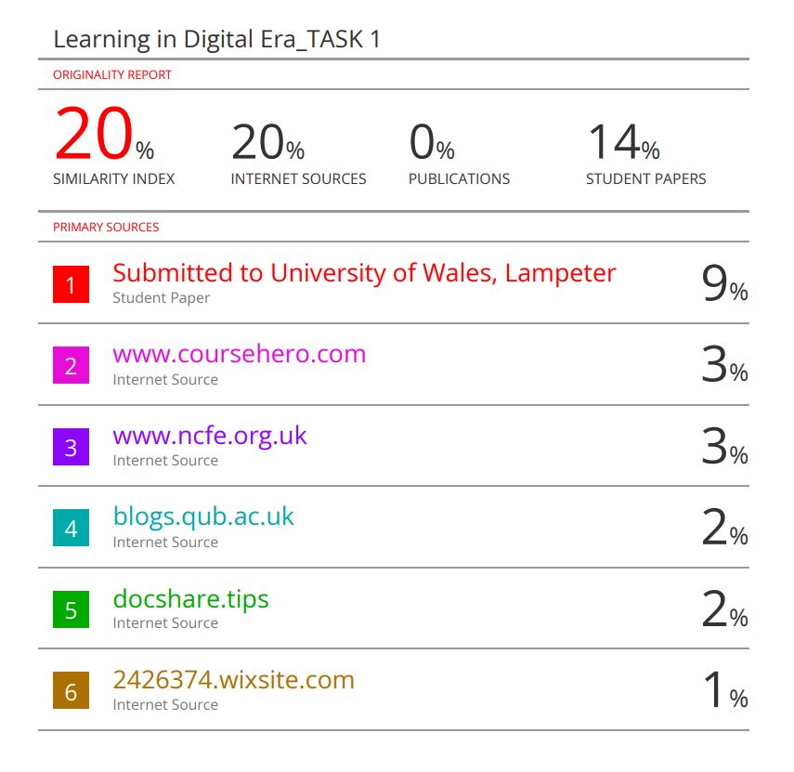
Figure 1: Similarity Report

Task 2

(a): Collaborative Teamwork and Professional Academic poster
https://www.canva.com/design/DAG48QpIEdA/h99comk2oGclGsPjxr5jfQ/view?utm_content=DAG48QpIEdA&utm_campaign=designshare&utm_medium=link2&utm_source=uniquelinks&utlId=hddc30d7496

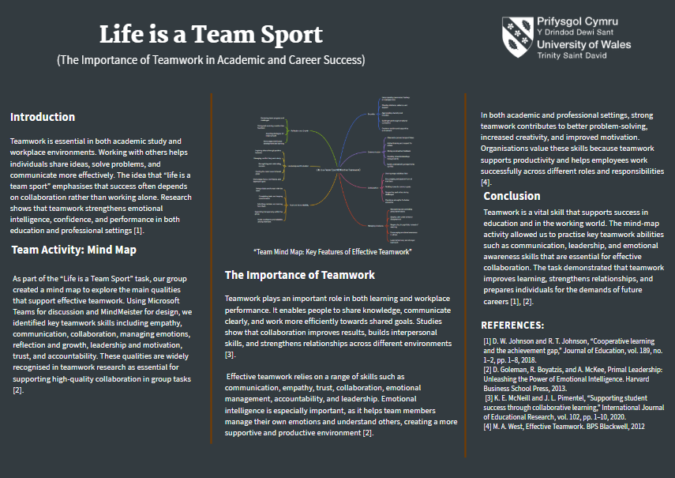
Figure 2: Academic Poster

(b): Team Activity: ‘Life is a Team Sport’ introductory activity

As a group, my two colleagues and I discussed the idea that “Life is a team sport.” During our conversation, we explored several key themes that support this concept. After our discussion, we organized these ideas into a structured mind map using the MindMeister website. This mind map helped us clearly illustrate how these skills and values contribute to effective teamwork in both personal and professional settings.

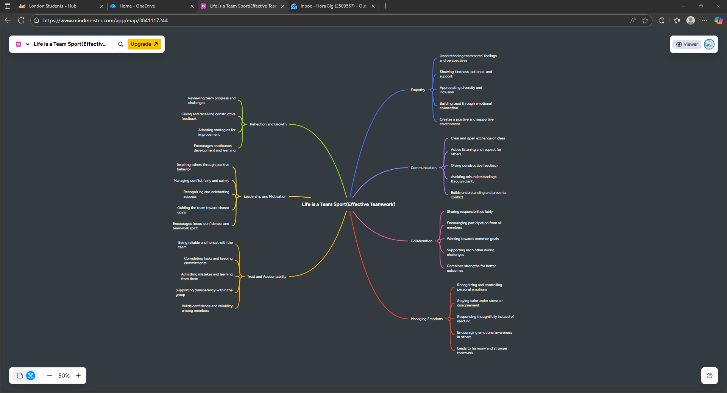
Figure 4: Mind Map
This mind map represents the key ideas from the topic “Life is a Team Sport” and explores why teamwork is essential for academic and career success. The diagram highlights important aspects such as communication, collaboration, leadership, adaptability, and problem solving. It shows how these elements are connected to build effective team dynamics in both education and professional settings. The central idea is that teamwork encourages sharing of ideas, supports motivation, and helps individuals develop interpersonal and organizational skills.
By contributing equally, team members can achieve better outcomes than working alone. In business environments, teamwork promotes creativity, productivity, and mutual respect, while in academic contexts it improves critical thinking and learning from peers. Overall, the mind map reflects how cooperation and shared responsibility lead to stronger results and prepare individuals for real-world professional challenges.

Task 3: Automatic Referencing tool

(a): Riding the Storm (Managing Conflict in Virtual Teams)
Conflict is an inevitable part of teamwork, particularly in virtual environments where communication relies heavily on digital tools rather than face-to-face interaction. As organizations increasingly adopt remote and hybrid working models, understanding how to recognize and manage team conflict has become a vital professional skill.
In virtual teams, conflicts often arise from miscommunication, cultural differences, time-zone barriers, and unclear task responsibilities. According to Fisher and Ury [6], conflict itself is not inherently negative; rather, when managed effectively, it can lead to innovation and stronger relationships. However, unresolved friction in online settings can quickly escalate due to a lack of emotional cues and delayed responses [7].
Research by Purvanova [8] highlights that virtual communication channels, such as email or instant messaging, may amplify misunderstandings, leading to reduced trust and morale. Therefore, leaders must promote transparent communication, psychological safety, and active listening within their teams. Regular video check-ins and open discussions help clarify expectations and allow early resolution of disagreements.
Another major challenge is conflict avoidance, where team members suppress disagreement to maintain harmony. While this may seem beneficial in the short term, it often results in disengagement and poor performance. Thomas and Kilmann [9]describe five conflict handling styles avoiding, accommodating, competing, compromising, and collaborating and recommend collaboration as the most effective approach in virtual contexts. Collaborative problem-solving encourages mutual understanding and strengthens team cohesion.
Effective leaders also model emotional intelligence by recognizing individual triggers and managing tension constructively. Technology can support this process: tools like Microsoft Teams or Zoom enable mediated discussions, while shared documents on OneDrive or Google Workspace ensure transparency in decisions and accountability. [10]
Overall, managing conflict within virtual teams requires both technical and interpersonal competence. Encouraging open communication, empathy, and structured feedback channels transforms conflict from a source of division into a driver of innovation and team growth.

(b): Using Microsoft Word’s Automatic Referencing Tool
To reference my sources accurately, I used Microsoft Word’s built in referencing feature. Under the References tab, I selected IEEE from the citation style options. Then I added each source by clicking Insert Citation, Add New Source and entering the required details such as author, title, and year. Word automatically formatted in text citations and generated a reference list using the Bibliography command. This process saved time, ensured consistency, and reduced the risk of formatting errors.

I took several screenshots to demonstrate each step:
These steps provided practical evidence of my ability to use digital tools effectively for academic documentation.

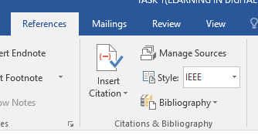
Figure 5: Selecting IEEE referencing style

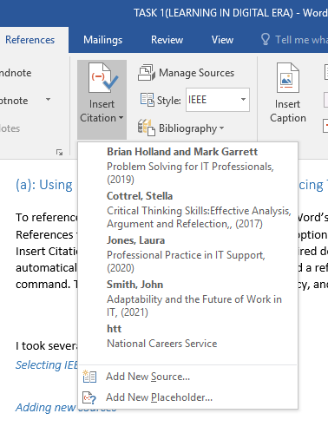
Figure 6: Adding new sources

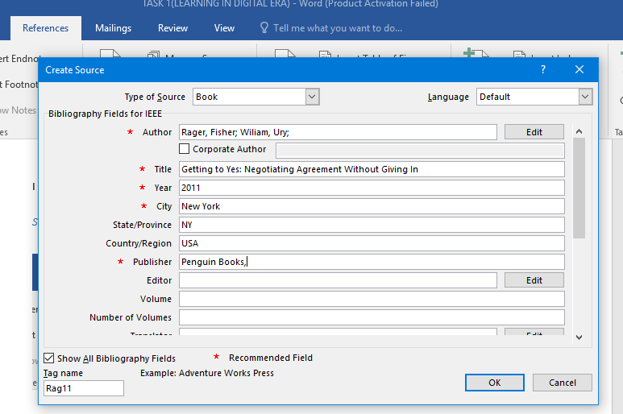
Figure 7: Inserting details

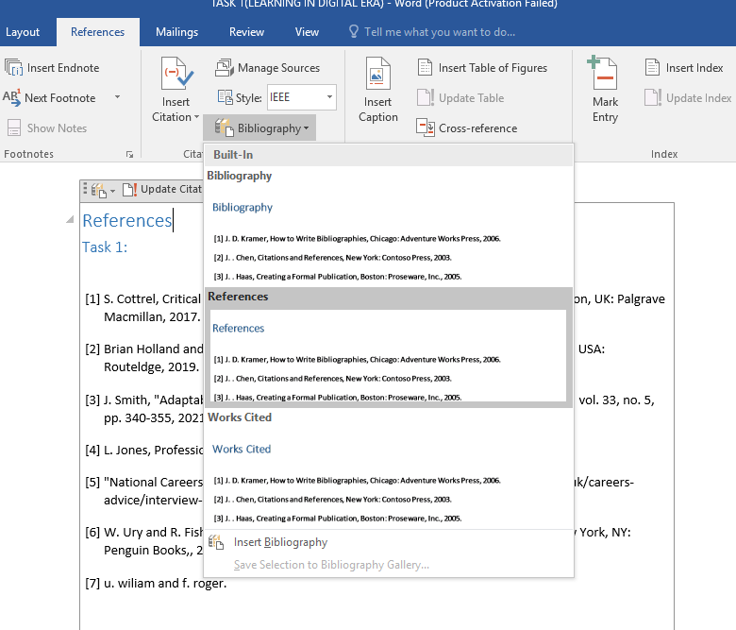
Figure 8: Add Bibliography

Task 4: E-Portfolio creation and review

(a): Portfolio Link
https://2509557.wixsite.com/my-site-4

(b): Produce an illustrative review

For this assignment, I created my e-portfolio using Wix. I selected Wix because it is a straightforward and user friendly website-building platform that provides the essential tools required to develop a clear and organised portfolio. The drag and drop interface made it easy to arrange content without needing any technical or coding skills, which supported an efficient workflow.

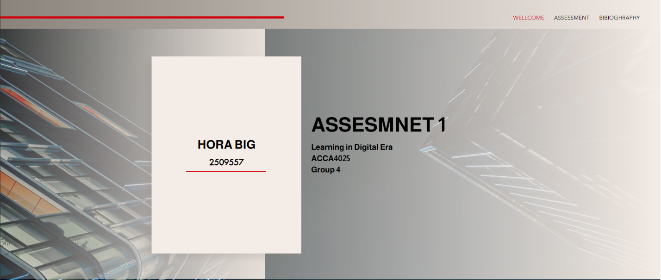
Figure 9 : welcome page

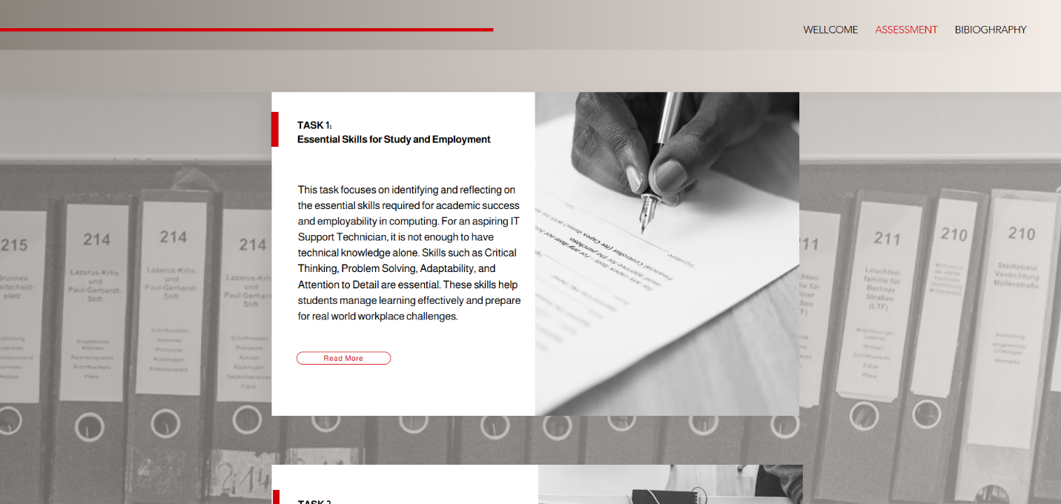
Figure 10:Assessment page

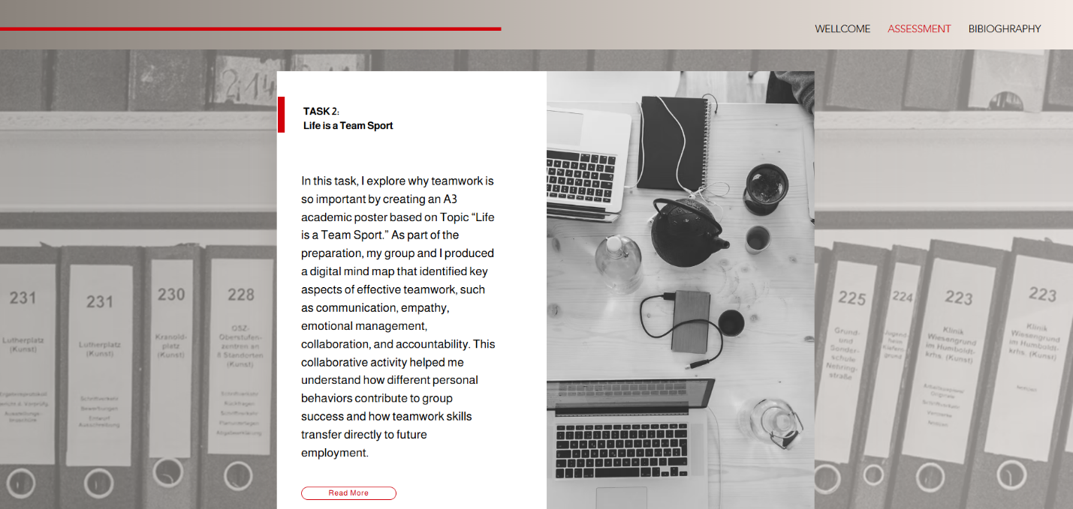
Figure 11: Assessment page

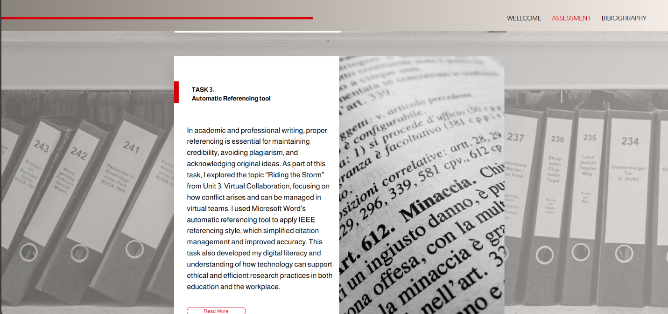
Figure 12: Assessment page

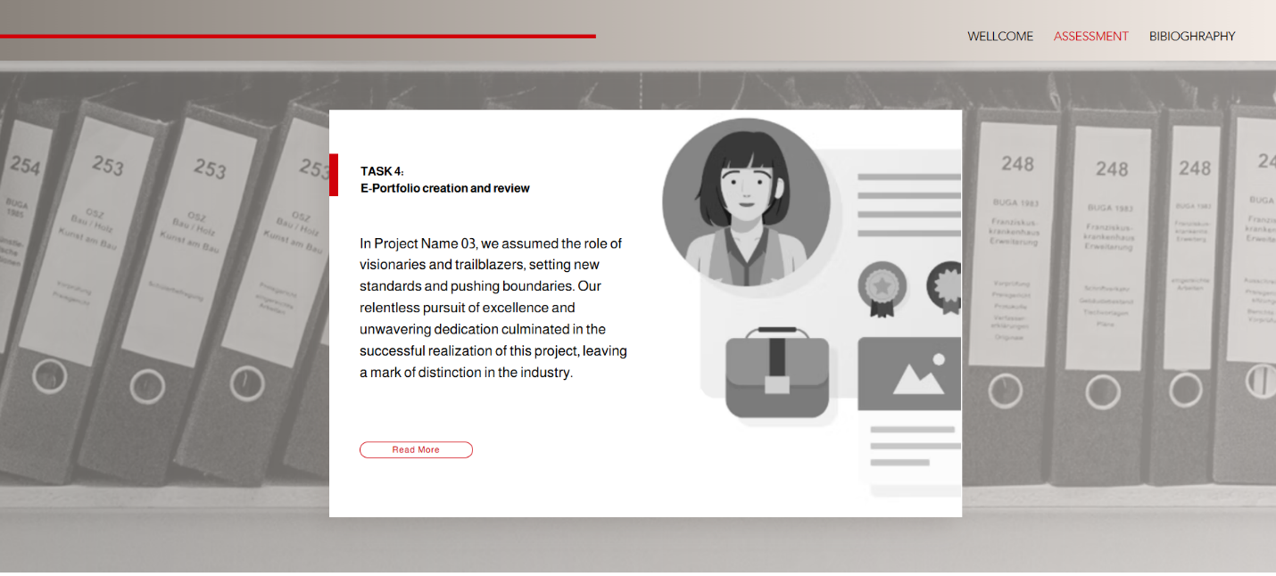
Figure 13: Assessment page

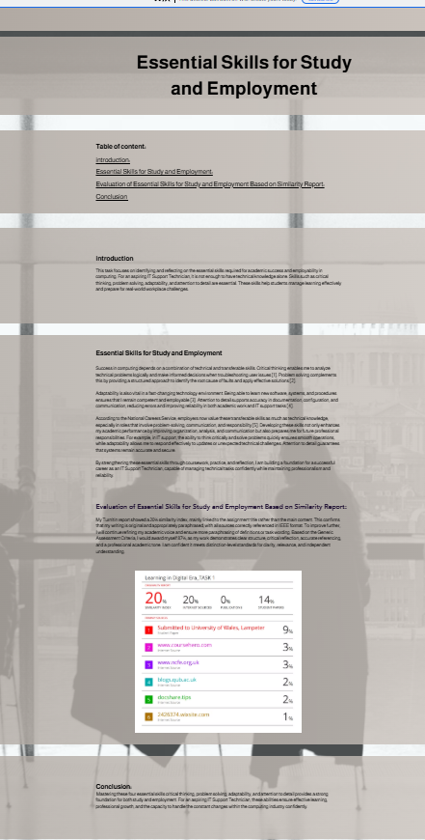
Figure 14: Task 1

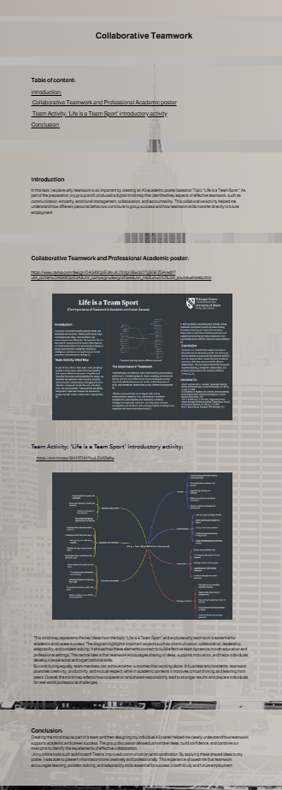
Figure 15: Task2

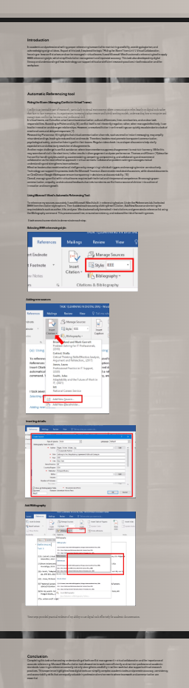

Figure 16:Task3
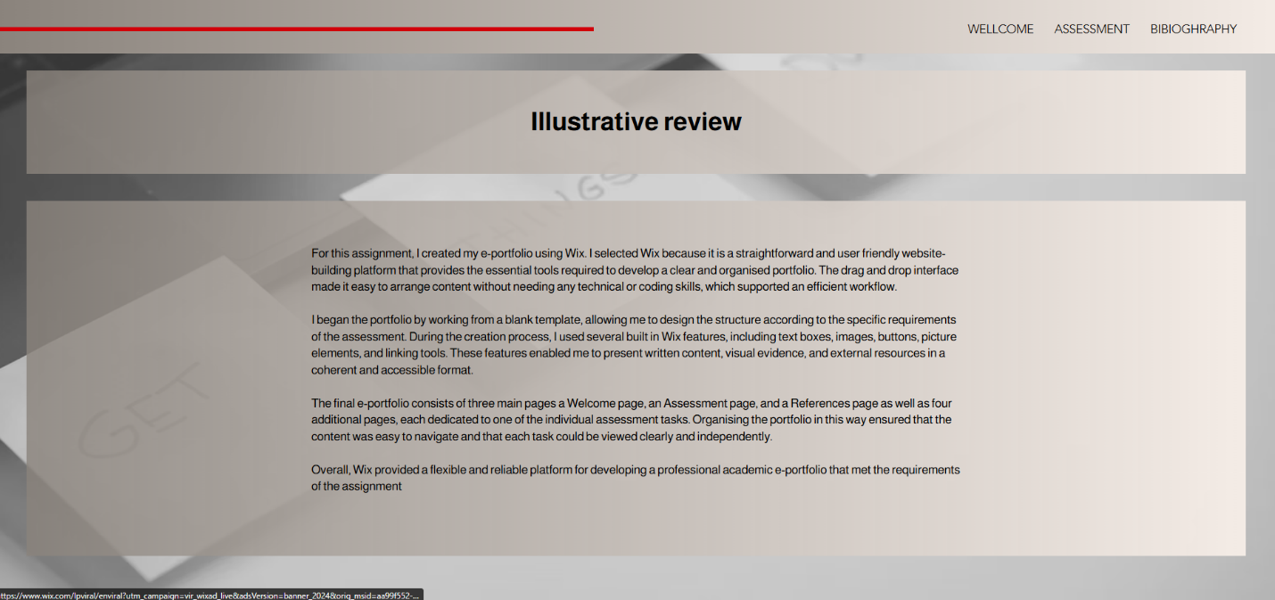
Figure 17:Task 4

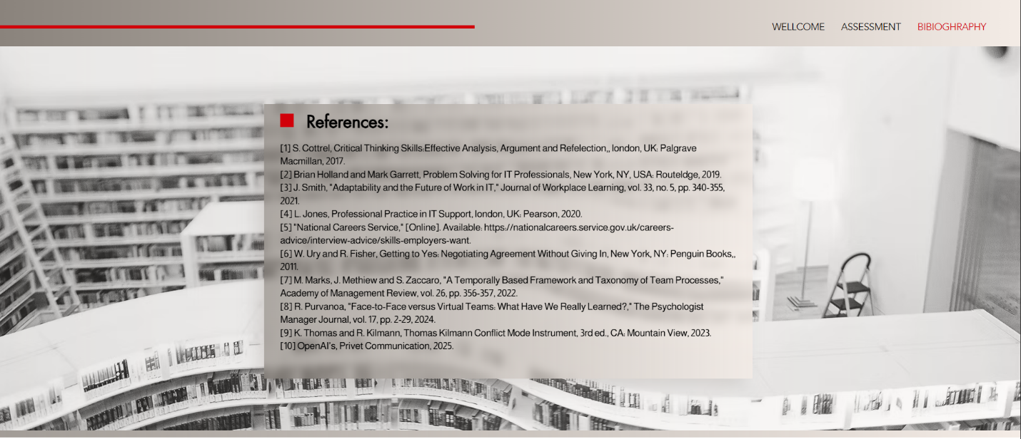
Figure 18: References
I began the portfolio by working from a blank template, allowing me to design the structure according to the specific requirements of the assessment. During the creation process, I used several built in Wix features, including text boxes, images, buttons, picture elements, and linking tools. These features enabled me to present written content, visual evidence, and external resources in a coherent and accessible format.
The final e-portfolio consists of three main pages a Welcome page, an Assessment page, and a References page as well as four additional pages, each dedicated to one of the individual assessment tasks. Organising the portfolio in this way ensured that the content was easy to navigate and that each task could be viewed clearly and independently.
Overall, Wix provided a flexible and reliable platform for developing a professional academic e-portfolio that met the requirements of the assignment

Conclusion

Task 1:
Mastering these four essential skills critical thinking, problem solving, adaptability, and attention to detail provides a strong foundation for both study and employment. For an aspiring IT Support Technician, these abilities ensure effective learning, professional growth, and the capacity to handle the constant changes within the computing industry confidently.

Task 2:
Creating the mind map as part of a team and then designing my individual A3 poster helped me clearly understand how teamwork supports academic and career success. The group discussion allowed us to share ideas, build confidence, and combine our strengths to identify the key elements of effective collaboration.
Using online tools such as Microsoft Teams improved communication and coordination. By applying these shared ideas to my poster, I was able to present information more creatively and professionally. This experience showed me that teamwork encourages learning, problem-solving, and adaptability skills essential for success in both study and future employment

Task 3:
Completing this task enhanced my understanding of both conflict management in virtual collaboration and the importance of accurate referencing. Microsoft Word’s citation tool allowed me to work more efficiently and maintain professional academic standards. Learning to reference correctly not only strengthens credibility in written work but also supports ethical research practices. This experience highlighted how digital tools can simplify complex academic tasks and promote accuracy, consistency, and accountability skills that are equally valuable in professional environments where teamwork and communication are essential.

References

[1] | S. Cottrel, Critical Thinking Skills:Effective Analysis, Argument and Refelection,, london, UK: Palgrave Macmillan, 2017.
[2] | Brian Holland and Mark Garrett, Problem Solving for IT Professionals, New York, NY, USA: Routeldge, 2019.
[3] | J. Smith, "Adaptability and the Future of Work in IT," Journal of Workplace Learning, vol. 33, no. 5, pp. 340-355, 2021.
[4] | L. Jones, Professional Practice in IT Support, london, UK: Pearson, 2020.
[5] | "National Careers Service," [Online]. Available: https://nationalcareers.service.gov.uk/careers-advice/interview-advice/skills-employers-want.
[6] | W. Ury and R. Fisher, Getting to Yes: Negotiating Agreement Without Giving In, New York, NY: Penguin Books,, 2011.
[7] | M. Marks, J. Methiew and S. Zaccaro, "A Temporally Based Framework and Taxonomy of Team Processes," Academy of Management Review, vol. 26, pp. 356-357, 2022.
[8] | R. Purvanoa, "Face-to-Face versus Virtual Teams: What Have We Really Learned?," The Psychologist Manager Journal, vol. 17, pp. 2-29, 2024.
[9] | K. Thomas and R. Kilmann, Thomas Kilmann Conflict Mode Instrument, 3rd ed., CA: Mountain View, 2023.
[10] | OpenAI’s, Privet Communication, 2025.

