
Marketing Management
Assessment 1

MODULE CODE: LCMB7001
STUDENT ID: 2133400
NAME OF THE STUDENT: RUPAL PATEL
LECTURER: TUSHARA BALENDRAN

Table of Contents
Introduction 2
Company Overview 2
Communication 2
Definition 2
Communication Model 3
Integrated Marketing Communication 4
Definition 4
Stages in IMC Campaign 4
New Promotional Strategies 5
Branding and Brand Equity 7
Definitions 7
Model of Brand Equity 7
Advantages and Disadvantages of the Model 9
Customer Journey 9
What is it? 9
Stages in a Customer Journey 9
Customer Touchpoint 10
What is it? 10
Pre-purchase Touchpoints 11
During a Purchase Touchpoints 11
Post-purchase Touchpoints 12
Customer Journey Map/mapping (CJM) 13
What is it? 13
Mapping Customer Journey 13
Strengths and Weakness of CJM 14
Total Engagement Model 15
Conclusion 16
Recommendations 17
References 17

Introduction
The Chartered Institute of Marketing (CIM, 2015) defined it as ‘a management process that recognises, anticipates and fulfils the needs of the consumers in a profitable manner’. In accordance, the focus of this report is to determine integrated marketing communication and innovative marketing strategies, draft customer journey and identify various touchpoints for their total engagement in relation to Samsung, the company selected for the purpose of this report.

Company Overview
Samsung Electronics Co. Limited, a subsidiary of Korea’s Samsung Group, was established by Lee Byung-Chull in 1938 as a trading company (Park, et al., 2014). Later in 1969, the company penetrated into the electronics industry and since then it has evolved and expanded its business in telecommunications and digital technologies (GlobalData, 2021). The mission of Samsung is to dedicate its ‘technology’ and ‘talent’ in producing excellent quality goods and services that helps in creating a better global community (Samsung, 2022).
Today, Samsung is a global leader and a biggest manufacturer of mobile phones and smartphones. As of December 2021, the company’s global network across 74 countries with 266,673 employees had earned a revenue of KRW 279.6 trillion (£173 billion) mostly from smartphones and semiconductor units (Laricchia, 2022; Samsung Newsroom UK, 2022).

Communication

Definition
According to Castells (2013) communication is a process of transferring information and exchange of meaning and understanding between individuals. This process is effectively explained by Shannon and Weaver through their macro model of communication (Refer to Fig. 1).

Communication Model
In 1948, Claude Shannon and Warren Weaver created the ‘Shannon-Weaver Model of Communication’ consisting of 5 key concepts that are highly significant in a communication process (Argenti, 2013).
Figure 1: Shannon-Weaver Model of Communication
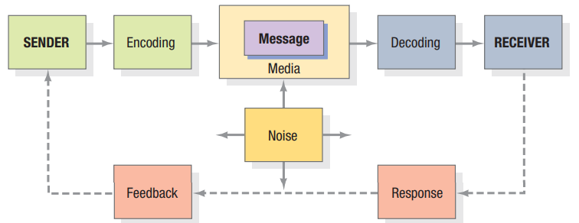
Source: Kotler and Keller (2015)
As described in the study by Floridi (2016), these concepts are:
Sender (Source of information) – It can be an individual, group or organisation who creates the message that needs to be communicated and also decides the channel for message delivery.
Encoding – An ‘encoder’ or a ‘transmitter’ can be a person, object or equipment that translates the message into signals or binary data. For example, written or spoken language, GIFs, emoji, body language, etc.
Channel – It is a medium through which the message is transferred. For example, in a verbal conversation, voice is transferred via airwaves (channel). Electronically, a phone or a computer/laptop is a channel to transfer binary data in the form of text or email.
Decoding – At this stage, the receiver decodes or interprets the message by turning it into meaningful languages. For example, a verbal communication message is decoded by the brains and electronically the binary data is decoded in the form of text, images, intonations, etc.
Receiver – It is an individual or a destination where the message reaches finally. Based on the message/information, the receiver responds to or sends the feedback back to the sender.
The entire process of communication can be obstructed by noise as described by Shannon and Weaver (Al-Fedaghi, 2012). This noise interrupts the flow of communication at the channel stage of the model (Refer to Fig. 1) due to which the receiver may not be able to get the message properly. For example, background noise/voice or any mental, physical or emotional stress that distracts the focus of the receiver is regarded as noise (Kotler and Keller, 2015).
Shannon-Weaver model is termed as ‘the mother of all communication models’ as it describes the basic principles of communication found in various models and theories developed over the years (Onobrakpor, 2019). However, this model overlooks how the receiver interprets the message and how contemporary mass-media communication reaches different people accessing information at varying times (Chandler and Munday, 2020).

Integrated Marketing Communication

Definition
IMC is defined by The American Marketing Association as, a strategic process that ensures all brand communication, on goods, services and organisation, are related to the existing and potential customers and are consistently received by them (Porika, 2015). IMC ensures that all communication channels are harmoniously linked and delivers a unified message for maximum persuasion of current and prospective customers (Ferrell and Hartline, 2011).

Stages in IMC Campaign
When Samsung promotes its products using IMC, it needs to consider following stages:
1. Identify the target audiences – Samsung can gain awareness about its target audiences by collecting their behavioural data (needs, preferences, spending and buying pattern) and demographic data (gender, age, location, qualification, occupation, etc.) in order to appropriately segment/group them and to focus its campaigning efforts on customers who are most likely to buy its products. (Thorson and Moore, 2016)
2. Define the promotional objectives – After identifying the target audiences, Samsung needs to set the end goals or promotional objectives which could be to persuade the customers to buy its products that would increase sales, to penetrate new market, or to increase the awareness amongst its new and existing customers about any new launch or modification in the product-lines. (Kitchen and Burgmann, 2010)
3. Set the promotional budget – The next step is to plan the budget which involves a decision on how much money Samsung can allocate to different promotional activities so that it can manage its financial resources effectively. (Clow and Baack, 2012)
4. Create the promotional mix – Based on the customer segment, Samsung can choose appropriate promotional channels (advertising, social media campaigns, sales promotions, etc.) to reach the specific audience in a specific region with the right promotional tool/s (Key and Czaplewski, 2017). For example, there would be a different promotional tool for young millennials (more social media campaigns) than for adults (advertisement on television, newspaper, etc.)
5. Evaluate the results – This includes evaluation of whether or not Samsung achieved its set objectives or if any correction were needed in the process. However, when evaluating, Samsung needs to consider uncontrollable factors like inflation or recession, pandemic or calamities, etc. that may influence the buying behaviour of the customers. (Patti, et al., 2017)

New Promotional Strategies
Online and offline promotions are two essential promotional strategies that Samsung can focus on to raise awareness about their brand as well as their offerings (Roberts and Zahay, 2012).

Online promotion
Chaffey (2000) illustrated that online promotions is usually digital marketing which is referred to as promotion through digital channels, like social media platforms, websites, search engines, emails and phone apps. According to the Shopper Experience Index 2021, 23% of the people in the UK use social media to find information about new products (Paige, 2021). Dixon (2022) stated that more than half of the online users in the UK are highly active on WhatsApp (75%), Facebook (73.5%), YouTube (66%) and Instagram (56.3%). Therefore, Samsung should target these platforms to grab the attention of their target audiences and to communicate with them about their offerings.
Offline promotions
Although online trends have increased amongst the consumer in recent time, especially post Covid-19 (Calugar-Pop and Lee 2020), offline promotions are still an effective medium for Samsung to reach and attract the target audiences. They are a great medium to reach customers who do not use the internet or those who are not proficient in using the internet (Pauwels, et al., 2016).
Offline promotions include traditional forms of marketing like advertising on television or radio or cinema or through print media (billboards, newspaper and magazines) (Zook and Smith, 2016). Regular radio listeners, television viewers, newspaper or magazine readers as well as thousands of people walking past the billboards on the streets can be easily persuaded through offline ads (Keller and Fay, 2012).
Sales promotion, in the form of sales-incentives, can also be used by Samsung to attract customers to its new launch, to persuade them to make the purchase which in turn will increase the sales, or to clear the stock (Low and Mohr, 2000).
Public relations is another form of traditional promotion that can be used by Samsung to manage the perception of its customers, to improve the brand image and reputation, to raise awareness and attract more customers (Ehling, et al., 2013).
Brand publicity by celebrities and sponsoring charity or sports events, like football or rugby matches, are yet another methods that Samsung can use to increase brand awareness (Tufail, et al., 2014).

Branding and Brand Equity

Definitions
Branding is defined, from the perspective of the organisation, by Kotler and Keller (2015) as offering valuable products and services along with creating a strong brand image in the mind of the customers. From the perspective of the customers, branding refers to the financial value (of the company and its offerings), name and logo (brand identity symbols), and reflection of the brand (positive or negative) in the customers’ minds (Keller, 2003).
Brand equity is defined by Aaker (1991) as ‘a group of assets and liabilities in terms of brand awareness, brand recognition and loyalty of the customers that is increased or diminished due to the existing or prospective products or services offered by the brand. A positive brand equity entices the customers to remain with the brand and purchase its products over competitors’ products (Shariq, 2018). Therefore Samsung should strive to develop a good brand equity for its products/services by making them reliable, qualitative, recognisable, memorable and identifiable (Budac and Baltador, 2013).

Model of Brand Equity
To increase the brand equity of Samsung’s smartphone, it can follow Keller’s Brand Equity Model, which is also known as Customer-Based Brand Equity (CBBE) Model (Keller, 2013). Kitchen and Tourky (2022) explained that, this pyramid-shaped model has 4 stages to build a strong brand, create positive brand image, and develop good brand experience (Refer to Fig. 2).
Figure 2: Brand Equity Model
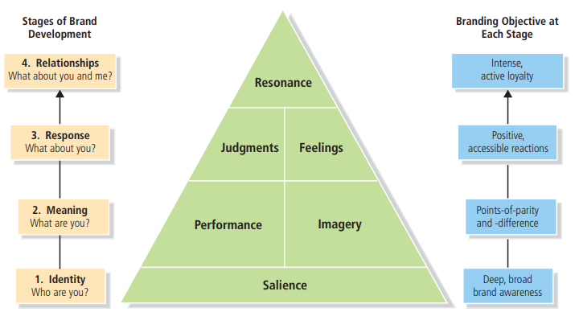
Source: Keller (2013)
1st step: Identity – Samsung needs to first create brand identity or awareness about its smartphone by constantly communicating the right message to its customers through persuasive advertising strategy and digital marketing. By creating a deep and broad awareness, Samsung can help the customers to know if their needs will be satisfied by Samsung’s smartphone. (Free Management Books, 2022)
2nd step: Meaning – Samsung should establish brand meaning with its smartphone in order to win customers’ loyalty which is associated with the quality of the smartphone and its pricing in the market, performance and image of its products in the market, its ability to satisfy customers’ social and psychological needs, the quality of Samsung’s customer service, company’s social responsibility towards the environment as well as the community, and the values and experience that customers have with Samsung’s smartphone. (Free Management Books, 2022)
3rd step: Response – After the customers have purchased Samsung’s smartphone, their judgement and feeling about the purchase is highly essential for Samsung in order to identify whether or not the smartphone maintained the reputation of the company and also helped to fulfil the customers’ needs. (Keller, 2013)
4th step: Relationship – This is the tip of the brand equity pyramid which focuses on brand resonance and the way customers identify themselves with Samsung and its products/services. If Samsung successfully develops strong relationships with its customers, through its smartphone products, the customers will be actively engaged and loyal to the brand and have strong personal attachment and a sense of community with it. (Keller, 2013)

Advantages and Disadvantages of the Model
Advantages - This is an excellent model which guides the brand to build brand equity in a systematic manner. It tracks the current stage of the brand and helps it to identify steps it needs to take to move to the next stage. By achieving strong resonance and relationship, the brand can have premium price benefit amongst its customers and can easily persuade them through its marketing campaigns. (Bhasin, 2019)
Disadvantage – Achieving the first stage of the model, i.e. creating strong brand identity may be a difficult and toughest task for a brand as it requires a lot of time and constant team efforts to develop customer satisfactory products and services and to create a positive brand image. (Remy, 2013)

Customer Journey

What is it?
In marketing, customer journey indicates the path, through touchpoints, which the customer experiences when interacting or engaging with a company, its products and/or services (Peppers and Rogers, 2017).
It covers the journey from the time a customer is not aware about the brand and its offerings, to when he/she becomes aware, explores, purchases, uses and adapts to it, until he/she becomes an advocate, motivating other people to use or purchase from the brand (Transformation, 2019).

Stages in a Customer Journey
A customer journey comprises of the following stages as explained by CIM (2022) and Parise, et al. (2016):
Awareness – At this stage the prospective customers identify that they have a problem or a need and therefore engage in active search to find information that would help them to solve their problem or satisfy their need. This is the stage where a brand can strive to create a first impression on the potential customer.
Evaluation and Consideration – On reaching this stage, the potential customers complete their primary search and become aware about various options available to them. However, they are also likely to research more information to confirm their choice. For example, a customer at this stage may compare different offerings of different providers in the market.
Purchase – This is a crucial stage where the prospects make the final choice from the available options and are involved in a purchase. By this stage, the customers may have done all the possible research and may have identified the company or the product/service that would help them to satisfy their need. Reviews of the customers at this stage of their journey is highly essential for the company.
Retention – Customer retention indicates the capability of a brand to hold the customer over time. At this stage, the company converts the potential customers into constant buyers and stops them moving to its competitors. Customers on the other hand value the brand and become loyal to it.
Advocacy – At this stage, the loyal customer becomes the brand’s active advocate and influences other customers through word-of-mouth and by saying positive things about the brand.

Customer Touchpoint

What is it?
As claimed by Aichner and Gruber (2017), customer touchpoint refers to the point through which an existing or a potential customer interacts or engages with the brand and its offerings. Such interactions occur at different times and places, like through offline and online promotions, through packing, when conversing with customer service agents, etc.
When purchasing a Samsung product, for example a smartphone, there are various touchpoints that the customers may encounter before, during and after making the purchase (George, 2022). These touchpoints are:

Pre-purchase Touchpoints
According to KPU Marketing (2020), before deciding whether or not to buy Samsung’ smartphone the customer uses following touchpoints:
- Social media platforms – like Facebook, Instagram, Twitter, Snapchats, WhatsApp, etc. where the customers can check the smartphone and read the comments of other people on it
- Peer referral – such as word-of-mouth experience of friends, colleagues, or family about the Samsung’s smartphone.
- Online advertisements – include advertisements about the smartphone and its salient features on the Samsung website or third-party websites, like Amazon, Curry’s, Argos, etc.
- Digital marketing contents – like podcasts, videos on YouTube, blogs, social media posts, etc. that would rank Samsung’s smartphone which the customer intends to buy and that describe both negative and positive aspects of it.
- Company events – include business events, webinars, trade shows, conferences, etc. that Samsung may organise throughout the year.
- IMC – online or direct advertising, sales promotions and public relations which informs the customer about Samsung’s smartphones, via physical or sensory communication, human interaction and messages directly (text or email) from Samsung.

During a Purchase Touchpoints
When buying a Samsung smartphone, customers may interact with the brand at following touchpoints, as explained by Fontanella (2021):
Talking to customer service agent/representative – at the Samsung store or over the phone to get additional information about the smartphone and to make a purchase.
Websites –Samsung or third-party websites, like Amazon, Curry’s, etc. to check the features, compare the price and finally make the purchase.
Product catalogue – available in the Samsung store or on the web page to persuade the customer to buy the smartphone. The catalogue contains images from multiple angles, price, descriptions, and customer reviews that can help customers in their buying decision. Also, a catalogue may contain a series of Samsung smartphones that the customers can choose depending on their budget and requirements.
Product review – on social media platforms or on websites, from the customers who have used the smartphone. Such authentic reviews, in comparison to the brand created content, are twice more likely to persuade the customers to make a purchase.
Point of sale – By this stage, the customers decide which smartphone to buy and how it will help them to satisfy their needs. For Samsung, this is the most important stage of the customer journey as it helps to bring in revenue for the company.

Post-purchase Touchpoints
Indeed Editorial Team (2022) explained that post-purchase touchpoints are experienced by a customer after making a purchase. These consist of:
Feedback surveys – sent by the customers after they have purchased the smartphone which conveys the experience of the customer, good or bad, about the smartphone. It serves as a source of information for Samsung to enhance its products/services or operation in future.
Thank you letters – in the form of an email or printed or hand-written letters can be sent by Samsung to develop a strong and long-term bond with the customers.
Upselling/cross-selling emails – After using the smartphone, there are possibilities that the customers may have additional requirements, like ear pods, charger, etc., and this can be an opportunity for Samsung to upsell or cross-sell those items to the customers.
Subscription/Membership – After purchase, Samsung can encourage customers to sign for their membership which will help them earn points on purchase, gain rewards and discounts, get customer support 24/7 and have access to new offers and content. This will help Samsung to attract more customers to its business and to increase customers on their database.

Customer Journey Map/mapping (CJM)

What is it?
As stated by Moon, et al. (2016) a CJM is a diagrammatic presentation of customers’ journey every time they engage with the brand and its products/services. Such mapping can help Samsung to view its business from the customer's perspective, identify their needs, pain points, and problems in their journey, and accordingly improve their experience (Micheaux and Bosio, 2019).

Mapping Customer Journey
When creating a CJM, Samsung needs to first define its customers’ persona (Refer to Fig. 3) to gain a complete understanding about them (Pepper and Roger, 2017). A persona describes the behaviour traits and personal characteristics of the potential customer (Boneli, 2017).

Figure 3: Samsung Customer Persona
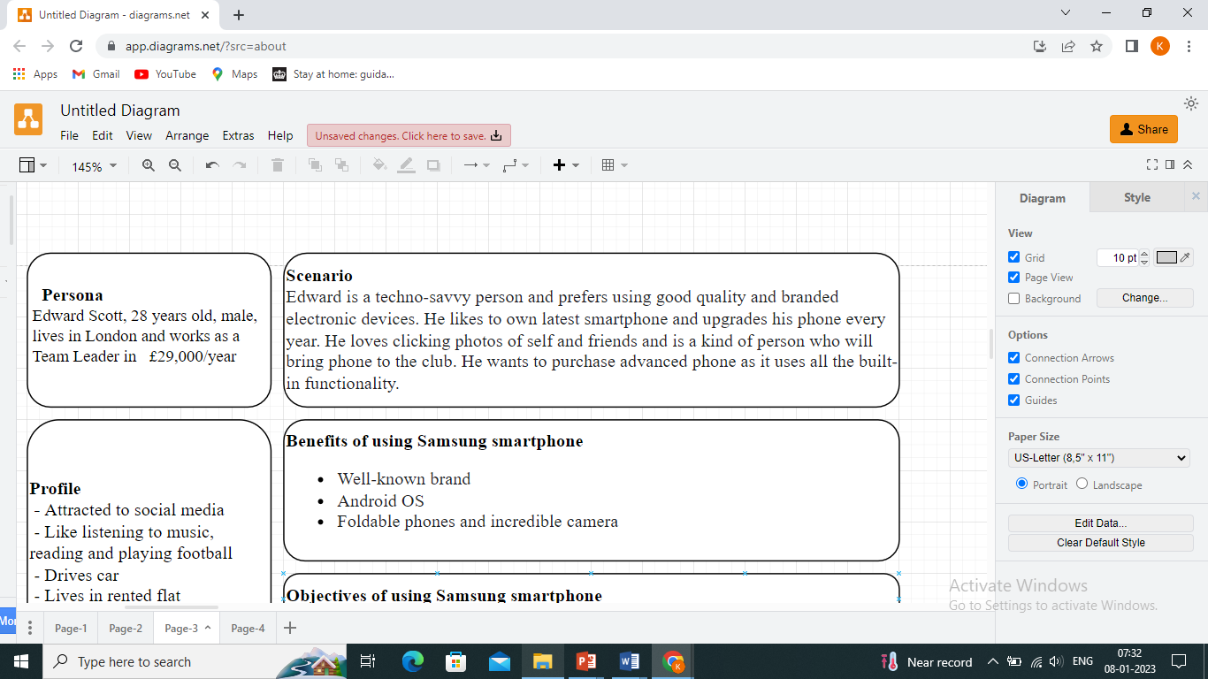
Source: Designed by author

Based on above Edward Scott’s persona, the following CJM can be created for buying a Samsung smartphone:
Figure 4: CJM of Edward
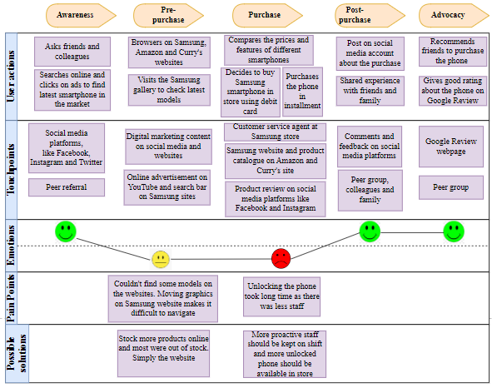
Source: Designed by author

Strengths and Weakness of CJM
Strengths – From the CJM of Edward, it can be analysed that he was motivated to buy a Samsung smartphone after peer referral and checking the reviews on social media. Digital marketing content on social media sites and product catalogue on Samsung site as well as Amazon and Curry’s website gave useful information on the product which helped Edward to confirm his choice.
Weaknesses – Buying in store was a bad decision of Edward as due to fewer staff, he had to wait for a long time to get his phone unlocked. There were moving graphics on the Samsung website which made it difficult for Edward to navigate from one page to another when browsing information.

Total Engagement Model
Roberts and Alpert (2010) claimed that the profitability and success of an organisation is highly dependent on customers' intention to buy its products. However, the organisation should ensure that its interaction with the customer is not limited to a single purchase and rather strive to create engaged customers who would repeatedly purchase from the organisation over its competitors (Pansari and Kumar, 2016) as this will result in enhanced business performance and increased revenue and growth.
To increase the total engagement of the customers, Samsung should have a strong internal corporate culture and highly talented workforce (Brodie, et al., 2016). With reference to the Total Engagement Model (Refer to Fig. 5), the first step to engage customer is to develop customer value proposition (CVP), based on the knowledge about the customers, which signifies the benefits that Samsung would deliver to its customers through its products/services (Roberts and Alpert, 2010). The next step is to transfer the CVP to existing and potential customers, in the form of brand promises, through strong brand advertisement (Roberts and Alpert, 2010). The employees of Samsung can also play a significant role in fulfilling the CVP through the delivery of great customer service that would enhance the customer’s experience (Brodie, et al., 2016). However, to achieve this, Samsung should ensure that their existing employees and potential employees match with their corporate values. According to Frow and Payne (2009), the employees who can relate with the values and norms of the company are highly involved in the company and deliver great service. Also, the company should transfer corporate values and behaviour to their employees through regular effective hiring and regular training.
Figure 5: Total Engagement Model
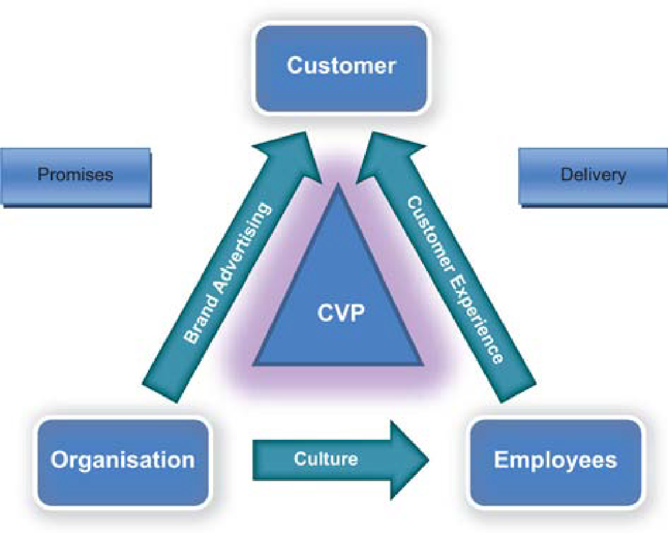
Source: Roberts and Alpert (2010)

Conclusion
To conclude, Samsung is a highly popular brand yet it needs to constantly communicate with its customers, using IMC, to increase awareness about its business operations and its upcoming products and services. When doing so, the company should use new promotional strategies, both online and offline, to attract the customers. Secondly, to maintain the brand equity, Samsung needs to follow Keller’s Brand Equity Model that will help to achieve strong resonance and relationship with its customers. Thirdly, when creating products/services, Samsung needs to map its customer journey to understand their touchpoints and pain points and accordingly enhance its products/service to satisfy customers and their needs. In addition, the company works towards developing total engagement with the customers through effective brand advertisements and with the help of its competent employees.

Recommendations
- Samsung can consider customised IMC to gather real-time data about its customers and their preferences in order to give them more personalised experience (McKinsey & Company, 2020). For instance, if a customer browses Samsung’s website to check different products and exists without making any purchase, the company can target the customer on different touch points through click-on ads and encourage them to make a purchase.
- Samsung can use virtual reality at its own stores or partnership stores to give close-to-reality experience to its customers.
- Besides billboards and outdoor advertisement, Samsung can attract and promote to customers through ‘Flash mobs’ on streets, shopping malls, and at busy places.

References
Aaker, D.A. (1991) Managing brand equity. 1st edition. New York: The Free Press.
Aichner, T. and Gruber, B. (2017) ‘Managing customer touchpoints and customer satisfaction in b2b mass customization: A case study’, International journal of industrial engineering and management, 8(3), p.131-140.
Al-Fedaghi, S. (2012) ‘A conceptual foundation for the Shannon-Weaver model of communication’, International Journal of Soft Computing, 7(1), pp.12-19.
Argenti, P. A. (2013) Corporate communication. 6th edition. New York: McGraw-Hill.
Bhasin, H. (2019) ‘Keller’s Brand equity Model – CBBE Model by Keller’, Marketing91. Available at: https://www.marketing91.com/kellers-brand-equity-model/ (Accessed 3 January 2023).
Boneli, S. (2017) ‘Use buyer personas to understand your customer’, Corridor Business Journal, 13 (44), pp. 21.
Brodie, R.J., Hollebeek, L.D. and Conduit, J. (2015) Customer engagement: Contemporary issues and challenges. 1st edition. Oxon: Routledge.
Budac, C. and Baltador, L. (2013) ‘The value of brand equity’, Procedia Economics and Finance, 6, pp.444-448.
Calugar-Pop, C. and Lee, P. (2020) ‘Lasting lockdown habits: a new digital consumer? Digital Consumer Trends 2020’, Deloitte. Available at: https://www2.deloitte.com/uk/en/pages/technology-media-and-telecommunications/articles/digital-consumer-trends-lockdown-behaviour.html (Accessed 2 January 2023).
Castells, M. (2013) Communication power. 2nd edition. Oxford: Oxford University Press.
Chaffey, D. (2000) ‘Achieving Internet marketing success’, The Marketing Review, 1(1), pp.35-59.
Chandler, D. and Munday, R. (2020) A dictionary of media and communication. 3rd edition. New York: Oxford University Press.
Clow, K.E. and Baack, D. (2013) Integrated advertising, promotion and marketing communications. 4th edition. New Delhi: Pearson Education India.
Dixon, S. (2022) ‘Most popular social media platforms in the United Kingdom (UK) as of the third quarter 2021, by usage reach’, Statista. Available at: https://www.statista.com/statistics/284506/united-kingdom-social-network-penetration/ (Accessed 3 Jan 2023).
Ehling, W.P., White, J. and Grunig, J.E. (2013) Excellence in public relations and communication management. 1st edition. London: Routledge, pp. 357-393.
Ferrell, O. C. and Hartline, M. D. (2011) Marketing strategy. 5th edition. Mason: South-Western Cengage Learning.
Floridi, L. (2016) The Routledge Handbook of Philosophy of Information. 1st edition. New York: Routledge.
Fontanella, C. (2021) ‘20 Customer Touchpoints That Will Optimize Your Customer Journey’, HubSpot, Inc. Available at: https://blog.hubspot.com/service/customer-touchpoints (Accessed 3 January 2023).
Free Management Books (2022) Keller’s Brand Equity Model. Available at: http://www.free-management-ebooks.com/news/kellers-brand-equity-model/ (Accessed 3 January 2023).
Frow, P.E. and Payne, A.F., 2009. Customer relationship management: a strategic perspective. Journal of business market management, 3(1), pp.7-27.
George, R. (2022) ‘Tapping into brand touchpoints’, MarketingProfs. Available at: https://www.marketingprofs.com/3/george2.asp (Accessed 3 January 2023).
GlobalData (2021) Samsung Electronics Co Ltd: Overview. Available at: https://www.globaldata.com/company-profile/samsung-electronics-co-ltd/ (Accessed 30 December 2022).
Indeed Editorial Team (2022) 30 Customer Touch Point Examples (Plus How To Identify Them). Available at: https://www.indeed.com/career-advice/career-development/customer-touchpoint (Accessed 3 January 2023).
Keller K. L. (2013) Strategic brand management. 4th edition. Essex: Pearson Education Limited.
Keller, E. and Fay, B. (2012) ‘Word-of-mouth advocacy: A new key to advertising effectiveness’, Journal of Advertising Research, 52(4), pp.459-464.
Keller, K. L. (2003) ‘Understanding brands, branding and brand equity’, Interactive Marketing, 5, pp. 7-20.
Key, T.M. and Czaplewski, A.J. (2017) ‘Upstream social marketing strategy: An integrated marketing communications approach’, Business Horizons, 60(3), pp.325-333.
Kitchen, P. J. and Tourky, M. E. (2022) Integrated Marketing Communications: A Global Brand-Driven Approach. 2nd edition. New York: Palgrave Macmillan.
Kitchen, P.J. and Burgmann, I. (2015) ‘Integrated marketing communication: making it work at a strategic level’, Journal of Business Strategy, 36 (4), pp. 34-39.
Kotler, P. and Keller, K. L. (2015) Marketing Management. 14th edition. New Jersey: Prentice Hall.
KPU Marketing (2020) Chapter 45: Touchpoints. Available at: https://kpu.pressbooks.pub/openimc/chapter/touchpoints/ (Accessed 3 January 2023).
Laricchia, F. (2022) ‘Samsung Electronics - statistics & facts’, Statista. Available at: https://www.statista.com/topics/985/samsung-electronics/#dossierContents__outerWrapper (Accessed 30 December 2022).
Low, G.S. and Mohr, J.J. (2000) ‘Advertising vs sales promotion: a brand management perspective’, Journal of Product & Brand Management, 9 (6), pp. 389-414.
McKinsey & Company (2020) The end of shopping’s boundaries: Omnichannel Personalization. Available at: https://www.mckinsey.com/business-functions/marketing-and-sales/our-insights/the-end-of-shoppings-boundaries-omnichannel-personalization (Accessed 3 January 2023).
Micheaux, A. and Bosio, B. (2019) ‘Customer journey mapping as a new way to teach data-driven marketing as a service’, Journal of Marketing Education, 41(2), pp.127-140.
Moon, H., Han, S.H., Chun, J. and Hong, S.W. (2016) ‘A design process for a customer journey map: a case study on mobile services’, Human Factors and Ergonomics in Manufacturing & Service Industries, 26(4), pp.501-514.
Onobrakpor, U.D. (2019) ‘Information transfer in Libraries and Information Centers: role of Communication’, Information Impact: Journal of Information and Knowledge Management, 10(2), pp.99-108.
Paige, J. (2021) ‘UK shoppers turn to social media to discover and buy new products’, Retail Insight Network. Available at: https://www.retail-insight-network.com/features/uk-shoppers-turn-to-social-media-to-discover-and-buy-new-products/ (Accessed 1 January 2023).
Pansari, A., & Kumar, V. (2017) ‘Customer engagement: the construct, antecedents, and consequences’, Journal of the Academy of Marketing Science, 45(3), pp. 294-311.
Parise, S., Guinan, P.J. and Kafka, R. (2016) ‘Solving the crisis of immediacy: How digital technology can transform the customer experience’, Business Horizons, 59(4), pp.411-420.
Park, S.C., Alvstam, C.G., Dolles, H. and Strom, P. (2014) ‘Samsung Electronics: From ‘National Champion’ to ‘Global Leader’, Asian Inward and Outward FDI. London: Palgrave Macmillan. pp. 179-200.
Patti, C.H., Hartley, S.W., van Dessel, M.M. and Baack, D.W. (2017) ‘Improving integrated marketing communications practices: A comparison of objectives and results’, Journal of Marketing Communications, 23(4), pp.351-370.
Pauwels, K., Demirci, C., Yildirim, G. and Srinivasan, S. (2016) ‘The impact of brand familiarity on online and offline media synergy’, International Journal of Research in Marketing, 33(4), pp.739-753.
Peppers, D. and Rogers, M. (2017) Managing customer experience and relationships: A strategic framework. 3rd edition New Jersey: John Wiley & Sons, Inc.
Porika, B.K. (2015) ‘A study on integrated marketing communication’, Trends, Challenges & Innovations in Management. 1st edition. Vol. III, Hyderabad: Zenon Academic Publishing.
Remy, A. (2013) ‘Brand Equity’, Word Press. Available at: https://avaremy.wordpress.com/2013/11/09/brand-equity/ (Accessed 3 January 2023).
Roberts, C., &Alpert, F. (2010) ‘Total customer engagement: designing and aligning key strategic elements to achieve growth’, Journal of Product & Brand Management, 19 (3), pp.198-209.
Roberts, M.L. and Zahay, D. (2012) Internet marketing: Integrating online and offline strategies. 3rd edition. South-Western Cengage Learning.
Samsung (2022) About us. Available at: https://www.samsung.com/us/about-us/leadership-and-mission/heritage/ (Accessed 30 December 2022).
Samsung (2022) Our mission & values. Available at: https://www.samsung.com/uk/about-us/company-info/ (Accessed 30 December 2022).
Samsung Newsroom UK (2022) Fast Facts: Samsung Electronics. Available at: https://news.samsung.com/uk/fast-facts (Accessed 30 December 2022).
Shariq, M. (2018) ‘Brand equity dimensions-a literature review’, International Research Journal of Management and Commerce, 5(3), pp.312-330.
The Chartered Institute of Marketing (2015) Marketing and the 7Ps: A brief summary of marketing and how it work. Available at: https://www.cim.co.uk/media/4772/7ps.pdf (Accessed 30 December 2022).
The Chartered Institute of Marketing (2022) Five stages of your customers' buying journey. Available at: https://www.cim.co.uk/content-hub/blog/five-stages-of-your-customers-buying-journey/ (Accessed 3 January 2023).
Thorson, E. and Moore, J. (2016) Integrated Communication: Synergy of Persuasive Voices. 3rd edition. Oxfordshire: Taylor & Francis Group.
Transformation (2019) Customer Journey Definition. Available at: https://transformation.ai/customer-journey-definition/ (Accessed 2 January 2023).
Tufail, S., Saeed, R., Zameer, H., Bilal, M. and Naeem, B. (2014) ‘Impact of sponsorship and publicity on brand equity’, International Journal of Academic Research in Business and Social Sciences, 4(12), p.15.
Zook, Z. and Smith, P.R. (2016) Marketing communications: offline and online integration, engagement and analytics. 6th edition. London: Kogan Page Publishers.

