Funerary Cone Object Analysis
I will be drawing upon objects that have been examined throughout past lectures and workshops and making my own assumptions and interpretations based upon archaeological evidence and a reconstruction of my own funerary cone to understand Ingold’s concept of Thinking through making. Ingold believes that learning through the use of physical materials and reacting to them by fully engaging in the craft of an object is the direct, effective method of learning. Using these principles in a modern perspective, it allows a deeper consideration towards the objects with reconstruction archaeology to form interpretations of how the funerary cones were functioning in Gaza and in Egypt and the process of making them.
Egyptian and Gazan funerary cones alike have been found with the top broken off consistently. This could be a break in antiquity usually around the area of the stamped cartouche with the name facing outwards. This would be set into the building in an attempt to protect the tomb, between Egypt and the Southern Levant which would be consistent to the usual breaks found within the cones. ‘The Gaza cones, which were made from coarse, reddish-yellow clay and covered with a red slip, were stamped on the round face and upper side with a single cartouche before firing.’ (Steel, 2016)
Through the use of Ingold’s principles of making, I will attempt to gain a comprehensive understanding of the methodologies that could have been used by the craftsman in Ancient Egypt. I believe that to gain the most out of this experience, a number of variances and compensations have to be taken into consideration. This would include the clay originally used in contrast to the materials that we have access to in the present day. The modern clay used is subsequently siltier in comparison to the clay used in ancient Egypt and so would have to take into consideration if this would have affected the process of creating the cone.
The making:
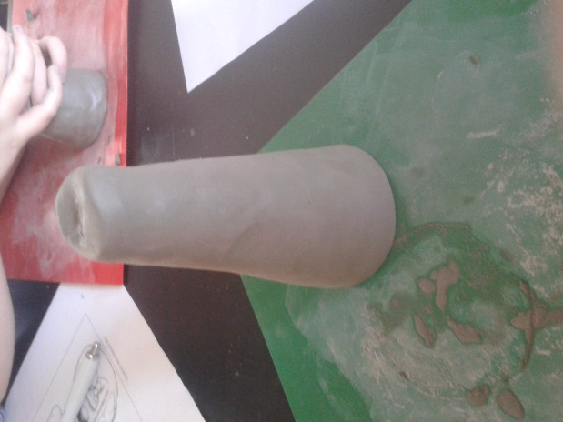
In the first steps towards the making of the funerary cone, the thought of the best method to accomplish the shape of the cone. The first attempt was to roll the clay across the table in order to smooth out the curves while also using my hands to mould the clay. Found quite difficult to shape. I found that applying more pressure at one end, while rolling the clay, was successful in forming the cone shape at one end. (See fig.1)

Stamping Process:
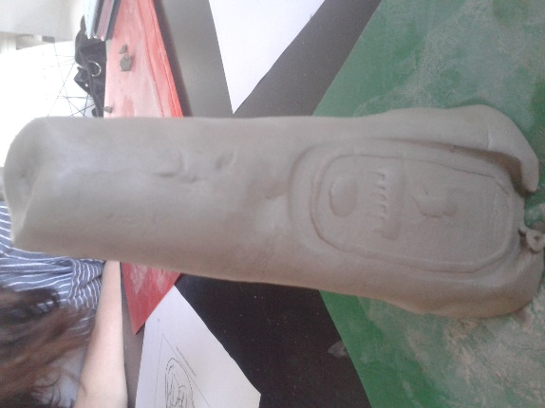
Using a wooden carved stamp with the name of Tuthmose III, I found the process easier to stamp if the clay is wet. Stamping on the face of the cone while using a good amount of pressure and force, a good seal impression was left. Although, as a result there was a manipulation to the shape of the cone which became a continuous concern to the end result of the shape of the cone (see fig.2). On the underside on the cone, using the same process I found that using less force than the face due to the possibility of disfiguring the cone. The impression was not as predominant as the face of the cone. Other methods I chose to apply did not quite have the same effect in correlation to the appearance and shape of the object.

By following Ingold, the means have been provided of gaining fresh information and potential insight into the lives of the ancient Egyptians and their funerary procedures.
- Cultural significance? – Theban burial practices - relation.
- The making – materiality and hybridity. Using Egyptian techniques adopted by the peoples of the Levant to create hybrid object.
- What the object depicts. Give immense detail, every specific detail on funerary cone
- The most distinctive features; stylization, hybridity. What does this represent?
- Why is the piece significant? Materials – imported or found in the local area?
- What is the result? With reference to hybridity and how it applies to the cone
- Brief interpretations of the original funerary cones found in Egypt and Gaza. Would the cones have been made in Egypt or from a close trade connection.
- Similarities and differences to the reconstruction we made to the ones made over 3000 years ago
- Think about the methodology we used in lecture and our experience and contrast to the other possible alternative methods that the ancient Egyptians could have used.

Shaw, Tim. “Thinking Through Making: a Practical Approach to Research and Knowledge Creation.” Open Lab, Newcastle University, 1 Apr. 2014, openlab.ncl.ac.uk/phd-projects/sound-space-and-synthesis/.
Steel, L. Shifting Relations in Bronze Age Gaza: In, T. Clack (edited) 2016. Archaeology, Syncretism and Creolisation Oxford: Oxbow. (in press)

