University of Wales Trinity St David
Computing (Data & Information)

Assignment

Course: L4 - Computer Architecture and Operating Systems (ACCA4022)
Student Name: Collette Owen
Student ID: 2517697
Lecturers: James Williams, Lee Colby, Munyaradzi Nicholas Murira
Word Count: 1288
Submission Date: 20/05/2026

Contents

- Cover
- Contents
- Introduction
- Task 1 - Memory & Process Management
- Task 1 - Memory & Process Management
- Task 1 - Device Management: I/O Devices
- Task 1 - File & Directory Management
- Task 1 - System Performance Monitoring
- Task 1- System Security
- Task 2 - Command ‘dir’
- Task 2 - Command: Echo & cls
- Task 2 - Command: Color xx
- Task 2 – Command: help
- Task 2 – Command: ipconfig
- Task 2 – Command: whoami
- Task 2 – Command: ping
- Task 2 – Command: netsat
- Task 2 – Command: net statistics workstation
- Task 2 – Command: powercfg –energy
- Task 2 – Command: net use/add/delete
- Task 3 – Command: pwd & ls
- Task 3 – Command: echo
- Task 3 – Command: date
- Task 3 – Command: whoami
- Task 3 – Command: history
- Task 3 – Command: netstat & arp –a
- Task 3 – Command: top & htop
- Conclusion
- References
- – 38 – Online Learning - Learning PowerShell via LinkedIn Learning

Introduction
Here in this assignment are evidence of practice of commands and online learning. Learning to better understand the fundamentals of commands and their uses. In addition, taking an online learning course to deepen my understand and expanding my knowledge on this subject.

Task 1
Memory & Process Management

Memory
Some key functions of Memory management are:
- Memory allocation
- Allocation and deallocation
- Isolation and protection#
- Virtual memory management
A process cannot exist without memory; it needs RAM to store its code and stack data. Conversely, memory is useless without process management to execute the instructions stored.
“All the runnable software on the computer, sometimes including the operating system, is organized into a number of sequential processes, or just processes for short. A process is just an instance of an executing program, including the current values of the program counter, registers, and variables” (Tanenbaum, 2015, p. 85). [1]

Process
Process management involves an array of key points:
- Process Creation/Termination.
- CPU Scheduling
- Contact Switching
- Synchronisation
- Deadlock handling
For process creation, a request will begin with a user's instructions in order to use a program of application.
“When an operating system is booted, typically numerous processes are created. Some of these are foreground processes, that is, processes that interact with (human) users and perform work for them” (Tanenbaum, 2015, p. 88). [2]
CPU scheduling as part of the process management process, allows for tasks to be carried out in a timely way using algorithms.
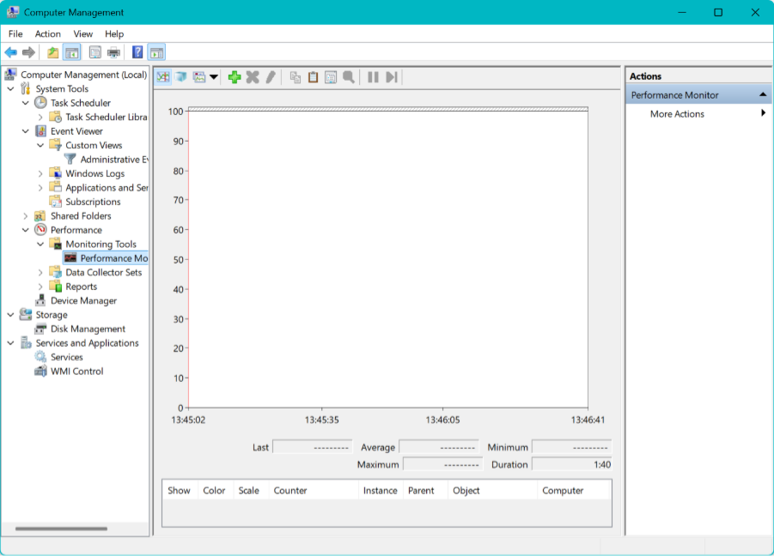
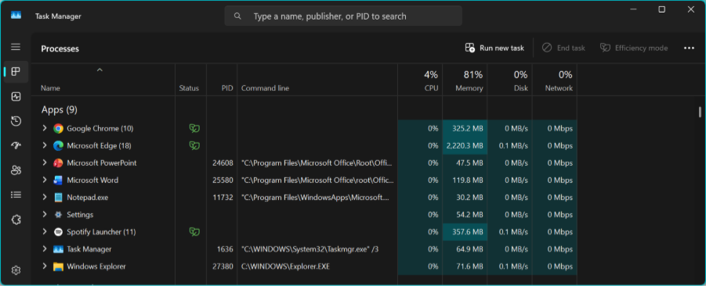

Device Management: I/O Devices.
Device drivers: act as translators between the operating system and hardware peripherals, enabling applications to successfully execute user instructions.

“When the processor is executing a program and encounters an instruction relating to I/O, it executes that instruction by issuing a command to the appropriate I/O module.” (Stallings, 2005, p. 34). [3]

The function of a device driver is to connect the bridge between the OS and I/O device to allow for correct operation as the OS does not have a local instruction for an external device.
Tracking Device Status: Monitors connected hardware to determine whether a device is currently available or disconnected.
Device Allocation and Deallocation:
- Allocation: It grants temporary exclusive or shared access to the I/O device.
- Deallocation: Once the process finishes or closes, the device manager instantly revokes access and releases the hardware so other applications can use it.

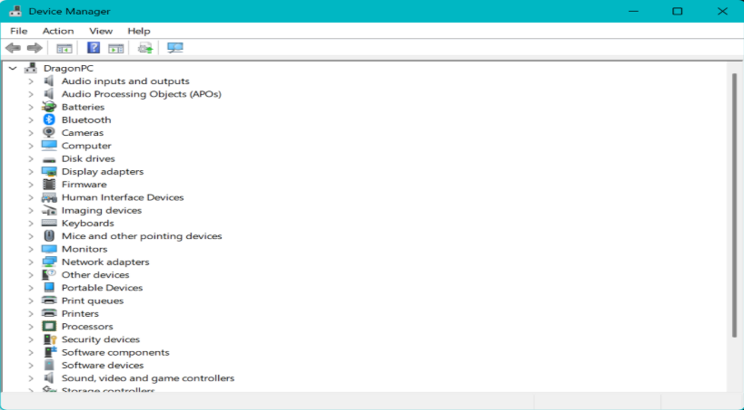

File & Directory Management
File Abstraction and Naming – This process defines how files are named, formatted (e.g., .docx, .pdf), and logically organised. It maps out paths and locations, making it easy to access stored data regardless of the physical hardware.
“A file is an abstraction mechanism. It provides a way to store information on the disk and read it back later. This must be done in such a way as to shield the user from the details of how and where the information is stored, and how the disks actually work.” (Tanenbaum and Bos, 2014, p. 265). [4]

Directory Structure and Hierarchy - Most modern operating systems use a hierarchy (tree) directory structure.
Storage Allocation and Tracking - Files grow, shrink, and get deleted constantly. The file system uses specific allocation methods to locate data.
Access Control and Security - The file manager carries out security measures through Access Control Lists (ACLs). Whenever a process requests to open, modify, or delete a file, the file manager validates the permissions of the user.

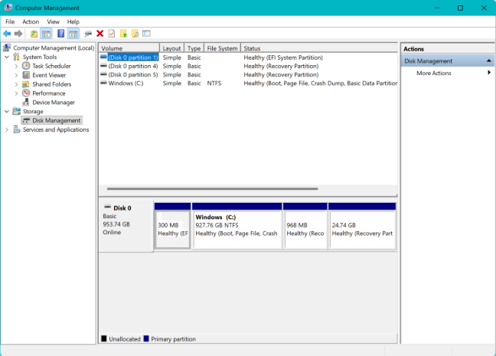

System Performance Monitoring
Metrics Collection: Gathers real-time performance data from the CPU, memory, disk, and network, tracking specifics like CPU utilisation and used-to-available memory ratios.
Thresholding & Alerting: Triggers immediate alerts (via logs, emails, or flags) when a metric crosses a safe limit—such as 95% RAM usage or critical CPU heat—allowing users or the OS to intervene before a crash.

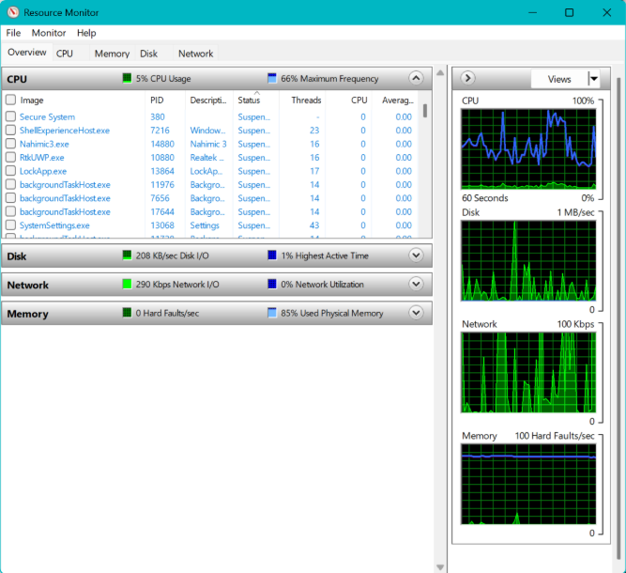

System Security

Authentication & Identification: Verifies user/process identity via three factors: what you know (passwords/PINs), what you have (tokens/apps), or what you are (biometrics).
Authorization & Access Control: Manages privileges by differentiating between Standard Users and Administrators.
Auditing, Logging, & Intrusion Detection: Logs failed logins, privilege changes, and network activity. Integrated Intrusion Detection Systems (IDS) flag suspicious patterns (e.g., rapid failed logins) to automatically block offending accounts or IPs.

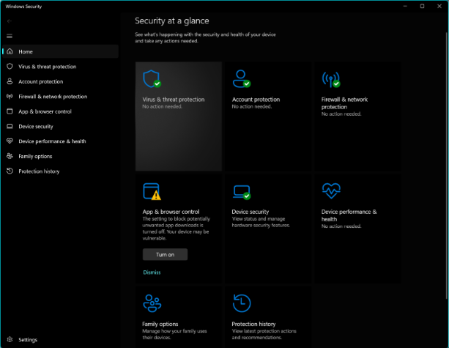

Task 2

File & directory management

Command ‘dir’ listing the directories
The dir command was executed in the Windows Command Prompt to list all files and subdirectories within the current directory path.

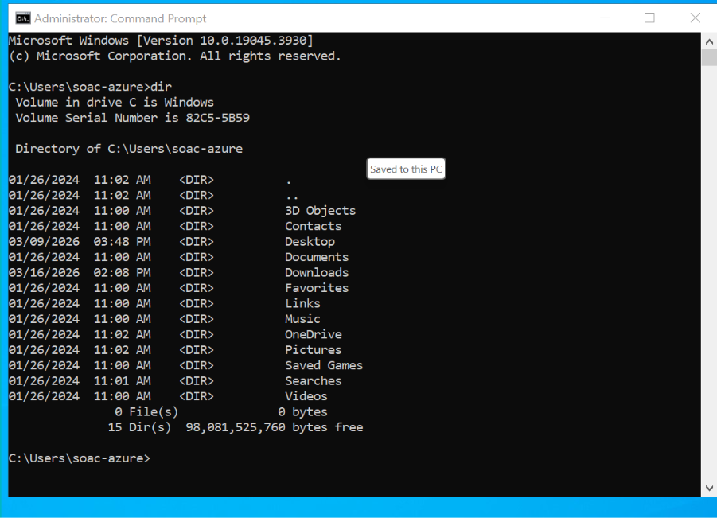

Command: Echo -
The echo command was run without any additional arguments to check the current state of command echoing in the console.
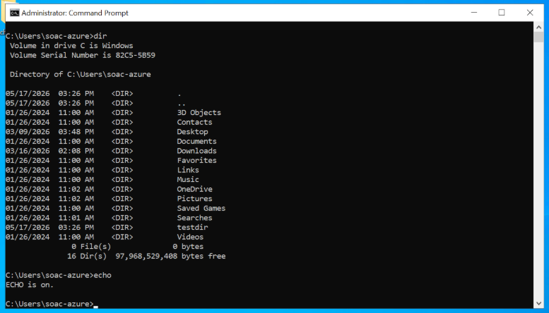

Command CLS:
The cls (Clear Screen) command was entered into the command line.
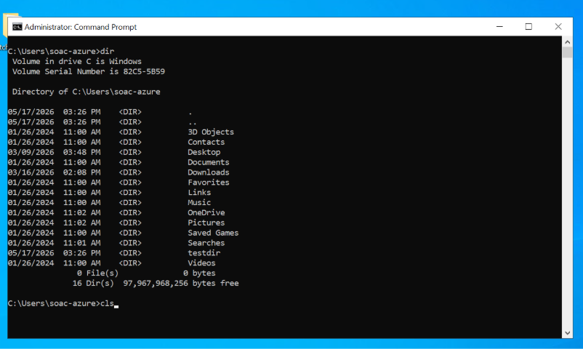

Command: Color xx:
The color command was used to modify the background and text colours of the Command Prompt interface. After an initial syntax error when trying to use an invalid utility name, I successfully amended the background and text colour.
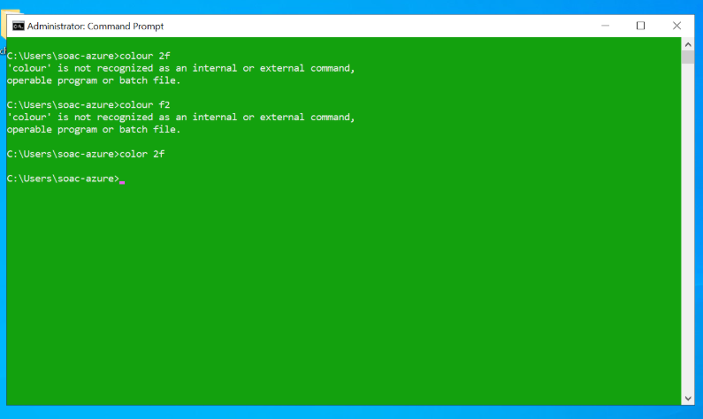
I continued to amend the colour to view the variations:
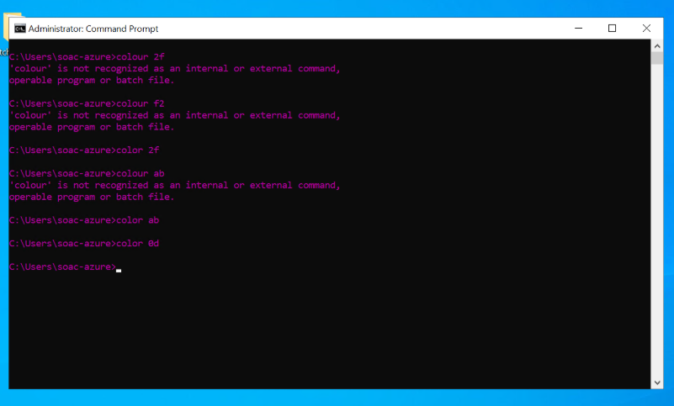

Command: Help:
The help command was executed to pull up the system's built in reference manual for command line utilities. The command outputs an alphabetical list of standard Windows commands alongside a brief explanation of what each command does.

“Displays a list of the available commands or detailed help information on a specified command. If used without parameters, help lists and briefly describes every system command.” (Microsoft, 2024). [5]

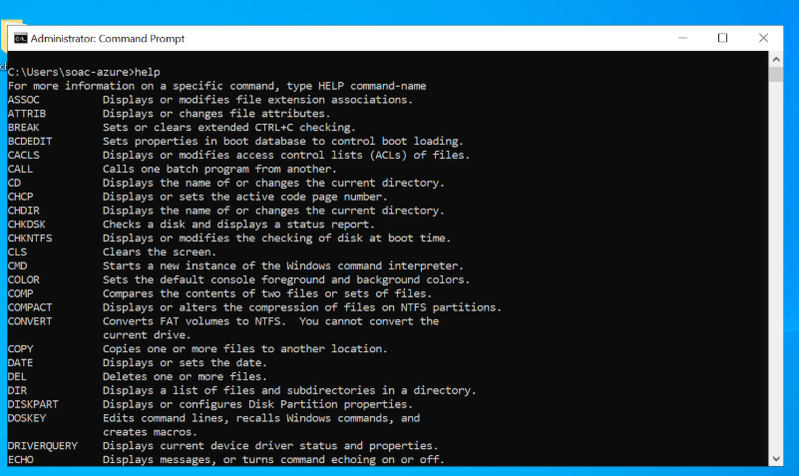

Command: Ipconfig:
The ipconfig utility was run to view the machine's current network interface settings. The output reveals the network parameters for the active Ethernet adapter, showing a Link-local IPv6 address, an IPv4 address of 192.168.100.75, a subnet mask of 255.255.254.0, and a default gateway of 192.168.100.1
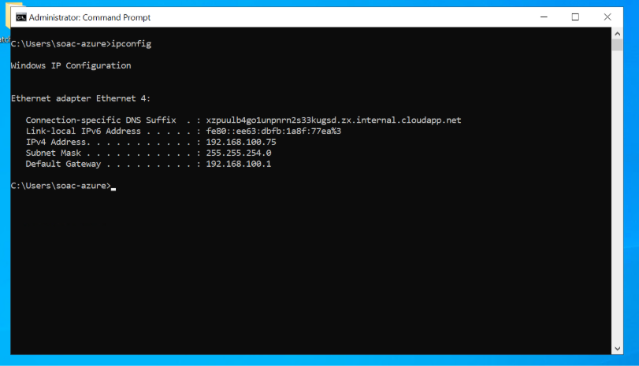

Command: Whoami:
The whoami command was executed to retrieve the username and domain context of the currently logged-in network session.
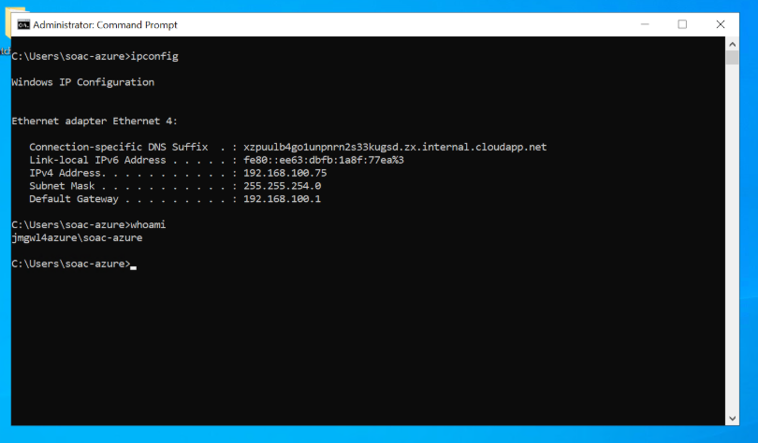

Command: PING:
The ping command was initiated without a target host, which prompts the system to display its syntax documentation, usage flags, and configuration options.

“Verifies IP-level connectivity to another TCP/IP computer by sending Internet Control Message Protocol (ICMP) echo Request messages. The receipt of the corresponding echo Reply messages is displayed, along with round-trip times. ping is the primary TCP/IP command used to troubleshoot connectivity, reachability, and name resolution. Used without parameters, this command displays Help content.” (Microsoft, 2024). [6]

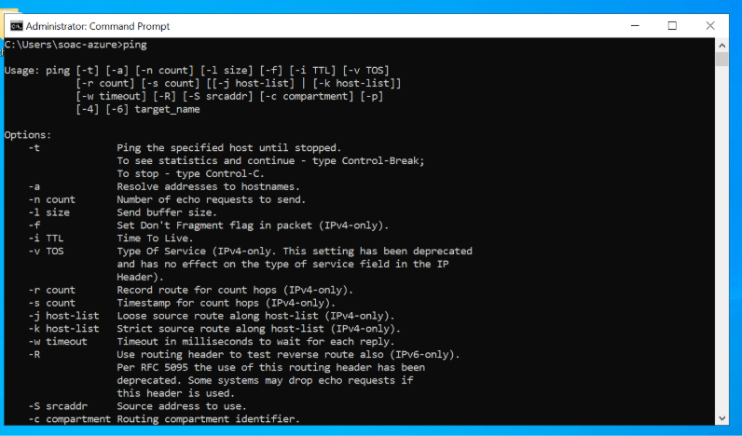

Command: Netstat:
The netstat (Network Statistics) command was run to display all active inbound and outbound network connections.

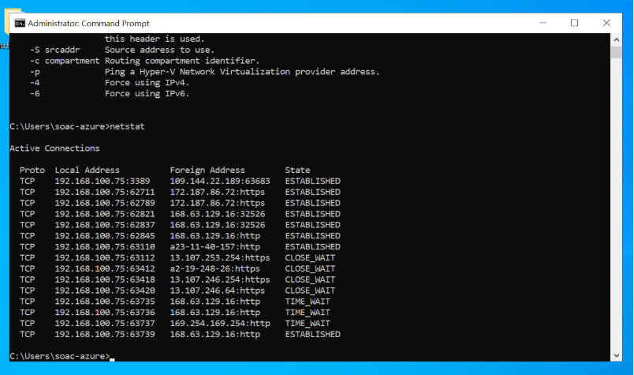

Command: net statistics workstation
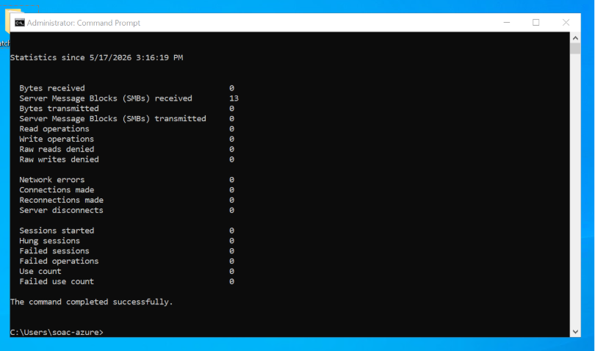

Command: Powercfg –energy & energy-report.html
The powercfg -energy utility was executed to run a 60 second background evaluation of the system's power management behaviours.
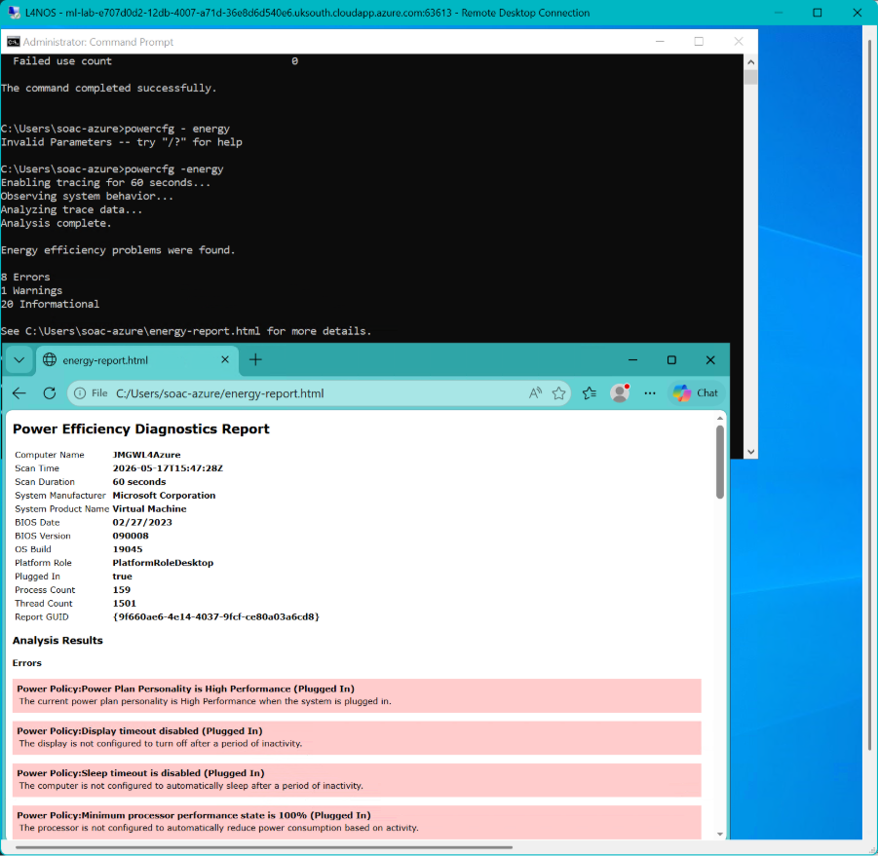

Commands:
net user username password /add
net user
net user username /delete
A demonstration of adding a user in managing profiles. Firstly, a new profile was successfully created using net user username password /add
Next, net user was run to list all active accounts.
Finally, the profile was deleted by using net user username /delete

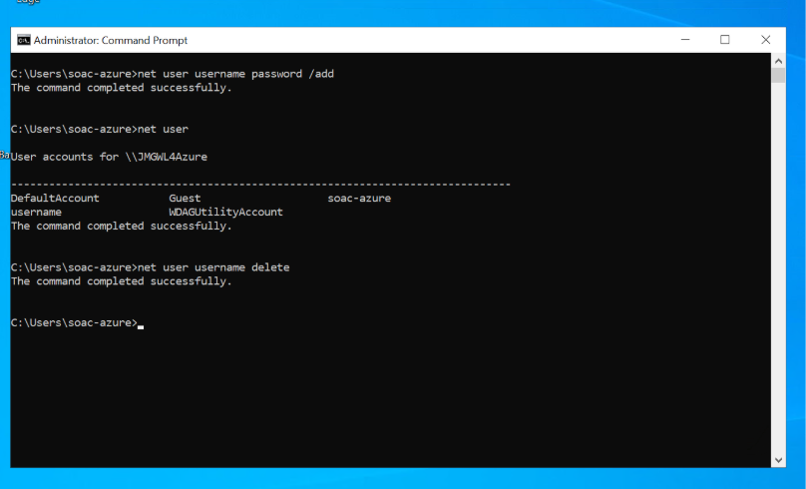

Task 3

Commands: pwd and ls
Print Work Directory: States where the current location is in the system hierarchy.
List: This shows me the folder I am currently in. Giving me insight into the directory contents.
“Linux sysadmins need to move around the file system, set up directories, locate files and collect information on files. The following commands will be needed:
- cd, pwd and ls – to navigate the file systems and view directory contents” (Stocker, 2025) [7]

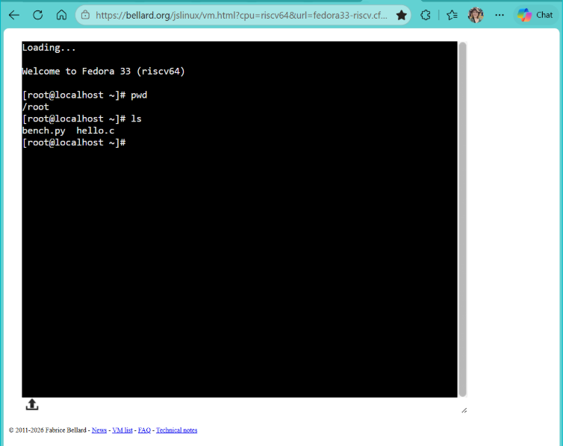

Command: Echo
Prints the text following the command. Below are 2 demonstrations of the echo command:
- Hello World!
- Hello World! Testing, testing, 1-2-3 . . .
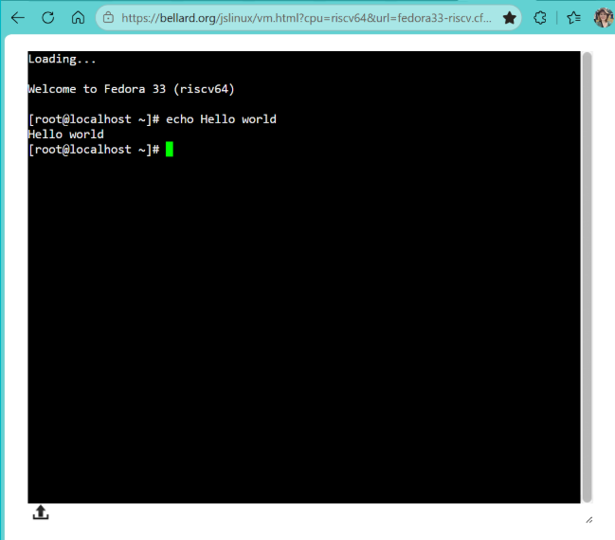

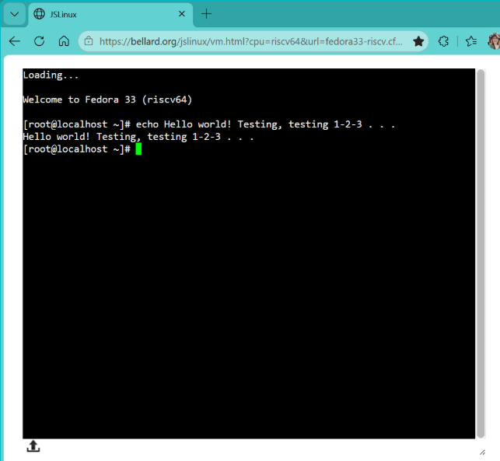
Command: Date
This displays the date. It will include the day of the week, day of the month, time and the world time zone.
“The exact result of many of these codes is locale specific and depends upon your language setting, particularly the LANG environment variable.” Siever, E. (2009). [8]

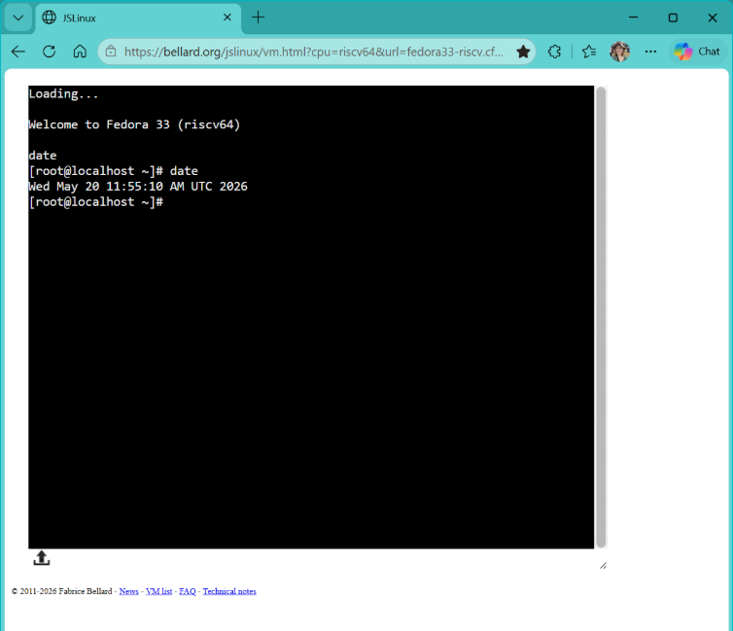

Command: whoami
This shows the account name that is running. A useful command if you wish to identify the user account you are in if you are using a shared device. It didn’t work in the version I sued so I used the same command in PowerShell as pictured below.
“ The 'whoami' command is a simple yet powerful utility designed to reveal the current username associated with the active user session. When executed, it provides a swift response by outputting the username associated with the user who issued the command.” (GeeksforGeeks, 2025). [9]

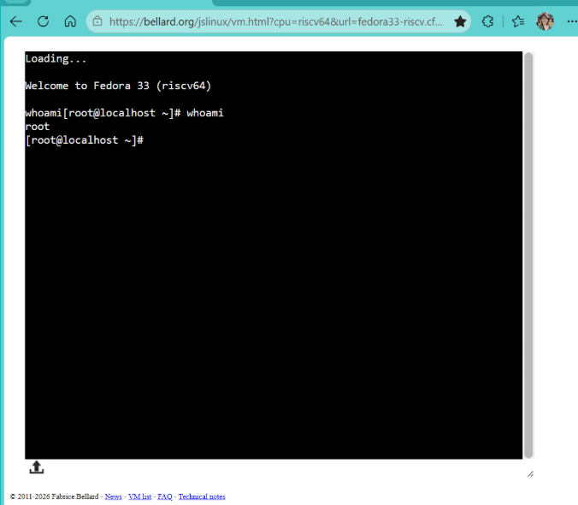

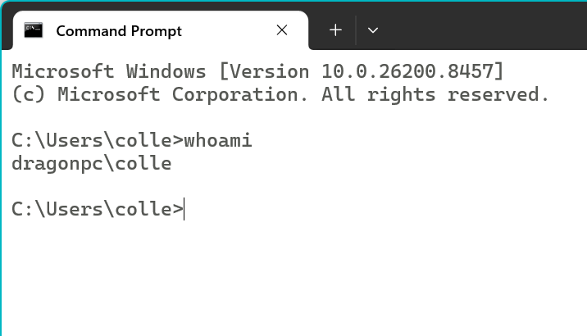

Command: history
I was able to review my previous commands I had used by using the command: history
This listed my previously used commands for this session. Additionally looking at if a command was successful or not.
The list gives a clean chronological log of your commands and their outcomes.
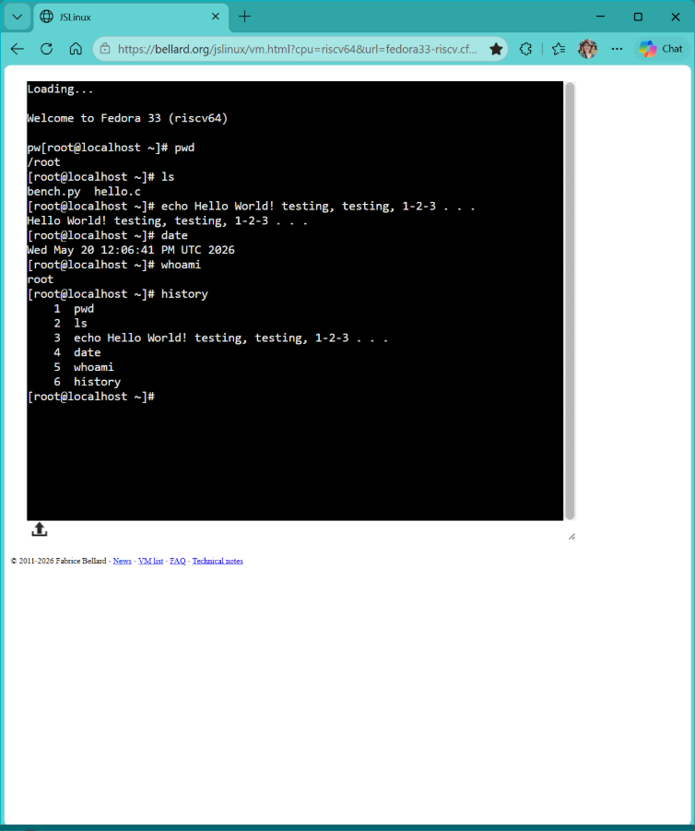

Command: Netstat & arp -a
Network Statistics reveals the data around active inbound and outbound network traffic on the system.
Arp –a (Address Resolution Protocol): Below using this command revealed the MAC address and gateway number.

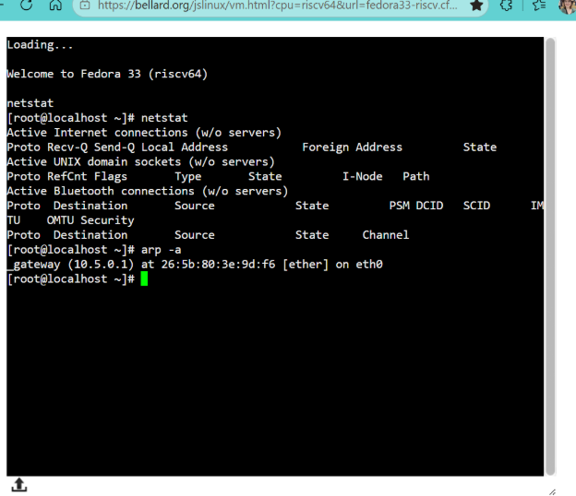

Command: top and htop:
Top: (Table of Process) - system monitor tool used present me with data on CPU usage, RAM usage and along with summarising the number of tasks in place. this dashboard displays the usage place at time of the command.
Htop: This dashboard is more colourful but showing similar core data as top. If a computer is running slowly, I would use this tool to gather information to diagnose the issue.
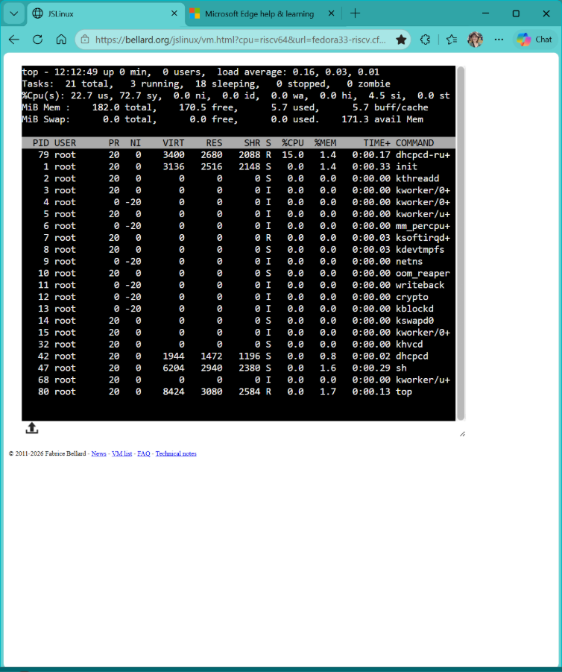

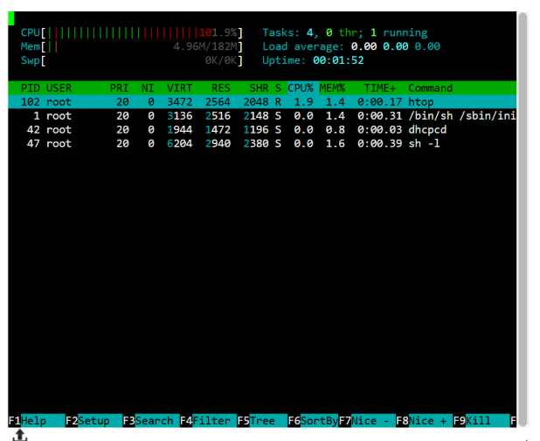
Conclusion

I have learned many practical elements of the basics of operating systems and it’s uses. Testing various system monitoring tools, commands using a variety of methods via Microsoft and Linux I have gained deeper understanding of the differences and benefits to each method.

I have limited prior learning on these subjects so all that i have learned so far has been very beneficial and enlightening.

I found that Microsoft offers a more structured environment with easy pathways to follow. Being easy to access and use I learned a lot about the variety of the commands available and their uses.

For Linux, learned that there is an extensive array of commands to be used even within one command. For example, the date format, whilst dependant on the setting of your system, can be displayed according to your preference using the relevant commands.
I feel the modular way in which Linux is built gives more room for learning and engaging learning to which I will be exploring more int he near future.

I have gained a deeper understanding of the information I can obtain or use via the command prompts and how to manage

References

[1] pg: 86 section 2.1.1. Tanenbaum, A. S., & Bos, H. (2014). Modern operating systems (Global edition, Fourth edition.). Pearson.
[2] pg 88 section 2.1.2 Tanenbaum, A. S., & Bos, H. (2014). Modern operating systems (Global edition, Fourth edition.). Pearson.
[3] pg 34 section 1.7 I/O Communication Stallings, W. (2005). Operating systems : internals and design principles (5th ed, [international ed.]). Pearson Prentice Hall.
[4] pg: 265 section 4.1.1. Tanenbaum, A. S., & Bos, H. (2014). Modern operating systems (Global edition, Fourth edition.). Pearson.
[5] Microsoft. (2024). Ping Command. Https://Learn.Microsoft.Com.
[6] Microsoft. (2024). MS Command: Help. Https://Learn.Microsoft.Com.
[7] Sandra Henry Stocker. (2025). Essential commands for Linux server management. Www.Networkworld.Com.
[8] Siever, E. (2009). Linux in a nutshell (6th ed.). O’Reilly.
[9] GEEKSFORGEEKS, 2025. How to Display the current Username in Linux | whoami Command. GeeksforGeeks. Available from: https://www.geeksforgeeks.org/linux-unix/whoami-command-linux-example/ [Accessed 20 May 2026].
[10]

Online Learning

Learning PowerShell











