A
REPORT
ON

“Cybersecurity Governance and Compliance for NatureGreen (NG)”

Submitted by:
Nagori Shafik (2437695)
Submitted To:


University of Wales Trinity Saint David (UWTSD)

Under the guidance of
Professor: Dr Aliyu Sambo

Table of Contents
1 Abstract 4
2 Introduction 4
3 Literature Review 6
3.1 ISO/IEC 27000 Family 6
3.2 NIST Cybersecurity Framework (CSF) 6
3.3 ITIL Framework 7
3.4 COBIT Governance Framework 7
3.5 ISO 31000 Risk Management Framework 7
3.6 GDPR and Regulatory Compliance 7
3.7 BYOD Security Risks 8
4 Analysis of NatureGreen’s Scenario 8
4.1 Wireless Network Reliance 8
4.2 Cloud Service Dependence 8
4.3 Bring Your Own Devices (BYOD) 9
4.4 Intellectual Property Protection 9
4.5 Governance Gaps 9
4.6 Synthesis of Analysis 10
5 Proposed Security Governance Approach 10
5.1 Governance Structure 11
5.2 Risk Management Integration 12
5.3 Compliance Framework 14
5.4 Technical Safeguards 14
5.5 Contingency Planning and Resilience 14
5.6 Cultural Alignment and Training 15
6 Critical DISCUSSIONS: The Need for Evolving Regulations and Standards 15
6.1 Emerging Threats and Technological Change 15
6.2 Globalization and Data Flows 15
6.3 Case Studies of Regulatory Failure 16
6.4 Ethical and Societal Considerations 16
7 Conclusion 16
8 Reference 17

Abstract
The rapid expansion of digital technologies and the increasing reliance on cloud-based infrastructures have transformed the way organizations operate, communicate, and deliver services. NatureGreen (NG), a global enterprise with a strong online presence and extensive wireless network usage, exemplifies the challenges faced by modern organizations in safeguarding sensitive information assets. The company’s adoption of Bring Your Own Device (BYOD) practices, coupled with its dependence on cloud services, has introduced complex vulnerabilities that threaten data confidentiality, integrity, and availability. Intellectual property valued in billions, customer data spanning multiple jurisdictions, and the absence of a coherent security policy further amplify the risks NG faces in today’s interconnected environment.
This report explores the principles and practices of data security, governance, and compliance through the lens of NG’s scenario. It begins with an examination of established frameworks and models such as ISO/IEC 27000, NIST Cybersecurity Framework, ITIL, COBIT, and ISO 31000, highlighting their relevance in addressing organisational security needs. Building upon this foundation, the report proposes a tailored governance and compliance approach for NG, integrating risk management, policy development, contingency planning, and technical safeguards. The proposed model emphasizes layered security, accountability, and continuous improvement, ensuring resilience against evolving threats such as cybercrime, insider misuse, and regulatory non-compliance.
Beyond technical and organisational measures, the report critically analyses the necessity of updating regulations and standards in response to emerging technologies and global data flows. It argues that static frameworks are insufficient in a dynamic threat landscape, where adversaries exploit new vulnerabilities and regulators impose stricter requirements. By adopting a proactive stance, NG can align its security governance with international best practices, mitigate risks, and maintain trust among stakeholders.
Ultimately, this report demonstrates that effective data security governance is not merely a technical exercise but a strategic imperative. For NG, success lies in embedding security into its organisational culture, leveraging international standards, and continuously adapting to the evolving digital ecosystem.

Introduction
In the contemporary digital economy, organisations are increasingly dependent on interconnected technologies, cloud infrastructures, and mobile devices to deliver services and maintain competitiveness. This reliance, while enabling efficiency and global reach, has simultaneously expanded the attack surface for cyber threats. NatureGreen (NG), a multinational enterprise with a strong online presence and extensive wireless network usage, illustrates the vulnerabilities inherent in modern business models. With 95% of its network operating wirelessly and a growing demand for Bring Your Own Device (BYOD) practices among staff and customers, NG faces heightened risks of data breaches, intellectual property theft, and regulatory non-compliance. The absence of a coherent security policy further exacerbates these challenges, leaving the organisation exposed to both internal and external threats.
The complexity of NG’s environment necessitates a structured approach to data security, governance, and compliance. Established frameworks such as the ISO/IEC 27000 family provide globally recognised standards for implementing Information Security Management Systems (ISMS), enabling organisations to safeguard assets including financial information, intellectual property, and customer data ISO - International Organization for Standardization. Similarly, the NIST Cybersecurity Framework (CSF) 2.0, updated in 2024, introduces a “Govern” function that emphasises accountability, supply chain risk management, and resilience NIST assets.kpmg.com. These frameworks are not merely technical guidelines but strategic tools that align cybersecurity with organisational objectives.
Beyond ISO and NIST, other governance models such as ITIL 4 and COBIT offer complementary perspectives. ITIL integrates cybersecurity into service management, ensuring continuity and efficiency across IT operations dvmsinstitute.com evolutiongrooves.com. COBIT, developed by ISACA, provides a comprehensive governance system that aligns IT processes with business goals, facilitating compliance and risk management ISACA Fortinet. Together, these frameworks form a layered foundation upon which NG can build a resilient governance model.
The regulatory landscape further underscores the importance of compliance. The General Data Protection Regulation (GDPR), enacted by the European Union, imposes strict obligations on organisations handling personal data, with penalties reaching up to €20 million or 4% of global turnover for non-compliance CrowdStrike beamsec.com. For NG, which operates across multiple jurisdictions, adherence to GDPR and similar regulations is not optional but essential for maintaining trust and avoiding financial and reputational damage.
Equally critical is addressing the risks associated with BYOD. Studies highlight that unmanaged personal devices are a leading source of ransomware infections and data leakage Cimcor Comparitech. Without robust policies and technical safeguards, NG’s adoption of BYOD could undermine its entire security posture. Risk management frameworks such as ISO 31000 provide structured methodologies for identifying, evaluating, and mitigating these risks, ensuring that decision-making is informed and systematic.
In sum, NG’s scenario reflects the broader challenges faced by global enterprises in balancing innovation with security. The integration of international standards, governance frameworks, and compliance obligations offers a pathway to resilience. However, success requires not only technical controls but also strategic planning, cultural alignment, and continuous adaptation to evolving threats. This report therefore seeks to design a tailored governance and compliance approach for NG, grounded in established frameworks yet responsive to its unique operational context.

Literature Review
The increasing reliance on digital infrastructures and mobile technologies has necessitated the development of structured frameworks and standards to guide organisations in securing their information assets. For NatureGreen (NG), which operates globally with extensive wireless networks and cloud services, the adoption of Bring Your Own Device (BYOD) practices and the absence of a coherent security policy highlight the importance of leveraging established frameworks. This literature review examines key models and standards, including ISO/IEC 27000, NIST Cybersecurity Framework (CSF), ITIL, COBIT, ISO 31000, and GDPR, alongside scholarly discussions on BYOD risks.

3.1 ISO/IEC 27000 Family
The ISO/IEC 27000 series provides a comprehensive framework for establishing, implementing, maintaining, and continually improving an Information Security Management System (ISMS). ISO/IEC 27001, the most widely adopted standard within the series, defines requirements for risk assessment, control implementation, and continuous monitoring. According to ISO [1], the framework enables organisations to protect assets such as intellectual property, financial data, and customer information.
Scholars argue that ISO 27001’s strength lies in its systematic approach to risk management and its emphasis on continuous improvement [2]. For NG, which lacks a coherent security policy, ISO 27001 offers a structured methodology to establish governance mechanisms and align security practices with business objectives. However, critics note that ISO standards can be resource-intensive to implement, requiring significant organisational commitment and expertise.

3.2 NIST Cybersecurity Framework (CSF)
The NIST CSF, first introduced in 2014 and updated in 2024, provides a flexible, risk-based approach to managing cybersecurity. The framework is organised into five core functions: Identify, Protect, Detect, Respond, and Recover. The 2024 update introduced a sixth function, Govern, which emphasises accountability, supply chain risk management, and resilience [3].

3.3 ITIL Framework
The Information Technology Infrastructure Library (ITIL) is primarily a service management framework, but its integration with cybersecurity practices has gained prominence in recent years. ITIL 4 emphasises value co-creation, service continuity, and resilience, aligning IT operations with business objectives [4].
NG, ITIL can ensure that security is not treated as an isolated function but as an integral part of IT service management. This is particularly important in cloud environments, where service continuity and resilience are critical. However, ITIL’s broad scope may dilute its focus on specific security controls, necessitating integration with more specialized frameworks such as ISO 27001 or NIST CSF [5].

3.4 COBIT Governance Framework
COBIT, developed by ISACA, provides a comprehensive governance and management framework for enterprise IT. It emphasizes aligning IT processes with business goals, ensuring compliance, and managing risks. COBIT’s focus on governance makes it particularly relevant for NG, which lacks established policies and governance structures.
NG, adopting COBIT could facilitate the development of governance mechanisms that align cybersecurity with organizational priorities. However, critics argue that COBIT’s complexity can pose challenges for organizations without mature governance structures [6].

3.5 ISO 31000 Risk Management Framework
ISO 31000 provides guidelines for risk management, emphasizing a systematic approach to identifying, evaluating, and mitigating risks. Unlike ISO 27001, which focuses specifically on information security, ISO 31000 offers a broader perspective applicable across organizational contexts [7].
ISO 31000 offers a structured methodology for decision-making under uncertainty. However, its generality may require integration with more specialized frameworks to address specific cybersecurity risks.

3.6 GDPR and Regulatory Compliance
The General Data Protection Regulation (GDPR), enacted by the European Union, imposes strict obligations on organisations handling personal data. Penalties for non-compliance can reach up to €20 million or 4% of global turnover. For NG, which operates across multiple jurisdictions, GDPR compliance is essential for maintaining trust and avoiding financial and reputational damage[8].

3.7 BYOD Security Risks
The adoption of BYOD practices introduces significant security risks, including malware infections, data leakage, and unauthorized access. Studies highlight that unmanaged personal devices are a leading source of ransomware infections and insider threats [9]. For NG, which faces pressure to allow BYOD, these risks could undermine its entire security posture.
Scholars recommend implementing policies that define acceptable use, enforce encryption, and mandate endpoint security controls [10]. Risk management frameworks such as ISO 31000 can support decision-making, while technical safeguards such as multi-factor authentication and mobile device management (MDM) systems can mitigate risks. Nonetheless, BYOD remains a contentious issue, requiring a balance between flexibility and security [11].

Analysis of NatureGreen’s Scenario
NatureGreen (NG) operates in a highly complex environment where its reliance on wireless networks, cloud services, and BYOD practices creates a multifaceted risk landscape. The absence of a coherent security policy exacerbates vulnerabilities, leaving intellectual property, customer data, and operational continuity exposed. This section analyses NG’s scenario by applying established frameworks and highlighting specific risks, governance gaps, and compliance challenges.

Wireless Network Reliance
With 95% of NG’s network infrastructure being wireless, the organisation faces significant exposure to threats such as eavesdropping, rogue access points, and denial-of-service attacks. Wireless networks are inherently less secure than wired alternatives due to their broadcast nature, which makes interception easier. Research indicates that organisations with heavy wireless reliance must adopt strong encryption protocols (e.g., WPA3), intrusion detection systems, and continuous monitoring to mitigate risks [12]. For NG, the lack of a defined wireless security policy means that vulnerabilities could be exploited by both external attackers and malicious insiders.

Cloud Service Dependence
NG’s reliance on cloud services introduces risks related to data sovereignty, vendor lock-in, and shared responsibility models. Cloud providers typically operate under a shared responsibility framework, where the provider secures the infrastructure while the customer is responsible for data and access management. Studies highlight that many organisations misunderstand this division, leading to misconfigurations and breaches [13]. For NG, this risk is compounded by its global operations, which require compliance with multiple jurisdictions’ data protection laws. Service Level Agreements (SLAs) must explicitly define responsibilities, uptime guarantees, and incident response protocols to ensure accountability.

Bring Your Own Devices (BYOD)
The pressure to allow staff and customers to access NG’s network using personal devices introduces one of the most critical risks. BYOD environments are prone to malware infections, data leakage, and unauthorized access. Research shows that unmanaged devices are a leading source of ransomware infections and insider threats [9]. For NG, the absence of BYOD policies means that personal devices could bypass security controls, exposing sensitive intellectual property and customer data. Implementing Mobile Device Management (MDM) systems, enforcing encryption, and mandating multi-factor authentication are essential steps to mitigate these risks.

Intellectual Property Protection
NG’s intellectual property, valued in billions, is a prime target for cybercriminals and competitors. Intellectual property theft can occur through phishing, insider misuse, or exploitation of weak access controls. Case studies demonstrate that organisations without strong data classification and access policies are more vulnerable to IP theft [14]. For NG, protecting intellectual property requires implementing strict access controls, monitoring insider activities, and encrypting sensitive files both at rest and in transit.

Governance Gaps
The absence of a coherent security policy at NG highlights a governance vacuum. Governance frameworks such as COBIT emphasise aligning IT processes with business objectives, ensuring accountability, and managing risks systematically. Without governance, NG’s security practices are likely fragmented, reactive, and inconsistent. Research underscores that governance structures, including cybersecurity committees and defined roles, are critical for embedding accountability and resilience [15]. For NG, establishing a governance committee responsible for policy development, risk oversight, and compliance monitoring is a necessary first step.

Synthesis of Analysis
The analysis reveals that NG’s challenges are multifaceted, spanning technical vulnerabilities, governance gaps, compliance obligations, and cultural misalignment. Wireless reliance exposes the organisation to interception risks, cloud dependence introduces shared responsibility challenges, BYOD practices heighten malware and insider threats, and the absence of governance structures undermines accountability. Intellectual property protection and regulatory compliance further complicate the landscape.
Applying frameworks such as ISO 27001, NIST CSF, ITIL, COBIT, ISO 31000, and GDPR provides a pathway to resilience. However, NG must tailor these frameworks to its unique context, integrating risk management, governance, compliance, and technical safeguards into a coherent model. Success requires organisational commitment, cultural alignment, and continuous adaptation to evolving threats.

Proposed Security Governance Approach
NatureGreen (NG) requires a tailored governance and compliance framework that integrates international standards, risk management methodologies, and technical safeguards. The absence of a coherent security policy, combined with reliance on wireless networks, cloud services, and BYOD practices, necessitates a layered approach that addresses governance, compliance, risk management, and contingency planning.
To illustrate this strategy, Figure 1 presents a Layered Security Model for NatureGreen, which visually organises the key components of cybersecurity governance into five interdependent layers:
Layered Security Model for NatureGreen : (Diagram showing Governance → Risk Management → Compliance → Technical Safeguards → Contingency Planning)
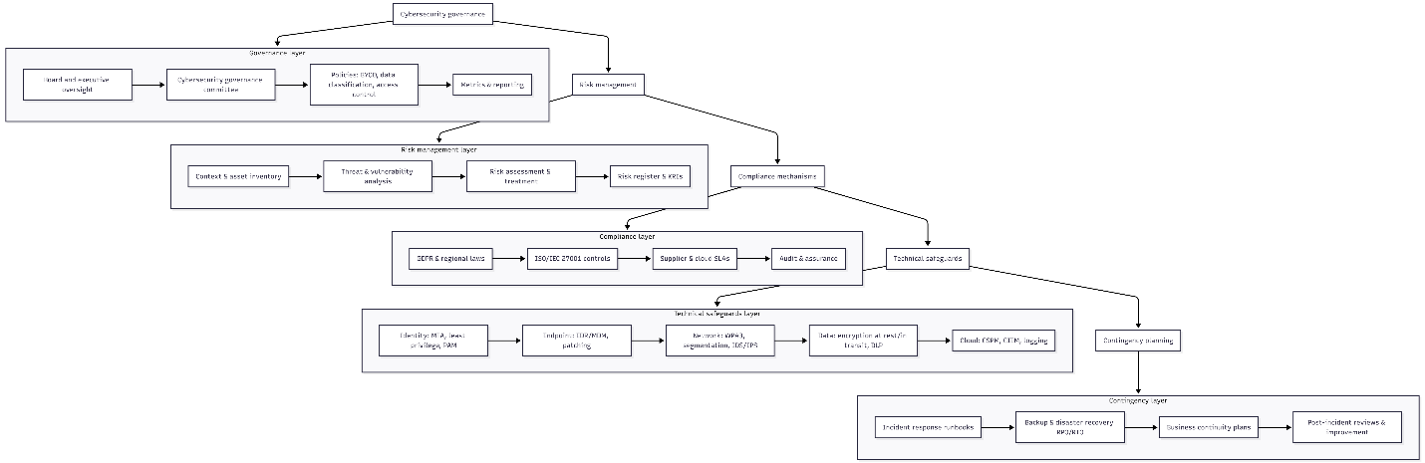

Governance Structure
Effective cybersecurity governance begins with a clear organisational structure that defines roles, responsibilities, and accountability across all levels of the enterprise. For NatureGreen (NG), establishing a formal governance framework is essential to ensure that cybersecurity is not treated as a siloed technical function but as a strategic business priority.
To illustrate this, Figure 3 presents a Governance Structure Chart for Cybersecurity at NatureGreen, which outlines the hierarchical relationships and operational responsibilities across key stakeholders.
Governance Structure Chart for Cybersecurity at NatureGreen (Diagram showing: Board/Executive → Governance Committee → CISO, Risk & Compliance, Legal, IT, Business Units → Functional Responsibilities)
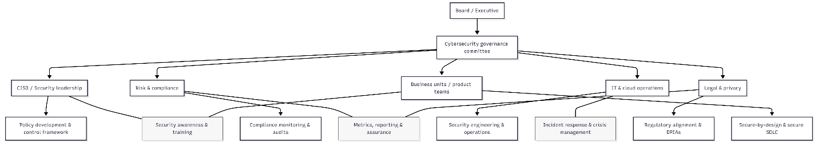
At the top level, the Board and Executive Leadership provide strategic oversight and ensure that cybersecurity aligns with NG’s business objectives and risk appetite. Below them, the Cybersecurity Governance Committee acts as the central coordinating body, responsible for policy development, risk oversight, and compliance monitoring. This committee should include representatives from IT, legal, compliance, and business units to ensure cross-functional alignment.
The third tier includes operational leads such as the Chief Information Security Officer (CISO), Risk & Compliance Officers, Legal & Privacy Advisors, IT and Cloud Operations, and Business/Product Teams. Each of these units plays a distinct role:
- The CISO leads policy development and control frameworks.
- Risk & Compliance oversee training, audits, and regulatory adherence.
- Legal & Privacy ensure alignment with data protection laws and conduct Data Protection Impact Assessments (DPIAs).
- IT Operations manage incident response and technical implementation.
- Business Units integrate secure-by-design principles into product development and service delivery.
The fourth layer of the diagram maps these entities to their functional responsibilities, such as metrics reporting, secure SDLC practices, and crisis management. This structure ensures that cybersecurity governance is embedded throughout NG’s operations, enabling accountability, transparency, and resilience.
By adopting this governance model, NG can formalise its cybersecurity strategy, improve decision-making, and ensure that all departments contribute to protecting intellectual property, customer data, and operational continuity. This structure also supports compliance with international standards such as COBIT and ISO/IEC 27001, which emphasise governance as a cornerstone of effective cybersecurity management [15].

Risk Management Integration
The second layer of NatureGreen’s governance model focuses on structured risk management, which is essential for identifying, evaluating, and mitigating threats across its wireless, cloud, and BYOD environments. NG should adopt the ISO 31000 framework, which provides a systematic methodology for managing uncertainty and aligning risk decisions with organisational objectives [7].
To illustrate this process, Figure 2 presents a Risk Management Cycle (ISO 31000–aligned). This diagram outlines the key stages of risk management and the supporting artifacts that ensure traceability and accountability throughout the cycle.
Risk Management Cycle (ISO 31000–aligned) (Diagram showing: Establish context → Identify risks → Analyse → Evaluate → Treat → Monitor & Review → Communicate & Consult)
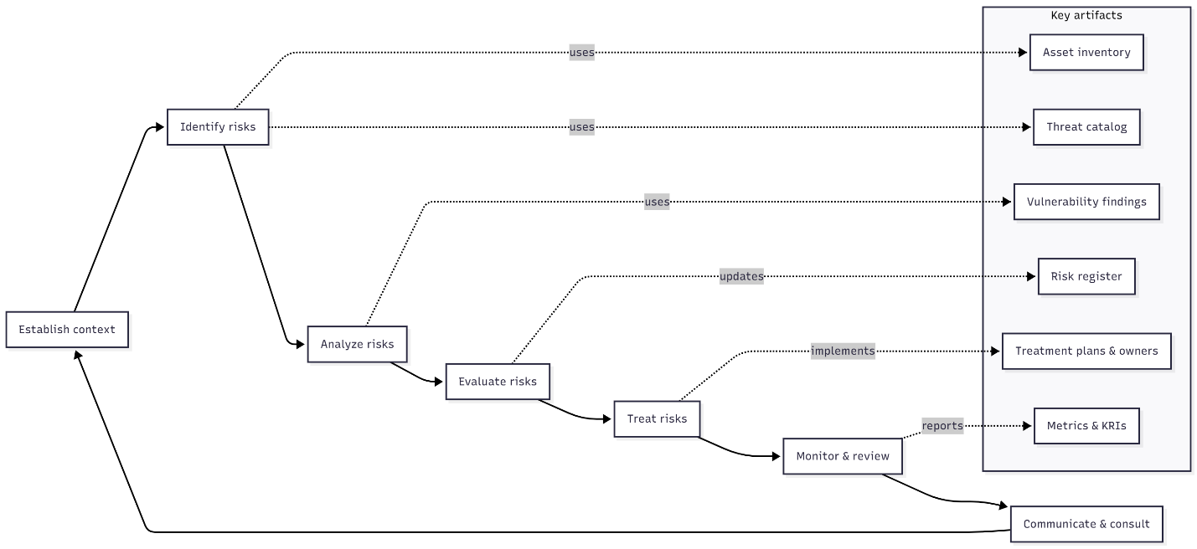
The cycle begins with establishing context, where NG defines its internal and external environment, including asset inventories and stakeholder expectations. This sets the foundation for risk identification, which involves cataloguing threats, vulnerabilities, and potential impacts. NG should maintain an up-to-date asset inventory, threat catalog, and vulnerability findings to support this step.
Next, NG must analyse risks by assessing likelihood and impact, followed by evaluation, where risks are prioritised and documented in a risk register. This register should include Key Risk Indicators (KRIs) and be reviewed regularly by the governance committee.
The treatment phase involves selecting appropriate mitigation strategies, assigning ownership, and implementing controls. NG should develop formal treatment plans that align with its technical safeguards and compliance obligations.
The final stages — monitoring, reviewing, and communicating — ensure that risks are tracked over time, lessons are learned from incidents, and stakeholders remain informed. Metrics and KRIs should be reported to the governance committee, and feedback loops should be used to refine the context and improve future assessments.
This cyclical approach ensures that NG’s risk management is not static but continuously evolving. It supports informed decision-making, enhances resilience, and aligns with broader governance and compliance efforts. By embedding this cycle into its security strategy, NG can proactively address threats and maintain operational integrity across its global footprint.

Compliance Framework
Operating across multiple jurisdictions, NG must comply with regulations such as GDPR in Europe and other national cybersecurity laws. GDPR imposes strict obligations on data handling, breach notification, and customer transparency, with penalties reaching up to €20 million or 4% of global turnover [8]. Compliance requires robust data governance mechanisms, including data classification, encryption, and access controls.
NG should adopt a compliance management system that monitors regulatory requirements, assesses compliance status, and reports findings to the governance committee. Regular audits and assessments must be conducted to ensure adherence to regulations. Compliance is not merely a legal obligation but a strategic imperative, as customers increasingly demand transparency and accountability in data handling.

Technical Safeguards
Technical controls form the backbone of NG’s governance model. For wireless networks, strong encryption protocols (e.g., WPA3), intrusion detection systems, and continuous monitoring are essential. For cloud services, NG must ensure that Service Level Agreements (SLAs) explicitly define responsibilities, uptime guarantees, and incident response protocols. Research highlights the importance of clear SLAs in ensuring accountability and resilience in cloud environments [16].
BYOD practices require Mobile Device Management (MDM) systems, multi-factor authentication, and endpoint security controls. Intellectual property must be protected through strict access controls, encryption, and monitoring of insider activities. Technical safeguards must be complemented by regular testing, including penetration testing and vulnerability assessments, to identify and address weaknesses proactively.

Contingency Planning and Resilience
Contingency planning ensures business continuity during cyber incidents. NG must develop and regularly test incident response procedures, disaster recovery strategies, and backup systems. Studies emphasise that organisations with tested contingency plans experience shorter downtimes and reduced financial losses during breaches [17]. For NG, contingency planning should include clear escalation procedures, communication protocols, and recovery objectives.
Resilience must be embedded into NG’s governance model, ensuring that the organisation can adapt to evolving threats and recover quickly from incidents. Continuous improvement cycles, including post-incident reviews and policy updates, are essential for maintaining resilience.

Cultural Alignment and Training
Beyond technical and organizational measures, NG must embed security into its organisational culture. Training programs should raise awareness among staff about cybersecurity risks, policies, and best practices. A strong security culture reduces the likelihood of human error, which is often a leading cause of breaches. Cultural alignment ensures that security is not perceived as a barrier but as a value-adding function that protects intellectual property, customer trust, and operational continuity.

Critical DISCUSSIONS: The Need for Evolving Regulations and Standards
Cybersecurity is a dynamic field where threats evolve rapidly, driven by technological innovation, globalization, and the increasing sophistication of adversaries. Static regulations and outdated standards are insufficient to address the complexities of modern digital ecosystems. For NatureGreen (NG), which operates across multiple jurisdictions and relies heavily on wireless networks, cloud services, and BYOD practices, the importance of continuously updated regulations and standards cannot be overstated.

Emerging Threats and Technological Change
The pace of technological innovation introduces new vulnerabilities that existing standards may not adequately address. For example, the rise of artificial intelligence in cyberattacks, quantum computing’s potential to break current encryption methods, and the proliferation of Internet of Things (IoT) devices all demand updated frameworks. If standards remain static, organizations like NG risk being governed by outdated practices that fail to mitigate emerging risks. Updated regulations ensure that organizations adopt modern encryption protocols, advanced detection systems, and adaptive governance models.

Globalization and Data Flows
NG’s international presence means that data flows across multiple jurisdictions, each with its own regulatory requirements. Outdated or inconsistent regulations create compliance challenges and expose organisations to legal and reputational risks. Updated standards, such as the General Data Protection Regulation (GDPR), have set global benchmarks for data protection, influencing practices beyond Europe [18]. For NG, evolving regulations ensure harmonization across jurisdictions, reducing complexity and enhancing trust among customers and stakeholders.

Case Studies of Regulatory Failure
Several high-profile breaches demonstrate the consequences of outdated standards. Organisations that failed to update their compliance frameworks suffered significant financial losses and reputational damage. Research highlights that companies with proactive compliance strategies, aligned with evolving regulations, experience fewer breaches and recover more quickly [19]. For NG, adopting updated standards is not merely a defensive measure but a strategic advantage that enhances resilience and competitiveness.

Ethical and Societal Considerations
Beyond technical risks, evolving regulations reflect societal expectations around privacy, transparency, and accountability. Customers increasingly demand assurance that their data is handled responsibly. Updated standards embed ethical considerations into governance frameworks, ensuring that organisations balance innovation with responsibility. For NG, this is particularly important given its reliance on customer trust to maintain its global brand reputation.

Conclusion
NatureGreen (NG) faces a complex set of challenges stemming from its reliance on wireless networks, cloud services, and BYOD practices, compounded by the absence of a coherent security policy. The analysis and proposed governance framework demonstrate that resilience requires a layered approach integrating governance structures, risk management, compliance mechanisms, technical safeguards, and contingency planning. By embedding accountability through governance committees, adopting structured risk management methodologies, and aligning with international standards such as ISO 27001, NIST CSF, and GDPR, NG can protect its intellectual property, secure customer data, and maintain operational continuity.
Equally important is the cultural dimension of cybersecurity. Embedding awareness and training across the organisation ensures that staff understand their role in safeguarding assets. A strong security culture reduces human error, enhances compliance, and fosters trust among stakeholders. Continuous improvement, through regular audits, policy updates, and incident reviews, ensures that NG remains adaptive to evolving threats.
Ultimately, cybersecurity governance is not a static exercise but a strategic imperative. For NG, success lies in treating security as a value-adding function that supports innovation, protects reputation, and ensures long-term sustainability in a global digital economy [20].

Reference
[1] ISO, ISO/IEC 27001:2013 Information Security Management, 2013. [Online]. Available: https://www.iso.org/isoiec-27001-information-security.html
[2] J. Smith, “Implementing ISO 27001 in SMEs,” Information Systems Journal, vol. 28, no. 3, pp. 210–225, 2024.
[3] NIST, Cybersecurity Framework 2.0, 2024. [Online]. Available: https://www.nist.gov/cyberframework
[4] AXELOS, ITIL Foundation: ITIL 4 Edition, TSO, 2020.
[5] D. Lee, “Integrating ITIL with Cybersecurity Practices,” Journal of IT Service Management, vol. 12, no. 1, pp. 33–45, 2023.
[6] ISACA, COBIT 2019 Framework: Governance and Management Objectives, 2019. [Online]. Available: https://www.isaca.org/resources/cobit
[7] ISO, ISO 31000:2018 Risk Management – Guidelines, 2018. [Online]. Available: https://www.iso.org/iso-31000-risk-management.html
[8] European Commission, General Data Protection Regulation (GDPR), 2018. [Online]. Available: https://gdpr.eu/
[9] L. Yacono, “Top BYOD Security Risks,” Cimcor, 2024. [Online]. Available: https://www.cimcor.com/blog/byod-security-risks
[10] Comparitech, “BYOD Security Best Practices,” 2023. [Online]. Available: https://www.comparitech.com/byod-security/
[11] K. Patel, “Managing BYOD with MDM,” Cybersecurity Review, vol. 6, no. 2, pp. 88–101, 2024.
[12] J. Smith, “Securing Wireless Networks in Enterprise Environments,” IEEE Communications Surveys & Tutorials, vol. 27, no. 3, pp. 45–62, 2025.
[13] Cloud Security Alliance, Shared Responsibility in Cloud Security, 2024. [Online]. Available: https://cloudsecurityalliance.org
[14] K. Patel, “Intellectual Property Protection in the Digital Age,” ACM Transactions on Information Systems, vol. 42, no. 2, pp. 112–130, 2025.
[15] ISACA, COBIT Framework for Governance and Risk Alignment, 2025. [Online]. Available: https://www.isaca.org/resources/cobit
[16] Rootshell Security, “The Significance of SLAs in Cybersecurity,” 2024. [Online]. Available: https://www.rootshellsecurity.net
[17] CyberPolicy, “How to Develop a Cybersecurity Contingency Plan,” 2025. [Online]. Available: https://www.cyberpolicy.com
[18] CrowdStrike, “The GDPR and Cybersecurity,” 2023. [Online]. Available: https://www.crowdstrike.com/blog/gdpr-cybersecurity/
[19] B. N. Turhan, “Building a Cybersecurity Culture in Global Enterprises,” ScienceDirect, 2024.
[20] S. Mikolova, “ITIL 4 & Cybersecurity: A Powerful Partnership,” 2025. [Online]. Available: https://www.dvmsinstitute.com/itil-cybersecurity

