

Assessment: Individual Report — Analysis of Strategic Management Practices at Marks and Spencer Group plc
Master of Business Administration (MBA)
Module: Strategic Management
Module Code: LCMB7003
Lecturer: Amara Desta

Name: FAKRUL ISLAM
Student ID: 2510584
Submission date: 1 May 2026
Word count: 5000
Contents
Executive summary 1
Introduction 2
Organisational context and performance 2
Key metrics for the rewritten company overview 3
External environment and industry pressures 5
Critical success factors for the rewritten analysis 9
Internal capabilities and strategic fit 9
VRIO assessment 10
Sustainability and CSR evaluation 13
Targets versus latest reported performance 13
Performance framework and implementation priorities 14
Balanced Scorecard for the rewritten report 15
Evidence-based recommendations 16
Strategic evaluation 18
SWOT summary 18
Ansoff application 19
Gibbs Application 20
Strategic Recommendations 21
Reflection 23
Conclusion 25
Reference List 26

Executive summary
The strongest way to improve the current M&S draft is to shift it from a mostly descriptive company profile into a clear strategic argument: M&S has moved beyond a simple turnaround story and is now in a more demanding “reshape for growth” phase. The core evidence is strong. The latest audited full year, 2024/25, shows statutory revenue of £13.8bn and adjusted operating profit of £984.5m, up from £626.6m in 2022/23. Food sales reached £9.0bn, Fashion, Home & Beauty reached £4.2bn, and M&S reported 34% of Fashion, Home & Beauty sales through online channels. Management’s medium-term targets are equally explicit: 420 bigger Food stores, 180 more productive Full Line stores, online Fashion, Home & Beauty sales rising from 34% to 50%, and more than £500m of structural cost reduction (M&S, 2025b).
However, the draft should not overstate strategic strength. The 2025 cyber incident showed that digital capability remains a strategic vulnerability, not just a support function: in the first half of 2025/26, M&S Group adjusted profit before tax fell to £184.1m, with direct incident costs of £101.6m and a temporary pause in online operations between late April and early June. At the same time, M&S’s ESG story is credible but uneven. Carbon and waste ambitions are substantial, yet major packaging targets remain short of plan, and food redistribution performance slipped from 85% to 80%. The revised report should therefore argue that M&S’s durable strengths lie in its trusted brand, Food momentum, supplier relationships, store renewal economics and improving capital discipline, while its biggest strategic priorities are digital resilience, sharper Fashion, Home & Beauty execution, tighter international discipline, and harder commercial integration of sustainability. (Reshaping M&S, 2025)

Introduction
This report critically evaluates the strategic position of Marks & Spencer plc in the context of contemporary UK retailing. It examines whether the company’s recent improvement reflects a sustainable competitive advantage or a strong but still fragile recovery. M&S is a long-established British retailer whose current model combines Food, Fashion, Home & Beauty, international partnerships and an increasingly important digital and omnichannel proposition. The analysis focuses on the latest audited full-year evidence available for 2024/25, while also drawing on 2025/26 interim and trading updates where they materially change the strategic picture.
The report applies PESTEL, Porter’s Five Forces, critical success factor analysis, internal resource and capability assessment, VRIO, SWOT, Ansoff and the Balanced Scorecard. These frameworks are used not as descriptive templates, but as tools to test strategic fit between M&S’s environment, its capabilities and its implementation choices. The central argument is that M&S has rebuilt momentum through better product, stronger capital discipline, store renewal and Food growth, but that digital resilience, Fashion, Home & Beauty online profitability, international execution and sustainability delivery remain decisive tests of long-term advantage (M&S, 2025b).

Organisational context and performance
M&S began in 1884 as Michael Marks’s market stall in Leeds and has since developed into a multi-segment retailer with a strong own-brand emphasis. Its stated purpose is “to bring the magic of M&S” through exceptional quality, value, service and innovation, and its vision is to be the most trusted retailer. In 2024/25 business reported 32m customers, 63,000 colleagues, 1,053 UK-owned and franchise stores, and a presence in 32 international markets. It is reporting segments centre on UK & ROI Food, UK & ROI Fashion, Home & Beauty, International, and its relationship with Ocado Retail, over which M&S obtained control on 6 April 2025 (Marks & Spencer, 2024; Reshaping M&S, 2025).
Strategically, the company is no longer just “fixing the basics”. Its 2024/25 annual report presents a deliberate reshaping agenda: growing market share in both UK businesses by 2027/28, achieving operating margins above 4% in Food and 10% in Fashion, Home & Beauty, taking online Fashion, Home & Beauty sales from 34% to 50%, and delivering more than £500m of structural cost reductions. Store rotation is central to the model, with 420 bigger Food stores and 180 more productive Full Line stores targeted and returns on new and renewed stores reported as above hurdle rates. Later official updates show that the strategy is still moving forward despite disruption: more than 50 Food stores were approved for opening by H1 2025/26; M&S also relaunched its loyalty agenda around Sparks for 2026 and expanded international marketplace and wholesale relationships with Amazon, Zalando and David Jones (Price, 2026).

Key metrics for the rewritten company overview
FY | Statutory revenue | Operating profit | Online sales | Strategic reading
2022/23 | £11.9bn | £626.6m | 31.7% | Recovery phase, but margin pressure remained
2023/24 | £13.0bn | £838.6m | 32.4% | Strong improvement, especially in Food
2024/25 | £13.8bn | £984.5m | 33.7% | Highest profit in this three-year set; online mix still below medium-term ambition
Revenue and adjusted operating profit are taken from official M&S reports (M&S, 2023).
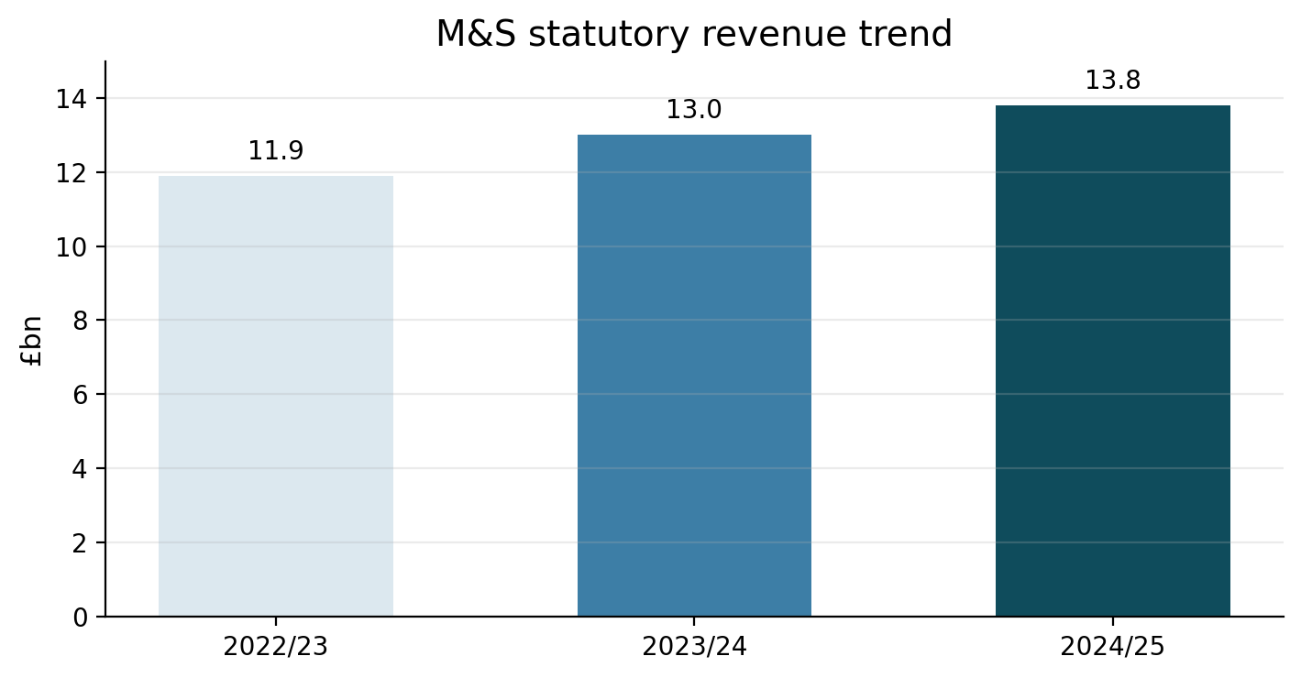
Figure 1. M&S statutory revenue trend, 2022/23-2024/25
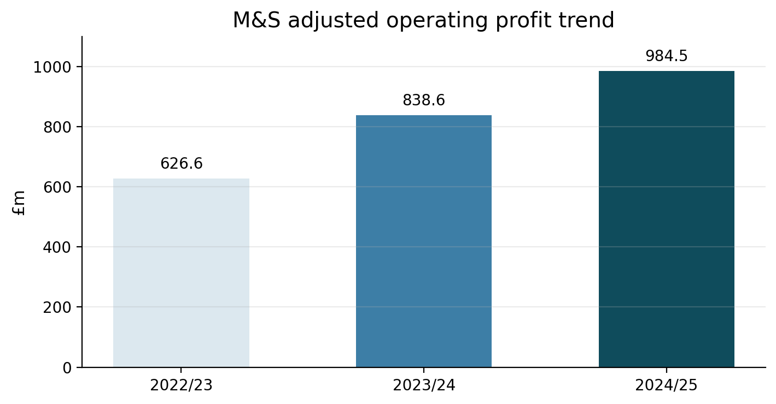
Figure 2. M&S adjusted operating profit trend, 2022/23-2024/25
These numbers support a better analytical narrative than a generic company-history paragraph. The key point is not that M&S is “large”; it is that the business has restored profitable growth, reweighted its mix towards a stronger Food platform, lifted online penetration gradually, and set explicit return-based targets. Yet the latest interim and trading updates also show why the strategy still needs critical evaluation: Food share reached a historic high of 4.0% in November 2025, but the cyber incident disrupted online trade, depressed Fashion, Home & Beauty profit in H1 2025/26, and forced management to accelerate the technology reset.

External environment and industry pressures
The external section of the draft should do more than define PESTEL and Five Forces. It should show why M&S’s strategy is being shaped by three interacting pressures: cost inflation and labour regulation, a consumer who still wants value but will not sacrifice quality, and a retail model that now depends on digital resilience as much as on stores. That makes the current environment simultaneously favourable for M&S’s Food value-quality proposition and dangerous for its Fashion, Home & Beauty online model.
PESTEL factor | Current evidence | Strategic implication for M&S
Political | M&S explicitly cites lessons from the invasion in Ukraine and the Red Sea disruption in adapting its supply chain, and it operates across 32 international markets. | Political and trade shocks matter because M&S’s own-brand model depends on stable sourcing and reliable international partner flows; resilience and supplier diversification are strategic, not operational.
Economic | UK CPI was 3.0% in February 2026; retail sales volumes fell 0.4% month on month in February 2026 even as online spending values rose 11.4% year on year; BRC reported food sales up 6.8% in March 2026; the BRC also said employment costs rose by more than £5bn last year (Ons.gov.uk, 2026). | M&S must hold a difficult line: invest in value to keep volume growth, but protect margin through mix, cost-out, forecasting and store productivity.
Social | M&S reports that 78% of UK consumers consider sustainability important, 84% say reducing food waste matters, and health-and-wellbeing trends remain strong; Kantar reports that only 9% of British shoppers are willing to pay more for more sustainable products. | The winning proposition is not “sustainability premium”; it is sustainability made easy inside trusted value, quality and convenience.
Technological | The Office for National Statistics[19] reports that online sales accounted for 28.2% of all retail spend in February 2026; M&S wants online Fashion, Home & Beauty sales to rise from 34% to 50%, but the 2025 cyber incident paused online operations and imposed direct recovery costs (Ons.gov.uk, 2026). | Digital capability is now a primary source of strategic risk and opportunity. The draft should therefore treat tech resilience, app experience, data and personalisation as core strategy.
Environmental | M&S identifies climate-driven raw-material volatility, extreme weather and supply-chain disruption as principal risks. It targets a 55% reduction in Scope 1 and 2 emissions by 2029/30 and a 50% reduction in food waste by 2029/30. | Climate pressure affects cost, availability, sourcing and trust. Sustainability is therefore a margin, supply and reputation issue all at once.
Legal | The British Retail Consortium[22] states that the Employment Rights Act, passed in December 2025, raises concerns over guaranteed hours, shift-change compensation and reduced flexibility; 2026 business-rates revaluation also changes the cost base for retail property; M&S’s cyber updates confirm that some customer data was taken, though not usable payment data or passwords (Brc.org.uk, 2026). | Labour regulation, property taxation and data governance all raise the cost of complexity. M&S needs simpler processes, stronger cyber controls and a more productive estate.

Porter force | Evidence | Force strength | What this means for M&S
Rivalry among existing firms | In grocery, Aldi and Lidl reached a combined 16.8% Christmas market share, while Tesco held 28.7% and Sainsbury's 16.3%; M&S also faces strong non-food competition, and a Reuters report on Next highlights continuing online-store competition (M&S, 2023). | Very high | M&S cannot compete effectively on price alone. It must win through quality-value trust, convenience, innovation and tighter execution.
Threat of new entrants | Scale, trust, stores and supplier depth still matter, but platforms and marketplaces lower distribution barriers; M&S itself is using Amazon and Zalando in international markets. | Moderate | Brand and operational competence remain barriers, but digital channels make category entry easier and faster.
Buyer power | Buyers can compare price, quality and service instantly; Kantar shows shoppers still prioritise value, and only a small minority will pay more for sustainability. | High | Loyalty must be earned continuously. Sparks, online experience, value architecture and quality cues matter more than heritage alone.
Supplier power | M&S’s own-brand scale and longstanding strategic supplier partnerships reduce dependence, but climate shocks and geopolitics increase source risk and raise the strategic importance of reliable suppliers. | Moderate | Supplier power is manageable, but not trivial. The real issue is not bargaining power alone; it is resilience, speed and sustainability capability.
Threat of substitutes | In food, M&S notes that eating out in pubs and restaurants fell while food consumed at home increased; in fashion, consumers can switch spend across formats, brands and marketplaces with low switching cost. | Moderate | Food has a supportive at-home trend, but basket competition is intense. In Fashion, Home & Beauty, substitution keeps pressure on relevance and returns.
Overall industry attractiveness is therefore moderate to low. The best revision of the draft should say plainly that M&S is operating in structurally tough markets where advantage is hard won and easy to dilute.

Critical success factors for the rewritten analysis
Critical success factor | Why it matters now | M&S position
Trusted value plus product differentiation | Consumers remain price-sensitive, but M&S wins when it combines quality, innovation and value rather than promotions alone | Strength in Food; improving in Fashion, Home & Beauty
Store productivity and convenience | New and renewed stores are delivering superior returns and sales uplifts | Strong and improving
Digital reliability and personalisation | Online share is structural, but cyber disruption exposed fragility | Strategically important, operationally inconsistent
Forecasting and supply resilience | Margin and waste depend on availability, allocation and lead-time discipline | Improving, especially in Food
ESG credibility with measurable delivery | Sustainability affects trust, compliance and cost | Strong narrative, mixed operational performance
Capital discipline and structural cost-out | Growth needs to translate into returns, not just sales | Increasingly strong under the reshaping programme

Internal capabilities and strategic fit
The internal section should move beyond a simple list of resources and instead distinguish threshold assets from genuinely strategic capabilities. M&S’s tangible resource base is substantial: 1,053 stores, a broadened logistics footprint, a stronger balance sheet, and a now-consolidated relationship with Ocado Retail. Its intangible base is arguably more important: a heritage brand, high trust in product quality and value, long-term supplier relationships, and strong customer reach. Its organisational capabilities are the real strategic hinge: designing and sourcing own-brand products, building “shopping list” credibility in Food, renewing stores with higher productivity, and using digital channels to widen customer frequency and category participation. The problem is that some of these capabilities are mature and defensible, while others are still being built.
A good draft should therefore make a sharper distinction between where M&S already has an advantage and where it is still in capability transition. For example, the company’s supplier ecosystem looks stronger than its technology ecosystem. M&S describes suppliers as essential to quality, value, style and innovation, has signed five long-term supplier contracts in Food, and links product development directly to trusted relationships. By contrast, the annual report itself says that technology infrastructure has become costly and complex, prompting the five-year Evolution plan and a one-off £324m investment in core technology foundations. The cyber incident then made that weakness visible to customers and investors. That combination makes supplier capability a more credible source of enduring advantage than digital capability today, even though digital capability may become more important over time.

VRIO assessment
Resource or capability | Evidence | Valuable | Rare | Difficult to imitate | Organised to exploit | Strategic implication
Trusted brand and customer trust | M&S says 32m customers shopped with it in 2024/25 and reports leading perceptions of quality and value; later trading updates say it held the number one position for customer perceptions of style, quality and value. | Yes | Partly | Partly | Yes | Strong temporary advantage that can become more durable if trust is protected operationally
Store estate and locations | 1,053 UK-owned and franchise stores; 96% of the UK population lives within 25 minutes of an M&S store; renewed stores are delivering strong returns and c.16% sales uplifts. | Yes | Partly | Partly | Yes | Valuable advantage, especially when stores are renewed; legacy stores are less strategic
Supplier partnerships and own-brand sourcing | Longstanding trusted supplier partners; suppliers are described as essential; collaboration covers lead times, digital transformation, ethics, net zero and innovation. | Yes | Yes, relative to weaker own-brand rivals | Yes | Yes | One of M&S’s strongest sources of defendable advantage
Omnichannel capability and the Ocado ecosystem | Online Fashion, Home & Beauty mix reached 34%; M&S aims for 50%; control of Ocado Retail was obtained in April 2025; Ocado growth and M&S sales participation improved in H1 2025/26. | Yes | Partly | Partly | Partly | Potential advantage, but still underexploited and exposed to execution risk
Digital and data capability | Five-year Evolution plan; £324m approved to reshape technology foundations; online Fashion, Home & Beauty market share improved in FY2024/25, but the cyber incident disrupted online trade materially in H1 2025/26. | Yes | No | No | Partly | Necessary capability, but not yet a source of sustainable advantage
ESG and Plan A credibility | M&S says it leads the market in ESG trust with consumers; it also has meaningful carbon, waste and sourcing targets, but key plastic targets lag plan. | Yes | Partly | Partly | Partly | Reputational asset, but not fully protected from imitation or performance gaps
The stronger conclusion, then, is that M&S’s competitive position is credible but mixed. The business has several capabilities that create real advantage, especially in Food, sourcing, product authority and renewed stores. It has fewer capabilities that are clearly rare and hard to imitate in digital retail. That is why the internal analysis should not claim a fully secure sustainable competitive advantage yet; it should argue for a defendable position with clear capability gaps.

Sustainability and CSR evaluation
The CSR section should be rewritten as a strategy section, not a reputation section. M&S’s Plan A agenda is not peripheral: it is tied directly to trust, sourcing, packaging, food waste, emissions, healthier ranges and the commercial promise of doing the right thing for customers. The annual report explicitly links sustainability credentials to quality perceptions and says M&S leads the market in ESG trust with consumers. That matters because the company’s own customer research shows sustainability, animal welfare and food waste are now salient decision factors, even if most consumers still want these benefits delivered inside a value-for-money proposition.

Targets versus latest reported performance
Area | Company target | Latest reported performance | Assessment
Scope 1 and 2 emissions | 55% reduction by 2029/30 vs 2016/17 | 33% reduction achieved in 2024/25 | Progressing, but still a sizeable delivery gap
Food waste | 50% reduction by 2029/30 | 31% reduction in 2024/25; prior year was 42% reduction | Progress exists, but momentum weakened
Food own-brand primary plastic packaging widely recyclable in the UK | 100% by 2025/26 | 93% in 2024/25 | Close, but not yet achieved
Fashion, Home & Beauty own-brand primary plastic packaging widely recyclable in the UK | 100% by 2025/26 | 82% in 2024/25 | Material gap remains
Plastic clothing hangers reused in the supply chain | 45% by 2025/26 | 38.4% in 2024/25 | Behind plan
Operational waste to landfill | Maintain 0% | 0% in 2024/25 | Achieved
Food sales from healthier products | 70% by 2024/25 | 70% in 2024/25 | Achieved
Source: M&S ESG Report 2025.
The critique should therefore be balanced. M&S is not simply using CSR as a communications device: it has concrete science-based carbon pathways, measurable packaging targets, product-health targets, traceable cotton work, and established sourcing frameworks such as Better Cotton. It also raised £4.4m with YoungMinds since October 2023 and donated the equivalent of 30m meals in 2024/25. But the draft should also say clearly that performance is uneven. Food redistribution slipped from 85% to 80% because of process changes; recyclable-plastic targets are not yet on track; and the company still must reconcile profitable volume growth, online convenience and returns with lower packaging and waste. In other words, Plan A is strategically material, but not yet fully embedded into every commercial trade-off.

Performance framework and implementation priorities
A stronger Balanced Scorecard section should translate strategy into measurable cause-and-effect logic. The current strategy already supplies several company-stated targets; the table below adds a smaller set of student-recommended metrics to sharpen accountability.

Balanced Scorecard for the rewritten report
Perspective | Strategic objective | Baseline | Suggested KPI and target | Main initiatives
Financial | Convert growth into returns, not just sales | FY2024/25 adjusted operating profit £984.5m; target margins above 4% in Food and 10% in Fashion, Home & Beauty by 2027/28. | Adjusted operating profit; Food margin >4%; Fashion, Home & Beauty margin >10%; ROCE progression (Barney, Wright and Ketchen, 2001). | Structural cost-out, disciplined capital allocation, better mix, lower waste, higher store productivity
Customer | Deepen trust, frequency and cross-shop behaviour | Food market share reached 4.0% in Nov 2025; Fashion, Home & Beauty online mix 34%; No.1 perception on style, quality and value in the period. | Food share +1 percentage point by 2027/28; Fashion, Home & Beauty online share 50%; improved repeat purchase and loyalty engagement | Sparks relaunch, clearer value architecture, personalisation, improved app and website, stronger campaigns
Internal business processes | Improve availability, speed, resilience and estate economics | Twelve renewals produced c.16% sales uplifts; more than 50 Food stores approved; forecasting, ordering and allocation rollout completed in Food; cyber recovery still ongoing (Ansoff, 1957). | Renewal payback against hurdle rates; lower stock-outs; lower waste; zero major trading outages | Store rotation, planning-platform rollout, cyber hardening, automation, supplier collaboration
Learning and growth | Build the operating model and culture needed for the next phase | Five-year Evolution plan in place; one-off £324m investment approved; 63,000 colleagues; M&S states more simplification is still needed (Ansoff, 1957). | D&T milestone delivery; colleague digital capability; executive accountability for ESG and resilience metrics | D&T capability in-house, leadership development, process simplification, stronger governance
This scorecard makes a crucial analytical point: M&S’s financial targets depend on customer trust, technology resilience, store economics and supplier execution. That is better strategic reading than treating Finance, Customers, Processes and Learning as isolated categories.

Evidence-based recommendations
Recommendation | Why the evidence supports it | Expected impact | Main risk
Put digital resilience before digital expansion | The cyber incident paused online trading, hit H1 2025/26 profit, and exposed the weakness of technology foundations just as M&S targets a 50% online Fashion, Home & Beauty mix. | Protects revenue, lowers trading-risk exposure, supports personalisation and loyalty economics | High capex and execution complexity
Lock in Food share gains through store rotation, forecasting and basket-building value | Food is driving growth; market share reached 4.0%; new and renewed stores are outperforming; more than 50 Food stores are approved for opening. | Higher volume leverage, stronger frequency, better margin through lower waste and higher availability | Cannibalisation or overexpansion in weaker sites
Reset Fashion, Home & Beauty around faster planning, higher online conversion and lower returns | Fashion, Home & Beauty remains profitable in FY2024/25, but H1 2025/26 showed how fragile digital execution can be; online market share improved in FY2024/25, yet online profitability is still not market-leading. | Better full-price sell-through, improved online margin, stronger relevance against fast-moving rivals | Fashion misses, markdown risk, higher returns if range breadth grows too quickly
Keep International capital-light and partner-led | M&S’s international reset explicitly prioritises capital-light growth via franchise partners, marketplaces and wholesale, and H1 2025/26 already expanded Amazon, Zalando and David Jones relationships. | Higher ROCE, lower volatility, faster geographic reach | Weaker brand control and more partner dependence
Hard-wire Plan A into commercial KPIs | M&S’s sustainability reputation is valuable, but recyclable-plastic and hanger-reuse targets are behind plan and redistribution performance slipped. | Stronger trust, better regulatory readiness, lower waste-related cost | Short-term sourcing costs or slower execution
The following implementation roadmap aligns with the company’s public strategic direction on stores, online growth, cost reduction, international reset and digital transformation.
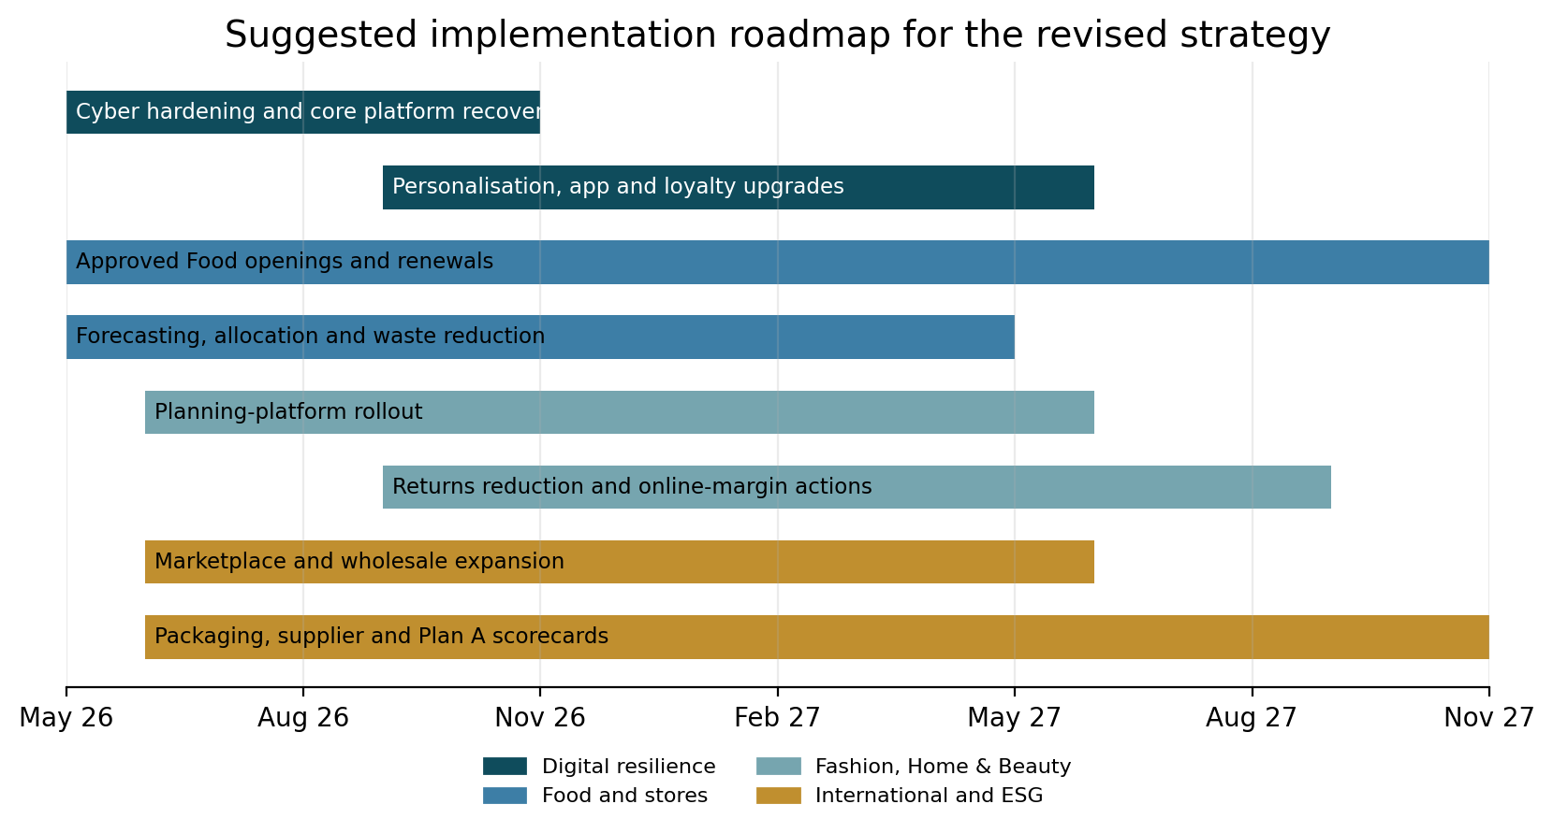
Figure 4. Suggested implementation of roadmap for the revised strategy

Strategic evaluation
A sharper evaluation section should conclude with explicit judgement rather than restating analysis.

SWOT summary
Strengths | Weaknesses
Trusted brand and product authority; Food momentum and rising market share; profitable store renewal; strong supplier relationships; improving capital discipline; meaningful own-brand differentiation | Digital fragility highlighted by the cyber incident; Fashion, Home & Beauty online profitability still less proven; mixed international performance; legacy estate complexity; uneven sustainability delivery

Opportunities | Threats
Grow online Fashion, Home & Beauty to 50%; build “shopping list retailer” status in Food; scale renewed stores; asset-light international growth; integrate Ocado more effectively; turn Plan A into a harder commercial advantage | Discounters and premium grocers intensifying rivalry; high buyer power; labour and property cost pressure; climate-driven supply shocks; cyber and data risk; partner dependence in international markets

Ansoff application
Growth route | Relevance to M&S | Strategic judgement
Market penetration | Strongest in UK Food and UK/ROI Fashion, Home & Beauty through value, loyalty, store renewal and better online experience | Highest priority
Product development | Strong potential in health-led Food, Beauty, partner brands and improved family-value ranges | Attractive if margin discipline is maintained
Market development | Best pursued selectively through franchise, marketplace and wholesale models rather than owned expansion | Attractive, but only if capital-light
Diversification | Low priority for the assignment; Ocado integration already adds complexity | Least suitable growth route now

Gibbs Application
Gibbs stage | What to write in first person | Strong M&S-specific angle
Description | I chose M&S because it is a familiar brand but one going through real strategic change | Explain that the assignment moved beyond reputation into evidence-led judgement
Feelings | I initially expected a straightforward improvement story, but I found tensions between growth, resilience and sustainability | Reflect on how the cyber incident complicated the analysis
Evaluation | What went well was using recent annual, ESG and interim sources; what was difficult was avoiding description | Mention the challenge of keeping theory linked to current data
Analysis | I learned that PESTEL showed macro pressure, Five Forces showed rivalry, and VRIO separated real strengths from threshold resources | Emphasise how digital capability looked weaker under VRIO than brand or supplier capability
Conclusion | My main lesson is that strategic success depends on fit between environment, capabilities and implementation, not on size alone | Link this to M&S’s need to translate reshaping into durable advantage
Action plan | Next time I would start earlier, use more primary sources first, and tighten evidence-to-argument links in each paragraph | Promise more concise writing and stronger judgement in the final submission

Strategic Recommendations
Recommendation 1: Intensify Digital Omni-Channel.
M&S should commit to building its digital and supply-chain automation. We know online sales and use of the app are increasing strongly (54% of online orders in 2024/25) but online share is lagging behind its competitors. M&S is already investing £600-650m in capital, including IT and supply chain, in 2025/26. We advise the company to prioritise roll-out of the new AI-powered merchandising system and robotics in its distribution centers.
Impact: This will increase product availability, reduce delivery times and enable M&S to offer nearly 24/7 cut-off times for orders, thus improving customer satisfaction and allowing M&S to aim for 50% online share in fashion. It may also lower operating costs, boosting margin. Steps to implementation: Accelerate warehouse automation (Castle Donington) and systems integration. Develop app features and customisation (data mining of Sparks customers). Collaborate with tech companies for augmented reality (virtual fitting) for online shopping.
Risk: upfront investment and complexity; changeover of systems; security issues (observed in past hacking). Incremental roll-out with pilot testing (as M&S is doing) reduces risk of failure.

Recommendation 2: Sharpen Product Differentiation and Value Perception.
M&S needs to strengthen their positioning in the market with an emphasis on both quality and value for money. In apparel, this involves new fashion brands and designer partnerships to refresh the brand (as tested in 2024/25) while offering value. In food, do more of the same. This will attract customers from "cool" competitors and support full price retailing, increasing gross margin. For example, boosting style & quality helped M&S boost fashion market share to 10.5%. Implementation steps: Hire more design & trend analysts, speed up "proof of concept" pop-up shops for new ranges and co-design with fashion brands to create buzz. Set pricing strategy so that less promotional discounts are required (with a target operating margin of 10% in Clothing & Home). Improve marketing value proposition (e.g. promoting quality materials, durability).
Risks: Increased development expense; fashion is fickle. Can also upset cost-conscious customers. Mitigation: Employ short cycle feedback (e.g. test-drops) to understand consumer reaction to products.
Recommendation 3: Be a Leader in Sustainability and Stakeholder Relations.
M&S can use its Plan A to become a leader in sustainability (beyond compliance) and link CSR to business. Leveraging current programs (e.g. community programs), M&S can 'value add' sustainability. Anticipated results: Improve brand value as consumers (particularly the younger ones) become more sustainable and lower regulatory risks. For instance, implementing full traceability through the supply chain and reducing operational carbon emissions can build loyalty and potentially premiumise their products. Steps to achieve: Establish near-term goals (e.g. 30% greenhouse gas reduction by 2030, 100% recyclable/biodegradable packaging by 2027) and report on performance (UWTSD Harvard style citations to M&S ESG reports). Create circular products (clothing repair, resale) in apparel to reduce waste; increase plant-based and low-waste food products (takeaways). Partner with suppliers on human-rights and living-wage initiatives (as committed to with Oxfam partnership).
Risks: Sustainability initiatives cost money upfront and have indirect benefits; if not met, M&S may be accused of "greenwash". Reduce risks by incentivising (e.g. link some executive pay to ESG KPIs) and use third-party verification.

Reflection
I began by defining the project a report on M&S strategy, involving analyses such as PESTEL, Five Forces, VRIO, Balanced Scorecard, SWOT, and reflection. I gathered sources: M&S annual and sustainability reports, investor presentations, and news articles. Through the browser tool, I sourced key information (such as the 2015 annual report and a Reuters interview) to include current and factual details. I drafted the report in accordance with the outline, writing the sections in order (Organisational Context, External/Industry Analysis, Internal Analysis, Scorecard/SWOT, Recommendations, Reflection). As I went, I included citations and made graphs (revenue trend, etc.) to highlight points. This was an iterative process: write a section, then edit content for clarity and reference.
Feelings
At first, I felt comfortable with writing a strategic report: I have written them before. I thought I would know the format (PESTEL, etc.) and background. Yet, researching M&S details, I recognised the need for in-depth, recent evidence. I struggled to find recent figures (2024/25 Financials). I was a little overwhelmed with the volume of information (graphs, mermaid diagrams, scores, reflections) and consolidation. I was sometimes concerned about meeting specifications (word count, layout). As I went along, I felt a sense of achievement when I found interesting facts (e.g. 54% of M&S's sales came from apps) and a sense of frustration when I couldn't format things (embedding images). Generally, I felt rewarded after each section but realised I needed to go beyond description.
Evaluation
- Strengths: I sourced multiple information (annual reports, Reuters, corporate web site) to base analysis on evidence. For example, annual reports had specific financial figures and news articles had strategic commentary (e.g. supply chain emphasis). The report was coherent, with a structure as requested. Critical analysis improved with time: rather than simply describe M&S's mission, I assessed its feasibility (hard in fast fashion). Structured analysis (PESTEL, VRIO) helped to think through all factors. Suggested word counts ensured balance.
- Challenges: Time Management It took a bit longer than planned to research current data, and I did have some trouble with including references (the format is not standard). It was also difficult to draw up tables in the text environment - I wanted to use images, but had to resort to describing them. Also, I initially struggled writing the reflection in first person; it took some reflection to think about myself. I had to be mindful of academic language but also more colloquial to get the tone right. Finally, I had to keep toggling between the big picture (SWOT, VRIO) and specifics (financial data) which was exhausting.
Key take-out is that you need to link external and internal perspectives with strategy. It's not enough to understand PESTEL or internal strengths, one must connect them: e.g. M&S's inflexible supply chain (internal weakness) and global trade uncertainties (external threat) point to the strategic decision to build more local and flexible sourcing. I also gained confidence that clarity and evidence form the basis of credibility: quoting figures made arguments credible. Ultimately, I improved my ability to use models for a real case and realised that critical writing is a balance of the global and the local.
Analysis
- Strategic Tools Complementarity:
Applying multiple models provided layered insight. For example, PESTEL highlighted macro threats (inflation, health trends) that Porter’s Five Forces contextualized (how consumer power and competition respond to those threats). VRIO helped me check if identified strengths truly gave long-term advantage. I learned that no single tool gives a complete picture; they must be synthesized. For instance, M&S’s brand is a strength (SWOT) but VRIO revealed it is not rare enough for a sustainable moat.
- Data-Driven Writing:
Relying on up-to-date, primary data (annual report numbers) made arguments credible. I saw the difference between saying “M&S grew” vs. “M&S grew by 8.7% in Food sales.” Quantitative details (e.g. “24/25 profit up 22%”) sharpened points. However, I also learned to interpret rather than list data. For example, noting that profit before tax jumped due to adjusting items (fine print in AR) helped me contextualize the bottom-line drop vs. underlying performance.

Conclusion
This report shows that Marks & Spencer has made good progress in recovering its strategic advantage, with growth in Food, better performance in Fashion, Home & Beauty, store refit, digital innovation, and better cost control. The external analysis demonstrates that M&S is operating in a fast-paced and uncertain retail market, with inflation, shifting consumer preferences, online competition, sustainability and supplier issues all impacting strategy. Within the company, M&S has key strengths, including brand loyalty and product quality, supplier partnerships, food innovation and an increasing omnichannel presence.
But, the analysis also reveals that M&S cannot rest on its past. Its sources of advantage are strong but not impenetrable, as competitors can readily replicate many aspects of its strategy, and customers can switch to other stores. The VRIO and SWOT framework indicates that M&S's main strength is its Food business and strong brand, but that it needs to improve its digital strategy, clothing relevance and sustainability performance.
So the company will need to keep improving its digital, product, supply chain and sustainability performance. This will safeguard its brand, enhance customer loyalty, boost profitability and sustain a competitive advantage. Finally, M&S is no longer a struggling retailer; it is on a new growth trajectory, but is likely to succeed only if it can turn current advantages into long-term competitive advantages.

Reference List
Ansoff, H.I. (1957) ‘Strategies for diversification’, Harvard Business Review, 35(5), pp. 113–124.
Barney, J.B. (1991) ‘Firm resources and sustained competitive advantage’, Journal of Management, 17(1), pp. 99–120.
Barney, J.B. (2001) ‘Resource-based theories of competitive advantage: A ten-year retrospective on the resource-based view’, Journal of Management, 27(6), pp. 643–650.
Barney, J.B., Wright, M. and Ketchen, D.J. (2001) ‘The resource-based view of the firm: Ten years after 1991’, Journal of Management, 27(6), pp. 625–641.
British Retail Consortium (2025) Employment Rights Act. Available at: https://brc.org.uk/membership-communities/communities/hr/employment-rights-act/ (Accessed: 10 April 2026).
Carroll, A.B. (1991) ‘The pyramid of corporate social responsibility: Toward the moral management of organizational stakeholders’, Business Horizons, 34(4), pp. 39–48.
Elkington, J. (1997) Cannibals with Forks: The Triple Bottom Line of 21st Century Business. Oxford: Capstone.
Gibbs, G. (1988) Learning by Doing: A Guide to Teaching and Learning Methods. Oxford: Oxford Polytechnic Further Education Unit.
Kantar (2025) Shoppers struggle to juggle cost, sustainability and health. Available at: https://www.kantar.com/uki/inspiration/fmcg/2025-wp-shoppers-struggle-to-juggle-cost-sustainability-and-health (Accessed: 11 April 2026).
Kaplan, R.S. and Norton, D.P. (1992) ‘The balanced scorecard: Measures that drive performance’, Harvard Business Review, 70(1), pp. 71–79.
Marks and Spencer Group plc (2023) Annual Report and Financial Statements 2023. Available at: https://corporate.marksandspencer.com/sites/marksandspencer/files/2023-06/M-and-S-2023-Annual-Report.pdf (Accessed: 12 April 2026).
Marks and Spencer Group plc (2025a) ESG Report 2025. Available at: https://corporate.marksandspencer.com/sites/marksandspencer/files/2025-05/Marks-and-Spencer-Group-plc-ESG-Report-2025.pdf (Accessed: 15 April 2026).
Marks and Spencer Group plc (2025b) Annual Report and Financial Statements 2025. Available at: https://corporate.marksandspencer.com/sites/marksandspencer/files/2025-05/Marks-and-Spencer-Group-plc-Annual-Report-and-Financial-Statements-2025_INTERACTIVE_FINAL.pdf (Accessed: 13 April 2026).
Marks and Spencer Group plc (2025c) Half Year Results 2025/26. Available at: https://corporate.marksandspencer.com/sites/marksandspencer/files/2025-11/m-and-s-half-year-results-2025-26.pdf (Accessed: 18 April 2026).
Marks and Spencer Group plc (2026) FY26 Q3 Trading Statement. Available at: https://corporate.marksandspencer.com/sites/marksandspencer/files/2026-01/fy26-q3-rns.pdf (Accessed: 23 April 2026).
Marks and Spencer Group plc (n.d.) Our History. Available at: https://corporate.marksandspencer.com/about-us/our-history (Accessed: 14 April 2026).
Office for National Statistics (2026a) Consumer price inflation, UK: February 2026. Available at: https://www.ons.gov.uk/economy/inflationandpriceindices/bulletins/consumerpriceinflation/february2026 (Accessed: 20 April 2026).
Office for National Statistics (2026b) Retail sales, Great Britain: February 2026. Available at: https://www.ons.gov.uk/businessindustryandtrade/retailindustry/bulletins/retailsales/february2026 (Accessed: 21 April 2026).
Porter, M.E. (1980) Competitive Strategy: Techniques for Analyzing Industries and Competitors. New York: Free Press.
Porter, M.E. (1985) Competitive Advantage: Creating and Sustaining Superior Performance. New York: Free Press.
Porter, M.E. (2008) ‘The five competitive forces that shape strategy’, Harvard Business Review, 86(1), pp. 78–93.
Prahalad, C.K. and Hamel, G. (1990) ‘The core competence of the corporation’, Harvard Business Review, 68(3), pp. 79–91.
Teece, D.J., Pisano, G. and Shuen, A. (1997) ‘Dynamic capabilities and strategic management’, Strategic Management Journal, 18(7), pp. 509–533.
The Guardian (2026) Aldi and Lidl grab Christmas sales as Asda and Co-op lose supermarket share. Available at: https://www.theguardian.com/business/2026/jan/06/aldi-lidl-grab-christmas-sales-asda-co-op-supermarket (Accessed: 24 April 2026).
Wernerfelt, B. (1984) ‘A resource-based view of the firm’, Strategic Management Journal, 5(2), pp. 171–180.
Whittington, R., Regnér, P., Angwin, D., Johnson, G. and Scholes, K. (2020) Exploring Strategy: Text and Cases. 12th edn. Harlow: Pearson.

