a critically evaluation and appraisal of the Private Finance Initiative (PFI)
Module: Public Sector Finance and Control
Module code: M3X9095
Module level: 6
Lecturer: Manjit Biant
Submission Date: 29/04/2019
Kirsty Bevan P152179
Wordcount: 2195
Contents
List of figures & tables 2
Executive summary 3
1. Introduction 4
2. Main findings 5
2.1 Overview of PFI 5
2.2 PFI and Public Assets 6
2.3 Critical evaluation of PFI/PPP schemes 7
2.5 The role of external audit agencies 10
3. Conclusion 12
4. References 13
Bibliography 13

List of figures & tables
Figure 1 Definitions of the different types of PPPs source: (Serghini, n.d.). 6
Figure 2 The structure of typical PFI contracts source: (Demirag, et al., 2012). 9

Table 1 Public sector provision of conventional methods vs the provision of PFI methods source: (Parliament.UK, 2008). 8

Executive summary

The purpose of this report was to conduct a critical evaluation of the Private Finance Initiative (PFI) and Public-Private Partnerships (PPP). The PFI was first introduced to the UK in the 1920s as a method to help the public sector obtain public assets through the finance and services of the private sector. The report identified that PPP contracts and projects help to maintain or build new infrastructure such as schools, prisons, hospitals, bridges and road repairs (IMF, 2006).
Research has identified that PPPs helped the UK government overcome some of its national debt in the financial crisis (Catsi, 2018), (Grimsey & Lewis, 2004) and (Leslie, 2009).
There are many arguments for and against PPPs due to several projects which have gone wrong such as Carillion however, research suggests that the government are not capable of building or maintaining infrastructure on their own (Friedman, n.d.). PPPs provide a sustainable and economic environment and most of the time complete projects to a high standard and in a timely manner (Zhou & Smith, 2013).
The role of the external auditors in PPP projects are under pressure to ensure that the projects will provide value for money due to the complexity an nature of each project (Edgar & Beck, 2016). Research has identified that Public audit reports have revealed relatively few success and numerous failures (Barrett, 2015).

1. Introduction

The aim of this report is to critically evaluate and appraisal of the Private Finance Initiative (PFI) and if it really has the value for money for the end users and taxpayers. To achieve the aim of this report there are four objectives; the first objective is to provide an overview of the PFI mechanism. The second objective is to discuss how the PFI has changed the way in which Public assets were once traditionally financed and how it has impacted the UK governments national debt. The third objective is to discuss the perceived advantages and disadvantages of the PFI schemes by using examples of appropriate PFI schemes. Lastly, is to discuss the role of the external audit agencies in relation to the PFI schemes in the UK and what the statutory requirement is to achieve value for money and sustainability.

2. Main findings

2.1 Overview of PFI

PFI was first implemented in 1992 by the conservative government led by Sir John Major (Telegraph, 2011), providing a form of finance of public assets through PFI infrastructure projects or contracts for government agencies to serve the public which is a type of Public Private Partnerships (PPP) suggests (Ball, et al., 2007). PPP projects usually involve long-term agreements between both public and private sectors to provide services and infrastructure such as schools, hospitals, prisons, bridges and road repairs (IMF, 2006).
According to GOV.UK (2017) the private sector usually has a major share of the risk in the projects such as the financing, construction, design, planning and the long-term maintenance and PPPs have a limited impact on the public sectors net debt (Richards, et al., 2019). There are various types of PPP that can be used (Serghini, n.d.), see figure one for some examples;
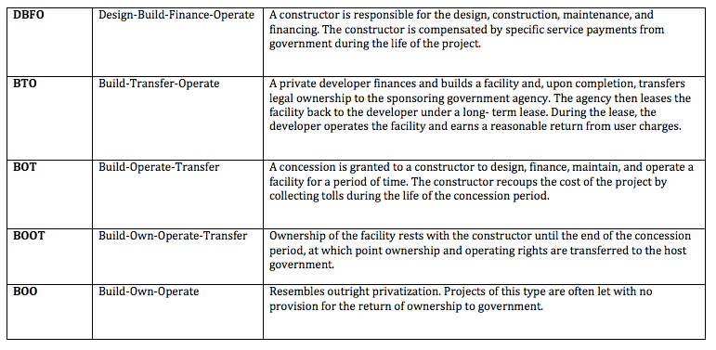
Figure 1 Definitions of the different types of PPPs source: (Serghini, n.d.).
According to Richards et al (2019) the most common type of PPP used are DBFO or DBFM, and most UK PFI/PPP are funded firstly, from the private sector and then repayments made from the public sector funds for example tax increment finance, grants or bonds over a long period of time usually over a concession period of twenty-five to thirty years however, some projects such as road maintenance and bridges are paid for via the end user such as road toll fees.
According to Alshawi (2009) the key principles of PFI/PPP are;
- Purchase services not assets
- Value for money to the private sector
- Project risk management between sectors
- To utilize and incorporate private sector knowledge and expertise
- To incorporate whole life-cycle costing in infrastructure projects
Friedman cited in (IWB, 2018) suggests that the private sector are able to complete projects a lot faster and are more successful than the government, the reason for this is because there are more capital and human resources, experts and workers in the private sector such as management or specialist skills in design, developers, architects and technology.

2.2 PFI and Public Assets

Traditionally Public assets were financed through sources such as long-term borrowing from The Bank of England which impacted on the UK Governments National debt due to debt rising as previous assets needed work or replacing this resulted in pressure on public services especially in the health and education sectors (Independent, 2017). Leslie (2009) reported on the Public Finance website that due to the banking crisis traditional funding methods for capital investments and public assets were proving to becoming riskier than adopting PFI/PPP schemes.
However, to overcome the rise in the National debt the public sector adopted PPP contracts which respectively reduced the amount of pressure that the public sector was under (Catsi, 2018). PPP’s is a method for the public sector bodies to make capital investments without any borrowing which is beneficial for the public sector as the PPP is an off-balance sheet method to finance new public sector assets which does not require to record anything on the public sectors net debt (Grimsey & Lewis, 2004).
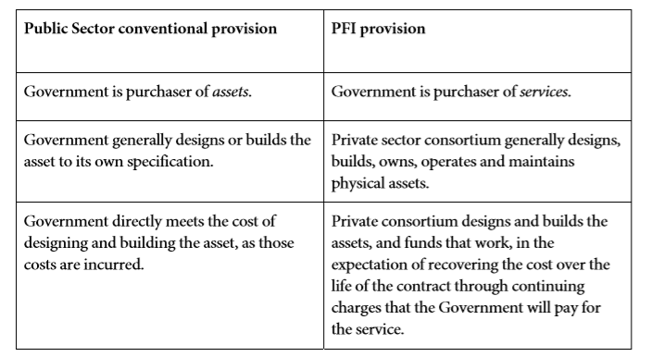
The provision of PPP projects compared to conventional public sector provision of assets can be seen below in table one (see table 1) which has been published by (Parliament.UK, 2008).

Table 1 Public sector provision of conventional methods vs the provision of PFI methods source: (Parliament.UK, 2008).
According to the office for National statistics (2018) public sector net debt is at it’s all time lowest since 2008 for the financial year 2017-2018, with a decrease in £7.2 billion in borrowing and an increase of £55.7 billion of GDP.

2.3 Critical evaluation of PFI/PPP schemes

PPP contracts can be a very complex process, the structure of a PPP contract can be seen in the figure below (see figure 2) and take quite some time for agreement between both sectors which can result in being more expensive for the public sector than if they were to use another method of finance especially as it is based on long-term contracts which would mean that it could take around twenty-five years for the public sector to get ownership of the assets however, PPP might only be the only option at the time (Bergmann, 2010).
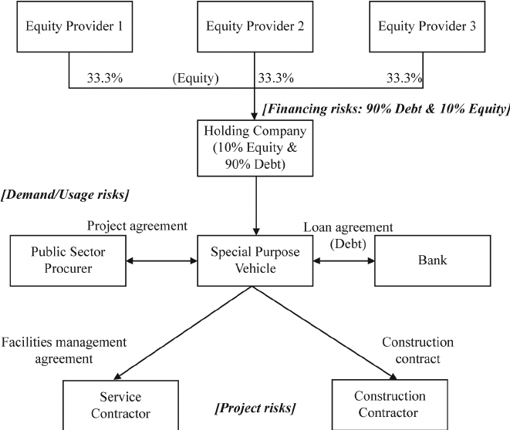
Figure 2 The structure of typical PFI contracts source: (Demirag, et al., 2012).

There are many advantages of PFI schemes for the public sector as it provides a solution to previous issues and pressure of not being able to upgrade, maintain or provide new infrastructure, allows government funds to be used in other areas, PPPs are based on the performance which suggests that projects are completed to the highest of standard and in a timely manner and also, provides some security for the public sector (Eadie, et al., 2013).
However, a disadvantage of this is that in regards to the public sector is that the private sector is concerned with making money which questions if the schemes really provide value for money for the public sector tax payers (Telegraph, 2011). An example of a PPP project which has not provided value for money was the St Bartholomew’s Hospital according to (Benjamin & Marshall, 2017) it cost £1.4 billion to build, but in total it will cost UK taxpayers £9.1 billion however, (Zhou & Smith, 2013) suggest that this project provided sustainability and economic growth for the public and the PPP project was completed in best practice.
Gov.UK (2017) reported that PPPs have invested £56 billion in over 700 UK PPP projects such as new schools, hospitals, roads, housing and prisons, the public sector have protection from delays, cost overruns and poor performance as the private sector transfers all the deliver, cost and performance risk. All PPP contracts in the UK must seek approval from HM Treasury before it can go ahead (EPEC, 2012).
An example of a successful private sector company in PPPs is Skanska UK, this company provides infrastructure development operations in transportations, social infrastructure and utilities, providing construction of over 400 schools, 5 major hospital developments and manages the M25 network (Skanska UK, 2017).
In reflection though not all PPP schemes have been successful such as the collapse of Carillion (Parliament.UK, 2018), this resulted in the government being blamed for not operating correctly and did not assess the risks correctly, according to (Sky News, 2018) Carillion were contracted to construct the HS2 rail link to deliver school meals, maintenance of prisons and building hospitals and that Carillion were forced by the government to take on too many high risk projects which questions if the contracts were correctly negotiated and poor risk management on both sides. Another example is G4S who were suppose to be in charge of security at the Olympics in 2012 (Quinn & Urquhart, 2012), however a few days before had discovered that the company were unable to provide enough security guards which resulted in the government rely on military, police and volunteers to help out, not only did G4S get hit by £88m in fines, the public accused the government as being a humiliating shambles (Plimmer & Moules, 2013).
However, before the collapse of Carillion the private organisation helped with most of the infrastructure that was needed and not just in the UK but in Canada, India and Australia along with construction company Balfour Beatty reports (Financial Times , 2012).
Yescombe (2013) suggests that the PPPs that have ended badly can be counted on one hand although he is a consultant in PPPs and project finance so his views could be potentially bias to some degree. Although the Financial Times (2017) report that PPPs are fundamentally needed to maintain the quality of life and growth within the economies.
On the other hand (Atkins, et al., 2017) reported on behalf of The Institute for Government that Brexit will add more pressure when it leaves the EU because their relations with the European Investment Bank will dramatically change and will result in losing one of its cheapest sources of finance. From the perspective of the private sector this could also be the case with any PFI projects overseas once Brexit comes into force as the implications are not yet known (Pereira & Zahib-Majed, 2017).

2.5 The role of external audit agencies

The statutory role of the external auditor is to ensure that public money is spent wisely, within the principles of the law and to ensure that the public will obtain value for money in the provision of public services (Edgar & Beck, 2016). However, (APMG International , 2018) guidelines for PPP audit framework suggests that there is more to it than that such as regularity audits, performance and value for money.
Generally, PFI contracts are not straight forward and are all negotiated differently (Bergmann, 2010), which can be very time consuming for auditors to ensure that the contract will provide value for money in the provision of services (Edgar & Beck, 2016) have identified that the National Audit Office are under pressure and suggest that PPP contracts could have been done more efficient, effective and economically if independent auditors were fulfilling their roles.
The Chartered Institute of Public Finance & Accounting published a document and Barret (2015, p. 31) claims that ‘The UK has had by far the greatest experience of PPPs in infrastructure and service delivery, Public audit reports have revealed relatively few success and numerous failures’. Whereas The National Audit Office (2011) suggest that auditors should not have all the blame and that the government need to improve their negotiating skills with the private sector to secure value for money which could result in savings in the future on delivery costs and welcomes the Treasury and Cabinet Office to strengthen assurance in PPP projects.
Usually the external auditors are not involved in any pre-contract negotiations, assessments or evaluations and it can be difficult for the auditor when dealing with large complex and long term contracts (Prowle, 2016) Stafford and Stapleton (2017) suggest this is because the managers in the public service organisations can commit public funds which can be difficult for the auditor to assess the value for money, and the quality of the decisions of contracts after they have already taken place and (EPEC, 2012) suggests this is why contracts need approval from the HM Treasury, this could be one reason for such PFI schemes as mentioned previously for not being successful (English, 2007).

3. Conclusion

In conclusion to this report it is evident that PFI/PPP have helped the public sector since the early 1990’s which is a more sufficient and successful way to source finance for upgrading, maintaining and building new infrastructure, this is because the private sector have more resources and expertise to complete projects in a timely manner compared to the public sector if they were to do it alone (Hodge, et al., 2018). The report has identified that there are both arguments for and against PPP which needs further research due to implications that could arise due to Brexit.
Research has identified that the advantages of PPP projects out way the disadvantages as a source or method to finance public assets (Yescombe, 2013). The main disadvantage for the public sector is the overall cost of PPP projects for the end user or taxpayers however, the private sector can complete projects more efficiently and provide a more sustainable and economic environment than the public sector (Zhou & Smith, 2013).

4. References

Bibliography
Alshawi, P. M., 2009. CONCEPT AND BACKGROUND TO PUBLIC PRIVATE PARTNERSHIP (PPP) / PRIVATE FINANCE INITIATIVE (PFI) UK EXPERIENCE. [Online]
Available at: https://www.oecd.org/mena/47562550.pdf
[Accessed 14 March 2019].
APMG International , 2018. Establishing a PPP framework: 1.9.2 Audit entities and Ex-post evaluation. Online ed. Buckinghamshire: World Bank Group .
Atkins, G., Davies, N. & Bishop, T. K., 2017. Public versus Private how to pick the best infrastructure finance option, s.l.: Institute for government .
Ball, R., Heafey, M. & King, D., 2007. The Private Finance Initiative in the UK: A value for money and economic analysis. Public Management Review, 9(2), pp. 289-310.
Barrett, P., 2015. Protecting the Public Purse/ The future of Public audit, s.l.: CIPFA.
Benjamin, J. & Marshall, T., 2017. The UK's PPPs Disaster: Lessons on private finance for the rest of the world. [Online]
Available at: https://jubileedebt.org.uk/wp-content/uploads/2017/02/The-UKs-PPPs-disaster_Final-version_02.17.pdf
[Accessed 17 March 2019].
Bergmann, A., 2010. Public Sector Financial Management. Harlow: Prentice Hall .
Catsi, M., 2018. Public-Private Partnerships. Economic Development Journal, 17(3), pp. 12-21.
CIPFA, 2015. Protecting the Public purse / The future of Public audit, s.l.: Public Finance.
Demirag, I., Khandaroo, I., Stapleton, P. & Stevenson, C., 2012. The diffusion of risks in public pirvate partnership contracts. Accounting, Auditing & Accountability Journal, 25(8 ), pp. 1317 - 1339.
Eadie, R., Millar, P. & Grant, R., 2013. PFI/PPP, private sector perspectives of UK transport and healthcare. Built Environment Project and Asset Management, 3(1), pp. 89-104.
Edgar, V. & Beck, M., 2016. The role of the National Audit Office in Private Finance Initiative endurance. aper presented at Irish Accounting & Finance Association Annual Conference, 19th – 20th May, 2016, 20 May, pp. 1-43.
English, L. M., 2007. Performance Audit of Australian Public Private Partnerships: Legitimising Governement policies or providing independent oversight?. Financial Accountability & Management, 23(3), pp. 313-337.
EPEC, 2012. United Kingdom - England PPP Units and Related Institutional Framework. [Online]
Available at: https://www.eib.org/attachments/epec/epec_uk_england_ppp_unit_and_related_institutional_framework_en.pdf
[Accessed 8 April 2019].
Financial Times , 2012. UK contractors export PFI exoertise. [Online]
Available at: https://www.ft.com/content/0139c544-1126-11e2-a637-00144feabdc0
[Accessed 27 March 2019].
Financial Times, 2017. Public-Private Partnerships need to bypass ideology. [Online]
Available at: https://www.ft.com/content/823c1e22-a829-11e7-ab55-27219df83c97
[Accessed 16 March 2019].
Friedman, M., n.d. Private Vs Public Sector, s.l.: atlas Society.
Gov.UK, 2017. Public Private Partnerships. [Online]
Available at: https://www.gov.uk/government/collections/public-private-partnerships
[Accessed 3 April 2019].
GOV.UK, 2017. Public Private Partnerships - GOV.UK. [Online]
Available at: https://www.gov.uk/government/collections/public-private-partnerships
[Accessed 20th March 2019].
Grimsey, D. & Lewis, M. K., 2004. Public private partnerships: The worldwide revolution in infrastructure provision and project finance. Cheltenham: Edward Elgar Publishing Limited.
Hodge, G., Greve, C. & Biygautane, M., 2018. Do PPPs work? what and how have we been learning so far?. Public Management Review, 20(8), pp. 1105-1121.
IMF, 2006. Public-Private Partnerships, Government Guarantees, and Fiscal Risk, Washington D.C: International Monetary Fund.
Independent, 2017. What is the Private Finance Initiative?. [Online]
Available at: https://www.independent.co.uk/news/business/analysis-and-features/labour-pfi-john-mcdonnell-scheme-government-hospitals-private-finance-initiative-party-conference-a7966521.html
[Accessed 09 March 2019].
IWB, 2018. Milton Friedman: Private Sector vs. Government. [Online]
Available at: https://www.investmentwatchblog.com/milton-friedman-private-sector-vs-government/
[Accessed 12 March 2019].
Leslie, C., 2009. Public Finance News & Insights. [Online]
Available at: https://www.publicfinance.co.uk/2009/09/name-bond
[Accessed 20 March 2019].
NAO, 2011. Lessons from PFI and other projects. [Online]
Available at: https://www.nao.org.uk/report/lessons-from-pfi-and-other-projects/
[Accessed 14 April 2019].
ONS, 2018. Public sector finances, UK: January 2018. [Online]
Available at: https://www.ons.gov.uk/economy/governmentpublicsectorandtaxes/publicsectorfinance/bulletins/publicsectorfinances/january2018
[Accessed 20 March 2019].
Parliament.UK, 2008. Private Finance Initiative – its rationale and accounting treatment. [Online]
Available at: https://www.parliament.uk/documents/upload/0807pfi.pdf
[Accessed 14 March 2019].
Parliament.UK, 2018. The collapse of Carillion. Briefing Paper Nmber 8206, 14 March, pp. 1-46.
Pereira, M. & Zahib-Majed, P., 2017. Impact of Brexit on UK Infrastructure, s.l.: DLA PIPER.
Plimmer, G. & Moules, J., 2013. G4S takes £88m hit for Olympic Fiasco. [Online]
Available at: https://www.ft.com/content/73df1bae-74e9-11e2-8bc7-00144feabdc0
[Accessed 2 April 2019].
Prowle, M., 2016. The Changing Public Sector: A Practical Management Guide. 1 ed. New York: CRC Press.
Quinn, B. & Urquhart, C., 2012. G4S Boss discovered Olympic security guard shortfall only a few days ago. [Online]
Available at: https://www.theguardian.com/sport/2012/jul/14/london-2012-olympic-security-g4s
[Accessed 3 April 2019].
Richards, M., Calder, K. & Hadrill, A., 2019. The Public-Private Partnership Law Review - Edition 5. [Online]
Available at: https://thelawreviews.co.uk/edition/the-public-private-partnership-law-review-edition-5/1189721/united-kingdom
[Accessed 20 April 2019].
Serghini, Y., n.d. Types of Public-Private Partnerships. [Online]
Available at: https://youssef-serghini.weebly.com/types-of-ppp.html
[Accessed 10 March 2019].
Skanska UK, 2017. Our Public-Private Partnership projects in the UK. [Online]
Available at: https://www.skanska.co.uk/expertise/investment/public-private-partnership-projects/
[Accessed 6 April 2019].
Sky News, 2018. Carillion: Government blamed for creating 'dysfunctional' public sector market. [Online]
Available at: https://news.sky.com/story/carillion-government-blamed-for-creating-dysfunctional-market-11218076
[Accessed 13 March 2019].
Stafford, A. & Stapleton, P., 2017. Examining the use of Corporate Governance Mechanisms in Public-Private Partnerships: Why do they not deliver Public Accountability. Australian Journal of Public Administration, 76(3), pp. 378-392.
Telegraph, 2011. Private Finance Initiative: where did it all go wrong?. [Online]
Available at: https://www.telegraph.co.uk/news/health/news/8779598/Private-Finance-Initiative-where-did-all-go-wrong.html
[Accessed 08 March 2019].
Yescombe, E. R., 2013. In Focus:Public-Private Partnerships [Interview] (15 May 2013).
Zhou, L. & Smith, A., 2013. Sustainability best practice in PPP: case study of a hospital project in the UK. Preston, UK , s.n.

