Student name: Viorica Buzatu
ID no: 1817387
Lecturer name: Afzal Munna

PROBLEM SOLVING AND DECISION MAKING
Absenteeism due to Sickness and/or lateness
TABEL OF CONTENT:
- Part 1. Problem at Workplace……………………………………………….……..2
  - 1.1 Chosen problem………………………………………………….……….2
  - 1.2 Absenteeism due to sickness and/or lateness – why is it a problem?.....2
  - 1.3 Advantages/disadvantages of the problem……………………………...2
  - 1.4 How to overcome/resolve the problem…………………………………..3
  - 1.5 My experience of the problem at workplace……………………………3
  - 1.6 Seven steps to problem solving…………………………………………..4
- Part 2: Decision Making…………………………………………………………….4
  - 2.1 Types of decisions…………………………………………………………5
  - 2.2 Factors affecting decision making……………………………………….5
  - 2.3 Ingredients of good decision making…………………………………….5
  - 2.4 Fishbone analysis……………………………………………………….…5
  - 2.5 SWOT analysis ……………………………………………………….….6
  - 2.6 PESTEL analysis……………………………………………………….…6
  - 2.7 Porter’s Five Force Model……………………………………………….7
- Part 3. Solution………………………………………………………………….…...7
  - 3.1 Proposed solution 1 ………………………………………………………7
  - 3.2 Proposed solution 2……………………………………………………….7
  - 3.3 Evaluation of the proposed solutions……………………………………8
- Part 4: Implementation …………………………………………………………….8
  - 4.1 Implementation plan the proposed solution……………………………8
  - 4.2 Monitor and review of implementation plan. ………………………….8
  - 3.3 Evaluation of the proposed solutions……………………………………8
- Conclusion……………………………………………………………………………8
References……………………………………………………………………………9
Appendix……………………………………………………………………………..10

“If I had an hour to solve a problem, I’d spend 55 minutes thinking about the problem and 5 minutes thinking about solutions.”
Albert Einstein

Problem – a created situation which does not bring us a pleasure feeling, which we try to solve through the different ways, just to obtain the best results.
There is no organization, which had not meet one problem during the activity and this is normal, as long as the staff consists of human beings.
So, in this report I will try to describe what kind of problem usually persists, why this is a problem, types of decision making and how to overcome this.
Also, I will try to analyze the problem at workplace by using types of decision and propose solutions.

Part 1. Problem at Workplace

  - Chosen problem
Working in a hotel, I observed different kind of problems such as:
- Absenteeism due to sickness and/or lateness
-Communication barriers
- Favoritism
- Pay gap etc.
I could speak about every of them, but I will stop on one of them, and this will be - Absenteeism due to sickness and/or lateness.
There are different reasons of lateness why the employee can’t get at work on time or worth can’t come at all. In the morning as we all know it is a big traffic (especially in big cities, as London), transport delays etc. Even a simple human factor as oversleep is influencing on the punctuality.
Monitoring the times of lateness/absences of an employee, can help to identify the reasons and to understand if these are due to the circumstances or to the irresponsibility. In this way you can find out what kind of attitude has one related to his work.

1.2 Absenteeism due to sickness and/or lateness – why is it a problem?
"Unscheduled absences hurt," wrote (M. & Silver, 2010) in September 1993 issue of Small Business Reports.
The impact of late or absent staff is significant, because it can affect costs and especially productivity (which goes again to costs).

1.3 Advantages/disadvantages of the problem
Planning daily activities as a manager, you are counting on employees you have, but it is inevitable that lateness or absences can be. Even so you are planning the work day according to the number of employees must to be. And then every person from staff who is late or absent according to The SOHO Guidebook cause evident cost factors:

- Lost productivity of the absent employee
- Overtime for other employees to fill in
- Decreased overall productivity of those employees
- Any temporary help costs incurred
- Possible loss of business or dissatisfied customers
- Problems with employee morale

1.4 How to overcome/resolve the problem

Attend today, achieve tomorrow.
As you know every of us needs to respect some rules in this life. The rules do not limit our actions, they help us be organized, well prepared and productive. That is why, for not permit that the employee absenteeism become a habit for staff, it is better to make some rules to reduce this absenteeism. There are some steps to do make the attendance positive.
- Attendance policy.
First of all, it is welcome for each company to develop an attendance/absenteeism policy, which will encourage employees to reduce the number of days they miss work.
This policy means anything which is connecting to employee attendance. Any workplace policy includes such points as:
-paid time off,
-vacation days,
-sick days,
-parental or other leave, etc.
In addition, it includes a guidelines of actions which will be done in case if an employee misses too many days of work beyond what is allowed.
- Enforce your attendance policy consistently
- Keep track of employee absences
- Address unscheduled absences and no-show’s immediately
- Do not just treat the symptoms, discover the cause
- Do not forget to reward good behavior

1.5 My experience of the problem at workplace
A Hotel is not just a building of bricks and mortar, glass and steel. It is a complex of activities orientated for the organization of the most pleasant stay for people who are using the hospitality services. Being part of hospitality industry, it involves a big number of employees, people with different culture, nationalities and points of view.
As you can understand my professional activity is related to hospitality. Well, being more exactly, I am working as Housekeeping Supervisor. In this Department we have a big staff of room attendance workers. People of different ages and from different countries. For most of us, English language is the second language, communication barriers are present here. But these barriers we can manage somehow.
The big problem is the attendance. There is no Saturday or Sunday that someone call and tell that he/she will come later or even worth (in most cases) don’t come to work, because of sickness or does not have transport to get to work.
As it is known, a Hotel is working 24/24 hours and 7/7 days per week, it is not possible offer to the staff a 5 days week working, from Monday to Friday. Especially on Sundays the Hotel needs more employees than other days, because the guests usually finish their staying. So here we have implemented a rotation graph of working days for each. Well, many of employee wants to stay at home on Sundays. Knowing that it will not be possible to have this day off every week, they are calling to announce that they are sick. This sickness is only for one day.
One more reason of law attendance, especially in weekends, is the transport. The employees say, that are not able to come to work, because from their zone there is not any transport.
It is clear that the manager knows that all these motivations are not true, but he accepts them. Why? Because it is very difficult to find a good staff in this field. Even if you will try to change some employee, nobody can guarantee you, that a new coming will be always at work according to the work schedule.
From my point of view, the most relevant reason of all these absences is, because people don’t like their workplace. It is understandable that there are very few people who really like to work in this field.

1.6 Seven steps to problem solving.
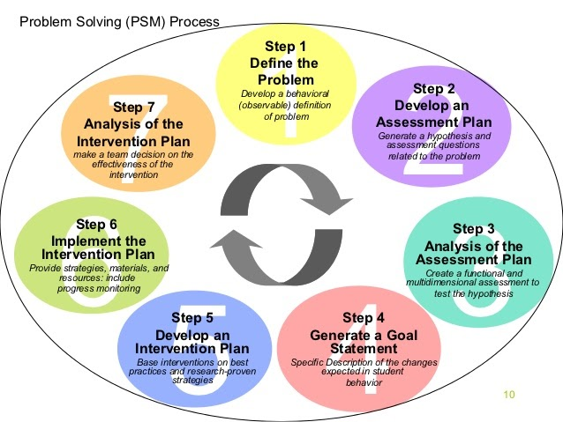

Part 2: Decision Making
To find a solution for a problem, it is necessary to analyze and make some decisions based on well-known theories and procedures.
Decision making is the process which consists in making choices by identifying a decision, and collecting information.

2.1 Types of decisions.
We know that there are:
- Routine Decision – a daily decision, which not required a lot time to think.
- Adaptive Decision – a decision which we make using the experience from the past.
- Innovative Decision – a decision which require creativity and unique methods.

2.2 Factors affecting decision making
The decision depends on a number of factors, like the knowledge, experience, understanding and intuition. Also, we can mention:
- Creating Thinking
- Risk Associated with decision
- Self Concept
- Critical nature of work
- Stress
- Interpersonal Conflict
- Organization's attitude
- Time available
- Money
- Degree of acceptance of decision and support
- Manager’s personal ability etc.

The Manager’s personal ability and the organization's attitude are the most relevant for the problem from my workplace.

2.3 Ingredients of good decision making.
To make a decision, a good one, we will need some ingredients for this, such as:
- Follow a systematic process
- Involve the team Involve the team
- Delegate
- Brainstorm
- Be creative
- Be objective

In order to make a decision, we should analyze all the pros and cons, for this we will need to use one of well-known analyzes.

2.4 Fishbone analysis
Is a cause-and-effect diagram that helps to follow the reasons for imperfections and defects. This analysis I will use for my personal problem.

The diagram below consists of causes which usually lead to the creation of problem of Absenteeism. Once this causes have been identified, we can look for solutions. This analysis I will use for my personal problem.

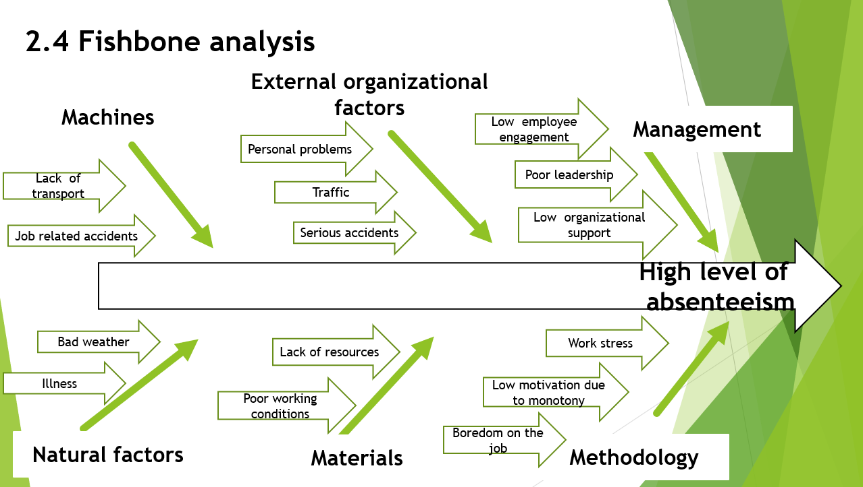

2.5 SWOT analysis

A powerful but simple technique which helps to analyze Strengths, Weaknesses, Opportunities, and Threats of one company.

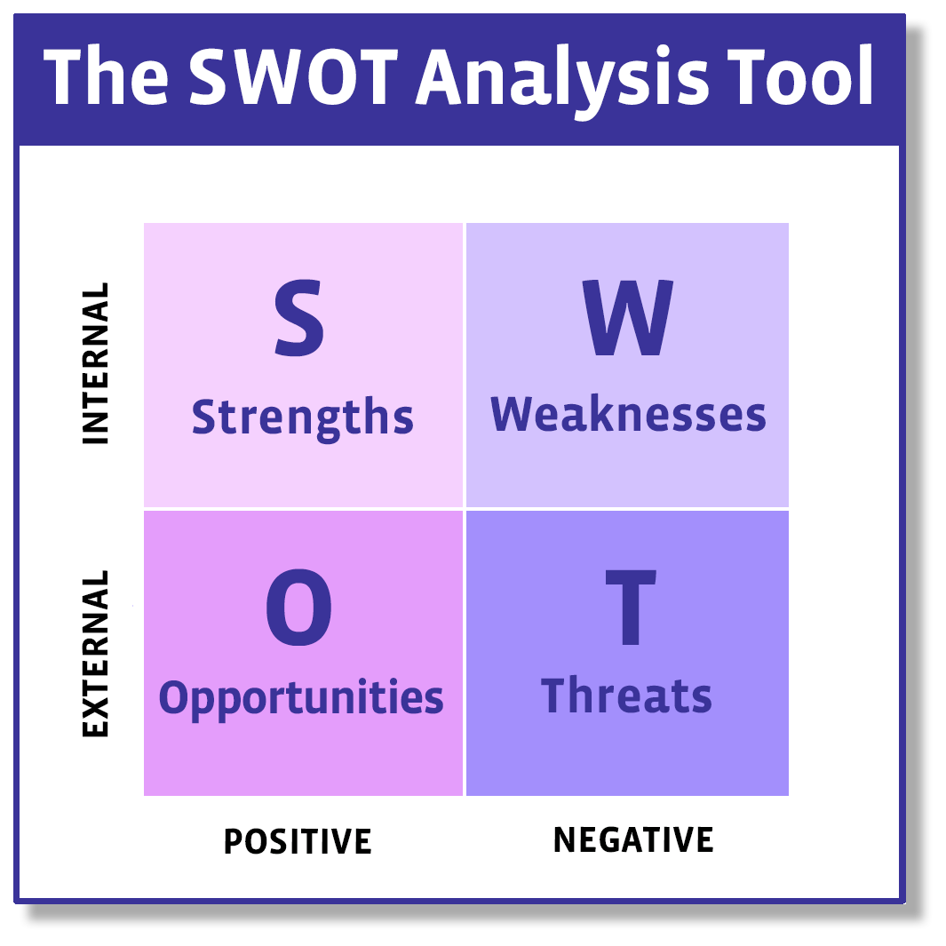

2.6 PESTEL analysis

An acronym for a tool used to identify the macro (external) forces facing an organization. The letters stand for Political, Economic, Social, Technological, Environmental and Legal.
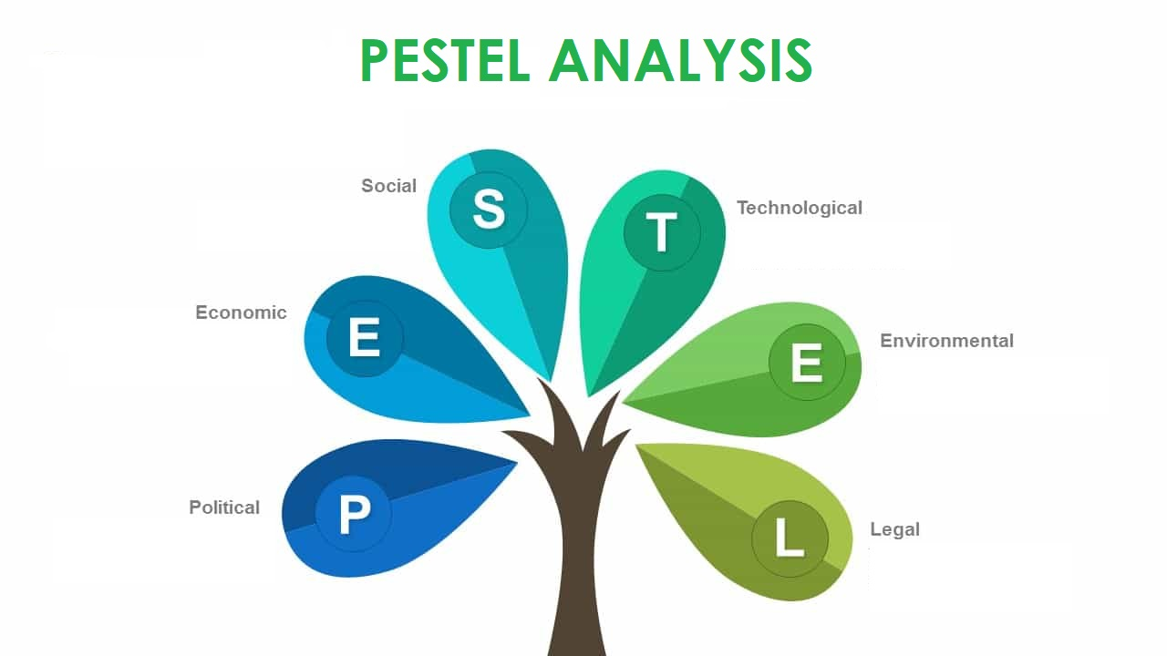
2.7 Porter’s Five Force Model

Five Forces analysis helps to identify strengths and weaknesses of one industry, is frequently used to identify an industry's structure to determine corporate strategy. Porter's model can be applied to any segment of the economy to understand the level of competition within the industry and enhance a company's long-term profitability. The Five Forces model is named after Harvard Business School professor, Michael E. Porter.

Part 3. Solution

3.1 Proposed solution 1

- Write Attendance Policy
In order to keep your presence at work under control, it is welcome to elaborate the attendance policy. A document with written rules, always helps to organize and monitor the activity of employee.
This document must to contain information about lateness, unplanned absences, what is admissible and for what are the consequences of non-compliance.
For example: the term Tardiness can be used in case of arrival at work 40 minutes later. Excessive absenteeism – an employee who has 7 or more unplanned absences during six months.
This policy then becomes a measure for good performance.

3.2 Proposed solution 2.

- Reward Good Attendance.
From my point of view, it is welcome to offer to employee a bonus for having a good attendance, for having no unplanned absences in a 12 month period.
In this way, at the end of the year making an evaluation of the activity of each employee, we can mention the attendance as a performance.

3.3 Evaluation of the proposed solutions.
Well, the first solution has its benefits, it brings clarity to the employee in terms of his work activity. At the same time, it gives to the manager the possibility to monitor the attendance in the right way, without violating the employee's rights.
A small minus in this attendance policy is that some employees get scared when they see so many conditions.
About reward of good attendance, it is one the best options to use in such field. As I mention above, in the cleaning job there are very few people who really like it. But this industry needs employees and the best way to keep them is to offer some bonus periodically. Especially if thanks to this bonus, the attendance will become a stable one.

Part 4: Implementation

4.1 Implementation plan the proposed solution.
The implementation of Attendance Policy will be done in written form by giving to every employee to sign, and it will be attached to the employment contract. For the new coming employee this Attendance Policy will be included in the employment contract.
Second one, Reward Good Attendance, will be made as an additional document for the performance map. In order to respect this document, I propose to implement the bonus for the attendance every 6 months. The size of this bonus will be established with the authorized persons.

4.2 Monitor and review of implementation plan.
The monitoring of the implementation plan will take a time, at least we need 6 months to make the first conclusion about how effective it is.

Conclusion
In this report I related some knowledge about Problem Solving and Decision Making,
have identified the problem at Workplace, based on my own experience. I tried to explain in some words about Decision making, by enumerating the types of decisions and what factors and ingredients can affect them, also the well-known analyzes used in making decisions.
After identifying the problem, I proposed some solutions and their implementation, based on a previous experience of others.

References
- Anon., 2020. https://structx.com/. [Online]
Available at: https://structx.com/Article002-7_Step_Problem_Solving.html
[Accessed 26 04 2020].
- Anon., n.d. asq.org. [Online]
Available at: https://asq.org/quality-resources/fishbone
[Accessed 13 04 2020].
- Anon., n.d. https://addtimerecording.co.uk/. [Online]
Available at: https://addtimerecording.co.uk/blog/measuring-employee-lateness-absences/
[Accessed 25 04 2020].
- Dietrich, C., 2010. Inquiriesjourna. [Online]
Available at: http://www.inquiriesjournal.com/articles/180/decision-making-factors-that-influence-decision-making-heuristics-used-and-decision-outcomes
[Accessed 20 04 2020].
- G, G., n.d. http://www.economicsdiscussion.net/. [Online]
Available at: http://www.economicsdiscussion.net/management/types-of-decision-making/32202
[Accessed 29 03 2020].
- Hicks, T., n.d. mediate.com. [Online]
Available at: https://www.mediate.com/articles/thicks.cfm
[Accessed 13 04 2020].
- Madlinger, G., 2018. https://wheniwork.com/. [Online]
Available at: https://wheniwork.com/blog/how-to-deal-with-employee-absenteeism
[Accessed 15 04 2020].
- marketing, O. c. o., 2016. Oxford college of marketing. [Online]
Available at: https://blog.oxfordcollegeofmarketing.com/2016/06/30/pestel-analysis/
[Accessed 7 04 2020].
- M., M. M. & Silver, C. A., 2010. journals.lww.com. [Online]
Available at: https://journals.lww.com/jhmonline/Abstract/1989/04000/How_to_Reduce_Absenteeism__A_Comparative_Analysis.7.aspx
[Accessed 29 04 2020].

Appendix

