

LEVEL 4

SEMESTER 2

MODULE CODE: SHSS4086
INTRODUCTION TO SPORT AND EXERCISE PSYCHOLOGY
aSSESSMENT TYPE: REPORT
Assessment/Component: 2

COMPONENT WEIGHTING: 50%

WORD COUNT: 1500 WORDS

MODULE TUTOR: ALISON CONNAUGHTON

SUBMISSION DETAILS:
Assignments should be submitted via Turnitin (Moodle) by 3pm on Friday 26th of April, 2019.

TASK:
Write a report on the following topic:
As a group, you will gather data using the measure provided for at least 20 team sport participants and 20 individual sport participants from the student population at UWTSD.

Motivation to take part in Team vs. Individual Sports

Aim: To undertake a comparison of the motives for taking part in team and individual sports. Participants will be gathered from the School of Sport, Health and Outdoor Education.
Introduction – Review of relevant literature relating to motivation for taking part in sport (approx. 500 words).
This should include research relating to differences found between team and individual sports participants.

Method – Briefly outline the participants, procedures and design of the study (approx. 200 words).

Results – Using the data provided, present the results in an appropriate format. This should include descriptive statistics, table, figure and associated narrative (approx. 250 words).

Discussion – Discussion of your findings in relation to previous motivation research (approx. 550 words).
In this section you will need to relate your findings to the research discussed in the introduction and either support or reject previous research findings. Briefly explain the practical implications of research your findings.

The format required for the different section of the report will be discussed during lectures, with further guidance placed on Moodle.

Word count – 1500 Words

Submission Date: Friday 26th of April, 2019.

School of Sport, Health & Outdoor Education

Assessment Feedback Sheet

Student No./Name: 1809246 Hannah Warlow
Module: Introduction to Sport and Exercise Psychology

Module Code: SHSS4086

Personal Evaluation – to support your academic progress please complete the section below BEFORE submitting your work.
What do you consider to be the best aspects of this work? |  |  | Bar charts are clear and easy to understand
Which aspects do you consider could have been improved in this piece of work? |  |  | More research used from previous studies done to make better comparisons, more data collected to conduct the study.
What have you found most satisfying whilst undertaking this submission? |  |  | Learning about motivations and getting an understanding of how beneficial partaking in sport can be to aid the growth and strength of a person’s personality.
ASSESSMENT CRITERIA | Learning  Outcomes |  | GRADE
ASSESSMENT CRITERIA |  |  | Poor  < 20% | Weak  20-29% | Unsatisfactory  30-39% |  | Satisfactory  40 – 49% | Good  50 – 59% | Very Good  60 – 69% | Excellent  70 – 84% |  | Exceptional  85– 100% | %
1. Introduction:  Review of relevant literature relating to motives for taking part in team and individual sports.  (approx. 500 words) | 1,2 |  |  |  |  |  |  |  |  |  |  |  | 30%
2. Method:  Outline the participants, procedures and design of the study (approx. 200 words) | 1,2 |  |  |  |  |  |  |  |  |  |  |  | 15%
2. Results:  Descriptive statistics, use of tables, figures and associated narrative (approx. 250 words) | 1,2 |  |  |  |  |  |  |  |  |  |  |  | 25%
3. Discussion:  Discussion of your findings in light of previous research & Practical implications.  Use of appropriate resources (approx. 550 words) | 1,2 |  |  |  |  |  |  |  |  |  |  |  | 30%
It is expected that students will present work that is proof read, correctly referenced and adheres to the Assessment Checklist. Therefore a range of 0 – 10 marks will be deducted for non-completion of any of the points on the checklist below.
TUTOR COMMENTS:

Submission date: 26/4/19  via Turnitin |  | Return date:  (at least within 4 weeks) |  |  |  | Tutor: Alison Connaughton |  |  |  |  | Mark:

Assignment Checklist

- Please complete the Personal Evaluation section of the Assessment Feedback sheet, add your name and details, and paste the whole of this assignment document into the front of your assignment

- Submission is a single word file, clearly labelled with your name and module code
- Font style - Times New Roman, size -12 for text and 14 for headings
- Ink colour – black only
- Line spacing – 1.5 line spacing and 2cm- 2.5cm page margins
- Quotations more than three lines to be indented 1 line spacing
- One line space between paragraphs, paragraphs must be left aligned
- Pagination (your assignment should have page numbers)
- All tables and figures are internally referenced and have a title
- Word count checked and written at end of text (before references and any appendix)
- Assignment is within 10% of the word limit (excluding references and any appendices)
- All references in the text are included in the reference list
- Correct referencing following the Harvard style, as described in the UWTSD referencing guide.
- Correct spelling using UK English
- Correct use of punctuation
- Grammar and syntax correct- double check anything that has a green line under it
- I have read my assignment out loud to myself and it makes sense and is easy to read
- Somebody else has read my work and it makes sense to him or her!
- I have checked and I have not plagiarised
Failure to follow these guidelines will cost you marks!

SHSS4086 Introduction to sport and exercise science.

Motivations to take part in Team vs. Individual Sports

Introduction

Motivation is a theory used to explain behaviour. It can help give reasons for people’s actions, wants and needs. It can give reasons for someone to repeat an action. The three components to motivate are: activation, persistence and intensity. Activation, this is said to involve the decision to initiate a behaviour. Persistence is continuing to make an effort towards a goal and overcome any obstacles along the way. Finally, intensity this can be explained by vigour and concentration that goes in to a goal. (International journal of applied research. Kumar P) (2015)

Research between the differences of team and individual sport motivations has been conducted many times this particular research was to compare overall emotional intelligence, psychological skills and athletic success. This study was made up of 400 male athletes, split into team sports players 153 and individual sport players 247. Chosen by random, multistage sampling method. The participants were asked to complete a psychological skills questionnaire Ottawa-3, Bar-on emotional intelligence inventory and a perception of sport success questionnaire. Using the “mean” data was analysed also by standard deviation and MANOVA statistical methods. The results found using the MONOVA. Pointed out that there was a big difference between the individual group and team sports group, in the motivation and psychological skills of the athlete. The results of the intelligence between the two groups showed there not to be a great deal of difference. (Journal pf physical education and sport) (2011)

The sms-6 scale (Sport Motivation Scale -6: a six factor sport motivation scale) is a form of measuring different level of motivation, of people who have to participate in sport. It measures intrinsic motivation, extrinsic motivation and motivation in sport. It does not measure integrated regulation the most autonomous form of extrinsic motivation. This has an inconsistency to the self-determination theory. The sport and motivation scale, metric properties, evaluations with college Varsity athletes from the UJ journal of sport and exercise psychology have questioned the validity of facts from the SMS results. (Psychology of sport and exercise) (SMS-6) (2007)

A research in to differences in motives between team sport and individual sport was carried out by the university of Nordland in the department of sport, Norway. The aim was to explore what motivates dominate adolescents. There were 78 athletes in four different sports, 28 boys and 54 girls from age of 13-19 years old, giving a mean age of (14.3) The only inclusion criteria was that they had to play either team or individual sport. When it came to individual or team sports, it was expected intrinsic motivations would dominate in both. The hypothesis was people who competed in individual sport would have a lower score on extrinsic motivation and higher on intrinsic motivation. It is also expected that intrinsic motives could explain the individual sport was chosen over team sport. Fitness motive – extrinsic in both groups had the highest scores. In this study, no difference was found between individual or team sport. (Martin A. Lase journal of sport and science.) (2014)

Method
There were 23 participants from the student population at UWTSD (University of Wales, Trinity St David) asked to take part and complete the sport motivation scale – 6 (SMS-6) questionnaires. (Pelletier, L. G) (1995) The ages ranged from between 18 to 32 years of age. One group consisted of 12 students that had participated in individual sport, split in to 6 males and 5 females. Examples of the types of sports are swimming, cycling, triathlon, marathon, athletics, squash, tennis, badminton and MTB (Mountain Biking). The other group consisted of team sport players. 11 in total, 6 males and 5 females. The team sports were rugby, football, netball, cricket, hockey and basketball. The questionnaire on sms-6 scale, asked why do you practice your sport? The possible reasons ask 24 different ways with an answer of 1-7 to choose from. 1 – doesn’t correspond at all, 2- corresponds a little, 3- corresponds moderate, 5- corresponds a lot, 7- corresponds exactly.

Using a key, the scores are added together and divided, they are split into groups of motivation, identified external integrated and introjected regulation and intrinsic motivation. This can then be plotted on a bar chart and the results can be compared simply and quickly.

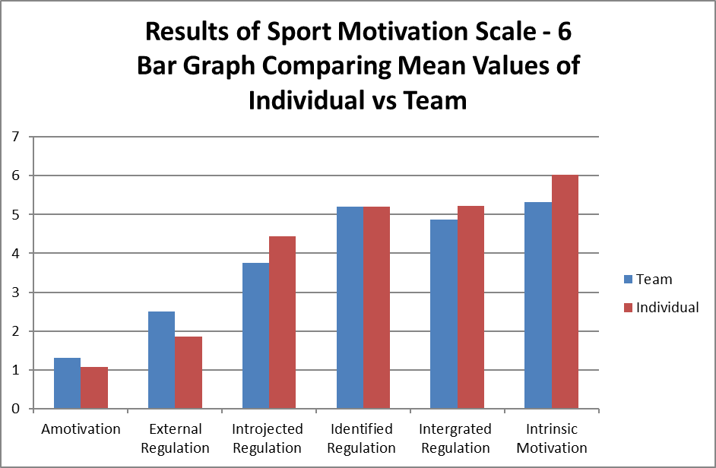

Results

The standard deviation bar chart clearly shows; the individual sports players have scored a lot less in Amotivation giving a reason they may be motivated to participate in sport making this result an out layer. They do score a lot higher in external regulation in comparison to the team sport player. Individual sport players score higher in motivational factors in introjectected, identified, intergrated regulations and instrinsic motivation.

Looking at the, mean value bar chart to make a comparison it can be clearly seen, that firstly both groups of sport players (individual and team players) score equally in identified regulations. It’s clear also to see that the group of team players score higher in Amotivation and external regulation.

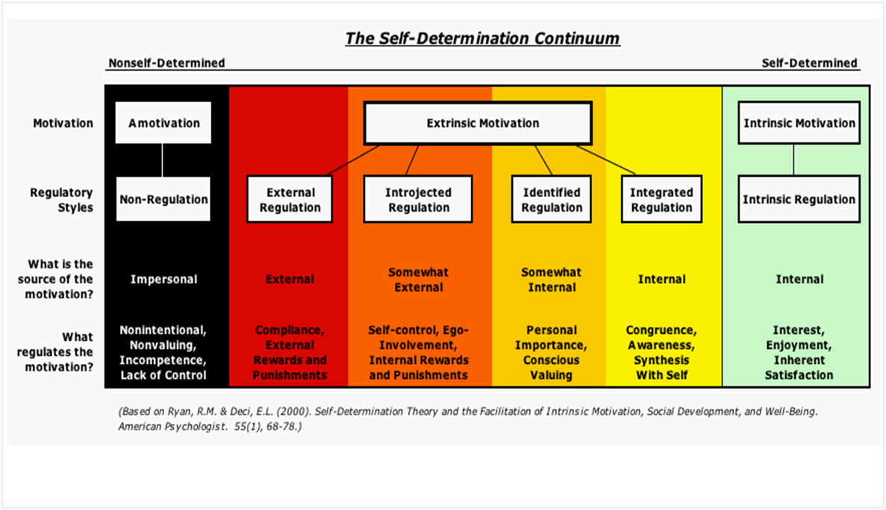

Discussion

This research I have conducted has compared different levels of motivation given reason, these two different groups of people currently play their sport of choice, either in a team or individually. They are a group of students from the university (UWTSD) sports department who all currently play sport. They are all likeminded people so I had expected the results from the two side to be very similar.

The different motivations that are grouped together for the SMS-6 questionnaire sit under one umbrella, from the self-determination continuum. (Ackerman. C. (2019) Based on Ryan, R.M. Deci, E.L) (2000) Self-determination theory is the personality and motivation that house the three things universally recognised. Psychological need and innate: competence psychological relatedness and autonomy. Self-determination theory (SDT) address important theories and issues of extrinsic and intrinsic motivations. The innate psychological needs that people have are competence, relatedness and autonomy. The theory is people will grow and function optimally if these needs are met. This is a universal theory, in order to get the best out of someone these needs must be nurtured. (David L, Self-determination theory, (Deci and Ryan, learning theory’s.) (2014)

Three main motivations are intrinsic motivation and in general it refers to taking part in an activity or sport because you gain satisfaction and pleasure from doing it. (Edward L Deci,) (1975) You do not do it for a reward or external constraints, its done entirely voluntary. (Richard M. Ryan, Edward L. Deci.) (2017) The extrinsic motivation, is described as a means to an end and not for one’s self. (Edward L Deci) (1975) The meaning of Amotivation is very similar to the concept of learned helplessness. (Abramson, Seligman and Teasdale,) (1978) The feelings from this motivation can be like a lack of control or incompetence experienced. (Richard M. Ryan, Edward L. Deci.) (2017) When this is felt the person is no longer motivated, intrinsically or extrinsically. This is not a good place to be for an athlete as they no longer want to train. They may even feel that they do not want to continue in that sport at all. (Journal of sport and exercise psychology.) (1995)

What was interesting about the results from the external regulation. Relating to the mountain biker, he scored a 6.00 skewing the results. Showing on the standard deviation bar chart there being a significant difference between the two groups. It’s hard to really know if this is a mistake in the results or a correct marker. There were very few participants this is a floor in this research. A Re- test would be advisable. In order to get a truer result of people’s motivation a much larger group would need to take part a randomised selection may give a more varied result too.
The SMS-6 questionnaire is aimed at people who current play sport, so it can only get results from that particular population, when the answers are expected to be the similar.
The age group was between 18-32 years old. Keeping the age groups closer with hundreds of participants, age 18-21 for example and splitting male and female groups up, into just male or just female participants would break the study down a bit and also having a wide range of ages mixed sex or not. I believe this research alone is not enough to get a true comparison.

REFRENCES

Abramson, Seligman, Teasdale. Learned helplessness in humans: Critique and reformulation. (1978)
https://psycnet.apa.org

Ackerman C. (2019) What is the self-determination theory of motivations? (Based on Ryan, R.M, & Deci,E.L) (2000)
https://positvepsychologyprogram.com/self-determination-theory/

David L. “Self-determination theory (Deci and Ryan), “learning Theories, (2014)
https://www.learning-theorys.com/self-determination-theory-deci-and-ryan.html.

Edward L Deci. Intrinsic Motivation. (1975)

Jakobsen A. M. Lase journal of sport and science. Are there differences in motives between participants in individual sport compared to team? (2014)
https://www.researchgate.net.

Journal pf physical education and sport (2011)
https://www.researchgate.net

Kumar P. Motivation among individual and team sports players.
International journal of applied research (2015)
http://www.allresearchjournal.com

Pelletier, L.G. Fortier, M.S., Vallerand, R.J., Tuson,K.M .et al. The sport motivational scale (SMS) Journal of sport and exercise psychology (1995)
https://psycnet.aca.org

Psychology of sport and exercise, sport motivation scale-6 (SMS-6): a revised six factor sport motivation scale. (2007) https://www.sciencedirect.com
Richard M. Ryan, Edward L. Deci. Self-determination theory: Basic psychological needs in motivation, development and wellness. Guilford publications. (2017)

Tuson, Briere, Fortier, Pelletier. Journal of sport and exercise psychology. Human Kinetics. Towards a new measure of intrinsic motivation, extrinsic motivation and Amotivation in sports: The sport motivation scale (SMS) (1995)
https://pdfs.semanticscholar.org

