ASSIGNMENT2
Project Management & Innovation

Module: Changemakers: Creativity and Value Creation

Code: ACCA5033

Student: Beda Clement NDEPO

Student No: 2411399

Lecurer: Dr Fahad Ahmed



UNIVERSITY OF WALES ST DAVID TRINITY
BSC Applied Computing
Table of Contents
INTRODUCTION 1
TASK1 Project Management 2
Q1 Project Management & Planning 2
Hotel Management Software Development Project Plan 2
1 Project Management & Planning 2
1.2 Project Scope 2
1.3 Solutions 2
1.4 The Required Technology 3
1.5 Project Timeline. Hotel Management Software Development 3
1.6 Project Constraints 4
1.7 Development Method 4
Q2 Project Design 5
Storyboard 5
Network Structure 6
TASK2 Enterprise & Innovation 6
T2 Enterprise 6
Q1 SWOT & PESTEL 6
SWOT Analysis 6
JBL SWOT Analysis 6
JBL PESTEL Analysis 7
Q2 HOTEL SOFTWARE MANAGEMENT DEVELOPMENT START UP 7
Tech Start up Name 7
Business Start-up Logo 8
Business Start-up Type 8
Business Start-up Strategy 8
Initiatives 9
TASK3 Project Reflection 9
CONCLUSION 11
References 12

INTRODUCTION
Project management is the structured practice of organizing, guiding, and overseeing projects to meet defined objectives within constraints such as time, cost, and performance. It draws on a blend of methods, skills, and processes to initiate, plan, execute, and monitor work, ensuring that outcomes deliver value, functionality, and capabilities aligned with organizational priorities. [1] This report addresses three key questions: how to effectively manage a project, how to define innovation, and how to reflect on your project experience.

TASK1 Project Management

Q1 Project Management & Planning
Project management applies structured principles and techniques to ensure successful delivery, especially in engineering, construction, and technical fields. It covers the full lifecycle, initiation, planning, execution, control, and closure. while balancing constraints of time, cost, and quality. Within this, planning is pivotal: it defines scope, schedules tasks, allocates resources, and establishes monitoring systems to track progress and resolve challenges. [2]

Hotel Management Software Development Project Plan

1 Project Management & Planning
- Objective: Build a hotel management system to optimize reservations, billing, staff, and customer service.
- Approach: Follow structured phases, initiation, planning, execution, monitoring, closure.
- Stakeholders: Owners, managers, IT team, front desk staff, customers.
- Success Criteria: Usability, seamless workflow integration, scalability, and cost efficiency.

1.2 Project Scope
- Reservation & booking system
- Customer database & CRM features
- Billing & invoicing
- Staff scheduling & payroll
- Inventory management (rooms, supplies)
- Reporting & analytics dashboard

1.3 Solutions
The hotel software management system is a centralized web and mobile platform with integrated payments, notifications, and cloud storage. It ensures security through role-based access, encryption, and GDPR compliance, while its modular design enables scalability for future features like loyalty programs and AI chatbots.

1.4 The Required Technology
hotel management software requires a full-stack approach: frontend for usability, backend for operations, database for records, cloud for scalability, and strong security for compliance

1.5 Project Timeline. Hotel Management Software Development
Phase | Duration | Activities
1. Initiation | 14 Days | Define objectives, identify stakeholders, gather requirements, feasibility analysis
2. Planning | 21 Days | Scope definition, resource allocation, risk assessment, project schedule creation
3. Design | 28 Days | UI/UX mock-ups, system architecture, database schema, integration planning
4. Development | 84 Days | Backend & frontend coding, database setup, API integrations, security implementation
5. Testing | 28 Days | Unit testing, integration testing, user acceptance testing (UAT), and bug fixes
6. Deployment | 14 Days | Production rollout, staff training, documentation, system handover
7. Maintenance | Ongoing | Updates, bug fixes, feature enhancements, performance monitoring

Table 1 Project Timeline

Gantt Chart
Phase | Start date | End date | Duration
Initiation | 1/1/26 | 15/1/26 | 14
Planning | 15/1/26 | 5/2/26 | 21
Design | 5/2/26 | 5/03/26 | 28
Development | 5/03/26 | 28/5/26 | 84
Testing | 28/05/26 | 25/6/26 | 28
Deployment | 25/6/26 | 9/7/26 | 14

Table 2 Timeline for Gantt Chart
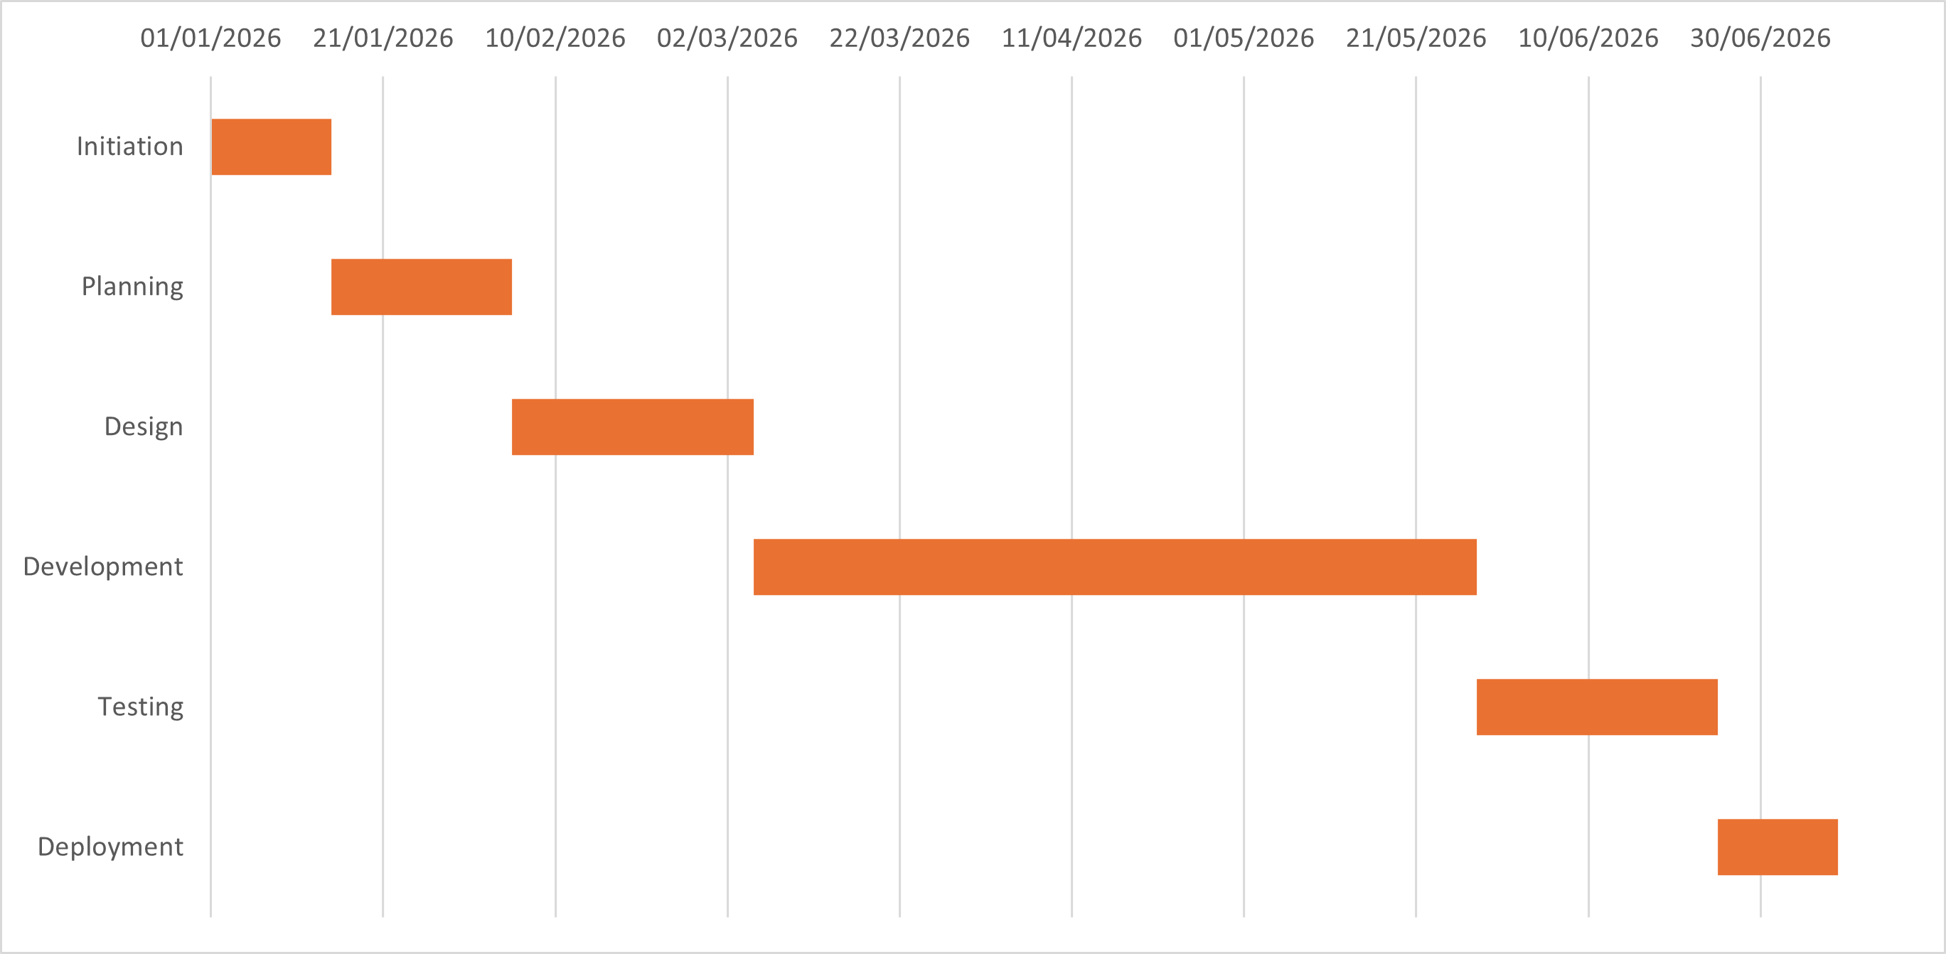
Figue1: Gantt Chart

1.6 Project Constraints
Risk management requires choosing optimal responses, as budget, resource, and schedule constraints prevent implementing every treatment. [3]
In this task the constraints remain:
Time, Budget, Resources, Technical and operational constraints

1.7 Development Method
The hybrid Agile-Waterfall is the most suitable approach for hotel software management projects. Its iterative delivery, stakeholder collaboration, and adaptability ensure effective development of evolving modules such as reservations, billing, housekeeping, POS, and CRM.

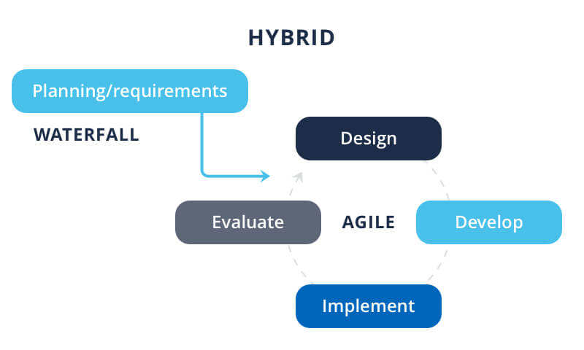

Figure 2 Hybrid Project Management approach azoft.com [4]

Q2 Project Design
Project design in product and project management leverages systems engineering methods such as Model-Based Design Structure Matrix (DSM) to map and analyse relationships and dependencies within complex systems. By enabling bidirectional transformations between system models and DSM representations, this approach enhances understanding, streamlines workflows, and optimizes product development efficiency. [5]
To achieve a system that is easy to operate yet highly resilient, I’ve mapped storyboards for guest and staff experiences and paired them with a network topology that works seamlessly for one property and scales across multiple sites.

Storyboard
The hotel management system streamlines operations across
- Reservations & Check-in: PMS processes bookings with room assignment, payment security, and instant folio activation.
- Housekeeping: Tasks auto-generated at check-out or events, tracked by SLAs, executed via mobile tools, and supervisor-verified.
- Billing & POS: Nightly charges and outlet activity post to folios; compliant invoicing and reconciliation ensure financial accuracy.
- Overbooking & Room Moves: Managed through inventory controls and segmented stays, preserving folio continuity and guest communication.
- Guest Self-Service: Digital check-in, mobile key access, and real-time folio visibility reduce front-desk workload, boost upsell conversion and enhance satisfaction

Network Structure
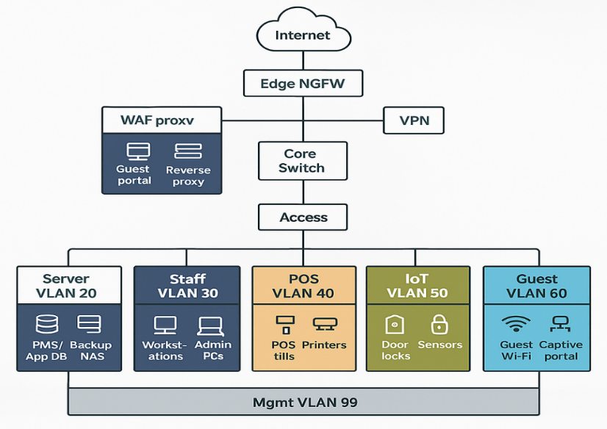

Figure 3 Diagram of Network Structure [6]

TASK2 Enterprise & Innovation

T2 Enterprise

Q1 SWOT & PESTEL
Established in 1946 by James Bullough Lansing, JBL has grown into a global icon in the audio industry, celebrated for its premium speakers, headphones, and sound systems. [7]

SWOT Analysis
SWOT analysis is a widely used strategic tool that evaluates internal strengths and weaknesses alongside external opportunities and threats. Its simplicity and adaptability make it a valuable framework for guiding strategic positioning, decision-making, and planning across organizations, industries, and academic or consulting contexts. [8]

JBL SWOT Analysis
JBL leverages strong brand and product diversity, with growth in audio tech and global markets tempered by competition, counterfeits, and supply chain risks.

Strengths  Strong brand, diverse portfolio, Samsung backing, U.S. market penetration | Weaknesses  High competition, price sensitivity, reliance on parent, commoditized market
Opportunities  Bluetooth LE Audio, sustainability, global expansion, smart integration | Threats  Price wars, counterfeits, supply chain issues, retail shifts, fast tech cycles

Table3 JBL SWOT analysis

JBL PESTEL Analysis
JBL’s audio business is driven by trade regulations, influenced by economic cycles, shaped by lifestyle trends, propelled by technological innovation, guided by sustainability demands, and governed by legal compliance.

FACTOR | KEY IMPACT
Political | Trade tensions, import/export regulations, geopolitical risks
Economic | Inflation, currency shifts, consumer spending cycles
Social | Lifestyle audio demand, youth demographics, streaming culture
Technological | Bluetooth LE Audio, smart integration, rapid innovation cycles
Environmental | Sustainability, energy efficiency, e-waste management
Legal | IP protection, safety compliance, data privacy

Table4 JBL PESTEL analysis

Q2 HOTEL SOFTWARE MANAGEMENT DEVELOPMENT START UP

Tech Start up Name
The name chosen for this project is Smart Hotel
A smart hotel is a technology-enabled hospitality property that leverages internet of things (IoT), AI, and automation to deliver enhanced guest experiences, optimize operations, and promote sustainability.


Business Start-up Logo
A business logo is more than an identifier; it is a symbolic artifact that conveys organizational identity and meaning. As an identity marker, it shapes how employees and external audiences perceive the brand and its environment, particularly during transitions such as mergers. [9]
We have chosen three colours to identify the logo
Blue: means trust, technology
White: often used by health tech and cloud services.
Green: Eco friendly initiative Figure4: Logo

Business Start-up Type
Tech startups are defined by their lifecycle and evolving financial needs. They typically begin with early-stage funding from business angels to support research and development. As they grow, they seek institutional banking, venture capital, corporate investors, banks, and private equity to secure the financial, human, and social capital required for scaling operations and expanding into new markets. [10]
(SaaS) Software as a Service start up remains the best start up business type
Target Market: boutique hotels, midsized chains, resorts

Business Start-up Strategy
A tech startup strategy must balance multiple dimensions to address the challenges of innovation-driven firms. At its core is strategic agility, the ability to adapt quickly to shifting markets and technological change. This agility enables streamlined operations and real-time value co-creation with customers, essential for sustaining competitiveness in dynamic environments. [11]
Find below the business strategy we have chosen to drive our projrct.
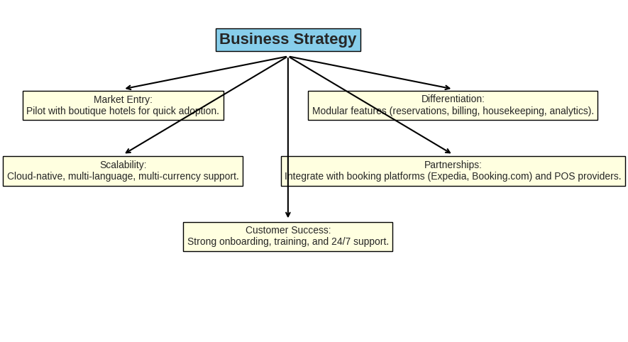
Figue5 Business Strategy Diagram for hotel Startup

Initiatives
- Pilot Program: Collaborate with boutique hotels to refine core features.
- AI Integration: Enable forecasting, dynamic pricing, and personalized guest services.
- Mobile Tools: Provide staff apps for housekeeping, maintenance, and front desk efficiency.
- Sustainability: Monitor energy use and promote eco-friendly practices.
- Analytics: Deliver real-time insights on occupancy, revenue, and guest satisfaction.
These initiatives could help funding the project through the government grant and some multitude funding companies.

TASK3 Project Reflection
Gibb’s reflective cycle is a structured framework that guides reflection through clear stages, helping individuals analyse experiences and learn from their actions and feelings. In nursing education, it was adopted to strengthen students’ reflective journals. While learners initially found the later stages challenging, ongoing feedback and support improved their skills, showing that educator involvement is key to developing effective reflective practice.
Would you like me to make this even more concise say, into a single sentence summary or keep it at this balanced length for clarity? [12]
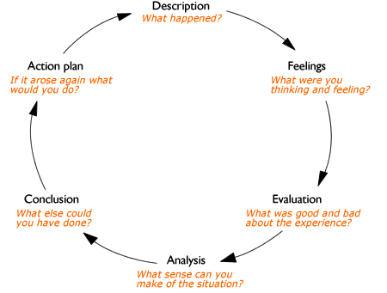
Figure 6 Gibb’s Reflective Cycle

Applying Gibb’s Reflective Cycle to the Project of Hotel Software management development.
Description: The project centred on creating a hotel management system through stakeholder interviews, requirements analysis, and visual tools such as Gantt charts and mind maps, producing outputs like executive summaries, surveys, and branding concepts.
Feelings: Excitement about innovation was tempered by anxiety over simplifying technical detail for non-technical stakeholders; later, satisfaction grew as visuals and concise summaries improved communication, though frustration remained when complex information had to be reduced.
Evaluation: Frameworks, visuals, and surveys boosted stakeholder engagement and improved documentation, though balancing brevity with completeness and adapting technical language remained challenging.
Analysis: Strengths included structured planning, empathy, and modular design, while weaknesses lay in simplifying complex IT concepts; iterative feedback and scenario-based examples were crucial for connecting technical and non-technical perspectives.
Conclusion
The project showed that reflection, feedback, and iteration enhance clarity and stakeholder buy-in, underscoring that effective communication is as essential as technical accuracy.
Action Plan: Refine summaries, use scenarios to connect IT with hotel operations, strengthen visuals, and seek continuous feedback for clarity and depth.

Through this startup project, I aim to strengthen strategic agility, deepen technical expertise in SaaS and AI, and refine project management through pilot hotel collaborations. I will expand business perspicacity via funding and partnerships, advance sustainability practices with eco-friendly modules, and enhance communication and leadership by translating complex technical concepts into clear strategies for diverse stakeholders.
Through the development of technology, sustainability, and leadership skills, this project contributes to society by advancing hospitality experiences, promoting eco-friendly operations, driving economic growth, and empowering communities.
The project’s risks spanning technology integration, data security, costs, adoption, competition, scalability, and compliance can be mitigated through modular design, robust security, phased funding, effective training, niche differentiation, scalable infrastructure, and proactive regulatory alignment.

CONCLUSION
The hotel management system project showed that structured planning, stakeholder engagement, and clear communication alongside technical accuracy are vital for bridging perspectives, ensuring operational effectiveness, and building stakeholder confidence in long-term usability. The project highlights how technology streamlines hospitality management, elevates guest satisfaction, and drives smarter decisions serving as a strategic tool for sustainable growth in the hotel industry

References

[1] | A. Rocha, F. Romero, D. Miranda, M. Amorim and R. M. Lima, “Project management practices to direct and control the project planning and execution in R&D units,” International journal of productivity and quality management, vol. 44, no. 2, pp. 139-159, 2025.
[2] | A. Lester, Project Management, Planning and Control - Managing Engineering, Construction and Manufacturing Projects to PMI, APM and BSI Standards, london: Chantilly: Elsevier, 2021.
[3] | T. W. Kwan and B. Cheung, “Determining and Selecting the Optimal Sets of Risk Treatments under Project Constraints,” in Asia-Pacific Software Engineering Conference, 346-349.
[4] | Azoft. [Online]. Available: www.azoft.com.
[5] | A. Sharon, O. L. de Weck and D. Dori, “Improving Project-Product Lifecycle Management with Model-Based Design Structure Matrix: A joint project management and systems engineering approach,” Systems engineering, vol. 16, no. 4, pp. 413-426, 2013.
[6] | S. D. E. a. J. M. R. Sosa, Design Structure Matrix Methods and Applications, Cambridge: MIT Press, 2013.
[7] | Wikipedia. [Online]. Available: www.wikipedia.com.
[8] | M. M. Helms and J. Nixon, “Exploring SWOT analysis - where are we now?,” journal of strategy and management, vol. 3, no. 3, p. 215, 2010.
[9] | A.-M. Erjansola, L. Virtanen and J. Lipponen, “It Broke My Heart When They Ripped the Old Logo Off the Wall”: Places, Uses and Meanings of the Rebranded Logo,” Corporate reputation review, vol. 28, no. 3, pp. 204-216, 2025.
[10] | S. Singh and B. S. Mungila Hillemane, “Sources of finance for tech startups over its lifecycle: what determines their approach of sources and its success?,” International journal of emerging markets, vol. 18, no. 8, pp. 1766-1787, 2023.
[11] | s. s. ghorbi, H. R. Seresht and A. Moghaddasi, “Identifying Key Drivers of Business Strategy among Technology Entrepreneurs in the Circular Economy,” University of Birjand, vol. 4, no. 3, pp. 31-46, 2025.
[12] | H. Mahlanze, M. Sibiya and S. Govender, “Guided reflection : a valuable tool for improving undergraduate student nurses' levels of reflection : teaching and learning in health care professions,” African journal for physical health education, recreation, and dance, vol. 21, no. 1, pp. 396-408, 2015.

