Module code-BMSW102_LON

Module name -DEVELOPING RELATIONSHIPS AND WORKPLACE ACHIEVEMENTS

Module lecturer- MODAK KOUSHIK
Student name- MARIAN SALCA
Student number-1915301

Contents
Introduction 2
Knowledge, skills and behaviour required for a hr officer 3
Training and development needs for an HR officer 5
Experience achievement as a HR officer 9
Conclusion 11
REFERENCE LIST 12
Appendix 13

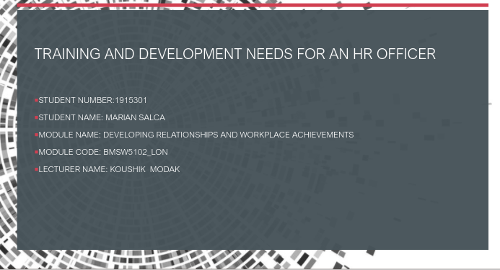

Introduction
Work environment in general requires individuals to work at a high standard and to complete complex task and have to be time and cost effective. To achieve employees have to be skilled and develop existing or new skills by identify the needs for self development. A HR officer ,to be effective at the workplace needs skills and behaviour as:

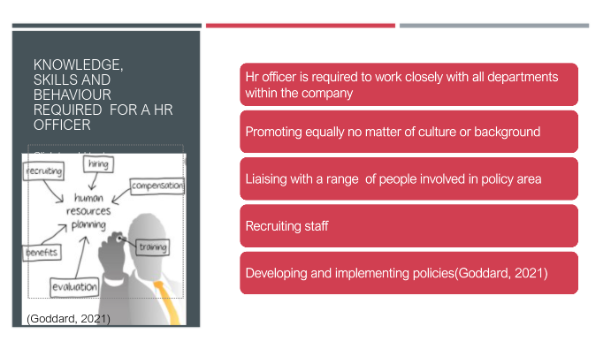

Knowledge, skills and behaviour required for a hr officer

Working with various areas of the company, assisting managers from company in understanding and creating rules and procedures, promote equality and diversity as part of the organization's behaviour are part of the HR officer's responsibilities. Collaborate with the stakeholders interested in policy areas such as employee engagement and health and safety.

Recruiting employees entails creating work requirements and person specifications, writing job advertisements, reviewing application forms, shortlisting, interviewing, and choosing applicants. create and enforce policies on topics such as working conditions, performance management, equal opportunity, disciplinary procedures, and absence management are skills that a manager needs in order to be able to run HR resources efficiently.
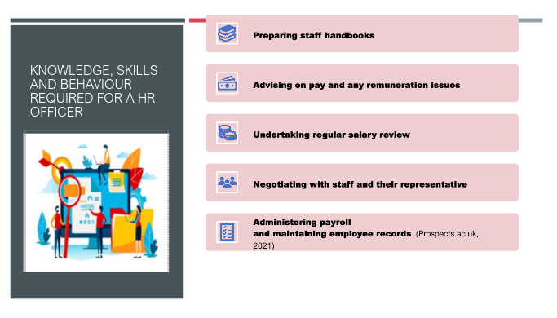An HR officer needs to have the knowledge and skills on how to write handbooks for the employees within the department, a human resources officer must also guide pay and other remuneration matters, such as promotion and benefits. It is very important for an employee to regularly review the salary as their performance might be improved. They expect to be rewarded with an increase in the salary.

Negotiate with the employee and their representative is part of this job role, concerning salaries and working conditions, contracts, and redundancy packages. Administrating payroll and maintaining employee records is also part of the skills and knowledge required for this job. (Prospects.ac.uk, 2021)

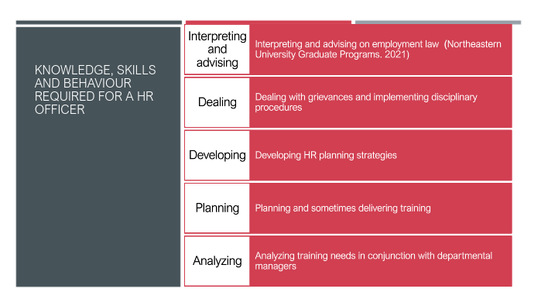
HR executives are responsible of strategically handling employees within an organization while fallowing to laws handling employee rights and employer duties. If an organization not fallows these rules, it puts the company itself in danger. (Northeastern University Graduate Programs, 2021) Where the substantive and procedural fairness of a dismissal is considered, questions such as complaints and administrative procedures are often raised during unfair dismissal proceedings. Good HR practices, on the other hand, should ensure that problems are handled properly from the start, using existing processes, well before the issue of unfair dismissal occurs.

An essential aspect of the HR process in the planning and implementation of an HR strategy. All HR processes and strategies must be implemented as part of a comprehensive people plan that is aligned with and structured to support, the organization's overall strategy and goals. Training, as one of the methods of employee growth, is an excellent way to prepare workers with specific skills or to enable them to complete gaps in their productivity (Shree, 2017). More training offered leads to more benefits to employees, improved skills and capabilities, and more advantages for the organization.

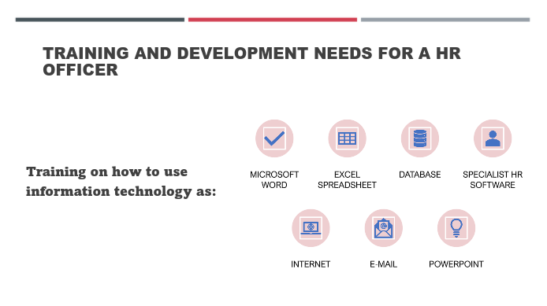

Training and development needs for an HR officer
Appropriate and professional human resources are needed to ensure the development of high-quality statistics as well as the implementation of more productive and reliable production processes based on those statistics. To achieve the aforementioned change and to enable statistical offices to meet the demands of today and tomorrow, proactive human resource management is needed.
HR managers and employees must be able to adapt to emerging technologies as the environment becomes increasingly digital. You're supposed to do more than ever before, whether it's handling information in the cloud, operating on the go with mobile devices and laptops, or connecting with people on social networking sites. (UNECE.org, 2021)
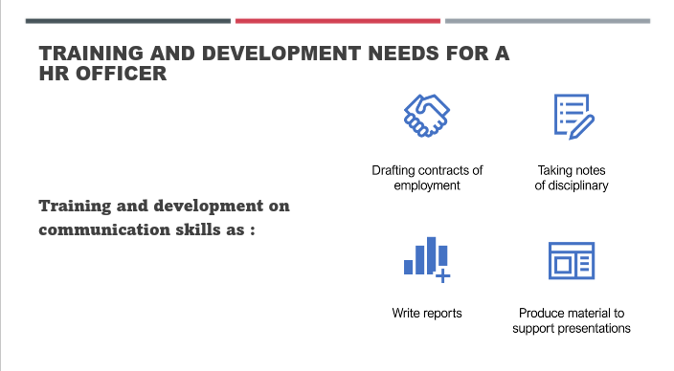
HR is a role that focuses on individuals. HR practitioners, who are responsible for the management of an organization's employees, must be skilled communicators. HR professionals must be able to interact clearly and efficiently with their colleagues in order to overcome disagreement and maintain company values. Good communication is critical in every organization. It facilitates the organization's notification, persuasion, and encouragement processes. Staff must have outstanding organizational verbal exchange competencies in order to achieve great results.

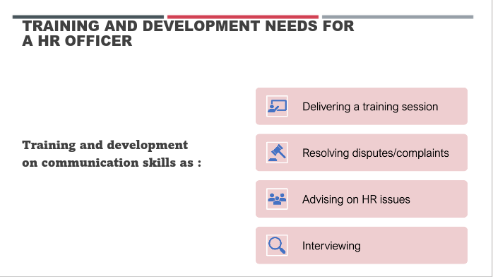
As a result, Oribabor (2004) believes that communication in organizations is necessary for next reasons: empowers employees and motivating them helps to express emotions, and is a toll of communicate information. The purpose of disseminating database within a company is to enable employees to do their tasks efficiently. Awareness ensures a worker's understanding of a group's values and structures. Employment instability is often reduced when employees are well educated. Communication influences member behaviour in a variety of ways.
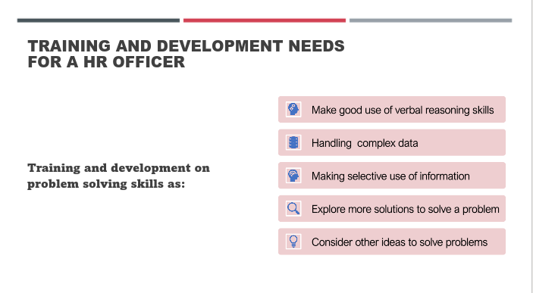
Moreover, the most prosperous businesses face challenges of varying degrees, which, if not addressed properly, can exacerbate inefficiencies, lower employee morale, and result in millions of dollars in lost revenue. Problem-solving is an acquired skill that will win you kudos in senior management circles once you've mastered it. If you develop a strong problem-solving ability, you might be able to increase your earning potential or gain a seat at the strategy table.

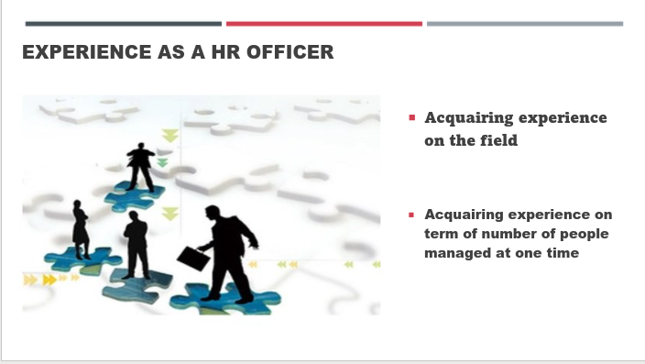

Experience achievement as a HR officer

To gain more experience, as an HR officer, you must be transparent that you want to gain more professional experience in a sector that interests you and that, for the time being, you're willing to do extra work on your own time and for no extra pay. Working harder for a year or two to learn new skills is an investment in your future, even though it requires more time.

A well-trained HR officer could have multiple benefits from developing itself not only for the company but also for himself. Strategic management, managing wages accordingly for each employee, managing safety and risk at the workplace, minimizing liability issues are tasks that an HR officer could do effectively by being trained appropriately. 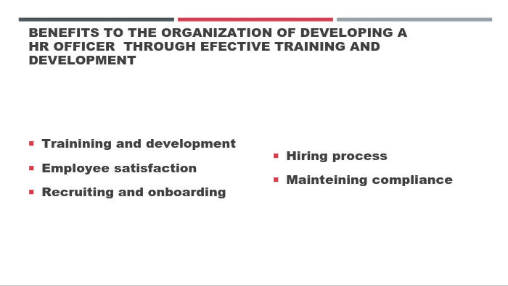
Employees within a company will benefit from effective training and development increasing their satisfaction at the workplace. A well trained HR manager will recruit the right people for the job role from which the company will benefit.

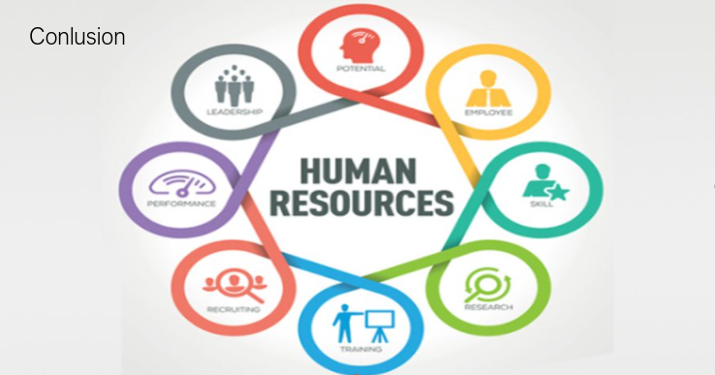

Conclusion
Identifying the skills needed of an HR officer, having a review on what skills have to be improved is part of the development plan. Improving and adding new skills will benefit the company, the employees, and the HR representative in the company.

REFERENCE LIST

Goddard, W., 2021. Why Is Human Resource Planning Important? - ITChronicles. [online] ITChronicles. Available at: <https://itchronicles.com/human-resources/why-is-human-resource-planning-important/> [Accessed 3 May 2021].
Northeastern University Graduate Programs. 2021. Laws Every HR Professional Should Know. [online] Available at: <https://www.northeastern.edu/graduate/blog/hr-laws-to-know/> [Accessed 3 May,2021].
Oribabor P.E. (2003). Management Theory Jungle: Where We Are. Ile-Ife: Obafemi Awolowo University Press
Prospects.ac.uk. 2021. Human resources officer job profile | Prospects.ac.uk. [online] Available at: <https://www.prospects.ac.uk/job-profiles/human-resources-officer> [Accessed 3 May 2021].
Shree, S. (2017). Investigating training through the lens of dramatic possibilities, Industrial and Commercial Training, 49(4), 157-163.
Unece.org. 2021. [online] Available at: <https://unece.org/DAM/stats/publications/HRMT_w_cover_resized.pdf> [Accessed 3 May 2021].

Appendix



