

Assessing a buildings life cycle through the use of different environmental calculation programs
By
Sebastian Samuel Swezey DeCurtins
P147474

Table of content

Chapter 1 . . . . . . . . . . . . . . . . . . . . . . . . . . . . . . . . . . . . . . . . . . . . . . . . . . . . . . . . . . .3

Introduction . . . . . . . . . . . . . . . . . . . . . . . . . . . . . . . . . . . . . . . . . . . . . . . . . . . . . . . . .3

1.2 Key Definitions . . . . . . . . . . . . . . . . . . . . . . . . . . . . . . . . . . . . . . . . . . . . . . . . . . . .3

Life Cycle Assessment . . . . . . . . . . . . . . . . . . . . . . . . . . . . . . . . . . . . . . . . . . . . . . . .3

Carbon footprint . . . . . . . . . . . . . . . . . . . . . . . . . . . . . . . . . . . . . . . . . . . . . . . . . . . . . 4

Chapter 2: Assessments . . . . . . . . . . . . . . . . . . . . . . . . . . . . . . . . . . . . . . . . . . . . . . .4

2.1 BREEAM . . . . . . . . . . . . . . . . . . . . . . . . . . . . . . . . . . . . . . . . . . . . . . . . . . . . . . . .4

2.2 LEED . . . . . . . . . . . . . . . . . . . . . . . . . . . . . . . . . . . . . . . . . . . . . . . . . . . . . . . . . . .4

2.3 Passivhaus . . . . . . . . . . . . . . . . . . . . . . . . . . . . . . . . . . . . . . . . . . . . . . . . . . . . . . 5

Chapter 3 an evaluation of Life Cycle Assessments . . . . . . . . . . . . . . . . . . . . . . . . . .5

3.1 BREEAM Life cycle assessment . . . . . . . . . . . . . . . . . . . . . . . . . . . . . . . . . . . . . .5

3.2 LEED life cycle assessment . . . . . . . . . . . . . . . . . . . . . . . . . . . . . . . . . . . . . . . . . 7

3.2.1 Option 1 Historic building reuse: . . . . . . . . . . . . . . . . . . . . . . . . . . . . . . . . . . . . .7

3.2.2 Option 2 renovation of abandoned or blighted building: . . . . . . . . . . . . . . . . . . .7

3.2.3 Option 3 building and material reuse: . . . . . . . . . . . . . . . . . . . . . . . . . . . . . . . . .7

3.2.4 option 4 hole-building life-cycle assessment: . . . . . . . . . . . . . . . . . . . . . . . . . . .8

3.3 Passivhaus Life cycle assessment . . . . . . . . . . . . . . . . . . . . . . . . . . . . . . . . . . . . 8

Chapter 4 Conclusion . . . . . . . . . . . . . . . . . . . . . . . . . . . . . . . . . . . . . . . . . . . . . . . . . 8

Bibliography . . . . . . . . . . . . . . . . . . . . . . . . . . . . . . . . . . . . . . . . . . . . . . . . . . . . . . . . .9

Chapter 1

Introduction

In the past 25 years, the use of limited resources and the impact of their continuous usage has been a central topic of conversation in every industry. The construction industry is one of the biggest impacts on the environment due to the use of non-renewable materials involved in every step of a construction process. Everything from the land use, energy, waste caused by demolition and the disposal of said waste have a big impact on the environment. This Paper seeks to analyse three of the main construction assessments programs and observe how they each deal with the Life Cycle Assessment (LCA). The first sustainability assessment program that will be analysed is BREEAM. Building Research Establishment Environmental Assessment Method or BREEAM for short is an establishment which assesse, rates and certifies the sustainability of buildings. There main objective is to reduce the life cycle that buildings have on the environment. This helps us understand how much energy and resources where used to build and maintain the building. Secondly we will analyse LEED is currently the most widely used green building rating system thought the world. LEED similar to BREEAM provide a certification recognizing the impact that a building has on the environment. Finally Passivehaus is a German institute that seeks to improve the energy consumption of buildings by focusing mostly on the design of the building, things such as orientation, shapes and insulation are very important to achieve a passivhaus certificate.

1.2 Key Definitions

    - Life Cycle Assessment

Life Cycle Assessment (LCA) is deﬁned as “the compilation and evaluation of the inputs, outputs and the potential environmental in-pacts of a product system throughout its life cycle” (ISO, 2006d). This system moves from a separate study of every individual element of production to an overall view, where every part of the process is taken into account. Starting at raw material extraction to end of life disposal. This analysis is also commonly known as “Cradle to Grave” or “Cradle to Cradle” by recycling or reusing materials. It is important to acknowledge that the application of a Life cycle assessment will not guarantee the reduction of energy consumption or carbon emissions, nonetheless it will highlight the weak points of the manufacturing process and will recognise potential improvements of management. The Life cycle assessment is divided in four main areas: Goal and scope, Life Cycle Inventory, Life Cycle Impact Assessment and Life Cycle Improvement.
Areas:

1) Goal and Scope: In this phase the investigated product, the system boundaries and the data sources are described; the functional unit used in the analysis is defined as well. (Proietti et al., 2013)
2) Life Cycle Inventory LCI: In this phase a data-based process of quantifying energy and raw material supplies such as air emissions, water, solid waste and other environmental releases acquired thought the life cycle of a product, process or activity. (Proietti et al., 2013)

3) Life Cycle Impact Assessment LCIA: In this phase a quantitative and or qualitative technical process is determined which characterizes the effect of the environmental loadings in the list of components
4) Life Cycle Improvement: a systematic assessment of the needs and opportunities to reduce environmental problems associated with the materials and construction.
1.1.2 Carbon footprint
Carbon footprint (CF) is a process used to quantify the amount of green-house gas emissions. The carbon footprint can be of a company known as Corporate Carbon Footprint (CCF), it can be associated with a certain product (PCF). This serves the purpose to determine the contribution to climate change (Fullana et al., 2008). It is important to note that Carbon footprint not only involves CO2 emissions but also other green-house gasses which also contribute to global warming. When taking into account other green-house gases it is important to convert each individual result to CO2 equivalents. In the case of a products carbon footprint it can be seen as a limited version of a Life cycle assessment and can be used as a life cycle assessment representation (Baitzet al., 2013; Bala et al., 2010).

Chapter 2: Assessments

2.1 BREEAM

Building Research Establishment Environmental Assessment Method or BREEAM for short is the most used building environmental rating scheme in the U.K. Even though BREEAM is a voluntary scheme the energy assessment adopts the U.K. building regulations as a benchmark with the aim to improve performance. BREEAM uses a rating system which defines categories and awards credits according to the impact that the building has on the environment (Stroma Tech, 2018). BREEAM’S categories are as follow: Management (MAN), Health & Wellbeing (HEA), Acoustic Performance., Energy (ENE), Transport (TRA), Water (WAT), Materials (MAT), Waste (WST), Land Use & Ecology (LE), Pollution (POL), and Innovation (INN). Each category has a different value and percentage to the overall scoring, once the total score is calculated the building can be granted one of the following performance achievement Unclassified (<30), Pass (≥30), Good (≥45), Very Good (≥55), Excellent (≥70) and Outstanding (≥85). For each category, there are a minimum number of credits that must be achieved. For example: The energy assessment in BREEAM is Ene1 and focusses on the reduction of CO2 emissions. On this category there are 15 credits to be achieved, if the building focuses and shows an improvement on energy efficiency it is more likely to be granted the full credits (Stroma Tech, 2018).

2.2 LEED

Leadership in Energy and Environmental Design or LEED for short is the most recognised environmental scheme worldwide. Similar to BREEAM, LEED is based on a set requirements and credits. Each credit discusses one of these aspects. These are the following credits: Water efficiency, sustainable sites, energy and atmosphere, indoor environmental quality, materials and resources and design process. Each credit can be awarded with one point except for energy performance and renewable energy, both of these can be awarded with numerous points. There are sixty-nine points that can be awarded. Based on the amount of points given there are four levels of qualifications, from twenty six to thirty two the building is certified. From thirty three to thirty eight the building is classified as silver. From thirty nine to fifty one the building is Gold and finally from fifty two to sixty nine the building is classified as a Platinum building (Freitas and Zhang, 2018).

2.3 Passivhaus
Passive house refers to a construction standard which focuses on building with a very low energy use and a higher internal comfort condition. The term passive when discussing about the construction industry refers to a building which reduces the amount of heat loss and focuses on the heat gains that can be achieved by natural ways. It is capable of doing this thanks to the design and materials that the building uses. A passive house requires that the heating should be lower than 15 kWh/m2 year, this is about 75% less than a standard construction designed per the building regulations. Passive construction can allow a reduction of up to 90% of the energy demand of the typical Central European building stock. Passive housing are also very useful in countries that face warmer climates. This is since in countries with higher temperatures there is also an energy consumption when it comes to cooling the houses, a passive design can easily minimize the effort and energy (Proietti et al., 2018). The passive house concept was first developed in Sweden, from collaboration between Bo Adamson of Lund University and Dr. Wolfgang Feist. This type of buildings were mainly built in Germany (the first passive house was built in 1991 in Darmstadt Kranichstein by Dr. Feist; the energy demand amounts to an average of 10 kWh/m2 year and has remained stable for 15 years) (Passipedia.org, 2018).

Chapter 3 an evaluation of Life Cycle Assessments

3.1 BREEAM Life cycle assessment
The life cycle assessment within BREEAM can be found in the Materials category. It aims to recognise and encourage the use of construction materials with a low environmental impact (including embodied carbon) over the full life cycle of the building. BREEAM awards credits based on the building’s quantified environmental life cycle impact through assessment of the main building elements, as set out on the table below (Breeam.com, 2018)

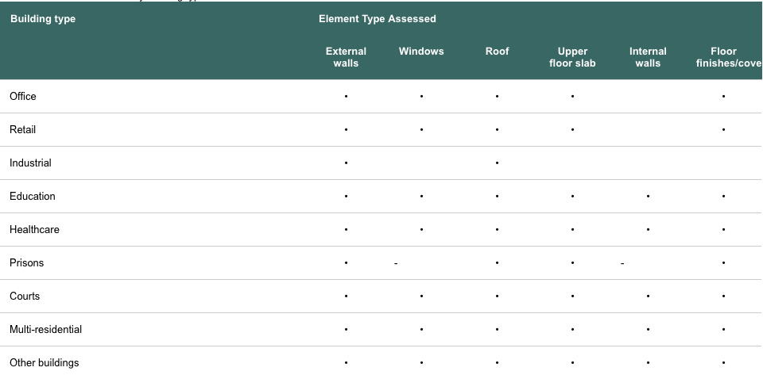
Credits are awarded on the total number of points achieved. The table below indicates the points one can achieve. It is important to note the these are calculated using the BREEAM Mat01 calculator, which is based on the Green Guide ratings (Breeam.com, 2018)

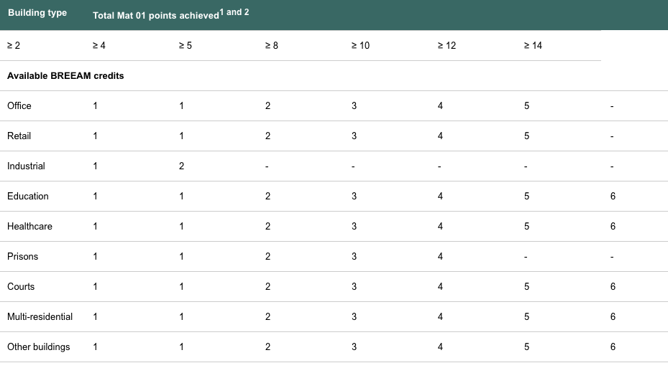
The first step is translating the green guide rating into points. The table blow shows what each value on the green guide rating system translate to BREEAM points.
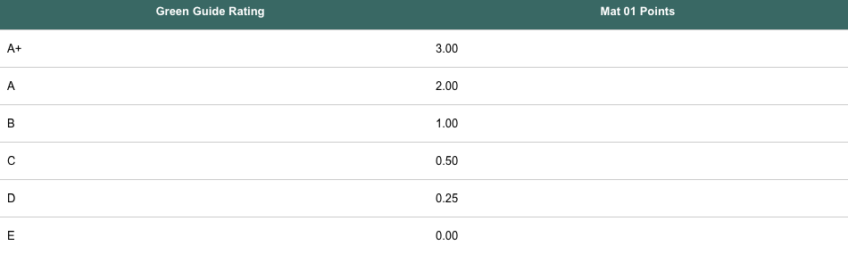
Once that step is completed the next step is to weighing the performance of each individual specification an element category. The table below demonstrates an example of an external wall and how this is calculated. Important to observe the percentages.
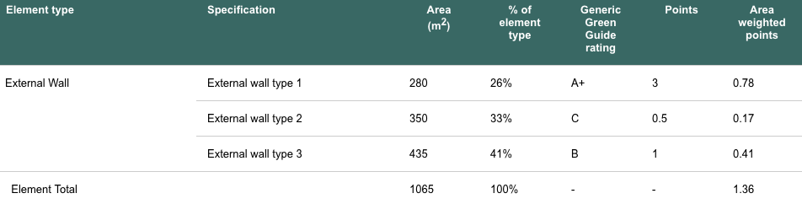 (Breeam.com, 2018)

Step three, Weighting the performance of individual elements relative to all elements assessed
Weights the performance of the building elements based on its area relative to the overall area of the different elements. This is done by multiplying the area of each element by the weighted Green Guide score, adding the total for all elements and then dividing by the total area of the assessed elements. (Breeam.com, 2018
3.2 LEED life cycle assessment

Similar to BREEAM the life cycle assessment points can be found in the MR category within LEED. LEED has prompted market transformation of construction products by generating a cycle of consumer requests and industry delivery of products which are more environmentally friendly. This includes responsibly harvested wood to increase the recycle content to bio-based materials. A common example and one used on LEEDS web page is the following: cabinets made of wheat husks sourced from all over the country and bound together in resin versus solid wood cabinets made from local timber. Life-cycle assessment (LCA) provides a more comprehensive picture of materials and products, enabling project teams to make more informed decisions that will have greater overall benefit for the environmental, human health, and communities, while encouraging manufacturers to improve their products through innovation. (New.usgbc.org, 2018) There are five possible points to be awarded when it comes to the life cycle assessment on LEED and there are a total of four options in which one can achieve these five points.

3.2.1 Option 1 Historic building reuse:

The first option is to maintain the existing buildings structure, envelop and interior non-structural elements of a historic building. Therefore, this option is mostly used when dealing with a building which already exists and is listed or with a possibility of it being listed. (New.usgbc.org, 2018)

3.2.2 Option 2 renovation of abandoned or blighted building:

To gain five points the option two states that at least 50% of the surface are of the existing building structure, enclosure, and interior structural elements for buildings that meet local criteria of abandoned. The said building must be renovated to a state of occupancy. Up to 25% of the construction surface may be excluded from this criteria if there is problem with deterioration and or damage. (New.usgbc.org, 2018)

3.2.3 Option 3 building and material reuse:

It is important to note that in option three only two to four points can be awarded. This option requires the reuse or salvage building materials from off site or on site and will depend on a percentage of surface area, as listed in the table below. This includes structural elements such as floors and roof decking’s, enclosure materials such as skin and framing and permanently installed interior elements such as walls, doors, floor coverings and ceilings. This excludes windows and any other material that has the potential of being hazardous. (New.usgbc.org, 2018)

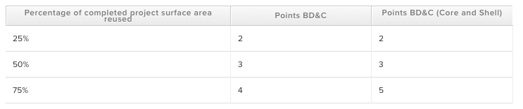

3.2.4 option 4 hole-building life-cycle assessment:

Three points may be awarded if option four is used. For new construction (buildings or portions of buildings), conduct a life-cycle assessment of the project’s structure and enclosure that demonstrates a minimum of 10% reduction, compared with a baseline building, in at least three of the six impact categories listed below, one of which must be global warming potential. No impact category assessed as part of the life-cycle assessment may increase by more than 5% compared with the baseline building. (New.usgbc.org, 2018)

3.3 Passivhaus Life cycle assessment

Due to passivhaus not being as systematic as both BREEAM and LEED it is hard to compare, as previously mentioned the passivhaus gains its title by the reduction of energy use once the building is constructed. And therefore, one of the main problems when evaluating the impact on the environment that a passivhaus has over a BREEAM certified is difficult. Nonetheless there are many ways in which a passivhaus can still have a very low impact in its construction process. Even though it may not be as systematic as BREEAM it may still use BREEAM or LEED as a guide to calculate different materials. As passivhaus aims to have a close to zero carbon footprint it is very common for most passive houses to use photovoltaic system on environmental indicators, performing a balance between the impacts of production, maintenance and disposal of the plant, and the avoided emissions relative to electricity produced from renewable solar source (Proietti et al., 2013)

Chapter 4 Conclusion

Conclusion

As mentioned previously it is easier to compare how BREEAM and LEED face the life cycle assessment due to the more methodical nature of the scheme even though there are notable differences between both schemes. It is often said that LEED is a simpler version of BREEAM and that is considered a weakness, this inferring that people would go for LEED over BREEAM to achieve a higher building status. When it comes to the life cycle assessment there is not much to say about passivhaus. It may be that a passive house will have a smaller environmental impact but that of course is only when the building is being used. Therefore to increment the energy efficiency of any further constructions what is recommended is to mix the ideals of these three schemes. Making it easier for people to get involved and calculate their carbon footprint whilst taking a lot in consideration the building design and creating a passive design whilst like BREEAM focusing on materials, water, land and other important aspects that may not be taken into account.

Bibliography

Balaguera, A., Carvajal, G., Albertí, J. and Fullana-i-Palmer, P. (2018). Life cycle assessment of road construction alternative materials: A literature review. Resources, Conservation and Recycling, 132, pp.37-48.
Breeam.com. (2018). Materials. [online] Available at: https://www.breeam.com/BREEAM2011SchemeDocument/content/09_material/mat01_general.htm [Accessed 21 Nov. 2018].
Freitas, I. and Zhang, X. (2018). Green building rating systems in Swedish market - A comparative analysis between LEED, BREEAM SE, GreenBuilding and Miljöbyggnad. Energy Procedia, 153, pp.402-407.
Gbci.org. (2018). Whole building life cycle assessment through LEED v4 | GBCI. [online] Available at: http://www.gbci.org/whole-building-life-cycle-assessment-through-leed-v4 [Accessed 21 Nov. 2018].
https://www.edie.net/. (2018). LEED vs BREEAM: What's best?. [online] Available at: https://www.edie.net/library/LEED-vs-BREEAM-Whats-best/6124 [Accessed 21 Nov. 2018].
Kesidou, S. and Sorrell, S. (2018). Low-carbon innovation in non-domestic buildings: The importance of supply chain integration. Energy Research & Social Science, 45, pp.195-213.
Lee, J. (2014). A Study on Comparing and Analyzing Domestic and Foreign Green Building Certification Criteria for School Facility -Focused on the G-SEED and LEED, BREEAM-. The Journal of Educational Environment Research, 13(3), pp.15-22.
New.usgbc.org. (2018). LEED v4: Building Design + Construction Guide | USGBC. [online] Available at: https://new.usgbc.org/guide/bdc [Accessed 21 Nov. 2018].
Passipedia.org. (2018). The Passive House – historical review [ ]. [online] Available at: https://passipedia.org/basics/the_passive_house_-_historical_review [Accessed 21 Nov. 2018].
Passipedia.org. (2018). The Passive House – historical review [ ]. [online] Available at: https://passipedia.org/basics/the_passive_house_-_historical_review [Accessed 21 Nov. 2018].
Proietti, S., Sdringola, P., Desideri, U., Zepparelli, F., Masciarelli, F. and Castellani, F. (2018). Life Cycle Assessment of a passive house in a seismic temperate zone.
Proietti, S., Sdringola, P., Desideri, U., Zepparelli, F., Masciarelli, F. and Castellani, F. (2013). Life Cycle Assessment of a passive house in a seismic temperate zone. Energy and Buildings, 64, pp.463-472.
Seinre, E., Kurnitski, J. and Voll, H. (2014). Building sustainability objective assessment in Estonian context and a comparative evaluation with LEED and BREEAM. Building and Environment, 82, pp.110-120.
Yoon, E. and Lim, Y. (2016). A Study on Green Building Certification Criteria for Healthcare Facilities - Focused on System and Contents for Healthcare in BREEAM, LEED, CASBEE. Journal of The Korea Institute of Healthcare Architecture, 22(3), pp.17-26.

