Megan Phillips.
Surface Pattern Design
P149400
Dissertation Tutor: Ainsley Hillard
Dissertation Title:

Could traditional embroidery go hand in hand with mechanically produced embroidery? If so, would this create a new birth of ‘’Aura’’ within the textile industry?

Content Page:
Content: | Page Numbers:
Introduction. | p.3 – p.6
Chapter 1. | p.6 – p.14
Chapter 2. | p.14 – p.22
Conclusion. | p.22 – p.25

Could traditional embroidery go hand in hand with mechanically produced embroidery? If so, would this create a new birth of ‘’Aura’’ within the textile industry?

Introduction

This essay will explore the art of embroidery and embellishment in the 21st century, concentrating on the Industrial Revolution and its effect on this traditional craft. Considering the historic background of embroidery, the essay will question if the ethical and handmade ideals enhance its beauty or whether this beauty has been lost due to the lack of touch after these mechanical changes were made.

Focusing on the use of embroidery in contemporary textiles and channelling Walter Benjamin’s theory of the aura, ‘’Historically, works of art had an ‘aura’ – an appearance of magical or supernatural force arising from their uniqueness (Robinson, 2013)’. This ‘Aura’ seems to have been disregarded over time, perhaps due to the reproduction of art. This essay will consider the uniqueness and almost exclusivity that comes with authentic pieces of textiles, or in this case, hand embroidery. In the book The Art of Embroidery this skill is described as such; ‘’Among the textile arts embroidery is unique, a law unto itself. Its sole purpose it to adorn and it brooks no limitation of this function’’ (Schuette & Christensen, 2006, p. xIII). Although this could be seen as the main function behind embroidery, there is such power and symbolism behind the simple practice that elevate it almost into an ‘’Aura’’ in itself.
Another theoretical depiction of this embellishment is suggested in The art of Embroidery- Inspirational stitches, textures and surfaces ‘’To embroider is to express yourself, as you progress, your initial ideas will need to be extended, enriched, refined and connected to other ideas’’ (Teller – Loumagne, 2008 p.9). This expression through the hand is one of the most prominent notions behind embroidery, particularly the idea of extending and enriching the initial thoughts of the maker; almost suggesting that the hand embroidery takes control and expresses through its own development which wouldn’t necessarily be possible with a digital embroidery file that is unable to change within its journey.

The writing will be separated into two chapters; Chapter One will highlight the importance of the hand and the personal traces within hand stitching; underlining the labour and time invested into each embroidered piece. This is expanded in the book Hand Stitched – Perspective;
Many revel in the pleasure of working with their hands in an age of overarching technology. They delight in the simple act of working a piece of stitch in the hand (Kettle & McKeating, 2012. P.11).

The intimacy between the maker and the piece of embroidery is instantly elevated with the simple element of personal touch; almost as if the makers leave their own spiritual impression upon their work with their hands. The reference to the ‘’age of overarching technology’’ almost furthers the importance and pleasure for the makers to work within their hands, as this is often disregarded with the growing use of digital and machine embroidery in the age of Mechanical Reproduction. This will link to the additional section of Chapter One, where the essay with lead towards to the changes of embroidery as a result of the Industrial Revolution, where we saw a high decline in the use of the hand in craftsmanship as a result of faster and more efficient approach.

Referring to the beliefs of Richard Sennett in The Craftsman on the notion of the digital age the chapter will consider both handmade embroidery and digital embroidery that has developed post Industrial Revolution and consider the idea of a compromise between the two. ‘’The seduction of CAD lies in its speed, the fact it never tires’’ (Sennett, 2008, P. 81). Could makers and designers indulge in this seduction of digital embroidery while reflecting on the contextual history, symbolism and handmade element to traditional hand embroidery?

The second chapter of the essay will focus on contemporary designers that take inspiration from the handmade concept and apply this to their work as a gesture towards the historic context behind embroidery. Referencing textile designers Belinda Polit; a designer who pushes conventional embroidery into the unknown, creating embroidery at such a miniscule scale that she is unaware of the outcome until she has completed her last stitch. (Kettle & Mceating, 2012, p. 100) This contemporary way of working with stitch by using the miniature size elevates traditional embroidery but the handmade and wholesome feel to the work remains with the uncertainty of the outcome. Juxtaposing the rigid precision of digital machine embroidery that often lacks individuality.
Another textile maker referenced in this chapter is Orly Cogan; who reimagines vintage pieces of embroidery with contemporary designs with meaningful contextual backgrounds, as she explains in her artist statement;
Through my own hand stitching I update the content of the vintage embroidery to incorporate the unladylike reality and wit of contemporary women; their struggles and the stereotypes which must now be overcome. (Cogan, 2018)
This collaboration between the traditional hand embroidery technique and the current political and social views of woman, elevate this maker’s use of embroidery to a different standard. No longer using embroidery simply to adorn, but to make political statements; almost as a subtle form of protest. The use of the vintage embroidery pieces almost creates a stitched bond between two makers of different eras; joining women’s stories through embroidery and passing the work through different hands, enriching the ‘’Aura’’ and spiritual existence to the embroidery.
Throughout this chapter, there will be reference to the Schiffili Project; a machine that is able to reproduce and repeat single embroidery patterns up to 80 times in a single use; but the embroidery needles are all controlled by the movements and drawings of the hand, demonstrated in this short video; (https://www.youtube.com/watch?v=yxnY4kAxv_I ,Schiffili Machine, 2006). Could this be reintroduced to the textile industry? Creating the perfect solution to the breach between tradition and mechanical?
As a textile designer myself, with high interest in both hand and machine embroidery in my work and studies, this essay will support me in discovering a way of including both traditional and contemporary methods of embroidery in my work. Through researching contemporary artists and considering the methodology and moral context of literary thinkers it will perhaps blossom my knowledge and conclude in a the old and the new existing hand in hand.
Chapter 1;
This chapter of the essay with explain the physical skill behind hand embroidery; emphasising the time and labour invested into each hand stitch, therefor enriching the textile piece with the element of handmade. Although embroidery has a lengthy historical background, some dating back to 1323 B.C. (TRC Needles, 2017), one of the most prominent features that have been lost is the traditional symbolism and linguistic identification that originated through embroidery. This will be considered throughout the chapter, questioning weather traditional hand embroidery has lost its value due to the loss of historic symbolism, or weather this beauty has survived through time but is displayed through a different kind of Aura.

The traditional aspects of this craft will also be cross-referenced with the effect of the Industrial Revolutionary developments that have changed the way in with the maker connects and handles their textile work. The key points of this chapter will be highlighting the differences between authentic handmade embroidery and the embroidery resulted from a digital machine; questioning whether these must be segregated or if they can be joined together in the middle; creating a compromise.

When considering and appreciating embroidery as a craft, it’s important to grasp the time and labour that goes into the skill; with some makers investing hundreds of hours completing a piece that could be completed twice as fast with a machine. It is explained in the book Hand Stitch- Perspectives, ‘’hand stitching takes time. That is not only the time it takes to complete, but also one’s own time spent in learning how to make stitch ac as a mark to develop concept’’ (Kettle & McKeating, 2012, p. 90). Taking this into consideration, why would a craftsman make such a time-consuming investment to create something a digital programme could create in a more efficient way? This could be answered with many explanations.

One way to understand the time and efforts that go into hand embroidery is the importance of the hand. In The Craftsman, Richard Sennett explains that ‘’Immanuel Kant casually remarked... The hand is the window to the mind’’ (Sennett, 2008, P.149) This parallels beautifully with the reason why we make anything. The use of the hand enables us to project our thought into the real world, including mistakes, changes in thought and self-improvement. By removing this personal connection from the embroidered work, some could argue that everything created on a digital machine has less richness and soul. This is not stating that these digitally created pieces are in any way less physically beautiful, but the lack of the personal touch and intimacy could diminish the appreciation of the craft, as not as much thought and effort is invested into them.

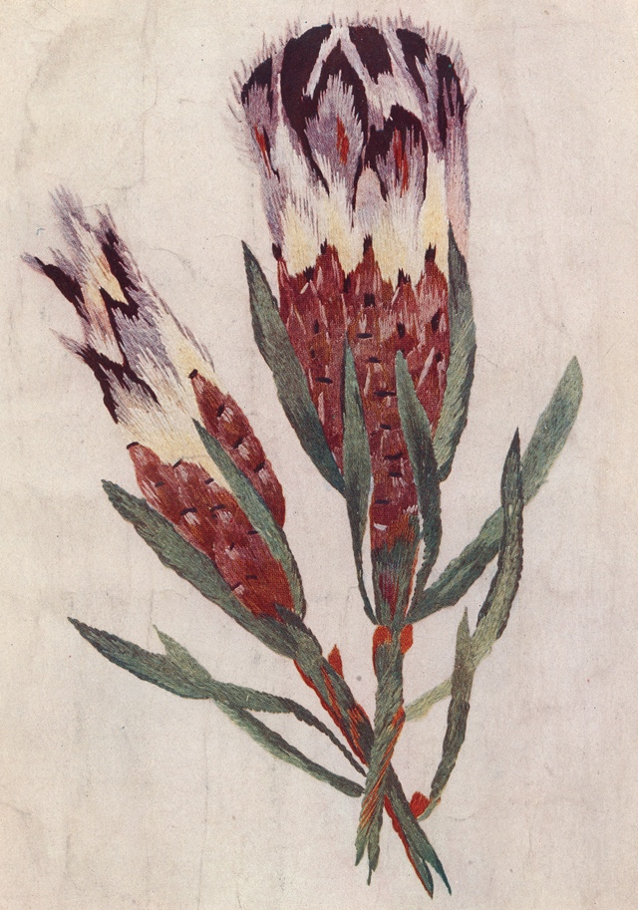
Florence Caulfield was a hand embroidery specialist from South Africa in the 1900s and although having great success with her finished work, some being sold to royals, she “preferred to hold the work in her hand rather than use an embroidery frame.” (V&A, 2012) This, furthers the importance of the physical and spiritual connection that is made with the

(Image 1: Florence Caulfield, The Illustrated Needlework Book, 1914)

maker and their embroidery piece, where they have invested such an amount of time into the garment, that they feel a physical connection between them. While studying Caulfield’s embroidery piece demonstrated as Image 1, the intricacy and detail although beautiful to the eye, seems to hold some kind of spiritual presence of the past. Imagining her investing hundreds of hours with the cloth touching and embracing her working hands.

This assembly could not be replicated with a digital machine. These ideals could be linked to the theories of Edward T Hall ‘‘Personal space develops in a culture as part of an individual’s mobile territory, a territorial domain associated with one’s physical body but extending beyond it’’ (Hall, 1996).
This highlights the intimacy associated with embroidery, the craft maker invests so much of their time into building the piece, it becomes a part of them; thus becoming a ‘territorial’
object, which could juxtapose the speed and impersonality between a maker and a digital embroidered piece that has been uploaded and left to complete by itself.

The official description of digital embroidery machinery itself almost underlines the lack of personal connection that goes into the work;

The efficiency and convenience of machines allows designs of superlative creative design to be formed. All you need to do is to design the picture on a computer. The embroidery machine will do the rest (Dall, 2014)

This, although the faster and easier option, almost diminishes the integrity behind hand embroidery; as if there is no longer need for the traditional skill, as you can simply upload your artwork and a machine will complete the stitches instantly and perfectly. This also highlights the idea that it is very easy to create dozens of the same image, mirroring each other faultlessly. Some argue that experiencing the replica of a piece of art does not compare to the authenticity when holding the original. Benjamin argued that '’even the most perfect reproduction of a work of art is lacking in one element: Its presence in time and space’’ (Tate, 2018). These beliefs link closely to the loss of skill in embroidery work today; where these embellished pieces would be abounding with historic meaning and magical references only to be used for its synthetic yet aesthetically beautiful element today. The lack of historic and physical touch almost results in the absence of presence in the textiles, leaving behind the physical beauty only; almost disregarding the initial reason of the origin of embroidery.

One element in specific that divides the handmade with the mechanically produced is the sense of uniqueness and individuality that is achieved with hand stitched embroidery. Historically, embroidery was used as a sort of private language between different tribes.
This was at a time when our ancestors had a close magical connection with the world of Nature: plants, animals, fields and heavenly bodies. They drew their destiny using symbols of the Sun, Earth, Universe and Family, reproducing them on fabrics, creating mysterious ancestral symbols as amulets, as a kind of family code (Chraibi, 2016)

This sense of connectivity and mythology that historically paralleled with embroidery stresses the strong contextual background that has been lost over time. Where embroidery was once used as individual linguistic cyphers to connect with families and has now developed into merely an aesthetically beautiful adorning technique in some cases. The strong reference to nature elevates the power and authority that was invested into cloth as stitched pattern. Where today we see many businesses and textile makers using embroidery as only a decoration technique, disregarding its rich and linguistic background.
The individuality in the embroidery of different families is emphasised further; “It is interesting to note that embroiderers did not copy other people’s patterns” (Chraibi, 2016) This simply elevates the idea of intimacy between the maker and the embroidery that used to exist, in this case in Ukrainian families and tribes, even predicting their destiny and drawing the energy from the natural world and injecting it into their embroidered garments.

This is often lost in the embroidery work today, but what remains is the handmade ideals behind the context, where makers continue to draw inspiration from the natural world in their embroidered patterns, although the literal symbolism and the correlating meaning behind the symbols aren’t often understood.

As well as symbolism from the natural world, traditional embroidery used to contain many symbolic shapes that included more depth behind them that what meets the eye. One of the main symbols that historically appeared in embroidered garments was the Circle; a primary symbol that represents the Sun, a mark of life-giving energy. ‘’The circle symbolizes eternity as it has no beginning or end’’ (Allan, 2017). A Symbol of flawlessness, which focuses on the clarity of hand embroidery. A technique that has remained pure to craftsmanship over time, demonstrating the humble and modest elements of life that we should celebrate. The circle also symbolizes the intimacy in embroidery, referencing back to Florence Caulfield, who insisted on keeping her embroidery close to her hands, the circle invites the viewer to be drawn in and to be ‘’included in the experience’’ (Allan, 2017) of what it holds inside. The reference to eternity being included as symbolism in embroidery could also connect to the time and labour that is invested into hand stitching, where textile makers and designers are unaware of how much time will be needed to complete their work; which almost elevates the depth and uncertainty behind hand embroidery.

Before the beginnings of the Industrial Revolution in the early 1700s, the textile industry was very personal, with most product created by hand in small houses in communities. ‘’People produced the bulk of their own food, clothing, furniture and tools. Most manufacturing was done in homes or small, rural shops, using hand tools or simple machines’’ (HISTORY, 2009) This, initially indicates that life in the textile industry before the Industrial revolution was very intimate, imagining parents creating their own clothing for their children, with their own personal touches and essence. But, with the basic and deprived living spaces of the time, came very undeveloped and disadvantaged product. ‘’Early 18th century British industries were generally small scale and relatively unsophisticated’’ (White, 2009).

Since the Industrial Revolution, we have seen drastic changes to the production of embroidery in the textile industry. The most substantial of changes is the use of mass production; seeing duplicates of an embroidery piece that would historically be considered a unique and personal way to embellish. Today, this seems to be of the main differences between hand embroidery and digital machine embroidery. With each hand stitched piece slightly different to the next, bringing a certain characteristic charm with its individuality.

The technique of reproduction detaches the reproduced object from the domain of tradition. By making many reproductions it substitutes a plurality of copies for a unique existence (Benjamin, 1936, p. 12)

Here, Benjamin emphasizes the lack of personalization between the creator and the consumers in the age of mechanical reproduction, especially with the disconnected terminology such as ‘’detaches’’ and ‘’copies’’ which further indicate that by removing the unique and personal elements to a piece of work, it almost loses its original existence. After the industrial revolution we see embroidery being used simply for its aesthetic purpose, for decoration on garments ‘’the Industrial Revolution has also made many realize and cherish past works because it has become even more precious when products were hand-made and one of a kind” (Chua, 2016) This is still evident today, as its almost as if were attracted to the mechanically created embellishment for the aesthetic of it looking and feeling as if it was in fact handmade. But, is replicating hand stitch a compliment to the craft and labour of its historic context? Are we simply paying tribute to the luxurious craftsmanship that began this journey into the textile industry in this age? It is important to ask ourselves weather beauty is lost when the hand made and personally crafted elements are missing.

Designers have since become very reliant on digital development in the age of Mechanical reproduction. We are continuously searching for a faster and more financially efficient way of creating product. There are undoubtedly beneficial values that arose from the industrial revolutionary development for the fashion and textile world, but did these benefits come hand in hand with the loss of contextual value behind the creations? Richard Sennett raises similar questions in The Craftsman, asking ‘’The greatest dilemma faced by the modern artisan-craftsman is the machine. Is it a friendly tool or an enemy replacing work of the human hand?’’ (Sennett, 2008, p. 81) Although it would be nearly impossible to replicate the kind of individuality that comes with hand embroidery into every garment or product in the textile industry today, with the demand constantly raising, perhaps there could be an alternative to the robotic method that stands today.

Chapter 2

The second chapter of this essay with highlight the efforts of embroidery in contemporary design, exploring the new ways of using embroidery as an embellishment but also the ways in which new craft designers are keeping the contextual feeling behind the skill. There will also be references to the ways in which innovative designers can find a cooperation and almost compromise between the old and the new to achieve handmade essences.

Considering the beliefs of William Morris and the Arts and Craft movement, Walter Benjamin and the Schiffili project; to guide the chapter into the direction of a discovery towards the union of the old and new. Using the work of contemporary textile designers to question whether there is a future for the traditional and mechanical ways of embroidery to coincide together in the textiles industry, closing the divide between the old and the new.

There seems to be a nice synergy between craftsmanship with its drive for detail … and the modern culture of sharing and connectedness. Also combining craft techniques and the hands-on approach with knowledge and tools emerging and still to come, we have the potential to achieve a very sustainable combined value of old and new (Kuust, Tomico & Langereis, 2012)

The article Crafting Smart Textiles – a meaningful way towards societal sustainability in the fashion field? Have recognized the need to merge the traditional methods of craft with the modern developments, which suggests that this balance already exists and is very tangible to be spread across a wider area of the textile industry. The ‘‘synergy’’ of the old and new is evident in the textile production today, where we see designers taking the context and

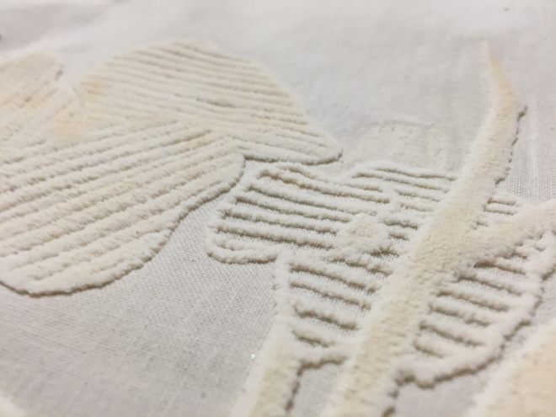
historical value behind embroidery and craft skills and combining them with new technology in order to expand on this tradition.
(Figure 2- Chanaley Anthea, 2016)

The use of ‘’puff binder’’, a form of screen printing paste that raises to emulate stitch when heated is an example of this. Designers and creators could benefit from this faster and more efficient way of working, but keeping the traditional value behind it with more of a contextually inclined context. As displayed in (Figure 2 ), Chanaley Anthea has used this puff
binder to create a textured and surfaced effect on her floral pattern. Although this isn’t embroidery in its self, its advancing on its almost handmade feeling which returns the luxurious quality to the work. Although this was the initial design behind puff binder- that is to emulate stitch, we don’t often see this process used for this purpose in the textile industry. Therefore, designers could benefit more from this process, by reducing the time spend on hand stitched embroidery itself, but investing more time into the contextual and traditional context behind the motifs and also sustaining the handmade feel as this is a hand printed technique.

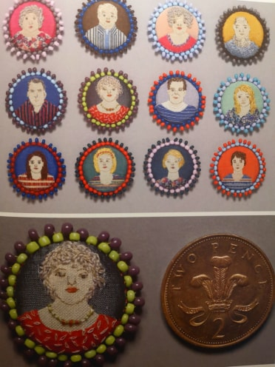
Belinda Pollit; a textile maker, creates miniscule embroidered portraits at such a micro level that the details are almost unreadable to the eye. What is most intriguing about her work, and the element that relates to the importance behind traditional craft skills, is her innovative method of working, as she explains;
(Figure 3, Belinda Pollit, Miniature Portraits, 2011)
When I began... I have no idea what I wanted to produce, but each embroidery had a will of its own... it was only when the last stitch was completed [that I] would know what character I had produced (Kettle and McKeating, 2012)

This is the element that gives embroidery the unrestricted creative freedom that results in the almost naïve and endearing finishing. One could argue that this kind of natural form is lost when digital machined embroidery is used, where everything is in formation, lacking the innocence and handmade touch of imperfection. Although many embroidery artists invest many hours into creating perfect, detailed pieces, sometimes it is the imperfections that differentiate the handmade work from the work of a machine. The idea that Pollit is unsure of the result until she is finished really elevates the idea that beauty isn’t faultless and that sometimes this imperfect style isn’t tangible through mechanical reproduction.

This parallels with the ideas of William Morris, and his ideals behind starting the Arts and Crafts movement. They believed that “hand crafted objects were superior to those made by machine” (Artyfactory, 2016) This could be seen as a juxtaposition to the work of Pollit as the superlative ‘’superior’’ suggests that the work is of higher standard in the technical sense while Pollit’s work displays a flawed and unpredictable feeling. But, we know that Morris saw the beauty behind the artwork, and believed that craftsmanship and handmade skills were an important asset to making something beautiful. Therefore, when comparing a handmade piece of embroidery side by side with a mass-produced piece, although the machine produced work may seem more beautiful and seamless on the surface, Morris argues that it’s the beauty and story behind the art that shines through. ‘‘Nothing which is made by man will be ugly, but will have its due form, and its due ornament, and will tell the tale of its making and the tale of its use’’ (National Portrait Gallery, 2018)

It is easy to follow Morris’ belief that the traditional crafts and the ideology behind craftsmanship is superior to the new age of high reliance on machinery in craft, it is also important to understand the ever growing demand for a faster and more financially beneficial ways of producing.
We are raised with a notion – whatever you do, you cannot reinvent the wheel. Yet, the production of the wheel has evolved from wood to rubber (Kajema, 2016).

This is interesting as it contrasts the longing for a traditional and morally inclined use of embroidery with the explanation that everything must expand and grow as we have also grown past many historic traditions. In many ways it is almost unreasonable for wish for a contextual background behind every piece of textiles in the ever evolving technical industry, as it is impossible for designers to withhold their longing for quicker and more economically constructive processes. But could there be a compromise? Where we see handmade pieces making an appearance in the industry and possibly stores? If designers found a way to take inspiration from the impression and handmade elements demonstrated from the contemporary embroidery artists and combine this with the powerful and mechanically developed technology, there could be some kind of cooperation.

Although mechanical development in the textile world is often described as a negative movement for pure craft, the multi-needle Schiffli embroidery machine was invented in Switzerland by Isaac Groebli in 1863. This embroidery machine has the ability to mechanically stitch in repeat.

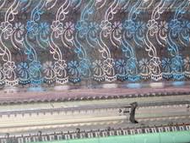
the schiffli’s design attempted to bridge the gap between the artist’s hand and the machine’s output by way of a pantogram or mechanical arm that controls the stitch pattern (Hemmings, 2008)
(Figure 4: Image Schiffili Embroidery, 2018, Textiles School)

The machine is able to develop the artists’ delicate hand movements, into intricate repeat stitched patterns, acting as a giant muscle, every twitch and clasp imbedded through stitch, as demonstrated in (Figure 4), the repeat of this motif, although created by a machine, knowing that every detail was determined by the movement of the hand, elevates it from a flat mass-produced product.

‘’The closeness of the hand to this mechanical process means that deviation and uncertainty are recorded in repeat’’ (Hemmings, 2008) Again, referring back to the closeness of the hand, emphasizing the extra sense of richness and depth that comes alongside handmade product; although this is a mechanical drawing, you can almost see the artist’s thought process through the embroidery, like you would with a hand embroidered hoop. This machine, although no longer highly used in Britain, demonstrates the importance of simplicity in craft work, and that although it is important to progress and develop in the industry, we must also remember the history and the past of this historic technique; as highlighted by Millar here;
The contribution these individuals have made does not make them “custodians of the past” but instead suggests that the schiffli’s “mechanical limitations [are used] as a means of questioning the boundaries between the new and the old (Hemmings, 2008)

This would be a very tangible and realistic method of compromise between the old and the new. It is important to not forget about the historic and basic way of working in this age of mechanics and digital loopholes and shortcuts.

Textile artist Orly Cogan, who explains her work in the book Contemporary Textiles- the fabric of fine art; a collection of craft and handmade objects in modern art. Cogan is an embroidery artist who, with her needle and thread, creates stories with a moral contextual background. She describes her work as such;
I work with vintage, printed fabrics and found embroideries made by women of previous and more modest eras. I act as a collaborator, modernizing their traditional work and altering its original purpose (Jefferies, 2008, p. 75)

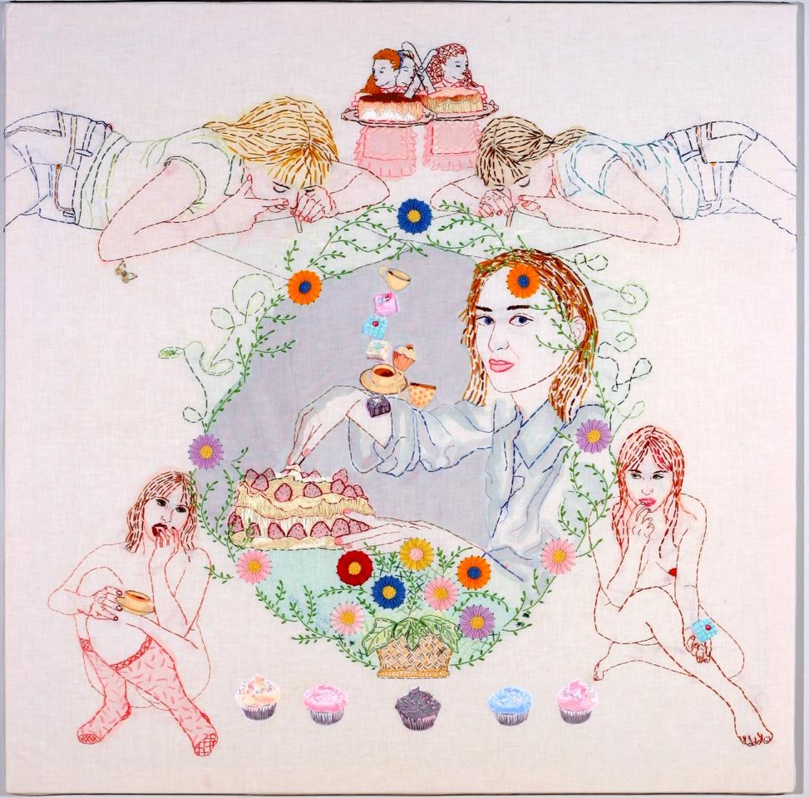
Here, we see a textile artist, taking other maker’s work, and transforming them into new and contemporary pieces. The way that Orla reuses and re invents these found embroideries introduces a different level of intimacy between the creator and the artwork; providing a sense of nostalgia towards the original woman that made the initial piece. When imagining the piece of embroidery being passed from hand to hand it elevates the sense of touch and spirit within the piece, emphasizing the handmade and emotion invested into these textiles that sometimes seems to be lost in embroidered pieces today.
(Figure 5- Orly Cogan, Sweet Obsessions, 2007)

This type of reimagining embroidery could be the future of this craft in the textile industry, with women continuously progressing in the quest for equality, perhaps textile makers could challenge this political matter in a subtle and light hearted manner. Which would reinject the kind of Aura and meaning behind this historic craft, re elevating it back to where it once stood.

Cogan works as a collaborator, modernizing former embroiderers work and altering their initial purpose. The way in which she includes the stories and social development of women today in her embroidery (demonstrated in Figure 5) almost honours the labour of the women of the past; creating a new meaning behind embroidery.

Nigel Hurlstone explains his relationship with embroidery in Hand Stitched- Perspectives, stating;
my fascination with silence comes from the subject that I teach, embroidery. With it, comes a complex history of those who have sewed in lieu of having a voice and through stitching have described the struggles (p. 146)

This cross-references with the beliefs of Cogan and her relationship with embroidery. Both textile artists believe that the history of previous embroidery of the past should be acknowledged today, although this isn’t connecting the old and the new in the physical sense of hand embroidery and digital embroidery; but connecting with historic context. Almost connecting their work with the work of previous makers, carrying their voice forward with the hand.

Conclusion.

The reality behind handmade craft, is the amount of time and expenses needed to commit to the style of working; this in hand would raise the prices of the textiles to unaffordable prices in the industry. As demonstrated in the book Handmade ‘’Craft is always about having either the time or the money to produce something that is materially realized’’ (Becker, 2011, P. 103) Therefore, it’s easy to understand why many companies have developed and began using digitally modified technique. Specifically, it is the time invested that makes hand embroidered pieces difficult to produce in this fast paced industry, with some pieces taking hundreds of hours to complete; especially considering the difficulty in this pastime.

Embroidery artist Anne Morell describes the skill as such; ‘’Certainly, hand stitching is labour intensive and not necessarily the comfortable pastime, physically or mentally’’ (Kettle & McKeating, 2012, p.90) At first read, this almost sounds like a contradiction of Florence Caulfield’s beliefs of connectivity and intimacy with her embroidery, almost as if Morell dislikes the amount of labour and time that goes into the craft. But this would almost elevate the relationship between herself and the embroidered piece, as the pain and toil that has been invested into the process results in a beautiful finished piece that she would treasure.

To extend on this further, Jane Mckeating voices;
It is the rhythmic and meditative quality of stitch that is in part perhaps, makes the worth … Its repeat like the beat of the heart (Hand Stitch- Perspectives, Mckeating, p.31)

These references to the rhythm and the heartbeat, alongside Morell’s description of the intensive and labour filled journey of embroidery, almost links to childbirth. Where a lot of time and energy and often even pain is imbedded into building the embroidery, stitch by stitch; paralleling the pain and energy invested into growing a child. Only when the child is born, or the embroidery piece is completed, that all of the physical and mentally draining time is rewarded, thus the pain forgotten.
It is true that ﬁne embroideries can be enjoyed just as ﬁne embroideries; but it is also true that they are immeasurably more interesting when seen as being the products of a particular time and place (Clabburn, 1981 P.7).

This almost summarizes this essay’s main focus and the questions throughout. Although both hand and mechanical embroidery can simply be enjoyed for their beauty alone, there are a lot of elements that elevate this beauty further that what meets the eye. Some may argue that hand embroidery has more worth than the digitally completed because of the sense of touch and almost human spirit that is injected into it, almost representing the mind and thought process of the maker. But we cannot neglect the beauty that remains in digital embroidery, although it is the faster and easier alternative, it still carries the history and origin of traditional hand embroidery, simply in the modern era.

After researching into contemporary embroidery artists using embroidery in their work today and considering their morals against literary thinkers such as Morris and Sennett, you could argue that although embroidery has developed into a digital process in some areas, there are many makers that maintain to express the purity and the simplistic beauty that correlates with the simple textile technique that has survived through time.
Through studying Walter Benjamins ideals, Esther Leslie concludes; ‘’The hand—so crucial to the Handwerker (artisan or craftsman)—is made redundant by techno- logical advance’’ (Leslie, 1998, p.7) Although this is true for many machines in the textile industry, there are many ways in which the hand continues to play an important part, even through digital methods of embroidery.
If designers saw more of themselves in these digital repeating machines, could there be space for personal touch through machinery? Throughout this research, the most promising and tangible outcome and compromise between hand and mechanical embroidery would be the rebirth of the use of the Schiffili Machine. Sennett has almost unintentionally defined this machine in the world today; ‘’A robotic machine is ourselves enlarged’’ (Sennett, 2008, p. 85). Although this could be seen as a negative reference to machinery, Sennett has noticed the personal similarities between the maker and a machine, almost as if the machine takes the skill and design work from the hand of the maker and translates it through a mechanical thought process; which is the physical purpose behind the Schiffili machine.
The Schiffili machine, along with puff binder to emulate embroidery in a more efficient speed, could rebirth the use of the hand to create embroidery. Although an increase in hand embroidery would be the ultimate objective for the handmade Aura to truly shine through the textile embroidery, the use of the Schiffili machine in some ways is the next best thing, combining the movement and thought process of the maker with the speed and perfect repeat of the machine. Joining both the hand and the machine, creating product of the past and present, coexisting hand in hand.

Bibliography.

Allan, D. (2018). Circles Are Symbols of the Universe. [online] Available at: https://www.thoughtco.com/circle-symbolism-3454058 [Accessed 15 October 2018].

Anthea, C. (2016). Printing with Flock, Foils and Puff Binder. [online] Chanaley Textiles. Available at: https://chanaleytextiles.wordpress.com/2016/02/02/printing-with-flock-foils-and-puff-binder/ [Accessed 5 Dec. 2018].

Artyfactory. (2018) William Morris-The Arts and Crafts Movement. (2017) [online] Available at: http://www.artyfactory.com/graphic_design/graphic_designers/william_morris.html [Accessed 9 Mar. 2018].

Becker, N. Handmade. Canadian Art, Spring 2011, Vol.28(1), pp.102-104

Benjamin, W. (1936). The Work of Art in the Age of Mechanical Reproduction. London: Penguin Books.

Beyer, C. (2017) What do squares mean? [online] Available at: https://www.thoughtco.com/squares-96016 [Accessed 1 November. 2018].

Chraibi, C. (2016). Secret ancestral codes: 12 main symbols in Ukrainian embroidery – EUROMAIDAN PRESS. [online] Euromaidan Press. Available at: http://euromaidanpress.com/2016/05/19/secret-ancestral-codes-12-main-symbols-in-ukrainian-embroidery/ [Accessed 2 November. 2018].

Chua, V. (2016). Reflections on Arts & Craft Movement and the Industrial Revolution – vchua002. [online] Oss.adm.ntu.edu.sg. Available at: https://oss.adm.ntu.edu.sg/vchua002/reflections-on-arts-craft-movement-and-the-industrial-revolution/ [Accessed 27 Nov. 2018].

Clabburn, P (1981) Masterpieces of Embroidery. Oxford: Phaidon Press.

Cogan, A. (2018). Orly Cogan. [online] Available at: https://www.orlycogan.com [Accessed 1 Nov. 2018].

Dall, A. (2018). The History of Hand Embroidery - Superlogo Blog. [online] Superlogo Blog. Available at: http://www.superlogo.co.uk/blog/the-history-of-hand-embroidery/ [Accessed 27 Nov. 2018].

De Castella, T. (2012). Are you a Luddite? [online] BBC News. Available at: https://www.bbc.co.uk/news/magazine-17770171 [Accessed 2 Dec. 2018].

Encyclopedia Britannica. (2018). Folk art - Style. [online] Available at: https://www.britannica.com/art/folk-art/Style [Accessed 9 September 2018].

Ginal. (2008). Summary: The Work of Art in The Age of Mechanical Reproduction. [online] Available at: https://frankfurtschool.wordpress.com/2008/02/28/summary-the-work-of-art-in-the-age-of-mechanical-reproduction/ [Accessed 9 May 2018].

Hemmings, J. (2008). Mechanical Drawing: The Schiffli Project ». [online] Jessicahemmings.com. Available at: https://www.jessicahemmings.com/mechanical-drawing-the-schiffli-project/ [Accessed 27 Nov. 2018].

HISTORY. (2009). Industrial Revolution. [online] HISTORY. Available at: https://www.history.com/topics/industrial-revolution/industrial-revolution [Accessed 5 Oct. 2018].

Jefferies, J. (2008). Contemporary textiles- the fabric of fine art. London: Black Dog Pub.

Kettle, A. and McKeating, J. (2012). Hand stitch- Perspectives. London: A. & C. Black.

Kuust, K., Tomico, O. and Langereis, G. (2012). Crafting Smart Textiles - a meaningful way towards societal sustainability. Nordic Textile Journal, pp.p6-15.

Leslie, E. (1998). Walter Benjamin: Traces of Craft. Journal of Design History, 11(1), pp.5-13.

Morris, J. (2018). History Of Embroidery, Handicraft Of Decorating Fabric, Embroidered Clothing, Fibre2fashion. [online] Available at: http://www.fibre2fashion.com/industry-article/4135/history-of-embroidery?page=1 [Accessed 2 October 2018].

National Portrait Gallery. (2018). Anarchy & Beauty: William Morris and His Legacy, 1860 – 1960. [online] Available at: https://www.npg.org.uk/whatson/anarchy-beauty-william-morris-and-his-legacy-1860-1960/home/explore [Accessed 27 Nov. 2018].

Robinson, A. (2018). Walter Benjamin: Art, Aura and Authenticity. [online] Ceasefire Magazine. Available at: https://ceasefiremagazine.co.uk/walter-benjamin-art-aura-authenticity/ [Accessed 4 May 2018].

Schuette, M and Muller- Christensen, S. (1963) The History of Embroidery. London. Thames and Hudson London. [Accessed on 27 of September, 2018]

Sennett, R. (2008). The Craftsman. London: Penguin Books.

Simpson, C. (2018). Textiles: Symbols and Meaning in the Embroidery of Epirus. [online] Academia.edu. Available at: http://www.academia.edu/11333615/Textiles_Symbols_and_Meaning_in_the_Embroidery_of_Epirus [Accessed 2 October 2018].

Spartacus Educational. (2018). Spinning Jenny. [online] Available at: https://spartacus-educational.com/TEXjenny.htm [Accessed 5 Dec. 2018].

Tate. (2018). Aura – Art Term | Tate. [online] Available at: http://www.tate.org.uk/art/art-terms/a/aura [Accessed 6 May 2018].

Tellier- Loumagne, F. (2008) The art of embroidery- Inspirational Stitches, textures and surfaces. Thames & Hudson

TRC Needles. (2018). Brief History of Hand Embroidery. [online] Available at: https://trc-leiden.nl/trc-needles/techniques/embroidery/general-embroidery/brief-history-of-hand-embroidery [Accessed 6 Dec. 2018].

Vam.ac.uk. (2018). Introduction to English Embroidery - Victoria and Albert Museum. [online] Available at: http://www.vam.ac.uk/content/articles/i/english-embroidery-introduction/ [Accessed 27 Nov. 2018].

Vayenas, P. (2018). Secret Ancestral Codes. [online] AUTUMN SALON. Available at: https://www.theautumnsalon.com/aswritings/secretcodes [Accessed 9 May 2018].

White, M. (2009). The Industrial Revolution. [online] The British Library. Available at: https://www.bl.uk/georgian-britain/articles/the-industrial-revolution [Accessed 2 Dec. 2018].

List of Figures.

Figure 1: Florence Caulfield, Embroidery piece, The Illustrated Needlework Book, 1914

Figure 2: Anthea Chanaley Printing with Flock, Foils and Puff Binder, (2016) [online] Accessed from: https://chanaleytextiles.wordpress.com/2016/02/02/printing-with-flock-foils-and-puff-binder/

Figure 3: Belinda Pollit, Miniature Portraits, (2011) Accessed from: Hand Stitched – Perspectives by Alice Kettle & Jane McKeating

Figure 4: Image Schiffili Embroidery, Textiles School (2018) Accessed from: https://www.textileschool.com/128/schiffli-machine-embroidery/

Figure 5: Orly Cogan, Sweet Obsessions, (2007) Accessed from: Contemporary Textiles- the fabric of fine art by Janis Jefferies

