Title

Written Assignment: Portfolio (7500 words)
Identify and critically reflect on five key areas that require review within your institution to facilitate curriculum reforms. Then present a proposal including a rationale for each change, and strategies and protocols which would facilitate the effective development of the curriculum within these five key areas.
Your portfolio must contain pertinent evidence from your individual establishments.
NB. Redact or remove any identifying information contained on documents presented, e.g. school insignias, staff names etc.

Contents Page

- Introduction

- Ensure parity in curriculum provision for Welsh and English medium learners

- Budget/Financial constraints

- Motivating/Upskilling staff- getting staff to ‘buy into’ change

- Recovery Curriculum

- Ensuring a curriculum that is inclusive and better prepares a workforce

Introduction

The word curriculum is a comprehensive term that has evolved rapidly since the announcement of the National Curriculum in Wales in 1988 as part of the Education Reform Act. In response to social, political and economic changes; including globalisation, technological innovation and long-term social trends, Government education ministers have had to be proactive rather than reactive in creating a curriculum that better reflects the wider, changing national and societal needs. As highlighted by Morgan in Turner (2016) ‘lessons in character are just as valuable as academic lessons because they give pupils the skills they need to succeed.’ With learning taking place in wider settings, at a faster pace and with career pathways becoming more flexible, it raises the question of whether the curriculum needs to focus more on soft skills development to prepare pupils for the unknown future. The education system in Wales is currently going through a transitional period with the implementation of the new curriculum. Donaldson recognises the need for schools to focus on soft skills development in his Independent Review of Curriculum and Assessment Arrangements in Wales and states that ‘the demand for young people with improved levels of literacy, numeracy and wider skills, including critical thinking, creativity and problem solving, has fueled an international trend towards curricula that give greater emphasis to the development of skills, alongside, or embedded in, a traditional subject or ‘area of learning’ approach’. The success of the Finnish education system has been recognised since they adopted a phenomenon-based learning approach of teaching by topic as they argue that pupils should be taught the skills, they need to be successful in future careers rather than subject knowledge. Other theorists like Furedi in Turner (2016) however, argue for the intrinsic value of academic education. Robinson also advocates a knowledge-driven curriculum and highlights the potential for pupils to develop the necessary key skills through the engagement of tackling difficult academic subjects. Each individual school has scope to acknowledge the requirements of the national curriculum but create a curriculum that is specific to them as an individual organisation. They should ensure all pupils have the right to an education that is well-taught, well-resourced and properly funded. Naturally, this does however, create a number of barriers in which schools need to work to overcome when considering the intent, implementation and impact of their curriculum. One thing they need to carefully consider is whether they want a school curriculum that is based on the development of core skills, subject knowledge or perhaps a combination of both? Bromley (2019) suggests that schools need to agree on a definition for the term ‘curriculum’ before deciding on a shared vision of what is important along with the purpose of education. There are many responses within literature around the question ‘Why Educate?’. William (2013) identifies four philosophies that underpin education and discusses how these, although are said to be often ‘in tension with one another’, are all important. These four philosophies include: personal empowerment, cultural transmission, preparation for citizenship and preparation for work. Schools need to decide what their curriculum will be centered around but be prepared for the need to change as the world becomes more complex. In order to identify the areas that require review within school A, I first wanted to develop an understanding of the purpose of education to them as the driver for their curriculum. School A stated that their vision was ‘to develop a purposeful, inclusive, knowledge rich curriculum underpinned by excellent pedagogy, that recognises each individual's unique characteristics and potential and is cognisant to the Hidden Curriculum, to instill cultural transmission and better prepare a workforce.’ Within this portfolio I will discuss five key areas that require review in school A in order to facilitate curriculum reform.
Ensure parity in curriculum provision for Welsh and English medium learners
School A is a bilingual school that is maintained by its local authority. There are 1,436 pupils on roll, 267 of whom are in the sixth form. The school is situated in a small town in Southwest Wales. Around half of its pupils come from the town itself, and the other half from the surrounding rural area and nearby villages. Almost a third of pupils come from Welsh-speaking homes. Around 47% of pupils speak Welsh fluently and a little over half study Welsh as their first language. Being a bilingual school, it is essential that the school curriculum provides parity in the provision for both its English and Welsh medium learners. The school is categorised as a 2C school according to its Welsh provision. This is certainly a central focus of the school’s curriculum design as their vision aims to instill cultural transmission in pupils and prepare them for the workplace. The school does however face a number of challenges when attempting to provide this parity. As shown in the bar graph below, there is a large number of teaching staff at School A who are Welsh speakers but are not currently teaching through the medium of Welsh.
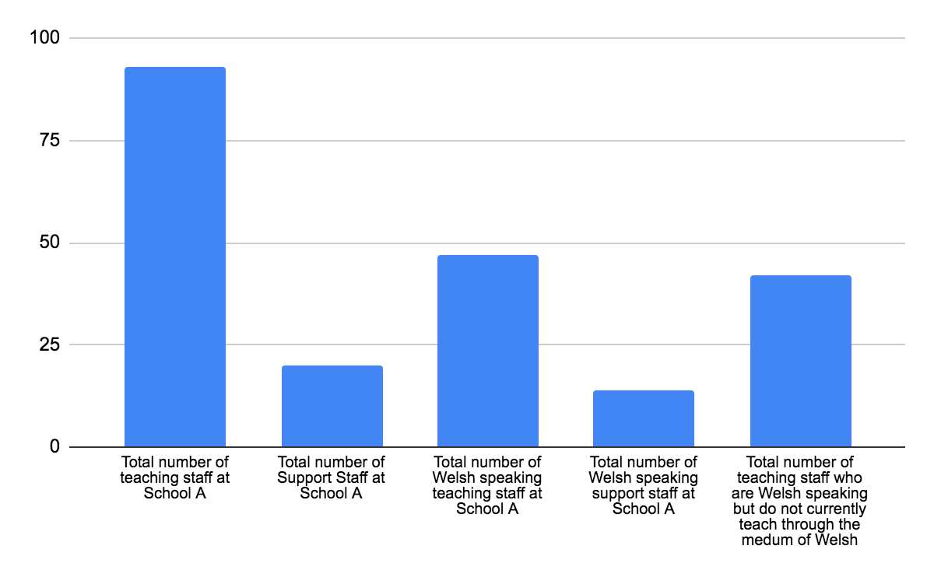

Empirical evidence shows a number of reasons for this: some staff lack confidence in their ability to teach through the medium of Welsh, some departments do not have enough Welsh speaking staff to offer the subject through the medium of Welsh and the majority of the Senior Leadership Team who have a very low, if any teaching allocation, are made up of Welsh speakers. The school sets out to meet the National Curriculum requirements, showing an awareness of the Welsh Government’s plans as identified in the ‘Guidance on Welsh in Education Strategic Plans.’ This highlights a number of strategic contexts that support and encourage the growth of Welsh Medium education in Wales. School A clearly identifies that one of the areas that needs development in order to support this growth is Welsh language teaching standards. Each Local Authority is required to submit a ten year Welsh in Education strategic plan to Welsh Ministers for approval no later than January 22nd 2022. This plan will need to be consulted with the Heads of schools and Governing bodies. The school should work closely with the Local Authority to ensure they continue to develop and embed opportunities for pupils to develop their Welsh language between key stages and are creating suitable pathways for pupils to study assessed qualifications in Welsh. In order to effectively embed this, the school needs to provide opportunities for staff to develop their Welsh speaking skills. This suggestion is supported by the National Assembly Wales (2016) who identify ‘the need for improved workforce planning and support for practitioners: ensuring a sufficient workforce for Welsh-medium education and training is vital.’ This could be achieved by targeting training for staff who teach in the school. Local authorities have a statutory duty under Section 10 of the Learner Travel Measure (Wales) 2008 to promote access to education and training through the medium of Welsh. This would certainly have an impact on the school’s financial position putting a constraint on the ever reducing budget, requiring an investment by the senior leadership team. Currently however, it is clear that due to such a low number of pupils opting to study subjects through the medium of Welsh at Key Stage 4 it raises the political debate of whether there is enough of a reason to cater for these subjects within the timetable. The school would face a number of barriers, including financial restraints, when attempting to provide the Welsh speaking opportunities outlined in Welsh Government documentation with potentially very little uptake by pupils themselves. As you can see in the bar graph below, the number of pupils opting to study a subject through the medium of English is consistently higher than in Welsh in School A.
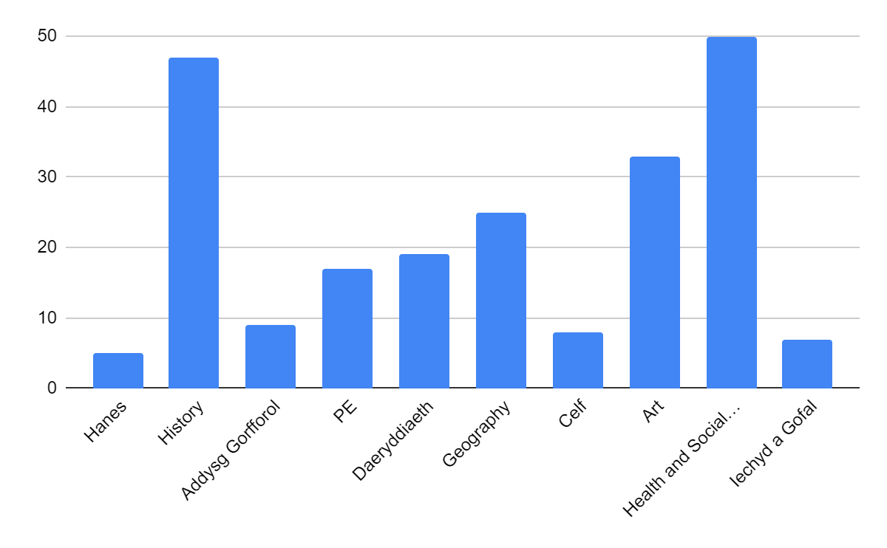

Should the school choose to invest in their staff's ability to deliver lessons through the medium of Welsh, the question of whether it would be beneficial to the school or the students within is raised. It would certainly be a substantial strategy to finance when considering future uptake within subjects delivered through the medium of Welsh may not be the desired. Empirical evidence shows that generally, pupils opt to study subjects through the medium of English rather than Welsh due to their personal lack of confidence in their ability to speak Welsh. Speaking and using the Welsh language on a day to day basis is very different to learning new subject related terminology. Pupils find it demanding to learn the subject content as well as subject specific language. They find it harder to communicate during the lessons and more difficult to demonstrate an understanding of the content within written class tasks or exams. This identifies a need for schools to consider how to effectively embed opportunities for pupils to develop knowledge of key terminology needed for subject progression within their curriculum design. Myatt (2018) discusses the importance of vocabulary building and how this can be done effectively through pre-teaching. She talks about closing the gap between those pupils who come from language rich backgrounds and those who don’t. This applies to School A in terms of the Welsh language. Not all pupils come from homes where Welsh is spoken creating a new ‘gap’ that needs attention.
In March 2016 the Welsh Government (Senedd, 2016) published ‘Welsh-medium Education Strategy: Next Steps’, which outlined its three main objectives for developing Welsh-medium and Welsh language education over the following 12 months. The following areas were identified as needing development: the need to embed processes for planning Welsh-medium provision, strengthening strategic planning processes for all phases of education and training, this continues to be a priority and the need for improved workforce planning and to support for practitioners ensuring a sufficient workforce for Welsh-medium education and training is vital. Within their Supplementary Guidance: Welsh (2017) Estyn highlights what inspectors should be inspecting and reporting on in terms of standards and progress in Welsh. Estyn inspectors aim to evaluate whether the curriculum provides pupils with the opportunity to develop the Welsh language skills needed to support them as they progress through the key stages. A recent Estyn report from an inspection of School A in 2019 states that ‘a minority of pupils’ Welsh linguistic skills are not as good as their English skills. The senior leadership team sets high expectations for staff and pupils. They share a clear vision to ensure the highest levels of wellbeing and improve pupils’ Welsh language skills. Leaders at all levels work together effectively and are willing to trial and evaluate experimental curricular arrangements’ (Estyn, 2019:3). Pupils are also given the chance to develop their use of social Welsh during extra-curricular clubs including ‘Clwb Clecs’. The report does highlight however, ‘in a minority of cases, teachers do not use the Welsh language with pupils or encourage them to use it’ (Estyn, 2019:3). As a bilingual school, it is essential that all staff drive the Welsh language as a central part of the culture within the school community. School A should consider including the Welsh language as a core part of the philosophy of their vision, building an ethos on pride and confidence of using the language based on the principles of Qualified for Life (2014). The new Donaldson Curriculum, Successful Futures recognises the importance of the Welsh language in the development of Wales ‘as a bilingual nation with the strength and assurance to nurture both languages’. School A should continue to work on and develop the use of the Welsh language as part of their vision and implementation of the new curriculum for September 2022 incorporating and embedding where possible opportunities for pupils to learn key terminology early. This might have a long-term impact on numbers of pupils opting to study qualifications through the medium of Welsh at KS4 presenting the school with a solid argument for budgeting and allocating staff and resources to support their delivery.

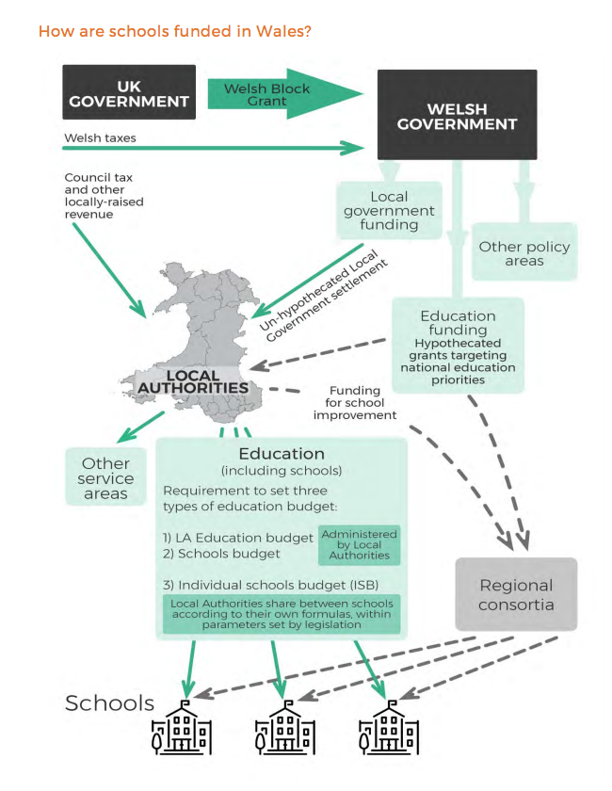
Budget/Financial constraints
The diagram on the right demonstrates the complex process in which schools are funded in Wales based on the results of the Barnett formula. The formula has evolved and been introduced for use although never originally designed specifically for Wales. ‘It aims for convergence however ‘devolution’ has created significantly greater awareness of the anomalies surrounding the application of the formula and its so-called ‘consequentials’, some of which create contentious outcomes for Wales. Much of the analysis of the scale and significance of these anomalies remains anecdotal (Bristow, 2018). One thing that is clear though is that the funding differs extensively between every County, Local Authority and School.
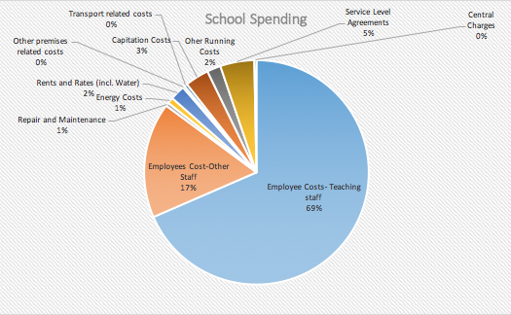
ASCL (2016) states that ‘Schools, academies and colleges are now struggling with the dilemma, which is how to deliver a balanced budget, avoid a financial deficit with the associated stigma that brings, or the prospect of a Financial Notice to Improve, and resource a curriculum which is creative, meets the students’ needs and which will stand the various benchmarks set by government and improve levels of attainment.’ One of the barriers that school A faces is their ever reducing budget. This is recognised by the Sennedd’s Children, Education and Young People Committee in the School Funding in Wales review (2019) who express a number of concerns around insufficient school budgets. Staff salaries make up the majority of all schools' budgets with schools making inclined staff cuts in an attempt to save money. Like others, School A faces the challenge of ensuring they continue to provide an excellent provision, following the Welsh Government’s reform agenda with the introduction of the new curriculum etc. with a standstill budget. As you can see in the pie chart below there are many costs in which a school has to budget for spending. Some of which are out of the school’s control, e.g. premises related costs, repair and maintenance etc.

The school does however have a large staffing made up of both teaching and non-teaching staff which as you can see makes up 86% of their total spending. As well as investing staff into the school’s curriculum the school invests 3% of their budget into the curriculum through capitation which includes: materials, examiner and examination expenses, computer materials and educational visits and courses. Reviewing the schools staffing structure could be a good way of saving money when designing the school’s curriculum. School A could consider designing elements around staff who are on flexible hours or are part time. Designing a curriculum that utilises the time of every member of staff would naturally allow potential over staffing/ over allocated hours to be identified and utilised more effectively. This should include careful consideration of distributing responsibilities as these carry extra financial cost. The broader the curriculum, the more Heads of Department you will need at therefore a higher expense. Class sizes can also impact staffing as the smaller the classes, the more classes that need to be allocated to a teacher. This would also naturally be more expensive than large classes with less teachers.
Additional spending on school resources has shown to have a positive influence on the overall academic achievement of all pupils but has been proven to impact more on the attainment of disadvantaged pupils (Ofsted, 2020). Eligibility for Free School Meals is the most prevalent statistic used to measure deprivation. Extra funding is given to schools in order to support this deprivation via the Pupil Deprivation Grant. The proportion of pupils who are eligible for free school meals at school A is 18.9%, which is a little higher than the average across Wales of 16.4%. School A makes beneficial use of grants to support the achievement of the school’s most vulnerable pupils, such as organising transport for pupils attending after-school activities. They also use this finance to support departments in creating a learning environment that is used purposefully in order to provide memorable learning experiences for pupils.
The Association of School and College Leaders (ASCL, 2016) states that areas such as the curriculum could be the greatest way to achieve saving. The school has designed its own curriculum which in itself has its pros and cons when considering cost implications. As discussed by Cornerstones (2020) this will allow the school to save money as they have created their own resources and assessment structure. Involving staff in house, celebrating their skills and expertise has its own benefits when considering teaching and learning experiences and overall attainment. This does however mean that staff will need to be given time away from their teaching commitment to design these resources which will also need regular revisiting and updating in turn further impacting on cover costs. The school needs to carefully consider how they can save money within their curriculum model (ASCL, 2016). This largely boils down to how many staff the school needs; how much those staff can teach and how many classes each year group has (this depends on how many pupils are put in each class). Schools receive supplements from the Welsh Government to provide parity in the provision between the Welsh and English language. The supplements are uniform for all eligible schools; however, School A as a bilingual school feels that the supplement is not enough to cater for the delivery of a bilingual curriculum. This supplement does not take into consideration the need for bilingual schools to staff, timetable, create resources and to support delivery through both languages. Translation of resources alone is a time-consuming task that the school needs to consider when planning for each academic year. School A is currently working their way out of a financial deficit that is licensed by the local authority. The recent Estyn inspection of the school highlighted that the school has ‘sensible plans to clear the deficit within three years’. Estyn (2019:9) states that ‘they have a purposeful funding strategy in which there is a close link between decisions on expenditure and the school’s priorities for improvement. For example, they have increased Welsh-medium provision in order to provide linguistic progression for pupils.’

Motivating/Upskilling staff- getting staff to ‘buy into’ change
According to the House of Commons National Curriculum report 2008-09 (cited in Turner, 2016:36), ‘teachers feel like ‘deliverers’ of the curriculum rather than creative developers, and this detachment from the process of curriculum design has led to arguments that there has been a ‘de-professionalisation’ of the teaching community.’ One of the main reasons that teachers leave the profession according to the findings of the Department of Education’s (2018) qualitative investigation, is that teachers felt a lack of recognition and autonomy. Although such curricular freedom may be welcomed by veteran teachers, it appears to be a burden for new teachers, who have not yet developed a robust repertoire of lesson ideas or knowledge of what will work in their classrooms (Fry, 2007 cited in Goodwin, 2012). Case studies have observed novice teachers struggling "just trying to come up with enough curriculum" and ‘spending 10 to 12 hours a day juggling lesson planning; grading: and the myriad demands of paperwork, committees, and extracurricular assignments’ (Fry, 2007, p. 225). Teachers could be said to be the most important person in curriculum design, ‘With their knowledge, experiences and competencies, teachers are central to any curriculum development effort (Alsubaie, 2016). School A has a very large teaching staff and have found that it can sometimes be difficult to encourage the long standing, experienced members of staff to make changes according to the newest research and curriculum movement. As previously identified, if School A wants their staff to be motivated and committed to change, it is clear they need to involve staff aspects of design. If staff feel their skills and expertise have been valued in this process, they are more likely to engage with changes. In order to keep staff's skill, set up to date, staff need to attend regular training and participate in continuing professional development opportunities where possible. Being involved in this training also gives staff the confidence they need to learn new aspects of the curriculum, therefore, also delivering it more willingly. School A highlighted the cost implications involved in arranging for staff to attend these professional development opportunities within an ever-reducing financial budget. The school can simply not afford to send them! For this reason, staff are often missing out on these sessions at the detriment of the curriculum. School A needs to reconsider the implications of not sending staff on continuing professional development opportunities and possibly look to amend curriculum investments.
It is essential to consider all stakeholders when introducing any changes within a school. Staff are a priority in this list of stakeholders as the deliverers of the curriculum. When attempting to include staff in curriculum reform, school A has found that many are naturally resistant to change. This is similar to the findings of, Zimmermann (2006, cited in Webster et al, 2012) who identifies the following barriers at work in which teachers may resist to change: failure to recognise the need for change, habit, fear of the unknown, failure of threats to their expertise or their allocation of resources and fear of threats to existing friendships within the school. School A have found that their staff become comfortable with the way things are done and when the strategies or teaching and learning methods they have always used have been successful over many years, many will be apprehensive to new ideas and ways of doing things. Many staff will not see the need for these changes when considering the success of their recent work. Many staff will state that they do not have enough time to introduce these changes and will sometimes question the experience of the leader wanting to implement them. School leaders need to approach this challenge logically trying to generate commitment from staff rather than the need to get staff to ‘buy into’ change. Leaders need to carefully consider how they go about generating this commitment to ensure the best results and avoid staff implementing the change with poor effort or low motivation. According to research, leaders should involve staff in the development of new strategies. Should they give staff specific roles within the development of new strategies, it would help them to better understand the benefits and potential positive impact. It is essential that the leader builds a trusting relationship with staff and supports them consistently throughout. (Getting Genuine Commitment for Change - ASCD, 2021).
Maughan et al. (2012) carried out research to find out what leads to positive change in teaching practice in schools. Their findings were grouped into four main themes: leadership, planning and preparation, practice development and monitoring and evaluating. Strong leadership on all levels was identified as a fundamental part of introducing and implementing positive change. Effective planning and preparation provided a structure and context for teachers to implement this change. Many staff are sometimes expected to teach outside of their subject specialism, especially in secondary settings. To avoid staff resisting to this change, it is essential that schools provide staff with the time and sources to resource high quality materials when they are expected to deviate away from their expertise. If staff are not given these opportunities, they will turn to the internet to source poor quality materials and resources to use. It is essential to share best practice where possible and dedicate departmental time around developing subject knowledge to ensure the best possible curriculum development and teaching and learning can take place. The school should financially support the development of these curriculum with the school’s budget (Myatt, 2020). At key stages 4 and 5, the longevity of courses differs with different examination boards. It is essential that school A choose to introduce courses that have longevity as well as meeting the needs of the students. This will help staff to develop and prepare better quality resources knowing that they will be able to use them for a number of years with minor amendments/updates being made. A range of practice development needs to be implemented including leader-led, peer-led and self-led. Each principle of practice development can provide and support teachers to make change. The monitoring and evaluation strategies allow schools and teachers to assess the impact of these changes over time. Again, these should also include school wide assessment, teacher led assessment and student led assessment to provide an holistic and inclusive picture. Evaluation of these strategies needs to be used effectively to ensure the necessary changes are made, in turn supporting the school, staff and pupils.

The Recovery Curriculum
The recent pandemic has had a significant impact on all learners in different ways. Some learners have been challenged mentally and others academic progress has been limited. Schools are now under pressure to decide how best to design a post covid curriculum. Should schools now consider designing a curriculum that is broad and balanced or would it be more impactful to provide a knowledge rich syllabus. The pandemic has shown us that by accepting the definition of ‘curriculum as content’ and a ‘lived experience’ leaves us with a curriculum that is difficult to adapt with changing contexts. Stenhouse's view (1975) argues that ‘a new curriculum expresses ideas in terms of practice, and disciplines practice by ideas.’ This allows us to view the curriculum as a framework of content that is an ‘ongoing process’ that involves discussion, reflective thinking and continual revision. The recent isolation rules have had a significant impact on learners’ education. How schools go about curriculum reform to address the gaps and what pupils have missed out on now becomes vital in attempting to close the attainment gap. The link between disadvantage and educational attainment has been something schools have considered within curriculum design for a number of years, using the Pupil deprivation grant to support. Schools have already recognised the further disparity the pandemic has now created. Bromley (2019) discusses the importance of considering Cultural Capital within curriculum design as a strategy to tackle this disparity. Those disadvantaged pupils will have lost language and literacy development as it is likely the language used at home would not contribute to the extension of their vocabulary. Bromley suggests careful consideration of pupil grouping in school could benefit this as the more academic students would share a more extensive range of vocabulary during conversations. Schools could also use their Pupil Premium Grants to provide disadvantaged pupils with educational experiences e.g. visits to museums. Schools could also consider specific interventions to increase Cultural Capital amongst pupils.
The Recruit, Recover, Raise standards: The Accelerated Learning Program produced by the Welsh Government has given all schools in Wales funding based on pupil numbers. This funding has been given as an attempt to impact on the principles identified within Welsh Government documentation as a strategy designed to inform practice to support all learners' development. Empirical evidence has noticeably identified a difference in Welsh language development especially in those pupils who do not speak Welsh at home. As identified by Bromley, school A used the accelerated learning program to introduce a number of interventions using the funding to support learners. One of these interventions included sessions focusing on Welsh language development. Other interventions included mentoring pupils in year 11, 12 and 13 as these were identified as the learners in greatest need within the most affected cohorts. A teacher was also temporarily employed to work with the most vulnerable learners in the school focusing on mental/wellbeing support before academics. The school will need to present how they have used the funding given to support learners with a review of its impact moving forward. When considering financial constraints as discussed above, a question is raised as to whether these interventions will be funded for long enough to have the desired impact. School A stated that they would not have been in a position to fund these interventions without the money from the Welsh Government.
Schools still have their curriculum and the opportunity to adapt this without the need for any extra funding to meet the needs and support learners returning to school after the recent pandemic. Some argue that the most important aspect of recovery should focus on wellbeing and social interaction. Research by Barry Carpenter highlights the need to now include a focus around wellbeing and the positive development of the child to ensure they are able to recover from the trauma, anxiety and loss they have experienced. He discusses how schools need to use the aims and values of the school before the pandemic to inform how they best design a curriculum that is ‘understanding of the children in the community’ (Carpenter, 2020). Hattie (2021) highlights the biggest implication of school closures is equity. The educational attainment gap between disadvantage was one schools were already attempting to tackle before the pandemic. Hattie (2021) argues that the school closures may not have had that much of a negative impact on pupils' learning and says that ‘schools, no matter via what medium, can be hubs of response and recovery, a place to support emotional recovery and promote social togetherness—and this is as important as any achievement gains.’ He highlights the recent pandemic as an opportunity for staff to share success stories, learn to learn from afar and meet the individual needs of all students.
Schools also have a statutory obligation to implement the new RSE curriculum in Wales from September 2022. Schools can, being careful in their design, embed this new area into the broader context of the already successful curriculum at their individual school. The RSE curriculum also provides schools with the potential of embedding elements of the RSE into their recovery curriculum as a focus on pupils' health and wellbeing and the impact the recent pandemic has had on it. According to Maslow’s popular theory of motivation, pupils' physiological and safety needs must be met before they can progress onto meeting their full potential. Maslow considers physiological needs as having access to food, water, warmth and sleep. Safety needs would involve whether pupils feel safe at home and at school. He is clear in his theory and argues that without these fundamental needs being met students will struggle and find it difficult to excel. It could be said that these needs have become more important to meet now than ever before due to the recent COVID related challenges people have encountered.
Others argue that the recovery curriculum should focus on delivering lost content. Mary Myatt focuses in her recent Back on Track publication that ‘the main thing is to keep the main thing the main thing’ (Covey cited in Myatt, 2020). Schools need to consider essentialism when considering an academic focus in their recovery curriculum. Myatt talks about how schools are becoming ‘bloated’ as they continuously introduce new and meaningful interventions and curriculum content but never seem to remove the old. With the recovery curriculum now introducing the need to address new challenges, with new visions and aims, it is essential that recent practices are reflected upon in order to review their impact and effect and keep the main thing, the main thing. Schools should trust their subject experts to map the key knowledge that students need to advance their learning. Schools will be tempted as part of this recovery curriculum design to put ‘core subjects’ on a pedestal at the possible detriment of non-core subjects when considering time restraints and the amount of content that needs to be covered. But as Myatt has highlighted, it is vital that schools map out the most powerful knowledge that remains and sequence it well. In order for schools to focus on delivering lost content, it is essential that they carry out effective formative assessment in order to identify exactly what pupils do and do not know as well as summative to measure pupils progress at the end of the year/qualification. It is essential that schools identify where the knowledge gaps are within each subject in order to map out what critical knowledge is needed for pupils to be able to make progress and move forward within that subject. This allows schools to map out a successful recovery curriculum allowing time for lost content to be delivered effectively, especially since some lost content may not be as important as others, subject dependent. As stated by the Department for Education (2021:6) ‘in some subjects and phases, well-targeted interventions, based on a range of high-quality assessments, can complement decisions about curriculum prioritisation and teaching.’
In all, it is up to schools to decide on how they design and implement their recovery curriculum, whether they decide to focus more on health and wellbeing, curriculum content or perhaps fairly include a balance of both considering the vital need for each. It appears School A have made good progress towards their recovery curriculum and have focused, to begin with, on wellbeing with the strategies that have been so far introduced. Continuing to focus on the health and wellbeing of their pupils, School A should consider how they intend to identify missed content in learning and introduce effective curriculum plans to target knowledge gaps, being careful not to ‘bloat’ their curriculum by squeezing in too much.

Ensuring a curriculum that is Inclusive and Better Prepares a Workforce
There are many approaches that can be adopted when designing a curriculum. Ultimately, it is argued that the curriculum should be designed according to what the school sees as the purpose of education. Turner (2016) identifies four areas for thought: ‘to build character, to prepare children for the world of work, to further social justice and to teach academic subjects for their intrinsic value.’ Turner attempts to defend the controversial position that in order to create ‘strong foundations’ the curriculum assessment and design should focus on just one of the areas identified. However, on the other hand, Dylan William identifies ‘four broad categories’ of justification for education as: ‘Personal Empowerment, Cultural Transmission, Preparation for Citizenship and Preparation for work’. He argues that schools should aim to include elements of all of these purposes when designing a curriculum rather than focusing on just one. Sir Ken Robinson (Robinson and Aronica, 2008) argues that ‘one size does not fit all. He states that ‘some of the most brilliant, creative people I know did not do well at school. Many of them didn’t really discover what they could do—and who they really were—until they’d left school and recovered from their education.’ Robinson feels that we spend too much time preparing pupils for employment and not enough time on ‘personal fulfilment’ and finding a person's true passions. These views argue for a more creative approach to education that encourages cross-curricular work that involves real-life contexts. They also support a more progressive perspective over traditional. These perspectives emphasise the importance of developing the skills needed to be successful within future careers. It is essential that opportunities to develop these soft skills are carefully incorporated into the curriculum to ensure they are not included at the detriment of other vital aspects. When focusing on encouraging the development of the soft skills that employer’s value, schools face the challenge of designing this curriculum around a future that is unknown. The jobs that we are preparing our students for now are not the same as even as little as ten years ago. Papert (cited in William, 2013:16) states that:
‘the model that says learn while you’re at school, while you’re young, the skills that you will apply during your lifetime is no longer tenable. The skills that you can learn when you’re at school will not be applicable. They will be obsolete by the time you get into the workplace and need them, except for one skill. The one really competitive skill is the skill of being able to learn. It is the skill of being able not to give the right answer to questions about what you were taught in school, but to make the right response to situations that are outside the scope of what you were taught in school. We need to produce people who know how to act when they’re faced with situations for which they were not specifically prepared.’
As previously stated, School A’s vision is ‘to develop a purposeful, inclusive, knowledge rich curriculum underpinned by excellent pedagogy, that recognises each individual's unique characteristics and potential and is cognisant to the Hidden Curriculum, to instill cultural transmission and better prepare a workforce.’ A key focus in the design of their curriculum is to aspire pupils to progress and have successful careers outside of the local community or bring something back to the community in which they live. School A has a vast curriculum at key stage 4 that certainly offers suitable pathways for learners of all abilities. The curriculum offers both academic and vocational pathways also providing vast progression opportunities including further education and employment. The curriculum offers pathways of study for pupils both on site and off site as the school has provided opportunities for pupils to study vocational qualifications within colleges and other further education sites in the local county. This vast curriculum provides pupils with the opportunities to develop soft skills that employers value as well as academic knowledge. The introduction of Project Based Learning has given School A the opportunity to deliver learning that is based on cross-AOLE delivery and develop a progressive perspective to their curriculum. Supporting the findings of Williams, it provides students with the opportunity to apply skills in a wide variety of ways to authentic problems and in so doing, to learn the key skills of critical thinking, problem solving, team working and communication subconsciously. It also provides natural (rather than forced) opportunities for teaching skills of research, presentation, design and promotes a level of independence and thinking that is not constrained by the requirements of examinations. Because of this, it supports all 4 purposes in the new curriculum naturally and in an integrated way. It also supports all subjects by developing and encouraging skills that otherwise can be constrained or pigeon-holed into subject areas. As well as a step towards the new curriculum, this is an exciting way for the school to build links with local businesses and help to better prepare pupils for work within their community. Pupils are also given the opportunity to develop these fundamental key skills in other areas of the curriculum including critical thinking, Prince’s Trust and Welsh Baccalaureate lessons. In all, empirical evidence shows that School A’s curriculum focuses on preparing students for life beyond school, supporting skills development to better prepare a workforce. Although School A provides sufficient opportunities for pupils to build character, to further social justice and to teach academic subjects for their intrinsic value it appears their main focus lies on preparing students for the world of work, adopting Turner’s perspective of creating strong foundations within curriculum assessment and design by focusing on one area of the four previously identified. Perhaps School A should focus equally on all four as to further support their ambition of recognising everyone’s individual characteristics as recognised and previously stated by Robinson.
Currently School A have created an inclusive academic curriculum providing suitable opportunities for all pupils to attain and reach their full academic potential. The school’s current curriculum provides suitable pathways for pupils with special educational needs or disabilities. School A should consider further developing their curriculum to create one that is further inclusive for all regardless of educational dispositional, circumstantial or cultural background. School A should consider this within their curriculum design ensuring that a range of diverse resources are created that include perspectives and voices of individuals from a range of ethnic backgrounds. They should aim to contextualise course materials considering the cultural and historical context in which the content was developed acknowledging any limitations in the demographic representation of course material. The school should avoid stereotypes and celebrate diversity within the projects/schemes of work that they create. The school should encourage staff to continue developing their own pedagogical knowledge as a tool for continuing to develop an inclusive curriculum (UCL, 2020). Scheluka (2018:2) states that Inclusive education is a continuous process of educational transformation, and a clear set of equity indicators – such as from UNESCO (2017) – can support inclusive education implementation. Measuring the success of inclusive education should go beyond merely counting students to evaluate access, but should include measures of educational quality, outcomes, and experiences.’

Reference List

2019. School Funding in Wales. [ebook] National Assembly for Wales Children, Young People and Education Committee. Available at: <https://senedd.wales/laid%20documents/cr-ld12643/cr-ld12643-e.pdf> [Accessed 14 May 2021].
2020. Creating an Inclusive Curriculum for BAME Students. UCL. [online] Available at: https://www.ucl.ac.uk/teaching-learning/publications/2020/apr/creating-inclusive-curriculum-bame-students [Accessed 3/9/2021]
2020. Review of School Spending in Wales. Welsh Government: Luke Sibieta, Director, Sibieta Economics of Education. [online] Available at: https://gov.wales/sites/default/files/publications/2020-10/review-of-school-spending-in-wales.pdf [Accessed 8 May 2021].
2021. Carmarthenshire’s Welsh in Education Strategic Plan. [ebook] Sir Gar Carmarthenshire County Council, pp.1-24. Available at: <https://www.carmarthenshire.gov.wales/media/4227/latest-versiongd4830_wesp_strategy5-en.pdf> [Accessed 13 May 2021].
2021. Guidance on Welsh in Education Strategic Plans. [ebook] Welsh Government. Available at: <https://gov.wales/sites/default/files/publications/2021-02/guidance-welsh-in-education-strategic-plan.pdf> [Accessed 4 June 2021].
2021. Teaching a broad and balanced curriculum for education recovery. [ebook] Department for Education, pp.1-6. Available at: <https://assets.publishing.service.gov.uk/government/uploads/system/uploads/attachment_data/file/1003469/Teaching_a_broad_and_balanced_curriculum_for_education_recovery.pdf> [Accessed 26 August 2021].
Alsubaie, M., 2016. Curriculum Development: Teacher Involvement in Curriculum Development. Journal of Education and Practice, 7(9), pp.1-2.
ASCD. 2021. Getting Genuine Commitment for Change - ASCD. [online] Available at: <https://www.ascd.org/el/articles/getting-genuine-commitment-for-change> [Accessed 30 July 2021].
BBC News. 2021. Could subjects soon be a thing of the past in Finland?. [online] Available at: <https://www.bbc.co.uk/news/world-europe-39889523#:~:text=In%20August%202016%20it%20became,a%20key%20part%20of%20it> [Accessed 7 May 2021].
Bristow, D., 2018. The Barnett Formula and its Consequences for Wales: A Literature Review Final report for the Independent Commission on Funding and Finance for Wales. [ebook] Cardiff University. Available at: <https://llyw.cymru/sites/default/files/publications/2018-09/barnett-formula-and-its-consequences-for-Wales.pdf> [Accessed 25 May 2021].
Bromley, M., 2019. School & College Curriculum Design: Intent. 1st ed. Spark Books.
Carpenter, B., 2020. Think Piece A Recovery Curriculum: Loss and Life for our children and schools post pandemic.. [ebook] Oxford Brookes University, pp.1-4. Available at: <https://barrycarpentereducation.files.wordpress.com/2020/04/recovery-curriculum-loss-and-life-for-our-children-and-schools-post-pandemic.pdf> [Accessed 10 July 2021].
Cornerstones Education. 2021. What is the real cost of curriculum design?. [online] Available at: <https://cornerstoneseducation.co.uk/news/the-real-cost-of-curriculum-design-how-to-plan-for-it/> [Accessed 21 June 2021].
Department of Education, 2018. Factors affecting teacher retention: qualitative investigation Research report. [ebook] Cooper Gibson Research, pp.7-8. Available at: <https://assets.publishing.service.gov.uk/government/uploads/system/uploads/attachment_data/file/686947/Factors_affecting_teacher_retention_-_qualitative_investigation.pdf> [Accessed 28 July 2021].
Estyn, 2019. [ebook] Estyn, Her Majesty’s Inspectorate for Education and Training in Wales, pp.1-13. Available at: <https://www.estyn.gov.wales/system/files/2020-08/Ysgol%2520Dyffryn%2520Aman%2520en.pdf> [Accessed 28 July 2021].
Goodwin, 2012. Research Says / New Teachers Face Three Common Challenges - ASCD. [online] ASCD. Available at: <https://www.ascd.org/el/articles/new-teachers-face-three-common-challenges> [Accessed 28 July 2021].
Hattie, J., 2021. Visible Learning Effect Sizes When Schools Are Closed: What Matters and What Does Not. [ebook] John Hattie, pp.1-5. Available at: <https://opsoa.org/application/files/2215/8689/0389/Infuences-during-Corona-JH-article.pdf> [Accessed 28 July 2021].
Jones, M., 2016. Research Briefing Welsh-medium education and Welsh as a subject. [ebook] National Assembly for Wales Research Service. Available at: <https://dera.ioe.ac.uk/27029/1/16-048-english-web.pdf> [Accessed 9 June 2021].
Jones, M., 2016. Research Briefing Welsh-medium education and Welsh as a subject. [ebook] National Assembly for Wales Research Service, pp.1-8. Available at: <https://senedd.wales/media/1d3glvbm/16-048-english-web.pdf> [Accessed 19 June 2021].
Kurt, D., 2021. Maslow's Hierarchy of Needs in Education - Education Library. [online] Education Library. Available at: <https://educationlibrary.org/maslows-hierarchy-of-needs-in-education/> [Accessed 3 May 2021].
Leading in Education with relentless hope. 2021. Learning and the Goddess of Lost Things. [online] Available at: <https://leadingineducationwithrelentlesshope.wordpress.com/2021/02/14/learning-and-the-goddess-of-lost-things/> [Accessed 28 July 2021].
Maughan, S., Teeman, D. and Wilson, R. (2012). What Leads to Positive Change in Teaching Practice (NFER Research Programme: Developing the Education Workforce). Slough: NFER.
Myatt, M., 2018. The curriculum. Woodbridge: John Catt Educational Ltd.
Myatt, M., 2020. Back on Track Fewer things, greater depth. Melton, Woodbridge: John Catt Educational Ltd.
Ofsted, 2020. Making the cut: how schools respond when they are under financial pressure. [ebook] Ofsted. Available at: <https://assets.publishing.service.gov.uk/government/uploads/system/uploads/attachment_data/file/870295/Making_the_cut_how_schools_respond_when_they_are_under_financial_pressure.pdf> [Accessed 28 April 2021].
Pollard, A., 2002. readings for reflective teaching. London: Continuum International Publishing Group.
Robinson, K. and Aronica, L., 2008. The element: How Finding your Passion Changes Everything. New York: Viking.
Scheluka, J. Matthew., 2018. Implementing Inclusive Education. [pdf] University of Brimingham, p.2. Available at: https://assets.publishing.service.gov.uk/media/5c6eb77340f0b647b214c599/374_Implementing_Inclusive_Education.pdf [Accessed 09 September 2021].
Turner, S., 2016. Bloomsbury CPD Library Secondary Curriculum and Assessment Design. London: Bloomsbury Publishing Plc.
Webster, A., Mcneish, D., Scott, S., Maynard, L. and Haywood, S., 2012. What influences teachers to change their practice? A rapid research review. [ebook] Bristol: University of Bristol, pp.6-7. Available at: <https://www.bristol.ac.uk/media-library/sites/cubec/migrated/documents/pr7.pdf> [Accessed 3 August 2021].
Welsh Government, 2017. Cymraeg 2050 A million Welsh speakers. [ebook] Welsh Government. Available at: <https://gov.wales/sites/default/files/publications/2018-12/cymraeg-2050-welsh-language-strategy.pdf> [Accessed 9 May 2021].
Welsh Government, 2021. Education in Wales is Changing. A Consultation for Young People and Communities.. [ebook] Welsh Government. Available at: <https://gov.wales/sites/default/files/consultations/2019-01/transformational-curriculum-consultation-for-young-people-and-communities.pdf> [Accessed 6 May 2021].
William, D., 2013. Redesigning Schooling - 3 Principled curriculum design. [ebook] London: SSAT (The Schools Network Ltd), p.17. Available at: <https://webcontent.ssatuk.co.uk/wp-content/uploads/2013/09/Dylan-Wiliam-Principled-curriculum-design-chapter-1.pdf> [Accessed 11 August 2021].

