issue. The climate is inseparably connected to about everything we do as beginning
Climate Change on Businesses Vol 8 Issue 4

Amanda Reports
The affects climate change has on
BUSINESSES
1907920

Climates alter is not just a natural issue. The climate is inseparably connected to about everything we do as a society. It is as of now beginning to effect businesses around the world, and it will proceed to have an indeed bigger impact in the future. Some of the foremost conspicuous ways in which climate alter will influence businesses will be highlighted in this article.

There are numerous impacts of climate alter on companies. On the one hand, it arranges of modern trade dangers. Other than the foremost self-evident physical dangers (for case, the operational impacts of extraordinary climate occasions, or supply deficiencies caused by water shortage), companies are uncovered to move dangers which emerge from society’s reaction to climate alter, such as changes in advances, markets and control that can increment commerce costs, weaken the reasonability of existing items or administrations, or influence resource values.

Another climate-related chance for companies is the potential risk for radiating nursery gasses. An expanding number of legitimate cases have been brought straightforwardly against fossil fuel companies and utilities later, holding them responsible for the harming impacts of climate change. But climate alter too offers trade openings. Firstly, companies can point to move forward their asset efficiency (for illustration by expanding vitality proficiency), subsequently decreasing their costs. Besides, climate alter can goad development, motivating unused items and administrations which are less carbon seriously or which empower carbon lessening by others. Thirdly, companies can upgrade the strength of their supply chains, for case by decreasing dependence on price-volatile fossil fills by moving towards renewable vitality. Together, these activities can cultivate competitiveness and open modern advertise openings. (1)

The Climate can change.
Can businesses adapt?



(9)
Changing Open Perceptions

Reputation is especially vital to businesses and, these days, numerous need to gain notorieties for natural responsibility. BP is one company that has contributed intensely to this drift with its "Past Petroleum" campaign. The company has too contributed billions in renewable vitality ventures to demonstrate its sincerity. "Going green" is, progressively, great trade. Salesforce, Nike, Apple, and Disney are among the enterprises that have as of late reported major natural programs

On the off chance that not most, expansive open companies work overseas as well as at domestic these days, which places them beneath the ward of a wide extend of climate alter laws and directions, whether the U.S. has received them. For occasion, the U.S. pulled back from the Paris Understanding on climate alter in 2017, but 200 other countries are portion of that understanding. A few are envisioning a worldwide cap and exchange framework as a successor to the Kyoto Settlement, which terminated in 2012. American organizations are subject to those laws when they do commerce overseas.

Commitments Beneath Outside Regulations Man.

These extraordinary climate occasions have the potential to disturb supply chains making getting the assets and materials businesses require more challenging. Serious dry spell and climate design changes may cause a deficiency of crops utilized for nourishment, attire, and other items. Rising power and transportation costs may moreover increment the taken a toll of moving products. Administrative confinements on products connected to climate alter might moreover increment costs. Asset shortage might drive companies to utilize elective materials and reuse more squander.

Changes in asset accessibility and cost.

Cap and Exchange Rules.
+

Cap-and-trade approaches point to lower carbon emanations by putting an upper constrain on the sum of contamination a company can emanate and permitting companies to offer any of their unused remittances to other companies. Though numerous nations have presented such programs, cap-and-trade arrangements have a checked history within the U.S.3 The state of California has its claim program, one of the worlds to begin with and greatest, with blended comes about. California's program is criticized for permitting the biggest and wealthiest enterprises to urge absent with commerce as regular, or indeed contaminate more, whereas managing an account contamination remittance are bought from other companies. On the other hand, 10 north-eastern states have shaped their possess territorial cap-and-trade consortium. However, the final government proposition on cap-and-trade died within the U.S. Congress amid the Obama organization.

Since 2013 more than $6 trillion in budgetary resources have been stripped from stores related to fossil fuel, and hundreds of businesses have made clean vitality commitments.

Combat Climate Alter And Adjust to Its Effects.

Some of the impacts on commerce are circuitous, like changes in how protections firms evaluate normal calamity hazard, whereas others are clearly coordinate, such as Coca-Cola’s fear of water shortage and IKEA’s fear of deforestation. These quicker physical impacts are driving companies to contribute to unused forms and innovations to moderate chance. There are too fewer natural impacts related to the move to a carbon-free economy, as well as modern patterns in how clients, speculators, commerce accomplices, and controllers make choices. For illustration, clients are fulfilling companies for maintainability endeavours, governments and accomplices are upholding objectives of the Paris Understanding, and financial specialists are requesting climate-risk revelation

Capital Consumptions for Outflow.

Control Systems Some companies have been required to spend critical sums of cash on overhauls to contaminating offices and on the establishment of outflow control frameworks in arrange to comply with controls on nursery gas emissions. The businesses hit most by these prerequisites are vitality and utility companies that work refineries and control plants.

Hazard Due to Extraordinary Scientists have connected climate change1 to expanding recurrence and concentrated of extraordinary climate occasions counting storms, surges, dry spells, and warm waves. Within the coming a long time, we are going likely see more occasions that disturb the operations of businesses and cause them extraordinary money related and physical harm. Serious climate could be an essential reason that climate alter increment's chance for businesses. Since of this expanded chance, protections costs for numerous companies will rise as well.

Some of the impacts on commerce are circuitous, like changes in how protections firms evaluate normal calamity hazard, whereas others are clearly coordinate, such as Coca-Cola’s fear of water shortage and IKEA’s fear of deforestation. These quicker physical impacts are driving companies to contribute to unused forms and innovations to moderate chance.
There are too fewer natural impacts related to the move to a carbon-free economy, as well as modern patterns in how clients, speculators, commerce accomplices, and controllers make choices. For illustration, clients are fulfilling companies for maintainability endeavours, governments and accomplices are upholding objectives of the Paris Understanding, and financial specialists are requesting climate-risk revelation. Since 2013 more than $6 trillion in budgetary resources have been stripped from stores related to fossil fuel, and hundreds of businesses have made clean vitality commitments. (3)

The SEC's 2010 report notes that climate alter is anticipated to alter climate designs all through the world. That reality has since been repeated by numerous other sources, counting the Joined together Countries, the National Flight and Space Organization (NASA), and the American Meteorological Society.567 Storms are anticipated to ended up more extreme, with a assortment of negative results for businesses. These might spread well past the self-evident misfortunes for protections companies. International shipping may gotten to be more unsafe. Long-established rural districts might be demolished. Coastal communities and foundation may endure repeatedly. On the other hand, 10 north-eastern states have shaped their claim. may endure repeatedly. On the other hand, 10 north-eastern states have shaped their claim territorial cap-and-trade consortium. However, the final government proposition on cap-and-trade died within the U.S. Congress amid the Obama organization. Higher Costs for Products and Services Even companies that aren't within the vitality industry can be by implication influenced by vitality control and the costs they create. Broad changes in costs for utilities and transportation must be passed on by suppliers. And the companies within the centre must pass them on to their clients. (2)

Expanded Hazard Weather

Changing Climate Patterns.

Combat Climate Alter And Adjust to Its Effects.


5

(4)
Changing Regulations.

Potential cap and exchange programs.

Pointed at relieving and anticipating contamination will too essentially affect businesses. Companies that deliver tall levels of outflows will ought to contribute significant financing into overhauling their offices to decrease, capture or dispense with them. Vitality companies, of course, are as of now working to move their control era toward cleaner assets.

Seem to have a considerable effect on the economy. Beneath these frameworks, companies are legitimately permitted a set level of emanations. Companies transmitting more than their lawful restrain must buy additional credits. Businesses that keep their outflows underneath their lawful edge can offer their abundance credits to other companies. Depending on how a firm handles outflows, a cap and exchange program might be either a cost or a source of additional income for them.

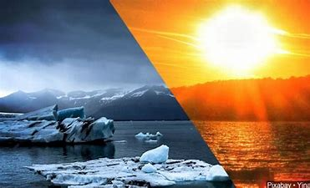

(5)
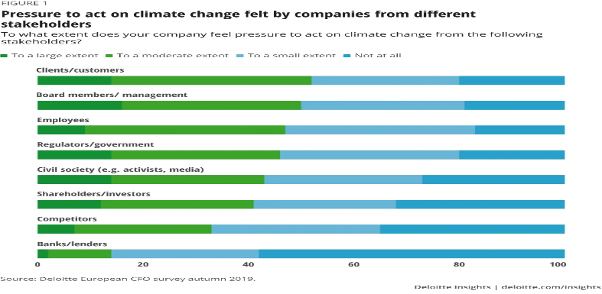
To pick up distant better a much better, a higher, a stronger, an improved understanding of how companies see the issue of climate alter, the most recent version of the European CFO study inquired about 1,200 budgetary administrators over Europe to what degree their companies are feeling the weight to act and what accurately they are doing. The study appears that most companies are feeling the weight from different partners. Clients are most regularly named as sources of critical weight, but workers, controllers, respectful society, and speculators are not distant behind. The degree to which companies are feeling outside weight shifts incredibly. 30 per cent do not see critical weight from anybody, whereas for 19 per cent the weight comes from as it were one or two partners – ordinarily from controllers and gracious society. Bigger companies are more likely to feel the weight from a few sides, with two-thirds of CFOs announcing that they feel the weight to act from three or more partners and 70 per cent feeling beneath weight from clients. By differentiate, the regulator is the most source of weight on littler companies.

Expanded Open Pressure.
As the open develops more tolerating of climate alter as truth, it gets to be less tolerating of businesses that do not work to decrease their natural affect. Progressively, customers search for items that are delivered or at slightest have a littler natural affect than other comparable items. Companies are moreover progressively anticipated to be socially dependable and take steps to form their operations more ecologically inviting or to give to natural charities. This thrust has been portioning of the reason that huge companies like IKEA, Swiss RE, Apple and Settle have committed to 100 percent renewable energy.

Do companies feel the weight to act on climate. change?

The weight felt from distinctive partners moreover shifts over businesses. In tourism, car, customer merchandise and vitality and utilities, the share of administrators announcing weight to act is among the most elevated for each partner gather. There are a few contrasts between these segments, nevertheless, within the degree of impact coming from the different partners. For illustration, in tourism, customer products and car, weight from clients is felt more unequivocally. In vitality and utilities, the weight comes more from speculators and controllers, respectful society, and speculators are not distant behind.

How ought to corporate administration respond?

The TCFD characterizes four key administration disciplines through which companies are anticipated to address climate alter: administration, procedure, hazard administration, measurements, and targets. Upgraded revelation in these regions will help financial specialists and other partners evaluate a company’s introduction to climate-related dangers, and the quality of its reaction to them. The TCFD’s suggestions are broadly appropriate but have a specific centre on high-impact businesses.

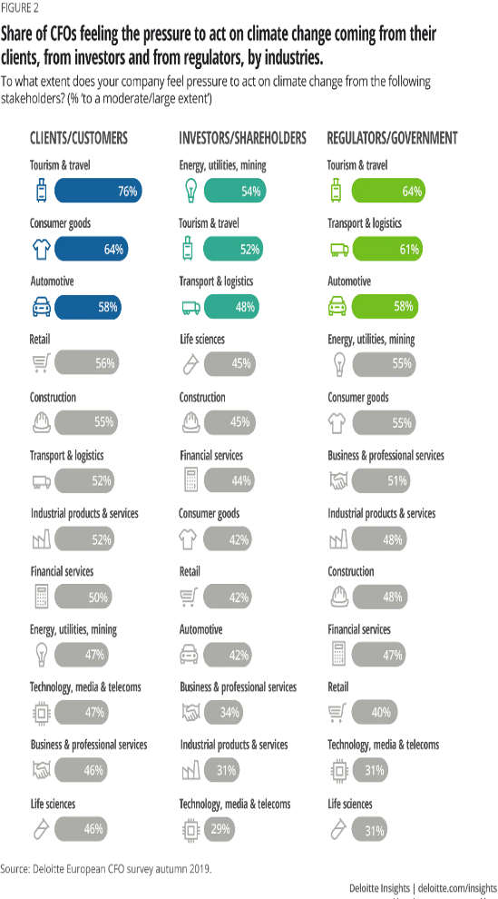
These incorporate banks, protections companies and resource supervisors, who will have to be deal with climate change-related dangers in their portfolios. Within the genuine economy, the divisions on which the TCFD centres incorporate vitality, transport, horticulture, and ranger service. Companies in these businesses are especially uncovered and can anticipate confronting expanding weight to reveal how they see and bargain with the impacts of climate alter on their commerce models and esteem chains.

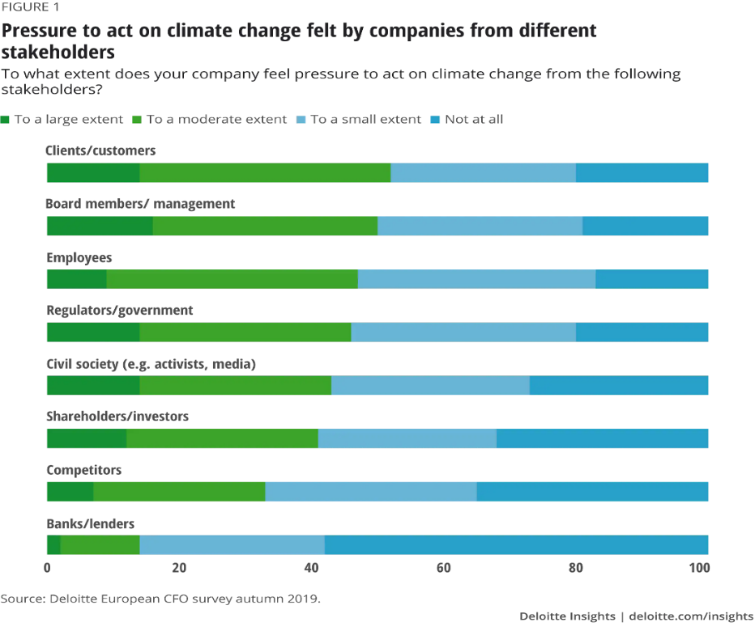
The weight felt from distinctive partners moreover shifts over businesses. In tourism, car, customer merchandise and vitality and utilities, the share of administrators announcing weight to act is among the most elevated for each partner gather. There are a few contrasts between these segments, nevertheless, within the degree of impact coming from the different partners. For illustration, in tourism, customer products and car, weight from clients is felt more unequivocally. In vitality and utilities, the weight comes more from speculators and controllers.
Advanced advances can, for case, help decouple financial development from asset utilization, improve straightforwardness and responsibility on natural impacts, and aid examine and foresee climate alter advancements.

The eagerness of companies to reveal climate change-related administration exercises and nursery gas emanations has developed quickly later. To date, more than 800 companies have marked up to the TCFD, subsequently giving bolster to the thought of upgraded administration and revelations, although so distant exceptionally few have really conveyed. Announcing of genuine carbon emanations execution, nevertheless, has as of now come a now come a 30 per cent do not see critical weight from anybody, whereas for 19 per cent the weight comes from as it were one or two partners – ordinarily from controllers and gracious society. Bigger companies are more likely to feel the weight from a few sides, with two-thirds of CFOs announcing that they feel the weight to act from three or more partners and 70 per cent feeling beneath weight from clients. By differentiate, the regulator is the most source of weight on littler companies.

The degree to which companies are feeling outside weight shifts incredibly. 30 per cent do not see critical weight from anybody, whereas for 19 per cent the weight comes from as it were one or two partners – ordinarily from controllers and gracious society. Bigger companies are more likely to feel the weight from a few sides, with two-thirds of CFOs announcing that they feel the weight to act from three or more partners and 70 per cent feeling beneath weight from clients. By differentiate, the regulator is the most source of weight on littler companies. The weight felt from distinctive partners moreover shifts over businesses. In tourism, car, customer merchandise and vitality and utilities, the share of administrators announcing weight to act is among the most elevated for each partner gather. There are a few contrasts between these segments, nevertheless, within the degree of impact coming from the different partners. For illustration, in tourism, customer products and car, weight from clients is felt more unequivocally. In vitality and utilities, the weight comes more from speculators and controllers. Advanced advances can, for case, help decouple financial development from asset utilization, improve straightforwardness and responsibility on natural impacts, and aid examine and foresee climate alter advancements.

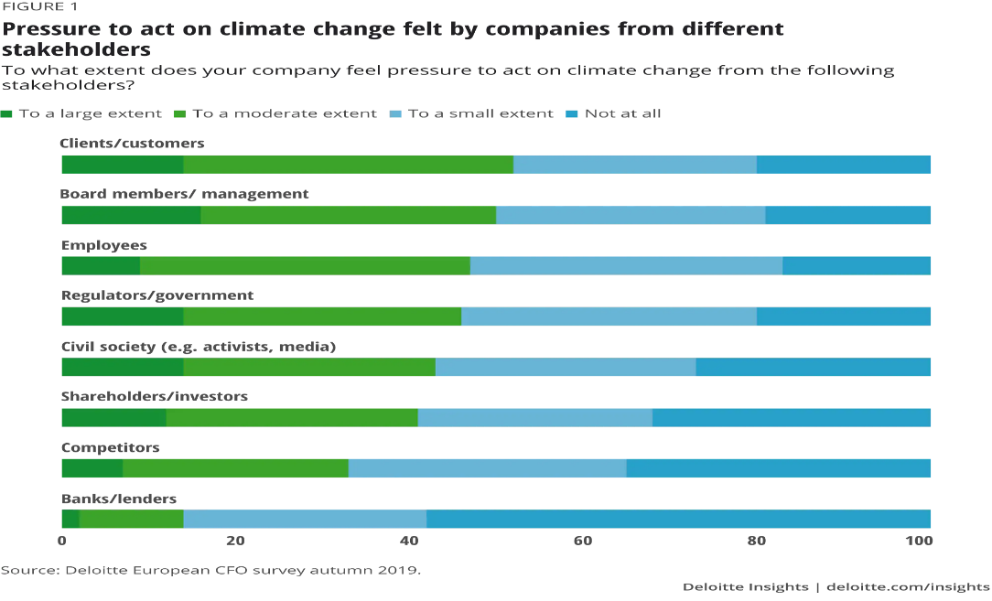

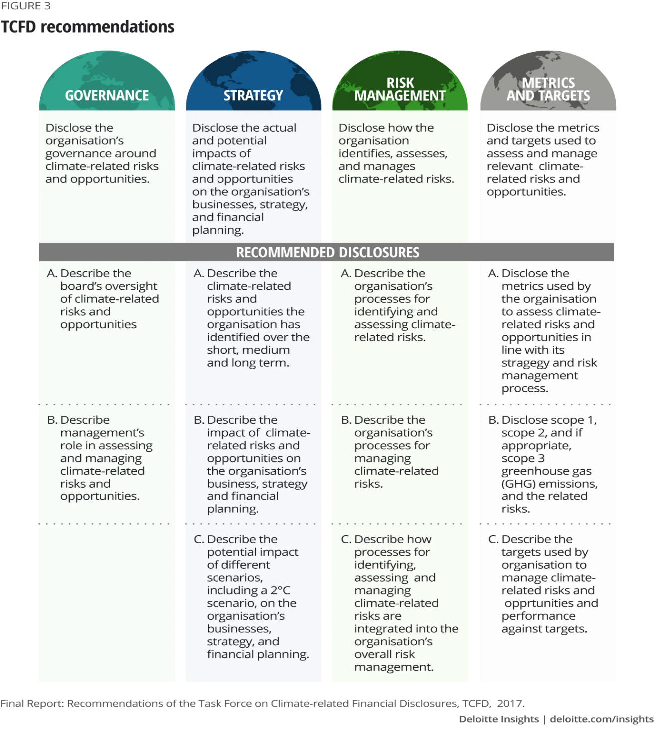
More vital are the real activities companies attempt to diminish outflows and moderate dangers. This may incorporate reorientation towards renewable energies and crude materials, a decrease in their dependence on rare water assets or the assurance of generation locales from extraordinary climate by building dams or introducing warm cover. Seizing openings to convey attractive arrangements to climate alter is another region of concrete, vital, but too beneficial activity. This might incorporate the advancement of less carbon-intensive items or of administrations that help individuals and economies maintain themselves in a world influenced by climate change. (6)

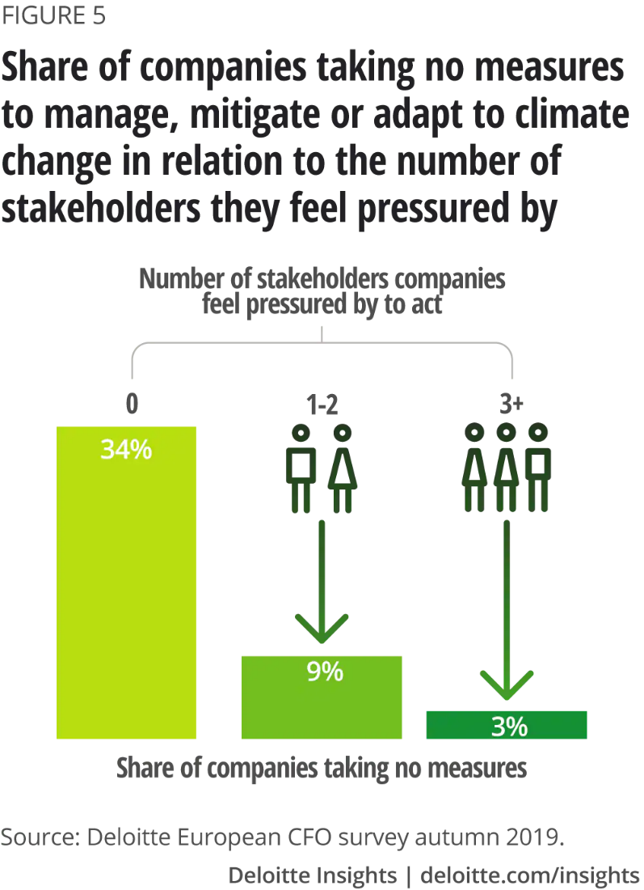
What are companies doing to combat climate change?

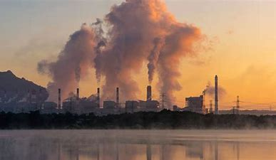
Stakeholder weight leads to activity. One-third of the companies that are not beneath noteworthy weight from any specific partner say they are not taking any activity to oversee, relieve or adjust to climate alter. But in companies that feel pressurized by three or more partners, as it were three per cent are coming up short to require activity.

most companies resort to expanding their vitality proficiency and utilizing more climate-friendly gear. These measures frequently advantage from government motivations and aid decrease corporate costs. Hence, companies are culling the low-hanging natural product and harvesting quick taken a toll benefit.

From what fund officials report are, companies’ climate reactions centre on measures that have a short-term cost-saving impact. When it comes to the activities taken,

(8)
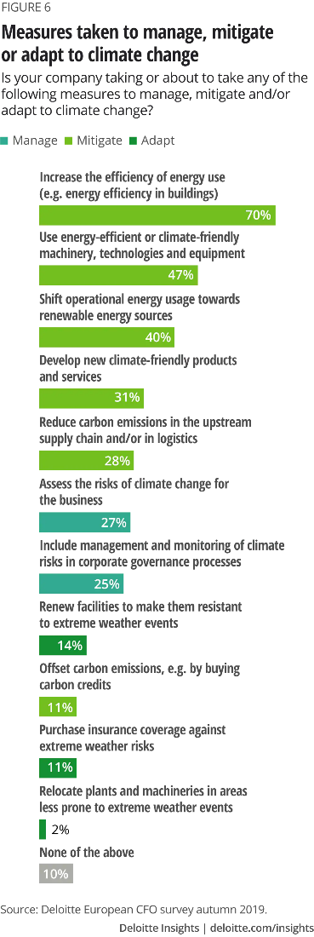
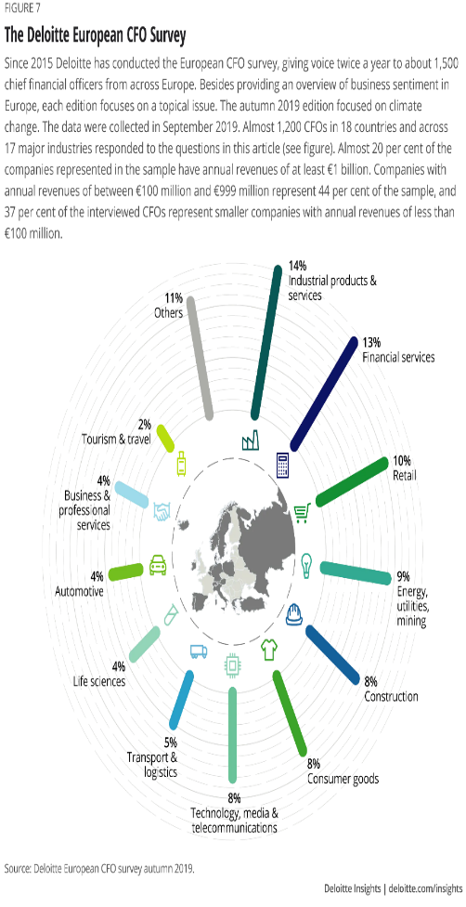
assess the scale of essential emanation decreases, and the levers that are key to accomplishing them calculate how much will emanation diminishment and adjustment endeavours cost. position the dangers and openings of climate alter inside the administration structure to guarantee a key quantifiable approach. Climates alter is changing how buyers, representatives and shareholders assess companies and connected with them. In a few cases, this will lead to a real move, where commerce models got to be re-evaluated. Companies do not as it were ought to degree their introduction to climate-related dangers and along these lines oversee them, but to consolidate climate alter in their key plans. Disappointment to do so will weaken the supportability of their commerce.1

Less unmistakable are longer-term measures that would produce incomes and more flexible development by creating climate-friendly items and administrations. In addition, companies show up in common very hesitant to lock in with other companies inside their supply chain to decrease carbon emanations. As it were 28 per cent of respondent's report doing so. Troubles planning with other companies and a need of any money related motivating force may be behind this. Companies may accept that climate alter will have less affect in Europe than somewhere else, but, in that case, they are likely to be thinking little of the dangers to which they are uncovered through their worldwide supply chains and markets. The taking after steps may help companies to urge to grasps with climate change: understand the dangers climate alter presents to the business, and the openings which will lie in getting to be portion of the solution

The start with step a trade must take is to conduct an examination to characterize how it impacts the environment, as well as the potential dangers it faces due to climate alter. In expansion to dangers, businesses ought to distinguish openings to make strides their natural execution. Companies ought to look at whether they can source elective materials and evaluate the possibility of sing renewable energy such as sun based, wind and biomass. Businesses can utilize this data to form a natural administration system they utilize to move forward their execution. (7)

How Trade Can Prepare

So, how can businesses plan for the impact's climate alter will have on them? Numerous companies have as of now begun to adjust, and all those that trust to succeed within the future will need to do the same.

References

Dr Michela Coppola& Thomas Krick, &Dr. Julian Blohmke, Companies are under pressure on climate change and need to do more. Impact of Climate Change on Business | Deloitte Insights (1)

ERIC FONTINELLE, 2020, 7 Ways Climate Change Affects Companies. 7 Ways Climate Change Affects Companies (investopedia.com) (2)

Salvatore Schiano, 2019, Climate Change Is Transforming Business. Climate Change Is Transforming Business (forbes.com) (3)

Getty Images, 2015, Climate Change, Tax Pledge Among Issues to Watch for 2016 .Climate Change, Tax Pledge Among Issues to Watch for 2016 (POLL) - ABC News (go.com) (4)

How Climate Change Will Affect Businesses. - How Climate Change Will Affect Businesses - Renewable Energy Magazine, at the heart of clean energy journalism (5)

Dr Michela Coppola& Thomas Krick, &Dr. Julian Blohmke, Companies are under pressure on climate change and need to do more. Impact of Climate Change on Business | Deloitte Insights (6)

Emily Folk, 2018, How Climate Change Will Affect Businesses. - How Climate Change Will Affect Businesses - Renewable Energy Magazine, at the heart of clean energy journalism (7)

Chris Watkins, 2019, Climate change could pose ‘existential threat’ to humanity by 2050, advocates say. Climate change could pose ‘existential threat’ to humanity by 2050, advocates say (waow.com) (8)

