Bibliographical Description Project,
[PHI 01238].
Darren Tierney
21/10/23
Level 6
Transcript of the Title Page.
CLAVIS | SCRIPTVRAE S. | ſeu de Sermone Sacrarum | Literarum, | Autore MATTHIA FLACIO | ILLYRICO, | PARS PRIMA: | IN QVA SINGVLARVM VOCVM, ATQVE | locutionum S. Scripturæ uſus ac ratio Alphabe- | tico ordine explicatur. | O P V S,& maximo annorum aliguot labore ac fludio,multisǵ uigiliis,atg | fide ſingulari confectum: & madximam quog S. Theologiæ ſtudioſis commo- | ditatem,quicung canidé ac dextré uti eodem uoluerint,allturum: ut ſimi- | le,in hoc quidem argumenti genere,nullum unquam eſſe editum, | reipſa facilé ſint deprehenſuri. | Acceeſsit Vocum ac phraſium, item Locorum S.Scrpturæ obiter | explicatorum, deniq; Rerum,&c.Trifeminus | I N D E X. | [PRINTERS MARK] | BASILEAE, PER IOANNEM OPRI- | NVM, & EVSEBIVM EPISCOPIVM.
Construction and Format.
The book I am describing is titled “CLAVIS SCRIPTVRAE S.” it is a 16th century printed book. The book cover has been bound with alum-tawed pig skin. On the front there are multiple different decorative features imprinted into the leather cover. These images seem to be of saints, and the tool used was most likely a Roll-tool design commonly found in this era. It seems that the centrepiece picture is a stamp of some form as it veers slightly from the spine of the book. On the rear side we find more of the same. There are five indented raised bands with horizontal blind fillets accentuating the compartments. The darker edges suggest some sort of treatment that has worn away over time. The integrity of the leather is decent for a book of its age. There is a possibility of degradation or fire damage due to black pock marks on its rear. The spine is intact, and the construction of the book is still sound. Whomever bound this book, which likely was shortly after it was printed, has taken great care to do a quality job. When we open the solid wooden panel, we find that the parchment backing is starting to peel off and is exposing the wooden board underneath. But this does not expose the bindings.
While there are a few pages that are loose in the first part of the book, it seems to be mostly in a good condition. This book is of a two-page folio format having a page size of 33cm, the font is Roman Type, it is set out in a two vertical paragraph style that coincides with other books of its time. This specific book was Created in 1576 in the month of March (Mense Martio) and the original publishing was written by Matthia Flacio Illyrico.

Provenance.
This volume is the first out of two, the Roderick Bowen special collections have an incomplete collection. It was donated by Philip Thomas, which we know today made his fortune during the exploitation of the Atlantic slave trade. Due to the nature of how he bought his books, it is difficult to say exactly when they were received and where from. It is likely a representative of Thomas or himself bought this book from one of the many wholesales in the city of London. Before that time though we see at least three distinct owners of the book, while tracking them down individually is a difficult task to achieve, we can gain some basic insight into the owners. Due to the difference in handwritings and dates found it is certain that these in my own opinion were different people, although it could be possible that it is the same person over a long period of time, but this seems unlikely.

The first owner of the Book has written two signatures in the volume, one of which is dated, both on the inside of the back panel. He marks his signature as what might be able to be seen as Christophori Schröteri, a latinised version of Christopher Schröter, he signs this book as Au 1580. This is the earliest evidence of an owner, and it falls very close to the production date of the volume.
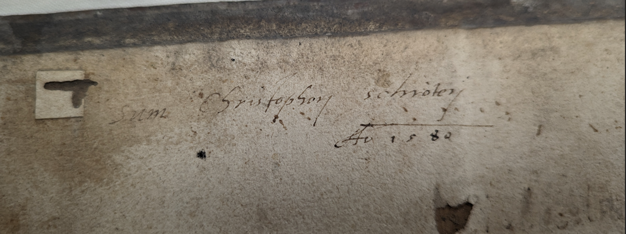
Just underneath this we see an interesting difference in handwriting ability, written by someone who states that his name is also Christopher Schröter, although it is in childlike handwriting. It states that Christopher is the owner of both volumes of these books. This leads me to speculate that this was a gift, given by a parent or a mentor, to someone younger learning how to write, and possibly understand Latin.
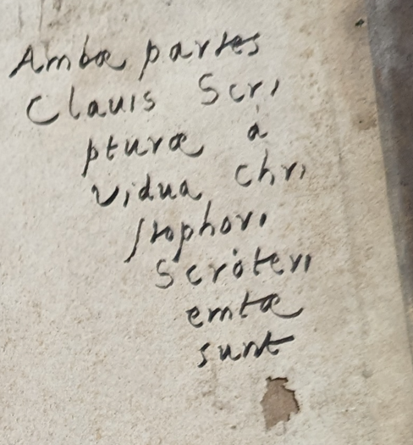

Next on the landing page we have our next candidate for the ownership of this book, the person who owns this goes by M. Christiani. They mark it with a date 1663 which is close to a century after the original owner was in possession of this book, another owner seems likely, but they have not marked the book with an obvious name and a date.
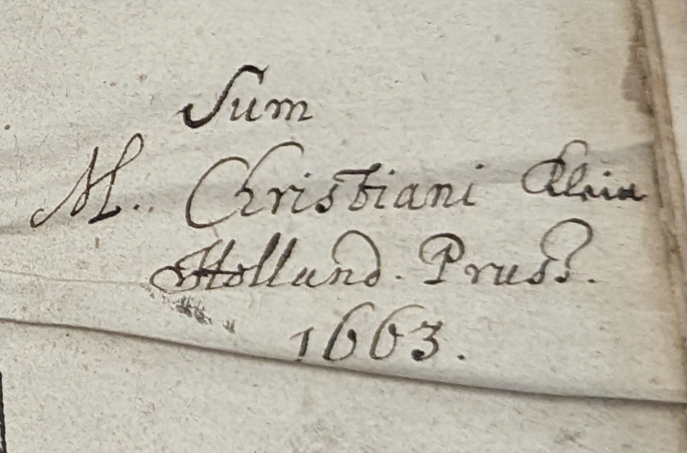
We then get a third date of 1708 on the top right of the page, this message states the date of 1559, when this certain volume was released in its current production. 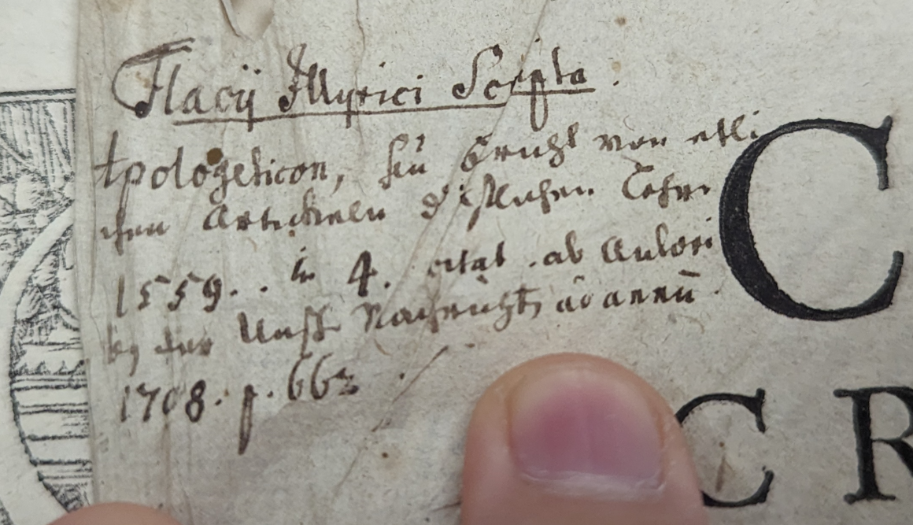

Unfortunately due to the difficulty of reading handwriting I was not able to decode another message on the back page, but if I had to speculate I might say that the number corrected with a red pencil could have been attributed to the print run number.
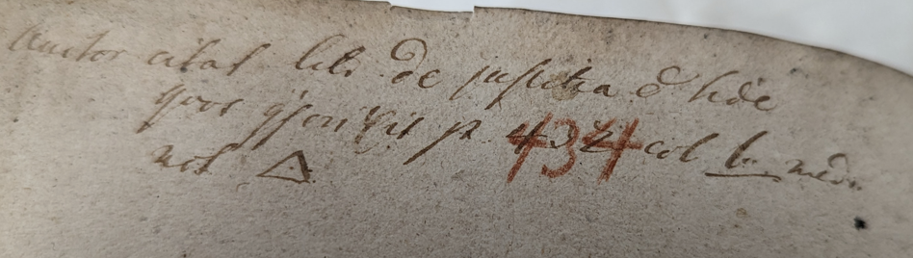

Last of all we get a lengthy paragraph that is difficult to decode, it seems that it is dated for 1851, so this could have been done around the time this book was donated, it could even be from the university itself. It notes that the Printer is Johannes Oporinus in the first sentence, and this is backed up by his printer mark that we see on the same page.
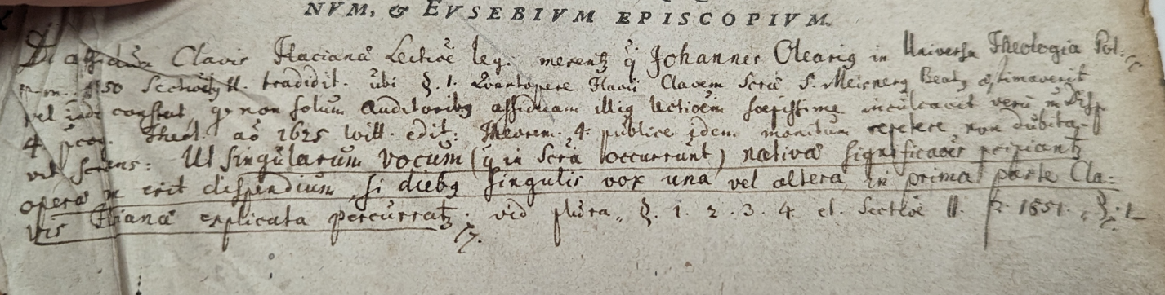

There is a two identical printers marks in this volume, both depicting the ‘Printing mark of Johannes Oporinus; Arion on the dolphin; Invia Virtuti Nulla Est via. The Greek poet Arion stands with one foot on a dolphin and with the other foot on the land. He plays the Lira Da Braccio. At the top of a quote in Latin from Ovid 'metamorphoses.’ Below I have two different sources for Oporinus’ printers mark to draw a comparison.

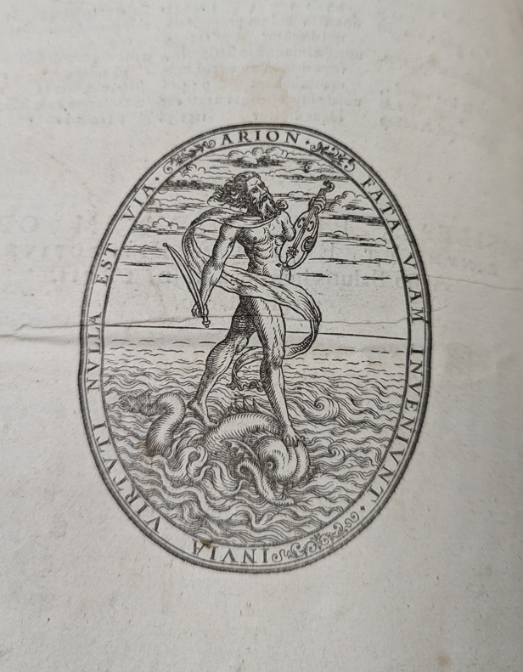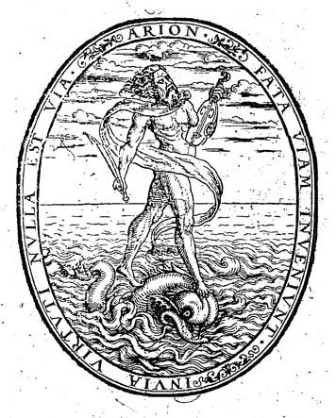
Johannes Oporinus was a humanist printer, he was born in Basel and he was a professor of Greek and Latin at the University of Basel, this book would have been printed less than 10 years before his death in 1968. He was infamous to be the first to print a Latin version of the Koran, for this he was imprisoned for a short time.
Bibliography.

Primary Sources.
Roderick Bowen Library and Archives, PHI01238, Clavis Scriptvrae S., 1567.

Secondary Sources.
‘Oporinus, Johannes’, The Oxford Dictionary of the Renaissance (Oxford University Press, 2003)

Vesaliusfabrica, Johannes Oporinus, Dedicated Printer of the Original Fabrica, https://www. vesaliusfabrica.com, Available from: https://www.vesaliusfabrica.com/en/vesalius/history-context/the-printer-oporinus.html, [Accessed: 20/10/23]
Britannica, Roman Typeface, Available at: https://www.britannica.com/topic/roman-typeface, [Accessed 20/10/23]
Alum-Tawed Skin, language of Bindings, Available at: https://www.ligatus.org.uk/lob/concept/1197, [Accessed 20/10/23]

Alum-Tawed Skin, language of Bindings, Available at: https://www.ligatus.org.uk/lob/concept/1197, [Accessed 20/10/23]
Britannica, Roman Typeface, Available at: https://www.britannica.com/topic/roman-typeface, [Accessed 20/10/23]
Roderick Bowen Library and Archives, PHI01238, Clavis Scriptvrae S., 1567.
Christophori Schröteri, Own Image, RBLV, PHI01238, Clavis Scriptvrae S., 1567
Christophori Schröteri Scrawl, Own Image, RBLV, PHI01238, Clavis Scriptvrae S., 1567
M. Christiani Signature, Own Image, RBLV, PHI01238, Clavis Scriptvrae S., 1567
1708, Own Image, RBLV, PHI01238, Clavis Scriptvrae S., 1567
Red Pencil Correction, Own Image, RBLV, PHI01238, Clavis Scriptvrae S., 1567
1851, Own Image, RBLV, PHI01238, Clavis Scriptvrae S., 1567
https://www.alamy.com/printing-mark-of-johannes-oporinus-arion-on-the-dolphin-invia-virtuti-nulla-est-via-the-greek-poet-arion-stands-with-one-foot-on-a-dolphin-and-with-the-other-foot-on-the-land-he-plays-the-lira-da-braccio-at-the-top-of-a-quote-in-latin-from-ovid-metamorphoses-image414477533.html
Own Image
Johannes Oporinus’ Mark, Johannes Oporinus, August 2016, Online Image, Available at: https://commons.wikimedia.org/wiki/File:Johannes_Oporinus_mark_3_-_BEIC.jpg, [Accessed:20/10/23]
‘Oporinus, Johannes’, The Oxford Dictionary of the Renaissance (Oxford University Press, 2003); Vesaliusfabrica, Johannes Oporinus, Dedicated Printer of the Original Fabrica, https://www. vesaliusfabrica.com, Available from: https://www.vesaliusfabrica.com/en/vesalius/history-context/the-printer-oporinus.html, [Accessed: 20/10/23]

