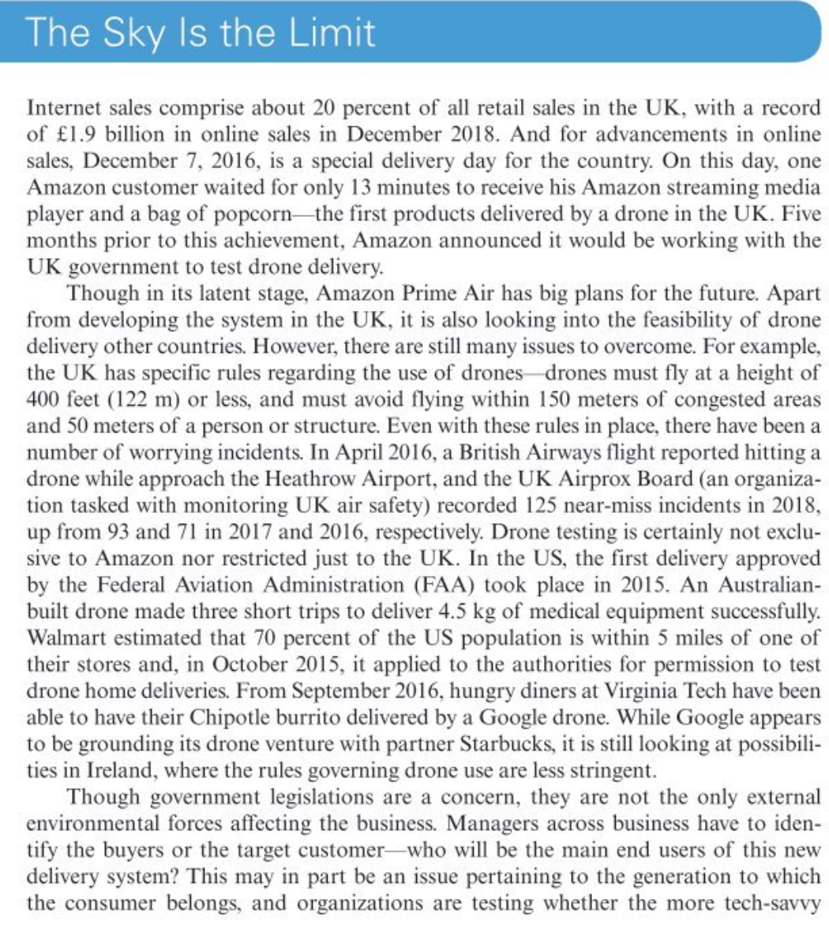
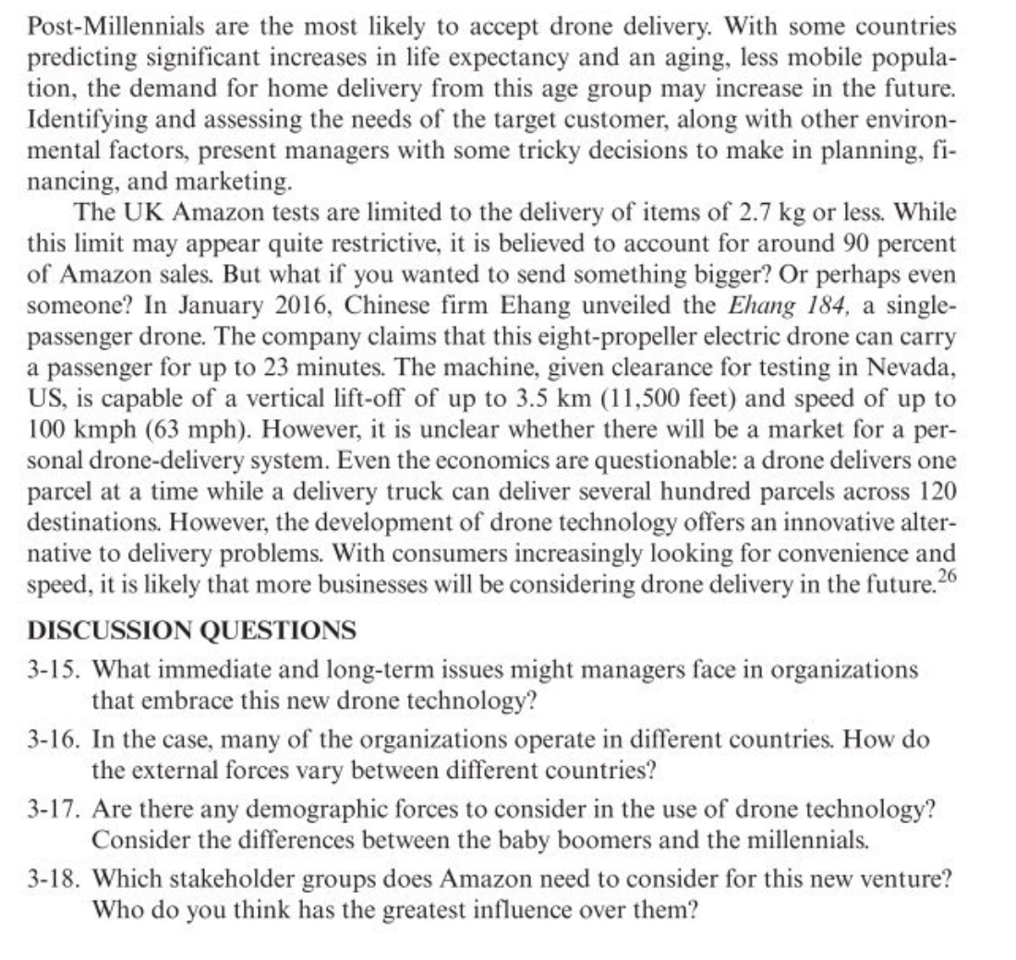
Source: Robbins, S.P., Coulter, M.K. and Randel, A. (2021) Management. 15th global ed. Harlow, England: Pearson Education.

