
How has the phenomenon of serial killers changed over previous decades compared to today’s UK.

​Name: Jessica Emily Parry
​Student ID: 1901894
​School: UWTSD Swansea
​Degree: Criminal Justice and Policing
Due Date: 15th December 2023
Word Count: 15,257

Acknowledgments
​
I would like to thank Bronwen Williams, and my Supervisor, Jane Davies, for their continued support and time throughout this dissertation process.​

​Lastly, I would like to thank my partner, as well as my family and friends, for their everlasting support, guidance, and encouragement throughout my entire duration at university, which has been of immense significance to me. I will eternally appreciate their assistance, both now and in the future.

Declaration
​
This work has not previously been accepted in substance for any degree and is not being concurrently submitted in candidature for any degree.

Name: Jessica Emily Parry Signed: JEParry Date: 15th December 2023

​

​Statement 1
​This dissertation is being submitted in partial fulfilment of the requirements for the degree of BA/BSc.

Name: Jessica Emily Parry Signed: JEParry Date: 15th December 2023

​

​Statement 2
​This dissertation is the result of my own independent work/investigation, except where otherwise stated.
​Other sources are acknowledged in the Reference Section.

Name: Jessica Emily Parry Signed: JEParry Date: 15th December 2023

​Statement 3
​I hereby give consent for my dissertation, if accepted, to be available for photocopying and for interlibrary loan, and for the title and summary to be made available to outside organisations.
​
​
Name: Jessica Emily Parry Signed: JEParry Date: 15th December 2023

​Statement 4
​I hereby give consent for my dissertation, if accepted, to be available on the university’s IT system to those who have consent to use the system.

Name: Jessica Emily Parry Signed: JEParry Date: 15th December 2023
​

Abstract
This dissertation aimed to conduct a thorough evaluation of the contemporary occurrence of British serial killers and to comprehend the elements that may have had a role in their decrease. In addition to a thorough evaluation, the research indicates that potential serial killers with underlying health disorders are given medication prior to being able to commit acts of killing in modern times. Furthermore, an additional element that has contributed to the decrease in the number of serial killers in the UK today is the advancements made by the police forces over the last few decades.
An online survey was designed and distributed to the general public through social media sites, including LinkedIn, Facebook, and Instagram. Seventy-six people were included, all of whom were at least 18 years old and voluntarily consented to participate. The data collected from the questionnaires in Chapter 4 effectively supported the secondary research results presented in Chapter 2.

Table of Contents
1. Chapter One: Introduction 9
1.1 Background 9
1.2 Research Aims and Objectives 12
• Establish theoretical approaches of serial killers in the UK. 12
• Evaluation of how police development has impacted the number of serial killers in the UK. 12
• Evaluation of modern phenomena of Serial Killers UK 12
1.3 Terminology 13
1.3.1 Serial Killers and Mass Murderers 13
1.4 Ethics 13
2. Chapter Two: Literature Review 14
2.1 Introduction 14
2.2 Establish theoretical approaches of serial killers in the UK. 14
2.2.1 Psychological Explanation of Male Serial Killers 14
2.2.2 MAOA Gene Among Male Serial Killers 15
2.2.3 Maltreatment Among Male Serial Killers 16
2.2.4 Psychopathy among UK Male Serial Killers 17
2.2.5 Anti-Social Personality Disorder among UK Male Serial Killers 19
2.2.6 Borderline Personality Disorder among UK Male Serial Killers 20
2.2.7 The Role of Early Detection and Intervention 21
2.2.8 Conclusion 22
2.3 Evaluation of how police development has impacted the number of serial killers in the UK. 22
2.3.1 Police Impact on United Kingdom Serial Killers 22
2.3.2 Evolution of DNA Technology 23
2.3.3 Role of DNA Profiling in Criminal Investigations 24
2.3.4 Impact of DNA Databases on Identifying and Apprehending Male Serial Killers 24
2.3.5 Advancements in CCTV Surveillance 26
2.3.6 Role of CCTV in Deterring and Capturing Male Serial Killers 26
2.3.7 Effectiveness of CCTV Footage as Evidence in Male Serial Killer Cases 27
2.3.8 Impact of DNA, CCTV, and GPS Tracking on Male Serial Killers 27
2.3.9 Challenges and Limitations 28
2.3.10 Conclusion 30
2.4 Evaluation of modern phenomena of Serial Killers UK 30
2.4.1 The Link between Serial Killers and Animal Cruelty 30
2.4.2 Factors Contributing to the Decline of Serial Killers in the UK 31
2.4.3 The Rise of Animal Cruelty 32
2.4.4 Theoretical Link Between Serial Killers and Animal Cruelty 34
2.4.5 Possible Explanations for the Shift 35
2.4.6 Conclusion 36
3. Chapter Three: Methodology 37
3.1 Introduction 37
3.2 Research Onion 38
3.2.1 Philosophy 38
3.2.2 Approach 39
3.2.3 Strategy 40
3.2.4 Choice 42
3.2.5 Time Horizon 43
3.2.6 Data Collection and Data Analysis 43
3.3 Limitations and Potential Problems 45
4. Chapter Four: Analysis of Results 46
4.1 Introduction 46
4.2 Demographics 47
4.3 Understanding Serial Killers 48
4.3 Notable British Serial Killers 50
4.4 Common Traits of Serial Killers 51
4.5 Sources of Information 53
4.6 Decline in the number of UK serial killers 55
4.7 Factors Contributing to the Decline 56
4.8 Nature vs. Nurture 59
4.8 Medical Care and Medication 60
4.9 Police Improvements 61
4.9.1 Forensics and DNA 61
4.9.2 CCTV 62
4.9.3 Media 62
4.10 Police 20 years ago 63
4.11 Feeling safe in their community 64
4.12 Animal Cruelty 65
4.13 Animal Cruelty and Serial Killing 66
5. Chapter Five: Conclusion and Recommendations 68
5.1 Introduction 68
5.2 Summary of Findings 68
5.2.1 Establish theoretical approaches of serial killers in the UK 69
5.2.2 Evaluation of how police development has impacted the number of serial killers in the UK 72
5.2.3 Evaluation of modern phenomena of Serial Killers UK 73
5.6 Limitations 74
5.7 Recommendations 75
5.8 Summary of Research 75
6. References 77
7. Appendix 104
7.1 Appendix 1 – Questionnaire 104

List of Figures
Figure 3-1 The Research Onion (Saunders, 2019) 38
Figure 3-2 Deductive and Inductive approach (Bryan, 2012). 40
Figure 4-1 Age and Gender Identification Graph 49
Figure 4-2 What comes to mind when you think about serial killers’ word bubble 50
Figure 4-3 List of British Male Serial Killers Graph 52
Figure 4-4 Common Traits of a Serial Killer Graph 54
Figure 4-5 Source of Information Graph 56
Figure 4-6 What are the factors contributing to the decline in the number of UK serial killers’ Word Bubble 58
Figure 4-7 Factors Contributing to the Decline in Serial Killers 59
Figure 4-8 Nature vs. Nurture Graph 62
Figure 4-9 Medicated Graph 63
Figure 4-10 Improvement in police developments graph 64
Figure 4-11 Police Effectiveness Today Compared to 20 Years Ago Graph 66
Figure 4-12 Feeling safe in their community graph 67
Figure 4-13 Link Between Serial Killing and Animal Cruelty Graph 68
Figure 4-14 The Contemporary Phenomenon of Serial Killers Graph 69

List of Abbreviations
MAOA: Monoamine oxidase A Gene
ASPD: Antisocial Personality Disorder
BPD: Borderline Personality Disorder
DNA: Deoxyribonucleic acid
CCTV: Closed-Circuit Television
STR: Short Tandem Repeats
NDNAD: National DNA Database
GPS: Global Positioning System
RSPCA: Royal Society for the Prevention of Cruelty to Animals

Chapter One: Introduction

Background
The study of serial killers can help shed light on issues such as mental illness, and psychopathy, which can be important for developing strategies to prevent and address violent crime (White, 2023). Not only has more research been done about them, but society has become more interested in them (White, 2023). Serial killers are those who have killed several people over a long period, frequently focusing on different victims in distinct instances. Their lack of empathy is usually what sets them apart, and there may be patterns or parallels in the way they commit their murders. Serial killers can be extremely intelligent and plan their murders with a clear goal, resentment, or fetish, which makes them a particularly unsettling and dangerous category of criminals, even if they may be psychologically unbalanced (Marono et al., 2020, p. 126). In most cases, serial killers exhibit total contempt for human life, narcissism, sadism, and psychopathy. They are often viewed as hideous and evil because of the horrible nature of their actions.

The global incidence of serial killers has seen a significant decline from the peak it reached in the 1980s (Felton, 2022). The prevalence of serial killers in the United Kingdom is comparatively lower than in other nations. According to the Online Learning College (2022), it is widely acknowledged that the United States has the most significant prevalence of serial murders. This phenomenon may be ascribed to factors such as the country's large population and the social and physical isolation experienced by several communities. In comparison, the United States is home to 67.5% of all serial murders, totalling 3,204 individuals. In contrast, while the United Kingdom has not shown the same frequency of serial killers as several other nations, it has witnessed several notorious serial killers throughout history who received significant notoriety for their perpetration of multiple acts of murder.

One of the most infamous figures is Jack the Ripper, who terrorized the Victorian London streets in the late 19th century. Harold Shipman, a trusted doctor who used his position to poison and kill at least 15 of his patients is another case (Crime and Investigation, 2023, p. 1). Peter Sutcliffe was another killer who haunted the northern England in the late 1970s, murdering 13 women. Another noteworthy figure in the history of UK serial killers is Dennis Nilsen, who operated in London during the late 1970s and early 1980s Lee (Lee, 2022, p. 1). Nilsen's crimes involved luring young men to his home and murdering them. In more recent times, Steve Wright shocked the nation with his series of murders in 2006 (Crime and Investigation, 2023, p. 1). These cases are haunting reminders of human nature's dark and disturbing side that can emerge even in the most unsuspecting places.

According to Cottier (2022), throughout the period spanning from the 1970s to the 1990s, there was significant media coverage of notorious serial killers such as Ted Bundy and the Green River Killer, both of whom confessed to the murder of several women. Nevertheless, contemporary records on the subject of serial killers are noticeably few in comparison (Cottier, 2022). According to Cottier (2022), it is evident that there has been a notable escalation in serial killings in recent decades, along with the broader trend of increasing crime rates. Likewise, there is a consensus among scholars that instances of serial killers have seen a reduction, aligning with the broader trend of decreasing crime rates. Thompson et al. (2012) reported a notable rise in crime statistics throughout the 1960s, coinciding with a doubling of crime rates within the same decade. Furthermore, the yearly number of recorded offences exceeded one million during the 1960s, increased to two million in the 1970s, and rose to 3.5 million in the 1980s. According to Thompson et al. (2021), the number of reported crimes reached 6 million by 2003, and after that period, there has been a consistent downward trend in the incidence of various documented criminal activities.

In addition, Jern (2022) suggests that a contributing factor to the decrease in serial killers is the provision of medical treatment and medication to individuals who may potentially engage in violent crimes before they have the chance to do so. Moreover, as stated by Hall (2021, p.174), the progress and improvements in police training and investigative methodologies have significantly contributed to the decline in the prevalence of serial killers. These advancements have empowered the police to identify, monitor, and capture potential perpetrators more efficiently. Enhanced collaboration and dissemination of information among police forces have additionally played a role in promptly intervening and preventing serial killers (Hall, 2021, p. 174). Nevertheless, it is crucial to examine the contemporary occurrence of a serial killer in the United Kingdom in order to ascertain their specific targets and determine whether the police should be vigilant regarding potential crimes that may be perpetrated.

1.2 Research Aims and Objectives
The purpose of this dissertation is to analyse the contemporary phenomenon of serial killers in the United Kingdom and identify potential factors that may have contributed to their decline.
This will be determined by the following three objectives:

Establish theoretical approaches of serial killers in the UK.

Evaluation of how police development has impacted the number of serial killers in the UK.

Evaluation of modern phenomena of Serial Killers UK

This study will examine both primary and secondary literature to investigate the variables that have led to the decrease in the number of serial killers in the UK, as well as the contemporary phenomenon of serial killers. This research is crucial in order to comprehensively address and effectively manage all the factors that contribute to the emergence of serial killers. By identifying the contemporary phenomenon of serial killers and addressing all aspects of crime accordingly, this research will ultimately instil a sense of safety and confidence in the public relating to the police. Existing study data will be collected, measured, and then compared with the conclusions obtained from independent research. The data will be collected independently via online questionnaires, seeking insights from professionals specialising in animal welfare and the general public's opinion of serial killers. The data obtained from these methodologies will identify the contemporary occurrences of serial killers and determine the underlying factors contributing to their decrease in prevalence throughout the last several decades.

1.3 Terminology

1.3.1 Serial Killers and Mass Murderers
Serial killers and mass murderers, although they share certain similarities, have distinct definitions. The distinguishing factor between the two is the time frame and quantity of the homicides. Serial killers engage in a prolonged series of killings, often occurring in multiple locations, while mass murderers carry out their killings within a single area and one after the other within the same time frame (Bonn, 2019).

1.4 Ethics
A full ethical assessment form was successfully completed and approved by the University's Research Ethics Committee to conduct this research, which involves collecting voluntary participation from the general public via the distribution of questionnaires on social media platforms such as LinkedIn, Facebook, and Instagram.

The next chapter will undertake a thorough evaluation of the three research objectives by using secondary research.

Chapter Two: Literature Review

Introduction
The global incidence of serial killers has significantly declined from its peak in the 1980s (Felton, 2022). The prevalence of serial killers in the United Kingdom is comparatively lower than in other nations. According to the Online Learning College (2022), it is widely acknowledged that the United States has the most significant prevalence of serial killers. This phenomenon may be ascribed to factors such as the country's large population and the social and physical isolation experienced by several localities. In contrast, the United States is home to 67.5% of all serial killers, resulting in a disproportionate focus on American-based studies on serial killers rather than the United Kingdom. While the United Kingdom has not shown a comparable prevalence of serial killers compared to other nations, it has still seen the emergence of some individuals who have garnered significant notoriety for their murderous acts (Online Learning College, 2022).

Establish theoretical approaches of serial killers in the UK.

2.2.1 Psychological Explanation of Male Serial Killers
Based on a comprehensive examination of many cases and a thorough analysis of pertinent components, it can be inferred that a range of multidimensional factors, including hormones, brain injury, and genetic predispositions, influence a person's propensity for criminal behaviour (Ji and Zhang, 2023). Moreover, it is evident that societal constructs, educational opportunities, and other related factors play a significant role in determining an individual's likelihood of committing a crime.

2.2.2 MAOA Gene Among Male Serial Killers
According to Kolla and Bortolato (2020), in the last twenty years, scholarly investigations have demonstrated that hereditary variables significantly influence the inclination towards aggressive, antisocial, violent, and criminal behaviour. The gene that has been extensively studied and linked to aggressive behaviour is the MAOA (Monoamine oxidase A) gene, which is responsible for encoding the primary enzyme involved in the breakdown of serotonin and dopamine. In essence, these neurotransmitters serve to maintain our emotional well-being, mental equilibrium, and psychological stability. In contrast, according to Korpal (2022), researchers have discovered that MAOA is well-recognised as a prevalent factor among those who have serial killer tendencies. The problem arises when there is a diminished level of MAOA expression. When such an event transpires, the human body experiences elevated concentrations of these chemical components, which afterwards engenders violent behaviour. Nonetheless, how could elevated quantities of compounds associated with pleasure produce psychopaths? There is an ideal quantity to which our bodies have adapted, and any deviation from this quantity results in severe repercussions. In this instance, the dysregulation of chemicals, such as serotonin, harms the neural responses to interactions with others (Korpal, 2022).

Moreover, Kolla and Bortolato (2020) stated that the presence of congenital MAOA deficiency, as well as the presence of low-activity MAOA variations, has been linked to an increased susceptibility to engage in antisocial behaviour and acts of violence. As stated by McDermott, et al (2009), the MAOA gene inhibits the expression of excessive amounts of aggression in individuals, which is widely considered a significant factor in the psychological makeup of individuals involved in criminal behaviour. Reason being those with lower levels of monoamine oxidase A (MAOA) face challenges in their ability to refrain from causing physical and psychological harm to others, whereas others with higher levels of MAOA exhibit greater resistance to engaging in such harmful behaviour (McDermott, et al., 2009). Furthermore, according to Stetler, et al (2014), acts of violence exhibited by humans with low levels of MAOA encompass a range of criminal offences, such as first and second-degree murder, aggravated assault, voluntary manslaughter, aggravated kidnapping, rape, and engaging in indecent liberties with children. Overall, the aetiology of MAOA-Low is attributed to a combination of genetic factors and environmental effects (Korpal, 2022).

2.2.3 Maltreatment Among Male Serial Killers
According to Verhoeven et al., (2012), the experience of childhood trauma, such as abuse, loss, or bullying, is associated with a reduction in the expression of the MAOA gene. The reduction in gene expression gives rise to various problems, spanning from relatively harmless consequences, such as social awkwardness, to more severe outcomes, such as hostility and a propensity for violent behaviour. Periodically, these matters persist, resulting in the emergence of a serial killer (Verhoeven et al., 2012). Moreover, the association with the low levels of MAOA gene is particularly evident in males who have experienced child trauma (Bortolato, 2020). As mentioned by the World Health Organisation (2022), these actions have the potential to cause harm to a child's health, survival, development, and overall sense of dignity and it occurs within the framework of a relationship characterised by responsibility, trust, or power (World Health Organisation, 2022).

A study conducted by Hernandez et al. (2015), determined that both MAOA and nature play significant roles in manifesting aggressive behaviour. Ted Bundy, the notorious serial killer, serves as an exemplification of this concept. Ted Bundy, a highly infamous individual in American society, has gained notoriety primarily due to his involvement in murder and sexual assault (Hernandez et al., 2015). Nicholls and Altieri (2009) assert that Bundy had several psychological and biological traits, with the MAOA gene being identified as one of these factors. One of the primary challenges he faced was the upbringing he received from his grandparents, who instilled in him the assumption that his mother was his sister. Bundy initiated his criminal endeavours at the age of 28, and at the time of his execution, he had perpetrated the murders of more than one hundred individuals (Nicholls & Altieri, 2009). Therefore, it can be seen that Bundy had increased levels of aggressiveness, despite being raised in a nurturing family setting. This may be attributed to his low levels of MAOA, as shown by the findings of Hernandez et al., (2015). Unfortunately, there is very little information in relation to whether UK male serial killers had low levels of MAOA gene, however, the MAOA gene has been identified as a prevalent factor among serial killers, thereby earning the reputation of being the most common denominator (Korpal, 2022).

2.2.4 Psychopathy among UK Male Serial Killers
Psychopathy is a formalised personality disorder characterised by a noticeable lack of empathy, low emotional affect, a susceptibility to manipulation, and impulsive behaviours (De Brito Stephane et al., 2021, p. 4). De Brito et al. (2021, p. 49) state that combining these attributes gives individuals with psychopathy the disturbing ability to commit shocking acts without remorse. The intricate nature of this condition indicates the complexities inherent to the human psyche, showing its potential for both deep wickedness and a strange lack of genuine remorse (De Brito Stephane et al., 2021, p. 6).

In the UK, a notable example of a male serial killer with psychopathic traits is Peter Manuel, who operated during the 1950s (Silvester, 2020, p. 1). Manuel's ability to effortlessly lure his victims into trusting him before brutally killing them shows his psychopathic nature. His crimes were characterised by planned and sadistic behaviour, marked by a complete absence of empathy or guilt for the terrible acts he committed (Silvester, 2020, p. 1). According to Greenfield (2020, p. 163), similar psychopathic traits can be observed in the case of Harold Shipman, a doctor who murdered over 200 of his patients. Shipman's charm and charisma masked his cold, calculating nature. He used his medical expertise to manipulate and murder his victims while maintaining a façade of trustworthiness (Greenfield, 2020, p. 163). Shipman's psychopathy allowed him to exploit people's trust in their healthcare providers for his sadistic satisfaction.

Collectively, serial killers also exhibit a range of personality disorders, such as psychopathy, anti-social personality disorder, and several others (Korpal, 2022). Although not all individuals with psychopathy engage in serial killing, it is evident that psychopathy, or at the very least, the presence of psychopathic characteristics, is a shared factor among serial killers, sex offenders, and a majority of violent criminals. As stated by Korpal (2022), psychopathy is believed to arise from a multifaceted interplay of genetic and environmental influences, whereby any of these elements might potentially heighten the susceptibility to developing the condition.

2.2.5 Anti-Social Personality Disorder among UK Male Serial Killers
According to Lad and Walker (2022, p. 5), antisocial personality disorder (ASPD) is a mental health condition characterized by a persevering pattern of neglect for other's rights, impulsivity, manipulative behaviour, and a notable lack of remorse. Individuals suffering from ASPD exhibit a chronic pattern of deceit, manipulation, and a disregard for societal norms and rules (Wang et al., 2022, p. 164). In extreme cases, this disorder leads to engagement in criminal behaviour, including acts as serious and dreadful as serial murder. Moreover, Lad and Walker (2022, p. 8) state that ASPD's primary features, such as a lack of empathy and an inclination towards antisocial behaviour, can contribute to an increased risk of harm to others and society.

One prominent UK male serial killer with ASPD traits is Dennis Nilsen, who operated in London during the late 1970s and early 1980s. Nilsen enticed young men to his home, where he strangled or drowned them before engaging in necrophiliac acts (Felton, 2020, p. 26). John Christie, who operated in the 1940s and 1950s, is another UK serial killer diagnosed with ASPD traits. Christie seduced vulnerable women into his home, where he sexually assaulted and murdered them (Evans, 2022, p. 1). The killers' absolute lack of empathy, disregard for the lives of their victims, and manipulative behaviour align with the criteria for ASPD, making them ideal examples of the frightening relationship between this disorder and serial killing in the UK. Lad and Walker (2022, p. 6) state that their ability to fake normality while hiding these dark impulses demonstrates the deceptive nature often associated with individuals suffering from ASPD.

2.2.6 Borderline Personality Disorder among UK Male Serial Killers
Borderline Personality Disorder (BPD) is marked by emotional instability, impulsive behaviour, enthusiastic and unstable relationships, and a distorted self-image. According to Cechak (2021, p. 113), BPD is not necessarily linked to violent behaviour. However, due to the difficulties people with this disease have in controlling their emotions, it frequently contributes to violent behaviours (Cechak, 2021, p. 113). Schug (2022, p. 562) mentioned that people with BPD struggle to control their anger and may resort to violent acts occasionally. The impulsivity and risk-taking inclinations linked with BPD can lead to impulsive acts of violence. Others may use violence to exert control or manipulate their victims (Schug, 2022, p. 562)

One UK male serial killer who exhibited traits suggestive of BPD is Robert Black, who operated during the 1980s and 1990s. Black's wicked crimes involved the abduction and murder of several young girls. His actions were characterised by alarming emotional instability and impulsive tendencies (Macdonald, 2020, p. 1). As stated by Cechak (2021, p. 115), his erratic behaviour and participation in multiple murders show the potential link between BPD and serial killing. Black's disturbing case shows the complex interplay of mental health and criminal behaviour (Cechak, 2021, p. 115). According to the Child Welfare Information Gateway (2019), the presence of childhood trauma is also strongly associated with an elevated likelihood of receiving a diagnosis of a mental health illness throughout adulthood. It is noteworthy that individuals with traumatic experiences throughout their childhood exhibit a 15-fold increase in the likelihood of receiving a diagnosis of borderline personality disorder in adulthood (Lippard and Nemeroff, 2020).

2.2.7 The Role of Early Detection and Intervention
Understanding the relationship between personality disorders and UK male serial killers is essential for early detection and intervention. Broyd et al. (2023, p. 260) state that even though it is impossible to predict who will become a serial killer, identifying individuals with personality disorders, and providing appropriate mental health treatment and support can help prevent them from escalating to violence. According to Johnson (2019, p. 78), authorities and mental health professionals can take a proactive approach by recognising these underlying mental health issues and providing tailored treatment and support, potentially redirecting these individuals from a destructive path and promoting a safer society. The strategy safeguards potential victims and shows the significance of addressing mental health concerns as an integral component of crime prevention and public safety in the UK.

The United Kingdom has made efforts to improve mental health services and increase awareness of personality disorders. These initiatives recognise that early intervention is crucial in positively impacting the lives of individuals struggling with such conditions. The Healthy London Partnership (2022, p. 4) states that providing timely support and resources helps individuals better manage their symptoms and lead more fulfilling and productive lives. Moreover, these proactive measures also serve as a crucial preventive strategy to mitigate the risk of individuals resorting to violence due to unaddressed mental health issues (Healthy London Partnership, 2022, p. 4). The holistic approach shows the importance of a compassionate and comprehensive mental health system prioritising early intervention and support to foster a healthier and safer society (Skett and Lewis, 2019, p.172).

2.2.8 Conclusion
Serial killing is a terrifying and disturbing aspect of society, and personality disorders are one of the factors that can contribute to the horrific actions. The traits associated with disorders like psychopathy, ASPD, and BPD can increase the likelihood of violent behaviour. The cases of UK male serial killers illustrate the complex relationship between personality disorders and serial killings. Understanding this relationship is crucial for early detection and intervention (Broyd et al., 2023, p. 260). By identifying those with personality disorders and providing appropriate support and treatment, society can mitigate the risk of their progression towards violence and safeguard potential future victims (Skett and Lewis, 2019, p.172).

Evaluation of how police development has impacted the number of serial killers in the UK.

2.3.1 Police Impact on United Kingdom Serial Killers
According to Hall (2021, p.174), police development and advancements in investigative techniques have played a crucial role in reducing the number of serial killers by enabling law enforcement agencies to identify, track, and apprehend potential offenders more effectively. The improved coordination and information-sharing among police departments have also contributed to early intervention and prevention of serial crimes (Hall, 2021, p. 174). The innovations have led to a significant evolution in DNA, CCTV, and GPS tracking in the United Kingdom (Palace et al., 2023, p. 85). DNA profiling has revolutionized criminal investigations by providing a reliable method to identify suspects and solve murder cases. Concurrently, as stated by Socha and Kogut (2020, p.6210), the extensive placement of CCTV cameras across urban areas enhanced surveillance capabilities and crime deterrence, with the UK becoming one of the most surveilled nations globally. Integrating GPS tracking into law enforcement operations made monitoring and apprehending criminals precisely possible. Evaluating the impact of the technologies on male serial killers in the UK is crucial in understanding the efficacy of modern policing methods and the balance between privacy and security in addressing these dangerous criminals.

2.3.2 Evolution of DNA Technology
The historical development of DNA technology in the United Kingdom represents a significant milestone in forensic science and law enforcement. DNA profiling emerged in the 1980s as an innovative scientific technique. The breakthrough is primarily attributed to Sir Alec Jeffreys, a geneticist at the University of Leicester, who developed the first DNA fingerprint in 1984 (Alketbi, 2023, p. 816). His innovative approach allowed for the unique identification of individuals based on their DNA sequences. According to Panneerchelvam, and M N (2003), this collaboration aimed to validate the credibility of a suspect's admission of guilt in two cases involving rape and murder. The results of the tests provided evidence indicating that the suspect was not responsible for the commission of the crimes. As Alketbi (2023, p.817) stated, the introduction of DNA technology in the UK marked a standard shift in criminal investigations. Before its widespread adoption, investigations relied heavily on fingerprinting, witness testimonies, and other less precise methods (Spencer, 2021, p. 479). The ability to extract, analyse, and compare DNA samples from crime scenes, victims, and suspects revolutionized how the police approached criminal cases.

2.3.3 Role of DNA Profiling in Criminal Investigations
As Alketbi (2023) stated, DNA profiling plays a crucial role in criminal investigations involving male serial killers. The technology works by examining individual's short tandem repeats (STRs). The regions are incredibly variable among people (Alketbi, 2023, p. 819). When compared, these STR profiles either conclusively match or exclude individuals as potential suspects (LaRue, 2019, p. 241). According to Wickenheiser (2019, p. 119), in the context of male serial killers, DNA profiling has been instrumental in linking suspects to crime scenes, victims, and even other unsolved cases. Scrutinizing DNA samples collected from crime scenes, victims, and potential suspects enables law enforcement to establish links that may not have been apparent through traditional investigative methods. DNA profiling also identifies serial offenders who may have committed crimes across different jurisdictions, contributing to the broader understanding of serial killer patterns (Wickenheiser, 2019, p. 119).

2.3.4 Impact of DNA Databases on Identifying and Apprehending Male Serial Killers
The establishment of DNA databases in the UK has significantly improved the impact of DNA technology on identifying and apprehending male serial killers. According to Skinner and Wienroth (2019, p. 103), the National DNA Database (NDNAD) is one of the world's most extensive DNA databases. It contains DNA profiles from individuals, including those convicted of crimes and individuals arrested but not convicted. The expansive database has facilitated the swift identification of suspects and the linkage of crimes (Skinner and Wienroth, 2019, p. 103). In the case of male serial killers, the NDNAD has proved vital (Amankwaa & McCartney, 2019, P. 49). As stated by Kennett (2019, p. 111), when a DNA profile obtained from a crime scene or victim matches an entry in the database, investigators can quickly identify potential suspects and prioritise their efforts. This has led to the resolution of cold cases and the apprehension of serial killers who might otherwise have remained at large. The database's ability to connect seemingly unrelated crimes has also assisted in recognising patterns and providing closure to victims' families (Kennett, 2019, p. 111).

Mello-Klein (2023) posits that the decline in the prevalence of serial killers may be attributed to significant advancements in forensic science, police strategies, criminal justice systems, and technological innovations. These advancements have made it more difficult for serial killers to flee prosecution. According to Bulman (2014), the progressions in forensic science and DNA testing have facilitated the police in conducting more efficient investigations into long-standing or questionable murder cases.
For example, in 1973, a tragic incident occurred involving three girls, all aged 16, who were transported to a remote rural area where they were subjected to acts of sexual assault, smothered, and ultimately lost their lives by a killer known as the ‘Saturday Night Strangler' (John, 2023). However, as stated by Owen (2023), the revelation of their murderer did not occur until 2002, coinciding with advancements in DNA technology. Identifying the individual responsible for these tragic acts in the Port Talbot region required an arduous and meticulous investigative effort spanning about thirty years (Owen, 2023). Although DNA testing had not been introduced at the time of these murders, research indicates that DNA testing has been able to resolve long-standing murder cases, even 3 decades later in this matter.
The initial limitations of DNA testing were the inability to extract DNA from hair samples, which has since been overcome. Additionally, a substantial amount of genetic material was formerly required to accurately detect DNA patterns, although recent advancements have alleviated this need (Mello-Klein, 2023).

2.3.5 Advancements in CCTV Surveillance
The history and expansion of CCTV surveillance in the United Kingdom represent a remarkable transformation in urban security and law enforcement. The first rudimentary CCTV systems in the UK were installed in 196Os, primarily for crime prevention and public safety (Underwood and Saiedian, 2021, p. 142). However, CCTV experienced significant growth during the 1980s and 1990s. As stated by Kashef et al. (2021), the expansion of CCTV networks in the UK was driven by a recognition of their potential to deter and document criminal activity. Major cities like London became pioneers in deploying large-scale surveillance systems (Long, 2022, p. 1). Cameras were strategically placed in public spaces, transportation hubs, and commercial areas. The growth continued into the 21st century, making capturing and storing footage easier (Long, 2022).

2.3.6 Role of CCTV in Deterring and Capturing Male Serial Killers
According to Mills and Klein (2021, p.401), CCTV surveillance has played a vital role in deterring and capturing male serial killers in the UK. As a deterrent, the mere presence of cameras discourages potential offenders from committing crimes, including acts of violence associated with serial killings. Knowing their actions will be captured on camera and used as evidence is a powerful deterrent for aspiring offenders (Mills and Klein, 2021). In capturing male serial killers, CCTV cameras have provided crucial evidence. As Brookman and Jones (2022, p.132) state, footage from public spaces, streets, and establishments helps establish the movements of suspects, potential witnesses, and even. The data aids law enforcement agencies in creating timelines and identifying potential suspects, contributing to more efficient and effective investigations.

2.3.7 Effectiveness of CCTV Footage as Evidence in Male Serial Killer Cases
The effectiveness of CCTV footage as evidence in male serial killer cases is significant. As Hood et al. (2021) stated, CCTV recordings have been essential in establishing timelines, corroborating witness statements, and identifying suspects. Moreover, Kim et al. (2023) stated that modern CCTV systems' high-resolution and continuous recording capabilities ensure that critical moments leading to a crime are captured in detail. In court, CCTV footage serves as a compelling piece of evidence. The authenticity and reliability of CCTV recordings have been well-established, making them difficult for defence attorneys to dispute (Koenig and Freeman, 2022, p. 1233). Their usage in trials involving male serial killers has resulted in convictions and lengthy prison sentences.

2.3.8 Impact of DNA, CCTV, and GPS Tracking on Male Serial Killers
DNA technology, CCTV surveillance, and GPS tracking have played a crucial role in improving law enforcement's ability to apprehend male serial killers in the UK. One notable case involving the application of the technologies is that of John Duffy and David Mulcahy (Crime and Investigation, 2023a, p. 1). The killers terrorised London in the 1980s with brutal murders and sexual assaults. According to Crime and Investigation (2023a, p.2), developments in DNA technology allowed detectives to reconsider evidence from the crime scenes, leading to the identification of both culprits through DNA matches. The case highlights how DNA profiling has been crucial in solving cold cases and bringing serial killers to justice (Crime and Investigation, 2023a).

CCTV surveillance has also been instrumental in capturing serial killers. As stated by Kempton et al. (2021, p.1), Levi Bellfield's case was partly broken due to CCTV footage showing his van near crime scenes. GPS tracking technology has also significantly impacted monitoring and apprehending serial offenders. For example, as stated by Bracchi and Gardner (2021, p.1), in the case of the "Suffolk Strangler," Steve Wright's vehicle was tracked using GPS data, placing him near the murder locations. The technological evidence was pivotal in securing his conviction for the murders of five women (Bracchi and Gardner, 2021, p. 1). Such cases demonstrate the effectiveness of technology in narrowing down suspects and verifying their presence at crime scenes.

2.3.9 Challenges and Limitations
Even though the adoption of DNA technology, CCTV surveillance, and GPS tracking has undoubtedly improved law enforcement's ability to combat male serial killers, it has also raised significant privacy concerns and civil liberties implications. Smith and Miller (2022, p.4) state that when used extensively, these technologies can violate individuals' privacy rights. DNA databases contain sensitive genetic information that can reveal an individual's familial relationships and predispositions to specific health conditions. According to De Groot et al. (2021, p.792), DNA sample collection and retention have raised concerns about the potential misuse of the information. Critics argue that the broad use of DNA databases raises concerns about genetic privacy and can lead to unauthorized access or discrimination based on genetic characteristics.

CCTV surveillance poses privacy risks when deployed in public spaces (De Groot et al., 2021). Constant surveillance can infringe on individuals' rights to anonymity and freedom from unwarranted government intrusion. According to Jones and Wang (2020, p. 28), the widespread use of facial recognition technology has also raised concerns about mass surveillance and the potential misidentifications. GPS tracking also presents privacy challenges, as it continuously monitors an individual's movements. Even though this technology is crucial for tracking serial offenders, it raises questions about the limits of government surveillance and the potential for abuse (Smith and Miller, 2022, p. 4). Ensuring that GPS tracking is used in a manner that respects individuals' privacy rights is a delicate balance that law enforcement agencies must strike.

DNA technology, CCTV surveillance, and GPS tracking also have limitations and vulnerabilities. DNA profiling relies on the availability of quality DNA samples. In cases where DNA evidence is degraded or contaminated, the technology's effectiveness diminishes. According to Van Oorschot et al. (2021, p.1766), false positives also occur if DNA samples are mishandled, or there are errors in the analysis process. CCTV surveillance to blind spots and the inability to monitor private spaces. In areas with limited camera coverage, criminal activities can go unrecorded. The systems are also vulnerable to tampering, hacking, or sabotage, compromising reliability and security. As stated by Tawalbeh et al. (2020, p. 4102), GPS tracking is highly dependent on signal reception and is easily disrupted in areas with poor GPS coverage, such as underground locations or remote areas. In addition, GPS devices can be tampered with or disabled, allowing offenders to evade tracking (Tawalbeh et al., 2020).

2.3.10 Conclusion
GPS monitoring, CCTV surveillance, and DNA technology have made it substantially easier to apprehend male serial killers in the United Kingdom. Regardless of some challenges, these technologies have proven effective in identifying, tracking, and apprehending offenders. The overall evaluation shows how vital these technologies are in improving law enforcement skills and making it more challenging for male serial killers to escape prosecution. Therefore, it is essential to continue with technological advancement in law enforcement to ensure a balance between safeguarding civil liberties and ensuring public security in the ongoing battle against serial killers and other serious offenders.

2.4 Evaluation of modern phenomena of Serial Killers UK

2.4.1 The Link between Serial Killers and Animal Cruelty
Serial killings cases in the United Kingdom have significantly decreased in recent years. In contrast, animal cruelty cases have increased over the same period. The shift in criminal behaviour has led to speculation about whether individuals with homicidal tendencies redirect their focus toward animals as an alternative outlet for their violent inclinations. Historically, the UK has struggled with prominent serial killer cases (Lee, 2022, p. 1). However, as Roux et al. (2021, p. 683) stated, changing societal dynamics, improved law enforcement techniques and advancements in forensic science have contributed to a notable decrease in such incidents. The concurrent rise in animal cruelty cases raises ethical, legal, and psychological concerns, necessitating a thorough investigation into the potential connections between these trends and the implications to both human and animal welfare (Roux et al., 2021, p. 683).

2.4.2 Factors Contributing to the Decline of Serial Killers in the UK
The number of serial killers in the UK has decreased due to several factors. As previously mentioned, the development of forensic technology is one of the key factors. In the past, the lack of sophisticated tools made it challenging to link crimes committed by the same individual (Eck and Rossmo, 2019, p. 609). However, the development of DNA analysis, fingerprint databases, and other forensic techniques has made law enforcement agencies significantly more effective at connecting serial crimes to a single perpetrator (Amankwaa and McCartney, 2021, p.414). This prevents potential offenders as they know the increased risk of being caught.

The forensic techniques UK police forces use have been updated in response to the changing nature of crime. Belshaw and Nodeland (2021, p. 9) stated that today, profiling, and behavioural analysis are crucial in criminal investigations because they help police build more accurate profiles of alleged serial killers. Information sharing and teamwork between various police units have also increased, enabling a more coordinated and successful response to serial crime (Belshaw and Nodeland, 2021, p. 9). Increased awareness of mental health issues and the significance of early intervention has resulted in greater identification and treatment of those with violent tendencies. The general public has also become more attentive to suspicious criminal actions due to awareness programs and personal safety education (Eck and Rossmo, 2019, p. 611). In addition, shifting social dynamics have transformed how people interact with and respond to possible dangers. As stated by Chuang (2021, p. 10), it is more difficult for serial killers to operate unnoticed since individuals are less likely to be alone and more likely to have access to support networks and resources.

2.4.3 The Rise of Animal Cruelty
The United Kingdom has witnessed an increase in animal cruelty cases, as reported by The Royal Society for the Prevention of Cruelty to Animals. The cases include violence towards pets, farm animals, and wildlife. The increase in reported cases indicates a broader problem beyond isolated incidents (RSPCA, 2022, p. 1). Several factors contribute to the growing problem of animal cruelty in the UK. One significant factor is the increasing urbanization and detachment from agriculture in modern society (Britton, 2023, p. 1). Vandresen et al. (2021, p. 105254) mention that as people become more disconnected from the realities of farming and animal husbandry, they develop a reduced understanding and empathy for animals. The disconnection leads to neglect or mistreatment when people interact with animals, whether as pets or in other contexts (Jegatheesan et al., 2020, p. 3116). Economic pressures also contribute to animal neglect and cruelty (Britton, 2023, p. 1).

Moreover, as stated by Spectrum News (2023, p. 1), the well-being of pets or livestock is put at risk when people or families struggle to make a living as there are insufficient resources for proper care. This worsens the issue by leading to instances of abandonment or neglect. In addition, Malvika Nair (2019, p. 1) states that the rise of social media and online platforms has played a role in the increase in animal cruelty cases. Some individuals exploit these platforms to showcase abusive behaviour towards animals for entertainment, perpetuating a harmful cycle of cruelty that influences others (Malvika Nair, 2019).

The increase in animal cruelty cases has significant implications for society. It reflects a concerning erosion of empathy and compassion within segments of the population (Jones, 2023, p. 1). Acts of cruelty towards animals precede violent behaviour towards humans, making it a matter of public safety and concern (Mota-Rojas et al., 2020, p. 977). Understanding and addressing this issue is essential to prevent potential future crimes. Animal cruelty also has economic consequences. Animal welfare organizations, police forces, and healthcare providers bear the financial burden of addressing and treating brutality victims. This diverts resources from other critical social issues (Morris, 2021, p. 388). Lastly, the rise in animal cruelty damages the reputation of the UK as a nation that values animal welfare. Furthermore, as stated by McCulloch (2018, p. 877), it undermines efforts to maintain high animal care and conservation standards, potentially impacting tourism, and international relations. Therefore, addressing the root causes of animal cruelty and working to reduce its prevalence is not only a moral imperative but also vital to the well-being and image of the nation.

2.4.4 Theoretical Link Between Serial Killers and Animal Cruelty
Criminologists and psychologists have studied the link between animal cruelty and serial killing. They have suggested that people committing violent crimes against animals eventually become desensitized to it. According to Reese et al. (2021, p. 2095), desensitization lowers the psychological barriers that prevent them from harming humans. When someone repeatedly inflicts pain and suffering on animals without remorse, they become increasingly capable of committing violent acts against people (Reese et al., 2021). The progression from animal cruelty to violence against humans is a concerning psychological phenomenon (Chan and Wong, 2019, p. 88). For instance, there is substantial evidence of Jeffrey Dahmer's past animal abuse. As a youth, he reportedly killed and mutilated animals, a precursor to the horrifying acts he would later perform (Lee, 2022, p. 1). Dahmer's case illustrates how early acts of animal cruelty can serve as a red flag for potential future violence against humans.

According to Mota-Rojas (2022, p.977), the violence graduation theory also suggests that acts of animal cruelty indicate an individual's potential to escalate toward harming humans. This theory recognizes that violence is a continuum, and individuals who start victimizing animals may eventually progress to more severe acts of aggression (Mota-Rojas, 2022). This progression often occurs as the perpetrator seeks to exert control and derive satisfaction from causing harm. Albert DeSalvo was another serial killer who had a history of animal cruelty. Before his brutal crimes against women, he exhibited a pattern of animal abuse (Lee, 2022, p. 1). The pattern reflects the idea that cruelty towards animals can be a precursor to more serious criminal behaviour.

2.4.5 Possible Explanations for the Shift
One possible explanation for the shift in the behaviour of serial killers toward animals is the changing societal attitudes toward violence. According to Kabene and Baadel (2019, p.12), violence against humans and animals has attracted more attention and condemnation in recent decades. Ethical and legal consequences awareness of animal cruelty has increased due to public education initiatives, judicial changes, and growing support towards animal rights (Kabene and Baadel, 2019). However, as stated by Malvika Nair (2019, p. 1), some serial killers have adapted to this changing social landscape by choosing animal victims instead of humans to avoid greater scrutiny and more severe legal penalties. They have recognised that society is less tolerant of violence towards humans, making animals an alternative target for aggression.

Another factor contributing to the shift in the behaviour of potential serial killers towards animals is the increased scrutiny and surveillance they face in the digital age. As previously stated, the advances in forensic science, law enforcement techniques, and the availability of surveillance technology have made it more challenging for serial killers to evade detection and continue their murderous acts (Roux et al., 2021, p. 687). Serial killers may have turned to harming animals to satisfy their violent urges while avoiding the close attention and risk associated with targeting humans (Menshawey, R. and Menshawey, E., 2022, 2022, 8). The fear of capture and the desire to continue their criminal activities may drive some individuals to exploit animals as their victims of choice.

The pervasive influence of digital media and the internet also plays a role in the shift toward animal cruelty by individuals with violent tendencies. Rizzo and Princiotta (2023, p. 15) state that exposure to violent content in movies, video games, and online platforms can desensitise individuals to acts of cruelty and violence. According to Riddle and MacKay (2020, p. 845), some individuals may find gratification in harming animals and documenting their actions, which can be shared on social media platforms. The anonymity provided by online spaces can encourage those with violent inclinations, leading them to conduct acts of animal cruelty without the immediate consequences they might face when targeting humans (Riddle and MacKay, 2020, p. 845). Therefore, the digital desensitisation to violence can contribute to a disturbing trend of animal cruelty.

2.4.6 Conclusion
The decrease in serial killers in the United Kingdom is a complicated phenomenon that cannot be attributed to a shift in their victim choices toward animals. Although people with violent tendencies may turn to animal cruelty, the decrease in serial killings is influenced by many factors. These multifaceted elements collectively contribute to reducing serial killers, suggesting that a transition to animal victims does not primarily drive it. The increase in animal cruelty figures is also influenced by improved reporting and awareness, economic challenges, and media coverage, distinct from serial killers' motives and behaviours. Recognizing this complexity is vital for a holistic understanding of these issues.

3. Chapter Three: Methodology

3.1 Introduction
The previous chapter successfully achieved its first, second, and third objectives by explaining the theoretical frameworks employed by serial killers in the United Kingdom, evaluating the influence of advancements in policing on the prevalence of serial killers, and reviewing evidence that indicates a potential correlation between serial killers and the escalation of animal cruelty. The objective of this study is to investigate the contemporary occurrence of serial killers in the United Kingdom and to determine if the British public perceives an enhanced sense of safety in light of the diminishing prevalence of serial killers. In order to facilitate the achievement of the objectives, primary research will be undertaken by administering questionnaires to both the general public and experts employed in the domain of animal cruelty. This approach collects qualitative and quantitative data to address the study objectives.

- Establish theoretical approaches of serial killers in the UK.
- Evaluation of how police development has impacted the number of serial killers in the UK.
- Evaluation of modern phenomena of Serial Killers UK

The decision-making process will be guided by the research onion framework developed by Saunders et al. (2019) in order to achieve these objectives. This study will take into account the concepts of reliability, validity, limitations, and ethical issues.

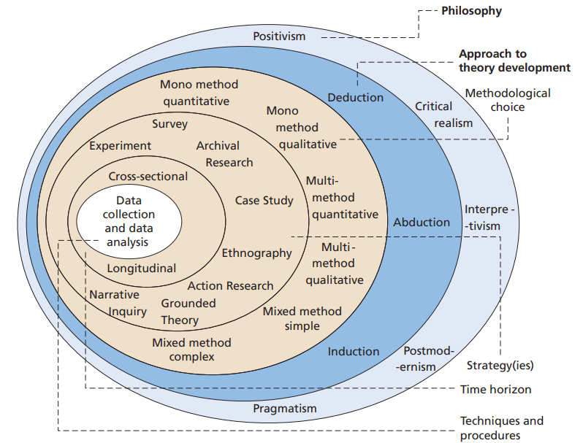
Research Onion

Figure 3-0-1 The Research Onion (Saunders, 2019)

3.2.1 Philosophy
Saunders et al. (2007, p.102) claim that the research onion encompasses three fundamental philosophies, epistemology, ontology, and axiology. Each viewpoint on research philosophy is also linked to a unique philosophical framework. Positivism, realism, interpretivism, and pragmatism are regarded as the most prominent theoretical perspectives that significantly shape the research methodology used by researchers. This research utilises an interpretivist approach since it acknowledges the subjectivity of several potential replies and relies on the analysis of participants' viewpoints via the administration of a questionnaire in order to gain understanding. According to Bhattacherjee (2012), although interpretivism research often involves the collection of qualitative data, the inclusion of quantitative data has the potential to enhance accuracy and aid in understanding. Every philosophical perspective has many benefits, and the most suitable choice is chosen by its suitability. Moreover, the field of philosophy serves to clarify the conceptual framework of research and emphasises its fundamental boundaries (Easterby-Smith et al., 2018). Consequently, having an understanding of the research theory might aid in providing clarity. This inquiry examines the underlying assumptions that underpin the research process and their interrelation with the chosen approach. Data collection will be conducted via the administration of questionnaires to both the general public and professionals employed in the area of animal cruelty.

3.2.2 Approach
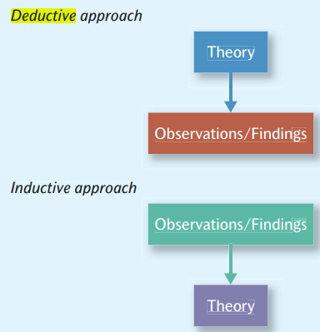
Figure 3-0-2 Deductive and Inductive approach (Bryan, 2012).
Figure 3.2 illustrates two distinct research procedures within academic writing, namely deductive and inductive methodologies. Bryman (2012) clarifies that the fundamental difference between the two methodologies lies in the fact that an inductive technique starts with pre-existing research and, after that, attempts to gather data and ascertain the underlying causes of a phenomenon. In contrast, a deductive approach involves formulating a theory as the basis for investigation, whereby the researcher aims to validate or invalidate their initial hypothesis. Hence, this study will use an inductive methodology to analyse data to appreciate the emergent patterns and ideas (Bhattacherjee, 2012). The distribution of these questionnaires includes the general public and specialists within the domain of animal cruelty. The intended demographic comprises individuals who are 18 years of age or older. Professionals specialising in the domain of animal cruelty are specifically focused on ensuring precise data collection to assess the causes contributing to the increase in incidents of animal cruelty. Additionally, these professionals are tasked with investigating if contemporary serial killers are directing their aggression towards animals rather than people. The general public is also being specifically focused on in order to ensure a precise comprehension of the public's opinion of UK serial murderers and if the decrease in their prevalence has engendered a heightened sense of security within their communities.

3.2.3 Strategy
Goundar (2012) defines methods as the procedures and approaches for gathering and examining data. Cleave (2021) demonstrates the efficacy of questionnaires for swiftly and cost-effectively collecting research data from large sample sizes. These measures have been shown to be advantageous in assessing subject behaviour, preferences, intentions, attitudes, and perspectives. In addition, using open and closed questions enables researchers to gather qualitative and quantitative data, leading to more comprehensive and insightful conclusions (Cleave, 2021).

This study aims to gather data from specialists in the area of animal cruelty as well as the general public, using both digital and paper-based questionnaires. The collected material will be analysed to provide insights to address the research goals. Using both digital and paper-based questions would facilitate universal accessibility to the questionnaire among experts and the general public. Furthermore, it has been acknowledged as a viable approach for studying and gathering fresh data to complement previous investigations (Villers, 2012). The survey will consist of inquiries associated with the research objectives, which will be distributed via email to professionals actively engaged in animal cruelty, such as veterinarians and animal rescue centres.

Additionally, professionals working in this industry will be granted access to the questionnaire through social media platforms like LinkedIn (LinkedIn, 2022). Furthermore, the questions targeting the general public will be disseminated throughout several social media pathways, including Facebook, LinkedIn, and Instagram, using the Google Forms platform. According to Melo (2018), Google Forms is a cost-free online tool that facilitates streamlined and compelling data collection. Surveys may be efficiently generated over a short period, providing immediate results as they are received. Additionally, Google Forms can provide a concise overview of findings via the use of charts and graphs, therefore facilitating a more efficient and effortless evaluation of the data. According to Asiedu (2019), using email and social media platforms facilitates faster engagement, cost-effectiveness, ease of use for participants, and simplified data analysis for researchers.

Furthermore, in order to capture correct data effectively, printed copies of the questionnaire will be made available to those who have little experience in the use of social media. This approach aims to engage the target audience directly and facilitate the collection of reliable information (Smart Survey, 2022a). The questionnaires begin by introducing the study to the participants, followed by a short debriefing and an explanation of the questionnaire's aim. Furthermore, the researcher's contact information is included in the brief for participants who want to discuss any aspect of the study.

3.2.4 Choice
The study will use a mixed-methods approach, using both qualitative and quantitative data collection methods. Creswell (2014) asserts that integrating qualitative results with quantitative approaches facilitates the interpretation and enhanced comprehension of research. The analysis of participants' perspectives will be conducted by using both qualitative and quantitative data, which will then be triangulated as a component of a mixed-methodological approach. According to Bhandari (2022), the concept of triangulation in research relates to the practice of tackling a research problem via the utilisation of several datasets, methodologies, theoretical frameworks, or researchers. This research approach can potentially enhance the validity and reliability of the study findings.

3.2.5 Time Horizon
The time horizons layer is responsible for determining the duration of the research and the collection of data within a specific timeframe (Melnikovas, 2018). Given the brevity of this investigation, the most appropriate temporal framework would be cross-sectional. Due to the temporal constraint imposed by the timeframe, researchers will use online questionnaires as a means of data collection. This method is preferred due to its expediency in engaging with the intended demographic and its efficiency compared to traditional paper-based surveys (Asiedu, 2019). Furthermore, the use of Google Forms may enhance the efficiency and ease of data assessment by providing prompt results and presenting a clear overview of findings via the incorporation of charts and graphs (Melo, 2018).

3.2.6 Data Collection and Data Analysis
According to Smart Survey (2022b), primary research involves directly accessing the original source of information rather than relying on pre-existing data samples. This particular kind of study is particularly suitable when the acquired data has to be contextually relevant. This research aims to acquire data via the distribution of questionnaires to specialists in the area of animal cruelty, including veterinarians and animal rescue centres, as well as to the general public. The objective is to get insights into the public's impressions of serial murderers. Ghauri et al. (2020) suggest that surveys are subject to several restrictions, such as temporal constraints and restricted availability of crucial resources.

Nevertheless, this research has the advantage of having direct communication channels, including email and social media platforms, with professionals actively engaged in animal welfare. These channels provide sufficient time to conduct a cross-sectional survey. Furthermore, Ghauri et al. (2020) show that surveys emphasise various occurrences, facilitating the ability to make comparisons.
The analysis will include both qualitative and quantitative data obtained from the questionnaires. McLeod (2019) claims that qualitative research involves the systematic collection, analysis, and interpretation of data that is not numerical. Furthermore, qualitative research may be used to enhance comprehension of the study by collecting subjective insights and perspectives on the topic. According to McLeod (2019), quantitative research involves the systematic collection and analysis of numerical data in an objective manner in order to characterise, forecast, or control elements of interest. Quantitative research tries to demonstrate causal relationships among variables, generate predictions, and extend the applicability of results to broader populations. The analysis of quantitative data would include the use of a Likert scale, as suggested by Bhandari (2020).
On the other hand, the analysis of qualitative data will be conducted thematically to identify repeating themes or patterns. All inquiries posed within the questionnaire refer to the study goals. The breakdown analysis will conduct a separate examination and evaluation of data for each question after the data has been assessed. The data gathered will be systematically displayed and evaluated with spreadsheet software, such as Microsoft Excel, focusing on maintaining a high level of organisation. This approach aims to facilitate the generation of reliable and precise conclusions (Natter, 2019). It is essential that all questions in the questionnaire effectively include the three goals outlined in the subsequent chapter. The inclusion of Appendix 2 in the present study encompasses a questionnaire.

3.3 Limitations and Potential Problems
One notable limitation of this study is the time demands associated with accessing essential resources, conducting primary investigations, and analysing the resultant data. In order to address this challenge, a Gantt chart has been devised, which will further facilitate effective time management. According to Ramos (2021), a Gantt chart is a graphical depiction of the progress of individual tasks within a project, organised by specific time intervals. The provided timelines visually depict the interconnections and dependencies among the various activities. Gantt charts provide a comprehensive representation of project activities and their respective progress, hence offering distinct advantages.
Furthermore, the researcher may face a potential barrier in the form of non-participation by the intended participants, particularly specialists employed in the domain of animal welfare, when it comes to engaging in an online questionnaire. Nevertheless, by using direct email communication with industry experts and utilising a specialised social media site like LinkedIn, this constraint may be effectively managed (LinkedIn, 2022).

Chapter Four: Analysis of Results

4.1 Introduction
The preceding chapter provided an overview of the methodologies and techniques used in gathering primary data for the present investigation. This chapter aims to evaluate the data collected in order to ascertain the public's perspective of male serial killers in the United Kingdom. The objective of this chapter is to present and examine the data obtained from the questionnaire. A total of seventy-six replies were obtained via the administration of the questionnaire. Morton et al. (2014) defines "data analysis" as the process of arranging and categorising gathered data in order to enhance comprehensibility and facilitate the identification of patterns or themes. The analysis included an examination of the purpose and objectives of the dissertation.
Online questionnaires provide a means of collecting quantitative data, which can be applied to statistical analysis using Microsoft Excel. The data collected from this study will be subjected to analysis in order to ascertain the public's impression of male serial killers in the United Kingdom. The participants were categorised into groups according to their gender and age in order to examine any inequalities in their viewpoints and experiences. In order to enhance the precision of the findings, individuals who self-identified as 'other' were eliminated from the data collection. DeCoster (2004) asserts that most researchers use the analytical process to ensure comprehensibility in their presentations. In addition, it is essential to communicate the results in a manner that is comprehensible, reliable, and valid (Doig and Groves, 2006). The questionnaires were sent to professionals, but unfortunately, there were no responses from the questionnaires.

Demographics
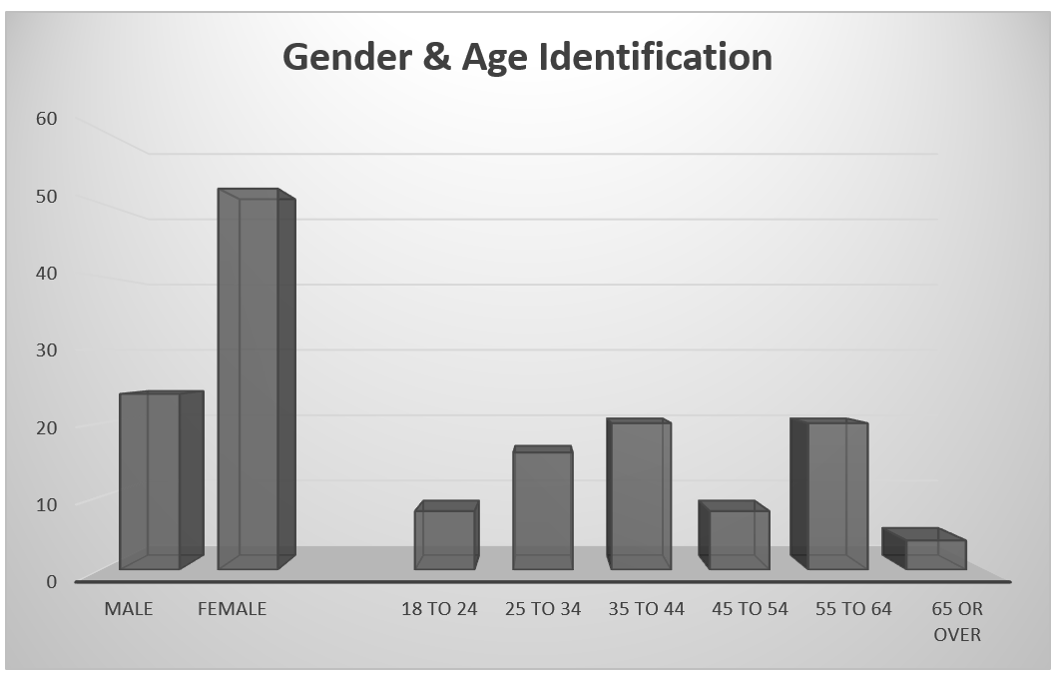
The present research obtained replies from a total of seventy-six participants. All participants in the study were 18 years of age or older and willingly chose to participate in the research. The distribution of questionnaires was conducted via social media platforms, including LinkedIn, Facebook and Instagram, as well as via the provision of paper applications to those who did not have access to these social media platforms.
Figure 4-1 Age and Gender Identification Graph

As presented above, the questionnaire respondents involved both males and females from the United Kingdom. Most respondents were female, representing 68.4% of the total population, and people aged 35 to 44 comprised the most people, which was 26.3% of the population. By getting this information, the questionnaire sets the context of subsequent questions and helps researchers understand the age composition of people who participated in the questionnaire.

4.3 Understanding Serial Killers
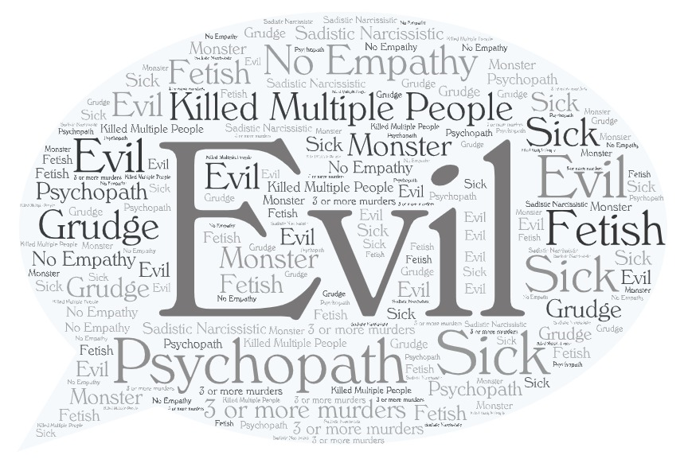
Figure 4-2 What comes to mind when you think about serial killers’ word bubble.

The word bubble above displays the responders’ answers to what comes to their minds when they think of serial killers. The responses show that the perceptions of the respondents share similar thoughts and viewpoints with all responses being precise, dark, and negative through utilising words like psychopathy, evil, lack of empathy, monstrous and psychopaths. Similarly, as discovered in the literature review chapter, psychopathy is a recognised personality condition that is distinguished by a conspicuous absence of empathy, diminished emotional affect, a vulnerability to manipulation, and impulsive actions (De Brito Stephane et al., 2021, p. 4).
This questionnaire delves deeply into the perceptions and conceptualisations of serial killers among British respondents. Their comments clearly show how the general population views these evildoers. A common thread between these answers is the correlation between serial killers and psychiatric characteristics like psychopaths. This phrase has much weight since it indicates that many respondents believe serial killers to be severely disturbed people who frequently have no moral or ethical bounds. As stated by De Brito et al. (2021, p. 49), the combination of these characteristics grants people with psychopathy the unsettling capacity to perpetrate appalling actions devoid of regret. The complicated characteristics of this disease exemplify the fundamental complexity inside the human mind, highlighting its capacity for profound evil and an unusual absence of genuine guilt (De Brito Stephane et al., 2021, p. 6). Moreover, the answers show that the most widely used definition of a serial killer is someone who has killed multiple people. As stated by the Online Learning College (2023), in the UK serial killer is often defined as an individual who commits the act of homicide on three or more occasions, with each occurrence being separated by a substantial amount of time, generally exceeding one month. This definition highlights the repetitive and deliberate acts of murder that characterise serial killers, effectively summarising their primary traits. Furthermore, the data conducted from this question of the questionnaires shows that the general public have a good understanding at what a serial killer is as well as the act, behaviour, and traits a serial killer displays.

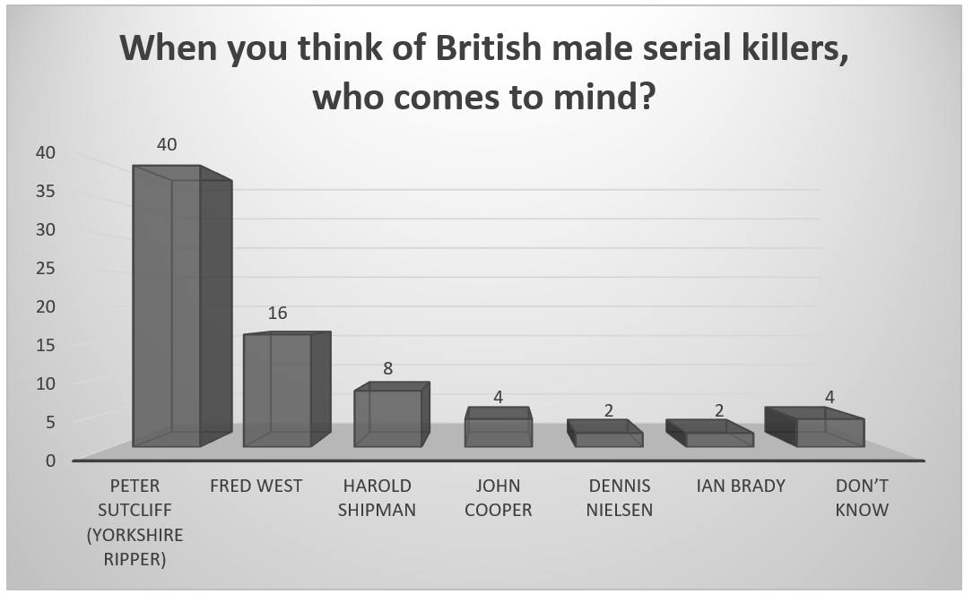
Notable British Serial Killers
Figure 4-3 List of British Male Serial Killers Graph

As shown above, the questionnaire asks respondents to list British male serial killers and explain their selections. Only four respondents out of seventy-six could not name a British male serial killer. However, ninety-four percent of responders were able to provide a name, indicating that the public can regulate these horrific acts carried out by serial killers even decades later. Notably, the Yorkshire Ripper, Peter Sutcliffe, was a well-known character in the respondents’ minds (Somma, 2023, p.19), with forty respondents out of seventy-six listing his name. The number of killings he committed, and his infamy are among the stated justifications. This inquiry provides information about these notorious offenders’ long-term effects and general public awareness. The questionnaire offers insightful information about how the public views prominent male British serial killers. To provide insight into the long-term impact of these criminals, respondents were asked to name these killers and provide justifications for their decisions. Peter Sutcliffe, also called the Yorkshire Ripper, is among the most well-known characters in the respondents’ memories (Somma, 2023, p.19). According to the questionnaire, the participants still find him distinctive. As stated by the participants they selected Sutcliffe as a prominent British serial murderer due to his reputation and the number of killings he committed. This decision reflects how widely known the public is about Sutcliffe’s horrific.

The questionnaire results align with historical data and studies related to notorious British male serial killers such as Peter Sutcliffe, Fred West and Ian Brady. The respondents’ choice of Sutcliffe as a notable serial killer based on the number of murders he committed, and his notoriety underscores the lasting impact of these criminals on the collective memory of the UK. This data can reflect the indelible mark of such individuals on society and highlights the importance of understanding the public’s perceptions and awareness of these infamous cases.

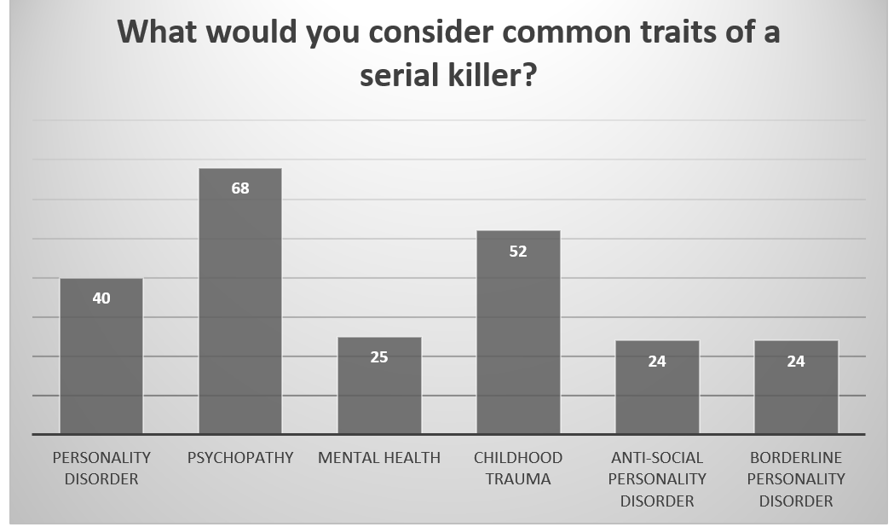
Common Traits of Serial Killers
Figure 4-4 Common Traits of a Serial Killer Graph

Above is presented the common traits of a serial killer listed by the respondents. Respondents noted that serial killers shared specific characteristics, linking 52.6% of personality disorders and 89.5% of psychosis to these attributes. This indicates a high conviction among respondents that mental health issues significantly influence the behaviour of serial killers (Tilley et al., 2019, p.9). The purpose of the questionnaire was to find out what characteristics respondents thought serial killers had in common. The gathered data sheds light on the perceived significance of mental health issues and offers insightful information on popular opinions and ideas about the psychological elements of serial killer activity.
In the questionnaire, 89.5% of respondents thought that psychopathy was necessary for serial murders. A person’s separation from reality characterises a severe mental illness known as psychosis and is frequently accompanied by hallucinations, delusions, and poor judgment (Lad and Walker, 2022). It appears that a significant portion of the population believes that serial killers may suffer from severe mental health problems due to the substantial correlation between psychosis and serial killers (Reid et al., 2019). It emphasises the idea that psychosis may be a prevalent characteristic or impetus for serial killers’ actions. Additionally, 52.6% of responders to the questionnaire linked personality problems to serial killers. Personality disorders include various persistent patterns of behaviour, thought, and inner experience that substantially depart from social norms (Tilley et al., 2019, p.9). Interpersonal problems, emotional instability, and impulsive behaviour can result from these diseases (De Brito et al., 2021, p. 49). The correlation between personality disorders and serial killers implies that participants believe there is a strong connection between specific personality disorders and the inclination to commit serial killings.

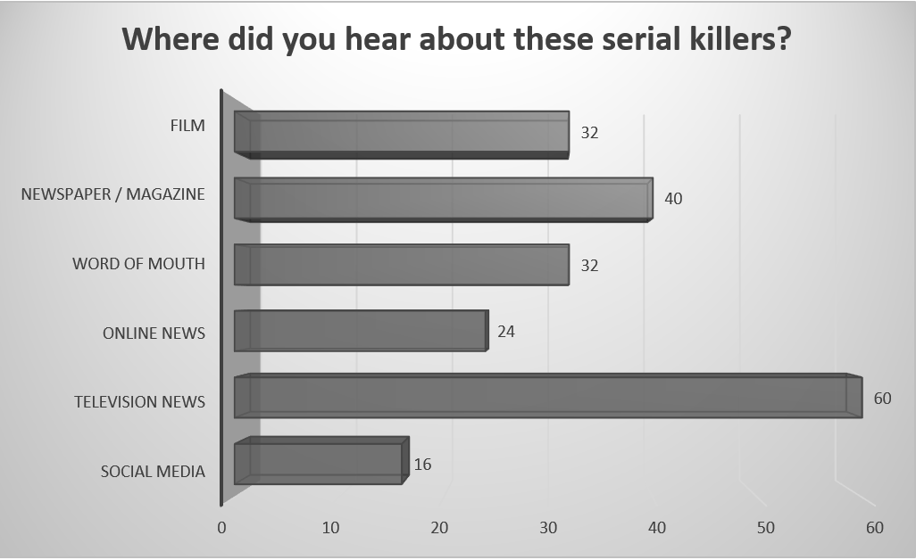
Sources of Information
Figure 4-5 Source of Information Graph

Where respondents first learned about serial killers is one of the questionnaire topics. Television news (78.9%), word-of-mouth (42.1%), newspapers or magazines (52.6%), and social media (21.1%) were the outlets most frequently mentioned. These sources show how information about this topic is widely available, with television news being the most often used. The questionnaire explores how respondents learned about serial killers and what information sources they used to do so. Comprehending these sources is crucial for evaluating the distribution of data and the general public’s interaction with this topic (Scrivner, 2022). The information shows that the public’s awareness of serial killers is shaped in large part by a variety of outlets (Haggerty and Ellerbrok, 2011).
With 78.9% of respondents stating that television news is their primary source of information on serial killers, it is clear that this is the most popular source of information. This result emphasises how important television news is in spreading knowledge about well-known criminal cases (Sutton and Keatley, 2021). It also implies that the public’s primary information source is still traditional media channels. Word-of-mouth, which 42.1% of respondents cited, is a sign of the influence of private interactions and debates between people. It suggests that people are interested in and talk about serial killers in social settings, which helps to disseminate knowledge and awareness.
In the questionnaire, 52.6% of respondents indicated that newspapers or magazines are still a reliable source of information for anyone looking for specifics about serial killers. This proves that print media is still a reliable and vital medium for in-depth reporting on these cases (Sutton and Keatley, 2021). Even though 21.1% of respondents mentioned social media, this indicates a more modern source of knowledge. The fact mentioned in the answers illustrates how information sharing changes (Sutton and Keatley, 2021). Social media sites provide a forum for exchanging ideas, discussions, and news on various subjects, including crime and serial killings.

According to this research, the public’s opinion of crime and criminal conduct is still shaped by traditional media, especially print and television news (Wang et al., 2021, p.10). Television news, which frequently includes in-depth coverage of high-profile criminal cases, has a strong narrative and visual impact. Nonetheless, the fact that social media and word-of-mouth are mentioned as essential information sources emphasises how the dynamics of information consumption have changed in the digital age (Wang et al., 2021, p.10). Word of mouth is a potent information-sharing tool, especially in close-knit groups and social circles, when recommendations and one-on-one interactions support it.


Decline in the number of UK serial killers
Figure 4-6 What are the factors contributing to the decline in the number of UK serial killers’ Word Bubble

The number of serial killers in the UK has decreased, raising the question of what variables led to this fall. Even while the responses displayed in the word cloud above does not offer specific information on the causes of the decline in serial killers, the questionnaire sheds light on participants’ beliefs about these causes (Simon, 2020, p. 261). The respondents ascribed the decrease in serial killers to many factors, such as enhanced tactics in policing, progressions in forensic science, and extensive utilisation of technologies like DNA profiling, CCTV, and cellular phones (Açıkgöz, 2023). This is in line with the circumstances in the UK, where police forces have made significant strides in locating and detaining serial killers by utilising cutting-edge methods and techniques for their investigations. Furthermore, the questionnaire has voiced the opinion that serial killers’ capacity to elude forensic analysis may not have contributed to their disappearance but rather to their continued undetected state (Simon, 2020, p. 261). This point of view emphasises the continuous difficulties and complications associated with discovering and apprehending serial killers, particularly in a technologically advanced society such as the UK, even though it may not be supported by hard evidence.

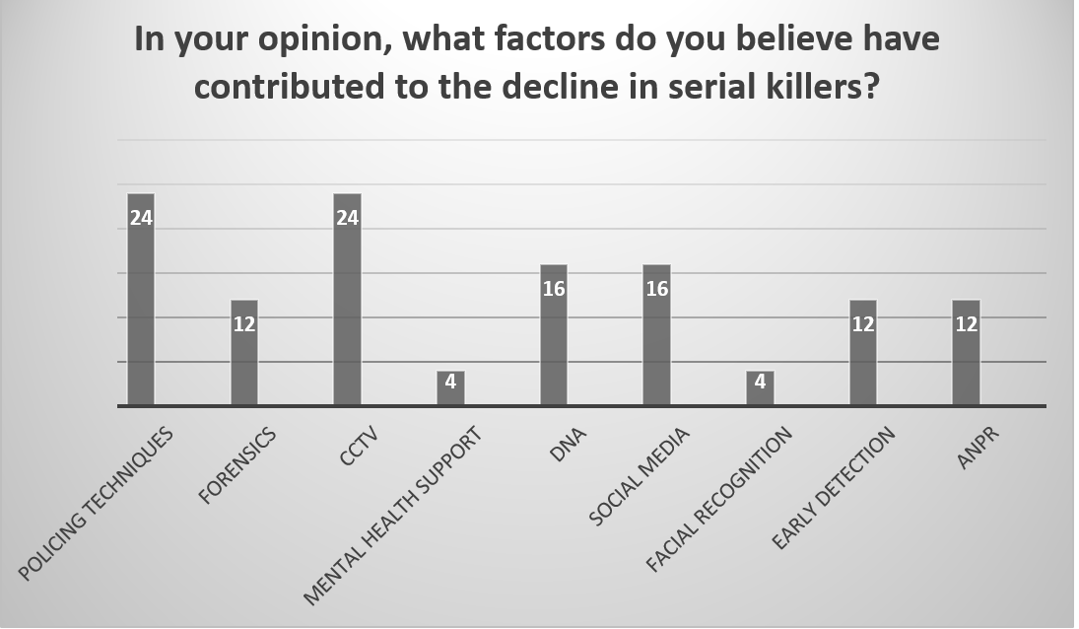
Factors Contributing to the Decline
Figure 4-7 Factors Contributing to the Decline in Serial Killers

As shown above, the questionnaire identifies the variables thought to be involved in the drop in the number of serial killers. Most respondents ascribed this decrease to improvements in policing methods (19%), specifically in CCTV (19%), forensics (10%), and DNA analysis (13%). The decrease in serial killings was partly attributed to social media and better press attention (Shaw‐Taylor, 2020, p.21). The UK study asked participants to rate the variables that they believed were responsible for the decrease in the number of serial killers. The gathered data sheds light on the varied contributions made by technological and policing improvements and the public’s understanding of the causes of this decline (Yaksic et al., 2019). A sizable percentage of respondents cited improvements in policing methods as a critical element in the drop in the number of serial killers. In particular, DNA analysis was cited as a significant contributing element by 52.6% of responders. Since DNA analysis is vital for identifying and apprehending individuals, it has changed criminal investigations (Shaw‐Taylor, 2020, p.21). The public recognises its relevance since it has been crucial in cracking cold cases and stopping serial killers from escaping justice.
Furthermore, forensics has been implicated in the decrease in serial killings, according to 52.6% of respondents. Police forces can now collect and evaluate evidence more efficiently thanks to forensic science, which helps connect suspects to victims and crime sites. The questionnaire results highlight how widely acknowledged forensic methods are for helping to catch serial killers (Yaksic et al., 2019). In the questionnaire, 42.1% of respondents stated that the usage of closed-circuit television (CCTV) has decreased serial killings. Since they help monitor and identify illegal activities and deter potential offenders, CCTV systems are becoming increasingly common in public areas (Shaw‐Taylor, 2020, p.21). The public’s opinion of closed-circuit television (CCTV) as a significant element implies that greater surveillance has prevented serial killings.
An additional intriguing discovery is that 21.1% of participants linked the decrease in serial killings to the use of social media. Social media sites are now practical resources for disseminating information and increasing public awareness of criminal cases. They have facilitated the quick spread of information to a large audience and increased the difficulty for serial killers to go undiscovered (Shaw‐Taylor, 2020, p.21). According to 42.1% of respondents, better news coverage was also considered a factor in the decline in serial killings. Public awareness has grown as a result of the media’s coverage of criminal cases, particularly those involving serial killers, and communities have been urged to report suspicious activity and remain watchful. To further elaborate on this information, it is critical to consider the background of serial killings in the UK (Yaksic et al., 2019). Several other reasons, including the success of crime prevention programs, alterations in policing tactics, and improved public awareness, may be responsible for the decrease in serial killings. This evidence suggests a public recognition of the advancements in police technology. It is evident that the public acknowledges the limitations of CCTV and forensic science during the era of serial killers such as Peter Sutcliffe as compared to their current capabilities. As stated by Underwood and Saiedian (2021, p. 142), the first simple CCTV systems were implemented in the United Kingdom throughout the 1960s with a primary focus on crime prevention and ensuring public safety. Nevertheless, CCTV saw substantial expansion during the 1980s and 1990s. Long (2022) asserts that in order to enhance surveillance capabilities, cameras were deliberately positioned in various public locations, transportation hubs, and commercial areas. This trend has persisted into the 21st century, facilitating the process of acquiring and storing video data. Furthermore, the findings suggest that respondents perceive a lower likelihood of serial killers successfully evading detection and remaining unidentified while conducting a series of horrific crimes today through the use of CCTV.

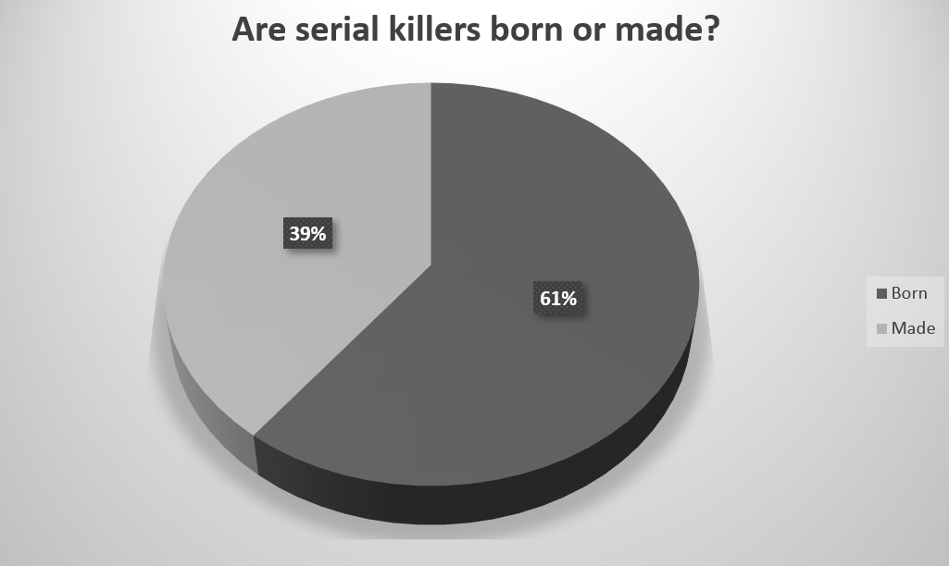
4.8 Nature vs. Nurture
Figure 4-8 Nature vs. Nurture Graph

As presented above, the questionnaire investigates respondents’ perspectives on the causes of serial killers. Remarkably, forty-six (61%) of respondents said that people with serial killer inclinations are born with these characteristics, while thirty (39%) said that life experiences mould them. There is disagreement on the fundamental causes of serial killing, with some blaming innate traits and others external forces. This inquiry exposes these differences in viewpoints. When considering the data and earlier research conducted in the United Kingdom, the questionnaires’ findings about the divergent views on the ancestry of serial killers are noteworthy (Simon, 2020, p. 261); gaining insight into how the public views this issue can help us better understand how society regards serial killers and how they evolve. Based on the findings of the questionnaires, it is evident that a significant proportion of participants, or 61% of the total, hold the belief that individuals who become serial killers had been born that way rather than being influenced by external factors (American Academy of Experts in Traumatic Stress, 2020). This shows that genetic factors play a more substantial role in shaping their propensity for such behaviour rather than life events (American Academy of Experts in Traumatic Stress, 2020).

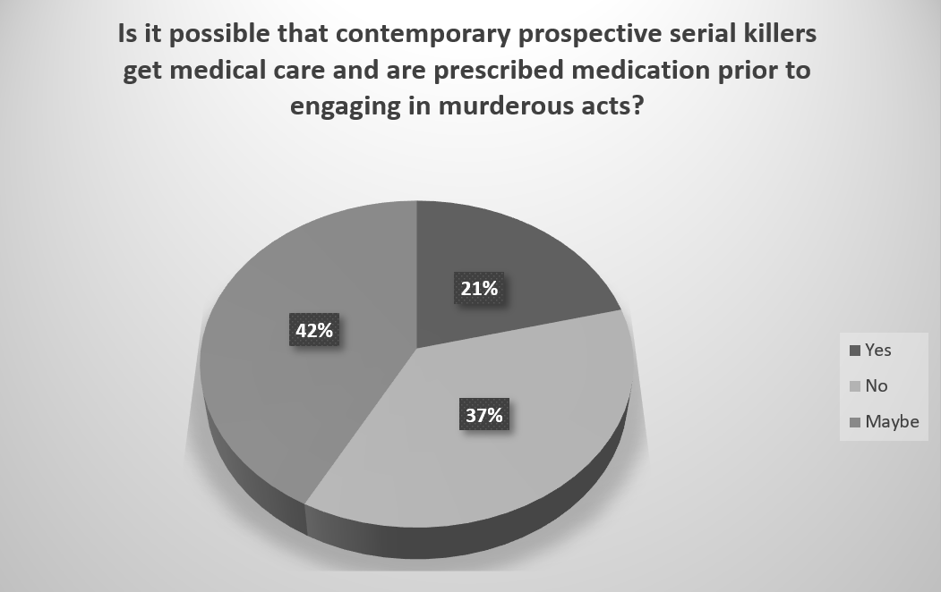
Medical Care and Medication
Figure 4-9 Medicated Graph

While 37% of respondents were doubtful, a sizable portion of respondents (42%) thought that potential serial killers might get treatment and medicine before committing violent crimes (Jern, 2022). This highlights issues about the accountability of mental health care providers and expresses worries about the part that mental health treatments may play in possible prevention (Knapton, 2016). The questionnaire asked participants to rate the variables that they believed were responsible for the decrease in the number of serial killers. The gathered data sheds light on the varied contributions made by technological and police forces improvements and the public’s understanding of the causes of this decline.

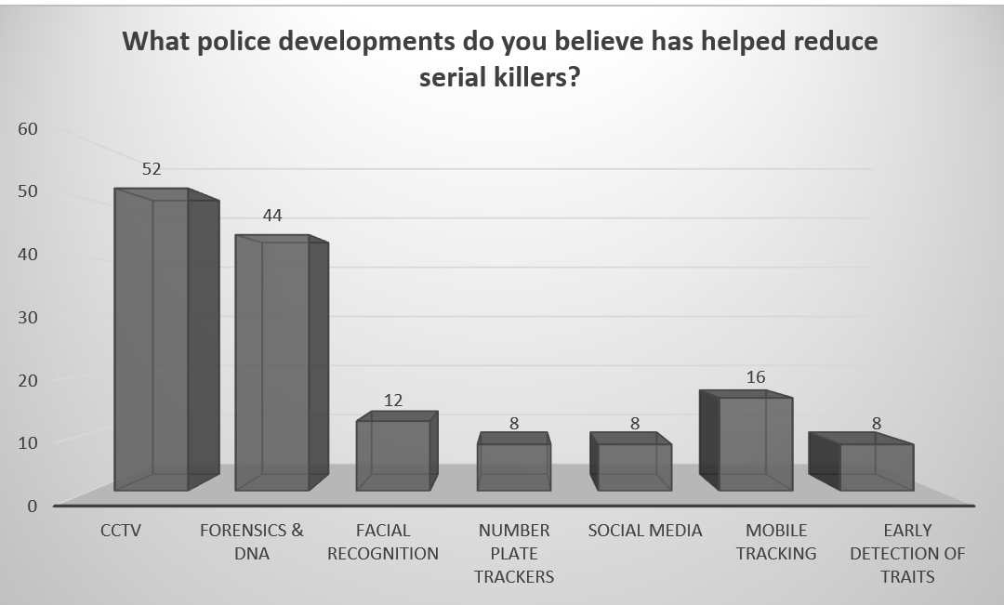
Police Improvements
Figure 4-10 Improvement in police developments graph

4.9.1 Forensics and DNA
A sizable percentage of respondents cited improvements in police forces methods as a critical element in the drop in the number of serial killers. Forensics and DNA analysis was cited as a significant contributing element by 52.6% (44) of responders. Because DNA analysis offers a vital tool for identifying and apprehending individuals, it has changed criminal investigations (Amankwaa and McCartney, 2021). The public recognises its relevance since it has been crucial in cracking cold cases and stopping serial killers from escaping justice (Kennett, 2019, p. 111). Police forces can now collect and evaluate evidence more efficiently thanks to forensic science, which helps connect suspects to victims and crime sites (Amankwaa and McCartney, 2019).

4.9.2 CCTV
42.1% of respondents stated that the usage of CCTV has decreased serial killings. Since they help monitor and identify illegal activities and deter potential offenders, CCTV systems are becoming increasingly common in public areas. The public’s opinion of CCTV as a significant element implies that greater surveillance has prevented serial killings (Townsend, 2021). An additional 21.1% of participants linked the decrease in serial killings to the use of social media (Information Law and Policy Centre, 2016).

4.9.3 Media
News about serial killers in the UK is provided by improved coverage, which is often seen as a contributing factor to the reduction of the killings in the UK, as indicated by 42.1% of respondents (Jones, 2020). In other words, the media plays a significant role in ensuring that all criminal cases in the country are reported, particularly those involving serial killers. As a result, the people in the country gained knowledge and heightened public awareness, encouraging people to be vigilant and report any suspicious activities of serial killing (Jones, 2020).

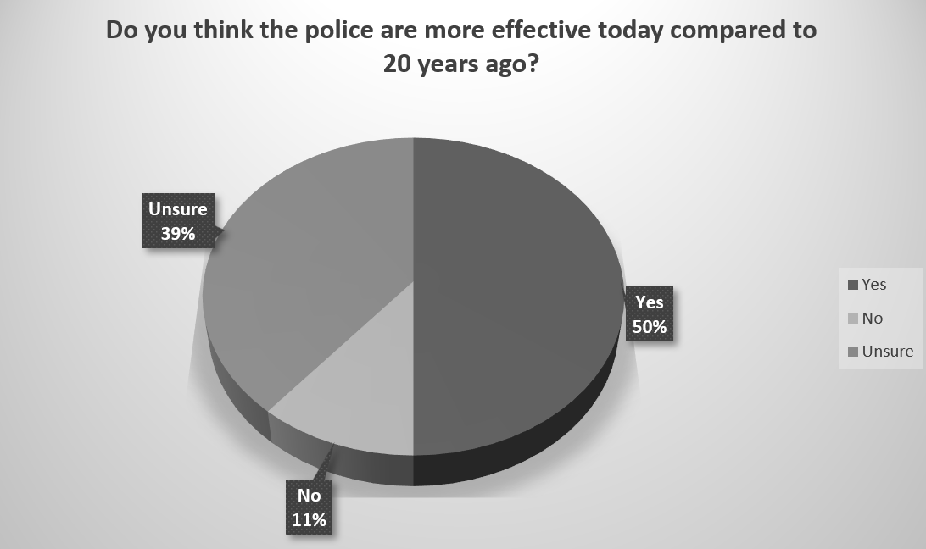
Police 20 years ago
Figure 4-11 Police Effectiveness Today Compared to 20 Years Ago Graph

In the UK today, police effectiveness has increased dramatically (Greater London Authority, 2013). As shown above, 50% of respondents agreed that the police are more effective today compared to twenty years ago, with only 11% of respondents stating there has been no changes. The majority (52.6%) thought that because of advancements like CCTV, fingerprints, DNA analysis, and facial recognition, police are now more successful than they were twenty years ago (Indeed, 2022). This indicates how confident the general public is in polices ability to combat crime. Evidently, police developments and new strategies in tackling crime supports the police and the public to gain trust in one another and to develop a positive relationship between the both (College of Policing, 2022b).

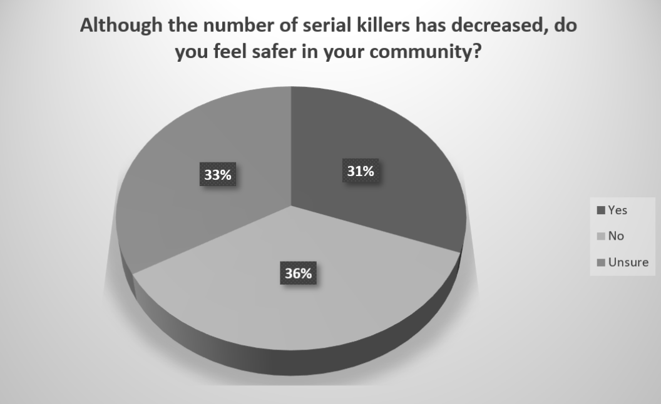
Feeling safe in their community
Figure 4-12 Feeling safe in their community graph.

There was variation in respondents’ perceptions of safety in their communities; 36% felt less safe, 33% were unclear, and 31% felt safer. The conflicting feelings people have about their safety despite the drop in serial killings point to several intricate elements influencing how the public views the police (Home Office, 2023). Majority of respondents had a clear awareness of different types of crime that happen today (Flatley, 2017), with a few stating that “a lot of the time the police are too late”. This information indicates that it is vital that all crime is dealt with accordingly and efficiently by the police, because in the long term, this could potentially make our people feel safer in their communities (Hafferty, 2020). This information also ties into another question in the questionnaire which investigates whether respondents believe that individuals who have committed acts of murder would continue to act violently if they were not caught on their first offence (West Yorkshire Police, 2023). There was severe fear about the possibility of additional violence, as seen by the overwhelming majority (89.5%) who thought they would continue to carry out their violent deeds (West Yorkshire Police, 2023). Again, this inquiry addresses the possible dangers of delaying appropriate action against violent activities (College of Policing, 2022a). Therefore, a high standard of service and responses from the police is vital in ensure the public feel safe in their communities, and also to support the development of trust between the police and the people they serve (Hobbs and Brown, 2023).

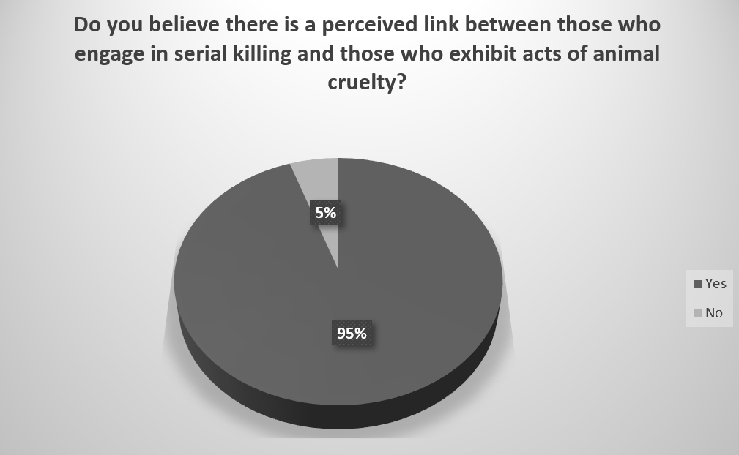
4.12 Animal Cruelty
Figure 4-13 Link Between Serial Killing and Animal Cruelty Graph

The questionnaire findings offer insightful information about how the British public view the drop in serial killers and any potential link to animal abuse. However, the questionnaire data itself does not provide exhaustive statistical support. However, it does reflect the public’s current opinion on these complicated issues surrounding serial killers in the UK and is consistent with contemporary criminological trends and discussions. As presented above, regarding the relationship between animal cruelty and serial killers, a significant 95% of participants in the questionnaire feel that there is a perceived connection between people who commit animal cruelty crimes and serial killing (Houghton et al., 2023, p.754). This view is noteworthy and may have its origins in research and information pointing to a possible link between childhood animal abuse and aggressive conduct against people. The “Macdonald Triad,” which postulates that animal abuse combined with other behavioural characteristics could be a precursor to violent inclinations in adulthood, has been the subject of some earlier research conducted in the United Kingdom (Parfitt and Alleyne, 2020, p. 305).

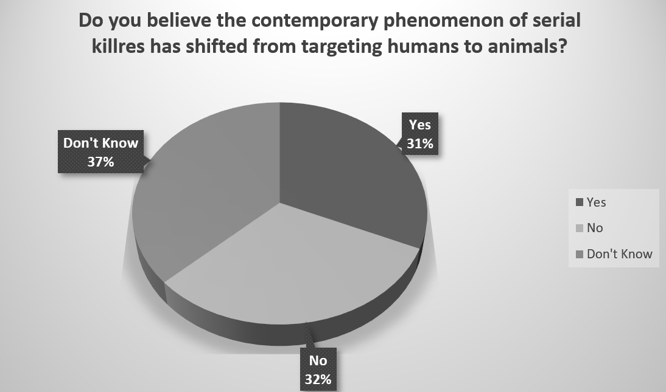
4.13 Animal Cruelty and Serial Killing
Figure 4-14 The Contemporary Phenomenon of Serial Killers Graph

A vast majority (95%) said there was a connection between people who commit acts of animal cruelty and serial killers. This association raises the possibility of a shared pattern of unsettling conduct among responders and shows a common belief in the connections between these two forms of violence (Reese et al., 2021). As shown in the pie chart above 31% (24) of respondents thought that serial killers now target animals instead of people. However, 37% were unsure. This change may point to changing trends in violent conduct and raise concerns about the psychology and motivations of those who commit crimes (Dalton, 2019). Hence, a definitive lack of empirical data exists to establish a direct correlation between the decline in serial killers and the increase in incidents of animal cruelty (RSPCA, 2022, p. 1). Nevertheless, it is widely anticipated that a significant proportion of individuals hold the belief that there exists a correlation between acts of animal cruelty and the perpetration of serial killings (Reese et al., 2021). Despite the increasing incidence of animal cruelty, the respondents do not attribute this trend to a decline in the number of serial killers. While a significant proportion of the participants expressed uncertainty or disbelief about the notion that serial killers may be shifting their focus from humans to animals, a notable 31% percent hold the belief that such a phenomenon may be occurring.

Chapter Five: Conclusion and Recommendations

5.1 Introduction

The preceding chapter analysed the data from this study, emphasising key conclusions and accomplishing the three objectives. The objective of this study was to determine the contemporary phenomena of current serial killers in the United Kingdom. After conducting a thorough analysis of both quantitative and qualitative data on public perception, it can be inferred that individuals who may become serial killers are receiving medical treatment for their underlying health conditions prior to engaging in such violent acts (Jern, 2022). These individuals are fully aware of the challenges associated with successfully carrying out such actions. Furthermore, it appears that the current trend among serial killers is a shift from targeting humans to targeting animals. The findings suggest that the healthcare system and the police have made substantial advancements over time, resulting in a notable decrease in the prevalence of serial killers. Consequently, serial killers have moved their focus from targeting people to animals.

5.2 Summary of Findings
From the UK general population, the questionnaire’s replies show that most people believe that a serial killer is someone who kills several people over time, frequently exhibiting psychopathic qualities, a terrifying lack of empathy, and a penchant for vicious, sadistic deeds. Many responders think that serial killers follow patterns when committing their murders and have particular goals or interests in mind. Based on how respondents described serial killers, such people tend to be sometimes highly disturbed mentally and bright (Marono et al., 2020, p. 126). Such is the typical way they are often portrayed in popular culture. The public shows and feels shock and disgust for the serial killers, hence calling them evil and monstrous as well as associating them with moral condemnation. The answers paint a picture of serial killers as extremely dangerous, frightening people who break society’s standards in terrible ways. Furthermore, it is crucial to consider other studies and research on serial killers in the UK to add context to this data. Research on the psychological characteristics of serial killers has frequently revealed evidence of a range of mental health conditions and personality abnormalities in these individuals (Reid et al., 2019). This is consistent with the population’s beliefs, as the questionnaire indicates.

5.2.1 Establish theoretical approaches of serial killers in the UK
The research gathered has discovered that the characterisation of serial killers as mentally unstable but notoriously intelligent complicates the public’s understanding of these individuals. It implies that although serial killers might suffer from mental illnesses, they are ironically gifted with a certain amount of intelligence and cunning (Baldeo, 2023). Their unique contrast in characterisation adds to the mystery surrounding serial killers and raises questions about the mystery surrounding their acts. One idea that keeps coming up in the perceptions of the respondents is that serial killers lack empathy. This remark highlights their fundamental psychological characteristic: they lack the most basic human empathy (Baldeo, 2023). This quality is mentioned as one of the reasons behind their ability to constantly conduct horrible crimes without feeling guilty.

The research also discovered that although other British male serial killers were mentioned, Peter Sutcliff was mentioned the most, where respondents used historical information and research in relation to him. Infamous serial killer Peter Sutcliffe plagued the UK in the late 1970s and early 1980s. Sutcliffe’s horrific acts of violence startled the country and sparked a large-scale quest to find him (Cunnington, 2020). His fame grew outside the criminal world as the public began associating him with terror and curiosity. The public’s long-lasting recall of Peter Sutcliffe is also a testament to the widespread media attention he received and the lingering effects of his crimes on British culture (Cunnington, 2020). The Yorkshire Ripper case was a turning point in the history of the UK, influencing public attitudes about safety, policing practices, and the way people are treated when they have mental health problems.

Overall, the data gathered from this section of the questionnaire demonstrates that a serial killers murderous actions has a significant impact on the public (Deeds, 2020). Interestingly 10.4% of respondents aged 18 to 24 all named serial killers dating from the 80s and before. These participants would not have been around in the time these horrific acts were carried out, therefore must have gained an understanding about these killers years later. As stated by (Eck and Rossmo, 2019) this indicates that the acts of these serial killers have not been forgotten and have an impact generations after their time and will continue to have an impact on future generations.

Furthermore, the questionnaire respondents placed a significant emphasis on mental health factors, which highlights the understanding of the complex relationship between criminal activity and mental health, especially when it comes to serial killers. It calls into question the effectiveness of mental health evaluations and treatments in recognising and deterring people who may turn into serial killers.

In contrast, it is intriguing to observe that the general public believe that adverse childhood experiences do not contribute to the development of features associated with serial killers. Instead, there is a prevailing belief that serial killers are inherently predisposed rather than influenced by their environment. It is noteworthy that a significant proportion of serial killers had encountered adverse childhood experiences, which have been empirically shown to be a contributing factor to their cognitive and behavioural patterns (Hernandez et al., 2015).

However, the perception of respondents on the common traits and factors that contribute to a serial killer are very similar if not identical. This indicates that the general public could potentially be gaining their knowledge from the same sources of information. For instance, the questionnaire findings about where to find information about serial killers show that there are many different places where knowledge is shared. Even though television news is still the most widely used source, newspapers, social media, and word-of-mouth significantly impact public awareness. This information emphasises how important it is to have a thorough grasp of the media landscape and how it affects how the general public in the UK views criminal cases and serial killers. Furthermore, information regarding serial killers is extremely accessible today, particularly with platforms like YouTube and Netflix where documentaries on cold cases are available everywhere.

Overall, this objective was achieved in Chapters 2 and 4. The objective was achieved through a thorough examination of the literature, focusing on prior research that identified different theoretical approaches for understanding serial killers in the UK. This research highlighted the significance of early detection and interventions in comprehending the connection between psychological disorders and male serial killers in the UK. In addition, the present study aimed to clarify the public's opinion of the motives behind the actions of serial killers. This was achieved by assessing questionnaires that were completed by seventy-six individuals from the general public.

5.2.2 Evaluation of how police development has impacted the number of serial killers in the UK
As discovered, potential serial killers underlying health conditions are diagnosed and medicated early enough to prevent them from carrying out horrific crimes. Furthermore, the data gathered from the questionnaire hypothesised that if individuals such as Sutcliff had received timely psychological and medical assistance, it could have potentially prevented the occurrence of his violent acts. However, the available data suggests that the general public holds the belief that Sutcliff possessed a desire to commit murder, and he carried out his actions with the knowledge that he would likely evade legal consequences during the 1970s. In contrast to today, the probability of his successful evasion would have been diminished.
Furthermore, the questionnaire findings highlight how widely acknowledged the vital contribution of forensic techniques, DNA testing and CCTV in apprehending serial killers. Additionally, social media sites and news coverage platforms are now practical resources for disseminating information and increasing public awareness of criminal cases. They have facilitated the quick spread of information to a large audience and increased the difficulty for serial killers to go undiscovered (Cartwright and Shaw, 2020). Overall, historical data on serial killers is a crucial component in evaluating the efficiency of crime prevention programs, public awareness, and police strategies.
Overall, this objective was accomplished in chapters 2 and 4. The literature effectively assessed the impact of police advancements on the prevalence of serial killers in the UK. It found that advancements in policing, such as the implementation of CCTV, advancements in forensics, and the use of DNA technology, have proven to be highly effective in deterring potential serial killers from committing horrific crimes. In addition, this study also collected data from questionnaires conducted among the general public to corroborate the findings of the secondary research. The data collected from questionnaires revealed that the general public concurs that the police force is now more efficient than it was two decades ago, mostly as a result of technological advancements such as CCTV. Hence, the implementation of effective police measures has undeniably played a significant role in diminishing the prevalence of serial killers in the UK and dissuading prospective perpetrators from engaging in murderous acts.

5.2.3 Evaluation of modern phenomena of Serial Killers UK
The overwhelming majority of respondents, 95%, feel that there is a correlation between those involved in serial killers and those who display acts of animal cruelty. Hence, the questionnaire results provide valuable insights on the British public's perception of the decline in serial killers and any correlation with animal cruelty. Nevertheless, the questionnaire data alone does not provide comprehensive statistical evidence. Hence, more investigation and thorough data analysis might be undertaken to get a deeper understanding of these events. In contrast, although many participants were hesitant or uncertain about the theory that serial killers could be redirecting their attention from people to animals, a noteworthy 31% of them believe that this phenomena is really happening. Consequently, it may be worthwhile to do additional investigation into this matter.
Overall, the objective was accomplished by Chapters 2 and 4. The literature research successfully established a correlation between acts of animal cruelty and those who commit many murders. Furthermore, the data collected in this study through questionnaires filled out by the general public corroborated prior research, indicating a correlation between the rising incidence of animal cruelty incidents and the declining number of serial killers. Overall, the data collected from the questionnaires indicates that contemporary serial killers are now more inclined to target animals rather than people.

5.6 Limitations
Regrettably, the limited time range of this study prevented the analysis and individual comparison of questionnaires. Therefore, conducting a comprehensive analysis of all respondents' replies is advisable since their attitudes and expertise may be influenced by factors such as age or geographical region. Additionally, despite some participants expressing hesitancy or uncertainty about the hypothesis that serial killers may be shifting their focus from humans to animals, a significant 31% of them firmly believe in the occurrence of this phenomenon. Furthermore, even though the questionnaires were sent to professionals in the animal care domain, regrettably, no replies were received to these questions.

5.7 Recommendations
It would be prudent to conduct more inquiry into the hypothesis that serial killers may have shifted their focus from individuals to animals by generating responses from professionals working in the field of animal welfare. Additionally, the second recommendation would be to include input from experts in the inquiry to guarantee the collection of precise data in order to ascertain the potential correlation between the increase in animal cruelty and the decline in serial killers to discover the modern phenomenon of serial killers.

5.8 Summary of Research
In summary, this research reflects the general public’s opinions about serial killers, their backgrounds, and the elements influencing their decline. In addition, it looks at the connection between animal abuse and serial killers, the value of healthcare, and how well police forces work to stop serial homicides. It offers perceptions into how society perceives and interprets this complicated problem. This study clearly demonstrated the elements that have led to the decrease in the number of serial killers in the UK. To prevent prospective serial killers from carrying out crimes, it is crucial to treat and regulate them for any underlying health disorders before they have the chance to act. Moreover, prospective serial killers possess knowledge about the progress made by the police, and the likelihood of successfully carrying out a murder and evading capture in the present day is very slim. Consequently, they may have redirected their focus from victimising humans to victimising animals.

References

- Açıkgöz, A. (2023) Perspective chapter: Serial Killers: The Severest of Criminal Behaviors. Available: < https://www.intechopen.com/online-first/1155099 > [Accessed: 8th November 2023].
- Alketbi, S.K. (2023) The role of DNA in forensic science: A comprehensive review. Alketbi, SK (2023) The role of DNA in forensic science: A comprehensive review. International Journal of Science and Research Archive, 9(02), pp.814-829. Available: < https://papers.ssrn.com/sol3/papers.cfm?abstract_id=4550489 > [Accessed: 19th September 2023].
- Altieri, M. and Nicholls, C. (2009) ‘Conventional agricultural development models and the persistence of the pesticide treadmill in Latin America’, International Journal of Sustainable Development & amp; World Ecology, 4(2), pp. 93-111. Available: < https://www-tandfonline-com.ezproxy.uwtsd.ac.uk/doi/abs/10.1080/13504509709469946 > [Accessed: 26th August 2023].
- Amankwaa, A. and McCartney, C. (2019) ‘The effectiveness of the UK national DNA database’, Forensic Science International: Synergy, 1, pp. 45-55. Available: < https://www.sciencedirect.com/science/article/pii/S2589871X19300713#:~:text=The%20match%20rate%20for%20SGM,about%2033.3%25%20of%20these%20detections. > [Accessed: 21st November 2023].
- Amankwaa, A.O. and McCartney, C. (2021) The effectiveness of the current use of forensic DNA in criminal investigations in England and Wales. Wiley Interdisciplinary Reviews: Forensic Science, 3(6). Available: < https://wires.onlinelibrary.wiley.com/doi/10.1002/wfs2.1414 > [Accessed: 16th September 2023].
- American Academy of Experts in Traumatic Stress (2020) Serial Killer: Nature vs. Nurture How Serial Killers Are Born. Available: < https://www.aaets.org/traumatic-stress-library/serial-killer-nature-vs-nurture-how-serial-killers-are-born#:~:text=Scientists%20searched%20and%20found%20what,killers%20grow%20into%20sadistic%20mass > [Accessed: 19th November 2023].
- Asiedu, F. (2019) Advantages and Disadvantages of Online Surveys. Available: < https://www.cvent.com/uk/blog/events/advantages-disadvantages-online-surveys > [Accessed: 9th October 2023].
- Bahattacherjee, A. (2012) Social Science Research: Principles, Methods, and Practices. Available: < https://digitalcommons.usf.edu/cgi/viewcontent.cgi?article=1002&context=oa_textbooks > [Accessed: 7th October 2023].
- Baldeo, N. (2023) Development of Serial Killers. Available: < https://www.proquest.com/openview/de854081344ebc01d59dbbe6a8cb812d/1?pq-origsite=gscholar&cbl=18750&diss=y > [Accessed: 3rd November 2023].
- Belshaw, S. and Nodeland, B. (2021) Digital evidence experts in the law enforcement community: understanding the use of forensics examiners by police agencies. Security Journal, pp.1-15. Available: < https://link.springer.com/article/10.1057/s41284-020-00276-w > [Accessed: 17th September 2023].
- Bhandari, P. (2020) Designing and Analyzing a Likert Scale | What, Why and How. Available: < https://www.scribbr.com/methodology/likert-scale/#:~:text=A%20Likert%20scale%20is%20a,operationalize%20personality%20traits%20or%20perceptions. > [Accessed: 9 October 2023].
- Bhandari, P. (2022) Triangulation in Research | Guide, Types, Examples. Available: < https://www.scribbr.com/methodology/triangulation/#:~:text=Triangulation%20in%20research%20means%20using,and%20credibility%20of%20your%20findings. > [Accessed: 8th October 2023].
- Bonn, S. (2019) Serial Murder Versus Mass Murder. Available: < https://www.psychologytoday.com/gb/blog/wicked-deeds/201901/serial-murder-versus-mass-murder > [Accessed: 6th December 2023].
- Bracchi, P. and Gardner, A. (2021) Does this CCTV image damn the suffolk strangler? Detectives probe murderer Steven Wright. Daily Mail Online. Available: < https://www.dailymail.co.uk/news/article-9845507/Does-CCTV-image-damn-Suffolk-strangler-Detectives-probe-murderer-Steven-Wright.html > [Accessed: 24th September 2023].
- Britton, P. (2023) Heartbreaking figures reveal rise in animal cruelty in Greater Manchester. Manchester Evening News. Available: < https://www.manchestereveningnews.co.uk/news/greater-manchester-news/heartbreaking-figures-reveal-shocking-rise-27235214 > [Accessed: 17th September 2023].
- Brookman, F. and Jones, H. (2022) Capturing killers: the construction of CCTV evidence during homicide investigations. Policing and society, 32(2), pp.125-144. Available: < https://www.tandfonline.com/doi/full/10.1080/10439463.2021.1879075 > [Accessed: 24th September 2023].
- Broyd, J., Boniface, L., Parsons, D., Murphy, D. and Hafferty, J.D., 2023. Incels, violence and mental disorder: A narrative review with recommendations for best practice in risk assessment and clinical intervention. BJPsych Advances, 29(4), pp.254-264. Available: < https://www.cambridge.org/core/journals/bjpsych-advances/article/incels-violence-and-mental-disorder-a-narrative-review-with-recommendations-for-best-practice-in-risk-assessment-and-clinical-intervention/6A934637D21AEE4C1D90FAF5FB63D769 > [Accessed: 16th September 2023].
- Bryman, A. (2012) Social Research Methods. 4th ed. Available: < https://www.academia.edu/38228560/Alan_Bryman_Social_Research_Methods_4th_Edition_Oxford_University_Press_2012_pdf > [Accessed: 8th October 2023].
- Bulman, P. (2014) ‘Solving Cold Cases with DNA: The Boston Strangler Case’. Available: < https://nij.ojp.gov/topics/articles/solving-cold-cases-dna-boston-strangler-case > [Accessed: 12th September 2023].
- Cartwright, A. and Shaw, C. (2020) ‘Evidence based social media use: An exploratory UK investigation into residents perception of police Facebook use’, Safer Communities, 19(2). Available: < https://www.emerald.com/insight/content/doi/10.1108/SC-09-2019-0033/full/html > [Accessed: 21st November 2023].
- Cechak, P., 2021. Borderline Personality Disorder: A review and analysis through the lens of the Unified Theory. Available: < https://www.proquest.com/docview/2615147358?pq-origsite=gscholar&fromopenview=true > [Accessed: 16th September 2023].
- Chan, H.C.O. and Wong, R.W. (2019) Childhood and adolescent animal cruelty and subsequent interpersonal violence in adulthood: A review of the literature. Aggression and violent behavior, 48, pp.83-93. Available: < https://www.sciencedirect.com/science/article/abs/pii/S1359178919300746?via%3Dihub > [Accessed: 17th September 2023].
- Child Welfare Information Gateway (2019) Long-Term Consequences of Child Abuse and Neglect. Available: < https://www.childwelfare.gov/pubpdfs/long_term_consequences.pdf > [Accessed: 3rd September 2023].
- Chuang, S. (2021) The applications of constructivist learning theory and social learning theory on adult continuous development. Performance Improvement, 60(3), pp.6-14. Available: < https://onlinelibrary.wiley.com/doi/10.1002/pfi.21963 > [Accessed: 17th September 2023].
- Cleave, P. (2021) Advantages of Questionnaires in Online Research. Available: < https://www.smartsurvey.co.uk/blog/advantages-of-questionnaires-in-online-research > [Accessed: 9th October 2023].
- College of Policing (2022a) First response. Available: < https://www.college.police.uk/app/major-investigation-and-public-protection/domestic-abuse/first-response > [Accessed: 29th November 2023].
- College of Policing (2022b) Technologies – step two. Available: < https://www.college.police.uk/guidance/serious-violence-hot-spots-policing-guide/technologies-step-two#:~:text=Technology%20for%20geo%2Dfencing%20(virtual,on%20force%2Dissued%20mobile%20devices. > [Accessed: 29th November 2023].
- Creswell, J. (2014) A Concise Introduction to Mixed Methods Research. 3rd ed. London: SAGE Publications.
- Crime and Investigation. (2023a) John Duffy and David Mulcahy: The railway rapists. Crime and Investigation UK. Available: < https://www.crimeandinvestigation.co.uk/article/john-duffy-and-david-mulcahy-the-railway-rapists > [Accessed: 25th September 2023].
- Crime and Investigation. (2023b) The most prolific British serial killers. Available: < https://www.crimeandinvestigation.co.uk/articles/britains-most-prolific-serial-killers-modern-history > [Accessed: 18th September 2023].
- Cunnington, C. (2019) ‘Revisiting the Yorkshire Ripper murders: histories of gender, violence, and victimhood’, Mortality, 25(4), pp. 509-510. Available: < https://www.tandfonline.com/doi/full/10.1080/13576275.2019.1691984 > [Accessed: 6th November 2023].
- Dalton, J. (2019) The link is established between serial killers and animal cruelty. Available: < https://www.independent.co.uk/news/long_reads/domestic-violence-animal-cruelty-abuse-neglect-murder-children-dogs-a9018071.html > [Accessed: 29th November 2023].
- De Brito, S.A., Forth, A.E., Baskin-Sommers, A.R., Brazil, I.A., Kimonis, E.R., Pardini, D., Frick, P.J., Blair, R.J.R. and Viding, E. (2021). Psychopathy. Nature Reviews Disease Primers, 7(1), p.49. Available: < https://www.nature.com/articles/s41572-021-00282-1 > [Accessed: 12th September 2023].
- De Groot, N.F., van Beers, B.C. and Meynen, G. (2021) Commercial DNA tests and police investigations: a broad bioethical perspective. Journal of medical ethics, 47(12), pp.788-795. Available: < https://jme.bmj.com/content/medethics/47/12/788.full.pdf > [Accessed: 20th September 2023].
- DeCoster, J. (2004) Meta-analysis Notes. Available: < https://www.researchgate.net/publication/239550494_Meta-Analysis_Notes > [Accessed: 2nd November 2023].
- Deeds, W. (2020) Serial Killers Play a Role on the Public Stage. Available: < https://www.psychologytoday.com/gb/blog/wicked-deeds/202002/serial-killers-play-role-the-public-stage#:~:text=In%20a%20sense%2C%20the%20serial,participate%20vicariously%20in%20his%20crimes. > [Accessed: 19th November 2023].
- Doig, B. and Groves, S. (2006) Easier analysis and better reporting: Modelling ordinal data in mathematics education research. Mathematics Education Research Journal, 18(2), pp.56-76. Available: < https://www.researchgate.net/publication/226223153_Easier_analysis_and_better_reporting_Modelling_ordinal_data_in_mathematics_education_research > [Accessed: 2nd November 2023].
- Easterby-Smith, M., Thorpe, R., Jackson, P. and Jaspersen, L. (2018) Management and Business Research. Available: < https://uk.sagepub.com/sites/default/files/upm-assets/95073_book_item_95073.pdf > [Accessed: 7th October 2023].
- Eck, J.E. and Rossmo, D.K (2019) The new detective: Rethinking criminal investigations. Criminology & public policy, 18(3), pp.601-622. Available: < https://onlinelibrary.wiley.com/doi/10.1111/1745-9133.12450 > [Accessed: 18th September 2023].
- Evans, H. (2022) London serial killer strangled eight women and hid bodies under wallpaper in Flat, MyLondon. Available: < https://www.mylondon.news/news/west-london-news/terrifying-serial-killer-strangled-eight-25182948 > [Accessed: 12th September 2023].
- Felton, D. (2021) Monsters and monarchs: serial killers in classical myth and history. University of Texas Press. Available: < https://books.google.co.ke/books?hl=en&lr=&id=x4cHEAAAQBAJ&oi=fnd&pg=PA1&dq=UK+Serial+killer+Dennis+Nilsen+and+Antisocial+Personality+Disorder&ots=E61J0ibUcf&sig=YNHVK7Azt-IDqRS_ytimy0k7qVc&redir_esc=y#v=onepage&q=Dennis%20Nilsen&f=false > [Accessed: 13th September 2023].
- Flatley, J. (2017) Public perceptions of crime in England and Wales: year ending March 2016. Available: < https://www.ons.gov.uk/peoplepopulationandcommunity/crimeandjustice/articles/publicperceptionsofcrimeinenglandandwales/yearendingmarch2016 > [Accessed: 29th November 2023].
- Ghauri, P., Gronhaug, K. and Strange, R. (2020) Research Methods in Business Studies. Cambridge University Press. Available: < http://assets.cambridge.org/97811084/86743/frontmatter/9781108486743_frontmatter.pdf > [Accessed: 11th October 2023].
- Goundar, S. (2012) Research Methodology and Research Method. Available: < https://www.researchgate.net/publication/333015026_Chapter_3_-_Research_Methodology_and_Research_Method > [Accessed: 9th October 2023].
- Greater London Authority (2013) How the Metropolitan Police Services can make better use of technology. Available: < https://www.london.gov.uk/sites/default/files/gla_migrate_files_destination/Police%20technology%20report%20-%20Final%20version.pdf > [Accessed: 29th November 2023].
- Greenfield, S. (2020) Contrasting Depictions of Medical Serial Killers. Monsters, Law, Crime: Explorations in Gothic Criminology, p.163. Available: < https://books.google.co.ke/books?hl=en&lr=&id=-3sGEAAAQBAJ&oi=fnd&pg=PA163&dq=UK+Serial+killer+Harold+Shipman++and+Psychopathy+&ots=zycSlOSsu8&sig=2HrUl_mRVYhp13kMatarqpTkc1E&redir_esc=y#v=onepage&q=Shipman&f=false > [Accessed: 13th September 2023].
- Hafferty, C. (2020) What factors are linked to people feeling safe in their local area?. Available: < https://www.gov.wales/sites/default/files/statistics-and-research/2020-03/what-factors-are-linked-to-people-feeling-safe-in-their-local-area.pdf > [Accessed: 29th November 2023].
- Haggerty, K and Ellerbrok, A. (2011) The social study of serial killers. Centre for Crime and Justice Studies. Available: < https://www.crimeandjustice.org.uk/sites/crimeandjustice.org.uk/files/09627251.2011.646180_0.pdf > [Accessed: 19th November 2023].
- Hale, R. (2023) The role of Digital Forensics in the Sarah Everard investigation. Available: < https://www.bcu.ac.uk/computing/news-events/blogs/digital-forensics-sarah-everard-investigation#:~:text=Together%20with%20the%20CCTV%20footage,he%20travelled%20between%20various%20locations. > [Accessed: 12th September 2023].
- Hall, M.J. (2021) The relationship between research and casework in forensic entomology. Insects, 12(2), p.174. Available: < https://www.mdpi.com/2075-4450/12/2/174 > [Accessed: 25th September 2023].
- Healthy London Partnership (2022) Increasing awareness and raising hope in relation to “personality disorders”. Available: < https://www.candi.nhs.uk/sites/default/files/Understand-personality-disorders-toolkit-2022.pdf > [Accessed: 13th September].
- Hernandez, J., Highsmith, J., Mercado, M. and Madrigal, S. (2015) ‘Nature (MAOA) and nurture in a criminal’, UC Merced Undergraduate Research Journal, 8(1). Available: < https://escholarship.org/content/qt5w51b7bg/qt5w51b7bg_noSplash_b63d15ddd4239fcdafdbc3dfadbca9b9.pdf?t=o23bnm > [Accessed: 26th August 2023].
- Hobbs, A. and Brown, R. (2023) Trust in the police. Available: < https://post.parliament.uk/research-briefings/post-pn-0693/#:~:text=Key%20factors%20that%20increase%20public,focused%20on%20addressing%20local%20concerns. > [Accessed: 29th November 2023].
- Home Office (2023) Public polling on community safety. Available: < https://www.gov.uk/government/publications/public-polling-on-community-safety/public-polling-on-community-safety > [Accessed: 29th November 2023].
- Hood, B., White, P. and Bunner, J. (2022) Method of identification: Catching serial killers. Forensic science international, 337, p.111377. Available: < https://www.sciencedirect.com/science/article/abs/pii/S0379073822002079?via%3Dihub > [Accessed: 24th September 2023].
- Houghton, C., Tzani, C., Ioannou, M., Williams, T.J.V. and Kissaun, G.D. (2023) Investigating the influence of perpetrator gender on public perceptions and media portrayals of teacher-student sexual relationships. Journal of Police and Criminal Psychology, 38(3), pp.754-765. Available: < https://journals.sagepub.com/doi/10.1177/0886260515618214 > [Accessed: 9th November 2023].
- Indeed (2022) Uses of Technology in Law Enforcement (Plus Pros and Cons). Available: < https://www.indeed.com/career-advice/career-development/technology-in-law-enforcement > [Accessed: 29th November 2023].
- Information Law and Policy Centre (2016) Social media and crime: the good, the bad and the ugly. Available: < https://infolawcentre.blogs.sas.ac.uk/2016/10/24/social-media-and-crime-the-good-the-bad-and-the-ugly/ > [Accessed: 21st November 2023].
- Jegatheesan, B., Enders-Slegers, M.J., Ormerod, E. and Boyden, P. (2020) Understanding the link between animal cruelty and family violence: The bioecological systems model. International journal of environmental research and public health, 17(9), p.3116. Available: < https://www.mdpi.com/1660-4601/17/9/3116 > [Accessed: 18th September 2023].
- Jern, A. (2022) Can Serial Killers Be Cured?. Available: < https://www.psychologytoday.com/gb/blog/overthinking-tv/202210/can-serial-killers-be-cured > [Accessed: 21st November 2023].
- Ji, J. and Zhang, Y. (2023) ‘Biological and social factors influence the tendency of serial killers to commit crimes’, Journal of Education Humanities and Social Sciences, 8, pp.1099-1104. Available: < https://www.researchgate.net/publication/368375709_Biological_and_Social_Factors_Influence_the_Tendency_of_Serial_Killers_to_Commit_Crimes/link/63e4fc3fc002331f7266c3cb/download > [Accessed: 23rd August 2023].
- Johnson, S.A. (2019) Understanding the violent personality: antisocial personality disorder, psychopathy, & sociopathy explored. Forensic Research & Criminology International Journal, 7(2), pp.76-88. Available: < https://www.researchgate.net/profile/Scott-Johnson-12/publication/331993478_Understanding_the_violent_personality_2019/links/5c9a3570a6fdccd4603bf2f8/Understanding-the-violent-personality-2019.pdf > [Accessed: 15th September 2023].
- Jones, A. (2023) ‘Massive scale’ animal cruelty worsened by cost-of-living crisis. Suffolk News. Available: < https://www.suffolknews.co.uk/woodbridge/massive-scale-animal-cruelty-worsened-by-cost-of-living-cr-9325597/ > [Accessed: 18th September 2023].
- Jones, B. (2020) The Influence of Social Media on Murder. Electronic Theses, Projects, and Dissertations. Available: < https://scholarworks.lib.csusb.edu/cgi/viewcontent.cgi?article=2239&context=etd > [Accessed: 29th November 2023].
- Jones, G. and Wang, S. (2020) Disparate Impact of Surveillance: The Precarious Condition of the Poor’s Right to Privacy. A Reexamination of Wisconsin v Yoder: An Untenable Holding in the Modern Era Disparate Impact of Surveillance: The Precarious Condition of the Poor’s Right to Privacy, p.28. Available: < https://static1.squarespace.com/static/5cb4edda94d71acb46468830/t/617619d2029039254bbf1bd2/1635129812345/CULR+Vol+XVII+%231+Fall+2020.pdf#page=36 > [Accessed: 25th September 2023].
- Jowett, A. (2020) Carrying out qualitative research under lockdown – Practical and ethical considerations. Available: < https://blogs.lse.ac.uk/impactofsocialsciences/2020/04/20/carrying-out-qualitative-research-under-lockdown-practical-and-ethical-considerations/ > [Accessed: 13th October 2023].
- Kabene, S. and Baadel, S. (2019) Bioethics: a look at animal testing in medicine and cosmetics in the UK. Journal of medical ethics and history of medicine, 12. Available: < https://www.ncbi.nlm.nih.gov/pmc/articles/PMC7166243/ > [Accessed: 18th September 2023].
- Kashef, M., Visvizi, A. and Troisi, O. (2021) Smart city as a smart service system: Human-computer interaction and smart city surveillance systems. Computers in Human Behavior, 124, p.106923. Available: < https://www.sciencedirect.com/science/article/abs/pii/S0747563221002466?via%3Dihub > [Accessed: 24th September 2023].
- Kempton, B. (2021) How DCI Colin Sutton put Milly Dowler’s murderer Levi Bellfield behind bars. MyLondon. Available: < https://www.mylondon.news/news/west-london-news/channel-5-missing-files-how-20542015 > [Accessed: 22nd September 2023].
- Kennett, D. (2019) Using genetic genealogy databases in missing persons cases and to develop suspect leads in violent crimes. Forensic science international, 301, pp.107-117. Available: < https://www.sciencedirect.com/science/article/abs/pii/S0379073819302014?via%3Dihub > [Accessed: 22nd September 2023].
- Kim, H., Choi, N., Kwon, H.J. and Kim, H., 2023. Surveillance System for Real-Time High-Precision Recognition of Criminal Faces from Wild Videos. IEEE Access. Available: < https://ieeexplore.ieee.org/stamp/stamp.jsp?arnumber=10143202 > [Accessed: 25th September 2023].
- Knapton, S. (2016) Treating criminals with anti-psychotic drugs could prevent 1,500 crimes a year, study suggests. Available: < https://www.telegraph.co.uk/science/2016/11/01/treating-criminals-with-anti-psychotic-drugs-could-prevent-1500/ > [Accessed: 21st November 2023].
- Koenig, A. and Freeman, L. (2022) Cutting-Edge Evidence: Strengths and Weaknesses of New Digital Investigation Methods in Litigation. Hastings LJ, 73, p.1233. Available: < https://repository.uclawsf.edu/cgi/viewcontent.cgi?article=3986&context=hastings_law_journal > [Accessed: 24th September 2023].
- Kolla, N.J. and Bortolato, M. (2020) ‘The of monoamine oxidase a in the neurobiology of aggressive, antisocial, and violent behavior: A tale of mice and men’, Progress in Neurobiology. Available: < https://www.ncbi.nlm.nih.gov/pmc/articles/PMC7609507/#:~:text=Congenital%20MAOA%20deficiency%2C%20as%20well,a%20history%20of%20child%20maltreatment. > [Accessed: 23rd August 2023].
- Korpal, S. (2022) ‘The Truth About the Serial Killer Gene’, SQ Online, 15 February. Available: < https://sqonline.ucsd.edu/2022/02/the-truth-about-the-serial-killer-gene/#:~:text=They%20found%20it%20in%20Monoamine,common%20denominator%E2%80%9D%20amongst%20serial%20killers. > [Accessed: 2nd September 2023].
- Kumar, S. (2020) DNA Databases: Risks, Benefits, Privacy, and Human Rights. Forensic DNA Typing: Principles, Applications and Advancements, pp.659-678. Available: < https://link.springer.com/chapter/10.1007/978-981-15-6655-4_34 > [Accessed: 22nd September 2023].
- Lad, S. and Walker, K. (2022) An Interpretative Phenomenological Analysis on the Experience of Probation Officers in Managing People with Antisocial Personality Disorder. International Journal of Offender Therapy and Comparative Criminology. Available: < https://journals.sagepub.com/doi/10.1177/0306624X221113526 > [Accessed: 13th September 2023].
- LaRue, R.A., 2019. The Science of Change: Familial Searches And Y-STR DNA. Ohio St. J. Crim. L., 17, p.241. Available: < https://kb.osu.edu/bitstream/handle/1811/91905/OSJCL_V17N1_241.pdf?sequence=1 > [Accessed: 23rd September 2023].
- Lee, D. (2022) Serial Killers from the UK. Online Learning College. Available: < https://online-learning-college.com/knowledge-hub/college-news/serial-killers-uk/ > [Accessed: 18th September 2023].
- LinkedIn (2022) An audience that means business. Available: < https://business.linkedin.com/marketing-solutions/cx/21/10/ad-targeting?trk=sem_lms_gaw&src=go-pa&veh=LMS-S_EMEA_GB_CoreP1_EN_SEM_SEM_GoogleAds_NA_ALL_NA_NA_Core_SelfServeLP_CatchAll1_Brand_Exact_550260671967__linkedin%20audience%20targeting_c__kwd-303697294944_14862369105&mcid=6851610546819604492&cname=LMS-S_EMEA_GB_CoreP1_EN_SEM_SEM_GoogleAds_NA_ALL_NA_NA_Core_SelfServeLP_CatchAll1_Brand_Exact&camid=14862369105&asid=133356491652&targetid=kwd-303697294944&crid=550260671967&placement=&dev=c&ends=1&gclid=EAIaIQobChMIkNnhksLu9gIVp-_tCh1uMAeNEAAYASAAEgIhzPD_BwE&gclsrc=aw.ds > [Accessed: 13th October 2023].
- Lippard, E. and Nemeroff, C. (2020) ‘The devastating clinical consequences of child abuse and neglect: Increased disease vulnerability and poor treatment response in mood disorders’, American Journal of Psychiatry, 177(1), pp. 20-36. Available: < https://www.ncbi.nlm.nih.gov/pmc/articles/PMC6939135/ > [Accessed: 3rd September 2023].
- Long, E. (2022) The history of CCTV in the UK, First County Monitoring. Available: < https://www.firstcountymonitoring.co.uk/the-history-of-cctv-in-the-uk/ > [Accessed: 23rd September 2023].
- Lopera-Mármol, M., Jiménez-Morales, M. and Jiménez-Morales, M. (2022) Aesthetic representation of antisocial personality disorder in British coming-of-age TV series. Social sciences, 11(3), p.133. Available: < https://www.mdpi.com/2076-0760/11/3/133 > [Accessed: 13th September 2023].
- Macdonald, S. (2020) Serial killer Robert Black said rape and murder of child victims was 'theatre,' Daily Record. Available: < https://www.dailyrecord.co.uk/news/scottish-news/serial-killer-robert-black-described-21292511 > [Accessed: 14th September 2023].
- Malvika Nair (2019) The Shocking Rise of Animal Abuse on social media, Jeevoka. Available: < https://jeevoka.com/the-shocking-rise-of-animal-abuse-on-social-media/s > [Accessed: 17th September 2023].
- Marono, A.J., Reid, S., Yaksic, E. and Keatley, D.A. (2020) A behavior sequence analysis of serial killers’ lives: From childhood abuse to methods of murder. Psychiatry, psychology and law, 27(1), pp.126-137. Available: < https://www.tandfonline.com/doi/full/10.1080/13218719.2019.1695517 > [Accessed: 3rd November 2023].
- McCulloch, S.P. (2019) Brexit and animal welfare impact assessment: Analysis of the opportunities Brexit presents for animal protection in the UK, EU, and internationally. Animals, 9(11), p.877. Available: < https://www.mdpi.com/2076-2615/9/11/877 > [Accessed: 16th September 2023].
- McDermott, R., Tingley, D., Cowden, J. and Johnson, D. (2009) ‘Monoamine oxidase a gene (MAOA) predicts behavioral aggression following provocation’, Proceedings of the National Academy of Sciences, 106(7), pp. 2118-2123. Available: < https://www.pnas.org/doi/10.1073/pnas.0808376106 > [Accessed: 24th August 2023].
- McLeod, S. (2019) What’s the difference between qualitative and quantitative research?. Available: < https://www.simplypsychology.org/qualitative-quantitative.html > [Accessed: 11th October 2023].
- Mello-Klein, C. (2023) ‘Why are there fewer serial killers now than there used to be?’. Available: < https://news.northeastern.edu/2023/04/26/serial-killer-decline/#:~:text=Fox%20also%20attributes%20the%20decrease,on%20the%20prowl%2C%20Fox%20says. > [Accessed: 12th September 2023].
- Melnikovas, A. (2018) ‘Towards an Explicit Research Methodology: Adapting Research Onion Model for Futures Studies’, Journal of Future Studies, 23(2), pp.29-44.
- Menshawey, R. and Menshawey, E. (2022) Brave Clarice—healthcare serial killers, patterns, motives, and solutions. Forensic Science, Medicine and Pathology, pp.1-12. Available: < https://link.springer.com/article/10.1007/s12024-022-00556-4 > [Accessed: 19th September 2023].
- Mills, C. and Klein, E. (2021) Affective technologies of welfare deterrence in Australia and the United Kingdom. Economy and Society, 50(3), pp.397-422. Available: < https://www.tandfonline.com/doi/full/10.1080/03085147.2021.1875692 > [Accessed: 24th September 2023].
- Morris, M.C. (2021) The Voiceless Animal Cruelty Index and its relationship to per capita purchasing power parity and inequality. Kōtuitui: New Zealand Journal of Social Sciences Online, 16(2), pp.384-395. Available: < https://www.tandfonline.com/doi/full/10.1080/1177083X.2021.1885453 > [Accessed: 19th September 2023].
- Morton, K. Balazinska, M., Grossman, D. and Mackinlay, J. (2014) Support the data enthusiast: Challenges for next-generation data-analysis systems. Proceedings of the VLDB Endowment, 7(6), pp.453-456. Available: < https://www.tableau.com/sites/default/files/2023-01/Morton-VLDB-2014.pdf > [Accessed: 2nd November 2023].
- Mota-Rojas, D., Monsalve, S., Lezama-García, K., Mora-Medina, P., Domínguez-Oliva, A., Ramírez-Necoechea, R. and Garcia, R.D.C.M. (2022) Animal abuse as an indicator of domestic violence: One health, one welfare approach. Animals, 12(8), p.977. Available: < https://www.mdpi.com/2076-2615/12/8/977 > [Accessed: 19th September 2023].
- Natter, E. (2019) The Advantages and Disadvantages of Spreadsheets. Available: < https://smallbusiness.chron.com/advantages-disadvantages-spreadsheets-26551.html > [Accessed: 13th October 2023].
- Palace, M., Frankel, R., Shortland, N., Jinag, W., May, B., Jones, A. and Starkey, J. (2023) CCTV operators’ perspectives on protecting soft target terrorist locations in England. Crime Prevention and Community Safety, 25(1), pp.82-93. Available: < https://link.springer.com/article/10.1057/s41300-022-00167-9 > [Accessed: 23rd September 2023].
- Panneerchelvam, S. and M N, Norazmi (2003) ‘Forensic DNA profiling and database,’ The Malaysian Journal of Medical Sciences: MJMS. 10(2), pp. 20-26. Available: < https://www.ncbi.nlm.nih.gov/pmc/articles/PMC3561883/#:~:text=DNA%20fingerprinting%20was%20first%20used,had%20not%20committed%20the%20crimes. > [Accessed: 12th September 2023].
- Parfitt, C.H. and Alleyne, E. (2020) Not the sum of its parts: A critical review of the MacDonald triad. Trauma, Violence, & Abuse, 21(2), pp.300-310. Available: < https://journals.sagepub.com/doi/10.1177/1524838018764164 > [Accessed: 9th November 2023].
- Ramos, D. (2021) The Advantages and Limitations of Gantt Charts in Project Management. Available: < https://www.smartsheet.com/content/gantt-chart-pros-cons > [Accessed: 11th October 2023].
- Reese, L. A., Vertalka, J. J., & Richard, C. (2020) Animal cruelty and neighborhood conditions. Animals, 10(11), 2095. Available: < https://www.mdpi.com/2076-2615/10/11/2095 > [Accessed: 19th September 2023].
- Reid, S., Katan, A., Ellithy, A., Della Stua, R. and Denisov, E.V. (2019) The perfect storm: Mapping the life course trajectories of serial killers. International Journal of Offender Therapy and Comparative Criminology, 63(9), pp.1621-1662. Available: < https://journals.sagepub.com/doi/10.1177/1524838018764164 > [Accessed: 7th November 2023].
- Riddle, E. and MacKay, J.R. (2020) Social media contexts moderate perceptions of animals. Animals, 10(5), p.845. Available: < https://www.mdpi.com/2076-2615/10/5/845 > [Accessed: 15th September 2023].
- Rizzo, A. and Princiotta, E. (2023) Exploring the link between Smartphone Use, Violence, and Social Sharing in 50 case studies. Qeios. Available: < https://www.qeios.com/read/JZ0KDD > [Accessed: 16th September 2023].
- Roux, C., Willis, S. and Weyermann, C. (2021) Shifting forensic science focus from means to purpose: A path forward for the discipline? Science & Justice, 61(6), pp.678-686. Available: < https://www.sciencedirect.com/science/article/pii/S1355030621001076?via%3Dihub > [Accessed: 18th September 2023].
- RSPCA. (2022) New figures reveal increase in dog cruelty since start of the pandemic. The Royal Society for the Prevention of Cruelty to Animals. Available: < https://www.rspca.org.uk/-/news-figures-revel-increase-in-dog-abuse-since-pandemic > [Accessed: 18th September 2023].
- Saunders, M. (2019) Research Methods for business Students. Available: < https://www.researchgate.net/publication/330760964_Research_Methods_for_Business_Students_Chapter_4_Understanding_research_philosophy_and_approaches_to_theory_development > [Accessed: 9th October 2023].
- Saunders, M., Lewis, P. and Thornhill, A. (2007) Research Methods for Business Students. 4th ed. Available: < https://sfa2142120804c535.jimcontent.com/download/version/1436278548/module/10058477483/name/Research_Methods_for_Business_Students.pdf > [Accessed: 7th October 2023].
- Schug, R.A. (2022) Personality Disorder Traits, Rorschach Performance, and Neuropsychological Functioning in the Case of a Serial Killer: The Importance of a Multilevel Approach in the Assessment of Personalities Associated with Extreme and Repetitive Violence. Journal of Personality Assessment, 104(4), pp.559-571. Available: < https://www.tandfonline.com/doi/full/10.1080/00223891.2021.1942023 > [Accessed: 13th September 2023].
- Scrivner, C. (2022) Why We Are Fascinated by Serial Killers. Available: < https://www.psychologytoday.com/gb/blog/morbid-minds/202205/why-we-are-fascinated-serial-killers > [Accessed: 19th November 2023].
- Shaw‐Taylor, L. (2020) An introduction to the history of infectious diseases, epidemics, and the early phases of the long‐run decline in mortality. The Economic History Review, 73(3). Available: < https://onlinelibrary.wiley.com/doi/10.1111/ehr.13019 > [Accessed: 8th November 2023].
- Silvester, N. (2022) Crime podcast: The story of Scotland's first known serial killer Peter Manuel, Glasgow Times. Available: < https://www.glasgowtimes.co.uk/news/23034356.story-scotlands-first-known-serial-killer-peter-manuel/ > [Accessed: 16th September 2023].
- Simon, G., (2020) Portrayal and Attributes of Serial Killers and Some of the Most Notorious Ones. Internal Security, 12, pp.261-273. Available: < https://internalsecurity.akademiapolicji.eu/resources/html/article/details?id=212348&language=en > [Accessed: 8th November 2023].
- Skett, S. and Lewis, C. (2019) Development of the Offender Personality Disorder Pathway: A summary of the underpinning evidence. Probation Journal, 66(2), pp.167-180. Available: < https://journals.sagepub.com/doi/10.1177/0264550519832370 > [Accessed: 13th September 2023].
- Skinner, D. and Wienroth, M. (2019) Was this an ending? The destruction of samples and deletion of records from the UK Police National DNA Database. BJHS Themes, 4, pp.99-121. Available: < https://www.cambridge.org/core/journals/bjhs-themes/article/was-this-an-ending-the-destruction-of-samples-and-deletion-of-records-from-the-uk-police-national-dna-database/B9454A08928AAE907FB0C8FF7103CFA3 > [Accessed: 20th September 2023].
- Smart Survey (2022a) Paper Surveys. Available: < https://www.smartsurvey.co.uk/survey-types/paper-surveys > [Accessed: 13th October 2023].
- Smart Survey (2022b) Primary Research Methods Explained. Available: < https://www.smartsurvey.co.uk/articles/primary-research-methods#:~:text=Primary%20research%20means%20going%20directly,customer%20perceptions%20of%20their%20brand. > [Accessed: 11th October 2023].
- Smith, M. and Miller, S. (2022) The ethical application of biometric facial recognition technology. Ai & Society, pp.1-9. Available: < https://link.springer.com/article/10.1007/s00146-021-01199-9 > [Accessed: 26th September 2023].
- Socha, R. and Kogut, B. (2020) Urban video surveillance as a tool to improve security in public spaces. Sustainability, 12(15), p.6210. Available: < https://www.mdpi.com/2071-1050/12/15/6210 > [Accessed: 24th September 2023].
- Somma, R. (2023) The space and time dimensions in the criminal behavior of lust murderers. Available: < https://cab.unime.it/journals/index.php/AAPP/article/view/AAPP.101S1A19 > [Accessed: 6th November 2023].
- Spectrum News. (2023) Severe animal cruelty cases rising post-pandemic, say N.Y. SPCA leaders. Available: < https://spectrumlocalnews.com/nys/central-ny/news/2023/07/25/severe-animal-cruelty-cases-rising-post-pandemic > [Accessed: 14th September 2023].
- Spencer, M.A., 2021. Forensic botany: time to embrace natural history collections, large scale environmental data and environmental DNA. Emerging Topics in Life Sciences, 5(3), pp.475-485. Available: < https://portlandpress.com/emergtoplifesci/article-abstract/5/3/475/228415/Forensic-botany-time-to-embrace-natural-history?redirectedFrom=fulltext > [Accessed: 22nd September 2023].
- Stetler, D., Davis, C., Leavitt, K., Schriger, L., Benson, K., Bhakta, S., Wang, L., Oben, C., Watters, M., Haghnegahdar, T. and Bortolato, M. (2014) ‘Association of low-activity MAOA allelic variants with violent crime in incarcerated offenders’, Journal of Psychiatric Research, 58, pp. 69-75. Available: < https://pubmed.ncbi.nlm.nih.gov/25082653/ > [Accessed: 24th August 2023].
- Sutton, M.R. and Keatley, D. (2021) Cooling-off periods and serial homicide: A case study approach to analyzing behavior between murders. Forensic science international: mind and law. Available: < https://www.sciencedirect.com/science/article/pii/S2666353821000230?via%3Dihub > [Accessed: 7th November 2023].
- Swinson, N., Webb, R. and Shaw, J. (2021) The prevalence of severe personality disorder in perpetrators of homicide. Personality and mental health, 15(1), pp.49-57. Available: < https://onlinelibrary.wiley.com/doi/10.1002/pmh.1503 > [Accessed: 14th September 2023].
- Tawalbeh, L.A., Muheidat, F., Tawalbeh, M. and Quwaider, M. (2020) IoT Privacy and security: Challenges and solutions. Applied Sciences, 10(12), p.4102. Available: < https://www.mdpi.com/2076-3417/10/12/4102 > [Accessed: 25th September 2023].
- Tilley, E., Devion, C., Coghlan, A.L. and McCarthy, K. (2019) A regulatory response to healthcare serial killing. Journal of Nursing Regulation, 10(1), pp.4-14. Available: https://www.journalofnursingregulation.com/article/S2155-8256(19)30077-8/fulltext > [Accessed: 7th November 2023].
- Townsend, M. (2021) How CCTV played a vital role in tracking Sarah Everard – and her killer. Available: < https://www.theguardian.com/uk-news/2021/oct/02/how-cctv-played-a-vital-role-in-tracking-sarah-everard-and-her-killer#:~:text=Police%20data%20has%20indicated%20that,ability%20to%20solve%20all%20crimes. > [Accessed: 21st November 2023].
- Underwood, B. and Saiedian, H. (2021) Mass surveillance: A study of past practices and technologies to predict future directions. Security and Privacy, 4(2), p.e142. Available: < https://onlinelibrary.wiley.com/doi/10.1002/spy2.142 > [Accessed: 24th September 2023].
- Van Oorschot, R.A., Meakin, G.E., Kokshoorn, B., Goray, M. and Szkuta, B. (2021) DNA transfer in forensic science: recent progress towards meeting challenges. Genes, 12(11), p.1766. Available: < https://www.mdpi.com/2073-4425/12/11/1766 > [Accessed: 21st September 2023].
- Vandresen, B. and Hötzel, M.J. (2021) Pets as family and pigs in crates: Public attitudes towards farrowing crates. Applied Animal Behaviour Science, 236, p.105254. Available: < https://www.sciencedirect.com/science/article/abs/pii/S0168159121000411?via%3Dihub > [Accessed: 17th September 2023].
- Verhoeven, F., Booij, L., Kruijt, A., Cerit, H., Antypa, N. and Does, W. (2012) ‘The effects of MAOA genotype, childhood trauma, and sec on trait and state-dependent aggression’, Brain and Behavior, 2(6), pp. 806-813. Available: < https://www.ncbi.nlm.nih.gov/pmc/articles/PMC3500467/ > [Accessed: 30th August 2023].
- Villers, R. (2012) Models for interpretive information system research. Available: < https://www.researchgate.net/publication/290307991_Models_for_Interpretive_Information_Systems_Research_Part_2_Design_Research_Development_Research_Design-Science_Research_and_Design-Based_Research_-_A_Meta-Study_and_Examples > [Accessed: 9th October 2023].
- Wang, H., Xu, C., Liu, Y., Jeppesen, E., Svenning, J.C., Wu, J., Zhang, W., Zhou, T., Wang, P., Nangombe, S. and Ma, J. (2021) ‘From unusual suspect to serial killer: Cyanotoxins boosted by climate change may jeopardize megafauna’, The Innovation, 2(2). Available: < https://www.cell.com/the-innovation/fulltext/S2666-6758(21)00017-5?_returnURL=https%3A%2F%2Flinkinghub.elsevier.com%2Fretrieve%2Fpii%2FS2666675821000175%3Fshowall%3Dtrue > [Accessed: 8th November 2023].
- Wang, J., Dong, H., Te, R. and Zhang, Y. (2022) The Criminal Behavior Resulting from the Comorbidity of Depression and Antisocial Personality. Available: < https://www.clausiuspress.com/conferences/AETP/ASSSD%202022/Y1289.pdf > [Accessed: 15th September 2023].
- West Yorkshire Police (2023) The 10 Principles of Crime Prevention. Available: < https://www.westyorkshire.police.uk/advice/10-principles-crime-prevention/10-principles-crime-prevention/10-principles-crime-prevention > [Accessed: 29th November 2023].
- White, I. (2023) Understanding the Psychology of Serial Killers. Available: < https://subjectguides.library.skagit.edu/white#:~:text=The%20study%20of%20serial%20killers,become%20more%20interested%20in%20them > [Accessed: 7th December 2023].
- Wickenheiser, R.A. (2019) Forensic genealogy, bioethics and the Golden State Killer case. Forensic science international: Synergy, 1, pp.114-125. Available: < https://www.sciencedirect.com/science/article/pii/S2589871X19301342?via%3Dihub > [Accessed: 20th September 2023].
- World Health Organisation (2022) Child Maltreatment. Available: < https://www.who.int/news-room/fact-sheets/detail/child-maltreatment#:~:text=It%20includes%20all%20types%20of,of%20responsibility%2C%20trust%20or%20power. > [Accessed: 23rd August 2023].
- Yaksic, E., Allely, C., De Silva, R., Smith-Inglis, M., Konikoff, D., Ryan, K., Gordon, D., Denisov, E. and Keatley, D.A. (2019) Detecting a decline in serial homicide: Have we banished the devil from the details? Cogent Social Sciences, 5(1). Available: < https://www.tandfonline.com/doi/full/10.1080/23311886.2019.1678450 > [Accessed: 9th November 2023].

Appendix

7.1 Appendix 1 – Questionnaire



