Name: Justina Kuffour
Student ID:

Contents
Introduction 1
Critical Review of Erik Erikson 1
Review on the Psychological Framework 3
Principles of Behaviourism 3
Strengths of Behaviourism 4
Weaknesses of Behaviourism 4
Application of Behaviourism in Contemporary Psychology 4
Learned Psychological perspectives taught at this Module in Future job setting. 5
Conclusion 6
References 7

Introduction
The aim of this report is to evaluate a life-span theory that was developed during a group presentation in week eight. It will examine the strengths and weaknesses of the theory and provide personal reflections on what has been learned throughout the module. The report will also highlight the most interesting aspects of the course and discuss how this newly acquired knowledge could be applied to oneself.

Critical Review of Erik Erikson
Erik Erikson was a German-American developmental psychologist who is best known for his theory of psychosocial development. His theory consists of eight stages, each representing a conflict or challenge that must be resolved for an individual to progress to the next stage of development. While Erikson’s theory has been widely influential in the field of psychology, it has also faced criticism from various sources.
One of the criticisms of Erikson’s theory is that it is not based on empirical evidence. While Erikson conducted extensive interviews and case studies to develop his theory, his work did not include controlled experiments or longitudinal studies. This lack of empirical evidence makes it difficult to determine the validity of his theory (Shelton Emmett, 2017).
Another criticism of Erikson’s theory is that it is too focused on Western culture. Erikson’s stages of development were based on his experiences with children from the United States and Europe, and he did not consider cultural differences in his theory. This means that his theory may not be applicable to individuals from non-Western cultures.
Additionally, some have criticized Erikson’s theory for being too rigid and deterministic. According to his theory, individuals must successfully resolve each stage of development to progress to the next stage. This means that if an individual fails to resolve a stage, they may be stuck in that stage for the rest of their life. This perspective does not account for the possibility of personal growth and development beyond the established stages (Maree, 2021).
Despite these criticisms, Erikson’s theory has also been praised for its contributions to the field of psychology. His focus on the importance of social relationships and the role of culture in development has helped to shape the way that psychologists understand human development. Additionally, his theory has been applied in a variety of settings, including education, mental health, and social work.
One aspect of Erikson’s theory that has received particular praise in his concept of identity formation. Erikson proposed that adolescence is a critical period for the formation of identity, and that individuals must successfully resolve the identity versus role confusion stage to establish a strong sense of self. This idea has been widely accepted in the field of psychology and has helped to shape the way that educators and mental health professionals approach working with adolescents.
Another strength of Erikson’s theory is its emphasis on the importance of both individual and social factors in development. His theory recognises that individuals were shaped by their interactions with others and the larger cultural context in which they live. This perspective has helped to move the field of psychology away from individualistic perspectives and towards more holistic approaches to understanding development.
Despite the criticisms and limitations of Erikson’s theory, it remains a valuable contribution to the field of psychology. His focus on social relationships, culture, and identity has helped to shape the way that psychologists approach the study of human development. While his theory may not be perfect, it has provided a foundation for further research and exploration in the field.

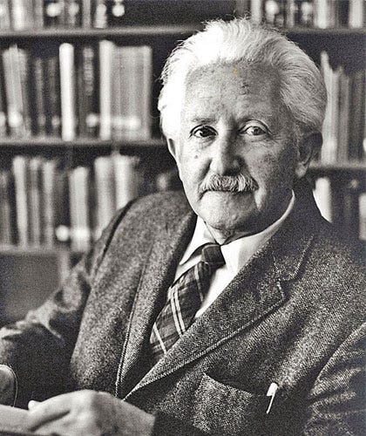
Image: Erik Erikson

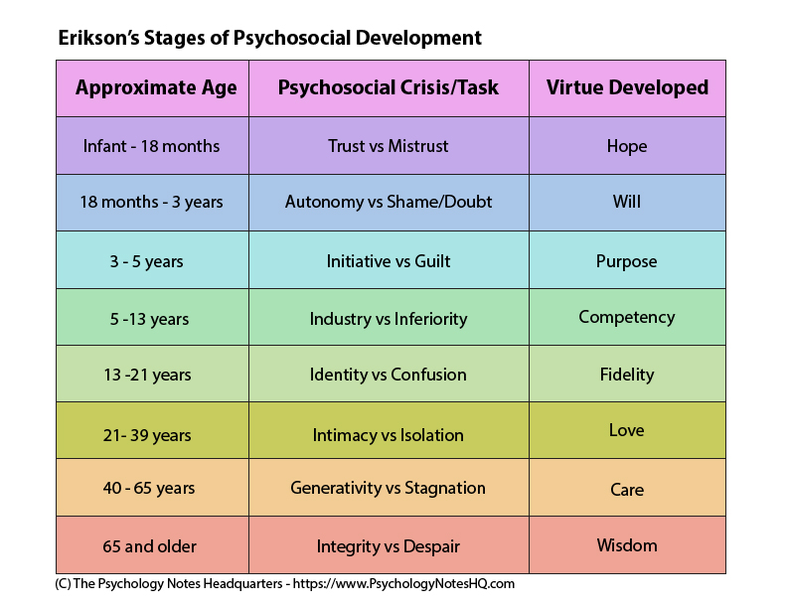

Review on the Psychological Framework
Behaviourism is a psychological framework that focuses on the study of observable behaviour and the environment’s influence on it. It is based on the belief that behaviour can be shaped by the consequences it receives, and the environment plays a crucial role in shaping behaviour. This approach to psychology emerged in the early 1900s and was pioneered by John B. Watson and B.F. Skinner. This review will discuss the principles of behaviourism, its strengths and weaknesses, and its application in contemporary psychology (Cherry, 2023).

Principles of Behaviourism
Behaviourism is grounded in three principles: classical conditioning, operant conditioning, and observational learning. Classical conditioning involves learning through association between a neutral stimulus and a naturally occurring stimulus that produces a reflex response (Mcleod, 2023). This is demonstrated in Pavlov’s experiment with dogs, where he conditioned them to associate the sound of a bell with the presence of food. Operant conditioning involves learning through the consequences of behaviour. Positive reinforcement, negative reinforcement, punishment, and extinction are the four types of consequences that shape behaviour. Positive reinforcement is the presentation of a desirable stimulus after a behaviour that increases the likelihood of that behaviour occurring again. Negative reinforcement is the removal of an aversive stimulus after a behaviour that increases the likelihood of that behaviour occurring again. Punishment is the presentation of an aversive stimulus after a behaviour that decreases the likelihood of that behaviour occurring again. Finally, extinction is the removal of the consequence after a behaviour that leads to a decrease in the likelihood of that behaviour occurring again. Observational learning involves learning through observing others’ behaviour and the consequences they receive. This is demonstrated in Albert Bandura’s famous Boo doll were more likely to behave aggressively towards the doll themselves (Moore, 1999).

Strengths of Behaviourism
One of the strengths of behaviourism is its empirical approach to studying behaviour. Behaviourists focus on observable behaviour rather than unobservable mental process, making their theories more objective and testable. This has led to significant contributions to the field of psychology, such as the development of effective treatments for disorders like phobias and anxiety. Behaviour therapy, based on the principles of operant and classical conditioning, has been shown to be effective in treating these disorders (Strengths and Weaknesses of Behaviorism theory in Psychology - How and When Learners Portal, 2021).
Another strength of behaviourism is its emphasis on environmental factors in shaping behaviour. This approach recognises that individuals are born with predetermined personality traits, but rather their behaviour is shaped by the environment. This has implications for education and parenting, as the environment can be manipulated to encourage positive behaviour.

Weaknesses of Behaviourism
One of the criticisms of behaviourism is its oversimplification of complex human behaviour. Behaviourists ignore the role of cognitive processes, emotions, and the internal state of an individual in shaping behaviour. This has led to the neglect of important factors that contribute to behaviour, such as motivation and personality.
Another weakness of behaviourism is its focus on the external environment and the neglect of internal factors that contribute to behaviour. This approach ignores the fact that individuals have agency and can make choices independent of external stimuli. This neglect of individual agency has been criticised for dehumanising individuals and reducing them to mere responders to environmental stimuli (Strengths, Weaknesses Of Behaviorism Essay Example - PHDessay.com, 2023).

Application of Behaviourism in Contemporary Psychology
Despite its criticisms, behaviourism has made significant contributions to contemporary psychology. Behavioural principles have been applied to the treatment of a variety of disorders, including depression, addition, and eating disorders. Cognitive-behavioural therapy (CBT) is a type of therapy that combines behavioural principles with cognitive strategies to treat mental health disorders. This approach emphasizes the role of thoughts and beliefs in shaping behaviour and uses behavioural techniques to change maladaptive thought patterns.
Behaviourism has also influenced the field of education, with the development of behaviourist approaches to teaching, such as direct instruction and programmed instruction. These approaches emphasises the importance of reinforcement (Cherry, 2022).

Learned Psychological perspectives taught at this Module in Future job setting.
The study of psychological provides valuable insights into human behaviour, emotions, and mental processes. The learned psychological perspectives taught in this module can be applied in various settings, including future job settings. In this essay, I will discuss how the learned psychological perspectives can be applied in future job settings.
Firstly, the cognitive perspective can be applied in job settings that require problem-solving, decision making, and critical thinking skills. For instance, individuals who work in business or management settings can use the cognitive perspective to understand how employees process information and make decisions. By understanding how cognitive processes work, they can identify areas that need improvement and develop strategies to enhance decision-making processes. Similarly, educators can use cognitive psychology to develop effective teaching methods that facilitate learning and enhance students’ cognitive abilities.
Secondly, the behavioural perspective can be applied in job settings that require behaviour modification and management. For example, psychologists and therapists can use behaviour modification techniques to treat individuals with behavioural disorders, such as autism and ADHD. They can also use behaviour modification techniques to help individuals overcome phobias, addictions, and other maladaptive behaviours. In the workplace, behaviour modification can be used to reinforce positive behaviours and discourage negative behaviours among employees. This can lead to a more productive and positive work environment.
Thirdly, the psychodynamic perspective can be applied in job settings that require an understanding of unconscious thoughts, emotions, and motivations. For example, therapists and counsellors can use the psychodynamic approach to help individuals overcome emotional and psychological difficulties. By understanding the underlying causes of their symptoms, therapists can help individuals gain insight into their behaviour and make positive changes. Similarly, human resources professionals can use psychodynamic approach to understand the underlying motivations and behaviours of employees. By understanding the reasons behind their behaviour, they can develop strategies to improve job satisfaction and employees retention.
Fourthly, the humanistic perspective can be applied in job settings that require a focus on personal growth and self-actualization. For example, therapists and counsellors can use the humanistic approach to help individuals achieve their full potential by promoting self-awareness, self-esteem, and personal growth. Similarly, educators can use the humanistic approach to facilitate learning by promoting student-centred approaches, such as experiential learning and problem-based learning. In the workplace, the humanistic approach can be used to promote employee well-being, job satisfaction, and engagement.
Fifthly, the evolutionary perspective can be applied in job settings that require an understanding of human evolution and behaviour. For example, anthropologists and biologists can use the evolutionary perspective to study the evolution of human behaviour and its adaptive functions. Similarly, marketing professionals can use the evolutionary perspective to understand consumer behaviour and preferences. By understanding the evolutionary roots of human behaviour, they can develop marketing strategies that appeal to human instincts and emotions.
Sixthly, the sociocultural perspective can be applied in job settings that require an understanding of how culture and society influence behaviour. For example, sociologists and anthropologists can use the sociocultural perspective to study how cultural norms, values, and beliefs influence behaviour. Similarly, educators can use the sociocultural perspective to develop culturally responsive teaching methods that are sensitive to the needs and experiences of diverse learners. In the workplace, the sociocultural perspective can be used to develop inclusive practices that promote diversity, equity, and inclusion.
Furthermore, understanding psychological perspectives can also improve communication and interpersonal skills, which are essential in many job settings. For example, if you are working in a customer service role, understanding different personality types and communication styles can help you effectively communicate with customers and resolve conflicts. Similarly, if you are working in a team setting, understanding individual differences and motivations can help you collaborate effectively with your colleagues and achieve team goals.
Moreover, knowledge of psychological perspectives can also be helpful in leadership positions. Understanding different leadership styles and the impact they have on team dynamics can help you effectively lead and motivate your team. Similarly, understanding the cognitive and emotional factors that influence decision-making can help you make informed and effective decisions as a leader.
In addition, the learned psychological perspectives can also be applied in fields such as marketing and advertising. Understanding consumer behaviour and motivations can help marketers create effective campaigns that resonate with their target audience. Similarly, understanding the impact of cognitive biases on decision-making can help marketers design products and services that meet the needs of their customers.
Overall, the learned psychological perspectives can be beneficial in a wide range of job settings, from healthcare and education to business and marketing. By understanding human behaviour, motivations, and cognitive processes, individuals can improve their communication and interpersonal skills, make informed decisions, and effectively lead and motivate others. Additionally, incorporating psychological principles into job settings can lead to improved productivity, job satisfaction, and overall success for both individuals and organizations.

Conclusion
In conclusion, the study of psychology offers a diverse range of perspectives that can be applied in various job settings. The four main perspectives covered in this module – biological, cognitive, behavioural, and psychodynamic – provide valuable insights into human behaviour, cognition, and emotion. Understanding these perspectives can help individuals improve their communication and interpersonal skills, make informed decisions, and effectively lead and motivate others. Therefore, incorporating psychological principles into job settings can lead to improved productivity, job satisfaction, and overall success for both individuals and organizations.

References
Cherry, K. (2022) Behaviorism: Definition, History, Concepts, and Impact. URL: https://www.verywellmind.com/behavioral-psychology-4157183 [6 April 2023].
Cherry, K. (2023) Biography of Psychologist John B. Watson. URL: https://www.verywellmind.com/john-b-watson-biography-1878-1958-2795550 [6 April 2023].
Maree, J. G. (2021) The psychosocial development theory of Erik Erikson: critical overview. https://doi.org/10.1080/03004430.2020.1845163, 191(7–8), 1107–1121.
Mcleod, S. (2023) Behaviorist Approach to Psychology: Definition, History, Concepts, and Impact. URL: https://simplypsychology.org/behaviorism.html [6 April 2023].
Moore, J. (1999) The Basic Principles of Behaviorism, 41–68.
Shelton Emmett (2017) A Critical Review of Erikson’sTheory Free Essay Example. URL: https://studymoose.com/a-critical-review-of-eriksonstheory-essay [6 April 2023].
Strengths, Weaknesses Of Behaviorism Essay Example - PHDessay.com (2023). URL: https://phdessay.com/what-are-the-strengths-and-weaknesses-of-one-of-the-perspectives-of-psychology/ [6 April 2023].
Strengths and Weaknesses of Behaviorism theory in Psychology - How and When Learners Portal (2021). URL: https://howandwhen.org/strengths-and-weaknesses-of-behaviorism-theory-in-psychology/ [6 April 2023].

