Title: The Effect of Digital Marketing Strategies on Consumer Purchase Decisions: A Case Study of E-Commerce Businesses in the UK

Student Name: Dumitru Ciprian Iancu
Student ID: 2133738

Table of Contents
1.Introduction 2
1.1 Problem Statement 2
1.2 Research Aim 2
1.3 Research Objectives 2
1.4 Research Questions 2
1.5 Significance of the Study 3
1.6 Proposal Outline 3
2. Literature Review 3
2.1 Theoretical Framework 3
2.2 Digital Marketing Strategies 3
2.3 Gaps and Contradictions in Current Research 4
2.4 Justification for a UK-Focused Study 4
3. Research Methods and Methodology 5
3.1 Research Design and Strategy 5
3.2 Rationale for Secondary Research 5
3.3 Data Sources 6
3.4 Data Collection Process 6
3.4 Data Analysis Method 6
3.5 Ethical Considerations 7
3.6 Limitations of the Methodology 7
4. Timeline (Gantt Chart) 7
5. References 8

1.Introduction
Online marketing has been the engine of customer interaction in the UK e-commerce market that made more than 120 billions of revenues in 2023 (Statista, 2024). Consumers have redefined their discovery process, consideration process, and eventual purchase process due to the rising popularity of online channels such as social media, email, paid search, and influencer marketing, among others. However, as the strategies are being diligently pursued by the business, it is hard to estimate the amount of money the business spends on the strategy and the returns to the actual purchasing decisions (McKinsey & Company, 2023).

1.1 Problem Statement
Although UK e-commerce businesses are increasing their expenditure on digital marketing, there is a trend of an increasing disparity of investment amount and lack of understanding of which strategies are effective in encouraging consumer action. This forms a strategic blind spot especially with the changing digital behaviours of the consumers. Marketers require empirical information on what works, what does not work and why.

1.2 Research Aim
To determine the influence of digital marketing strategies on the consumer purchase decisions in UK-based e-commerce businesses.

1.3 Research Objectives
- To determine the most popular digital marketing strategies used in the e-commerce sector in UK.
- To determine the effects of these strategies on consumer purchase intention and consumer purchase behaviour.
- To understand consumer attitude towards digital marketing tools like social media advertisements, emailing and influencer promotions.
- To be able to compare the effectiveness of different strategies among various types of consumers.

1.4 Research Questions
- Which are the digital marketing practices in the UK e-commerce businesses?
- What is the impact of these strategies on the consumer purchasing decisions?
- What are the most convincing platforms or tactics that UK consumers feel?

1.5 Significance of the Study
The research has value to the academic as it provides insight into digital marketing knowledge base with a UK specific audience and practical value to the marketer who can better make use of the budgets and enhance ROI.

1.6 Proposal Outline
The proposal entails a literature review, well-outlined methodology, research schedule, and references that will be used to inform the implementation of the final dissertation.

2. Literature Review

2.1 Theoretical Framework
To interpret the impact of digital marketing on purchase behaviour, a theoretical base should be made on the behavioural and communication theories. Engel-Kollat-Blackwell (EKB) model is a five-stage decision-making model, which outlines need recognition to post purchase reflection (Blackwell et al., 2006). It aids in understanding how digital channels are applicable to the various stages such as retargeting at the evaluation stage. Nonetheless, it presumes a rational linear straight, which does not necessarily represent real-time internet browsing and impulse purchases, particularly within social media.
The Theory of Planned Behaviour (TPB), in its turn, represents a more subtle perspective because it includes attitudes, subjective norms, and perceived behavioural control (Ajzen, 1991). It is a factor that considers the impact of peers and social media, which is directly linked to RQ2 (how strategies affect decisions). However, TPB has been faulty in its dismissal of the role of emotional and spontaneous behaviour, which is typical of fast-moving e-commerce environments (Grewal et al., 2020).
Digital campaign is usually designed using the AIDA model (Attention, Interest, Desire, Action). Rawal (2018) states that its power consists in simplicity and can be implemented in such platforms as Instagram or email. But its chronological reasoning can be overly simplified on nonlinear digital travel. To illustrate, the content of the influencers may generate a need to act before attention has been properly gained, and this makes the model flawed. This is relevant to RQ3 regarding the platforms that are viewed as the most persuasive.
The combination of these models presents divergent perspectives regarding consumer behaviour on the responsiveness of digital marketing-but they also reveal that no single model can exhaustively explain online behaviour of the modern consumer. This supports the necessity of a UK-based, practical research.

2.2 Digital Marketing Strategies
According to academic and industry studies, digital marketing has an influence on consumer behaviour, although the research results conflict on the most effective strategies. Email marketing is bragged with a high ROI and personalisation (Statista, 2023), but Sendinblue (2022) states that open rates have been dropping because of content fatigue. This paradox shows that there is a necessity to investigate the consumer perception, as RQ3 formulated.
Younger audiences, especially in fashion and beauty are becoming successful with influencer marketing. De Veirman et al. (2017) demonstrate that it develops trust by attaching perceived authenticity. Lemon (2018) is cautious of that, though, trust does not necessarily translate to action likes and shares do not necessarily translate into sales. It is implied in this comparison that although influencers can produce emotional involvement (the Desire of AIDA), the behavioural control of TPB is more likely to predict purchase desire.
High-intent traffic is driven by Search Engine Marketing (SEM) (Chaffey and Ellis-Chadwick, 2019), yet Kingsnorth (2022) claims that it is not as emotional as social media. These distinctions directly concern the RQ1 and RQ2, as they allow differentiating between the strategies, which produce awareness, and those that produce action.
In the meantime, retargeting can be a powerful approach to conversion (McKinsey & Company, 2023), though it has the issue of privacy and overexposure (ICO, 2021). This implies the possibility of diminishing returns, particularly in the case of a GDPR compliant UK setting- this is a good line of RQ2.

2.3 Identified Gaps and Justification for Study
Regardless of the accumulating research, many studies concentrate on non-UK ones or one platform, or strategy alone. Not many look at the interaction of several strategies in a real-life environment. There is also little comparison of consumer perception with actual behaviour, and this is what this study will seek to fill.
In addition, the current models (EKB, TPB, AIDA) tend to be used separately, as opposed to model clusters to describe end-to-end digital journeys. This study will use a question-based approach to answer the research questions, but the answers will be more precise by integrating secondary data related to the UK, along with a model-driven framework.

3. Research Methods and Methodology

3.1 Research Design and Strategy
This study will assume a qualitative, exploratory research design with the basis of secondary data analysis. The purpose will be to explore how digital marketing strategies affect the consumer purchases decision-making in the UK e-commerce market based on available and reliable data sources. The use of an exploratory approach will be appropriate since the researcher will be able to look at the complex relations, i.e., consumer perceptions and behaviours as influenced by different digital marketing strategies, without necessarily experiencing and engaging the participants in direct interaction.
The research approach adheres to a desk-based approach, as data will be acquired through peer-reviewed journals, industry reports, government publications, and whitepapers of professionals. This design facilitates an effective utilization of a wide range of quality of data of various perspectives that can be analysed in critical analysis without the limitations of resources that are common with primary research. It is also within the time limitation of the dissertation, giving it the opportunity to explore in depth the evidence based aspect of marketing effectiveness in a real-life situation in the UK. The design helps in thematic analysis to establish the major patterns, contradictions, and strategic information.

3.2 Rationale for Secondary Research
This paper is entirely based on the secondary data materials which present credible, pertinent, and current information about digital marketing techniques and consumer behaviour in the e-commerce industry of UK. The information to be utilized will be based on a mix of peer reviewed scholarly materials, business research reports, government databases and professional marketing reports. The theoretical foundation will be obtained by accessing databases like Google Scholar, ScienceDirect, and EBSCOhost using academic sources like journal articles and textbooks.
To make sure that it is relevant nowadays, the industry reports offered by reputable organisations will be selected, including Statista, Hootsuite, McKinsey and Company, and Deloitte to represent the market-level trends and digital marketing performance indicators. Moreover, such government sources as the Office for National Statistics (ONS) will also give official data on e-commerce in the UK and on consumer spending. Lastly, articles and reports of marketing agencies such as HubSpot, Smart Insights, and the ASA will be used to evaluate the campaign results in real-life scenarios and consumer reactions.

3.3 Data Sources
The secondary data will consist of the following resources and types:
- Academic Journals and Books: The peer-reviewed research on digital marketing effectiveness, consumer decision-making model (e.g. TPB, EKB, AIDA), and behavioural reaction to online stimuli.
- Industry Reports: Statista, McKinsey, Deloitte, and Hootsuite market research on the digital marketing trends and consumer purchasing behaviour in the UK.
- Government Data: ONS data on e-commerce transactions, electronic sales and consumer expenditure trends in the UK.
- Trade & Professional Sources: Whitepapers and annual reports of platforms like HubSpot, SEMrush, and Marketing Week, providing information on the performance of the strategy and industry standards.

3.4 Data Collection Process
Academic databases (e.g., Google Scholar, EBSCOhost), official government websites, and reliable industry research sources will be used to collect the data by keyword search methods. Inclusion criteria will be:
- Publications from 2017 onwards
- Studies specific to the UK or global studies that can be readily applied.
- References that have clear methodology and cited statistics.
- Exclusion criteria include:
- Sources that cannot be verified (e.g. unreferenced blogs, AI-generated content)
- Publications that are older than 2017 except seminal theories and models.

3.4 Data Analysis Method
The thematic analysis strategy will be applied to determine and compare the common patterns in data. This is the suitable way to synthesise the results of diverse qualitative and quantitative secondary sources. Key themes will include:
- Strategy application (e.g. use of influencer marketing or SEO)
- Consumer reactions related to various channels (e.g., trust, purchase intent).
- Measures of effectiveness (ex: conversion rates, engagement levels)
The data will also be explored to identify contradictions, outliers, and gaps to be examined in the data to interpret it in a balanced and critical manner.

3.5 Ethical Considerations
Although there are no human subjects in the research, the study will nonetheless comply with ethical research by:
- Only legally obtained publicly available data was used.
- Correctly cited referencing in Harvard.
- not deception or cherry picking of results.

3.6 Limitations of the Methodology
The main shortcoming of a secondary-only method is that there is no control of data quality and context. Certain sources might even take a biased view of the subject especially white papers in marketing. Moreover, the original study may not give any insights that may be applicable to this research due to its objectives which may not be entirely similar. Nevertheless, the reliability and the strength of results will be maximised with the help of triangulating the information provided by multiple and different sources.

4. Timeline (Gantt Chart)
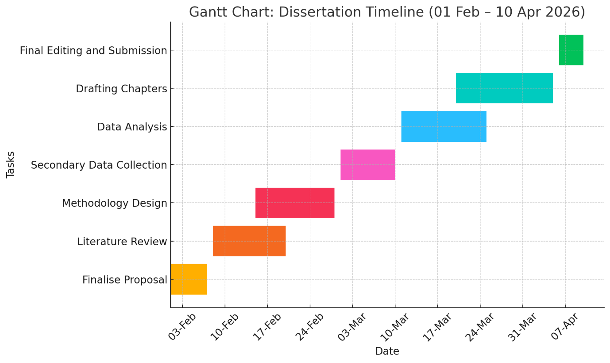
The research project will span the period of 1 st February to 10 th April 2026 in a structured and overlapping date to maintain efficient development. The first week will be dedicated to the completion of the proposal which includes the supervisor feedback and the clarification of the scope of the research. The literature review will be performed in the first half of February through mid-February to find out the theories and the latest research. This phase is also parallel to the methodology design phase, which entails ensuring the research methodology, determining the method to be used in data analysis, and determining the credible sources of secondary information. The databases will be collected during the early March, and the data will be targeted at peer-reviewed journals, industry reports, and the UK government datasets. Collected data will be then thematically analysed between middle and end of March to draw major findings. The analytical process will continue when the writing process starts in order to facilitate the process. The month of April will be used to edit, finish citations and make sure that the dissertation is in good academic shape before submission. This schedule will make sure that everything is achieved in an organized manner.

5. References
Ajzen, I. (1991) ‘The theory of planned behavior’, Organizational Behavior and Human Decision Processes, 50(2), pp. 179–211.
Advertising Standards Authority (ASA) (2022) ‘Influencer marketing and consumer impact’. Available at: https://www.asa.org.uk (Accessed: 23 October 2025).
Blackwell, R.D., Miniard, P.W. and Engel, J.F. (2006) Consumer Behavior. 10th edn. Mason: Thomson South-Western.
Chaffey, D. and Ellis-Chadwick, F. (2019) Digital Marketing. 7th edn. Harlow: Pearson Education.
De Veirman, M., Cauberghe, V. and Hudders, L. (2017) ‘Marketing through Instagram influencers: Impact of number of followers and product divergence on brand attitude’, International Journal of Advertising, 36(5), pp. 798–828.
Grewal, D., Roggeveen, A.L. and Nordfält, J. (2020) ‘The future of retailing’, Journal of Retailing, 96(1), pp. 86–95.
Hootsuite (2023) ‘Social Media Trends 2023’. Available at: https://www.hootsuite.com/resources (Accessed: 29 October 2025).
ICO (2021) ‘Guidance on the use of cookies and similar technologies’. Information Commissioner’s Office. Available at: https://ico.org.uk (Accessed: 24 October 2025).
Kapoor, K., Tamilmani, K., Rana, N.P., Patil, P., Dwivedi, Y.K. and Nerur, S. (2021) ‘Advancing social media analytics for business and management: Research landscape and future directions’, Information Systems Frontiers, 23(3), pp. 695–720.
Kingsnorth, S. (2022) Digital Marketing Strategy: An Integrated Approach to Online Marketing. 3rd edn. London: Kogan Page.
Lemon, K.N. (2018) ‘Interactive and social media marketing: A research agenda’, Journal of the Academy of Marketing Science, 46(2), pp. 261–271.
McKinsey & Company (2023) ‘UK digital marketing ROI benchmark report’. Available at: https://www.mckinsey.com(Accessed: 26 October 2025).
Office for National Statistics (ONS) (2023) ‘Retail sales, Great Britain: December 2023’. Available at: https://www.ons.gov.uk (Accessed: 20 October 2025).
Rawal, P. (2018) ‘AIDA marketing communication model: Stimulating a purchase decision in the minds of consumers through a linear progression of steps’, IUP Journal of Brand Management, 15(1), pp. 37–48.
Sendinblue (2022) ‘Email marketing benchmarks for 2022’. Available at: https://www.sendinblue.com (Accessed: 27 October 2025).
Smart Insights (2022) ‘Social media marketing trends for 2022’. Available at: https://www.smartinsights.com(Accessed: 25 October 2025).
Statista (2023) ‘Email marketing ROI in the UK 2023’. Available at: https://www.statista.com (Accessed: 18 October 2025).
Statista (2024) ‘UK e-commerce revenue 2023’. Available at: https://www.statista.com (Accessed: 22 October 2025).

