

Name: Leon Twynam
Student No: 2505767

Study Skills Assignment

University of Wales Trinity Saint David
Study Skills for Electronics (ACDA4021)

BEng Electrical and Electronic Engineering
Academic Year: 2025 - 2026

Abstract
This report contains the written reflection and evidence on the application of the skills covered during the course of this module. This includes research on required skill sets in a higher education environment, transferable skills employers look for in prospective job candidates, self-evaluation, ransomware, time management, and organisation. This research aims to provide the learner with the knowledge required to thrive in a higher education environment, and also the real world. In addition to this, this report contains evidence of self-evaluation exercises executed to discover strengths and weaknesses, personality type, as a baseline for the learner to consider personal areas of improvement or change.

Table of Contents
Abstract ii
List of Figures iv
List of Tables v
List of Abbreviations vi
1 Presentation skills 7
1.1 Brief overview of myself 7
1.2 Icebreaker presentation 7
1.3 Post-Presentation Delivery 10
1.3.1 Key Points Learnt 10
1.3.2 Future areas of improvement 10
2 Research on required skill sets 11
2.1 Skills required in a higher education environment 11
2.2 Generic transferable skills employers look for 12
3 Self-evaluation and action planning 13
3.1 Self-evaluation exercises 13
3.2 Short-term and long-term goals 16
4 Application 18
4.1 Data backup 18
4.2 Ransomware 18
4.3 Time management & self-organisation 19
4.4 Professional development plan (PDP) 21
5 Conclusion & Evaluation 23
References 24
Appendices 26
Appendix A - Self-evaluation personality types 27

List of Figures
Figure 1: Screenshot of presentation slide 2 8
Figure 2: Screenshot of presentation slide 3 9
Figure 3: Screenshot of presentation slide 4 10
Figure 4: Screenshot of presentation slide 5 10
Figure 5: Graph of percentage of high school students who would feel more prepared to enter college if they had stronger essential skills [2] 13
Figure 6: Online test results conveying which team roles suit the participant best [5] 14
Figure 7: Online personality test results [6] 15
Figure 8: Multiple intelligences test results [7] 15
Figure 9: Results of online colour personality test [8] 16
Figure 10: Test results for the suitable career suggestions quiz [9] 17
Figure 11: Screenshot of work Outlook calendar 20
Figure 12: Screenshot of the organisation of the documents area on the learner's work laptop 21
Figure 13: Screenshot of the organisation of subfolders 22
Figure 14: 1st page of learner's PDP 23
Figure 15: Page 2 of learner's PDP 23

List of Tables
Table 1: SMART goals action plan 18

List of Abbreviations
E, C&I | Electrical, Controls & Instrumentation
IT | Information Technology
PDP | Professional Development Plan
IEEE | Institute of Electrical and Electronics Engineers

Presentation skills

Brief overview of myself
My name is Leon Twynam. I am 20 years old and live in Pembroke Dock, Pembrokeshire. I am currently an E, C&I apprentice at Insite Technical Services Ltd, and I have been working there for just over a year. Before Insite, I was studying A-Levels in Physics, Maths, and IT at Ysgol Harri Tudur. In my spare time, I like to go to the gym, spend time with friends, watch football, and attend music events.

Icebreaker presentation
One of the skills covered during this course was presentation skills. We were set a task to complete a roughly 5-minute ice-breaker introduction to present to the class. We were also grouped so we could give each other feedback on what went well and what could be improved in our presentations. Prior to delivering this task, we were provided a lecture on successful presentation delivery, which included tips on public speaking, presentation layout, and more. From this lecture, I applied as many areas of advice as possible to my own presentation. Figures 1, 2, 3 & 4 below are screenshots of my icebreaker presentation slides.
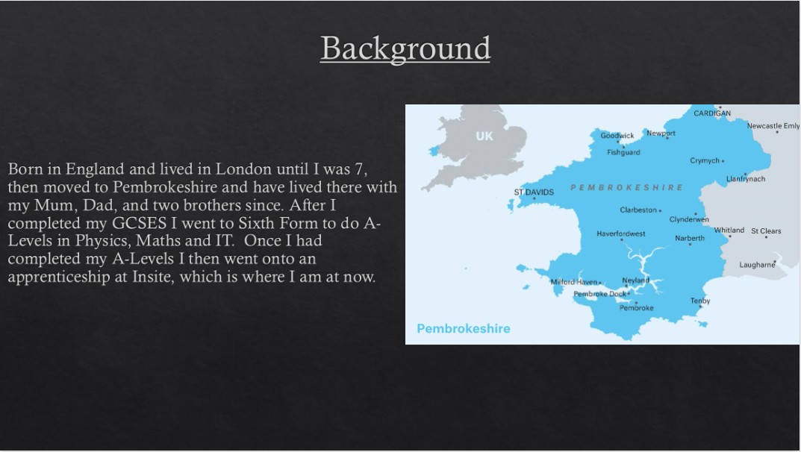
Figure 1: Screenshot of presentation slide 2
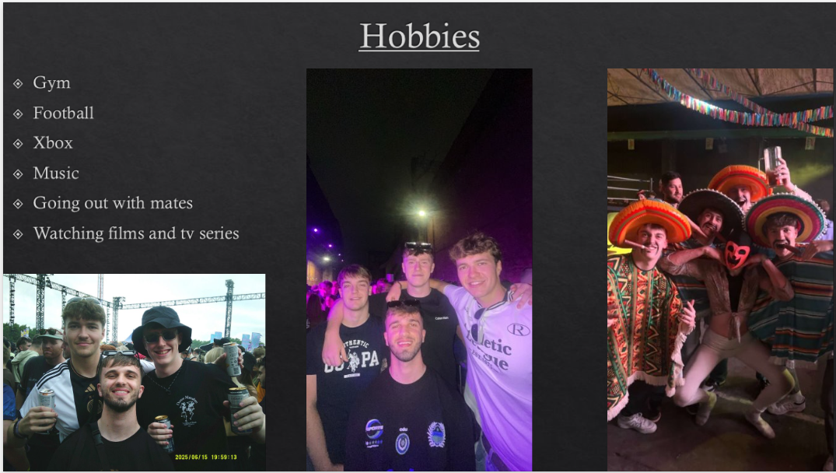
Figure 2: Screenshot of presentation slide 3
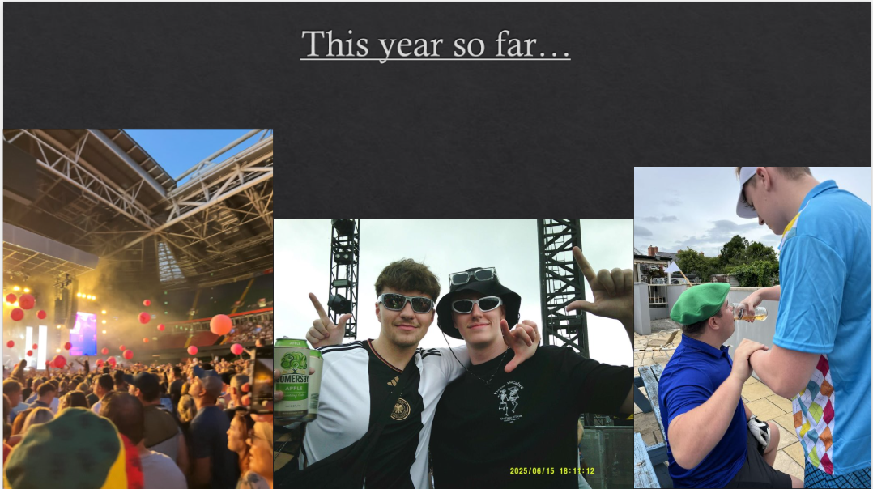
Figure 3: Screenshot of presentation slide 4


Figure 4: Screenshot of presentation slide 5

Post-Presentation Delivery

Key Points Learnt
One of the key points I learnt after delivering my presentation was to incorporate more visual cues for talking points. I noticed that in other students' presentations, they used a variety of visual cues, such as bullet points, images, and text, to prompt talking points and support their slides.
Another one of the key points that I had noted when trying to produce and deliver a successful presentation was to avoid large sections of text. This is so that when giving my presentation, I would pay less attention to the slides on the screen and instead focus on talking to the audience. This would also make the presentation more interactive, as it would prevent the audience from reading off the screen and would allow them to listen to the speaker.
An additional key point that I learnt was to slow down with my speech. Whilst observing everyone else’s presentations, I took note that other students would take a couple of seconds before moving on to the next topic. This helped with the overall flow of the presentation and supported meeting the 5-minute objective.

Future areas of improvement
After we had completed our presentations, we then gave each of the other members in our group feedback on what went well and what could have been better. One of the areas I had received feedback on was that my presentation was too short. To avoid this happening again in the future, I will time myself while presenting to see if the PowerPoint needs more or less content included.
Another area of improvement that I identified was my general public speaking. As I have not had a lot of experience in presenting to an audience, I was a little nervous and made some errors in my speech, such as rushing, stuttering, and beginning sentences with “ummm”. To improve my public speaking, I will continue to gain experience and expand on my skills by helping out in the taster days at work and other presenting opportunities.
An additional piece of feedback I received was to read off the screen less and engage more with the audience. To improve my future presentations, I will make on-screen text concise, and if necessary, I will write down notes on paper instead. I also think that to improve my future presentations, I should be more animated with my body language to keep the audience more engaged.

Research on required skill sets

Skills required in a higher education environment
In a higher education environment, certain skills are required for successful learning. Some examples of the skills required in a higher education environment include academic writing, communication, soft skills, time management, critical thinking, and reading [1]. One of the key skills required within academic writing is referencing and avoiding plagiarism. Different universities and courses will require certain referencing styles such as Harvard, IEEE, Vancouver, and more. Avoiding plagiarism is crucial while at university, as software is used to compare the similarity of your work to other sources, which is why you must properly reference the material you use [1].
According to the “Essential Skill Development in Higher Education: Student and Staff Perspectives,” 2025, they suggest that the five essential skills required in a higher education environment are grit, teamwork, resilience, curiosity, and leadership [2]. The authors of this source also write that these skills are highly valued by employers and that they can be developed both naturally and intentionally. The authors of this source also conducted research on students to find out the percentage of students who agreed that stronger essential skills would make them feel more prepared for entering college, which can be seen in Figure 5 below.
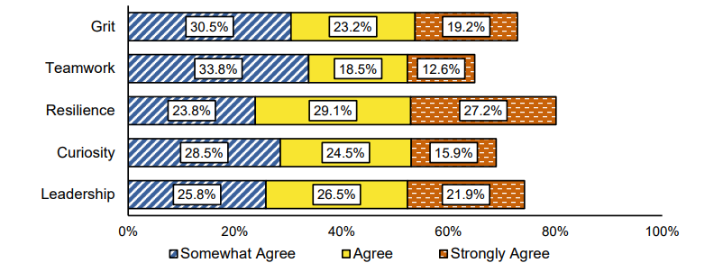
Figure 5: Graph of percentage of high school students who would feel more prepared to enter college if they had stronger essential skills [2]

Generic transferable skills employers look for
One of the generic, transferable skills that employers look for in prospective job candidates is a growth mindset. Some employers prioritise a growth mindset when hiring prospective candidates, as these are usually individuals eager to learn and adapt [3]. Forbes say that one of their 20 transferable skills employers should prioritise when hiring is curiosity. They state that “Curiosity shows spirit, caring and forward-thinking” and that “People who take an interest will always have thought-provoking ideas to share”. Another generic transferable skill employers seek is communication. Communication is a vital skill as it aids with collaboration and nurtures positive relationships and team building.
An additional skill that employers look for in prospective job candidates is integrity. Employers are more likely to hire people who are honest and trustworthy, especially if they are willing to admit their own mistakes and are loyal to those they work for [4]. The author, Amanda Augustine, also states that professionalism is another skill sought after by employers. This is because when an individual works for an organisation, they become an unofficial representative of their brand.

Self-evaluation and action planning

Self-evaluation exercises
During this section of the module, the learner was tasked with conducting self-evaluation exercises to discover their strengths, weaknesses, personality type, suitable career suggestions, etc. The first test carried out can be seen below in Figure 6.
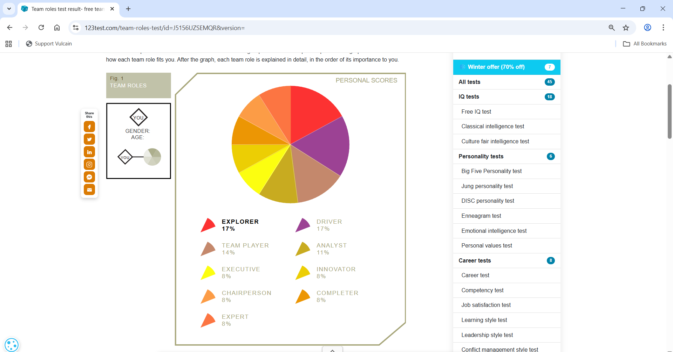
Figure 6: Online test results conveying which team roles suit the participant best [5]
As Figure 6 displays, the online test has identified the learners' three most suited team roles as the explorer, driver, and team player and their three least suited team roles as expert, completer, and chairperson. Although the learner agrees with their top three most suited team roles, they believe that the completer should be a higher percentage, as they believe they are very critical of their own work, especially in a team environment [5]. The next test conducted was a personality test, which can be seen in Figure 7 below.
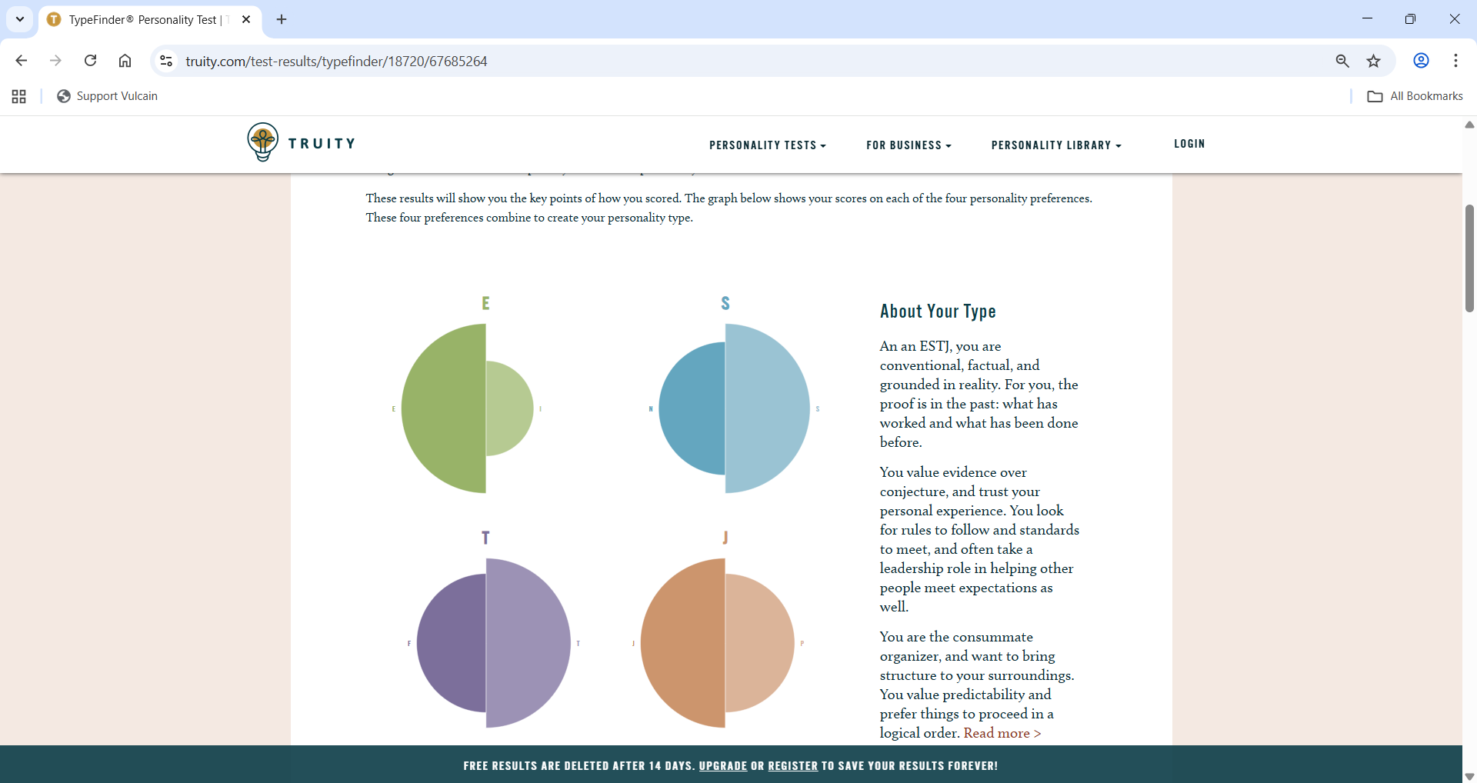
Figure 7: Online personality test results [6]
The results of this test have identified the learner as an ESTJ personality type, describing them as conventional, factual and grounded in reality. All possible Myers-Briggs personality types and their description are shown in Appendix A. The results also state that the test participant often takes a leadership role in helping others meet expectations as well, which also aligns with the test results in Figure 6 [6]. The results shown in Figures 6 and 7 mostly agree with each other; however, Figure 6 states that the learner is an explorer and on the other hand, Figure 7 states that they prefer what has worked and been done before. The next test completed was the multiple intelligences test, which can be seen below in Figure 8.
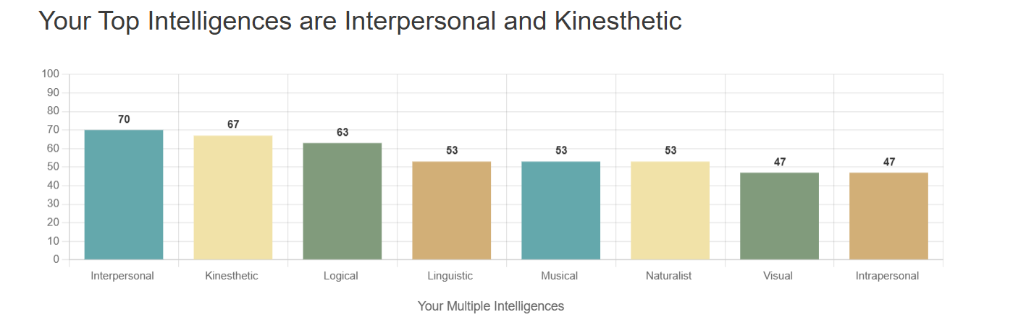
Figure 8: Multiple intelligences test results [7]
As seen in Figure 8 above, the test results describe the participant as mostly interpersonal, kinaesthetic, and logical. All multiple intelligence types and their descriptions are shown in Appendix A. Although the participant agrees with these, they think that the visual intelligence should be higher, as they believe that just because someone is a kinaesthetic learner doesn’t mean they can’t also be a visual learner. This test also matches up with the others, as it agrees that the participant works well with others [7]. Figure 9 below displays the next online test completed, which was a colour personality test.
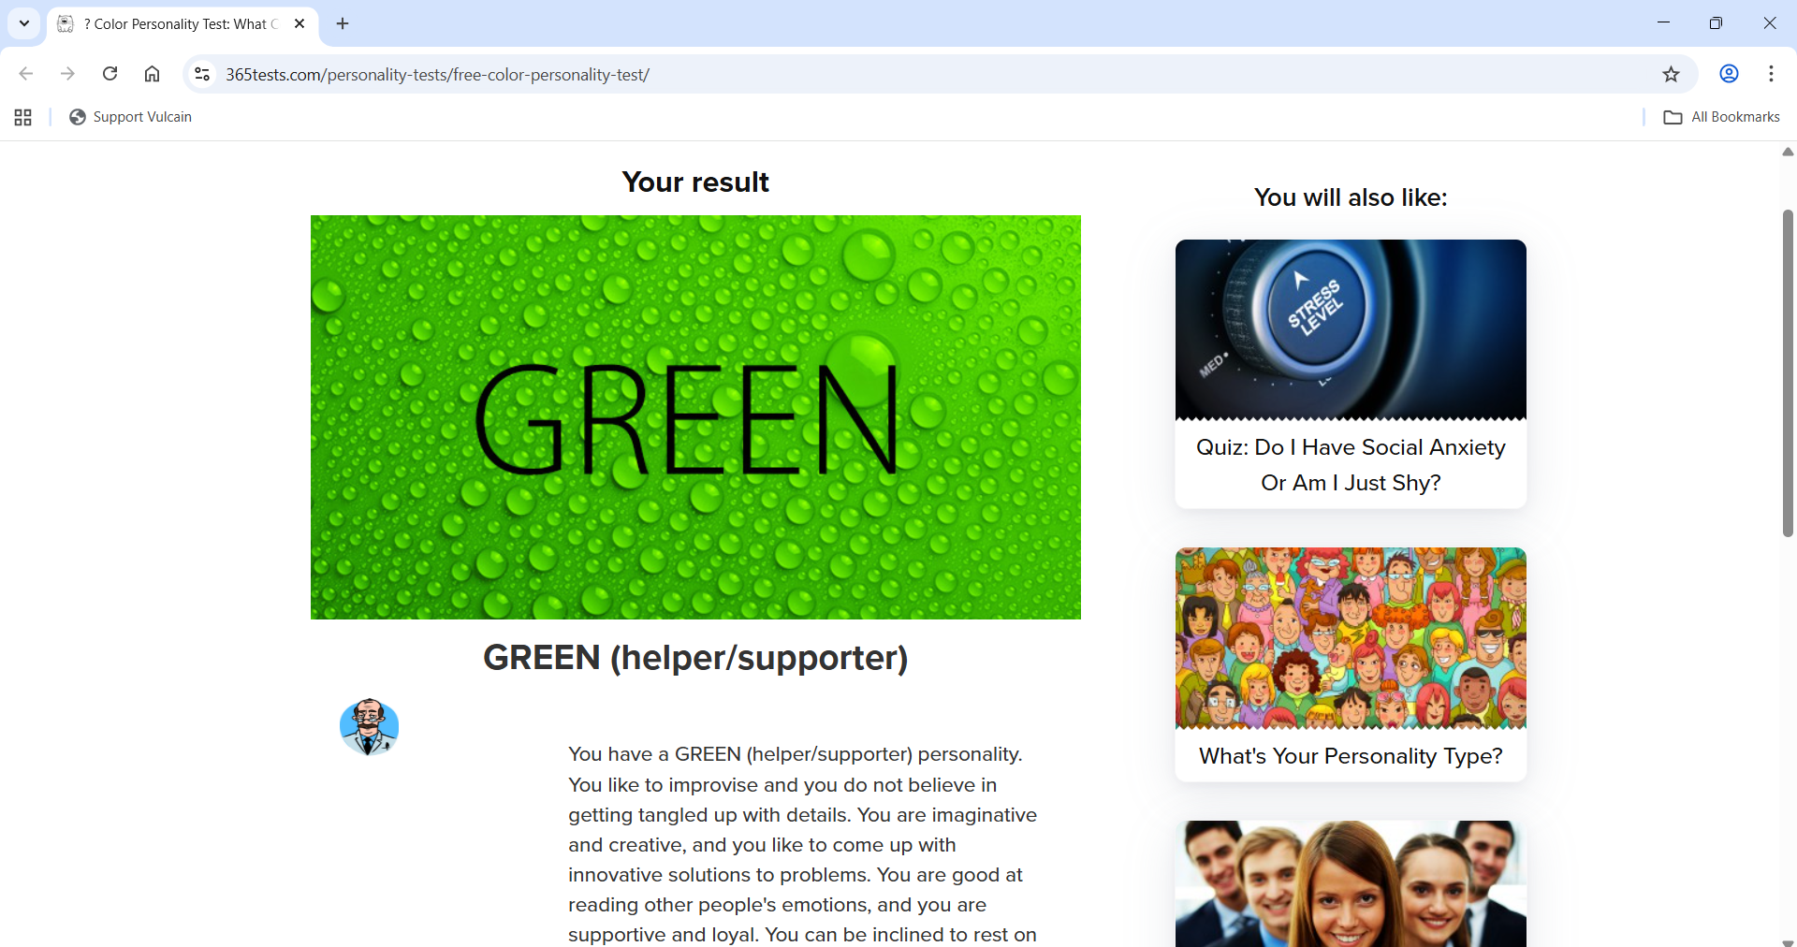
Figure 9: Results of online colour personality test [8]
The results of the colour personality test shown in Figure 9 state that the learner is of the green (helper/supporter) personality. All colour personality types and their descriptions are shown in Appendix A. This test also aligns with the others, as it describes the participant as creative, innovative and a helper/supporter. The only other part that didn’t agree with the other tests is where it describes the learner as someone who does not always challenge others when they should [8]. The final test that the learner completed was a suitable career suggestions test, which can be seen below in Figure 10.
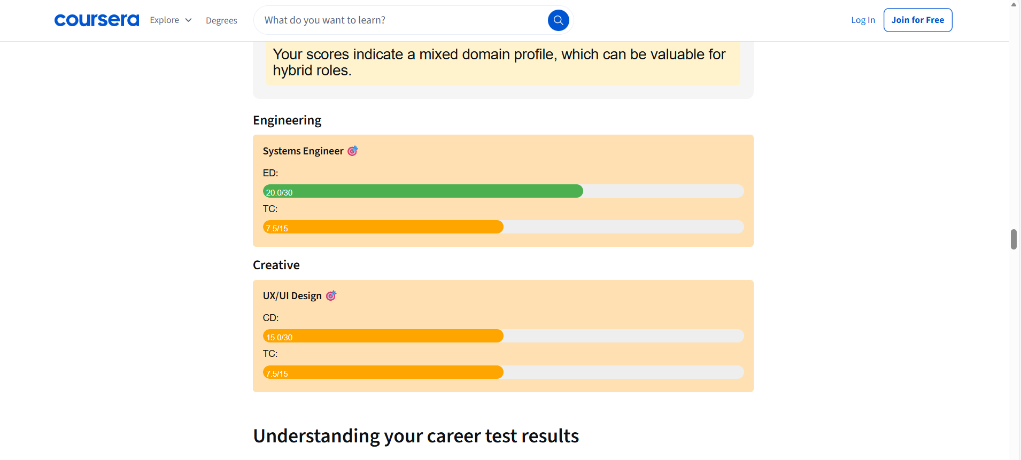
Figure 10: Test results for the suitable career suggestions quiz [9]
The test completed in Figure 10 above matches the other test results, as it describes the participant as creative and technical. The result also suggests that the learner should pursue a career in engineering, which is accurate as they are on a degree apprenticeship in electrical and electronic engineering [9].
To summarise, the learner has evaluated that based on these tests, they are creative, a team player, logical, and explorative. An area that can be improved on based on these tests is leadership/taking more responsibility in situations and being more independent. Further self-evaluation tests can be seen in Appendix A.

Short-term and long-term goals
The learner's main short-term and long-term goals include, but aren’t limited to:
- 1st classes in this academic year's exams
- Build up a good amount of savings
- Hit weight target by the end of May 2026
- Become a qualified engineer
To ensure that the learner can achieve these goals, they have created a S.M.A.R.T goals action plan, which can be seen in Table 1 below.
Table 1: SMART goals action plan
S  (Specific) | M  (Measurable) | A  (Attainable) | R  (Relevant) | T  (Time-based)
Achieve 1st classes in this year's academic exams | This will be measured when I achieve 1st classes in all my exams at the end of the academic year | This is attainable with the correct amount of revision and preparation before exams | This goal is relevant to my career and to completing my degree | To ensure I achieve 1st classes, I will revise at work (up to 4 hours per week) and at home (6 hours per week)
Build up a good amount of savings for holidays and events in 2026 | This will be measured by achieving £1000 in savings by the end of May 2026 | This is attainable if I save £200 a month until then, as it's less than 10% of my monthly wages | This goal is relevant to my plans in 2026, as I plan to go on holiday in the summer, as well as other events | To ensure I achieve this goal, I will put away £200 monthly for 5 months, plus any extra I don’t spend
Hit weight target | This will be measured by losing 7kg in 7 months | This is attainable as 1kg a month is realistic | This is relevant to my goal of becoming leaner | To ensure I achieve this, I will complete 3 hours of cardio a week and eat correctly
Become a qualified engineer | This will be completed once I have passed my degree | This is attainable as long as I pass my exams and coursework | This is relevant to both my personal and career ambitions | To ensure I achieve this, I will complete my assignments in time (week of or before) and revise sufficiently for my exams

Application

Data backup
Backing up data is vital as the loss of data can be devastating. One of the most effective and efficient methods to ensure data is sufficiently backed up is the “in 3 different places” rule. To summarise, the “in 3 different places” rule is where you have at least three copies of your data, so that the risk of losing everything is decreased. You can also further reduce this risk by including at least 2 different media types and at least one off-site backup. [10]
To guarantee that any work the learner is likely to produce during their time at university is provided with a robust level of data protection, the learner has applied the “in 3 different places” rule to their own practices. The learner has stored their university work in their OneDrive, their work laptop, and their personal laptop at home. This provides a robust level of data protection as my data is stored in 3 different locations, including 2 different media types (cloud & hard drive), and 3 different physical locations (home, work, and cloud storage).

Ransomware
Ransomware is a type of malware that can hold an individual’s data or device hostage, threatening to keep it locked, leaked, or worse, unless the victim pays a ransom. It is one of the most common forms of malware and can cost organisations millions, making it a major cyber threat. There are two main types of ransomware: the most common, called encrypting ransomware (or crypto ransomware), and the least common, called non-encrypting ransomware (or screen-locking ransomware). [11]
Encrypting ransomware secures the victim's data by encrypting it and then demands a fee for the encryption key needed to access the data. On the other hand, non-encrypting ransomware locks the victim's entire device, and instead of starting up as it normally would, the device screen displays the ransom demand. [11]

The way that the learner has backed up their data using the “in 3 different places” rule can cope with this type of malware. This is because this strategy can account for all potential threats by separating the way the data is stored, and it provides several failsafes. [12]

Time management & self-organisation
Time management & self-organisation are essential skills for work, university, and even personal life. Organisational skills are closely linked to time management, and they can also be helpful for awareness and adaptation. [13]
The learner has learnt several ways to efficiently manage their time whilst in the work environment. One of which is by frequently using their electronic calendar/diary, which can be seen in Figure 11 below.
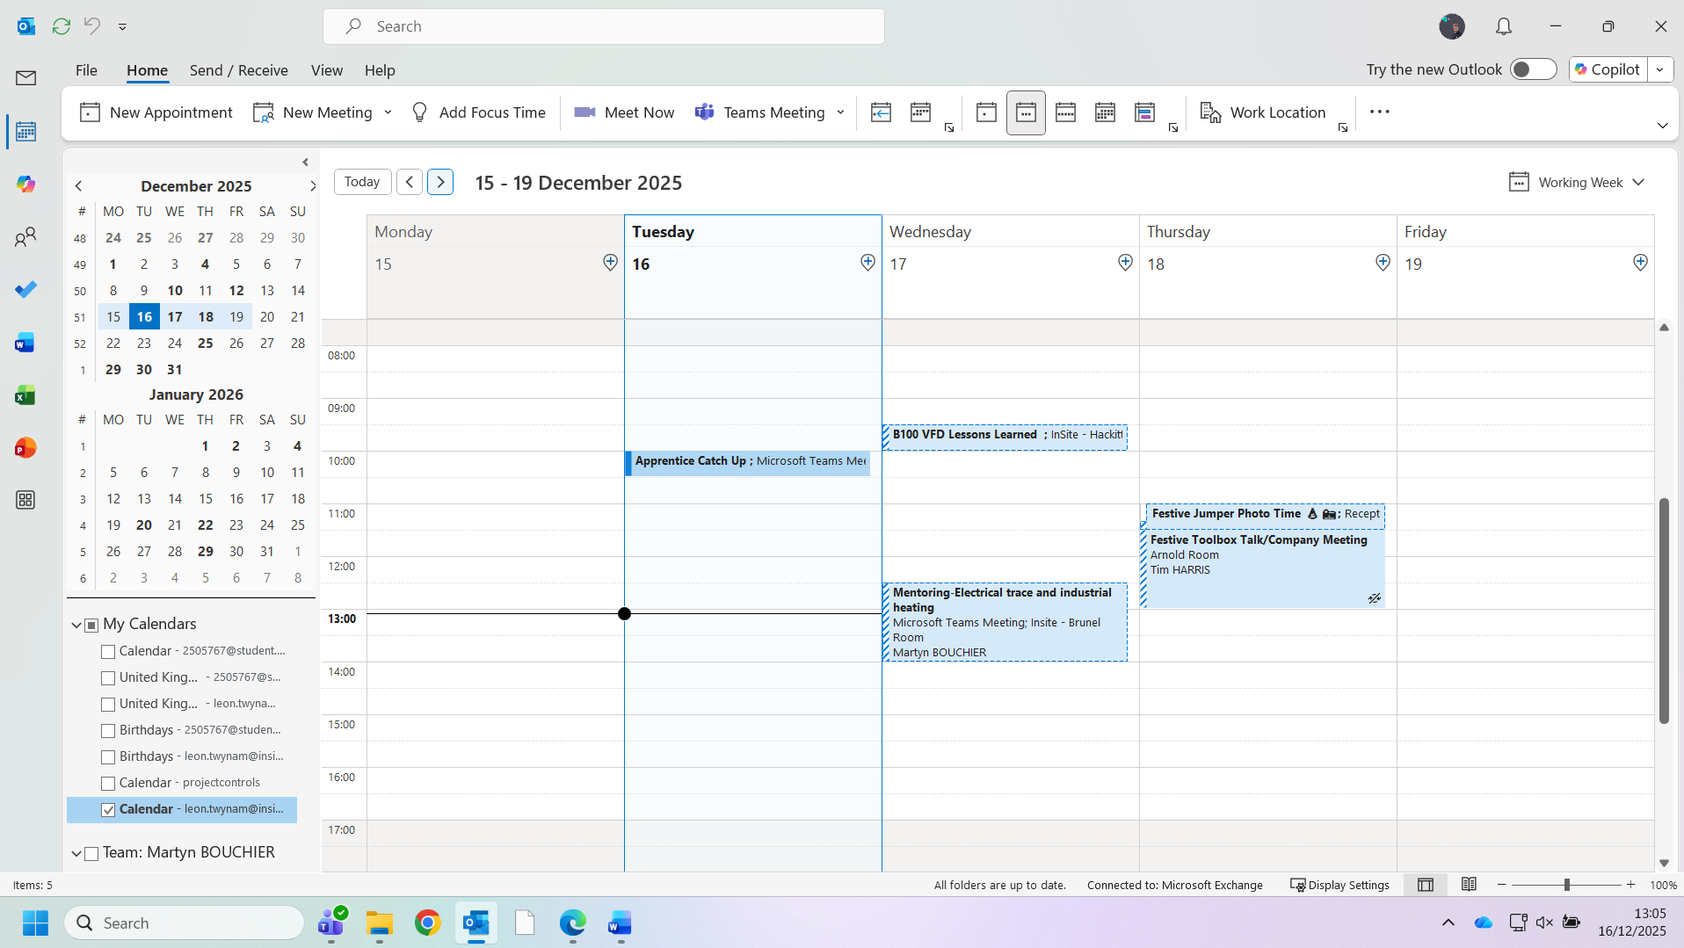
Figure 11: Screenshot of work Outlook calendar
The learner often refers to their work calendar during the week to see ahead of them. This helps them to manage their time during the week, such as when to do work, when to do university work, and to prepare for upcoming events and meetings.

Time management is an important aspect of organisation, and an effective organisation can decrease cognitive overload and improve our working memory [14]. Additionally, research has shown that disorganisation and clutter have a cumulative effect on our brains, and constant visual reminders of disorganisation drain our cognitive resources, reducing our ability to focus [15]. Figures 12 & 13 below are evidence of the learners' organisation of their file explorer area.
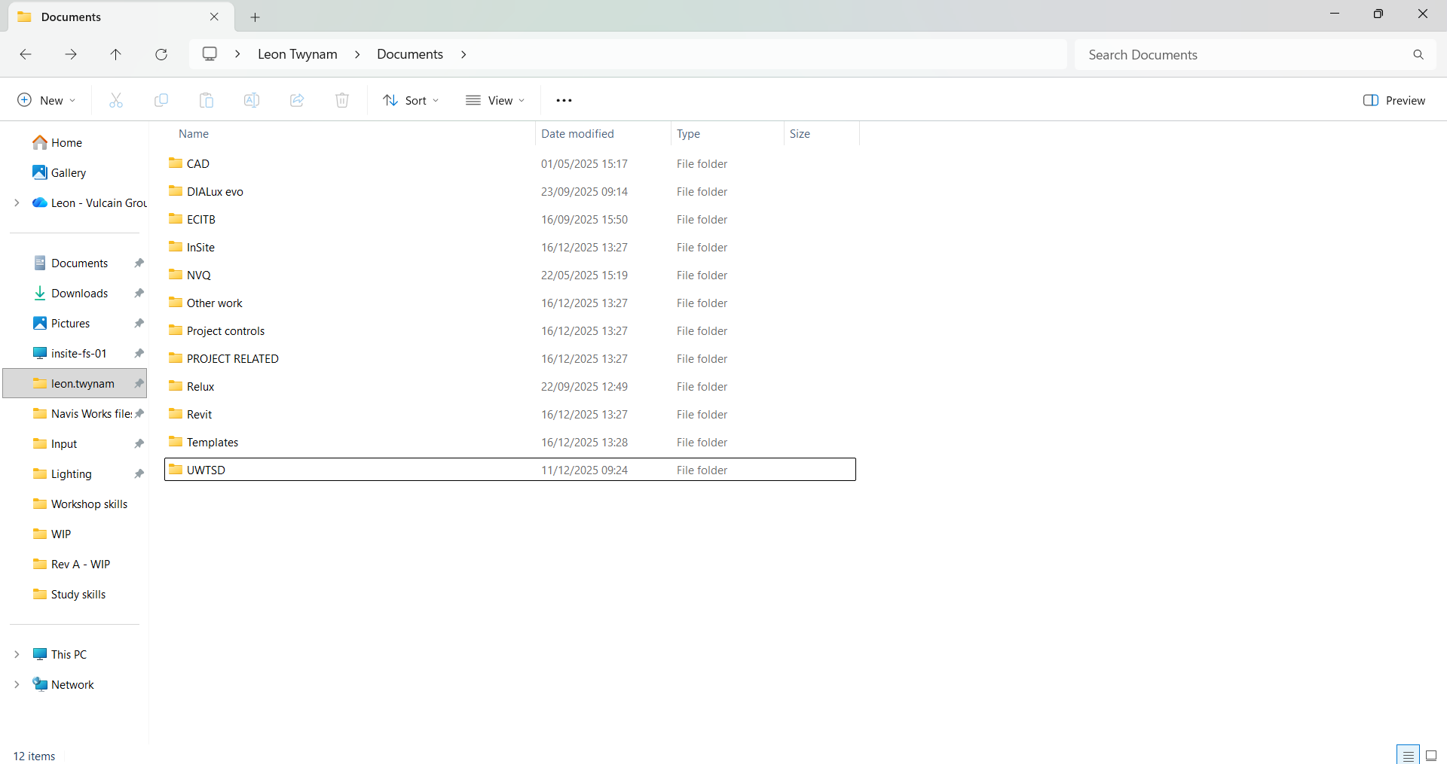
Figure 12: Screenshot of the organisation of the documents area on the learner's work laptop
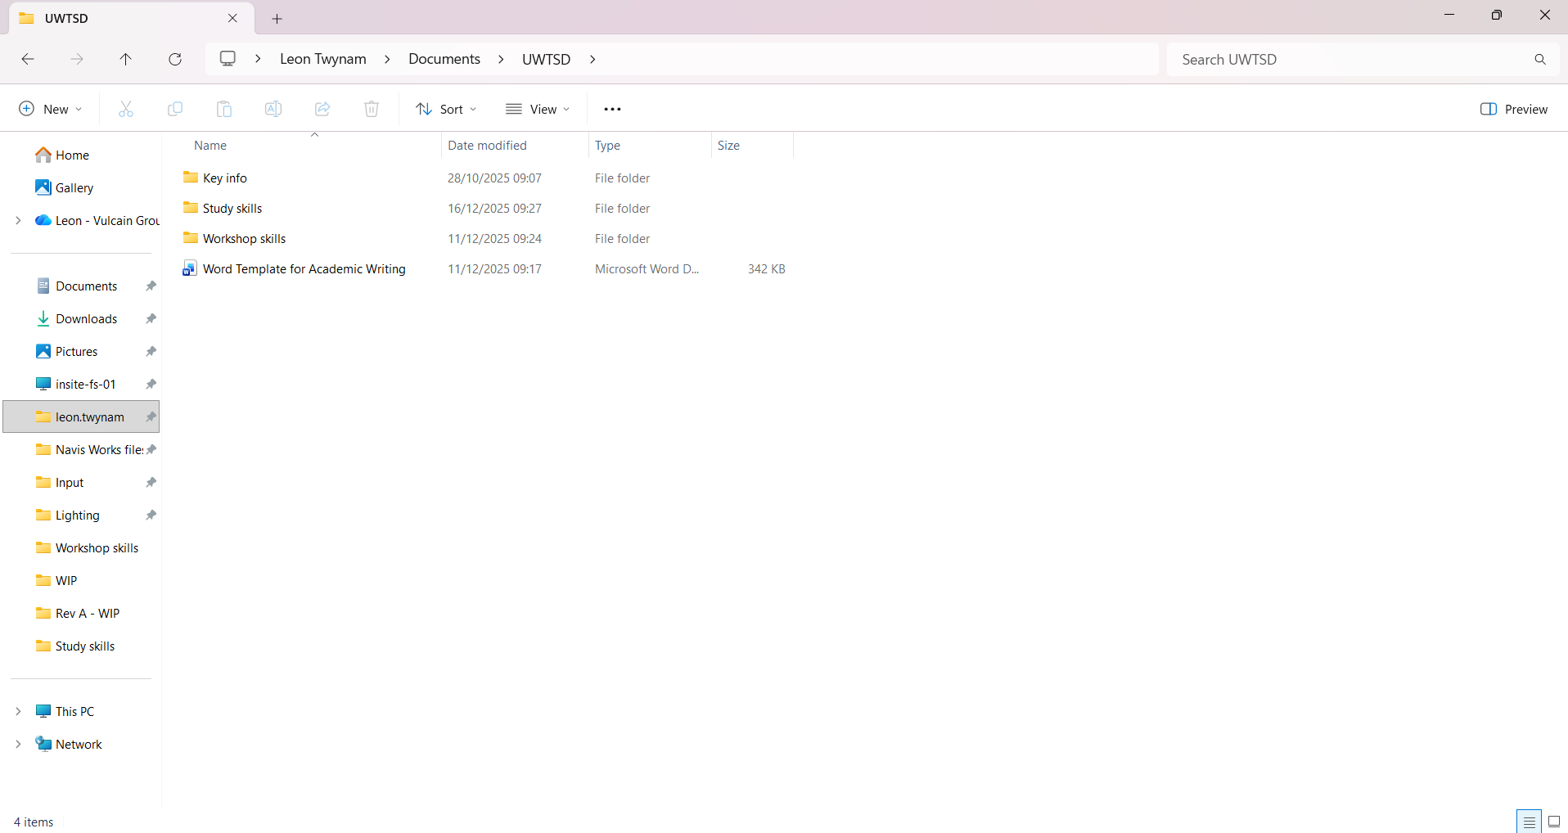
Figure 13: Screenshot of the organisation of subfolders
Figures 12 & 13 display the learners' current organisation of their file area and pinned files on the left-hand side. The benefit of this is that the learner has a system for finding specific documents and can access specific files quickly from the pinned section on the left.

Professional development plan (PDP)
A professional development plan is a widely used tool for planning goals and tracking the progress of those goals. In class, the learner created their own PDP containing personal, career, and academic goals, which can be seen in Figures 14 & 15 below.
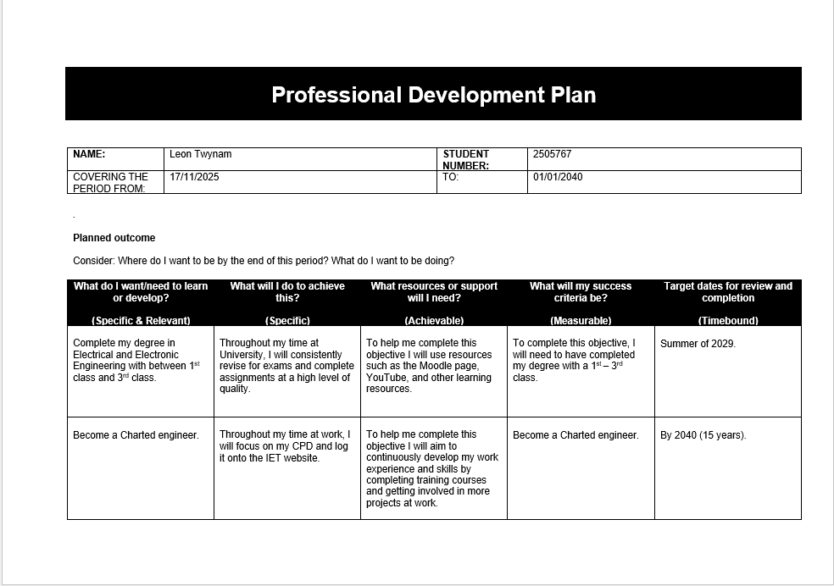
Figure 14: 1st page of learner's PDP
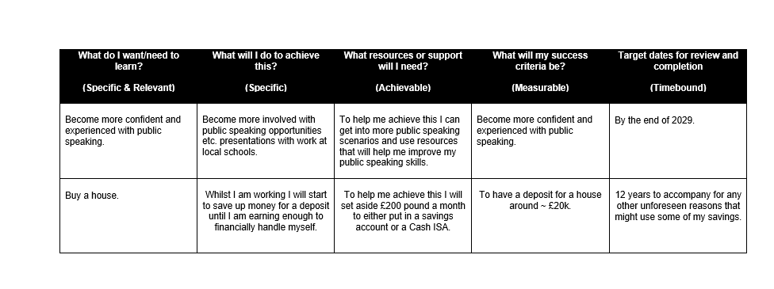
Figure 15: Page 2 of learner's PDP
As can be seen in Figures 14 & 15 above, the learner has completed a PDP containing personal, academic, and career goals. These have also been structured as SMART goals to prevent them from being vague, unachievable, etc. This method has allowed the learner to keep track of their goals and compare progress against them.

Conclusion & Evaluation
To conclude, the author of this document has learnt a lot about themselves and the topics included in this module. During the ice breaker presentation task, the author learnt that they would like to improve their public speaking skills and that there are several ways to do so. Whilst researching in this module, the learner has also gathered that the skills required in a higher education environment are mostly transferable to those employers look for in prospective job candidates.
The learner has also grasped the importance of looking after data and the dangers of ransomware. They have also been made aware of the importance of time management and self-organisation, and how they are linked to each other. The author was particularly interested in the research they conducted on ransomware and would consider further investigation into other types of malware and how individuals can protect themselves from them. Another area that sparked interest for further study and consideration was time management and organisation, the benefits of it, and the techniques used.

References
[1] R. Needleman, “What Are The 6 Essential Skills For University Students?,” UniAdmissions: The Oxbridge Experts, Jun. 30, 2021. https://www.uniadmissions.co.uk/application-guides/6-essential-skills-for-university-students/ (accessed Dec. 12, 2025)
[2] K. Walton, D. Murano, J. Burrus, N. Daley, and J. Mcvey, “Essential Skill Development in Higher Education: Student and Staff Perspectives,” 2025. Accessed: Dec. 12, 2025. [Online]. Available: https://files.eric.ed.gov/fulltext/ED673815.pdf
[3] Expert Panel, “20 Transferrable Skills Employers Should Prioritize When Hiring,” Forbes, Mar. 03, 2025. https://www.forbes.com/councils/forbesbusinesscouncil/2025/03/03/20-transferrable-skills-employers-should-prioritize-when-hiring/ (accessed Dec. 15, 2025).
[4] A. Augustine, “Top Transferable Job Skills Employers Look for in Candidates,” CV Knowhow, Feb. 22, 2016. https://cvknowhow.co.uk/career-advice/top-job-skills-employers-look-for (accessed Dec. 15, 2025).
[5] 123Test, “Team Roles Test,” 123test.com, May 12, 2023. https://www.123test.com/team-roles-test/ (accessed Dec. 15, 2025).
[6] Truity, “TypeFinder® Personality Test,” Truity, 2025. https://www.truity.com/test-results/typefinder/18720/67685264 (accessed Dec. 15, 2025).
[7] “My Personality Max Report,” personalitymax.com, Jan. 24, 2018. https://personalitymax.com/report/?mi=53-63-47-67-53-70-47-53 (accessed Dec. 15, 2025).
[8] “Color Personality Test: What Color Are You?,” 365 Tests. https://365tests.com/personality-tests/free-color-personality-test/ (accessed Dec. 15, 2025).
[9] “Career Test: What Career is Right for Me Quiz? [Free],” Coursera, 2025. https://www.coursera.org/resources/career-quiz?msockid=08d87c87db7a6f750455690bda5d6e0a (accessed Dec. 15, 2025).
[10] C. Sidoruk, “Chris Sidoruk Media,” Chris Sidoruk Media, Aug. 18, 2022. https://chrissidorukmedia.com/blog/digital-backups-3-2-1-rule (accessed Dec. 16, 2025)
[11] M. Kosinski, “Ransomware,” IBM, Jun. 04, 2024. https://www.ibm.com/think/topics/ransomware (accessed Dec. 16, 2025).
[12] D. Pearson, “The ‘3-2-1’ backup rule is still key to modern cybersecurity,” Data Centre Review, May 28, 2025. https://datacentrereview.com/2025/05/the-3-2-1-backup-rule-is-still-key-to-modern-cybersecurity/ (accessed Dec. 11, 2025).
[13] B. E. Team, “The Importance Of Time Management And Organizational Skills | BetterHelp,” Betterhelp.com, Mar. 16, 2024. https://www.betterhelp.com/advice/time-management/how-time-management-skills-and-organizational-skills-are-related/ (accessed Dec. 16, 2025).
[14] L. Sander, “What does clutter do to your brain and body?,” NewsGP, Jan. 25, 2019. https://www1.racgp.org.au/newsgp/clinical/what-does-clutter-do-to-your-brain-and-body (accessed Dec. 16, 2025).
[15] S. McMains and S. Kastner, “Interactions of Top-Down and Bottom-Up Mechanisms in Human Visual Cortex,” The Journal of Neuroscience, vol. 31, no. 2, pp. 587–597, Jan. 2011, doi: https://doi.org/10.1523/JNEUROSCI.3766-10.2011.

Appendices
Appendix A – Self-evaluation personality types

- Self-evaluation personality types

Table of Figures
Figure A - 1: Screenshot of Myers-Briggs personality types [A-1] 28
Figure A - 2: Screenshot of all multiple intelligence types [A-2] 29
Figure A - 3: Screenshot of colour personality types [A-3] 30

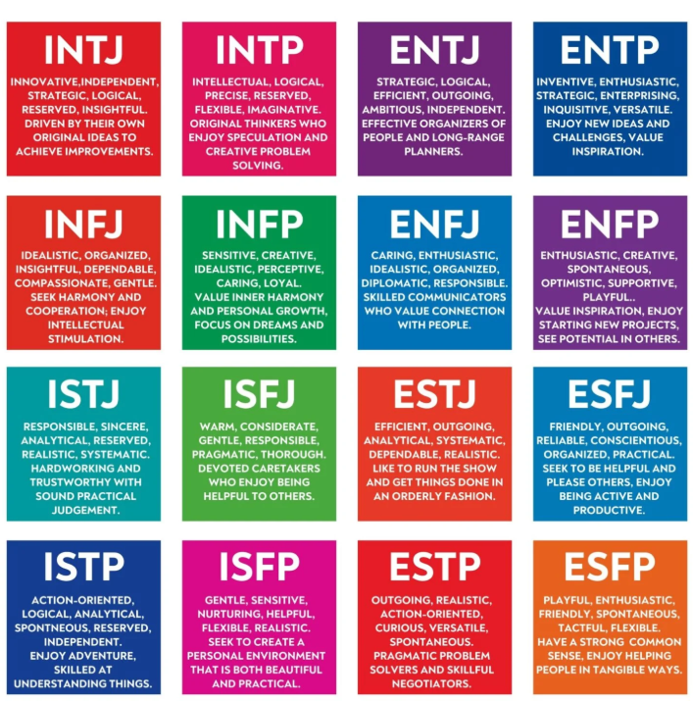
Figure A - 1: Screenshot of Myers-Briggs personality types [A-1]
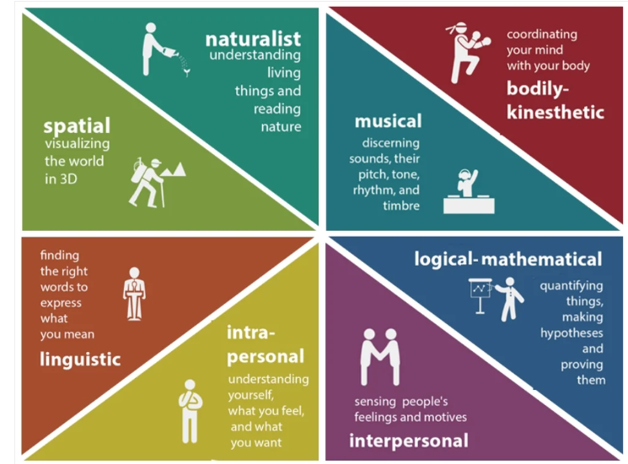
Figure A - 2: Screenshot of all multiple intelligence types [A-2]

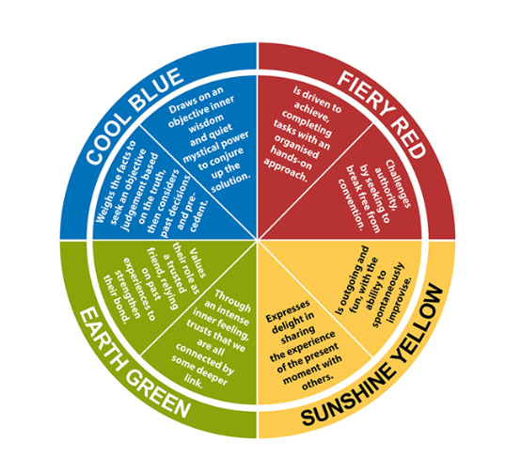
Figure A - 3: Screenshot of colour personality types [A-3]

References
[A-1] J. Simkus, “Myers-Briggs Type Indicator: The 16 Personality Types,” www.simplypsychology.org, Mar. 19, 2025. https://www.simplypsychology.org/the-myers-briggs-type-indicator.html (accessed Dec. 16, 2025).
[A-2] M. Marenus, “Gardner’s Theory of Multiple Intelligences,” Simply Psychology, Mar. 26, 2025. https://www.simplypsychology.org/multiple-intelligences.html (accessed Dec. 16, 2025).
[A-3] smeshnoy, “Insights Discovery 4 Colors, 8 Types & 72-Type Wheel Explained,” Strengths Test, Mar. 21, 2024. https://strengthstest.com/insights-discovery-colors-types-wheel/ (accessed Dec. 16, 2025).

