Title:5OS01 Specialist Employment Law

Ffion Evans

Content List: 1.1, 1.2, 1.3, 4.1, 4.2, 4.3, 4.4, 2.1, 2.2

Task 1

(AC 1.1) Evaluate the aims and objectives of employment regulation

In more recent years it has become vital for HR managers to maintain a good working knowledge of employment law. This is because employment law cases have increased significantly over the years. Due to this there are many situations where managers decisions and lack of oversight is leading to employees, ex-employees and failed job applications being challenged and an employing organisation is being brought to a court or employment tribunal. (Human Resource Management,2016)

Employment regulation is also known as employment law. The purpose of employment law is to regulate the relationship between the employer and employee. Employment law enforces rules and sets standards for both the employee and employer, it also provides protection for the employer and employees when unreasonable decisions or behaviour might occur. (CIPD) It governs what employers can expect from employees, what employers can ask employees to do, and employees’ rights at work. Having extensive employment regulations will help balance the power between employees and employers, deter employers from exploiting their powers unreasonably. There are some reasons against employment law. It raises unemployment and slows the economic growth; it deters inward investments and raises cost for employers and can make our economy less competitive internationally. (Introduction to Employment Law,2019)

Employment law can be divided into two categories, one concerning an employee and their respective rights and obligations, and secondly the concerning employer’s rights and obligations. (Introduction to Employment Law,2019). In employment law a contract is made between the employer and the employees, consisting of a number of obligations on both sides of the agreement. If one of those obligations is breached in some way, there can be a dispute under the law of contract.

There are many Legal requirements that come under employment law to regulate the relationships between employee and employer and what they can expect from one and other. These will help achieve inclusion and fairness and protect against unjust.
Please see some of these regulations below:
- Recruitment; the terms and conditions of employment.
- Data protection.
- Holidays Pay.
- Working hours and pay.
- Health and safety regulations.
- Maternity and parental rights.
- Discrimination.
- Grievance and dismissal procedures.
- Whistleblowing.
- Redundancy. (CIPD,2021)

(AC 1.2) Examine the role played by the tribunal and courts system in enforcing employment law

In the UK most employment law cases are categorised as civil or private law. This means that one party (claimant/employee/former employee) uses the court and employment tribunal system to sue another (respondent/employer) as they have (CIPD,2021) (CIPD, 2021) caused them detriment and has done so in contravention of the law.
The civil court system is hierarchical. This allows the losing party to appeal the decision of the employment tribunal to the EAT. Before 1998 employment tribunals would have been called “industrial tribunals”.

Process of employment Tribunal
- ACAS Early Conciliation
- ET1
- ET3
- Preliminary Hearing
- The hearing
- The judgment
- Review decision (CIPD,2021)

If an employee feels they have been unfairly treated, they are able to raise a tribunal claim against their employer. Before an employee is allowed to raise a tribunal claim, they must contact ACAS to try and resolve the dispute through an early conciliation process.
There are some exertions to this:
- If the claim is against the secret service
- Another person already has an early conciliation number
- If the claim is against an insolvent employer
- If the claim involves multiple claimants.
(Daniles,2022)
There are over 80 distinct types of claims brought to an employment tribunal for example (Human Resource Management,2016) discrimination of age, religion or beliefs and sexual orientation, paternity leave, rights of an agency worker etc.
When an unfair dismissal case comes to an employment tribunal, it will be up to the employee to prove that they have right to pursue the claim and they have been wrongly treated. The employee will need to prove that the reason for dismissal was correct and lawful. (CIPD,2021) The tribunal simply listens to the evidence presented and makes its decision ‘on the balance of probabilities’.

The civil court system is hierarchical. This enables a losing party to appeal their case to an EAT higher court. There will need to be grounds for arguing that a lower court has either misapplied the law or misinterpreted it in some way. (CIPD,2021) To be able to appeal a case up to a higher civil court it must be on grounds as a question of law. (CIPD,2021) Importantly, when a higher court makes a ruling on a point of legal principle, that then becomes a binding precedent which all the lower courts then must observe when similar cases are subsequently brought before them.
(AC 1.3) Explain how cases are settled before and during formal legal procedures
In many cases an employer and employee will try to resolve disputes in the workplace before proceeding to a formal employment tribunal/court. They will talk to one another, raise the problem informally and try and work out their differences by using private mediation or mediator supplied by Acas. (CIPD, 2021)
When claimants wish to make a claim, first of all they need to inform ACAS of what their aim is by completing an ET1 form (Taylor and Woodhams 2016). When someone informs Acas that they want to make a claim they become ‘the claimant’ and the other person in the dispute will be ‘the respondent’. In the first instance Acas will offer ‘early conciliation’. The benefits of using early conciliation are:
- It is free.
- Confidential.
- Easier and quicker than attending a tribunal.
- It is a voluntary form of resolving a dispute in the workplace. (acas.or.uk)
The purpose of mediation is to minimise employer and the employees’ time and stress of attending court and tribunals. Mediation’s aim is to restore workplace relationships and help the involved parties to continue working together and move forward. (acas.org.uk- settlement agreements) Acas will provide information, advice, training, conciliations and other services for employers and employees to help prevent or restore workplace problems. In some instances, before legal proceedings are fully committed to, and agreement is reached and Acas will write up what was agreed in a settlement called a ‘COT3’. An agreement can also be made by notifying Labour Relations Agency (NI) or notifying the Workplace Relations Agency (ROI). A settlement agreement may be offered by both parties, this will be a legally binding contract that can be used to end the employment relationship agreement. (Hurst, 2019) It is important to note that this doesn’t always result in the termination of an employment contract; it could be that the employer has recognised a grievance raised but they would prefer to come to a quiet result.
There are some differences between a settlement agreement and a COT3. A COT3 is usually much shorter and a simpler process than a settlement agreement, a COT3 is also verbally binding and can be signed by the representatives where a settlement agreement must be signed by both parties before it is binding (acas.org.uk).
If an agreement is not reached a claim to the employment tribunal must usually be made within 3 months less 1 day, this is known as the ‘limitation date’. Once Acas has received the early conciliation notification, the limitation date will be extended so that there is plenty of time for the early conciliation to take place(acas.org.uk).
If a tribunal makes their decision in favour of the claimant and its dependant on the type of claim, the tribunal can decide the following:

- Reinstatement – is when the employee is given their job back
- Re-engagement – is when returning the employee to the same organisation but in a new role
- Compensation - recognition of loss
- And Payment of money that is owing to the employee

Appeals from the employment tribunal can only be based on ‘points of law’ this is when it is believed that the judge has misused or misinterpreted the law, and so will go forward to the Employment Appeals Tribunal (EAT). (Taylor and Woodhams 2016).

(AC 4.1) Explain the major statutory rights workers have in relation to pay

Most employees will have a written or verbal contract. This will state the terms and conditions for both employer and employees. For example, work duties, salary, notice period, holidays. Anyone that is employed will have employment rights to national living wage, equal pay, right to itemised pay statement, sick pay, maternity pay, working time, and so forth.
The National Living wage has been put in place to recommend a wage that will maximise living standards for the lowest paid workers. (Gov.uk,2019)
Current rates are:
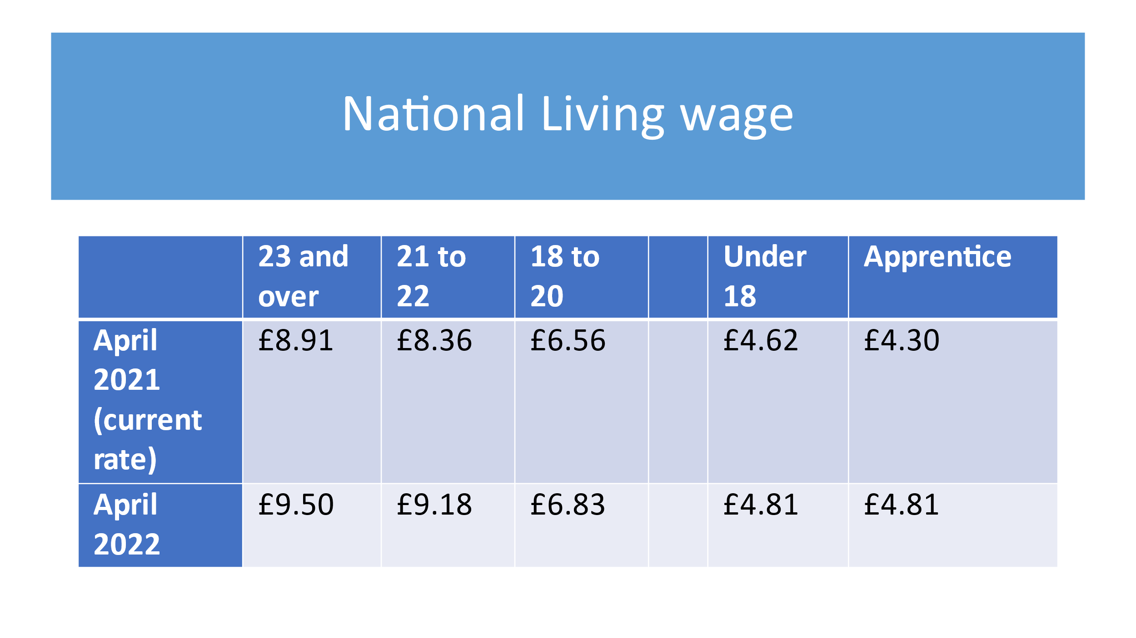
Equal pay is one of the longest established employment regulations and it stipulates those men and woman are paid the same for ‘like work’. The law states that if the work they do is of equal skill, experience, responsibility the job carries then their pay should be the same.

The employer has a legal obligation to provide the employee with a pay slip
(Gov.uk) Your payslip must show:
- your earnings before and after any deductions
- the amount of any deductions that may change each time you’re paid, for example tax and National Insurance
- the number of hours you worked if your pay varies depending on time worked
Sick pay, maternity pay, or paternity have been put in place to ensure that employees who are unable to work for a period of time are paid a reasonable daily rate through their employers’ payroll. Employers can claim back Statutory Maternity pay (SMP) and Statutory Paternity pay (SPP) from the government through reduced National Insurance contributions. (Human Resource Management, 2016)
Currently Statutory Sick Pay (SSP) is paid at £96.35 per week if you’re too ill to work. It’s paid by your employer for up to 28 weeks.

To qualify for statutory sick pay (SSP) you must:
- have been ill or self-isolating for at least 4 days in a row (including non-working days)
- be classed as an employee and have done some work for your employer
- earn an average of at least £120 per week (Gov.uk)

All the Statutory pay is reviewed and revised every year and can change each April depending on inflation.

(AC 4.2) Explain the major statutory rights in leave and working time

The working time directive regulation 1998 is a piece of legislation introduced by the European Union to lay down the minimum conditions relating to weekly working time. It was implemented to make sure individuals don’t work too many hours, take holidays, adequate rest periods in the interest of their health and safety and to prevent accidents happening in the workplace. (Introduction to Employment Law,2019)

The current basic rights and protection provided to employees within WRT regulations are the following (CIPD.2021)

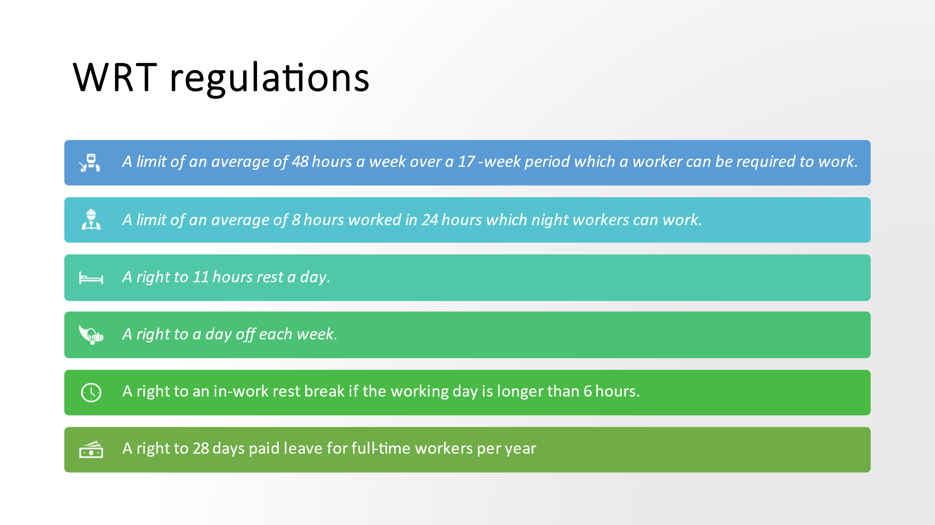
There are some provisions to night working staff and young workers:

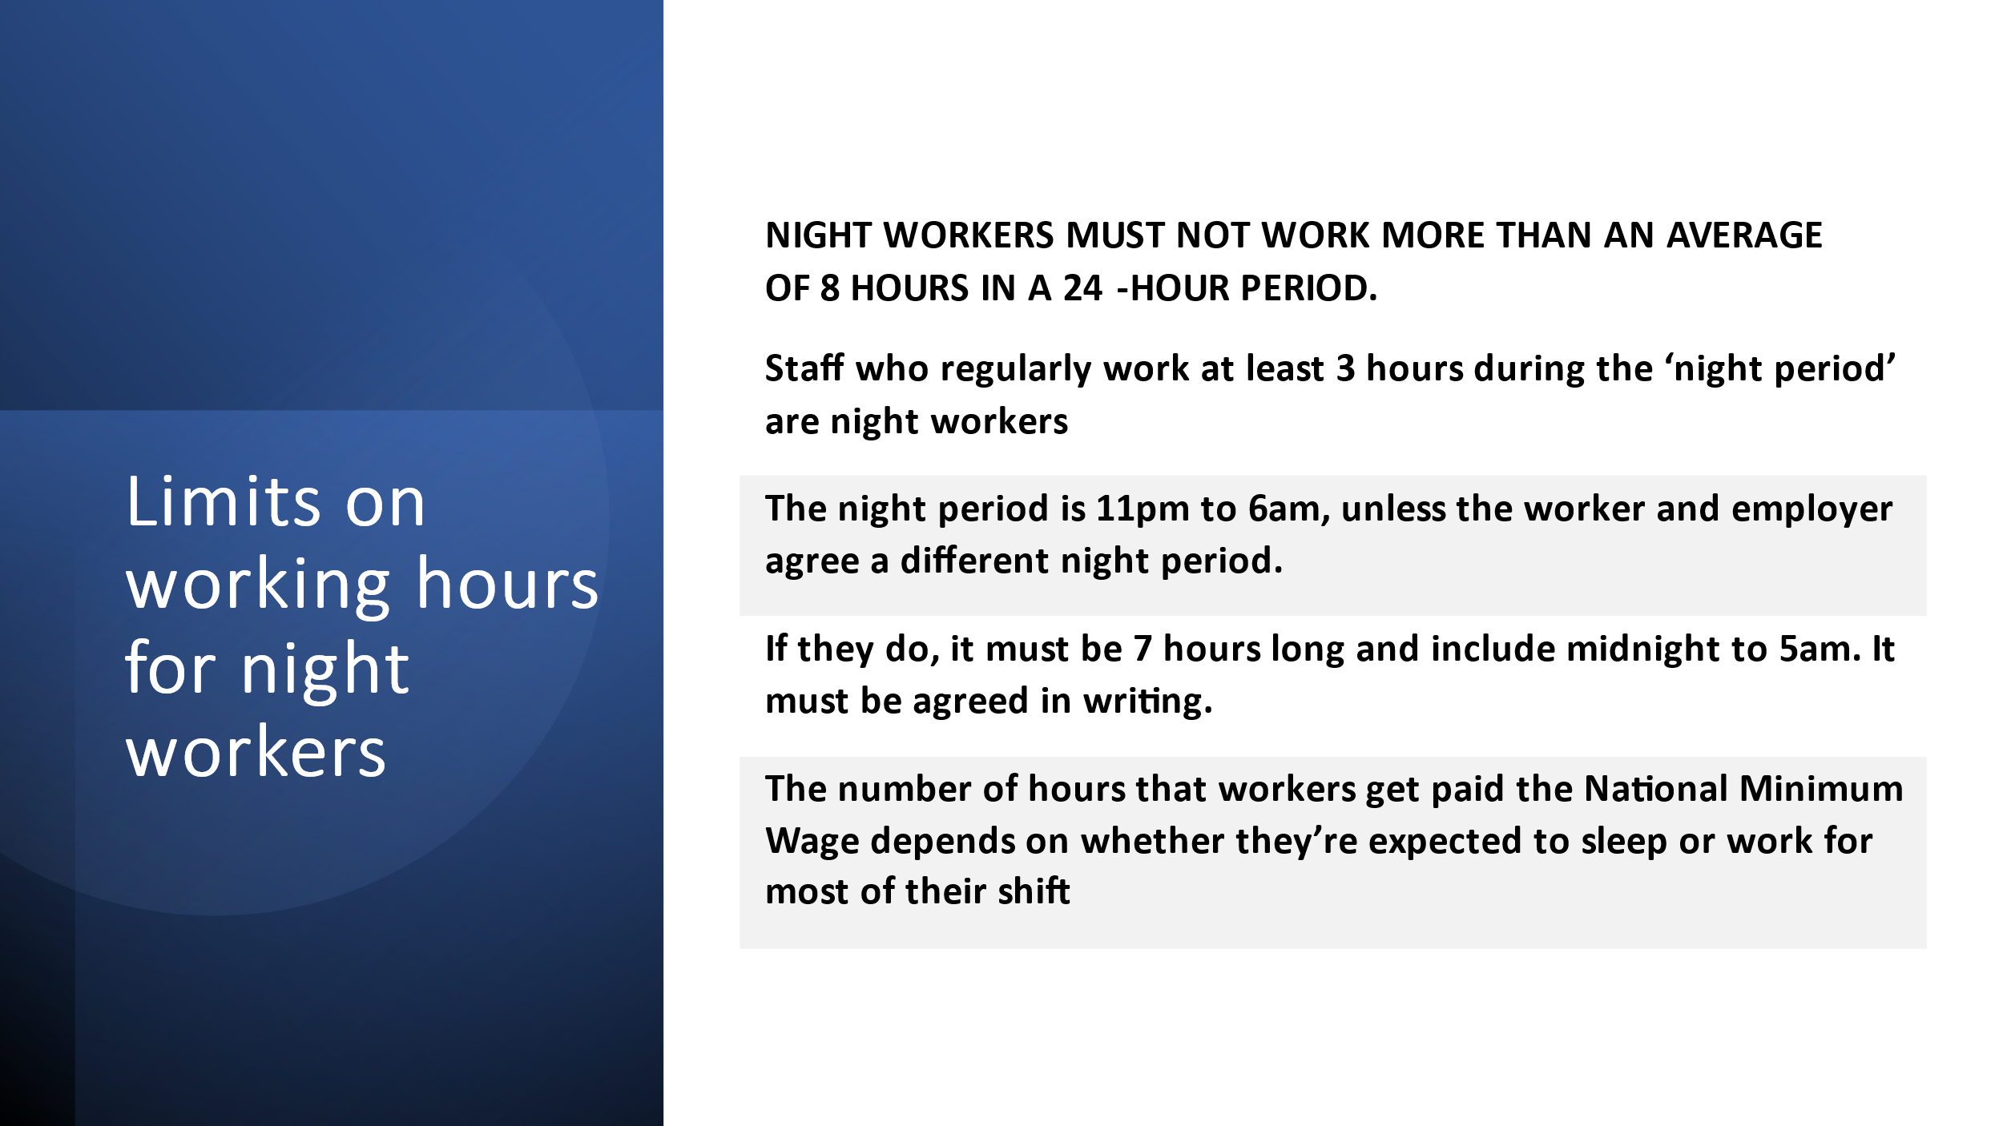

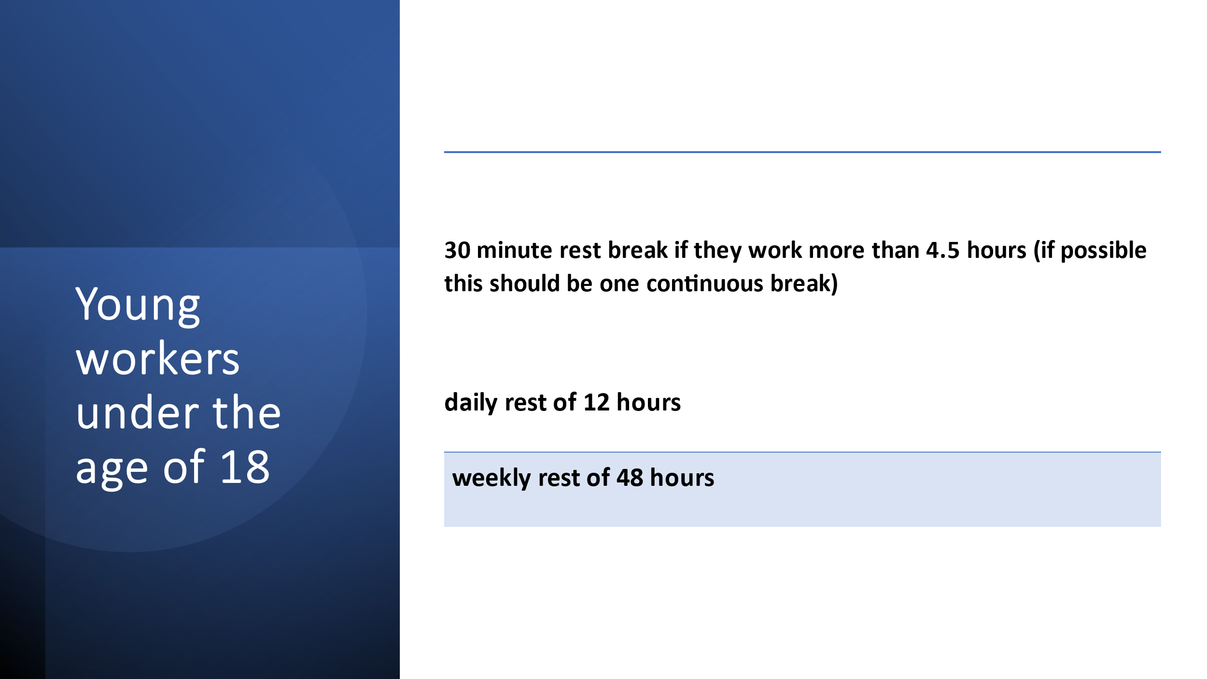

There is an option for employers to ask employees to opt out of the WRT if the staff agree to working more than 48hrs per week. Employers cannot force employees to opt out, workers must agree and not be dismissed if refusing to agree.
The right to 28 days statutory annual leave (this will be calculated pro rata) and may also include the 8 bank holidays (CIPD.2021). When and employee takes annual leave is an agreement between the employee and employer through application and approval. Employers must be careful when calculating annual leave for employees that have commission or overtime payments elements to their pay or have been off on long-term sick or maternity leave.

(AC 4.3) Explain the main principles of maternity, paternity and adoption rights in the context of employment rights.

Maternity leave consists of three parts however, not everyone is entitled to all three:
- Ordinary maternity leave (OML)
- Compulsory maternity leave (CML)
- Additional maternity leave (AML).
OML is a six-month (26 weeks) period of maternity leave that applies only to employees with no length of service.
CML is very straight forward. It is when a woman has given birth. She must not return to work for the first two weeks after childbirth.
AML is offered to employees, and it runs for 26 weeks following on from the OML.

SMP Statutory maternity pay is payable by the employers, for a period of 39 weeks, to pregnant employees who have worked for that employer for at least 26 continuous weeks at the fifteenth week before the expected week of childbirth.
Currently Maternity Pay (SMP) is paid for up to 39 weeks. (Human Resource Management, 2016)
- 90% of your average weekly earnings (before tax) for the first 6 weeks
- £151.97 or 90% of your average weekly earnings (whichever is lower) for the next 33 weeks
Paternity Pay is paid at the statutory rate of £151.97 per week, or 90% of your average weekly earnings (whichever is lower). Taylor and Woodhams (2016) state that father of new-born babies also have a statutory right to take ordinary paternity leave (OPL). The qualifying eligibility and details are as follows (GOV.UK)
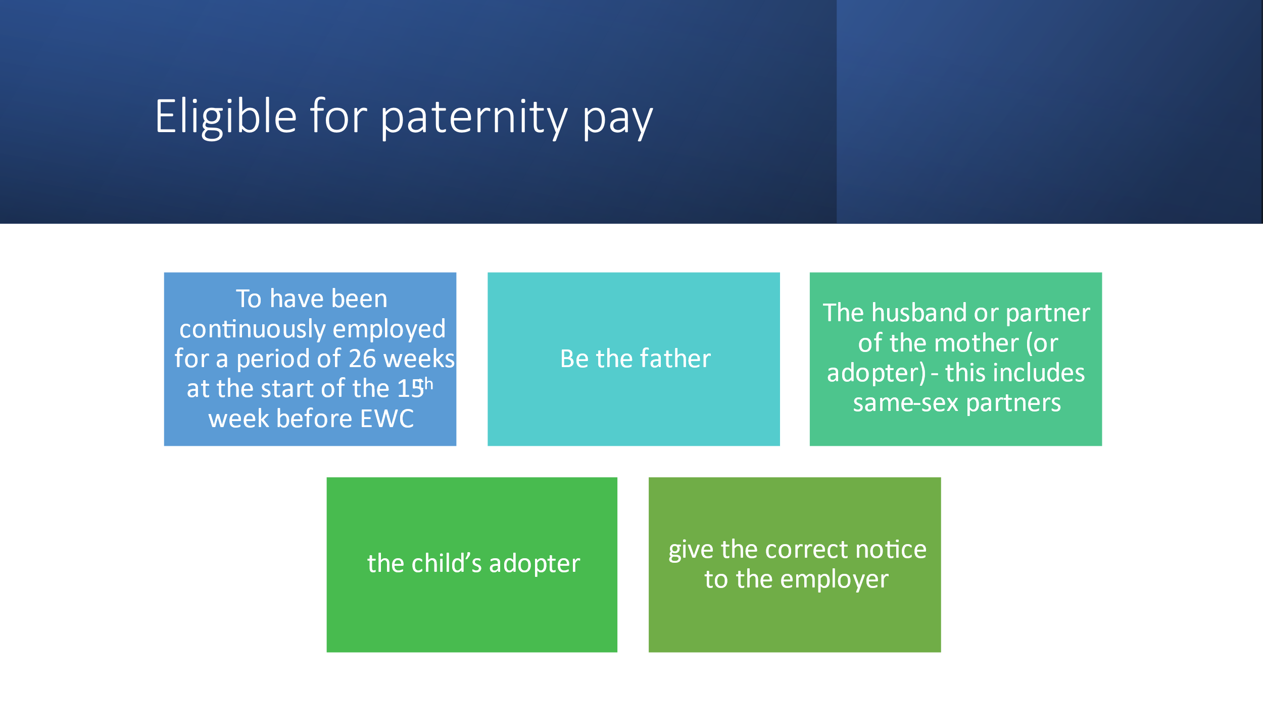
Shared parental leave (SPL) could also be applicable in some circumstances. Shared paternity leave is when employed mothers can change some of their SML.SMO into SPL and shared the parental pay if both parents meet the criteria below:
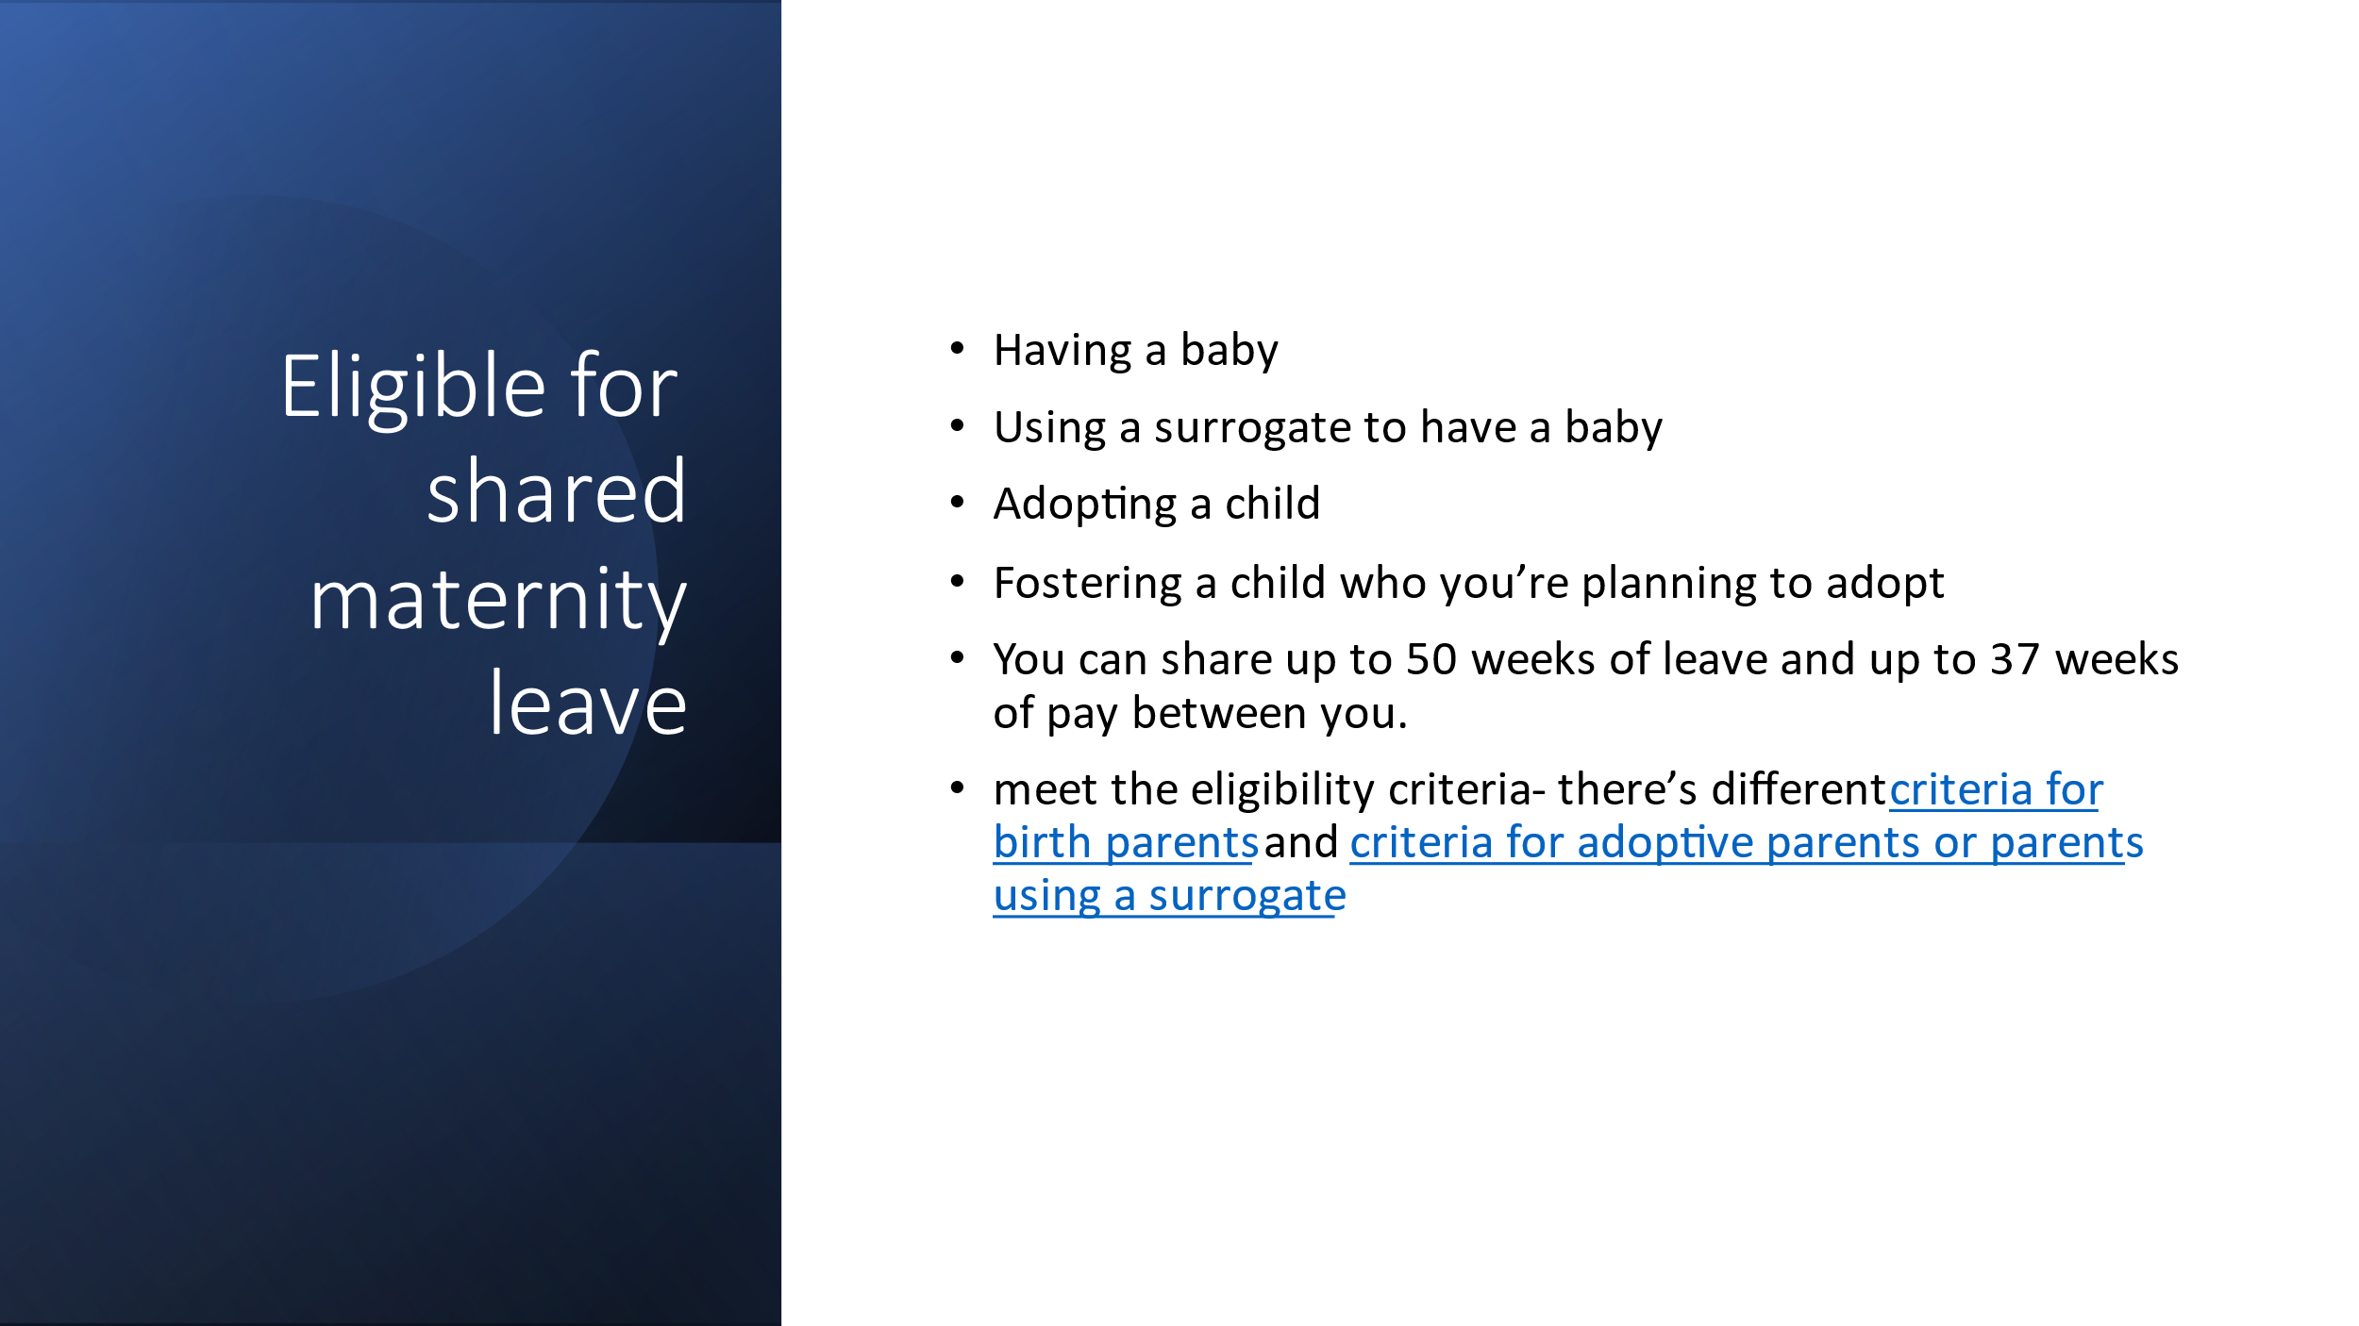

Since 2007, employers have gained the right to maintain reasonable contact with employees that are on maternity leave. This has been put in place that those employers and employees keep in contact about the return to work. Employees can come to work for 10 Keep in touch days (KIT) that are optional. Shared paternity leaves in touch days (SPLIT), employee can work up to 20 days during SPL without bringing it to an end. These days are in addition to the 10 KIT days.
Also, employees should be kept up to date with any important learning and development and any relevant promotions or job opportunities that arise during the maternity leave.

(AC 4.4) Explain other employment rights relating to flexible working

There is further family friendly employment rights in addition to being able to take leave for maternity, paternity and adoption leave. These include the right to take unpaid time off work to deal with a family emergency, the right to request flexible working. (Human Resource Management, 2016)

After 6 months (26 weeks) of working for an employer, an employee has the right to submit a request for flexible working application. An employee is allowed to make one request to work flexibly each year. The Flexible working hours could include working flexitime, staggering hours, school hours, home working, working shifts or job sharing. It is important to remember that it does not matter for what reason the employee is requesting flexible working, the reason is not relevant. (Introduction to employment law, 2019)
The employee must write to his/her employer requesting a change to flexible working and must explain and set out why the request is being submitted.
- the date of the application
- the nature of the change being sought, and when the employee wants this to take effect
- the effect that they think the change will have on the employer, and how this effect could be addressed
- that the request is a statutory request
- whether they have previously made a similar request, and if so when.

Once and employer has received a flexible working request it is important for them to arrange a meeting to discuss it. An employer must decide within three months of receiving the application. If the change is agreed, it must be specified in writing, and it will be a change of contract. It is important for the employee to realise that this is a permanent change and cannot just be reverted to the previous contract. If the request is refused the employee may appeal the decision. If the appeal is again refused this must be given in writing. If the employee’s request is still turned down, the employee can refer the issue to an Employment Tribunal.
An employer has the right to turn down a flexible application on the below grounds:
- burden of additional cost
- having a detrimental effect on fulfilling customer needs
- an inability to reorganise work among existing staff
- an inability to recruit additional staff
- detrimental impact on performance(acas.org.uk).

If an employer turns down an application, it is very important to look at alternative options that could work for the employee and staff member. Not resolving this could lead to the employee resigning.

(AC 2.1) Evaluate the principles of discrimination law in recruitment, selection and employment

There are three main types of staff who have entered a contract of employment through a recruitment process. To determine the type of workers we would need to see what is in the written contract. There are employees who have a contract of employment (ERA 1966), worker, who is contracted under another contractor where that individual agrees to personally perform work or service for another party, and self-employed.

It is important for employers to keep up to date with their legal obligations when recruiting staff. It is important their recruitment process comply with employment law. Managers need to ensure not only that they treat everyone fairly, but also that they are seen to do so. The main areas law affects the recruitment and selection process includes, discrimination, the right to work in the UK, criminal records, and data protection. (CIPD, Recruitment)

The Equality Act 2010 protects employees, workers, job applicants and ex-employees against unfair discrimination for the following people with protected characteristics:

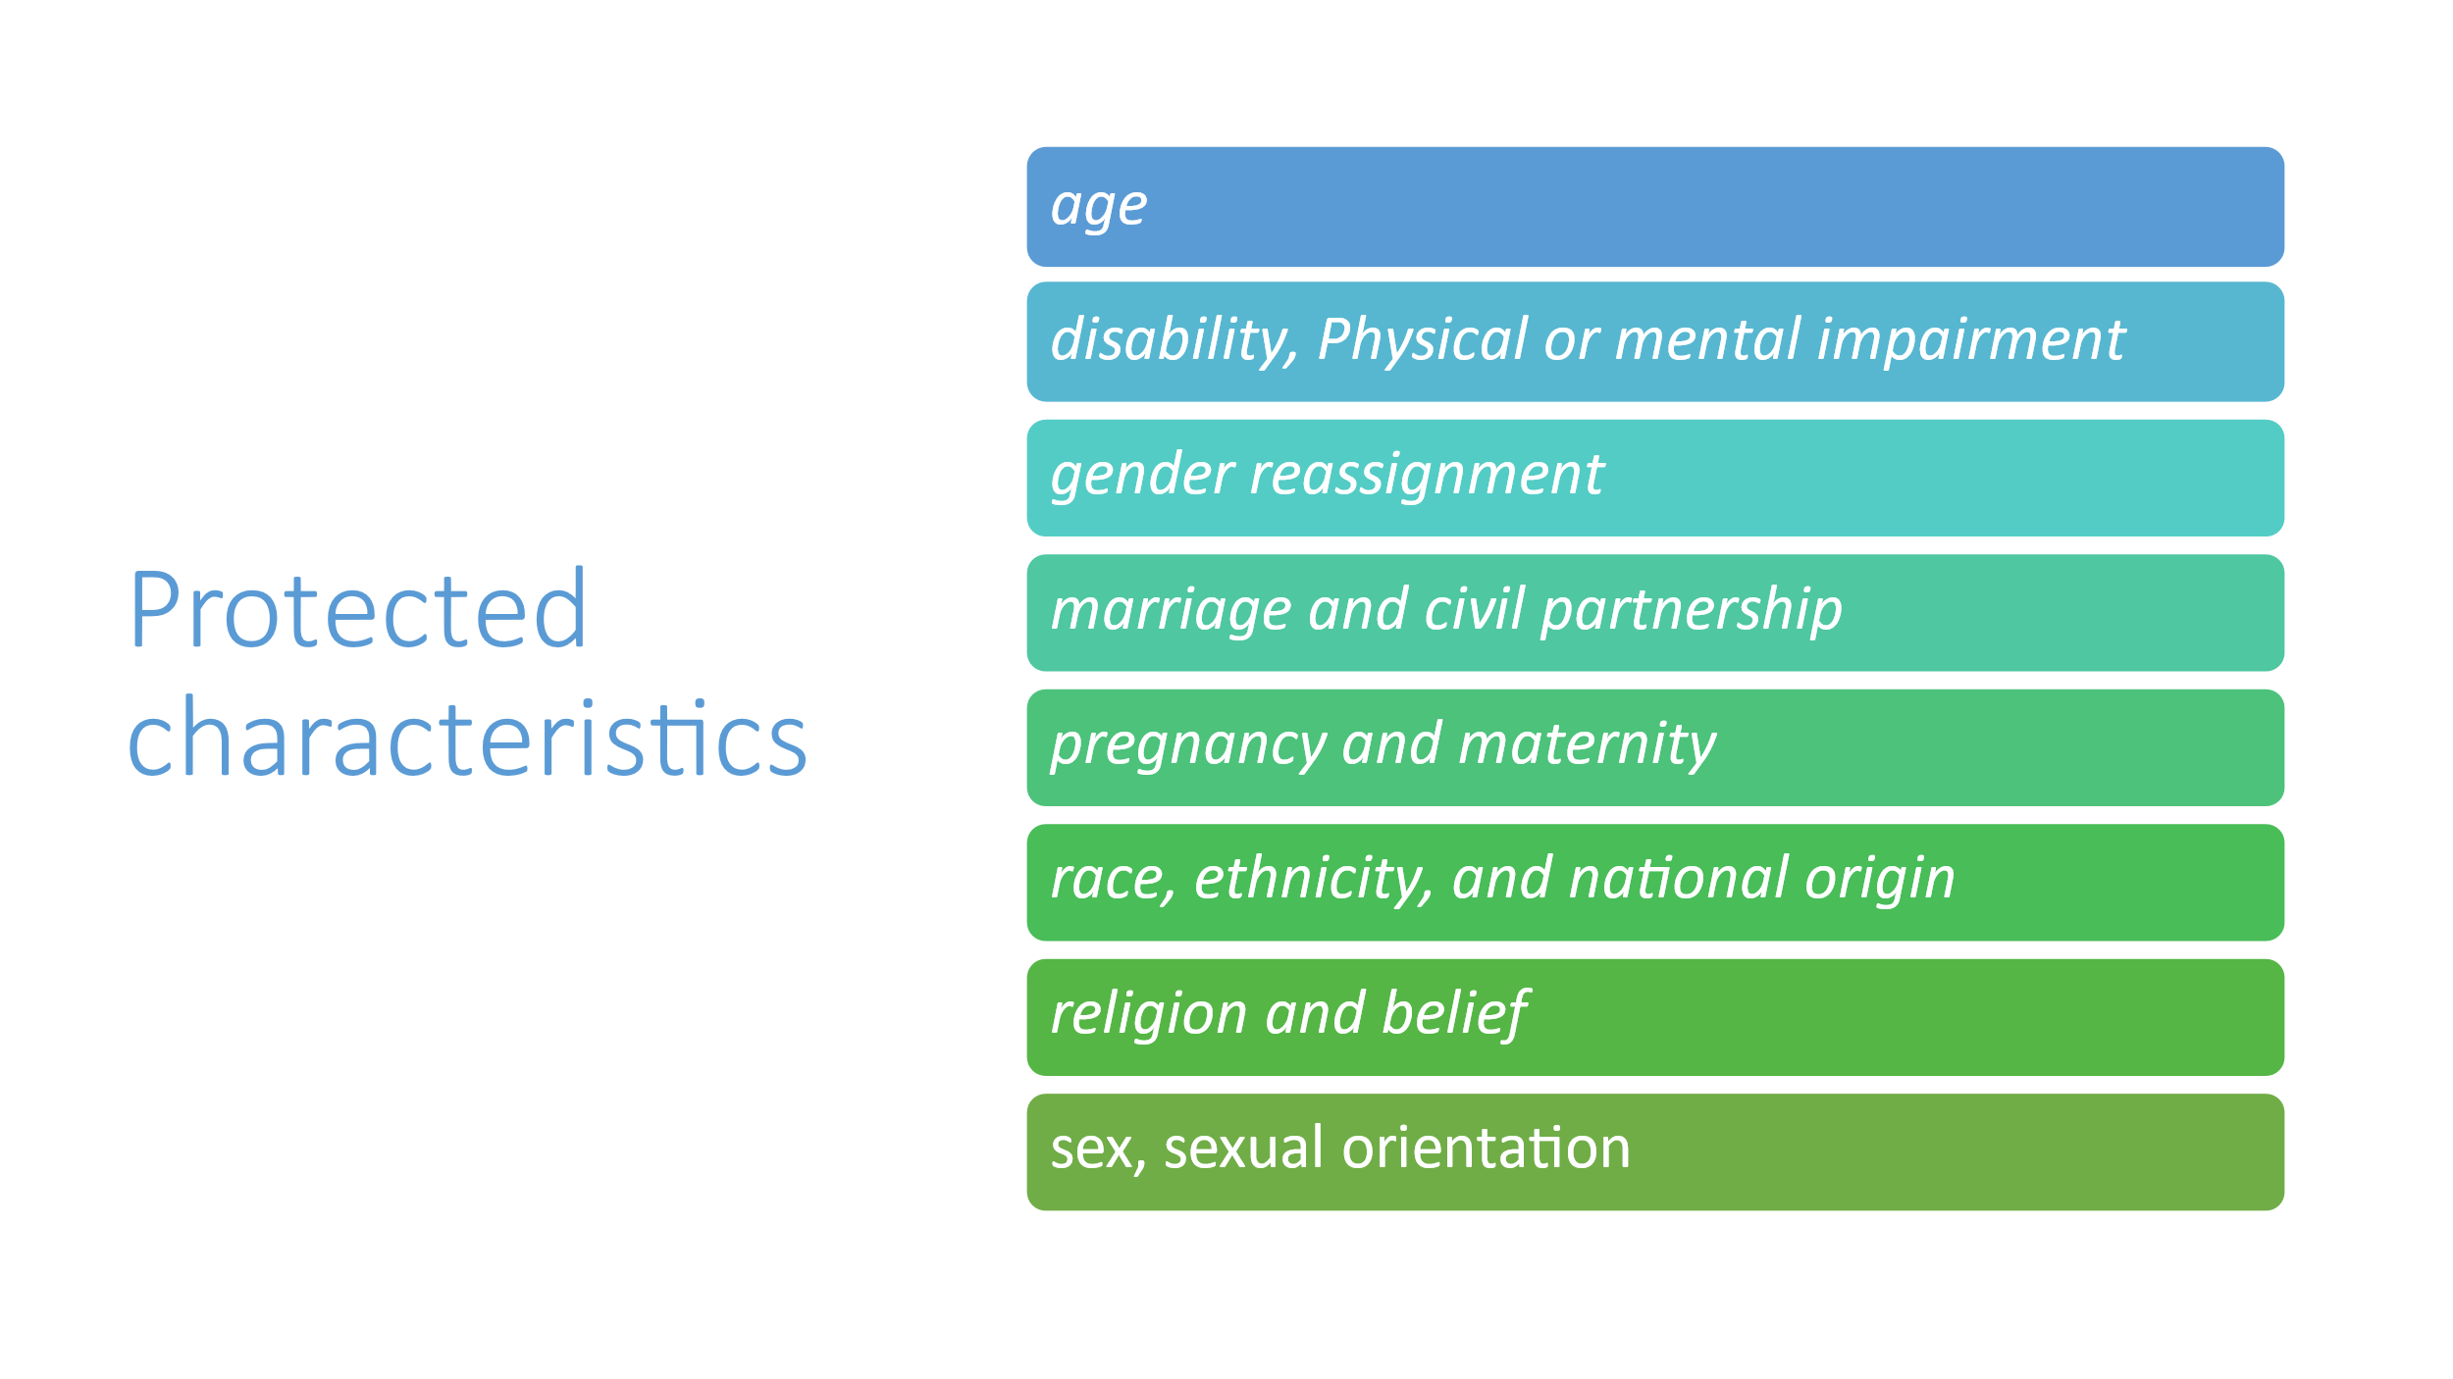
(Human Resource Management, pg29)

To ensure that an organisation’s recruitment and selection process is lawful, HR professionals need to understand key areas which could have an effect. HR need to understand and adhere to their legal obligations including the Equality Act (2010).

There are several types of discrimination, associative, perception, harassment, victimisation, direct and indirect discrimination and failure to make reasonable adjustments.
Direct and indirect discriminations. Direct discrimination occurs at the recruitment stage when an individual with a protected characteristic, B is treated less favourable than A would treats others.
(Acas,2020) Indirect discrimination can happen when there are rules or arrangements that apply to a group of employees or job applicants, but in practice are less fair to a certain protected characteristic.

(AC 2.2) Discuss the legal requirements of equal pay

(Armstrong Handbook,2020 pg607) The Equal Pay Act 1970 ended the previous common practice of employers paying men and women different amounts of money for doing jobs that were either the same or very similar. The relevant law is now found in Equal pay and is regulated by the Equality Act 2010. The equality act 2010 makes sure that women and men have the right to equal pay, where women and men are legally entitled to be paid at the same rate of like work. Work rated as equivalent analytical job study and work for equal value. Equal pay applies to employees, workers, apprentices, (CIPD,2021)
Agency workers, full time, part time and temporary contracts and self-employed that are hired to do the work.
In some circumstances a difference in pay or other terms and conditions might be allowed for instance, if the person is better qualified than others and has skills that are crucial for the job role, or they do night shifts and unsociable hours. Location can also be a factor, for example in London where living costs is higher

Equal pay law applies to pay and terms of conditions of employment including:
- salary
- wages
- pension
- working hours
- annual leave allowance
- holiday pay
- overtime pays/ non-discretionary bonuses
- redundancy
- sick pay
- performance related pay
- staff benefits.
(Acas.gov.uk)

(acas.org.uk) By law, employers must not pay an employee less, or give them terms and conditions that put them at a disadvantage, because of their disability, race, religion, sexual orientation or another 'protected characteristic'.

Bibliography

Works Cited
ACAS. “Acas | Making Working Life Better for Everyone in Britain.” Acas.org.uk, 2019, www.acas.org.uk/.
Acas. Settlement Agreements. 2018.
CIPD. “Employment Law | CIPD.” CIPD, 2019, www.cipd.co.uk/knowledge/fundamentals/emp-law.
---. “Working Hours & Time off Work | Factsheets | CIPD.” CIPD, 2019, www.cipd.co.uk/knowledge/fundamentals/emp-law/working-time/factsheet.
Daniels, Kathy. “BibliU - Reader.” Bibliu.com Introduction to Employment Law, 15 Mar. 2016, bibliu.com/app/#/view/books/9780749484156/epub/content/12_chapter01.html#.
---. Introduction to Employment Law : Fundamentals for HR and Business Students. London, United Kingdom ; New York, Ny, Usa, Kogan Page Limited, 2019.
---. Introduction to Employment Law : Fundamentals for HR and Business Students. London, United Kingdom ; New York, Ny, Usa, Kogan Page Limited, 2019.
Government Digital Service. “Employment Rights and Pay for Interns.” GOV.UK, 9 Oct. 2012, www.gov.uk/employment-rights-for-interns.
Taylor, Stephen. “UK Court System & Employment Law | Factsheets.” CIPD, 25 Mar. 2021, www.cipd.co.uk/knowledge/fundamentals/emp-law/about/uk-court-system-factsheet#:~:text=The%20claimant%20uses%20the%20court%20and%20employment%20tribunal.
---. “UK Court System & Employment Law | Factsheets.” CIPD, 28 June 2019, www.cipd.co.uk/knowledge/fundamentals/emp-law/about/uk-court-system-factsheet.
Taylor, Stephen, and Carol Woodhams. Human Resource Management : People and Organisations. 2nd ed., London, Chartered Institute Of Personnel And Development, 2016.

Task 2

(AC 3.1) Discuss the legal implications of managing change.

From: HR Officer
To: ABC limited
Date:01/03/2022
Subject: Closure of one Site of ABC Limited

I understand that you are looking at closing one of your three sites. Change is constant within an organisation. This can be influenced and driven by customers, market, technology, economy, change in strategic objectives and government legislation and more recent COVID 19. You have decided to close one site for financial reasons. Managing this change correctly is very important, it needs to be done with care and carefully consider the effects it may have on employees. If this change is managed incorrectly, it can have devastating consequences and end in fines or prosecution for the organisation. You will need to be careful not to breach employment law when introducing the closure. Breach of employment law would run a risk of employees being able to claim compensation in court (Human Resource Management pg32). As an employer you cannot lawfully make detrimental changes without securing the agreement of the affected employees first. However, from time-to-time employers must make changes for the good of the company and the law recognises this. (CIPD,2021 Managing change fact sheet)

By law your company ABC limited will need to obtain express agreement and consent by going through a consultation period. It is important that all members of staff have been informed and are present in any discussions that take place. Consult or negotiate with employees or their representatives (for example from a trade union or staff association)
To try and avoid resistance it’s important for you as a company to explain the reason for change and listen to alternative ideas that the employees might put forward, (Gov.co.uk) start discussions with employees’ representatives within 3 months of receiving a valid request for an agreement and come to an agreement within 6 months of negotiations stating about what exactly you will share or consult on (unless you and the employee’s representatives agree you can take longer), ABC has 19 employees at the site that they propose to close there will be no need for an ICE agreement (as it's part of the 'Information and Consultation of Employees' regulations) as this is less than 50 staff. ABC can start setting up an information and consultation agreement without a request from employees. This is called 'giving notice'.
The length of a consultation period will depend on the number of employees that will be affected and the length of service that they have.

If ABC Limited has an employment contract broad enough to accommodate the proposed change or if the contract includes flexibility clause that gives the employer, the right to make reasonable change to terms and conditions from time to time in accordance with business needs. They may not need a consultation period (CIPD)

If any employees disagree with the proposed changes, ABC limited will be able to terminate the employee’s contract and offer a new one incorporating the changes. However, you must ensure that the dismissal procedure is followed, taking into account different consultation periods from when dismissal can take effect and is dependent on the number of employees:
(gov.uk).
The deadline for notifying RPS depends on the number of proposed redundancies.
100 + employees | 45days consultation +HR1
29-99 employees | 30days consultation + HR1
Consolation | Case law states, consultation must take place over a ‘reasonable’ period of time
(gov.uk)

Redundancies is when an employer needs to reduce the size of its work force. Redundancies can be made for various reasons:
(CIPD,2021)
- If the employer has ceased, or intends to cease, continuing the business
- The requirements for the employees to perform work of a specific type, or to conduct it at the location in which they are employed has ceased or diminished or are expected to do so.

You as a company will need to demonstrate a genuine need for redundancy and the job will no longer exist. Employees that take compulsory redundancy have employment rights and may be entitled to redundancy pay. To be eligible for this the employee must be employed under a contract, have at least 2 years continued service, I understand that you have 5 members of staff that have been with ABC limited for three years or more.
You must give staff at least the statutory notice period, based on how long they have worked.
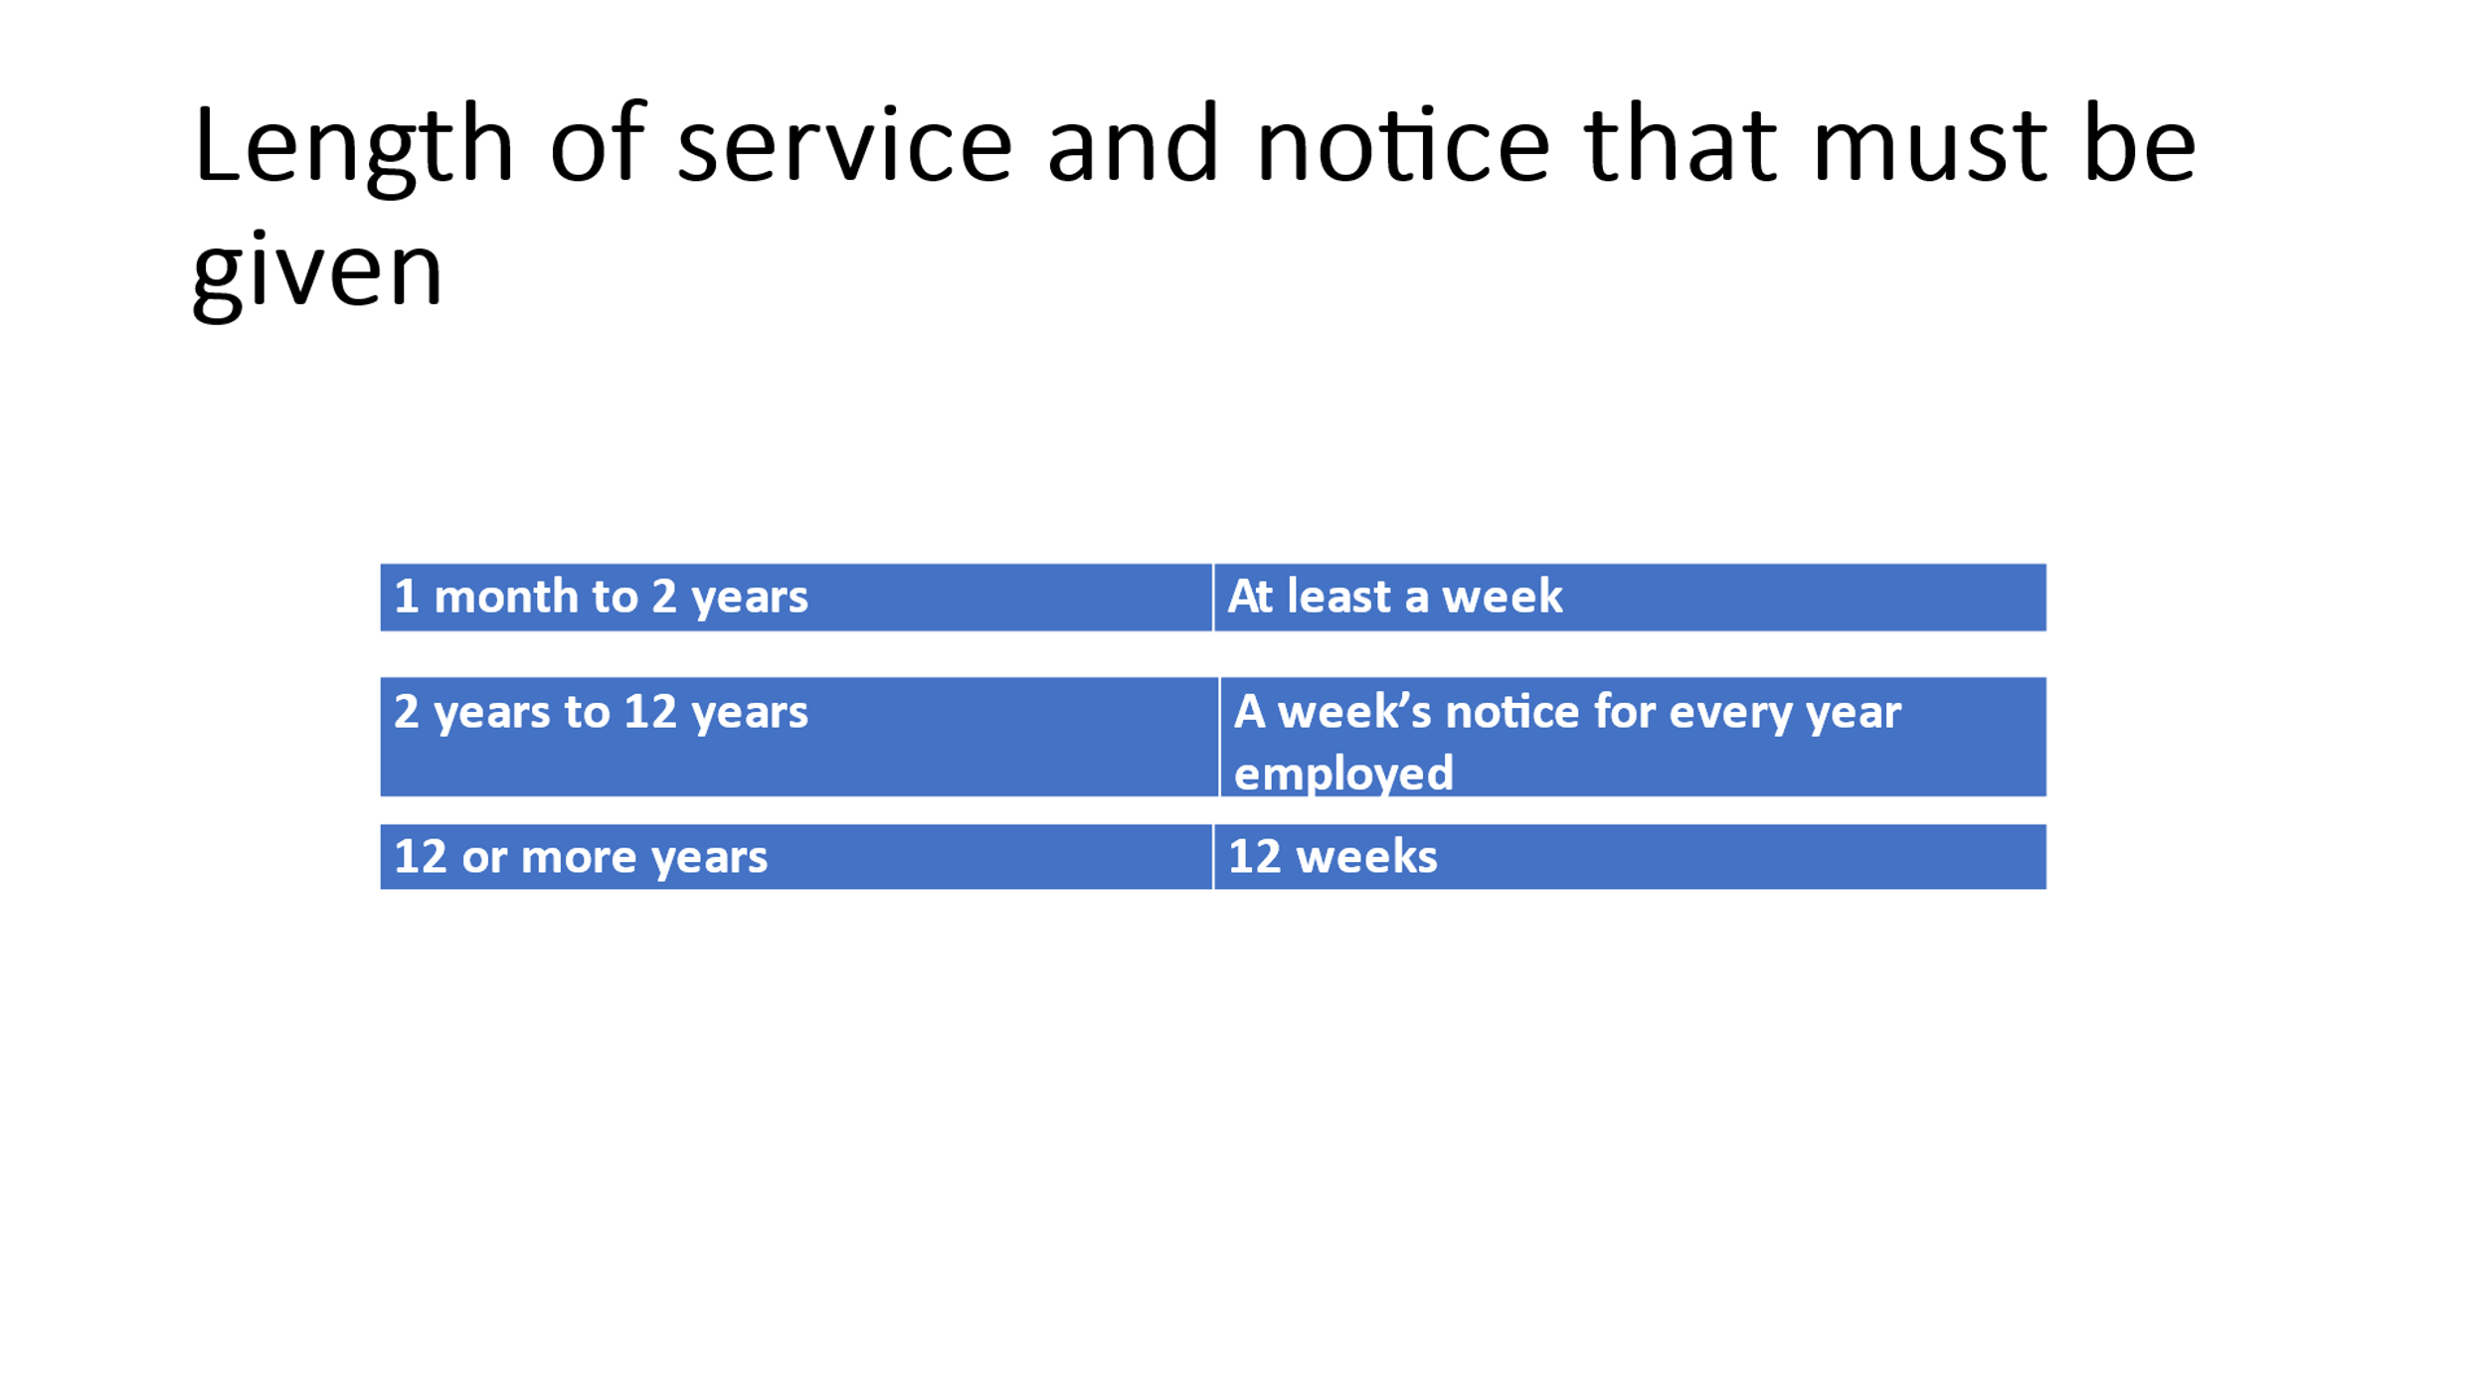
And the statutory redundancy pay that they qualify for. 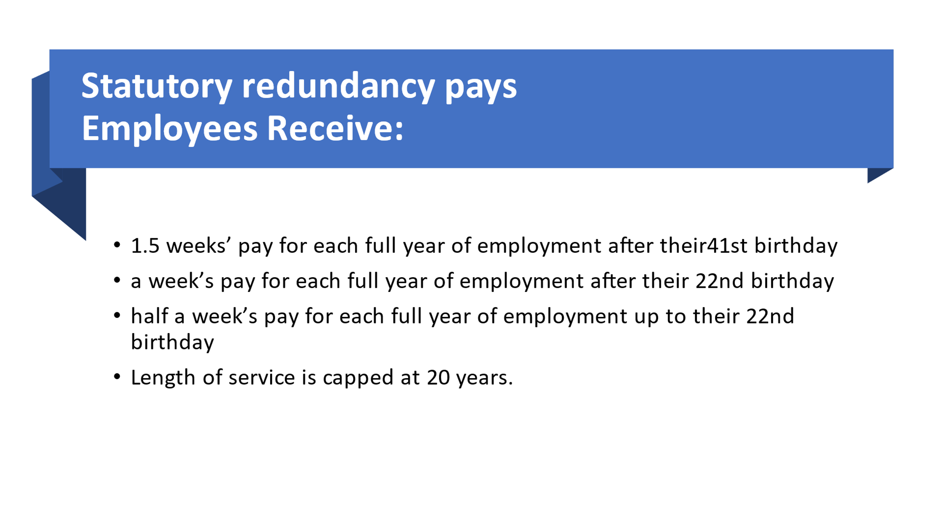

You must give staff notice and agree a leaving date once you’ve finished the redundancy consultations.
3.2 Explain the legal requirements relating to transfers of undertakings.
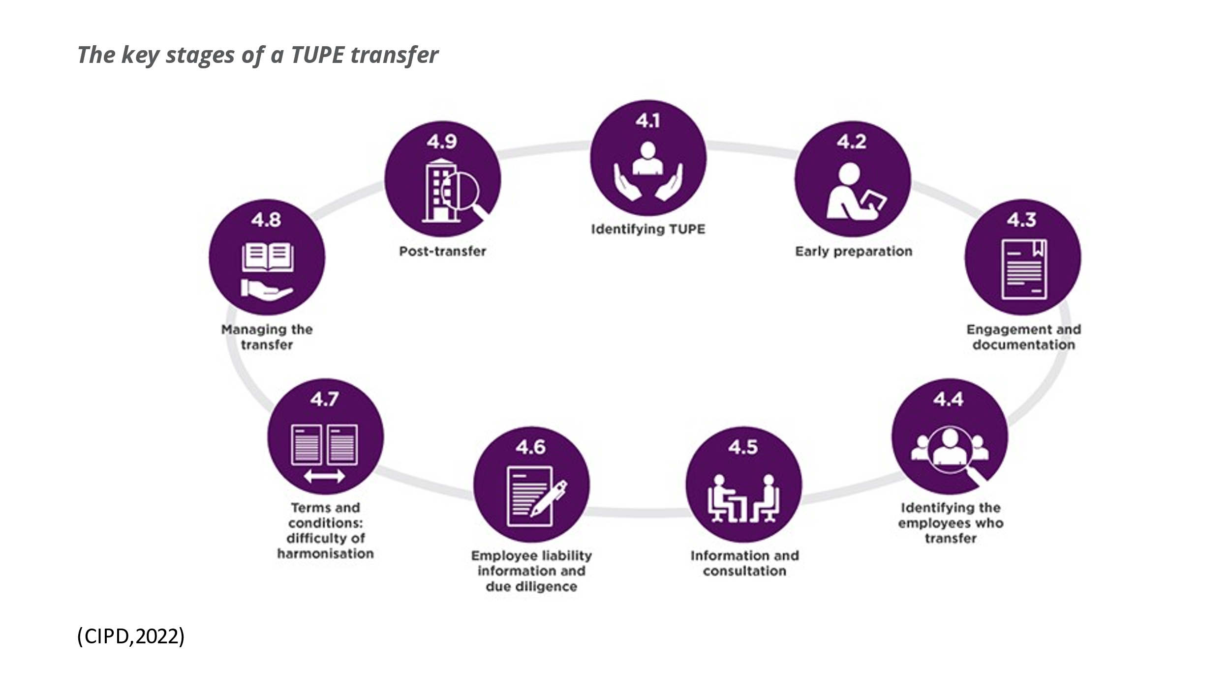
If ABC Limited wasn’t to close a store and sold to another company the would need to follow the process of TUPE. The are some main requirements of the law on the Transfer of Undertakings (Protection of Employment) known as TUPE. TUPE transfers are often complex and is essential for employers to plan well and seek advice and guidance plenty in advance (CIPD,2021). TUPEs aim is to protect employees if the organisation that they work for when it ‘changes hands’. (CIPD,2021) (Protection of Employment) Regulations 2006 (TUPE) apply to protect UK employees when one of these ‘relevant transfers’ takes place and the business changes to a new owner.
A transfer of an undertaking falls into two categories –
- A business transfers
- Service provision change (CIPD,2021

TUPE protects the entitlement of the UK employee to the same terms and conditions, which continues the same as they had before the transfer/change. Employees that object to transfer will not become employees of the transferee. Instead, their contract of employment will be terminated by operation of law on the transfer date. There will be no dismissal. (CIPD)
There must be a consolation and notice period conducted with the employees as early as possible. There is no specific minimum period of consolation before transfer. ABC would need to simply provide the required information (CIPD,2021) “long enough before the relevant transfer to enable the employer of any affected employees to consult the appropriate representatives". If ABC fails to consult properly, they will be liable to pay 13weeks pay in compensation. (CIPD,2021)
Employee engagement should be on going throughout TUPE. (CIPD,2022) There are specific legal requirements that set out the information that must be supplied, both to the incoming business, the trade union representatives and/or the staff themselves.

There are some situations where TUPE has been found to apply to the below: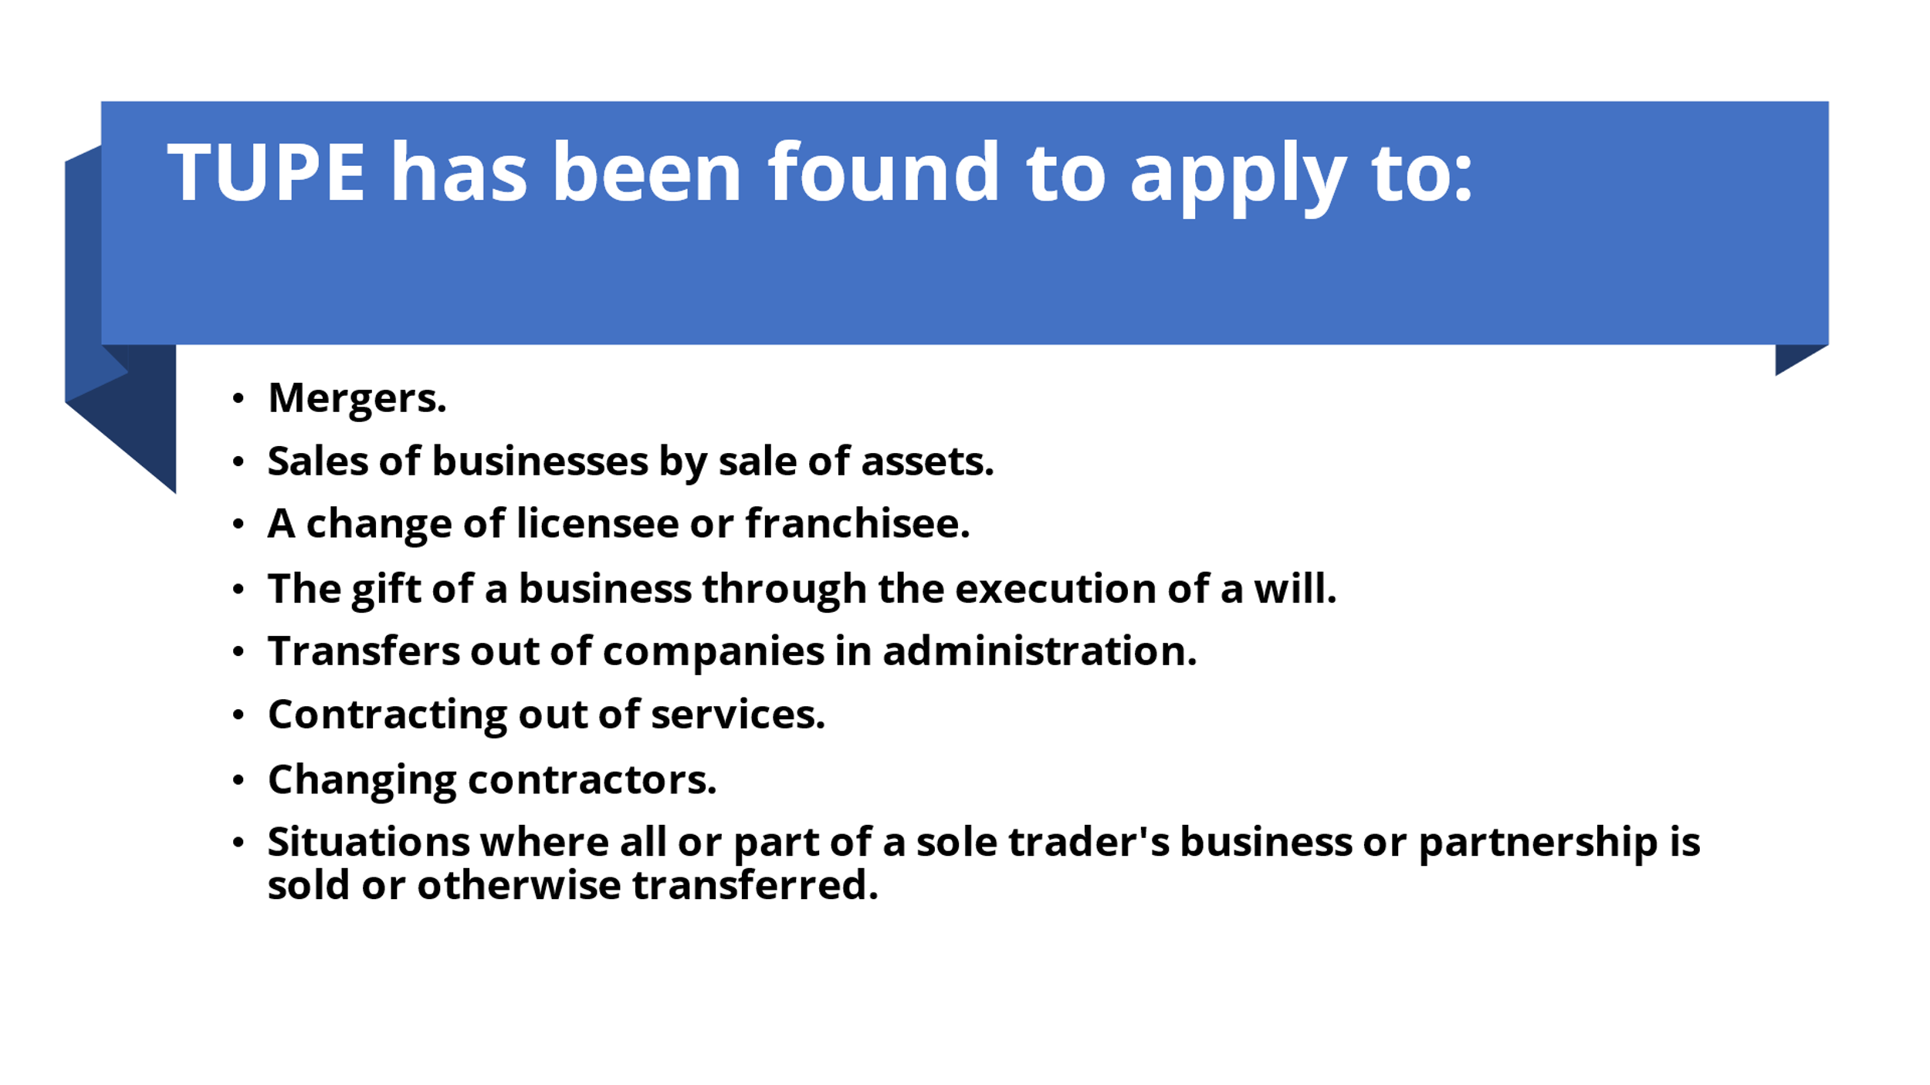
And situations where TUPE doesn’t apply to:
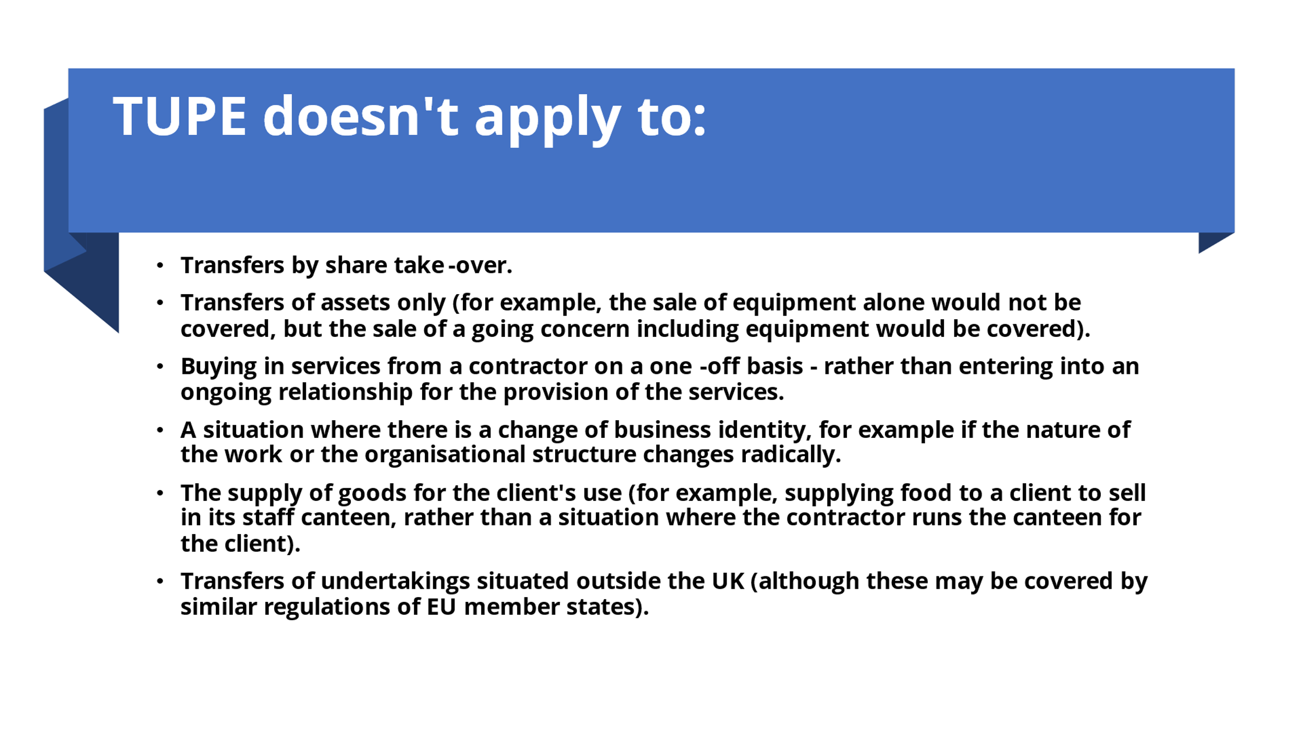
Forward planning, organisation, transparency, and communication is key to an organisational change. If these are done well change and transition will run smoothly
Works Cited
CIPD. “Change Management | Factsheets | CIPD.” CIPD, 10 Aug. 2020, www.cipd.co.uk/knowledge/strategy/change/management-factsheet.
---. “TUPE (Transfer of Undertakings) | Factsheets.” CIPD, 1 Oct. 2021, www.cipd.co.uk/knowledge/fundamentals/emp-law/tupe/factsheet#7087.
GOV.UK. “Making Staff Redundant.” GOV.UK, 24 Oct. 2012, www.gov.uk/staff-redundant.

