

An investigation into the impact of stress on modern day police officers

Samantha Neville 1922406
BSc (Hons) Professional Policing

ACKNOWLEDGEMENTS
I would like to thank my family, partner and colleagues for assisting me during my research project.

DECLARATION

This work has not previously been accepted in substance for any degree and is not being concurrently submitted in candidature for any degree.
Signed: Samantha Neville
Date: 22/04/2023
STATEMENT 1
This dissertation is being submitted in partial fulfilment of the requirements for the degree of BA.
Signed: Samantha Neville
Date: 22/04/2023
STATEMENT 2
This dissertation is the result of my own independent work/investigation, except where otherwise stated.
Other sources are acknowledged by footnotes giving explicit references. A bibliography is appended.
Signed: Samantha Neville
Date: 22/04/2023
STATEMENT 3
I hereby give consent for my dissertation, if accepted, to be available for photocopying and for interlibrary loan, and for the title and summary to be made available to outside organisations.
Signed: Samantha Neville
Date: 22/04/2023
STATEMENT 4
I hereby give consent for my dissertation, if accepted, to be available on the university’s IT system to those who have consent to use the system.
Signed: Samantha Neville
Date: 22/04/2023

ABSTRACT

Police officers are expected to complete a dangerous and demanding role, whilst ensuring the safety of the public they serve. This research project will investigate whether the modern day police officer is subject to stress, not only from the role they are expected to complete, but additional stress as a result of the expectation of completing university study along side the role, and stepping up to deal with mental health calls in addition to the workload of a UK police officer.
The research within this project will provide an additional viewpoint of police officers completing the PCDA programme, a programme coming up to it’s fourth year of operation, as there is academic literature in relation to stress, but a limited amount specific to the apprenticeship programme currently in place.
The researcher conducted their own primary research by means of a survey in order to compare this quantitative data against the available secondary research. In depth analysis and discussion will take place on result of the findings of the different data
The project concludes with recommendations made by the researcher as a result of examination of the primary and secondary research.

CONTENTS

- – Introduction…………………………………………………………………………………………………………6
  - – Aims & Objectives……………………………………………………………………………………6

- - Literature Review…………………………………………………………………………………………………..7
  - - An evaluation of the demand PCDA entry route on current South Wales Police officers…….7
  - - Identifying stress related factors as a result of being modern day police officer………………8
  - - Additional responsibilities police officers have relating to mental health……………………..10

- – Research Methodology…………………………………………………………………………………………11
  - – Introduction…………………………………………………………………………………………….11
  - - Research Strategy…………………………………………………………………………………….11
  - - Data Collection…………………………………………………………………………………………13

- – Analysis of Results…………………………………………………………………………………………………13
  - – Introduction……………………………………………………………………………………………..13
  - Online Survey Findings………………………………………………………………………………..13

- – Findings, Conclusion and Recommendations……………………………………………………..…22
  - – Main Findings………………………………………………………………………………………..…22
  - – Completion of Aims and Objectives……………………………………………………….…23
  - – Limitations…………………………………………………………………………………………….…23
  - Further Research…………………………………………………………………………………………25
  - Conclusion…………………………………………………………………………………………………..25
  - Recommendations………………………………………………………………………………………25
Bibliography……………………………………………………………………………………………………………………26
Appendix 1 – Survey Questions………………………………………………………………………………………31
Appendix 2 – Results from survey……………………………………………………………………………………34

1.0 Introduction
Policing has evolved with time from its modern day inception in 1829 when Sir Robert Peel, organised the London Metropolitan Police. In doing so, he created the nine ‘Principles of Policing’ and the process of ‘policing by consent’. Both of which are still utilised today within policing (Ortmeier, 2010). Modern day police officers whilst still utilise Principles of Policing, have also seen the role they complete change, and alter to keep up with an ever changing world.
The National Police Chief’s Council (NPCC) and the Association of Police and Crime Commissioners (APCC), recognise that the role is changing, along with the incidents police deal with. Therefore, both organisations have the ambition to make policing more representative of the communities it serves, with aligned skills to the ever challenging requirements of combatting crime. As a result, in 2018 the new Policing Education Qualifications Framework (PEQF) was developed, creating new three main entry routes into the police. One of the route created being the Police Constable Degree Apprenticeship (PCDA) – This is an apprenticeship, whereby the recruit will achieve a degree is Professional Policing Practice following a three year programme (‌College of Policing, 2021).
Further responsibilities being placed on officers on the front line in the form of university work and dealing with an ever growing population struggling with mental health problems, could be causing issues of stress on its workforce, causing poor health, and pushing officers out of the service.
The researcher has had significant experience of completing both university work whilst balancing the workload of a police officer, which is growing to include mental health incidents. This research aims to delve into these topics and discuss what the wider impact of these areas could have on our modern day police constable.

1.1 Aims and Objectives

- Complete an evaluation of the demand PDCA entry route on current South Wales Police officers.
This aim is to identify what demand is on newly recruited police officers, who have been selected to complete university studies alongside the full time response officer role. The researcher will cover a number of forms of literature to identify whether this entry route is beneficial to officers, and what the impact of this entry route is having on the officers participating in it, the wider police force and the rate of retention for student officers.

- Identify stress related factors as a result of being modern day police officer.
This aim is to establish what factors could impact the stress levels on a police officer, and what could be the root causes of any stress they experience. Organisational and public stressors could be impacting officers, which is an objective of this research project.

- Conduct a review additional responsibilities police officers have relating to mental health.
The aim of this research is to assess what responsibilities police officers have when dealing with calls in regard to the mental health of a subject, and what the reasoning is behind police intervention when matters are not of a crime related nature.

2.0 Literature Review
2.1 An Evaluation of The Demand PCDA Entry Route on Current South Wales Police Officers
In 2018 the new Policing Education Qualifications Framework (PEQF) was developed, creating new three main entry routes into the police. One of the more prevalent and popular amongst recruits being the Police Constable Degree Apprenticeship (PCDA). This is an apprenticeship, whereby the recruit will achieve a degree is Professional Policing Practice following a three year programme. (‌College of Policing, 2021).
The Policing Vision 2025 is a document drafted by the National Police Chief’s Council (NPCC) and the Association of Police and Crime Commissioners (APCC), whereby they state that they aim to have a more representative work force, with the correct skills to meet challenging requirements. The vision sets out how they aim to set consistent requirements for police entry, and the desire for officers to be accredited. The new PEQF framework is what has been implemented in order to achieve this (‌College of Policing, 2019)
The purpose of PCDA entry route is to focus on recruits obtaining practical learning experience whilst obtaining a degree, however unlike a standard degree, the process will be fully funded, therefore students would not be partial to tuition fees, and would be paid a police officer’s salary. A PCDA student will spend their time split between working as an operational police officer, spending time with other departments such as neighbourhood policing teams, investigative teams and completing classroom based studying, with a university in partnership with the chosen police force (Joining the Police, n.d.).
Following student feedback whilst still in the initial training, PCDA recruits explained the benefits of the course following their experiences, Summer Smith of Nottinghamshire Police, told how the entry route was ‘win-win’ for her, allowing her to explore different areas of policing the in forms of departmental attachments, whilst completing her studying. She confirmed how this entry route was the best way to provide new officers with a balance between education and working in the police (College of Policing, 2021).
Whilst recruitment of the new entry routes is continuing throughout UK forces, there has been significant negative scrutiny of the new entry routes. Data released by the National Police Chief’s Council in March 2022 found that the average attrition rate across UK forces is 9.1%, with 2,567 leavers from 28,173 new recruits (NPCC, 2022).
Zoe Wakefield, Chair of the Police Federation in Hampshire states that the new entry routes are to blame for high rates of attrition from new joiners. She states that officers do not have sufficient time to complete their university work, as they are working full-time shifts, leaving them exhausted and are being put under significant pressure to get the work done on time (Hampshire Police Federation, 2023).
Additionally, a study conducted by the University of Portsmouth in 2022 found that police officers voluntarily left roles within the police due to internal organisational issues, such as poor leadership, lack of promotion opportunities and a feeling that their voice was viewed as insignificant (Charman, 2022).
South Wales Police Federation Chair Steve Treharne, also expressed his issues when discussing the PCDA entry route, stating that he has heard of colleagues across the South Wales force area struggling to cope under the increased pressures of learning a challenging role whilst studying to complete a degree. He stated that officers were ‘drowning in the workload’ and stated that the low starting wage in addition to the pressures on officers would explain the high number of new recruits leaving prior to completing probation (South Wales Police Federation, 2022).
Police and Crime Commissioner for Lincolnshire, Marc Jones, stated that the entry routes were preventing applicants from military backgrounds, Police Community Support Officers PCSOs or officers who had served as Special Police Constables due to them not wanting to complete the degree, or take the pay cut required. He stated that this would be a loss for the police, given the relevant and significant experience these recruits would offer (Hubbert, 2022).
In November 2022, Home Secretary Suella Braverman agreed to allow a non-degree entry programme to be offered to prospective applicants, as policing needed to ‘draw from the widest pool of talent.’ Since the change in the degree process was announced however, forces across England and Wales are still recruiting via the PEQF routes and alterations to the process are still to be made. Many students who were recruited via PCDA are still required to complete their university work in order to progress to no longer be a student constable (Norfolk Police Federation, 2022).
2.2 Identifying Stress Related Factors as a Result Of Being Modern Day Police Officer
The term stress can be categorised under two separate meanings. The first can be considered as the events or challenges within an environment in which an individual is exposed to. These can be acute such as a particular incident as losing a job, or chronic, such as ongoing domestic issues with a family member or partner. These matters can also range from minor, severe or traumatic, all of which can occur within a person’s lifetime. The stress response of the individual can vary, depending on a number of factors within that person’s life. Some stress responses include and are not limited to anxiety, depression, psychological states of fear (Harkness et al, 2020).
Exposure to stress is an unavoidable part of life, with being exposed manageable levels of stress a simple requirement in order to live a normal functioning life. However, exposure to high and unmanageable levels of stress over long periods can impact numerous systems of the body, including the nervous, immune, cardiovascular, gastrointestinal, endocrine, respiratory, and even the reproductive system (Çakmur, 2020).
The Mental Health Foundation reports that 51% of adults who felt stressed reported feeling depressed, and 61% reported feeling anxious. Additionally, of the people who said they had felt stress at some point in their lives, 16% had self-harmed, and 32% said they had had suicidal thoughts and feelings. (Mental Health Foundation, 2018). Statistics as this show that mental health effects a large proportion of people within the UK, with there being currently 142,145 police officers within the UK currently (Home Office, 2023), it is fair to assume a number of these officers will also experience issues with mental health at least some point during their lives.
The Independent Officer of Police Conduct recognises modern day police officer will be expected to conduct themselves to high standards and navigate their career managing a role of complexity, whilst also being under constant scrutiny. High profile cases, such as George Floyd, Stephen Lawrence have caused people to lose faith in the police, and police accountability is very important in order to ensure police powers are not abused (Lockwood, 2020). However, this can place pressure on officers. Mahbu Rahman, a Blue light Programme Manager at Mind states that given that the role can be challenging and of a fast-paced nature, in addition to having its unique pressures and frequent exposure to difficult incidents, actually puts officers at a greater risk of poor mental health (Mind, 2019).
A study published by Routledge in 2019 states that it is commonplace within the police for organisational stressors to also play a role in stress within police officers. Bureaucracy within the workplace can result in the officers feeling constrained, when compared to other occupations. Instances of low morale have been highlighted within services across the globe, in addition to lack of recognition, punishment for ‘minor’ infractions, being ‘second guessed’ with the action that the officer has taken, which causes further stress on officers (Shane, 2019).
Government figures within the UK have found that the number of voluntary resignations within the police have risen by 196% in 2022 when compared to 10 years prior, in 2012 (Home Office, 2022). Interviews conducted with over 100 officers following their resignation found that 50% of those officers left following issues surrounding poor leadership and management, inclusive of management of all levels, varying from line, middle and senior management (Charman & Bennett, 2022).
Officer shifts vary between force, but will often be made up of day shifts, afternoon shifts and night shifts. Varying shift patterns will occasionally make it difficult for a person to adopt strong routine, meaning that officers can often struggle with issues such as sleep, and food consumption. Blue Light Together highlights that sleep issues are commonplace in shift workers, with many people aiming to assist sleep deprivation by self-medicating with alcohol, which does not fix the problem (Blue Light Together, n.d.).
In addition, a study completed into nightshift work and cancer by the European Journal of Epidemiology, found that persons working night shifts are at an increased risk of contracting a varying range of different health related ailments, including illnesses such as mental health disorders, obesity, and cancer (Cordina-Duverger, et al. 2018).
Police work will also very often spill over into the personal lives of officers. The expectations of officers are as such to always be mindful of how the present themselves, whilst both in and outside of work. Officers come under fire for how they have conduct themselves in their personal lives, with a number of officers experiencing disciplinary measures for incidents which have occurred outside of working hours. In addition to this, officers will also be expected to work on when required, come into work when they should be off duty in order to deal with demand and even have annual leave cancelled in order to attend court when required. Instances such as this can place pressure on officers, and cause friction and tension between the officer and their friends/family members. Missing events within an officer’s personal life can often add stress and decrease moral. (Shane, 2019)
However, there are a number of support mechanisms in place in order to help officers who are going through disciplinary measures or are struggling with the stressors of job related stress. The Police Federation are in place to support officers, whether this be supporting through the disciplinary process, providing legal aid, covering solicitor fees, or assisting with work related grievances. Furthermore, The Police Federation also provide many services free or at a reduced price, such as insurance, counselling support and discounted events/products, aiming to ease financial burdens which can be placed on officers (South Wales Police Federation, n.d.).
Further to the Police Federation wellbeing services such as Oscar Kilo, TRiM and Occupational health provide further health support to officers, whether this be physical or mental health support. Officers can receive a number of treatments if required, such as counselling to help deal with the physical and mental pressures they face as part of the role (‌Oscar Kilo, 2022). However, it is highlighted that there are barriers to those in emergency services requesting help in relation to their own mental health, due to the stigma attached (‌Edwards & Kotera, 2020).
Figures show that whilst population in the UK have risen, the number of police officers has not represented this growth, which is down to the government cutting police funding. Data shows that the number of police officers have declined from 139,771 in 2010 to 117,456 in 2018. This is the lowest number of officers in England and Wales since 1982 (Statista, n.d.).
Whilst operating with insufficient numbers of officers, the officers which are left to deal with an increasing population and increasing demand have shown to have felt the strain, with findings from the PEEL report, conducted by His Majesty’s Inspectorate of Constabulary and Fire and Rescue Services (HMICFRS) in 2022, demonstrated that the cuts and extra workload demands are ‘overwhelming’ for forces across the UK. This has in turn resulted in backlogs of emergency work, occasionally preventing police from protecting the public. The Police federation states that the current state of the service must receive government intervention by getting the right officers recruited, and to ease the burden on existing officers. The Police Federation request that the government compensate officers financially, bringing pay up to the rate of inflation to attract more candidates to apply, in addition to providing a non-degree entry route to those wishing to apply for the role. (Police Federation, 2022).
The Federation completed an annual survey, sharing findings with the government. The Police Federation Pay and Morale survey, found that within 2022, 9 in 10 officers feeling financially worse off than they were five years ago. Additionally, 1 in 5 officers stated that they planned on handing in their resignation as soon as possible within the next two years for reasons including unfair pay. 69% of participants stated that they worried about finances every day (Police Federation, 2022).
Findings of the survey are shared with stakeholders, including government, however unlike other areas of public services, police officers are exempt from taking any industrial action. Following the First World War and police strikes which took place during this time, the Police Act of 1919 was passed. In this act, strike action for police officers was made illegal, as it was decided that by the police being allowed to strike, would result in a threat to the public. An agreement was made that the government would maintain fair pay and conditions as a result of the removal of the ability to strike. (Robertson, 2023) There have been comments made by Federation representatives that strike option could be a future possibility, should the government not increase pay to an acceptable level, however given the legislation, this would be an absolute final resort (Police Federation, 2022).
2.3 Additional Responsibilities Police Officers Have Relating to Mental Health
Mental health awareness has risen significantly in recent years, which in turn has also meant that mental health illnesses such as anxiety and other aliments are more commonplace in modern day. The police have taken an active role in dealing with different forms of mental health related incidents, by being the first point of contact carrying out an emergency response on some occasions, although this does not fall within what would be considered as a police matter. The exception of when a crime has been committed as a result of a mental health incident. According to a report conducted by Lord Victor Adebowale in 2013, 20% of a police officer’s time is taken up by mental health incidents, which increases to 40% when expanding the scope to include incidents pertaining to vulnerable people (Adebowale, 2013). When relating these figures to current times, The Police Federation believe that it is possible that these levels have increased, with further demand in relation to mental health calls being placed on officers (The Police Federation, 2022).
An article published in 2018 by Her Majesty’s Inspectorate of Constabulary and Fire & Rescue Services (HMICFRS) has declared that the current UK Mental Health system is not fit for purpose, and a number of people across the UK are being let down and failed by the current system. Mental health has then in turn become a Police responsibility, given that the service is available 24 hours a day, 7 days a week (HMICFRS, 2018).
The College of Policing have recognised the increased demand on police and have agreed that Police can act within a Healthcare capacity during their service. Included in the Authorised Professional Practice document, being a source of police processes, they state that Police can act to support other healthcare agencies in the instance where someone is experiencing mental health issues, provide support to a person experiencing a mental health episode until they can be seen by a professional, and provide support to families/carers of persons experiencing a mental health incident, providing extra support where required. (College of Policing, 2022)
However, The Police Journal states that large portions of police demand for calls such as mental health, could be more appropriately dealt with other agencies, or with a police partnership approach. This will in turn improve the experience for the subject of the call, but also decrease the police workload, as police currently deal with these calls at first point of contact. Police officers will often manage the subject by getting them to a hospital to receive support, referring them to relevant agencies, or having to section the patient (Boulton, et al. 2016).
Although it is recognised by the College of Policing that mental health is a responsibility of police officer, Journal Medicine, Science and the Law, highlight that many police officers feel that the training regarding mental health is insufficient, and delivered in online workshops, or occasional lectures only when there are major changes to policy (Wondemaghen, 2021).
Furthermore, those people experiencing mental health concerns have highlighted themselves that they feel that the police do not have the required knowledge or training to deal with someone within a mental health crisis. 18 Detainees following being sectioned under 136 of the Mental Health Act 1984 stated they felt this way, some also stating they felt this way when being dealt with by hospital workers also (Sondhi, et al, 2018).
3.0 Research Methodology
3.1 Introduction
This chapter is detailed with what strategies will be utilised in order to obtain further researching and findings. This chapter will also include reasonings for the chosen research being used. The aim of the project is to establish how stress is impacting modern day police officers, with a particular focus on officer in South Wales who have pursued the PCDA entry route, in addition to highlighting the general stressors on a modern day police officer, and the additional responsibilities obtained as a result of the increasing prevalence of mental health in society. It is highly likely that stress is having a significant impact on police officers, and this research aims to obtain the opinion of police officers and gain more insight into officers’ opinions of the PCDA process, and the additional workload of dealing with mental health calls.
3.2 Research Strategy
The aim of this research project is to use both secondary and primary sourced of information. Secondary sources were explored within the literature review chapter, whereby specialist information was sourced from journals and books, with also online libraries and internet sources being utilised in order to gain the most relevant and up to date information. Although a focus of secondary resources have been used, the core of the project will be utilising findings from the use of police officers taking part in an online survey.
The findings of the survey will be collected and collated the responses of current PCDA and those who have completed the PCDA entry route within the South Wales Police area. These respondents will have first had experience of both working as an operational police officer whilst completing university studies. The purpose of the survey is to pinpoint whether officers are becoming stressed as a result of the role, additional responsibilities of mental health and the extra work provided by the PCDA route. The survey will utilise both closed and open questions, however there will be a primary focus on closed multiple choice questions in order to gain quantitative data which can be examined. The chosen interface of this survey will be completed by Google Forms, which following a response will automatically format the responses for collation and also chart the answers of each respondent.
Selection of the online survey as means of primary research have a number of benefits according to Hinge Marketing, and these benefits include a lack of financial input required, as compiling one comes at no cost. The surveys will reach their targeted audience, and online accessibility means that the survey can be shared via social media, internal intranet/email and directly sent to a participant’s mobile phone for ease of both the researcher and the participant (Tyreman, 2019).
Whilst online surveys have benefits, according to research conducted by Jared Cornell, for company proprofsurvey.com found that they have their disadvantages. These include ‘survey fraud’ whereby people will select answers without reading, or skipping answers which would result in skewed results. Additionally, there may be the issue of ‘response bias’, whereby the respondent may not answer truthly, as a result of fear of being judged. Furthermore, should the survey be considered to be a long survey (usually between 10-15 minutes long) respondents will often not complete the survey, or abandon the survey if they feel the questions used are irrelevant (Cornell, 2021).
Given the selection of research topic, a sampling approach was taken in order to get the best reliable responses. The respondents of the survey will have to be police officers, who have gone through the PCDA process as the questions within the survey would only be relevant to this group of respondents. According to South Wales Police HR team, the PCDA process started between 2018-2019 in South Wales Police, with there being regular intakes of approximately every 3 months, therefore a number of current police officers in the Northern BCU where the survey will be shared, will have participated in the entry route. The survey would not be accurate, should the survey be shared with wider colleagues who joined the service prior to the PEQF framework, as they would lack understanding and experience with completing university work alongside the role of police constable. The results would be skewed further should the survey be shared with the wider general public, as they would have no experience in both the PCDA and carrying out the police officer role.
This survey was sent out to those of the rank of PC and Police Sergeant covering response, investigations (such as the hub and CID) in order to capture those of have moved away from response teams, or had been promoted following completion of PCDA, however given the short time PCDA has been in place it would be expected that most respondents would still be within a response role. Given that there could be a number of reasons why the targeted respondents could not complete the survey (such as annual leave, sick, attachments, protected learning time or simply not having the time) I would not be expecting a 100% completion rate of the survey, however, would be aiming to target between 20-30 responses, based on the current information from HR that student officers make up between 70-80% of the response teams in the Northern BCU, with the total amount of officers equating to approximately 75 officers covering this geographical area in total.
An inductive method of research was also utilised, given that the survey would be capturing thoughts and feelings of the respondents, which would be analysed and related back to the hypothesis this research project set out to investigate.
3.3 Data Collection
The primary research will be conducted by a Google Form online survey, with the survey then being sent out via email, intranet and shared between directly with teams who are of the target respondent criteria. Upon completion of the survey, the researcher will observe the findings, and collate the results into appropriate charts in order to allow for easy reading of the results. The charts in questions would be labelled in order for it to be clearly identified the outcome of the respondents’ answers. In addition to charts, from the results the researcher will be able to obtain percentages of answers when referring to multiple choice questions. The researcher will then assess what trends can be identified if any.
The interface of Google forms allowed for quick dissemination of the survey, reaching the correct sample group required. The form was straightforward with there being multiple choice answers, allowing respondents to remain anonymous, which could also possibly assist with uptake of the survey. 30 responses were obtained with all questions answered.
4.0 Analysis of Results
4.1 Introduction
This chapter will conduct in-depth analysis of the findings of the primary search, obtained by means of survey, which was outlined in the previous chapter. All findings will be displayed in chart and graph formats to allow for ease of viewing the findings of the survey. The survey in question was completed by a total of 30 respondents, made up of both existing PCDA students, and those who have successfully completed the PCDA entry route.
A copy of the survey used in this research will be located in Appendix A.
4.2 Online Survey Results
The first and second question asked within the survey was used to gauge the audience that have taken part in the questionnaire. The first question asked for the police officers’ rank. A high percentage of 83.3% were police constables, with 10% being detective constables and the remaining lowest percentage of 6.7% being police sergeants. This was to be expected as the PCDA entry routes are relatively new. The second question asks for length of service as a police officer. The most common percentage was 3-4 years' service with 33.3% followed closely by 1-2 years' service with 30%. Only 6.7% of persons completing the survey had 12 months or less service.

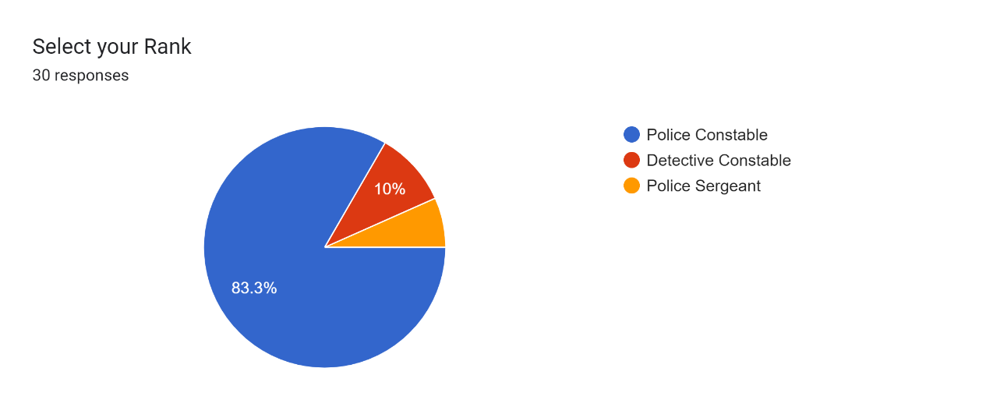

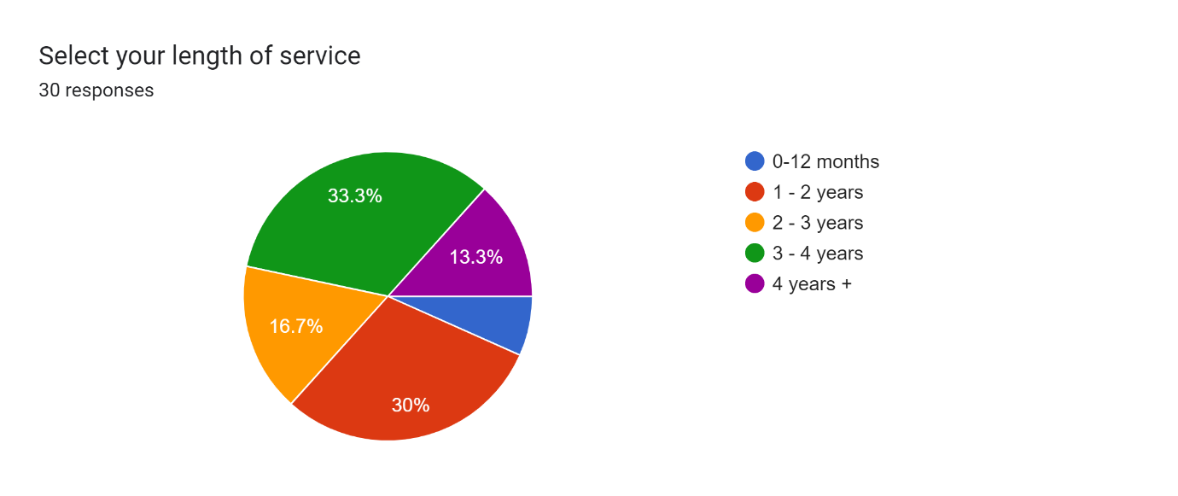

Questions three and four were posed to obtain information on whether the degree entry route is needed and if new starters are enticed to join due to the chance to gain a degree. Question three asks whether people believe a police officer requires a university degree. There was an overwhelming majority of 93.3% of people who answered that it is not required. Only 3.3% believed it is required to have a degree to be a police officer which equates to 1 person out of the 30 responses. Question four asks if the offer of obtaining the degree in Professional Policing Practice positively impact your choice of joining the police. Again, this showed and overwhelming majority of persons answering no to this question with 70%. 23.3% of answers stated that it did positively impact their choice, with the remaining percentage neither agreeing or disagreeing.
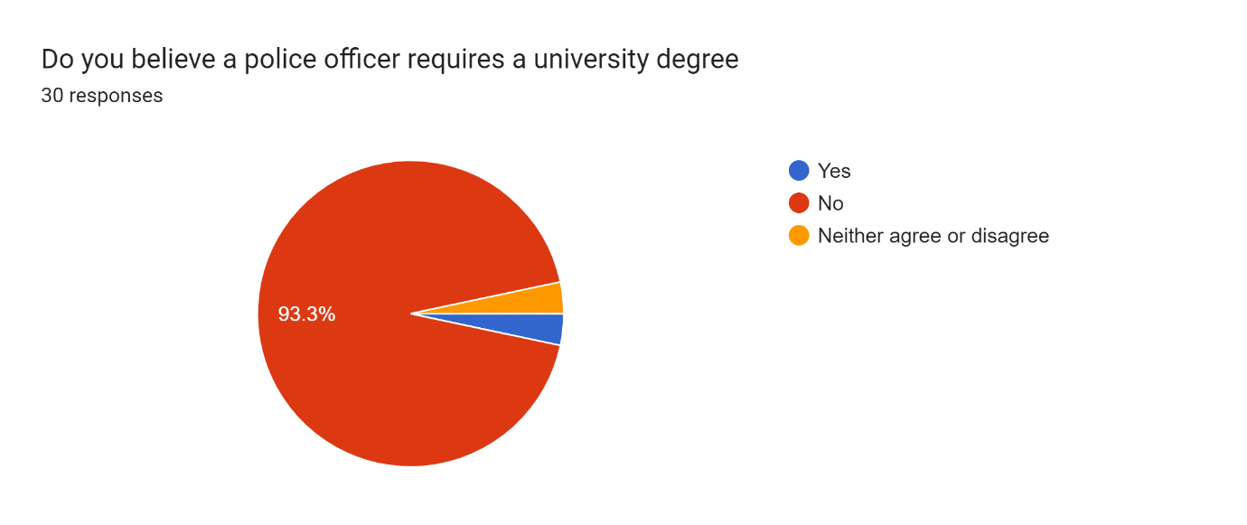

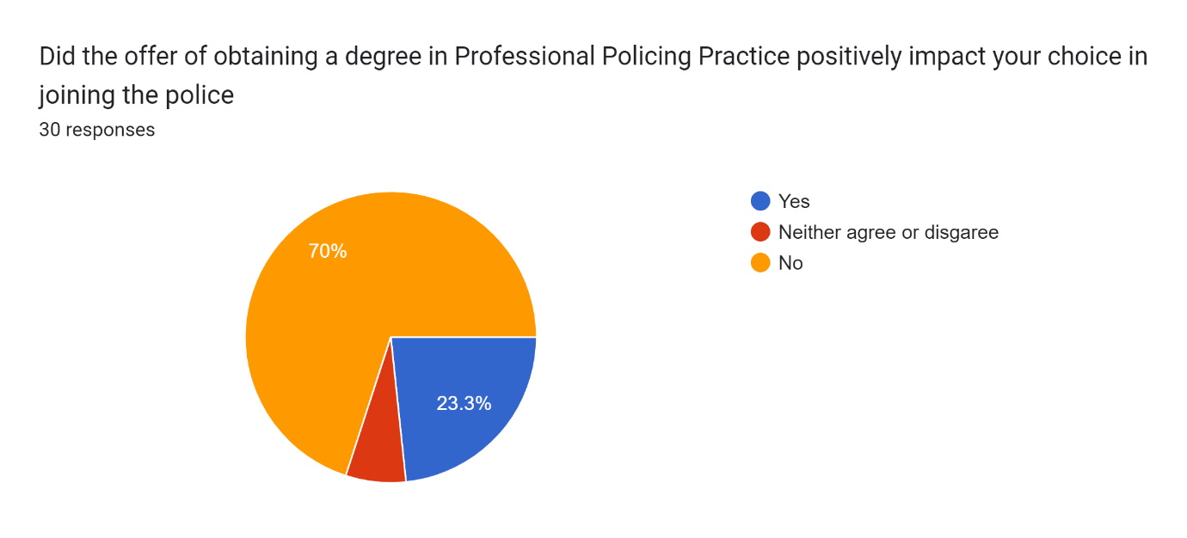

Question five poses the question of people's individual experience of the PCDA programme. 46.7% of the results stated their experience was poor and a further 26.7% of people stated it was extremely poor. That results to over 73% of people who are dissatisfied with their experience. Only two persons answered to having a good experience and not one person stated it was excellent. The remaining 20% of persons stated their experience was fair.
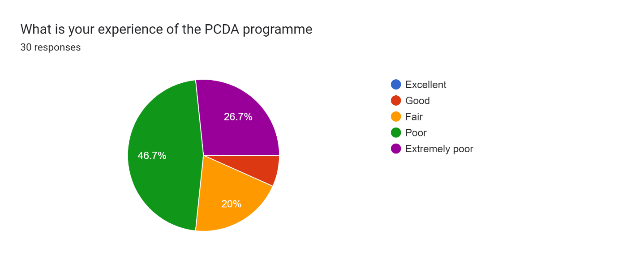

Question six asks whether the PCDA workload is manageable alongside the full-time role of being a police officer. There was a very high percentage of answers which stated that it was not manageable. This equated to 76.7% of answers, with only 13.3% believing that they can manage both.
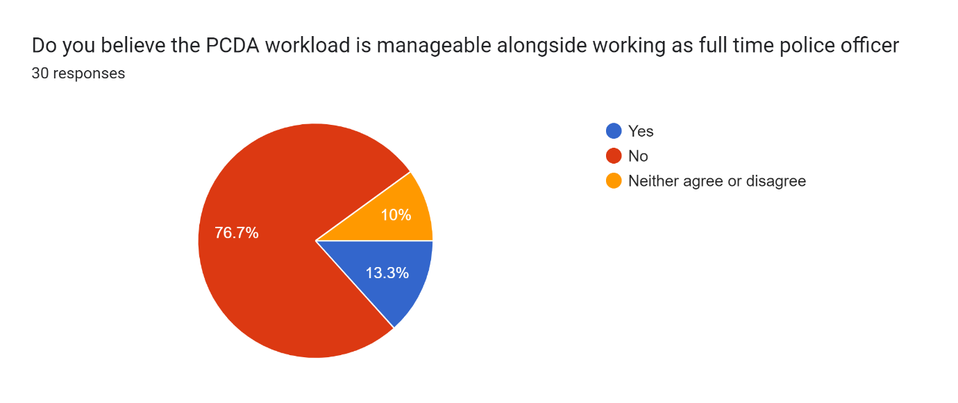
Question seven then goes on to ask whether or not the respondent has considered leaving the police force during their probation. The majority of people stated that they had considered leaving with only 40% of persons stating they had not considered leaving. Out of the 60% of the (18) people who have said they have considered leaving, 15 of these have stated the reason why to be is having to manage degree assignments with balancing work and personal life. 16 people have also stated another reason is better pay/prospects elsewhere.
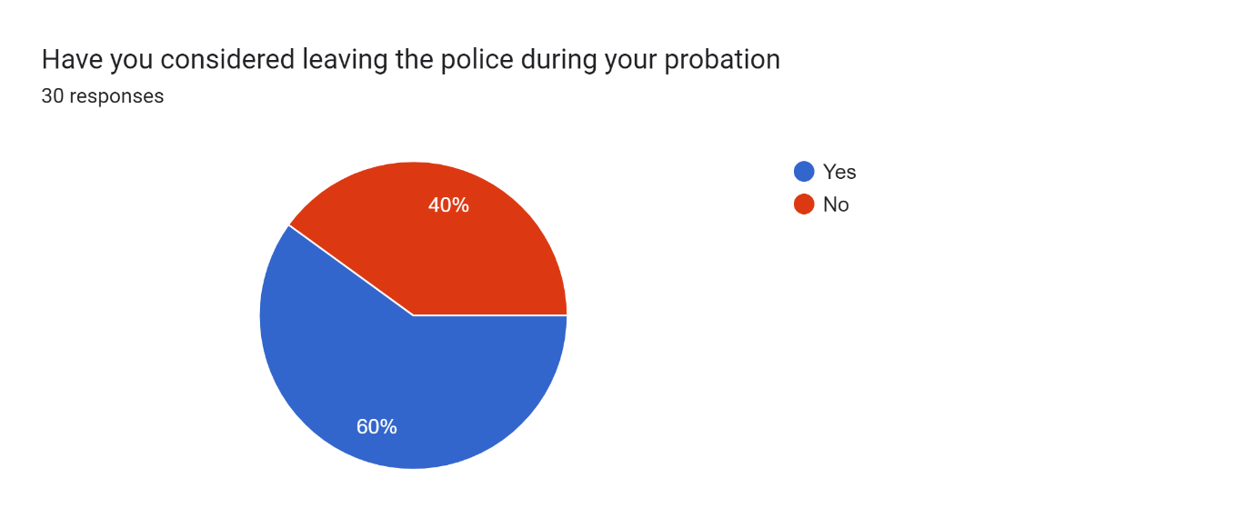
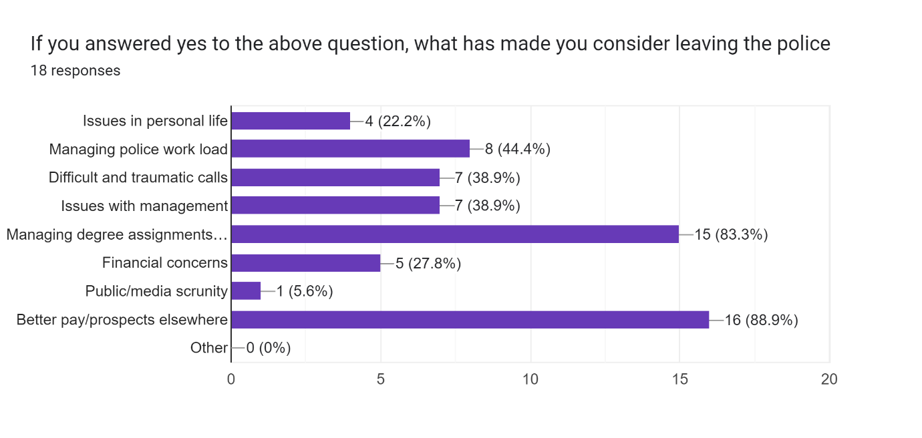
Another question posed asked whether the officer has experience levels of stress during their time as a police officer. This was a vast majority for the answer of yes with 96.7% of respondents stating this. Only 1 respondent stated they have not experienced stress during their time as a police officer making up the final 3.3%. The 29 respondents who answered yes to this question were then asked what causes their stress within the role. Managing police workload had the highest percentage as 80% of persons stated this caused them stress. This was followed closely by having to manage degree assignments with balancing work and personal life which had 76.7% of respondents chose this. The joint lowest percentage with 23.3% of persons choosing this option each was issues in people’s personal life and financial concerns.
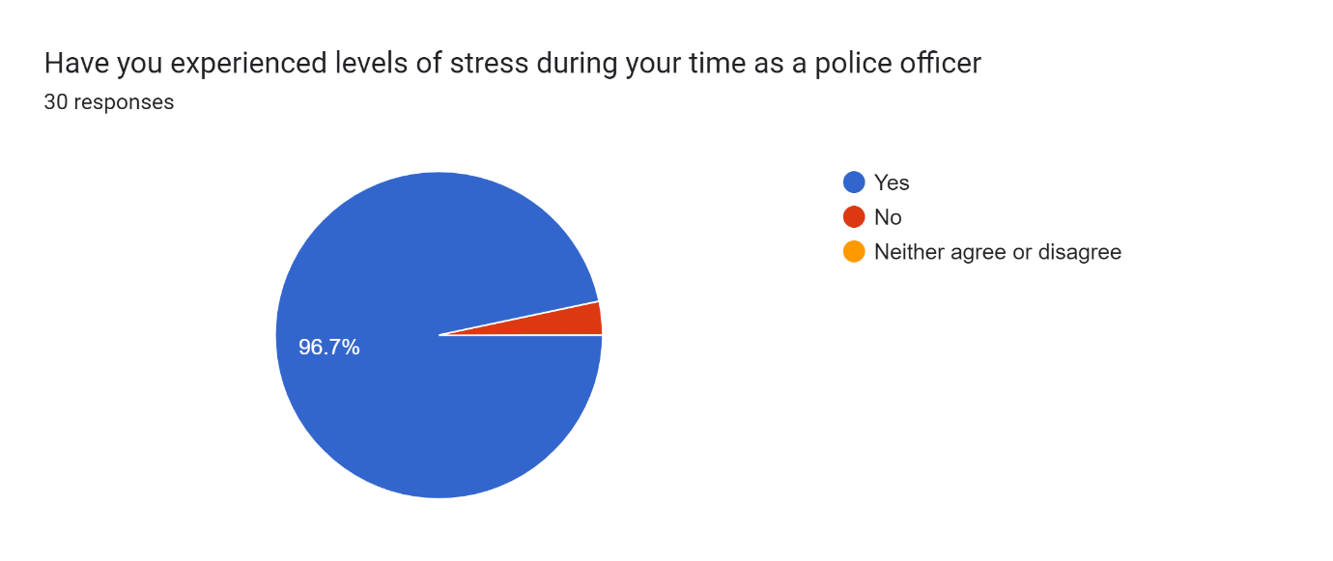
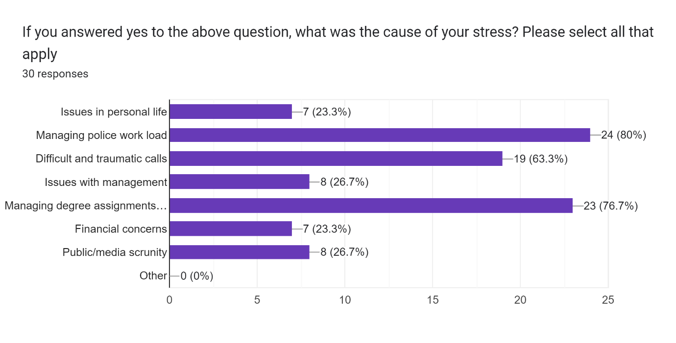

The next three questions relate to officers' use of support options which are put in place by the police force. 90% of respondents stated they were aware of what support is available to them, with 60% of persons stated that had not utilised any of this support available. Only 33.3% happy to say that they have used these services. Out of the officers who have used this service, 50% of them stated that they found the services useful with only a small percentage of 14.3% believing that it was not useful.
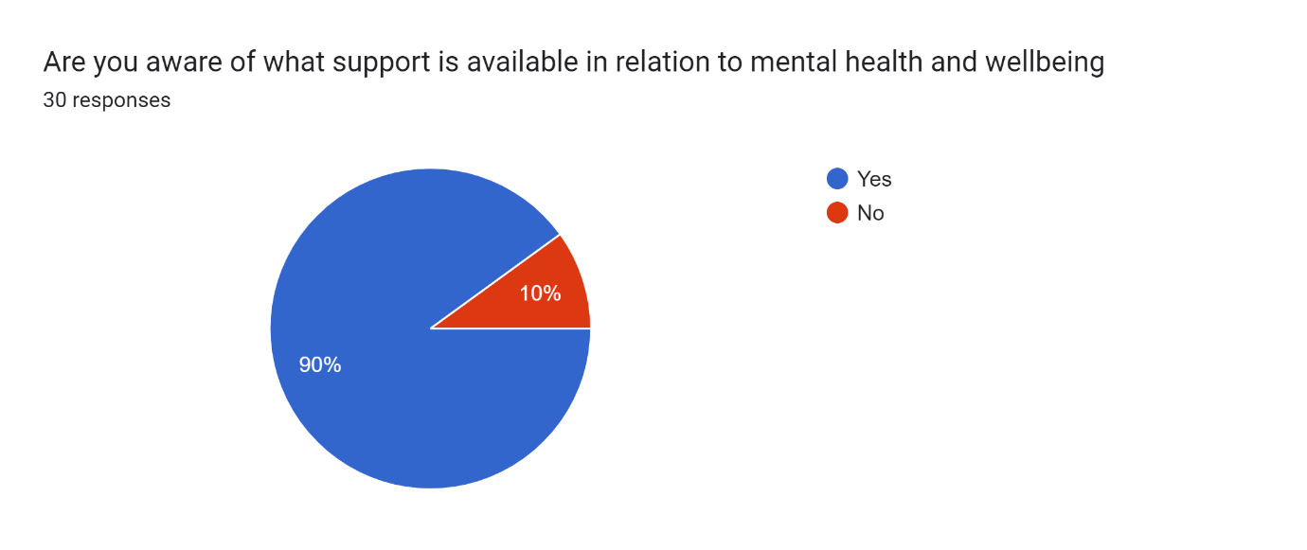
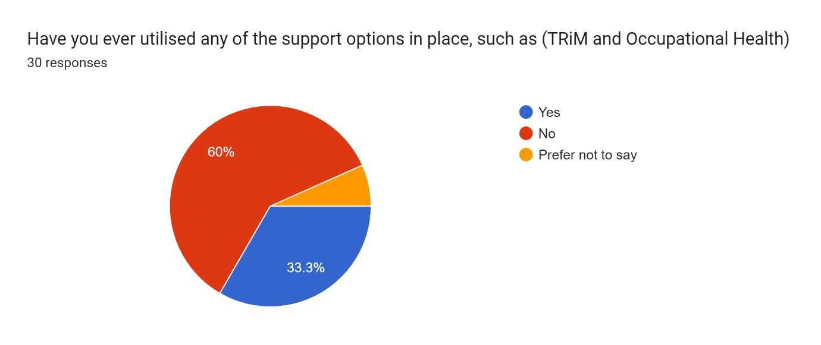
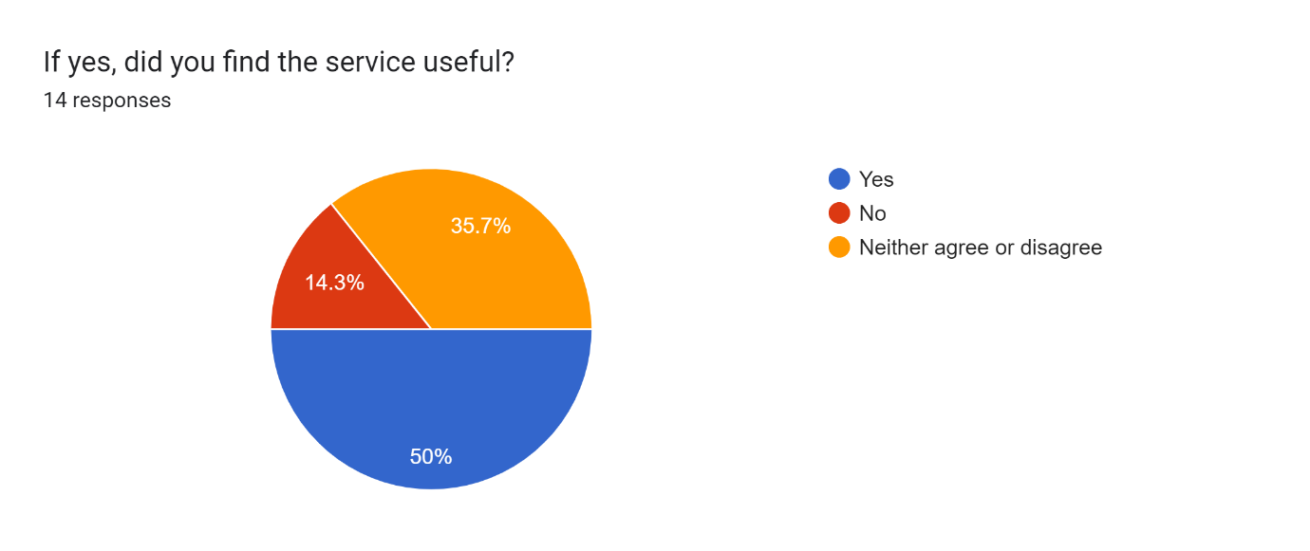
The remaining questions of the survey relate to mental health calls to police and how they affect front line officers. 66.7% of officers state that they deal with mental health calls every shift and 26.7% of officers stating that it is around 1-2 times per working set. A follow up questions asks whether police officers believe that they should have the responsibility of answering mental health calls. 70% of police officers in this survey believe that they should only attend if a crime has been committed alongside the mental health issues. The remaining 30% do not believe that police force should deal with any mental health calls and that this should purely be a health service job.
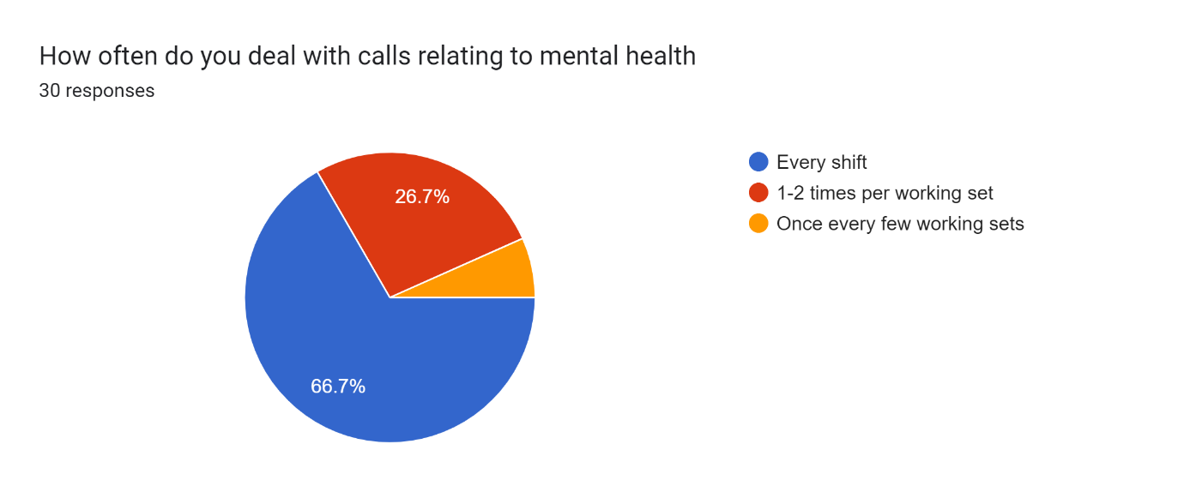
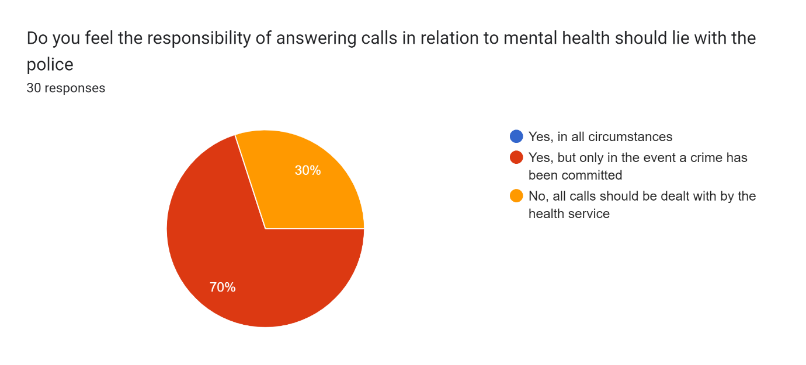
The next questions posed asks whether police officers believe they have sufficient training in the area of mental health. This was again an overwhelming majority of over 86% that do not believe the training is sufficient. Only 10% of police officers think that it is sufficient with 3.3% neither agreeing nor disagreeing. The final question asks if the respondent has ever felt stressed as a result of dealing with a mental health call. A vast majority of 70% of respondents believed that they have been stressed as a direct result of dealing with a mental health call. Only 20% of police officers believe that this type of call has caused them no extra stress and 10% of respondents neither agreed or disagreed.
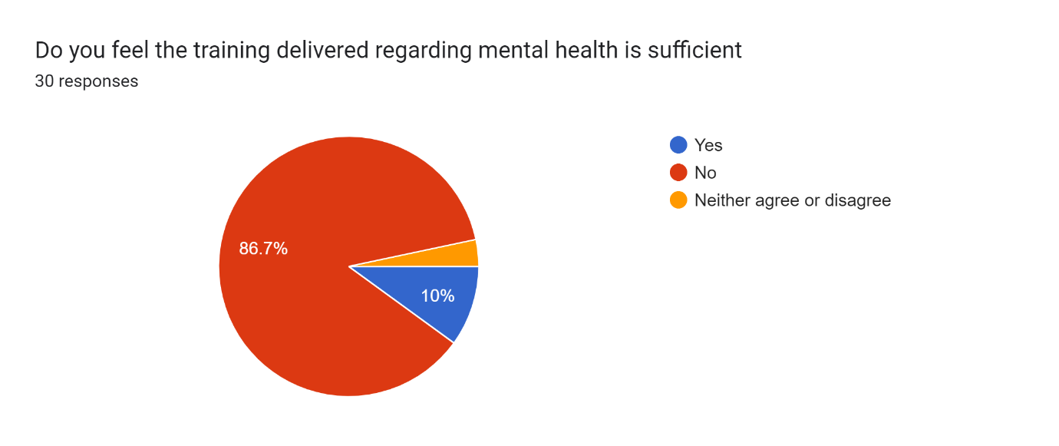

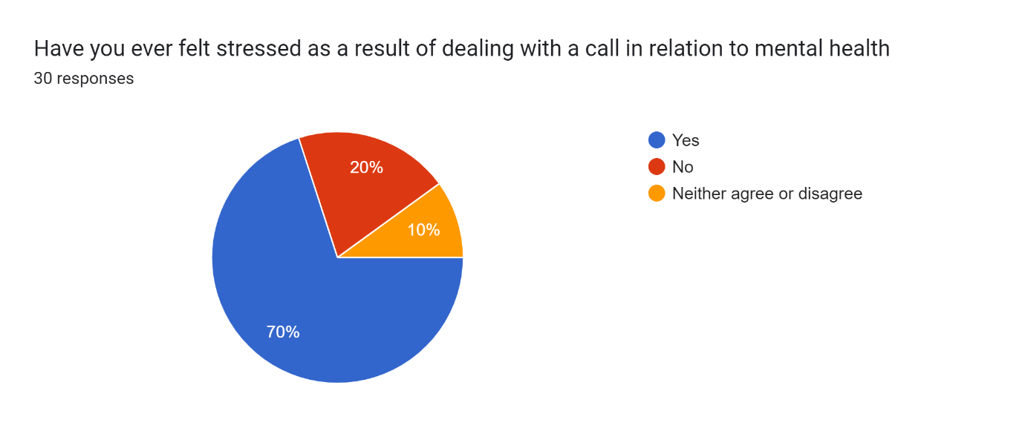

5.0 Findings, Conclusions and Recommendations
5.1 Main Findings
Findings of the primary research conducted support a significant amount of the literature that was reviewed in the initial research stages of this project, contained within the literature review chapter.
As a result of the findings, it is apparent that new police officers are experiencing increased levels of stress whilst in the role, many citing that the PCDA process and workload has placed further stress on them. Officers have also stated that increasing demand, particularly when relating to dealing with mental health calls, has placed stress on them.
A staggering 93.3% of respondents stated that they did not believe that role of police officer requires completion of a degree, which supports the opinion of Marc Jones, Police and Crime Commissioner, who stated that the PCDA route would mean the police would be missing out on significant experience of those who have different backgrounds such as military (Hubbert, 2022).
73% of respondents stated their experience of PCDA was either poor or extremely poor, with 77% of respondents stating that the PCDA workload is not manageable alongside working as an operational police officer, which reflects the concerns raised by the Police Federation chairs, Zoe Wakefield and Steve Treharne, who both expressed the high workloads of PCDA students was unmanageable and placed pressure on them (South Wales Police Federation, 2022 and Hampshire Police Federation, 2023).
A concerning 60% of respondents stated they considered leaving within their probationary period, mirroring the NPCC data released in 2022, whereby there were 2,567 leavers of 28,173 new police recruits (NPCC, 2022), with an overwhelming number of respondents stating that this was as a result of better pay prospects elsewhere, in addition to the stress of manging university work and the police work/life balance. This response also mirrors the opinion of the Police Federation, who do not believe that the wages paid to police officers are satisfactory to retain current officers and attract quality candidates to the role (Police Federation, 2022).
Respondents have also highlighted that the police workload also causes stress, suggesting that the years of austerity and lack of government funding has resulted in officers being ‘overwhelmed’ by their workloads, as highlighted by the PEEL Report (Police Federation, 2022), Even with the introduction of the PEQF scheme to recruit more officers being in its fourth year of operation.
Positive results show that majority of respondents are aware of support mechanisms in place for them in regard to their mental health, however only 14 of the 30 respondents states that they found the support tools available useful. Which can be argued that the resources available are deemed as not suitable by officers, or there could be a lack of engagement on behalf of the officers, as suggested by the study completed Edwards & Kotera in 2020, where it was outlined that emergency workers struggle to gain assistance when relating to their own mental health (‌Edwards & Kotera, 2020).
Furthermore, it is apparent that mental health calls take up a considerable amount of police time, 66% of respondents stating that they deal with a mental health related call every shift. This is an increase upon the figures reported by the report conducted by Lord Victor Adebowale in 2013, who stated 20% of an officer’s time was spent dealing with mental health. An alarming 70% of respondents stating they felt stressed as a result of dealing with a mental health call. 86% of respondents also stated that they felt the training delivered to them regarding mental health was not sufficient, which was highlighted already in the literature by Wondemaghen in 2011. It could be argued that stress is being caused by the lack of appropriate training officers are receiving to deal with mental health, in addition to 70% of respondents feeling that the mental health should only require a police response when a crime is committed. As covered in the literature, the current procedure outlined by the College of Policing whereby police are required to dispatched for a large manner of mental health calls, often with there not being crime attached (College of Policing, 2022).

5.2 Completion of Aims and Objectives
- Complete an evaluation of the demand PDCA entry route on current South Wales Police officers.
The first aim was completed within both the secondary literature chapter, in addition to Chapter 4 where primary research was conducted on serving South Wales Police officers. By reviewing secondary literature, the researcher was able to obtain clear objectives in relation to questions asked when compiling the online survey. The demand of the PCDA was highlighted in the responses obtained via the survey.
- Identify stress related factors as a result of being modern day police officer.
Aim 2 was also covered in the literature chapter whereby the researcher obtained literature to highlight was stressors are prevalent for operational police officers.
- Conduct a review additional responsibilities police officers have relating to mental health.
Mental health responsibilities were highlighted again as part of the literature review, where journals and online sources outlined that modern day policing has evolved to include significant responsibilities in relation to responding to mental health calls.

5.3 Limitations
It is worth highlighting that within the research conducted, there were a small number of limitations. The first limitation would be the time constraints on the project, given a number of external factors, more time spent on researching secondary research would have benefitted the project. Time constraints also meant that the primary data gathered was limited, and whilst there were 30 responses, further responses achieved over a longer period of time would have enhanced the quantitative data, and allowed for more accurate results, a wider scope of opinion and could have allowed for different trends and patterns to form.
It is also likely that officers completing the survey, are aware of the plans to allow for a non-degree entry route, which was not on offer upon the time of applying for them, resulting in some officers having negative feelings towards the process, as potential new applicants will be able to join without completing the additional work. Additionally, some of the respondents could also have a biased view in relation to dealing with mental health calls, as this topic has been raised by the Police Federation, and there will often be push back when asked to attend mental health calls by the control room.
Although a large amount of quantitative date was abstracted from survey completed, further qualitative data could have enhanced the primary data, by gaining individual opinions of officers in an interview setting, to allow respondents to speak freely, and provide their personal experiences and suggestions into improving stress management within the police.

5.4 Further Research
The research conducted by the researcher was that of a small scale, and a wider more extensive scale of research could be completed. The project’s size could be increased to include a bigger geographical area of South Wales PCDA officers, not just the Northern BCU, and could include the opinions of officers still completing basic training, to see whether there is a disparity between the officers on shift acting as an operational police officer, or the student officers who are still completing exams and classroom training.
5.5 Conclusions
To conclude, it is clear from both primary and secondary research conducted that police officers are under stress, with newer officers on the PEQF entry routes feeling that they do not require a degree to be a police officer, and the additional work causes further stress, which is in addition to an already stressful job role. However, although these feelings have been highlighted by a number of different sources, the government are yet to propose how they will alter the entry routes, so the PCDA process will continue until this has been laid out by those in command.
Research was also able to prove that a number of stressors frequent officers whilst carrying out their roles, including the high levels of workloads demonstrating that whilst efforts have been made to increase numbers on shifts, things such as workloads, low pay and juggling a degree have meant that further work is to be done in order to retain the recruits, in order to resolve the issue of there not being enough officers to manage workloads accordingly. Currently, it appears that the PCDA programme is resulting in new joiners leaving, and preventing some individuals with desire to join, due to them not wanting to complete a degree. Furthermore, the increased requirement on police intervention when it comes to mental health has demonstrated that this is further strain being placed on an already stretched workforce, with 87% of officers feeling unqualified to deal with such calls. Until proper and relevant investment into our current mental health service, this is unlikely to alter any time soon for police officers, and mental health service users.
This research project aimed to investigate the impact stress has on modern day police officers, highlights by both the primary and secondary research completed that the police service is an ever changing and evolving service, currently feeling the effects of lack of appropriate support from the government, which is directly impacting the wellbeing of officers. Strain on other areas such as mental health is also having a direct impact on officers. These issues have been ongoing since prior to the implementation of PEQF, however are continuing following 4 years of its implementation. This research will help highlight that further changes are required in both the recruitment of police, and within the mental health arena to assist with the stress of police officers.
5.6 Recommendations
Following the findings of this research project the researcher suggests the following recommendations in order to improve the impact of stress currently on the modern day police officer.
- Implementation of a non-degree entry route into policing
The first recommendation is for progression to be made in offering a non-degree entry route. Majority of respondents stated that they felt police officers do not require a degree to complete their job role effectively. This new entry route would also attract a wider range of potential candidates, those with high levels of experience whether this be backgrounds in armed forces, or students who would not consider themselves as academic, and could be deterred from the PCDA entry route. This would benefit existing teams, as persons with life experience would be able to offer a lot to response teams, creating a more diverse and representative workforce. Whilst the Home Secretary has recognised this in November 2022, in April 2023 there is no further update on when this will be put in place, as the stress of officers is at stake, it is important that progression is made here to retain the staff currently within the police constable role. This will also assist with getting more persons in role, to resolve issues highlighted with high workloads.
- Increased rate of pay
The second recommendation mirrors the requests of the Police Federation, and the respondents of the survey. It is clear that all potential stressors will not be resolved by removal of additional university work along side the role, as the role is inherently stressful. However, in order to ensure officers feel appropriately compensated for the stress they experience, pay should be of rate in order to co-inside with inflation. This will also reduce financial issues officers experience, whilst helping reduce the number of officers who leave due to financial prospects elsewhere outside of the police.
- Mental health investment in both Health Services and police mental health training
It is clear from the secondary research that police are picking up the pieces of a broken mental health system. Therefore, investment into health boards who deal with mental health is required. Within the primary research it was clear that officers are happy to deal with calls relating to mental health when there is a crime element, however, they still feel underqualified, so further training in the form of classroom training/workshops would benefit the officers when dealing with future incidents.

Word Count - 7448

Bibliography
Adebowale, V. (2013) Independent Commission on Mental Health and Policing Report. Available at: https://amhp.org.uk/app/uploads/2017/08/independent_commission_on_mental_health_and_policing_main_report.pdf (Accessed: April 9, 2023).

Blue Light Together. (n.d.). Sleep, shift work, and your mental health. [online] Available at: https://bluelighttogether.org.uk/all-services-draft/sleep-shift-work-and-your-mental-health/ [Accessed 20 Apr. 2023].

Çakmur H (2020) Introductory Chapter: How Does Stress Impact Human Body? Effects of Stress on Human Health. IntechOpen. DOI: 10.5772/intechopen.91984.
Charman, S. (2022). Police officer resignations have risen by 72% in the last year – we asked former officers why | University of Portsmouth. [online] www.port.ac.uk. Available at: https://www.port.ac.uk/news-events-and-blogs/blogs/democratic-citizenship/police-officer-resignations-have-risen-by-72-in-the-last-year-we-asked-former-officers-why. [Accessed 20 Apr. 2023].

Ciphr (2021). Workplace stress statistics: how stressed is the UK in 2021? [online] CIPHR. Available at: https://www.ciphr.com/workplace-stress-statistics/. Ciphr (2021). Workplace stress statistics: how stressed is the UK in 2021? [online] CIPHR. Available at: https://www.ciphr.com/workplace-stress-statistics/
‌College of Policing (2019). Introduction. [online] College of Policing. Available at: https://www.college.police.uk/career-learning/joining-police/joining-pcso/handbook/introduction. [Accessed 20 Apr. 2023].

College of Policing (2021). Why choose the Police Constable Degree Apprenticeship? [online] Available at: https://youtu.be/fpa1fq_MCUQ [Accessed 18 Apr. 2023].

College of Policing (2022). Mental health. [online] College of Policing. Available at: https://www.college.police.uk/app/mental-health. [Accessed 20 Apr. 2023].

‌College of Policing, (2021) Equality impact analysis Implementation of the new entry routes for police constables. Available at: https://assets.college.police.uk/s3fs-public/2021-09/peqf-equality-impact-analysis-pc-initial-entry-routes-v15.0.pdf. (Accessed: April 9, 2023).

Cordina-Duverger, E. et al. (2018) ‘Night shift work and breast cancer: a pooled analysis of population-based case-control studies with complete work history’, European journal of epidemiology, 33(4), pp. 369–379. Available at: https://doi.org/10.1007/s1065
Cornell, J. (2021). Advantages & Disadvantages of Online Surveys - ProProfs. [online] ProProfs Survey Blog. Available at: https://www.proprofssurvey.com/blog/advantages-disadvantages-of-online-surveys/. [Accessed 20 Apr. 2023].
‌Edwards, A.M. & Kotera, Y. (2020). Mental health in the UK police force: A qualitative investigation into the stigma with mental illness. International Journal of Mental Health and Addiction. Available at https://repository.derby.ac.uk/download/11fe38297c6d6477f3f882b0aef0f16a19953f1ab7c1496a152e4f6ab2a20385/323818/Mental%20Health%20in%20the%20Police%20Force.pdf [Accessed 20 Apr. 2023].
Hampshire Police Federation, (2023). Officers are leaving the force early as juggling a degree while working as an officer is too demanding [online] Available at: https://hantsfedfocus.co.uk/officers-are-leaving-the-force-early-as-juggling-a-degree-while-working-as-an-officer-is-too-demanding/. (Accessed: April 9, 2023).

Harkness, Kate L., and Elizabeth P. Hayden, 'Introduction', in Kate L. Harkness, and Elizabeth P. Hayden (eds), The Oxford Handbook of Stress and Mental Health, Oxford Library of Psychology (2020; online edn, Oxford Academic, 7 June 2018), https://doi.org/10.1093/oxfordhb/9780190681777.013.36, accessed 6 Apr. 2023.
Hill B, Paynich R (2014) Fundamentals of Crime Mapping. 2nd ed. Burlington, MA: Jones and Bartlett Learning.

HMICFRS. (2018) Policing and mental health: Picking up the pieces (no date) His Majesty's Inspectorate of Constabulary and Fire &amp; Rescue Services (HMICFRS) . Available at: https://www.justiceinspectorates.gov.uk/hmicfrs/publications/policing-and-mental-health-picking-up-the-pieces/ [Accessed 18 Apr. 2023].
Home Office (2019). National campaign to recruit 20,000 police officers launches today. [online] GOV.UK. Available at: https://www.gov.uk/government/news/national-campaign-to-recruit-20000-police-officers-launches-today.

Home Office (2023). Police workforce, England and Wales: 30 September 2022. [online] Available at: https://www.gov.uk/government/statistics/police-workforce-england-and-wales-30-september-2022/police-workforce-england-and-wales-30-september-2022#:~:text=As%20at%2030%20September%202022%2C%20there%20were%20142%2C145%20FTE%20police. [Accessed 18 Apr. 2023].

Home Office. (2022.). Police workforce, England and Wales: 31 March 2022. [online] Available at: https://www.gov.uk/government/statistics/police-workforce-england-and-wales-31-march-2022/police-workforce-england-and-wales-31-march-2022#promotions-joiners-and-leavers.
https://www.npcc.police.uk/SysSiteAssets/media/downloads/publications/publications-log/2022/npccs-prrb-2022-submission.pdf (Accessed: April 9, 2023).
Hubbert, A (2022) Lincolnshire PCC wins battle to scrap degrees for new police officers. Available at: https://www.lincolnshireworld.com/education/lincolnshire-pcc-wins-battle-to-scrap-degrees-for-new-police-officers-3920570 (Accessed: April 10, 2023).
‌ Joining the Police. (n.d.). Police Apprenticeship and Traditional Entry. [online] Available at: https://www.joiningthepolice.co.uk/application-process/ways-in-to-policing/apprenticeship-pcda-entry-route#:~:text=The%20PCDA%20training%20focuses%20on [Accessed 18 Apr. 2023].

Laura Boulton, Michelle McManus, Lauren Metcalfe, David Brian, and Ian Dawson (2016) The Police Journal 90:1, 70-85, https://doi-org.ezproxy.uwtsd.ac.uk/10.1177/0032258X16671032
Lockwood, M. (2020). Why independent scrutiny of police matters | Independent Office for Police Conduct. [online] Available at: https://www.policeconduct.gov.uk/news/our-podcasts-and-blogs/why-independent-scrutiny-police-matters. [Accessed 18 Apr. 2023].

Mental Health Foundation (2018). Stressed nation: 74% of UK ‘overwhelmed or unable to cope’ at some point in the past year. [online] www.mentalhealth.org.uk. Available at: https://www.mentalhealth.org.uk/about-us/news/survey-stressed-nation-UK-overwhelmed-unable-to-cope.

Mind (2019). Nearly 8 in 10 police officers recently felt stressed, finds Police Federation. [online] Available at: https://www.mind.org.uk/news-campaigns/news/nearly-8-in-10-police-officers-recently-felt-stressed-finds-police-federation/. [Accessed 18 Apr. 2023].

Norfolk Police Federation (2022). Police Degrees: Being a great cop doesn’t necessarily include being able to write a dissertation. [online] Available at: https://www.polfed.org/norfolk/news/2022/police-degrees-being-a-great-cop-doesn-t-necessarily-include-being-able-to-write-a-dissertation/ [Accessed 18 Apr. 2023].

NPCC, (2022) Eighth Submission to the Police Remuneration Review Body. Available at:
Ortmeier, P., Boston, P., Indianapolis, C., York, N. and Francisco, S. (2010). Challenges for the 21 st Century Second Edition. [online] Available at: https://testbank4textbook.com/pdf_samples/Solutions_Manual_for_Leadership_Ethics_and_Policing_Challenges_for_the_21st_Century_2nd_Edition_by_Ortmeier_sample_chapter.pdf.
‌Oscar Kilo. (2022). Oscar Kilo. [online] Available at: https://www.oscarkilo.org.uk/. [Accessed 20 Apr. 2023].

Police Federation (2018). Substantial cuts and extra workload demands are ‘overwhelming’ police officers. [online] Available at: https://www.polfed.org/gmp/news/2018/substantial-cuts-and-extra-workload-demands-are-overwhelming-police-officers/.

Police Federation (2019). Officers Bearing Brunt of Disorganised College of Policing Scheme. [online] www.polfed.org. Available at: https://www.polfed.org/news/latest-news/2019/officers-bearing-brunt-of-disorganised-degree-scheme/. (Accessed: April 10, 2023).

Police Federation (2022) Pay and morale. [online] Available at: https://www.polfed.org/resources/pay-and-morale/. [Accessed 10 Apr. 2023].

Police Federation (2022). National Chair Steve Hartshorn responds to police officers being asked to drive ambulances. [online] Available at: https://www.polfed.org/news/latest-news/2022/national-chair-steve-hartshorns-response-to-request-police-officers-cover-striking-ambulance-drivers/ [Accessed 10 Apr. 2023].

Robertson, D. (2023). Police union warns right to strike could be challenged without fair pay deal. [online] www.shropshirestar.com. Available at: https://www.shropshirestar.com/news/crime/2023/03/07/police-union-warns-right-to-strike-could-be-challenged-without-fair-pay-deal/[Accessed 10 Apr. 2023].

Sarah Charman & Stephanie Bennett (2022) Voluntary resignations from the police service: the impact of organisational and occupational stressors on organisational commitment, Policing and Society, 32:2, 159-178, DOI: 10.1080/10439463.2021.1891234

Shane, J. (2019). Stress Inside Police Departments (1st ed.). Routledge. https://doi.org/10.4324/9780429297229

Sondhi, A. et al. (2018) ‘Patient perspectives of being detained under section 136 of the Mental Health Act: Findings from a qualitative study in London’, Medicine, science, and the law, 58(3), pp. 159–167. Available at: https://doi.org/10.1177/0025802418774966.
South Wales Police Federation (n.d.). Federation calls for transparency around police recruitment [online] Available at: https://www.swpf.org/localnewsprint.php?LocalNewsID=220 [Accessed 18 Apr. 2023].

South Wales Police Federation. (n.d.). South Wales Police Federation. [online] Available at: https://www.swpf.org/index.php [Accessed 20 Apr. 2023].

Statista. (n.d.). Police officer figures England and Wales 2022. [online] Available at: https://www.statista.com/statistics/303973/police-officer-figures-england-and-wales/.

Syngress. Scene of the Cybercrime: Computer Forensics Handbook. Syngress; 2002. Accessed April 6, 2023. https://search-ebscohost-com.ezproxy.uwtsd.ac.uk/login.aspx?direct=true&db=nlebk&AN=75927&site=ehost-live)
Tyreman, J. (2019). In-Depth Interview vs Online Survey: A Marketing Director’s Guide to Brand Research Data Collection | Hinge Marketing. [online] Hinge Marketing. Available at: https://hingemarketing.com/blog/story/in-depth-interviews-vs-online-surveys-a-marketing-directors-guide-for-brand. [Accessed 20 Apr. 2023].

Tyson, J., Charman, S. and Conversation, T. (2022). UK police officer resignations have risen by 72% in the last year—we asked former officers why. [online] phys.org. Available at: https://phys.org/news/2022-11-uk-police-officer-resignations-risen.html.
Wondemaghen, M. (2021) “Policing mental illness: Police use of section 136 – perspectives from police and mental-health nurses,” Medicine, Science and the Law, 61(4). Available at: https://doi.org/10.1177/0025802421993363.

Appendix 1 – Survey Questions
- Select your Rank
Police Constable
Detective Constable
Police Sergeant

- Select your length of service
0-12 months
1-2 years
2-3 years
3-4 years
4+ years

- Do you believe a police officer requires a university degree
Yes
No
Neither agree or disagree

- Did the officer of obtaining a degree in Professional Policing Practice positively impact your choice in joining the police
Yes
No
Neither agree or disagree

- What is your experience of the PCDA programme
Excellent
Good
Fair
Poor
Extremely poor

- Do you believe the PCDA workload is manageable alongside working as a full time police officer
Yes
No
Neither agree or disagree

- Have you considered leaving the police during your probation
Yes
No

- If you answered yes to the above question, what has made you consider leaving the police
Issues in personal life
Managing police work load
Difficult and traumatic calls
Issues with management
Managing degree assignments with balancing work and personal life
Financial concerns
Public/media scrutiny
Better pay/prospects elsewhere
Other

- If selected other, please state below

- Have you experienced levels of stress during your time as a police officer
Yes
No
Neither agree or disagree

- If you answered yes to the above question, what was the cause of your stress? Please select all that apply
Issues in personal life
Managing police work load
Difficult and traumatic calls
Issues with management
Managing degree assignments with balancing work and personal life
Financial concerns
Public/media scrutiny
Other

- If selected other, please state below

- Are you aware of what support is available in relation to mental health and wellbeing
Yes
No

- Have you ever utilised any of the support options in place, such as TRiM and Occupational Health
Yes
No
Prefer not to say

- If yes, did you find this service useful
Yes
No
Neither agree or disagree

- How often do you deal with calls relating to mental health
Every shift
1-2 times per working set
Once every few working sets

- Do you feel the responsibility of answering calls in relation to mental health should lie with the police
Yes, in all circumstances
Yes, but only in the event a crime has been committed
No, all calls should be dealt with by the health service

- Do you feel the training delivered regarding mental health is sufficient
Yes
No
Neither agree or disagree

- Have you ever felt stressed as a result of dealing with a call in relation to mental health
Yes
No
Neither agree or disagree

Appendix 2 – Results of Survey



