Effective team working and communication

Component 1 – Report on Effective Teamworking for business success

Student Name: Andreea Alina Tudorache

Student ID number: 2130698

Module name: Effective Team Working and Communication (BMSW4002_BIRM)
Lecturer name: Hafiz Rahmani

Summary:
The term teamwork refers to a group of people all working together to achieve a common goal. Team working is crucial for the success of any business. This report uses a case study of Amazon to focus on analysing the different techniques that can be utilised to establish an effective team, as well as the different models of team development that can be applied. The report also analysed the team roles that are necessary to establish a successful team, as well as the benefits of teamwork and the barriers that were identified in this scenario that prevented effective teamwork from occurring.

Table of Contents
Summary: 2
Introduction: 5
Team and teamwork: 5
Characteristics of teamwork: 5
Team development Models: 6
The Bruce Tuckman (five stages model): 6
The T7 Model: 7
Roles and theories of an Effective Team: 8
Leader: 9
Executive Producer: 9
Facilitator: 9
Member: 9
Advantages of Effective Team working: 10
It Enhances Motivation: 11
Problem-solving: 11
It builds trust: 11
Improves Productivity: 11
Barriers to Effective Teamwork 11
No trust among team members: 12
Gender differences in team: 12
Unclear goals: 12
Lack of Management Involvement: 12
Conclusion and Recommendations 12
References: 14

Introduction:
Teamwork is "the method of combining the efforts of individuals to accomplish a common objective," as defined by the Oxford English Dictionary. Colleagues need to be able to work effectively together and put up their best effort no matter the circumstances. Therefore, teamwork is often essential in the workplace (Meslec et al., 2020). The report will discuss the term teamwork with its characteristics. In addition, the report will also elaborate on the models of teamwork. Moreover, the study will evaluate the role of teamwork and advantages of teamwork and the barriers to team working.

Team and teamwork:
The term teamwork refers to a group of people all working together to achieve a common goal. Teamwork is defined as "the action of collaborating with other individuals to achieve collective goals. When people are working together as a team, they put aside their differences and endeavour to achieve their goals by sharing information, utilising each other's strengths, and offering criticism to improve. Teamwork is more than just the coordinated efforts of several individuals. Collaboration is the capacity to collaborate with others to maximise individual and group performance toward common goals. Additionally, the ability to work effectively with others is one of the most desirable traits by employers. Having mutual trust amongst employees is the primary benefit of cooperation in the workplace. There are several different reasons why this is the case. Productivity rises, and morale soars when workers work well together. As a result, coworkers are more likely to support one another and work together toward common goals (Ozkan et al., 2022).

Characteristics of teamwork:
Good teamwork is related to productivity, engagement, satisfaction, and creativity. Working as a team increases motivation and working together has several personal and social benefits. There are several characteristics of effective teamwork, such as:
Team members recognise their reliance on one another. They appreciate the value of working toward common objectives. Understanding this means less time and energy is spent on petty arguments and attempts to advance one's own interests at the cost of that of others.
Teamwork fosters an environment where members feel safe to share their ideas and opinions without fear of retaliation. Members of the team are more likely to ask probing questions and come up with new approaches to issues while working in such an atmosphere (Meslec et al., 2020).
Team members take pride in their work and their team because they have a vested interest in its success. They care more about the team's success than they do about their own social standing.
Members of a team are more likely to use their skills and expertise to further the team's goals, which in turn benefits the company as a whole.
Team members are always comfortable talking to one another. They make sure they are on the same page. Building a trustworthy environment amongst the team is aided by this.
Good Teams inspire its members to grow professionally via experiential learning. Teams encourage members who seek knowledge and improvement. This is the deciding factor between success and failure and has a direct bearing on overall performance.
A strong team will be able to address disagreements promptly and effectively. It is safe for team members to be honest with one another, and they do so openly (Peralta et al., 2018).

Team development Models:

The Bruce Tuckman (five stages model):
It is impossible to anticipate peak performance from a newly established team immediately. Putting together a team is a lot like keeping a friendship alive. Forming a cohesive group out of a disparate collection of individuals who started out as strangers takes time, support, patience work, and, in many cases, a predictable progression through a series of phases.
A five stages model for group development was given by Bruce Tuckman, who identified five stages: “forming”, “storming”, “norming”, and “performing”. Bruce Tucuman's Model is the best Model for the development of the team. The Bruce Tuckman (five stages model) was first developed by Bruce Tucuman in 1965.
Forming stage: The first step in building a team is to establish its foundation. Group members are still in the process of figuring out their roles, the group's rules, and the range of behaviour that is considered appropriate.
Storming Stage: Interpersonal arguments are highlighted at this point in the task and procedural structuring process. At this point, leadership, power and structure are at the core.
Norming: At this stage in their development, teams create new approaches to working and interacting. When a team becomes cohesive, leadership accountabilities are shared between all members. Team members get an appreciation for the importance of trust among themselves in the context of shared leadership.
Performing: When a group reaches this point, true interdependence is the norm. Team members are adaptable, so they can always satisfy the requirements of their co-workers.
Adjourning: Now, the project is coming to a close, and its participants are dispersing to pursue other interests. During this phase, the team's well-being rather than the team's ability to solve a problem is prioritised (Noor et al., 2022).
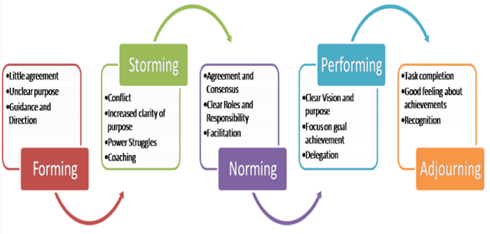
Figure 1(source: The Tuckman Model of team development)

The T7 Model:
With the goal of deciphering what makes the team successful, Michael Lombardo and Robert Eichinger created the T7 Model in 1995. They identified seven determinants, five internal and two externals, all beginning with the letter "T". This Model is most effective for users to large teams, and it evaluates individuals based on their actions and abilities while also evaluating the group against specified standards for cohesiveness and productivity. The T7 team concept classifies team members into seven distinct roles. Team leaders can use an honest assessment of their members' abilities to establish realistic goals for the group. The 7 Ts are:
Internal factors: Thrust, Trust, Talent, Teaming Skills, and Task skills.
External factors: Team Leader Fit and Team support from the organisation.
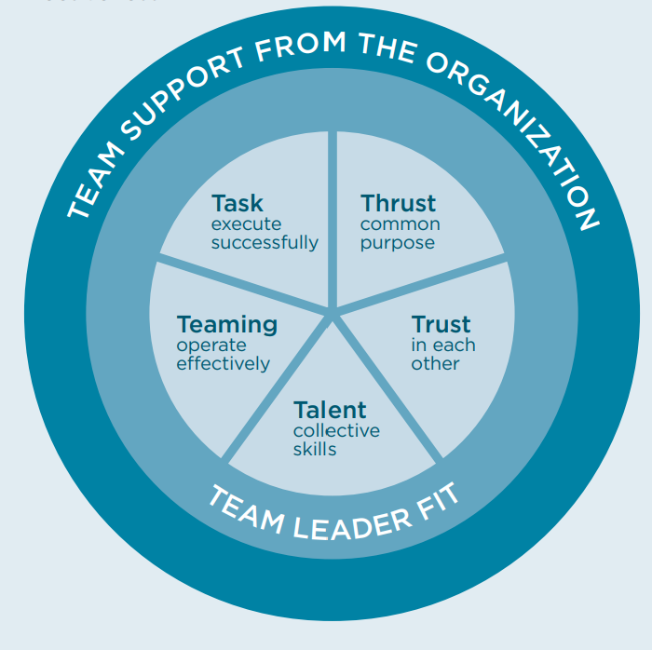
Figure 2 (Source: The T7 Model of Team Development)

Roles and theories of an Effective Team:
Working together as a team is essential for accomplishing organisational goals because it maximises the use of available resources, knowledge, and manpower. A well-functioning team is predicated on the principle of synergy, which states that the output of the team will be more than the sum of the contributions of its individual members. Therefore, teams are often small groups of individuals whose individual responsibility is to complete a single, well-defined task that contributes to the overall performance of the firm.
Team roles and responsibilities are the duties that are expected of an employee in their specific position. It is crucial that responsibilities be laid out in detail since each team member has many roles and is accountable for a wide variety of daily chores that have common themes. At a time, different individuals have a different role to perform. Leader, creative director, facilitator, and member are some important roles of an effective team (Solomon, 2020).

Leader:
It is the leader's responsibility to establish norms for team behaviour, inspire its members to achieve shared goals, and develop their potential as individuals and as a group for the team's success. Leaders are responsible for every aspect of the operation, including the nature of communications and the accuracy of reporting. A leader's ultimate responsibility is to see to it that the team's collective mission is accomplished in a way that accounts for everyone's specific contributions (Solomon, 2020).

Executive Producer:
A team is always better off with at least one member who can think creatively and bring fresh ideas to the table. It protects the group from festering and encourages them to always strive for better results. The role of the creative director is to help a team keep up a positive momentum that is essential to the group's success.

Facilitator:
A facilitator's job is to make sure the team knows what they are working toward and has the resources they need to get there. This is how a facilitator guides a group to success.

Member:
Effective team members need to show up to meetings and do any tasks they have been given. Members contribute to meetings and webinar platforms for support, brainstorming, and idea development. Team members should be in constant contact with the manager; they should know exactly what is expected of them (Noor et al., 2022).
The concept of team roles is crucial to success in team development. Using the Belbin Model, a skilled facilitator may better understand the underlying strengths and limitations of any team, making it a valuable tool for more advanced team-building activities. These patterns, once acknowledged, allow a team to better manage its shortcomings and utilise its strengths, particularly when existing biases snitch in under real-world pressure.
"A team is not a group of people with job roles but rather a congregation of individuals, each of whom has a function that is understood by other members." That's the foundation on which the notion of team roles developed by Meredith Belbin rests. The success of a group depends on the efforts of each individual member. Managers and leaders may make better use of their team's structure if they have a firm grasp of the contributions made by each position. Belbin's theory defines team roles as, Coordinator, The Plant, The Shaper, Resource Investigator, Monitor Evaluator, Implementer Complete Finisher, team worker, and Specialist. It is very important to consider all these roles when selecting team member because it plays a key role in the success of teamwork and the business (Meslec et al., 2020).
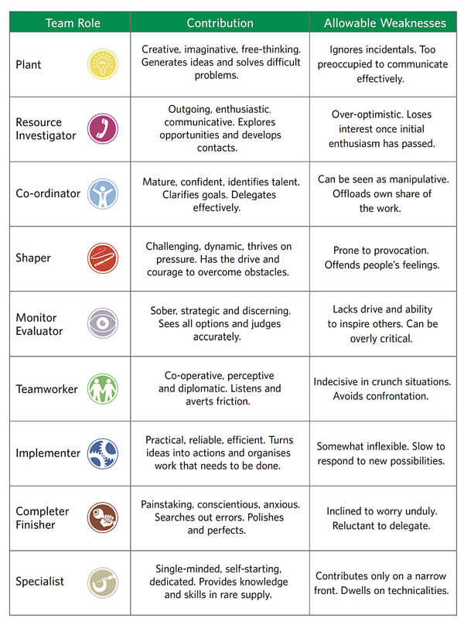
Figure 3: Roles of Effective Team

Advantages of Effective Team working:
Workplace teamwork is becoming increasingly essential. Teamwork has several benefits, from increased output to a more pleasant workplace. When individuals work together on a business project, they can share ideas and perspectives and benefit from each other's unique set of skills and capabilities (Solomon, 2020). There are several potential benefits to teamwork, including:

It Enhances Motivation:
Working in a team may motivate individuals to get things done since they will feel a sense of pride in contributing to the group's achievements. This can lead to an efficient work environment.

Problem-solving:
With the help of one another, a high-performing team may provide several potential solutions to any given problem, from which the most efficient can be determined. Typically, people have fewer options when it comes to coming up with a solution.
Enhances Flexibility:
Every member of the team understands his or her place in the operation and is prepared to step in and help if necessary. This allows for a more flexible group that can better respond to changing circumstances.

It builds trust:
When people work together, they form a close relationship and develop a sense of friendship. When people feel secure with one another at work, they are more likely to share and support one another, and they trust each other.

Improves Productivity:
Teams that put forth the effort to communicate and work together are more likely to achieve their objectives and goals. Teamwork increases productivity (Peralta et al., 2018).

Barriers to Effective Teamwork
Teamwork among workers is crucial to any company's success. However, working together is not always easy. This demands a significant investment of time and energy on the part of managers and executives. Some of the barriers to effective team working are:

No trust among team members:
Building trust amongst team members is crucial for successful collaboration. It is impossible for team members to rely on one another for help and resources if they do not trust one another. Conflicts and misunderstandings within a team can also be caused by a lack of trust among members of the team (Noor et al., 2022).

Gender differences in team:
Although it may seem ancient, there are still gender distinctions in teams. Different communication methods and patterns between sexes have been documented. Team members who are unaware of this may make assumptions that trigger disagreements (Meslec et al., 2020).

Unclear goals:
Members of a team are less likely to cooperate if they are not working for a common purpose. It can increase disagreements between members.

Lack of Management Involvement:
A company's success may be traced back to its leadership, which must be both strong and visionary. Leaders are essential for optimising productivity in a team setting. The inability of a team to reach its full potential is due to ineffective leadership (Kano et al., 2016).

Conclusion and Recommendations
In conclusion, working as a team is essential to achieve goals. It helps companies to generate more revenue in a short time. It is suggested that companies offer a supportive environment and make strategies regarding team works to achieve their goals. Through an open communication channel, companies can improve the team working.
Without teamwork, a group of smart people will be less productive. Companies without strong teams will lag rivals with them. Multiple studies show that encouraging workplace cooperation increases productivity, work quality, creativity, innovation, and employee satisfaction. Diverse teams should be prioritised above homogenous ones. It's human nature to seek out and be around like-minded people. Unclear positions and responsibilities cause conflict on a team. Everyone on the team must know their responsibilities for maximum efficiency. Miscommunication about responsibilities wastes employees' time and the team's effort.

References:
Burgess, C.T., Adkins, J., Suniga, N. and Mbanaja-Opara, F., 2021. Blending Leadership Roles and Theories in Today's Multi-Generational Organisational Culture: A Practical Review of the Organisational Culture. Handbook of Research on Multidisciplinary Perspectives on Managerial and Leadership Psychology, pp.42-61.
Dyson, B., Howley, D. and Shen, Y., 2021. ‘Being a team, working together, and being kind’: Primary students’ perspectives of cooperative learning's contribution to their social and emotional learning. Physical education and sport pedagogy, 26(2), pp.137-154.
Kano, A., Sonoda, A., Schultz, D., Usukura, A., Suga, K. and Yasu, Y., 2016. Barriers to effective team teaching with ALTs. Focus on the learner, pp.74-82.
Meslec, N., Duel, J. and Soeters, J., 2020. The role of teamwork on team performance in extreme military environments: an empirical study. Team Performance Management: An International Journal.
Noor, N., Rufino, K.A., Patriquin, M.A., Oldham, J.M. and Rohr, J.C., 2022. Impact of personality dysfunction on interdisciplinary treatment team working alliance in an inpatient psychiatric population. Personality Disorders: Theory, Research, and Treatment.
Ozkan, N., Erdil, O. and Gök, M.Ş., 2022, January. Agile Teams Working from Home During the Covid-19 Pandemic: A Literature Review on New Advantages and Challenges. In International Conference on Lean and Agile Software Development (pp. 38-60). Springer, Cham.
Peralta, C.F., Lourenço, P.R., Lopes, P.N., Baptista, C. and Pais, L., 2018. Team development: definition, measurement and relationships with team effectiveness. Human Performance, 31(2), pp.97-124.
Solomon, D., 2020. The Worth of Steady Digital Team Formation Strategy A Case Study of Bruce Tuckman's Model in the Software Industry.

