

Programme: Master of Business Administration in International Business
Module: Strategic Management
Module code: LCMB7003
Assignment Title: Assessment component - Individual report
Word count: 5260
Lecturer: Ejike Udeogu (Birmingham)
Student Name: Harshkumar Mangarola
Student ID: 2505073
Submission Date: 1st April 2026

Table of Contents:

Section 1: Strategic Management Analysis of Apple Inc. 3
1. Organisational Context and Overview 3
2. External and Internal Environment Analysis 6
2.1 External Environment Analysis: PESTEL Framework 6
2.2 Critical Success Factors and Strategic Challenges 9
2.3 Internal Environment Analysis: Resources and Capabilities 10
2.4 VRIO Analysis of Strategic Capabilities 10
2.5 Internal Strengths and Competitive Advantage 12
2.6 Industry Analysis Using Porter’s Five Forces 14
3. CSR and Sustainability Objectives 16
4. Comprehensive and Holistic View: Balanced Scorecard 17
5. Strategic Choices and Implementation 20
6. Strategic Evaluation and Recommendations 22
Section 2: Reflective Account on the Strategic Management Analysis of Apple Inc. 25
1. Description 25
2. Feelings 25
3. Evaluation 26
4. Analysis 26
5. Conclusion 27
6. Action Plan 28
References 28

Section 1: Strategic Management Analysis of Apple Inc.

1. Organisational Context and Overview
Apple Inc. is a globally recognised multinational technology corporation founded in 1976 by Steve Jobs, Steve Wozniak, and Ronald Wayne. Initially established as a personal computer manufacturer, Apple has evolved into one of the world’s most valuable and influential organisations, operating across consumer electronics, software, and digital services. Headquartered in Cupertino, California, the company serves a diverse global customer base spanning both developed and emerging markets, supported by a tightly controlled and highly integrated global value chain (Grant, 2019).
Apple’s mission emphasises delivering the best possible user experience through the seamless integration of innovative hardware, software, and services. Its long-term vision is centred on simplicity, creativity, and technological excellence rather than volume-driven growth or price-based competition. This strategic orientation differentiates Apple from many competitors that pursue rapid market expansion and broad product portfolios. Instead, Apple deliberately limits the range of products it offers, focusing on refinement, premium positioning, and ecosystem coherence to strengthen brand loyalty and customer retention (Johnson, Scholes and Whittington, 2020).
The company’s business model is vertically integrated and ecosystem-based, allowing Apple to exercise significant control over design, development, and distribution activities. Apple designs its own hardware, develops proprietary operating systems such as iOS and macOS, and manages tightly controlled distribution channels including the App Store and Apple Retail Stores. Revenue generation is primarily driven by hardware sales, particularly the iPhone, which remains the company’s flagship product. This is complemented by a rapidly expanding services segment encompassing digital subscriptions, cloud services, media content, and financial technology offerings. The integration of products and services increases customer switching costs and enables Apple to capture value across multiple stages of the value chain, reinforcing long-term customer lock-in (Porter, 1985; Prahalad and Hamel, 1990).
Apple operates within the highly competitive global technology and consumer electronics industry. Its key competitors include Samsung in smartphones and consumer electronics, Microsoft in computing solutions and operating systems, and Google in digital platforms and services. Despite intense rivalry and rapid technological change, Apple maintains a strong market position through differentiation rather than cost leadership. Its competitive advantage is derived from strong brand equity, distinctive design capability, consistent innovation, and deep ecosystem integration. Consequently, Apple is widely regarded as an organisation that sustains competitive advantage through strategic discipline, long-term investment, and effective alignment between corporate objectives and operational execution (Barney, 1991; Porter, 2008).
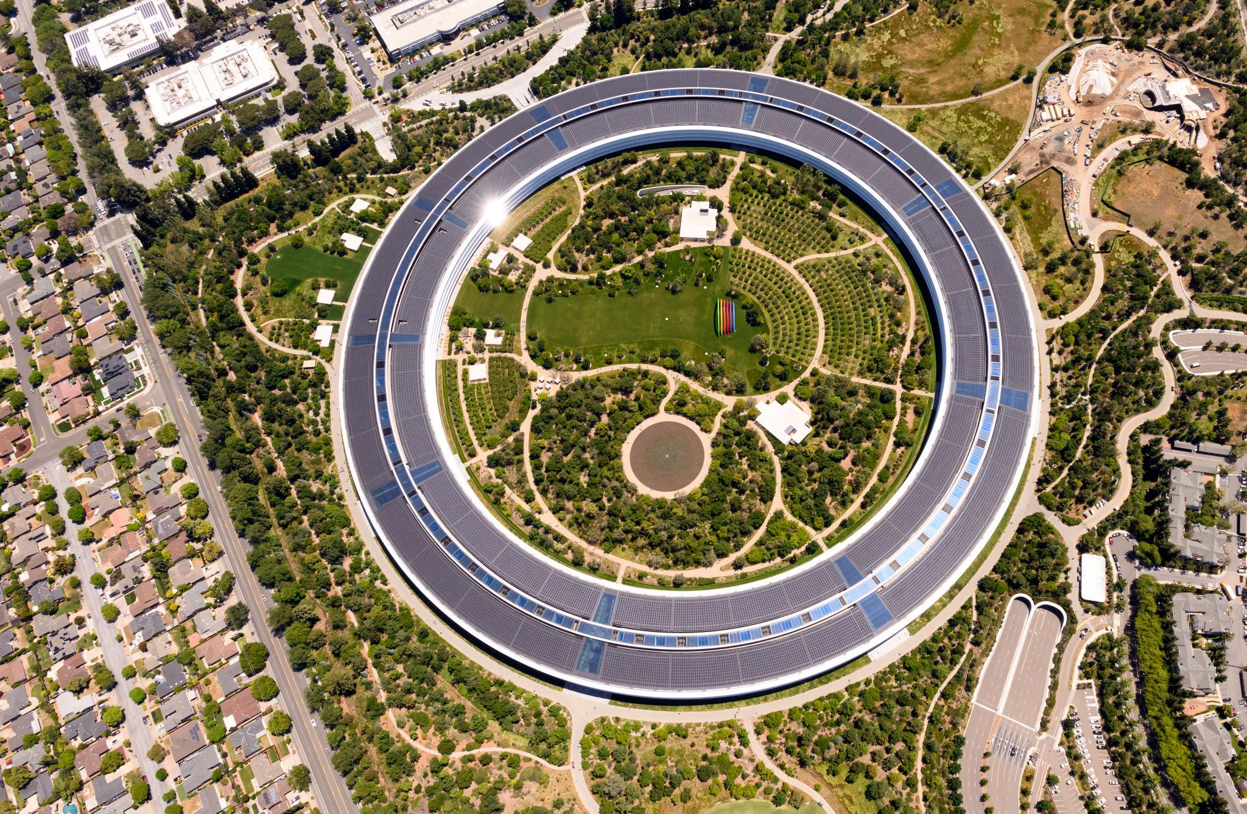







Figure 1: Corporate identity, headquarters, and core product portfolio of Apple Inc.
Source: Apple Inc. (2024)

2. External and Internal Environment Analysis

2.1 External Environment Analysis: PESTEL Framework
The external environment plays a critical role in shaping Apple’s strategic decisions, particularly given the firm’s global footprint and reliance on complex international supply chains. A PESTEL analysis enables a structured evaluation of the political, economic, social, technological, environmental, and legal factors influencing organisational strategy and long-term competitiveness (Johnson, Scholes and Whittington, 2020).
Political factors significantly affect Apple due to its dependence on international manufacturing and cross-border trade. Geopolitical tensions, particularly between the United States and China, pose supply chain risks and cost uncertainties. In response, Apple has strategically diversified parts of its manufacturing operations to countries such as India and Vietnam. While this reduces political risk exposure, it also increases coordination complexity and operational costs, presenting a strategic trade-off between resilience and efficiency (Grant, 2019).
Economic factors, including inflation, interest rates, and exchange rate volatility, influence consumer purchasing power and production costs. Apple’s premium pricing strategy makes it relatively resilient to short-term economic fluctuations in developed markets; however, economic downturns may constrain demand growth in price-sensitive regions. Conversely, rising disposable incomes in emerging economies present long-term expansion opportunities, albeit with limitations due to affordability constraints. This reflects the strategic tension between growth and brand positioning faced by differentiated firms (Porter, 1985).
Social factors reflect changing consumer lifestyles and increasing dependence on digital technology. Growing demand for smartphones, wearable devices, and digital services aligns strongly with Apple’s ecosystem strategy. At the same time, heightened societal expectations regarding ethical sourcing, labour standards, and data privacy place reputational pressure on the firm. Apple must therefore balance innovation and profitability with stakeholder trust and social legitimacy, as failure to do so may erode brand value (Carroll, 1991).
Technological factors are central to Apple’s competitive positioning. Rapid advancements in artificial intelligence, semiconductor design, and software integration require continuous innovation. Apple’s internal control over hardware–software integration allows it to optimise performance and security, reinforcing differentiation. However, shortened product life cycles increase research and development costs and heighten the risk of technological obsolescence (Teece, Pisano and Shuen, 1997).
Environmental factors have become increasingly prominent as regulators, investors, and consumers scrutinise corporate environmental performance. Apple faces challenges related to carbon emissions, electronic waste, and resource consumption. In response, the company has invested in renewable energy, recycled materials, and carbon neutrality initiatives, embedding sustainability considerations into long-term strategic planning. These initiatives support both regulatory compliance and reputational advantage (Elkington, 1997).
Legal factors include data protection regulations, intellectual property laws, and competition policy. Antitrust investigations related to app marketplace practices represent ongoing strategic constraints, potentially affecting Apple’s services revenue and ecosystem control. Such legal pressures reduce strategic autonomy and necessitate adaptive governance mechanisms (Porter, 2008).
From a strategic management perspective, the cumulative impact of these PESTEL factors underscores the complexity of Apple’s external operating environment. Political and legal pressures constrain strategic autonomy, while technological and social forces simultaneously create opportunities for innovation-led differentiation. The interaction between environmental regulation and technological capability further highlights the need for strategic alignment between sustainability initiatives and product development. Consequently, Apple’s ability to sustain competitive advantage depends not only on responding to individual external forces but also on integrating macro-environmental insights into coherent strategic decision-making, reinforcing the importance of dynamic strategic capabilities in managing uncertainty and long-term risk (Teece, Pisano and Shuen, 1997).
Taken collectively, the PESTEL analysis indicates that Apple’s external environment is characterised by high uncertainty and increasing regulatory and geopolitical complexity. Political and legal pressures constrain strategic autonomy, while economic volatility and social expectations place pressure on pricing strategies and corporate legitimacy. However, these external constraints also reinforce the strategic value of Apple’s differentiation-based model. By competing on experience, integration, and brand rather than price, Apple reduces its exposure to direct cost-based competition and macroeconomic volatility.
Furthermore, technological and environmental factors increasingly intersect, particularly in areas such as energy-efficient design, sustainable materials, and digital privacy. Apple’s ability to integrate sustainability and technological innovation into product development allows it to transform regulatory pressure into reputational and strategic advantage. This highlights the importance of dynamic capabilities in sensing environmental change, seizing emerging opportunities, and reconfiguring internal resources accordingly. As a result, Apple’s sustained competitiveness depends not merely on environmental awareness, but on its capacity to embed macro-environmental insights into long-term strategic decision-making (Teece, Pisano and Shuen, 1997; Johnson, Scholes and Whittington, 2020).
However, this analysis remains incomplete without evaluating strategic trade-offs. While Apple’s differentiation strategy reduces exposure to price-based competition, it increases reliance on continuous innovation and premium market demand. This creates vulnerability in periods of economic downturn and technological disruption. Furthermore, increasing regulatory pressures may constrain Apple’s ecosystem control, suggesting that long-term competitiveness depends not only on environmental alignment but also on strategic flexibility and governance adaptation (Porter, 1985; Teece, Pisano and Shuen, 1997).

2.2 Critical Success Factors and Strategic Challenges
Apple’s critical success factors are closely linked to its differentiation strategy. Continuous innovation, strong brand equity, ecosystem integration, and customer loyalty underpin its ability to command premium prices and sustain profitability. Apple’s design-driven philosophy and proprietary technologies enable it to deliver products that emphasise quality, security, and user experience, thereby reducing price sensitivity and strengthening customer retention (Porter, 1985; Prahalad and Hamel, 1990).
However, the firm also faces significant strategic challenges. Increasing regulatory scrutiny, particularly regarding competition policy and digital platform governance, threatens aspects of Apple’s services-based revenue model. Supply chain concentration exposes the organisation to geopolitical and operational risks, while dependence on flagship products such as the iPhone creates revenue concentration concerns. Additionally, sustaining innovation momentum in increasingly mature markets presents a long-term strategic challenge, as incremental innovation may yield diminishing returns (Grant, 2019).

2.3 Internal Environment Analysis: Resources and Capabilities
Apple’s internal environment comprises a strong portfolio of tangible and intangible resources. Tangible resources include advanced research facilities, proprietary chip design capabilities, and substantial financial reserves. These assets provide strategic flexibility and support large-scale investment in innovation and market development.
Intangible resources play a more decisive role in competitive advantage. Apple’s brand reputation, organisational culture, design expertise, and intellectual property portfolio represent valuable and difficult-to-replicate assets. The firm’s emphasis on secrecy, cross-functional collaboration, and long-term product planning enhances innovation effectiveness and strategic coherence (Barney, 1991).
Core capabilities emerge from the integration of these resources, particularly in product design, ecosystem orchestration, and supply chain coordination. These capabilities enable Apple to maintain consistent quality, protect differentiation, and respond effectively to external environmental pressures.
In addition, Apple’s financial strength constitutes a critical enabling resource that underpins its broader strategic capabilities. Strong cash reserves and consistent profitability allow the organisation to invest heavily in research and development, pursue long-term innovation projects, and absorb short-term market shocks without compromising strategic objectives. Collectively, these internal resources and capabilities enable Apple not only to compete effectively in the short term but also to sustain strategic adaptability in an increasingly uncertain global environment (Grant, 2019).

2.4 VRIO Analysis of Strategic Capabilities
Applying the VRIO framework demonstrates that Apple’s strategic capabilities satisfy all four criteria required for sustained competitive advantage. Its ecosystem integration and proprietary technologies create significant customer value, while the scale and complexity of these capabilities render them rare and difficult to imitate. Apple’s organisational structure and leadership systems are aligned to exploit these resources effectively, reinforcing long-term competitive advantage (Barney, 1991).
From a strategic perspective, the difficulty of imitating Apple’s capabilities is reinforced by path dependency and causal ambiguity. Apple’s ecosystem has evolved over decades through cumulative investment, learning, and organisational routines that competitors cannot easily replicate. Consequently, the VRIO analysis confirms that Apple’s internal capabilities represent a sustained, rather than temporary, source of competitive advantage.
However, the sustainability of these capabilities should not be assumed as permanent. While Apple’s resources are valuable and difficult to imitate, rapid technological convergence and competitive imitation may erode these advantages over time. Therefore, Apple must continuously reconfigure and renew its capabilities to sustain competitive advantage, reinforcing the dynamic nature of strategy (Barney, 1991; Grant, 2019).
The sustainability of Apple’s competitive advantage is further reinforced by the organisational and systemic nature of its resources. While competitors may replicate individual product features or technologies, the collective integration of hardware, software, services, and brand experience creates causal ambiguity that limits imitation. This complexity is amplified by Apple’s organisational routines, cultural norms, and long-term investment horizons, which competitors cannot easily observe or replicate.
Moreover, Apple’s organisational alignment ensures that valuable and rare resources are effectively exploited. Strategic decision-making structures, incentive systems, and cross-functional coordination mechanisms support the continuous renewal of core capabilities. This reduces the risk that competitive advantage will erode over time due to organisational inertia or misalignment. In this context, Apple’s advantage is not solely resource-based, but capability-driven, arising from its ability to integrate, protect, and evolve strategic assets in response to environmental change. Accordingly, the VRIO analysis confirms that Apple’s competitive advantage is sustained rather than temporary, consistent with the resource-based view of the firm (Barney, 1991; Grant, 2019).

2.5 Internal Strengths and Competitive Advantage
Apple’s internal strengths directly reinforce its differentiation-based competitive advantage. Brand loyalty, innovation capability, and ecosystem lock-in reduce customer price sensitivity and competitive threats. These strengths enable Apple to sustain premium positioning and long-term profitability in highly competitive markets (Barney, 1991).


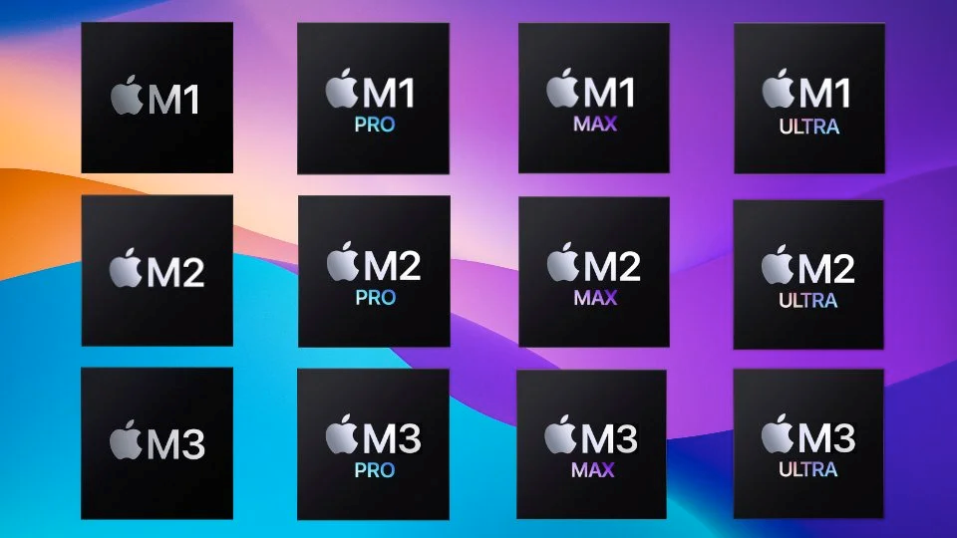


Figure 2: Apple’s integrated hardware–software–services ecosystem supporting competitive advantage
Source: Apple Inc. (2024)

2.6 Industry Analysis Using Porter’s Five Forces
Porter’s Five Forces framework provides additional insight into the competitive structure of the global technology and consumer electronics industry in which Apple operates (Porter, 2008). Competitive rivalry within the industry is intense, driven by rapid technological change, short product life cycles, and the presence of well-resourced competitors such as Samsung, Google, and Microsoft. Despite this, Apple mitigates rivalry through differentiation, brand loyalty, and ecosystem integration rather than direct price competition.
The threat of new entrants is relatively low due to high capital requirements, strong brand barriers, and the importance of intellectual property and technological expertise. Apple’s established ecosystem and economies of scale further raise entry barriers, limiting competitive entry.
Buyer power is moderated by high switching costs created through ecosystem lock-in. While consumers have access to alternative products, integration across Apple’s devices and services reduces price sensitivity. Supplier power presents a moderate strategic risk, particularly in relation to specialised components such as advanced semiconductors, although Apple partially offsets this through scale and supplier diversification.
The threat of substitutes remains significant due to technological convergence across platforms. However, Apple’s emphasis on user experience, security, and ecosystem cohesion reduces substitution risk. Overall, the Five Forces analysis indicates that while the industry is structurally competitive, Apple’s ability to sustain above-average returns is not derived from favourable industry structure alone, but from the strategic integration of its ecosystem. The interdependence between devices, services, and platforms reduces buyer power, raises switching costs, and weakens substitution threats, enabling Apple to manage competitive pressures effectively and sustain long-term competitive advantage (Porter, 2008). The interaction between Apple’s internal strengths, ecosystem integration, and external competitive pressures, and their combined role in sustaining competitive advantage, is illustrated conceptually in Figure 3.

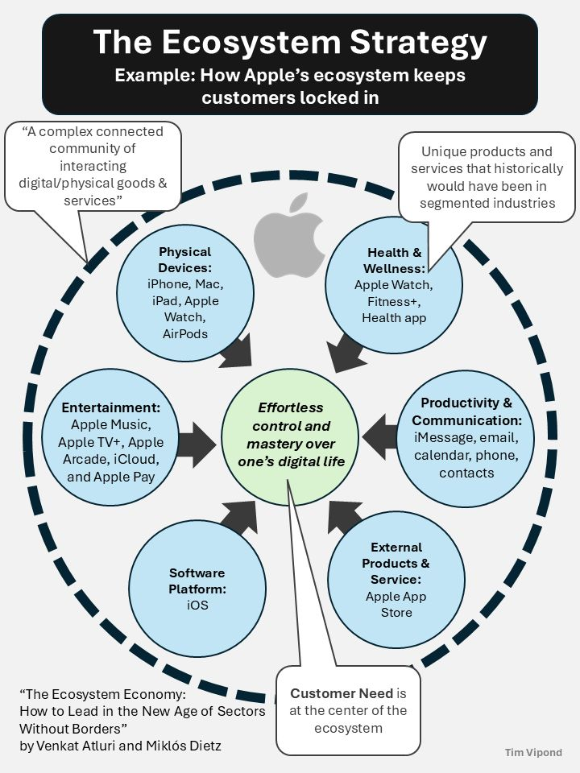
Figure 3: Strategic alignment between Apple’s ecosystem and sustained competitive advantage
Source: Adapted from ecosystem strategy literature and Apple Inc. ecosystem architecture

3. CSR and Sustainability Objectives
Apple’s corporate social responsibility (CSR) strategy is centred on environmental sustainability, ethical supply chain management, and the protection of customer data privacy. These priorities reflect both increasing stakeholder expectations and the strategic need to align corporate responsibility with long-term value creation. Apple has committed to achieving carbon neutrality across its corporate operations and product life cycles, supported by extensive investments in renewable energy, recycled materials, and energy-efficient product design. From a strategic perspective, such initiatives enhance organisational legitimacy while reducing long-term regulatory and operational risks (Carroll, 1991; Elkington, 1997).
From an environmental perspective, Apple has taken significant steps to reduce its carbon footprint by transitioning its global operations to renewable energy sources and encouraging suppliers to adopt similar practices. The integration of recycled aluminium, rare earth elements, and other sustainable materials into product manufacturing demonstrates an effort to minimise resource depletion and electronic waste. Strategically, these initiatives not only address regulatory and societal pressures but also contribute to cost efficiencies and supply chain resilience over the long term, particularly in the context of tightening environmental regulations and climate-related disruptions (Elkington, 1997).
Ethical sourcing and labour standards constitute another key dimension of Apple’s CSR agenda. The company has established supplier codes of conduct and auditing mechanisms aimed at improving working conditions, health and safety standards, and human rights compliance across its global supply chain. However, despite these measures, Apple continues to face criticism regarding labour practices and transparency in supplier operations. Addressing these concerns remains essential for maintaining corporate legitimacy and stakeholder trust, as persistent reputational risk may undermine brand equity and stakeholder confidence (McWilliams and Siegel, 2001).
Data privacy and security represent a further strategic CSR priority. Apple positions privacy as a core organisational value and a differentiating feature of its products and services. By emphasising strong data protection measures and limiting data monetisation, Apple aligns ethical responsibility with competitive differentiation, reinforcing customer trust and long-term loyalty. Overall, Apple’s CSR and sustainability objectives are closely aligned with its business strategy. While notable progress has been made, sustained competitive advantage will depend on deeper integration of social responsibility into operational practices and continued responsiveness to evolving stakeholder expectations (Carroll, 1991).
However, the effectiveness of these initiatives ultimately depends on their deep integration into core strategic decision-making processes rather than being treated as standalone ethical commitments.

4. Comprehensive and Holistic View: Balanced Scorecard
The Balanced Scorecard framework provides a comprehensive and integrated approach to evaluating organisational performance by combining financial and non-financial indicators (Kaplan and Norton, 1992). In the context of Apple, this framework enables a structured assessment of how strategic objectives are translated into measurable outcomes across multiple dimensions. However, a critical limitation in Apple’s performance management approach is the implicit emphasis on financial success, which may obscure underlying strategic risks and long-term sustainability challenges. Therefore, a more balanced evaluation incorporating operational, customer, and innovation perspectives is essential for a holistic understanding of performance.
Financial Perspective
Apple’s primary financial objective is to sustain long-term revenue growth while maintaining high profitability margins through premium pricing and ecosystem integration.
- Objective: Increase revenue diversification through services
- KPI: Services revenue growth rate
- Target: Achieve 12–15% annual growth in services revenue
- Initiative: Expansion of subscription-based services such as Apple TV+, iCloud, and Apple Music
Critical Evaluation:
While the expansion of services enhances recurring revenue and reduces dependence on hardware cycles, it also increases Apple’s reliance on digital platform ecosystems. This exposes the organisation to heightened regulatory scrutiny, particularly in relation to antitrust concerns, and intensifies competition from established digital service providers.
Customer Perspective
Apple’s strategic focus within the customer perspective is centred on enhancing customer loyalty, satisfaction, and long-term engagement through its integrated ecosystem.
- Objective: Strengthen customer loyalty and retention
- KPI: Customer retention rate and Net Promoter Score (NPS)
- Target: Maintain customer retention levels above 90%
- Initiative: Deepening ecosystem integration across devices and services to enhance user experience
Critical Evaluation:
Although ecosystem integration significantly increases customer stickiness and lifetime value, it may limit accessibility in price-sensitive markets and contribute to regulatory challenges associated with market dominance. This highlights a strategic trade-off between customer lock-in and market inclusivity.
Internal Business Processes Perspective
Apple aims to enhance operational efficiency and supply chain resilience to support consistent product quality and global distribution capabilities.
- Objective: Improve supply chain resilience and efficiency
- KPI: Supplier diversification ratio and production lead time
- Target: Reduce dependency on a single country by 20%
- Initiative: Expansion of manufacturing operations in alternative locations such as India and Vietnam
Critical Evaluation:
While supply chain diversification reduces geopolitical risk and enhances resilience, it introduces operational complexity and may increase short-term production costs. This reflects a strategic trade-off between efficiency and risk mitigation.
Learning and Growth Perspective
The learning and growth dimension focuses on sustaining innovation capability and organisational development to support long-term strategic competitiveness.
- Objective: Enhance innovation capability and technological leadership
- KPI: Research and development (R&D) expenditure as a percentage of revenue
- Target: Maintain R&D investment at 7–8% of total revenue
- Initiative: Investment in artificial intelligence, augmented reality (AR/VR), and proprietary chip development
Critical Evaluation:
Sustained investment in research and development reinforces Apple’s innovation-driven differentiation strategy. However, it also increases pressure to continuously deliver commercially successful innovations, thereby elevating long-term strategic risk if expected returns are not realised.
Overall Strategic Insight
The Balanced Scorecard highlights the interdependence between financial performance, customer value, operational efficiency, and innovation capability. Apple’s strategic success is not driven by any single dimension, but by the alignment across all four perspectives. However, maintaining this alignment requires continuous adaptation to external pressures, including regulatory constraints and technological change. Consequently, the Balanced Scorecard should be viewed not only as a performance measurement tool, but as a strategic management system that supports long-term competitive advantage (Kaplan and Norton, 2001).

5. Strategic Choices and Implementation
At the business level, Apple predominantly pursues a differentiation strategy, as conceptualised in Porter’s generic strategies framework. Rather than competing on price, Apple differentiates its offerings through innovation, superior design, product quality, and a tightly integrated ecosystem of hardware, software, and services. This strategy enables Apple to command premium prices and sustain high profit margins despite intense competitive rivalry within the global technology industry (Porter, 1985). Differentiation is reinforced by Apple’s emphasis on user experience, security, and seamless interoperability, which collectively reduce customer price sensitivity and strengthen brand loyalty.
Apple’s differentiation strategy is supported by substantial investment in research and development, proprietary technologies, and design capabilities. Vertical integration allows the firm to maintain tight control over product architecture and performance standards, ensuring consistency and reinforcing brand identity. Importantly, Apple avoids being “stuck in the middle” by rejecting cost leadership, as pursuing low-cost strategies would dilute brand equity and undermine its premium positioning (Porter, 1985).
At the corporate level, Apple follows a strategy of related diversification, primarily through the expansion of its services segment and selective international growth. Services such as digital subscriptions, cloud storage, and financial services leverage existing ecosystem capabilities and brand reputation, enabling economies of scope and revenue stability. This approach reduces dependence on cyclical hardware sales while strengthening recurring income streams (Ansoff, 1957).
Alternative strategic options, such as cost leadership or unrelated diversification, are deliberately avoided by Apple due to their potential to undermine strategic coherence. A cost leadership strategy would require price competition, operational standardisation, and margin compression, which conflict with Apple’s premium brand positioning and design-driven differentiation. Similarly, unrelated diversification would dilute managerial focus and weaken ecosystem synergies, increasing strategic complexity without clear value creation.
By contrast, Apple’s commitment to differentiation and related diversification reflects strategic consistency and disciplined choice. However, this approach is not without risk. Heavy reliance on differentiation increases exposure to rapid imitation and changing consumer preferences, while ecosystem dependence heightens regulatory scrutiny. Effective implementation therefore requires continuous innovation, governance adaptation, and strategic vigilance to ensure that differentiation remains meaningful and defensible over time (Porter, 1985; Johnson, Scholes and Whittington, 2020).
Strategic implementation at Apple has historically been characterised by strong leadership, disciplined execution, and a distinctive organisational culture. Centralised decision-making supports coordination and protects intellectual property, enabling effective implementation of long-term strategic initiatives. However, heightened regulatory scrutiny and geopolitical uncertainty have increased implementation complexity, requiring adaptive responses such as supplier diversification and governance adjustments. Overall, Apple’s strategic choices are internally consistent and supported by strong implementation capabilities, though balancing strategic control with organisational flexibility remains an ongoing challenge (Johnson, Scholes and Whittington, 2020).
However, Apple’s strategic approach also reflects inherent trade-offs. The emphasis on differentiation and ecosystem control strengthens brand loyalty but increases regulatory exposure and limits organisational flexibility. Alternative strategic options, such as partial ecosystem openness, could reduce regulatory pressure and improve compliance, yet they risk weakening Apple’s tightly integrated value proposition and competitive differentiation. This creates a strategic tension between maintaining control and adapting to external constraints. Therefore, Apple must carefully balance strategic consistency with adaptive capability to sustain long-term competitiveness in an increasingly regulated and technologically dynamic environment (Porter, 1985; Johnson, Scholes and Whittington, 2020).

6. Strategic Evaluation and Recommendations
To sustain long-term competitive advantage, Apple must adopt strategically grounded and critically evaluated actions that address both internal limitations and external environmental pressures. While existing strategies have enabled strong market positioning, emerging regulatory, technological, and market dynamics require more adaptive and carefully balanced strategic responses.
Recommendation 1: Tiered Pricing Strategy for Emerging Markets
Apple should implement a tiered pricing strategy to expand its presence in emerging markets while maintaining its premium brand positioning.
- Justification: PESTEL analysis highlights rising disposable incomes in developing economies alongside affordability constraints.
- Strategic Fit: Aligns with Ansoff’s Market Development strategy by targeting new customer segments.
- Risk: Potential brand dilution and erosion of premium perception.
- Mitigation: Maintain flagship products at premium prices while positioning older or adapted models in lower tiers.
- Impact: Increased market penetration, revenue diversification, and long-term customer acquisition.
Recommendation 2: Accelerated Supply Chain Diversification
Apple should further diversify its supply chain to reduce geopolitical and operational risk associated with overdependence on specific regions.
- Justification: PESTEL and internal analysis identify supply chain concentration as a major vulnerability.
- Strategic Fit: Enhances operational resilience and aligns with risk management objectives.
- Risk: Increased short-term costs and coordination complexity.
- Mitigation: Gradual implementation supported by strategic supplier partnerships and technological integration.
- Impact: Improved supply chain stability and reduced exposure to geopolitical disruptions.
Recommendation 3: Controlled Ecosystem Openness
Apple should adopt selective ecosystem openness to address increasing regulatory pressures while preserving its core differentiation.
- Justification: Legal and industry analysis indicate rising global antitrust scrutiny.
- Strategic Fit: Balances differentiation strategy with compliance requirements.
- Risk: Reduced control over ecosystem and potential dilution of user experience.
- Mitigation: Implement controlled third-party integration with strict quality and security standards.
- Impact: Reduced regulatory risk, improved stakeholder trust, and sustained ecosystem relevance.
Recommendation 4: Strategic Investment in Artificial Intelligence and Emerging Technologies
Apple should intensify investment in artificial intelligence, augmented reality, and advanced semiconductor technologies to sustain innovation leadership.
- Justification: Technological analysis highlights rapid industry evolution and increasing competition.
- Strategic Fit: Supports differentiation strategy and strengthens core capabilities.
- Risk: High R&D costs and uncertain returns.
- Mitigation: Strategic partnerships, acquisitions, and phased innovation investment.
- Impact: Sustained technological leadership and long-term competitive differentiation.

Recommendation 5: Deep Integration of Sustainability into Core Strategy
Apple should embed sustainability more deeply into its operational and strategic decision-making processes.
- Justification: CSR and PESTEL analysis indicate increasing environmental and regulatory pressures.
- Strategic Fit: Aligns with long-term brand positioning and stakeholder expectations.
- Risk: Increased operational costs and supply chain constraints.
- Mitigation: Leverage innovation in materials and energy efficiency to achieve cost savings over time.
- Impact: Enhanced brand reputation, regulatory compliance, and long-term value creation.
From a strategic perspective, these recommendations reflect a balance between growth, risk management, and sustainability. Their successful implementation depends on Apple’s ability to align internal capabilities with external environmental changes while maintaining strategic coherence. Importantly, each recommendation involves trade-offs between control, flexibility, cost, and innovation, reinforcing the need for continuous strategic evaluation and adaptive capability (Grant, 2019; Barney, 1991).
Overall, Apple’s sustained competitive advantage is not solely derived from its strong resources and market positioning, but from its ability to continuously align internal capabilities with external environmental conditions. However, increasing regulatory pressures, technological convergence, and market saturation present significant challenges. Therefore, Apple’s long-term success will depend on its capacity to balance strategic control with adaptability, ensuring that its differentiation remains both relevant and defensible in a rapidly evolving global environment (Barney, 1991; Porter, 2008).

Section 2: Reflective Account on the Strategic Management Analysis of Apple Inc.

1. Description
This assignment involved conducting a comprehensive strategic analysis of Apple Inc. using established frameworks such as PESTEL, VRIO, Porter’s Five Forces, Balanced Scorecard, SWOT, and Ansoff Matrix. The process required extensive academic reading, critical evaluation of secondary data, and the integration of theoretical concepts into a real-world organisational context. I initially approached the task by focusing on gathering information about Apple’s strategies and applying relevant models systematically.
However, I realised that my early approach was primarily descriptive. I focused on explaining Apple’s strategies rather than critically analysing them, which limited the depth of my work. According to Gibbs’ reflective cycle, reflection requires moving beyond description towards deeper evaluation and learning (Gibbs, 1988). As I progressed, I became more aware of the need to engage in critical analysis and develop stronger strategic judgement.
In addition, I adopted a structured approach to organising the report by aligning each section with specific strategic frameworks. This helped ensure logical flow and coherence throughout the analysis. I also engaged in comparative reading of different academic perspectives to understand how similar strategic issues are interpreted in various contexts. This process enhanced my ability to link theory with practice, although initially I relied more on describing Apple’s strategies rather than critically evaluating them. Over time, I became more conscious of the need to question assumptions and develop a more analytical approach to interpreting strategic decisions.

2. Feelings
At the beginning of the assignment, I felt confident in applying strategic models because I was familiar with their theoretical foundations. However, as I started writing, I found it difficult to translate theoretical understanding into critical analysis. I felt uncertain about whether my work met Level 7 expectations, particularly in terms of analytical depth and originality.
After receiving feedback, I realised that although my work was well structured, it lacked critical evaluation. Initially, this feedback was challenging, but it helped me recognise the gap between descriptive writing and critical analysis. This experience reinforced the importance of reflective learning in improving academic performance, and highlighted my tendency to prioritise structure over critical depth in earlier drafts, which I actively worked to correct (Kolb, 1984).

3. Evaluation
One of the strengths of my work was the logical structure and consistent use of strategic frameworks. I was able to apply models such as PESTEL, VRIO, and Porter’s Five Forces effectively, ensuring that all key aspects of strategic analysis were covered. This helped maintain clarity and coherence throughout the report (Johnson, Scholes and Whittington, 2020).
However, a key weakness was my tendency to focus on description rather than evaluation. For example, in the external and internal analysis, I identified relevant factors but did not sufficiently assess their strategic implications or trade-offs. Similarly, in the Balanced Scorecard, I initially focused on objectives and KPIs without clearly defining measurable targets and strategic initiatives, which limited the practical applicability of the analysis (Kaplan and Norton, 1992).

4. Analysis
This experience highlighted the importance of critical thinking in strategic management. The application of theoretical models alone is insufficient; it is essential to interpret findings, challenge assumptions, and evaluate alternative strategic options. Strategic analysis requires understanding not only what an organisation does, but also why certain strategies are effective or potentially problematic (Grant, 2019).
For instance, while Apple’s differentiation strategy appears highly successful, it also creates vulnerabilities such as regulatory exposure and dependence on continuous innovation. Recognising these trade-offs enabled me to adopt a more balanced perspective. Furthermore, the concept of dynamic capabilities emphasises that competitive advantage is not static but must be continuously renewed in response to environmental change (Teece, Pisano and Shuen, 1997). This reinforced the need to view strategy as an evolving process rather than a fixed position.
Furthermore, this process highlighted the importance of linking strategic analysis with practical implementation. Initially, I focused more on identifying strategic issues rather than evaluating how they could be addressed through realistic and measurable actions. This was particularly evident in my first version of the Balanced Scorecard, where objectives and KPIs were present but lacked clear targets and initiatives. Through revision, I understood that effective strategy requires not only analysis but also actionable planning and performance measurement. This reflects the broader principle that strategy must be both analytically sound and practically implementable.
In addition, I recognised that strategic management is inherently dynamic and context-dependent. The case of Apple demonstrated that even highly successful strategies involve trade-offs and risks. This understanding encouraged me to adopt a more critical and balanced perspective, considering both strengths and limitations rather than presenting strategy as inherently successful. As a result, my analytical approach evolved from descriptive explanation to more evaluative and reflective reasoning.

5. Conclusion
In conclusion, this assignment significantly enhanced my understanding of strategic management and the importance of critical evaluation. I learned that effective strategic analysis requires not only the application of theoretical frameworks but also the ability to critically assess strategic decisions and their implications.
If I were to undertake this assignment again, I would adopt a more analytical approach from the beginning, focusing on evaluating strategic trade-offs and supporting arguments with stronger theoretical justification. This would improve the depth and quality of my analysis and align more closely with Level 7 academic expectations.

6. Action Plan
Based on this experience, I have identified several areas for improvement in my future academic work:
- I will develop stronger critical thinking skills by consistently evaluating strategic assumptions and considering alternative perspectives rather than relying on descriptive explanations.
- I will engage more deeply with academic literature to strengthen theoretical grounding and support arguments with evidence-based analysis (Grant, 2019).
- I will improve my ability to integrate theory with practice by applying strategic frameworks more critically and contextually (Johnson, Scholes and Whittington, 2020).
- I will allocate more time for reviewing and refining my work to ensure that it demonstrates analytical depth, clarity, and originality in line with advanced academic standards.

References
Ansoff, H.I. (1957) ‘Strategies for diversification’, Harvard Business Review, 35(5), pp. 113–124.
Apple Inc. (2024) Form 10-K: Annual report. Cupertino: Apple Inc. Available at: https://investor.apple.com/sec-filings/default.aspx (Accessed: 20 March 2026).
Apple Inc. (2024) Environmental progress report 2024. Cupertino: Apple Inc. Available at: https://www.apple.com/environment/ (Accessed: 20 March 2026).
Barney, J.B. (1991) ‘Firm resources and sustained competitive advantage’, Journal of Management, 17(1), pp. 99–120. Available at: https://doi.org/10.1177/014920639101700108 (Accessed: 20 March 2026).
Bocken, N.M.P., Short, S.W., Rana, P. and Evans, S. (2014) ‘A literature and practice review to develop sustainable business model archetypes’, Journal of Cleaner Production, 65, pp. 42–56.
Carroll, A.B. (1991) ‘The pyramid of corporate social responsibility: toward the moral management of organisational stakeholders’, Business Horizons, 34(4), pp. 39–48. Available at: https://doi.org/10.1016/0007-6813(91)90005-G (Accessed: 20 March 2026).
Dyer, J.H., Gregersen, H.B. and Christensen, C.M. (2011) The innovator’s DNA. Boston: Harvard Business Review Press.
Eisenhardt, K.M. and Martin, J.A. (2000) ‘Dynamic capabilities: what are they?’, Strategic Management Journal, 21(10–11), pp. 1105–1121.
Elkington, J. (1997) Cannibals with forks: the triple bottom line of 21st century business. Oxford: Capstone.
Ghemawat, P. (2001) ‘Distance still matters’, Harvard Business Review, 79(8), pp. 137–147.
Gibbs, G. (1988) Learning by doing: a guide to teaching and learning methods. Oxford: Oxford Polytechnic.
Grant, R.M. (2019) Contemporary strategy analysis. 10th edn. Chichester: John Wiley & Sons.
Hitt, M.A., Ireland, R.D. and Hoskisson, R.E. (2020) Strategic management: competitiveness and globalisation. 13th edn. Boston: Cengage.
Johnson, G., Scholes, K. and Whittington, R. (2020) Exploring strategy. 12th edn. Harlow: Pearson.
Kaplan, R.S. and Norton, D.P. (1992) ‘The balanced scorecard: measures that drive performance’, Harvard Business Review, 70(1), pp. 71–79.
Kaplan, R.S. and Norton, D.P. (2001) Strategy-focused organization. Boston: Harvard Business School Press.
McWilliams, A. and Siegel, D. (2001) ‘Corporate social responsibility: a theory of the firm perspective’, Academy of Management Review, 26(1), pp. 117–127. Available at: https://doi.org/10.5465/amr.2001.4011987 (Accessed: 20 March 2026).
Pisano, G.P. (2015) ‘You need an innovation strategy’, Harvard Business Review, 93(6), pp. 44–54.
Porter, M.E. (1985) Competitive advantage: creating and sustaining superior performance. New York: Free Press.
Porter, M.E. (2008) ‘The five competitive forces that shape strategy’, Harvard Business Review, 86(1), pp. 78–93.
Porter, M.E. and Kramer, M.R. (2011) ‘Creating shared value’, Harvard Business Review, 89(1–2), pp. 62–77.
Prahalad, C.K. and Hamel, G. (1990) ‘The core competence of the corporation’, Harvard Business Review, 68(3), pp. 79–91.
Rumelt, R.P. (2011) Good strategy/bad strategy. New York: Crown Business.
Teece, D.J., Pisano, G. and Shuen, A. (1997) ‘Dynamic capabilities and strategic management’, Strategic Management Journal, 18(7), pp. 509–533. Available at: https://doi.org/10.1002/(SICI)1097-0266(199708)18:7<509::AID-SMJ882>3.0.CO;2-Z (Accessed: 20 March 2026).

