

LOCATION: Swansea | LLEOLIAD: abertawe
LEVEL 4 | LEFEL 4
EXAMINATION PERIOD | CYFNOD ARHOLIADAU
MOCK | MOCK

MODULE CODE: ACDA4013
Embedded C

TIME: 2 HOURS
ANSWER ALL QUESTIONS

Total Marks: 100

This exam does not allow the use of reference materials, scraps of paper, online resources, or observing any practice sessions.

- Equipment or materials required – PC running CAD software or Pencil/Ruler/Paper
- Use the Answer Sheet to respond to theoretical questions, including topics like working principles, operation, circuit diagrams, purpose, etc. Screenshots of schematic circuits, code, and simulation results should be included in a separate MS Word document.
- Save the name of the word Document in this pattern ‘Exam_studentname_studentid’ and upload the file in Moodle.
- Please note that only submissions uploaded during the official exam window, with an additional 10 minutes provided if needed, will be accepted.
QUESTION 1
Create a counter using a 7-segment display connected to PORTD of the PIC16F877A microcontroller that increments from 0 to 9 every 2 seconds and should repeat the process. Ensure that the design incorporates appropriate current-limiting resistors for the 7-segment display.
Consider Common Anode 7- Segment display using the hex values given below.
0 | 1 | 2 | 3 | 4 | 5 | 6 | 7 | 8 | 9
0XC0 | 0XF9 | 0XA4 | 0XB0 | 0X99 | 0X92 | 0X82 | 0XF8 | 0X80 | 0X90
Write an embedded C program to implement this functionality using the CCS compiler.
The project should include the following components:
- Design the circuit using simulation software. [10 Marks]
- Write a C program to accomplish the specified counting task. [10 Marks]
- Execute the simulation to verify the operation of the circuit and program. [5 Marks]
QUESTION 2
Design a circuit using the PIC16F877A microcontroller where each pin of PORTD is connected to an LED with a 100Ω current-limiting resistor. Additionally, connect a push button to the second pin of PORTC. The circuit should perform the following functions:
- When the switch is pressed, all LEDs on PORTB should be turned ON.
- When the switch is released, all LEDs should turn OFF.
The project should include the following components:
- Design the circuit using simulation software. [10 Marks]
- Write a C program to accomplish the specified counting task. [10 Marks]
- Execute the simulation to verify the operation of the circuit and program. [5 Marks]
QUESTION 3
The circuit shown below has been made available to you on Moodle, named ‘Question 3’, under the section ‘Embedded C ACDA4013: Mock Exam: 28/04/2026’
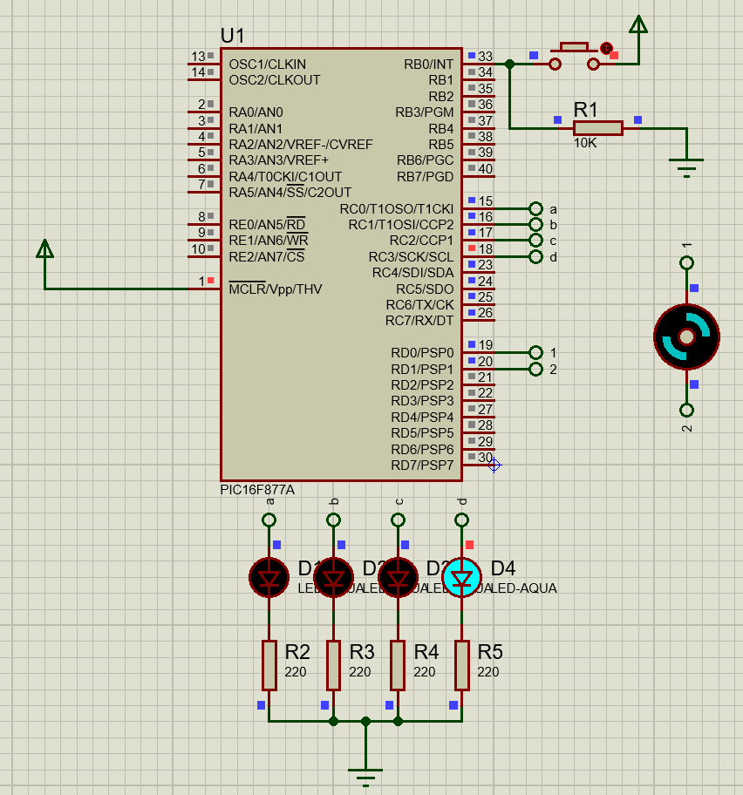
Simulate the provided Proteus circuit file on Moodle. Observe its behaviour when the push button is pressed. Identify the sequence and logic of operation of the LEDs and motor. Then, Answer the following questions.
- Based on your understanding from the simulation:
- Write a CCS C program that exactly replicates the working of the circuit. [13 Marks]
- Briefly explain:
- What happens when the button is pressed? [4 Marks]
- How the motor and LEDs are controlled using PORTC and PORTD. [4 Marks]
- The role of RD0 and RD1 in motor control. [4 Marks]

QUESTION 4
Below is the given Program
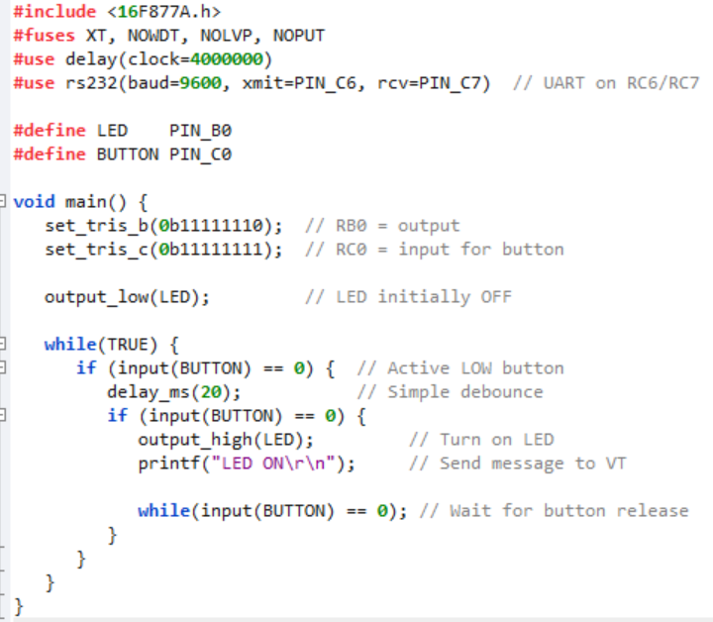
Answer the Following
      - Identify and describe the operation performed by the program when executed. [5 Marks]
      - Based on your understanding of the program, design a circuit schematic that would support its functionality. [5 Marks]
      - Write and run the program in a simulation environment. Submit the program and provide a screenshot of the simulated circuit. [5 Marks]
      - What does the set_tris_b(0b11111110) instruction indicate in terms of PORTB configuration? [5 Marks]
      - Explain how real-time LED switching is achieved in the program using input polling instead of delays. [2 Marks]
      - What problem might occur if the push-button connected to RC0 is used without a pull-down resistor in the circuit? [3 Marks]
Diwedd/End

