Pathway project one

Sustainability & Global Citizenship

Table of Contents
1 Introduction 2
2 Concrete experience 3
3 Reflective observation 4
4 Abstract conceptualization 5
5 Active experimentation 6
6 Conclusion 7
7 References 8
8 Appendices 9

Introduction
It was quite interesting to complete the pathway project one because I have experienced with innovative and creative learning issues. The pathway project one has enriched my self-managed (Boyer et al., 2014) and lifelong learning (Harties & Goller, 2014). It provided me opportunity to integrate my theoretical learning to practical application.
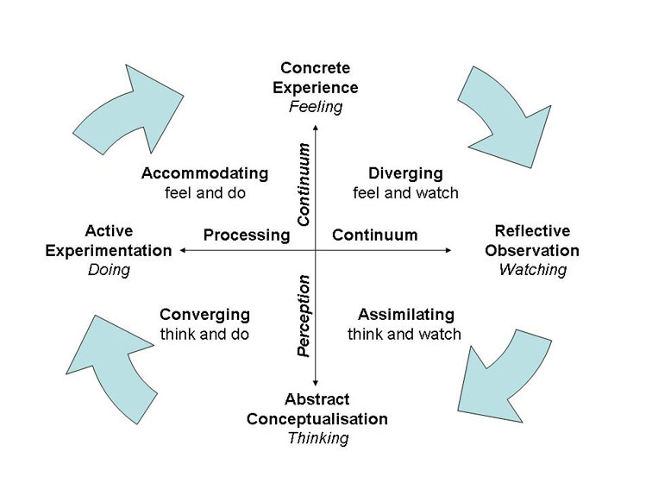
Figure 1 Kolb's reflective learning cycle (Source: Kolb, 1998)
In order to reflect my contribution to the project and to summarize my learning issues. I intend to apply the Kolb’s learning cycle (Kolb, 2014) which allows an individual to learn from the past experience and activities. Kolb’s learning cycle is made up of four phases including concrete experience, reflective observation, abstract conceptualization, and active experimentation (Thomas et al., 2016).

Concrete experience
During our class, we have informed regarding the pathway project one. Finally, our class teacher asked us to prepare a presentation on pathway project one. Therefore, the teacher provided some presentation topics to us such as community participation (locally and nationally), leadership and so on (Figure, 2). But, it was required to form a group to complete the project one. I feel confused to select my group.
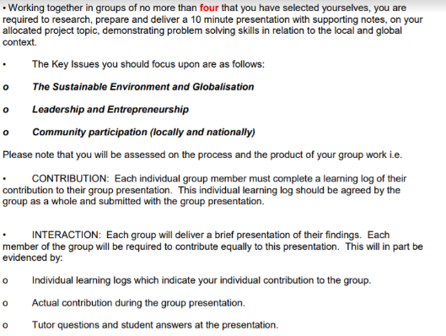
Figure 2 Pathway project one
However, I approached to some of classmates forming a group. Ultimately, I formed a group with three members. I was the group leader (Irene Kauzerni) and the rest of members were Mwda Mvita Kalonga and Diasis Biembongo. In order to carry out the project, we were asked to select a topic.
Finally we selected “Community participation (locally and nationally” as our project topic. Then, we arranged a group discussion to select group leader. Our group members noted that I have good group working skill, time management competency, and inter-personal communication skills (Brandler & Roman, 2015).

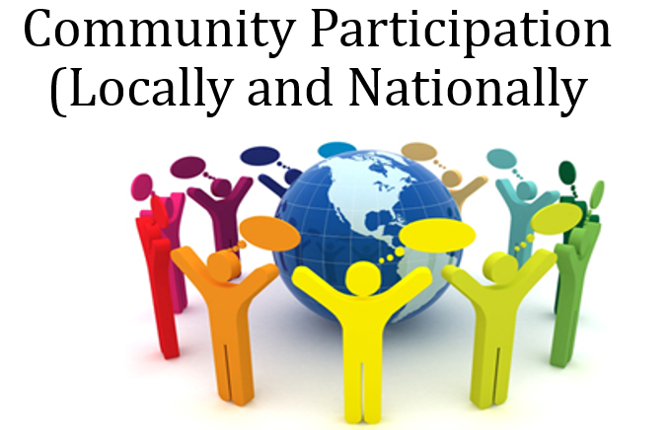
Figure 3 community participation (Source: Author, 2017)
Therefore, I have been selected as group leader. We arranged first group discussion on 17th November 2017. Then we made a decision to study about the project for few days. It was about 4 days. By studying about the project, we met together to delegate tasks of each individual group members on 22th November 2017. In order to assign the group task, we prepared a task schedule. Based on the schedule, we started to write down the presentation. For example, I was responsible to write about the meaning of community participation, categories of community participation, community capacity building and so on. We selected 27th November 2017 to submit our task activities. Please see appendix # A for learning log.

Reflective observation
While starting to write down the presentation slide, I was surprised that I did not understand how to write down the slide beautifully. However, I decided to conduct a secondary research to collect information for writing down the task activities (Silverman, 2016). I spent almost one days to collect necessary materials. I found enough information to design the presentation slide and to write down the project activities. Please see appendix # B for learning PowerPoint Slide.
But the most interesting thing is that I did not summarize the information from a bulk amount of information. Therefore, I was very nervous and tensed by thinking that I could not finish my project within deadline. Ultimately, I knocked down my group members over the phone. But I did not respond them.
Therefore, I sent message to them by using Viber. Finally, they respond to me that they also faced the similar problems like me. Then, we made a decision that we would meet out tutor. Therefore, we selected a date for getting the appointment from our tutor.

Abstract conceptualization
I communicated to my group members to come early at the morning for visiting our tutor. Our group members did activities as our planning. We met our tutor and expressed our problem. By listening our problem, the tutor told us not to worry. Even, he praised us due to our effort. Then, he provided us some suggestions. For example, writing down the presentation slide precisely by citing the author’s name and year. He also told us to use graph, figure, or any fact that would be used to prepare the slide nicely.
It was great suggestions to us. Then, we went out from our tutor room and discussed about the project. Therefore, I prepared a time scale to complete the project. In order to prepare the timescale, I applied my time management strategy. For example, I prioritized my task activities based on urgent, important, urgent and important, urgent but not necessary and so on. I informed my group members regarding the time plan of our project.

Active experimentation
I prepared my slide in advance. This is due to the fact that I have maintained the suggestions provided by the tutor. I noted down some key points before writing down my slide. For example, I collected resources from the quality secondary sources. In order to write about the community participation in relation to the tourism and development, I collected information from the relevant journal article (McMillan & Sumacher, 2014).
Then, I visited the company website to know about the practical application of the theory. It was quite interesting. But I also faced some difficulties to complete the project. Not only writing down the slide but also collaborating the group activities were challenges to me. I applied my time management, group working, delegating, and interpersonal communication skills. My time management skills allow me to complete the project within deadline (Mukhtar et al., 2016). For example, I applied my time management skills to break down the group activities in relation to the timescale. My delegation skills allowed me to distribute the group activities properly. For example, I assigned the tasks in relation to the ability and capability of my group members.
My inter-personal skills helped me to create a strong relationship with the group members. This skills also facilitated my group working skills. Brandler & Roman (2015) argued that group working skill is prerequisite to get a good job for 21st century graduate. The pathway project one also improved and developed my group working skills. However, I believed that the project also improved my delegation, interpersonal, and time management skills. This will further develop my future career. If I get further chance to complete such project, I will try to overcome the present mistakes.

Conclusion
In order to complete a project, it is required to apply different types of skills such as project management skills, time management skills, and inter-personal skills and so on. The completion of pathway project one is the outcome of the application of different set of skills of my group members and me. I have applied my delegation, time management, and interpersonal skills. It was not an easy task to complete the project. Conversely, it was not so tough. Therefore, I have faced some challenges and opportunities to complete the project. However, I have overcome the challenges by converting them into opportunities.

References
Boyer, S. L., Edmondson, D. R., Artis, A. B., & Fleming, D. (2014). Self-directed learning: A tool for lifelong learning. Journal of Marketing Education, 36(1), 20-32.
Brandler, S., & Roman, C. P. (2015). Group work: Skills and strategies for effective interventions. Routledge.
Harteis, C., & Goller, M. (2014). New skills for new jobs: Work agency as a necessary condition for successful lifelong learning. In Promoting, Assessing, Recognizing and Certifying Lifelong Learning (pp. 37-56). Springer Netherlands.
Kolb, D. A. (2014). Experiential learning: Experience as the source of learning and development. FT press.
McMillan, J. H., & Schumacher, S. (2014). Research in education: Evidence-based inquiry. Pearson Higher Ed.
Mukhtar, U., Ramzan, S., & Fatima, K. (2016). Analysis of Employees’ Time Management Behavior Skills and Strategies (TMBSS) in Pakistan. STRATEGIC MANAGEMENT, 21(4), 12-21.
Silverman, D. (Ed.). (2016). Qualitative research. Sage.
Thomas, T., Rafie, K., & Williams, E. (2016). 8: INTEGRATING FUNCTIONAL RESONANCE AND KOLB’S LEARNING CYCLE TO UNDERSTAND SOCIOTECHNICAL SYSTEMS. Critical Care Medicine, 44(12), 88.

Appendices
Appendix # A: Learning Log
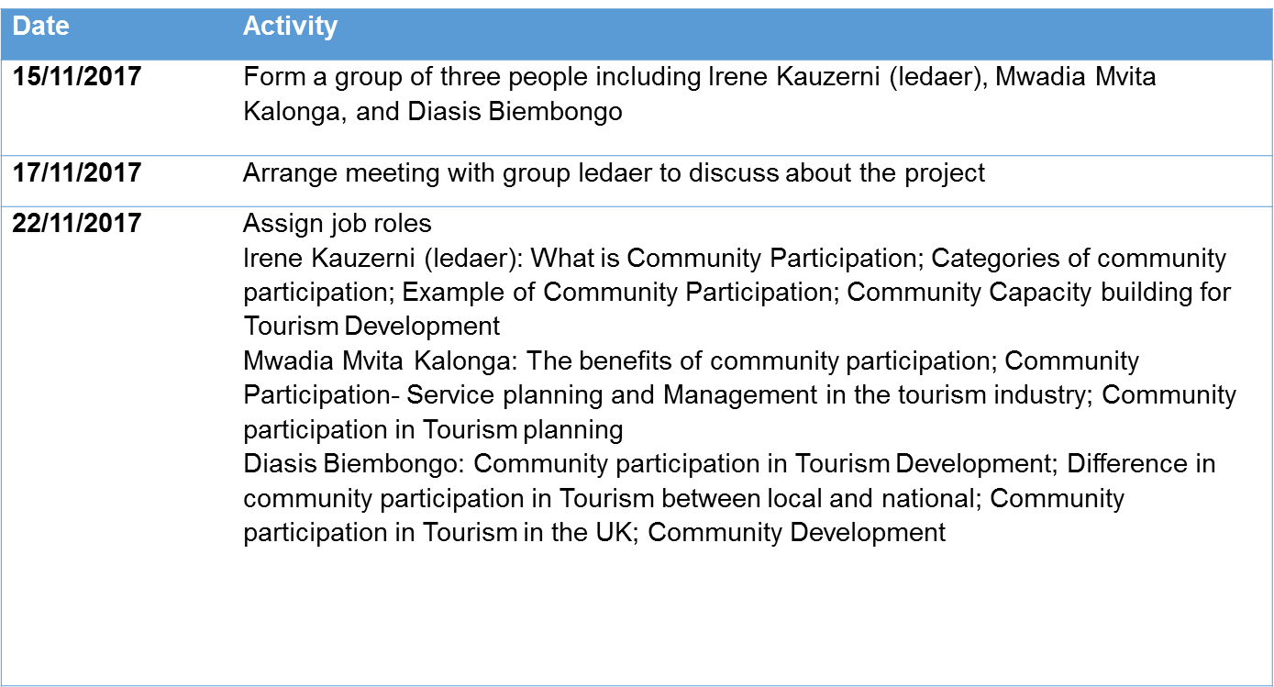
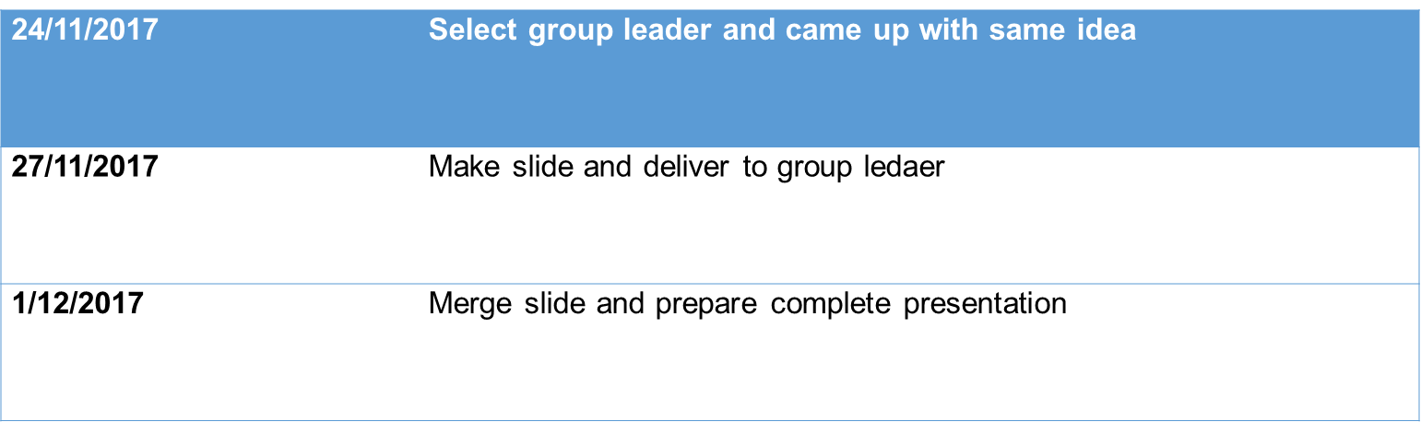

Appendix # B: PowerPoint slide

