12.04.2021
Jomir Ullah 1708855

Leading and Implementing Workplace Change
Lecturer: Syed Jaffery

Contents

1.0 Introduction 3
2.0 Recent History 4
3.0 Environmental Scanning 5
4.0 Impact of Covid-19 11
4.1 Recommendations 11
5.0 Developing Change Model 12
6.0 Kotters Eight Step Change Model 13
6.1 Leadership Self Examination 14
6.2 Step 1. Creating an Urgency 15
6.3 Step 2. Forming a Powerful Coalition 15
6.4 Step 3. Create a Vision for Change 16
6.5 Step 4. Communicate the Vision 17
6.6 Step 5. Remove Barriers/Obstacles 17
6.7 Step 6. Create Short-term Wins 18
6.8 Step 7. Build on the Change 18
6.9 Step 8. Anchor and Embed the change into Corporate Culture 19
6.10 Leadership Style during the Transformation 19
7.0 What is Organisational Culture? 20
7.1 How has Change Impacted on Organisational Culture? 20
7.2 Resistance to Change 23
7.3 Kubler-Ross Effect 23
8.0 Change Management Plan for the Future 24
8.1 ADKAR Model 27
9.0 Conclusion 28
10.0 Reference 29

Figure 1 Restaurant Industry Statistics Source: Statista.com (2020) 3
Figure 2 The Business Environment source: (Anon, 2021) 4
Figure 3 Rise in demand for Vegan Food source: Pi Datametrics Market Intelligence (2020) 7
Figure 4 Kotter Eight Step Model 1 Source: Preyasami, R (2020) 12
Figure 5 Organisational Hierarchy of Arden Ltd 15
Figure 6 Arden Ltd Values for Hofstede’s Cultural Dimensions 20
Figure 7 Corporate Culture source: HBR Groysberg et al., (2018) 21
Figure 8 Why People Resist Change source: HBR. Kanter (2018) 22
Figure 9 Kübler-Ross Change Curve Stewart (2021) 22
Figure 10 Stakeholder Power/Interest Grid for Arden Ltd 24
Figure 11 ADKAR Change Management Models 26

1.0 Introduction

The world is currently going through a radical change due to Covid-19 pandemic. Ritter and Pedersen (2020) assert the business environment has changed rapidly and many businesses have struggled or folded as they were not prepared to absorb the shockwaves of the pandemic and change their business model. Swift changes in legislation has led to the business operating on a limited basis.
In this report we will look at Arden Ltd a small SME based in Warwickshire. They were forced to close the doors and only operate a takeaway service. This report will examine how they have remained competitive in these difficult times with the current challenges that are apparent due to Covid-19. An environmental analysis will capture how the macro environmental forces have changed and impacted on Arden Ltd.
The business quickly adapted to the changing external forces as a result the business has gained market share and increased profits in a climate of uncertainty. The change management model by Dr Kotter (8 Step Model) was utilised to accommodate the changes, taking into consideration the people and in the workforce and how they can be encouraged to embrace and accept the new changes. The report will also address the culture within the business and the leadership style during the change management process. Further, the report will look at change management plan for the future and the necessary processes required to manage the future changes accordingly taking into consideration the rationale for change and the expectation of key stakeholders and their motivations.

2.0 Recent History

According to Lock (2021) the restaurant and hospitality industry has seen positive growth leading up to the coronavirus pandemic. Supply chain and logistical channels have been favourable to the UK economy as it has many established agreements with other nations. However, since the introduction of BREXIT, uncertainty has crept in, value of the sterling has dropped as changes in regulations meant agreements between European nations have now changed and new tariffs and charges are applied to trade (Tetlow and Stojanovic, 2018).
Furthermore, Bloom et al., (2019) state in their report many factors including the immigration status of migrant Europeans has negatively impacted on businesses and employees. Many are leaving work and returning to their country of origin. These sweeping changes have contributed to low performance and morale at work.

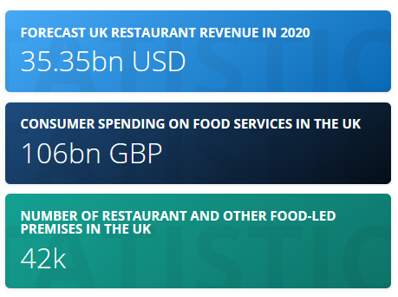
Figure 1 Restaurant Industry Statistics Source: Statista.com (2020)

3.0 Environmental Scanning

Arden Ltd is not operating in isolation, there are forces that can impact on the business operations, by doing an environmental analysis it is possible to see which forces are favourable and unfavourable to the organisation.

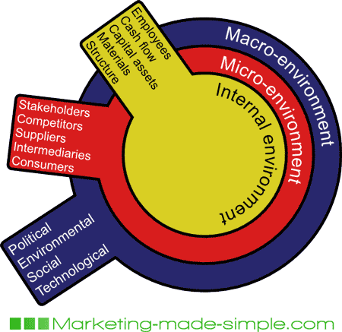
Figure 2 The Business Environment source: (Anon, 2021)
Below we will conduct a PESTLE analysis to determine the current factors at play in the Macro-environment and how these driving forces will inevitably change the strategic direction of the business to survive in the turbulent external environment (Johnson et al., 2020).

Political:
Political factors can have a significant influence on the hospitality sector. The common factors which are noted are tax increases and changes to safety regulations which are constantly updated by the government. It is imperative that organisation follow through on these guidelines to avoid fines and penalties (Jackson, 2021).
According to Wilson (2017) diplomatic relationships with foreign countries can also be a major deciding factor for change within a business. For example, the UK has a special relationship with the USA, which means interruptions to the flow of goods and services will be unlikely. Tariff and charges imposed on export and import will be lower which can increase the longevity of the business.
Brexit has caused a lot of complications for businesses as most of the UK sourced their goods from neighbouring Europe. As UK-EU relationship has changed and the prices of goods bound for the UK have now increased. There is still confusion and delay in goods crossing the borders. This is likely to negatively impact on the operations of the business.
Elections results or War in a particular country is likely to have a negative effect on other countries. This has been noticed a lot in Africa and Middle East region, where transport routes have been blocked or damaged by electoral result or war. As a result containers full of goods have been unbale to arrive at their destination in time. This creates an additional cost for the shipping companies and a burden for businesses relying on raw material imports.

Economical:
Organisations have no little or no control over the economic climate. Arden Limited was opened just after the 2008 economic disaster which impacted on businesses all over the world. During a period of austerity the business has managed to survive the economic climate as their clientele were mainly wealthy and the restaurant has a strategic location.
In times of recession and depression the general public have a low spending power and limited resources (Giles, 2020). Thus, they are more conscious of how they are spending their money. Therefore, any products and services the business provides must be suitable and satisfy a need for the customer.
During a poor economic climate inflation is likely to rise, and this in turn will increase business operational costs as the key ingredients required will cost more to procure. This increase in cost will most likely be reflected in the menu. Customers who have less disposable income are likely to satisfy the need for food at other cheaper locations during times of recession.
The pandemic has had major impact on the hospitality sector as many businesses have been forced to close due to political factors, as a result the economy is not improving in this sector. Also local and national lockdown rules stipulated by the government have further hampered the economic climate in hospitality sector.
Socio-Cultural:
Changes in society, local demography and work patterns as well as customers eating preferences all play a major factor in the business ecosystem. Arden has more to do in adapting to the changing nature of the environment in which they operate. In 2009 the local demography was mainly retired residents. However over time this has changed to include a different spectrum of locals. Social factors are not easily changed by the business and the business must find ways to factor this changes in their strategic decision making. For example, the opening times of the restaurant to capture lunch time trade.
Customers eating preferences have gradually swayed towards eating more organic food and nutritious food, with reduced sugars and carbohydrates. Previously customers did were very busy or ignorant of the health information available. Busy work schedule encouraged them to have more caffeinated drinks and junk food. Goffin, Lemke and Koners (2010) assert the business needs to take account of current changes and introduce healthier meals to increase customer base and maintain is competitive advantage in the marketplace. The business also needs to have ingredient labels identifying what the meals contain. This will help customers who have allergies such as gluten and nut allergies. There has been a few high-profile cases where restauranteurs have been taken to court for as they have not correctly identified and advised customers on allergens in the food (Parveen, 2018).
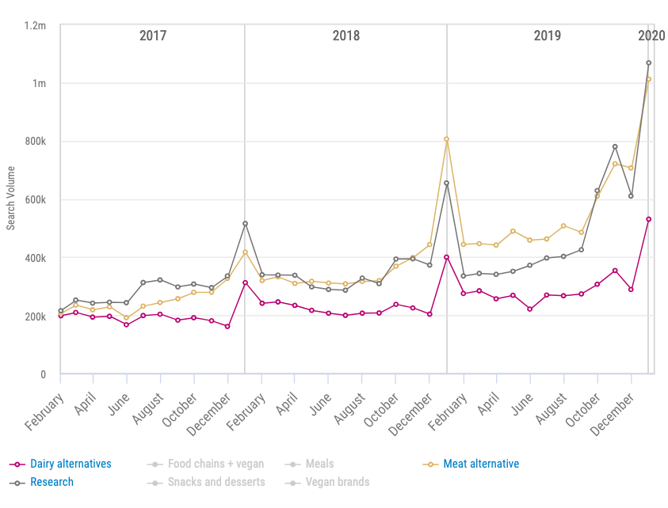
Figure 3 Rise in demand for Vegan Food source: Pi Datametrics Market Intelligence (2020)
Societal values are also changing such as more awareness of LGBT. The staff need to be aware of these changes so that they can provide a superior customer service. Sharma, (2020) in his book states millennials are not always available to work the evening shift or do manual work and thus this may create a human resources dilemma for the future. The business needs to create a human resource strategy to attract new talent to stay in the market.

Technological:
Technological factors are the most dynamic in nature as it is constantly evolving and restaurateurs find it difficult to adapt to these changes as a result of the workplace culture. As owners and the staff are accustomed to doing business the ‘old fashioned way’ i.e. pen and paper. However, Bocij, Greasley and Hickie (2015) assert the benefits of staying up to date with technology has a far-reaching positive impact on the business to sustain its competitive advantage.
Automation of processes such as taking customer orders digitally and processing orders for customers using technology speeds up the operational activities and provides a better customer experience (Foroudi et al., 2018). It also reduces errors and wastage of valuable resources of the business.
The restaurant has not adapted to changes in the technology over the past ten years. They introduced an EPOS system in 2015 whereas their competitors where already using this technology. Also the business has created a website but it does not have a full integration of IT to allow customers to order food and book tables online. The business can also use CCTV cameras to enhance the security of the premises.
Online communication with customer is limited as the business has not created a CRM database and advertising using social media infrequently as a result they have competitive disparity in this area (Galvão, de Carvalho, Oliveira and Medeiros, 2018).
Overall, this factor is where the business can take full advantage and introduce transformation in how they deal with customers and improve the processes within the business to save time and money and also attract new customers with innovative products and services.

Environmental:
The restaurant does not have a strategy for recycling. The packages used are aluminium and plastic carrier bags, this can be seen negatively by pressure group and focus groups. The business is sourcing their raw material from ethical suppliers. Steinfeld, McCue and Prier (2017) state these issues are critical for environmental success and to build a brand image and increase customer loyalty. The business needs to address these issues in their mission statement to make customers and potential investors aware of values and beliefs with regards to ethical and sustainable approach they take to reduce the carbon-footprint impact of their operations on the environment in which they conduct business.

Legal:
Legal factors can impact on the business such as changes in public health regulations. Currently the business has maintained a five-star certificate for food hygiene. However, if standards drop this will impact on how the customers view the business as this information is readily available on council website.
Where business have failed to meet specific standards they have been fined by regulators and some occasion had to incur a loss of business whilst the situation is remedied. This can be disastrous for the business as it will reduce customer loyalty and the business reputation.

4.0 Impact of Covid-19

Prior to the pandemic the business has been growing and attracting new customers. Statista.com (2020) shows that the industry has been growing. So the market attractiveness and growth in food sector has been predominantly rising.
However, during the pandemic, government policies regarding public heath have had a major negative impact on the business. Business have been forced to close and the food industry was only allowed to operate on a limited scale. i.e. takeaway service only.
This has impacted on the sales and profit of the organisation. Without a regular source of income the business had to furlough staff and reduce the number of staff available.
Often during the peak times, due to lack of staff the service level have dropped leading to extra time needed to complete orders, which meant some customers were waiting longer periods to collect their order.

4.1 Recommendations

According to Burke and Litwin (1992) the external environment is a critical and powerful organisational change driver. They purport that changes within the business ecosystem leads to important changes within the business culture, leadership and other factors such as management practises and behaviours, the organisational structure of the business.

As the report has identified the critical success factors, the researcher proposes the below list to consider for bringing change into the organisation. It is important to note that changes that are considered will bring a change in employee behaviour, motivation and performance. So going forward the leadership and management need to consider how they can introduce the change without impacting the success of the business.
1. Transactional Change: Business to go fully online, digital touchscreens for employees.
2. Process Change: Purchase new machinery and innovate cooking processes to achieve economies of scale.
3. Increase capacity: Renovate second floor to satisfy demand.
4. Recycling Strategy: Reduce the impact on climate change.
5. Increase Vegan and Vegetarian options on the menu and attract a new market segment.

5.0 Developing Change Model

Due to rapid progress in technology and online connectivity in a globalised world a change management program within an organisation has become one of the critical elements for survival of the organisation. Technology as mentioned previously can be a double edge sword where it helps in employee motivation and customer satisfaction. It can also be an obstacle where technology is not upgraded early on it can increase cost to procure, increase time to provide training to employees. If a plan is not generated and implemented early on; then employees on most occasion will resist change and this will hamper organisational success.
Arden Ltd has utilised the Kotters Change Model, however, they have further developed this model by including a leadership self-examination check to see if the leadership has the requisite skills and capabilities to carry out this change (Maund, 2018).

6.0 Kotters Eight Step Change Model

Kotter (2012) in his book purports that 30% of transformation programs fail to succeed as the change is not clearly communicated to the employees. They are key stakeholders that need to embrace the change to make the business strategy a success. Implementing change is difficult. Leaders need to manage the employee so that they can win over their teams confidence in accepting the change and thereby, changing the organisational culture and fulfilling the new mission and vision of the company.
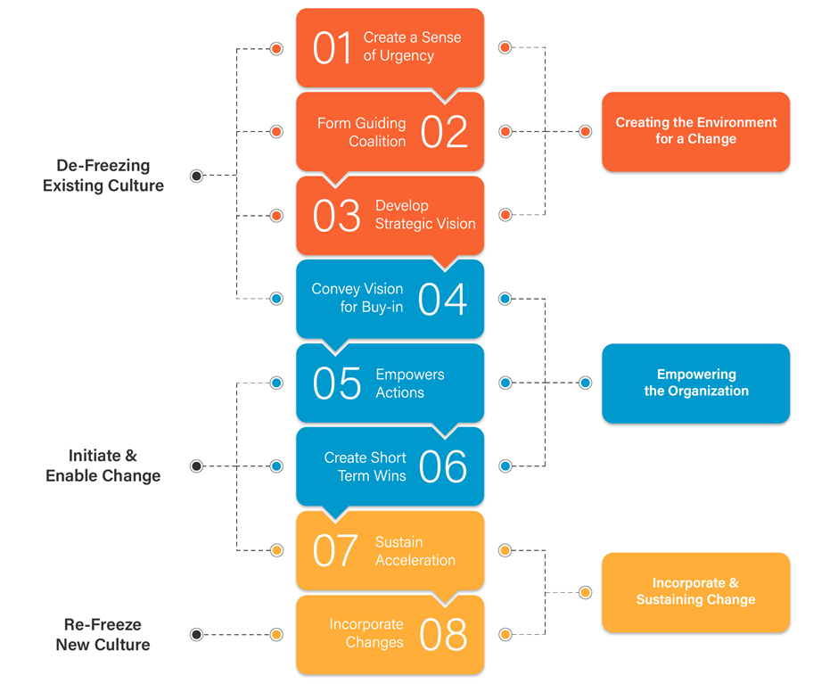
Figure 4 Kotter Eight Step Model 1 Source: Preyasami, R (2020)

6.1 Leadership Self Examination

Dobbins and Pettman (1997) state to achieve transformational success in business, the leaders need certain skills such as self-awareness, negotiating skills, influencing skills, strong personality and a transformational leadership style. This will inevitably help them to direct their energy and motivation in completing the change management program and winning the heart and minds of the workforce.
Leaders need to have a high level of Emotional Intelligence and interpersonal skills to maintain a healthy relationship with fellow workers to warrant their full cooperation and trust in achieving strategic objectives and goals (Singh, 2015). It is also advisable for the leader to take an MBTI test to see if their personality matches with their leadership style and how they can change to improve their approach to fellow workers.

6.2 Step 1. Creating an Urgency

Leadership needs to exhibit seriousness around the need for the change to occur. It is important for the entire organisation to understand and accept that continuing the same way will jeopardize the business and it is not sustainable. So therefore, there is a urgent need to transform in order to deal with the turbulent nature of the external environment. Hybels (2016) implies that leaders cannot rely on statistics and sales figures at this stage or informing them of intense rivalry in the marketplace. The leadership needs to connect the change with the future survival of the company. They need to show that if timely change is not done then this may lead to other changes in the business which are likely to be less positive.
Kotter (2008) suggests that more that 70% of the workforce will need to buy in to the change to make it successful. Leader needs to give significant time and energy to building urgency by sharing information, reflecting on the social and technological changes taking place in the business environment.

6.3 Step 2. Forming a Powerful Coalition

Al-Ali et al; (2017) claim successful change requires a strong leadership and discernible support from stakeholders in the organisation such as the manager, head Chef, and others who are enthusiastic and tech savvy. Managing change is not sufficient and employees need to be led through the change. To acquire this powerful group the change leaders need not follow the traditional hierarchy and personnel can be sourced from different sections of the organisation, or the change can be outsourced to an external provider. However, it is more cost effective to manage the change within the boundaries of the organisation.
The business can find effective change agents within the organisation. To lead the change the group or expert team need prominent people whose power is derived from numerous foundations such as title, rank in the organisation, level of expertise and political importance. A four member team was setup from each functional area of the business based on their expertise and technical experience. The change coalition worked as a team to further reinforce the change and continued to build urgency surrounding the need to change.
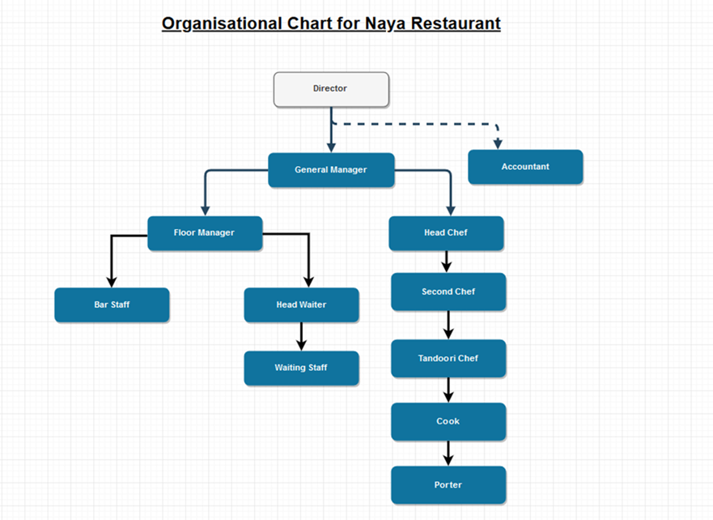
Figure 5 Organisational Hierarchy of Arden Ltd

6.4 Step 3. Create a Vision for Change

Post environmental scanning a lot of ideas for change were recommended. The change leader needs to link this change to an overall vision which the workforce can grasp easily and remember. A clear vision will aid the employees to understand why they are being asked to do something in a particular way. When the workforce can see for themselves the benefits of the change the organisation is trying to achieve they are more likely to be cooperative. Also when the vision is evident many employees will find their own way to achieve the objectives without needing continual guidance through each step.

6.5 Step 4. Communicate the Vision

Once the vision is formulated. The vision needs to be communicated to all the stakeholders within the organisation. Communication of the vision plan and execution needs to be done frequently and embedded within each process within the business operations. Leaders need to take every opportunity to discuss the vision with colleagues. They also need to use the vision to make executive decisions and to solve problems e.g. customer refund back to card using online facilities rather than paying in cash.
When the vision is fresh in everyone’s mind, they are more likely to remember and respond to it. It is also important to lead by example and show staff that this is the new way of resolving issues. Yaffe and Kark (2011) stress what the leader actually does is far more important than what they say as this shows credibility. Leaders also demonstrated the values and behaviour that they expect from the workforce in their everyday interaction with customers. Setting high performance expectations from their colleagues.

6.6 Step 5. Remove Barriers/Obstacles

The business needs to identify if anyone is resisting the change. Also identify if any processes or structures are hindering the change. New processes have been put in place and barriers to change continually monitored and recorded. Major obstacles to this change programme was a lack of training and using a Graphic user interface to process orders and make amendments to customers’ orders. Not every team member had sufficient training as the restaurant is a fast-paced business and time is often limited.
Therefore, the management gave specific training to key members gradually involving everyone in the team to become confident in using the new system.
Front staff, using a VoIP phone was difficult. What happens if call not answered or the internet fails? Customers were also educated in using QR codes to access the online menu. Procedures were put in place to cater for all kinds of scenarios and adequate training given.
Removing the obstacles empowered the workforce to execute the strategy more effectively and also improving their performance. This also helped the change to move forward in a timely manner. This step can be further improved by hiring coaches/mentors or new roles for change leaders whose main objective will be to deliver the change. So if any difficulties arise the staff can get immediate support and training to overcome the barrier to change.
The change leaders can themselves take the role of coaches or mentors and recognise and reward staff as they make change happen. Also the people who are resisting change can get the help they need to overcome any doubt or worries. These change leaders were given the freedom to make radical decisions to move the strategy forward. The key role of change leaders in this step is to identify barriers or resistance and take action promptly.

6.7 Step 6. Create Short-term Wins

The smallest of victories must be recognised, collected and communicated to the individual and the team early on in the change management process. They must be rewarded for their efforts. Success motivated the employees. Victories were celebrated early in the form of rewards, performance appraisal and staff dinner parties. When short terms wins are celebrated it holds back negative thinkers and critics of the change plan to alter their behaviour and adopt the vision of the company.
Short term wins can be created by setting short term targets such as 10% increase in sales, number of calls answered within five rings, time taken to process customers’ orders using the new method on the touch screen. The targets set were achievable and with little room for failure. Long terms goal will take longer to achieve and the team may lose interest in the change and try to go back to traditional methods of processing.

6.8 Step 7. Build on the Change

Kotter claims that many transformation fail as triumph is often announced prematurely. True change should run deep into the organisational culture, and sink into every team member to completely change their behaviour and values. Quick wins are only done to achieve long term change. Each success of the project allows time and opportunity to reflect on what went well and identify what needs to be improved. It is the researchers opinion that change agents and leaders believe that you can change the mindset and habits of the workforce as quickly as you can improve processes and the systems used in the organisation. In practical terms this is unrealistic and should be avoided.

6.9 Step 8. Anchor and Embed the change into Corporate Culture

Once the above steps have been completed it is now time to anchor the change and instil the required behaviours, values and attitudes into the mindset of the employees i.e. institute the change.
The leaders and managers need to articulate the connections between the new behaviours and the organisational success. Leaders need to continue this until the old habits are diminished and the change has been fully embraced by the workforce. Continuous commitment will improve communication and team morale with waiting staff and kitchen staff. This will result in new values being accepted and new work culture. Orders can now be tracked easily and provide customers with a unique new experience. This also helps to manage workload and distribute tasks evenly amongst staff.

6.10 Leadership Style during the Transformation

Prior to the transformation program Arden Ltd employed a democratic leadership style as the workforce was highly experienced and most employees had a long history with the company. They were highly committed, motivated and there was a high degree of trust. Luecke and Mcintosh (2011) signify that although managers want to adopt a participative style, they must acquire leadership traits and alternate styles dependent on the demands of the organisation.
Research carried out by Buil, Martínez and Matute (2019) claim transformational leadership is best suited to change management programmes as the leader can use their personality and behaviour to identify and engage better with the employees and have a deeper level of understanding why people might not like adapt to change.

7.0 What is Organisational Culture?

Academics have termed culture as the collective indoctrination of human thinking which differentiates them from one business to another.
Handy (1985); Hofstede (1984, 2003), and Schein (1999) define culture as the personality of the business, their preferred way of doing business i.e. the personal interactions in the business. Culture is intangible however, the organisation would have shared and espoused values, norms and attitudes and patterns of behaviour which is evident throughout the dealing of the business. A precursor to culture is institutionalisation where the leadership decides what values, beliefs and attitudes are desirable in the organisation (Robbins and Judge, 2013).

7.1 How has Change Impacted on Organisational Culture?

Arden Ltd has a strong organisational culture, with a very low employee turnover rate and thus, the team members are willing to accept challenges and willingly embrace change. As a result this change has had a positive impact on organisational culture and improved performance, employee engagement and reduced conflict in the organisation.
As the workforce has accepted the vision of the management and followed through with the change, they are less anxious and more productive. They know they can rely on the leadership to support and encourage them to develop and increase their own career opportunities. In the food industry, satisfaction and motivation is mainly gained through intrinsic satisfaction, when a customer is delighted with the meal prepared or leaves a wonderful review online.

Impact of change on organisational culture explained using Hofstede (2003) Cultural Dimensions:

Figure 6 Arden Ltd Values for Hofstede’s Cultural Dimensions

How people respond to change is dependent on the organisational culture that they are accustomed to Arden’s organisational structure (Fig.5) shows that they accept authority and are results orientated. Organisational structure can impact on culture as shown in the below diagram.

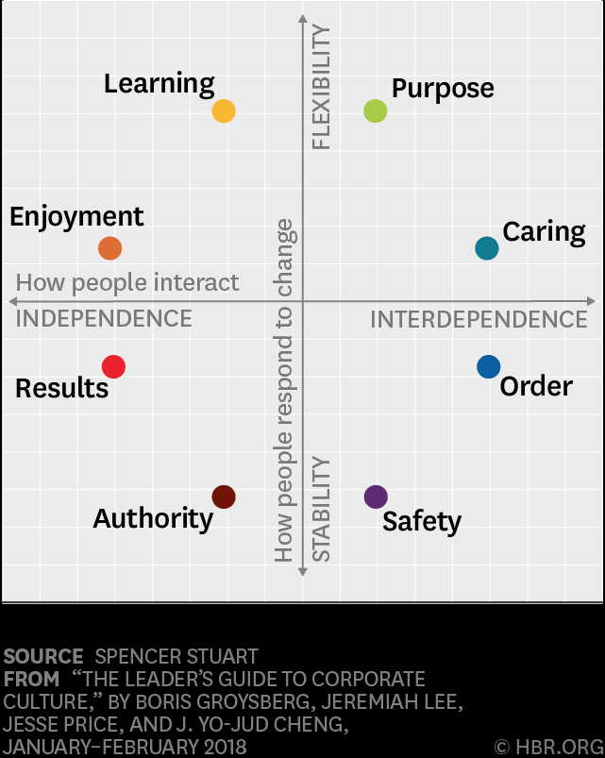
Figure 7 Corporate Culture source: HBR Groysberg et al., (2018)
Occasionally, a strong work culture can be detrimental to the change management programme. A strong culture is known for shaping individual to display similar behaviour, akin to regimentation in the army. This will reduce innovation and diversity in the workplace.
Similarly, organisation where a bureaucratic leadership style is evident will impact on the culture as employees will be expected to behave in a particular way and follow strict norms, values and attitudes. Within these organisation the change management programme will take longer or might not bear fruit as the employees are cloned to behave in a particular way. Accepting change will be seen as an attack on their personal values and beliefs. For example, the researcher worked for the government, the department introduced a strategy to unite the workforce by adopting a strict shirt and tie uniform. Some colleagues accepted this, however most experienced members of staff resisted this change vehemently and raised the matter with the civil service union.

7.2 Resistance to Change

In many organisations employees resist transformation for several reason such as fear of losing their position or adapting to disruptive technology and new processes as their organisational culture relies more on stability and order so they are likely to resist change. Below are further reason why people resist change:
Figure 8 Why People Resist Change source: HBR. Kanter (2018)

7.3 Kubler-Ross Effect

This model allows managers and leadership to have an insight into how their proposed changes will impact on the workforce. By using this model they can anticipate reactions and direct their attention, communication level and support to the individuals that are resisting the change.

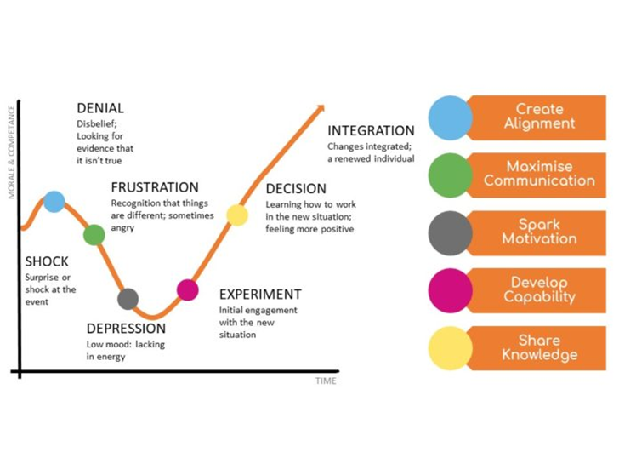
Figure 9 Kübler-Ross Change Curve Stewart (2021)

8.0 Change Management Plan for the Future

Introduction
Arden Ltd has enjoyed many years of success and gained market share in the small town of Henley-in-Arden. The owners now want to increase their market share by targeting different segments of the population, considering the changing social needs, and eating preferences that are prevailing at present. There is a lack of Vegan and Vegetarian Options on the Menu and the business now wants to attract a different market segment and offer quality vegetarian food to increase sales and brand reputation.

Objectives
- Serve food which is more nutritious and healthier.
- Produce food without allergens e.g., Gluten free, lactose free products.
- Innovative ways to produce food to a premium standard
- Increase food allergy awareness
- Increase market share
- Provide a variety of healthy options
Rationale for change:
- Customers eating preferences have changed due to social change.
- Increased demand for food which is allergen free.
- High profile cases, where owners taken to court and prosecuted for not informing customers of the ingredients used to prepare food.
- Local demographics and peoples work patterns have changed. More younger people are living in Henley and requesting vegetarian options.
- People are more focused about the environment and animal rights welfare.

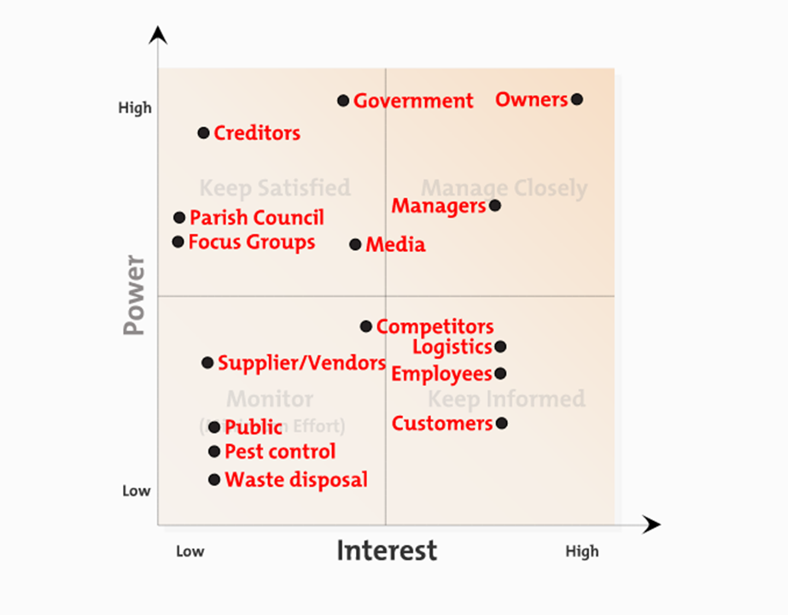
Figure 10 Stakeholder Power/Interest Grid for Arden Ltd

Stakeholder Communication Plan

Stakeholder | Interest / Concern | Communication Portal | Frequency
Customer | - More variety of foods  - Informed choices  - Healthier options  - Increase in price | - Social media  - Company website  - Leaflets  - Taster sessions | High
Employees | - Further training required  - Adapt to new ways of preparing food  - Fear of losing rank or position  - More workload | - Meetings  - Online training  - On the job training  - Coaching and mentoring  - External training | High
Shareholders | - Increased sales revenue  - Extra cost to train staff  - Extra cost to procure supply chain | - Board meetings  - Electronic communications | Medium
Suppliers | - Reduced uptake on other high price items such as meat and chicken  - Lower revenue | - Electronic mail  - Letters  - Meeting | Low

Assessment of Readiness to change
Currently the business has an egalitarian culture which is favourable to change programmes and senior managers are in support of this change. It also has the capacity to change as the business is profitable and finance is readily available to update procedures and create new menus. The business also has the ability to renovate the top floor if the demand for the service increases as a result of the new offerings. The Leadership style is currently transformational and the workforce are constantly being empowered to learn and develop with the organisation. The kitchen staff have a degree of autonomy in how they work. This might change as new procedures means extra caution to be taken as certain new ingredients may cause a health risk to some customers.

Identifying change element
Organisational Structure:
Currently the organisation has a hierarchical structure, this can hamper the communication link with staff on the operational level. The structure will need to change to include a specialist team who are introducing the new menu and then go on to provide guidance and support to the legacy team to help them transition into the change.
Processes change: The current way of producing the food will need to change as a knowledge database would need to be prepared so that each meal is prepared with uniqueness to maintain consistency and quality. Further a Quality management initiative would need to be established to monitor product quality and safety.
Resources: Extra resources would be required such as new machinery and new cooking area and protocols to deliver quality taste and freshness. The staff would need regular training in the beginning, this may impact on service levels. It is hoped in the long term this will improve as staff are more accustomed to the new way of preparing food.
Training and Certification: Staff might need external education and training to support their understanding of making allergen free meals and understanding hygiene and safety rules.

Evaluation and Control
The change process needs to be evaluated at each step and a control mechanism to assess if targets and objectives have been met. This can be done using:

Customer feedback
Total Quality Management
Feedback from staff
Feedback from coaching and Mentoring
Monitoring Sales and Revenue
Reflection on the Change Management Process

8.1 ADKAR Model

As the organisation is a SME and has a small number of employees the ADKAR model suggested by Hiatt (2006) would be most appropriate model to execute the plan. This model is significantly different from other models of change as it focuses primarily on guiding change at the individual level to embrace the change in contrast to other models which places emphasis on the organisational level.
This model stipulates that if change management plan is to be successful, then the employees, i.e. the individuals in the organisation must adapt and accept this change willingly.
The model allows leaders and change managers to focus their efforts on driving individual change and by doing this they will in turn drive organisational change. It is important to note that whilst carrying out these steps the outcome to be ‘achieved’ is the name of the step.
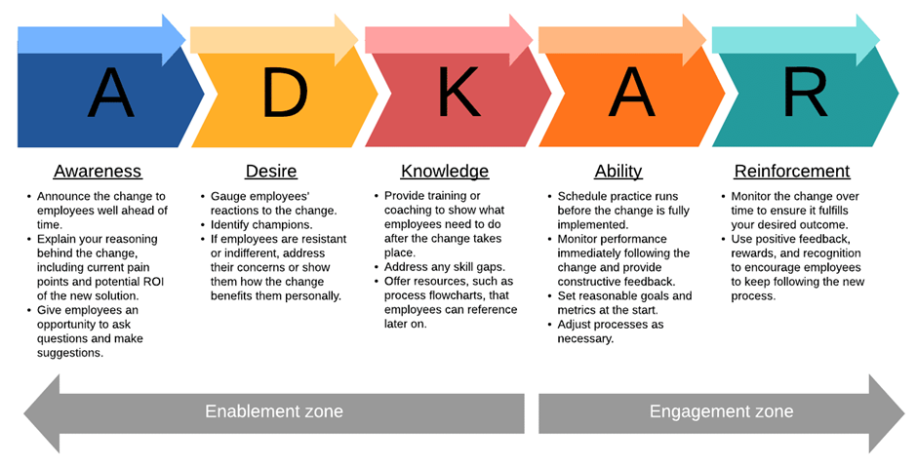
Figure 11 ADKAR Change Management Models
Advantages:
1. It focuses on outcomes rather than tasks; most change management models focus on processes ADKAR focuses on achieving outcomes with people.
2. Measure how well your change is progressing at the individual level and that makes it easy to rectify any gaps you identify.
3. Model recognises that it's ultimately people that facilitate change and not simply a process dictated from top management .
4. Easy to follow the check list.

9.0 Conclusion

Within the business environment organisation are constantly changing and adapting as an external forces are pressurising business to change their strategic objective in order to survive in the competitive marketplace.
In this report the environmental scanning helped identify key factors which were limiting the progress of the business. It gave an insight into potential future threats and opportunities which the business could encroach and pursue further.
The coronavirus pandemic sent a clear message home that science and technology was the clear winner in terms of fighting the virus and keeping the economy open. Political and legal factors put a major strain on the economy and the livelihoods of millions of people in the UK, as social distancing became a norm in the interest of public health.
Customers as well as businesses began to take their products and services online as physical stores were closed due to local and national lockdown. This meant that trade could still exist post coronavirus.
Change management is a difficult task but it is not impossible to achieve. Kotters 8 step model helped managers and leaders to understand change from the employees point of view. The people who were going to execute the change and satisfy the leaders vision and mission.
Therefore, in these circumstances, a transformational leadership style was most appropriate to work in collaboration and to address areas of concern with a empathy and ongoing support. The leader had to a coach, mentor and be the central pillar for the workforce to shadow and follow to achieve the overall business strategic objective and fulfil the vision of the company.
In doing this the culture within the organisation has played a major role in the transformation process. Organisational cultures where innovation and risk-taking was allowed thrived in uncertain times as they are able to adapt to change. Culture where collectivism and emphasis on building relationship and nurturing employees are more successful in change management programs. As these types of behaviour encourage the employee and motivate them to accept the change for the future.
Organisational structure is another factor in how people will accept change. Where it is seen as a hierarchy the line of authority may be obscured and line of communication will be hampered as information may not be clear when it reaches the operational level. Therefore, a flat structure would facilitate communication and improve team bonding and performance, making the change programme more successful.

10.0 Reference

- Al-Ali, A.A., Singh, S.K., Al-Nahyan, M. and Sohal, A.S., 2017. Change management through leadership: the mediating role of organizational culture. International Journal of Organizational Analysis.
- Anon (2021). Available at: https://funwithbusenvironments.weebly.com/macro-environment.html.
- Arnold, K.A. (2017). Transformational leadership and employee psychological well-being: A review and directions for future research. Journal of Occupational Health Psychology, 22(3), pp.381–393.
- Bloom, N., Bunn, P., Chen, S., Mizen, P., Smietanka, P. and Thwaites, G. (2019). The Impact of Brexit on UK Firms. National Bureau of Economic Research.
- Bocij, P., Greasley, A. and Hickie, S. (2015). Business information systems technology, development and management for the e-business. Harlow, England Pearson.
- Buil, I., Martínez, E. and Matute, J. (2019). Transformational leadership and employee performance: The role of identification, engagement and proactive personality. International Journal of Hospitality Management, [online] 77, pp.64–75. Available at: https://www.sciencedirect.com/science/article/pii/S0278431917308472.
- Burke, W.W. and Litwin, G.H. (1992). A Causal Model of Organizational Performance and Change. Journal of Management, 18(3), pp.523–545.
- Dobbins, R. and Pettman, B.O. (1997). Self‐development: the nine basic skills for business success. Journal of Management Development, 16(8), pp.521–667.
- Foroudi, P., Gupta, S., Sivarajah, U. and Broderick, A. (2018). Investigating the effects of smart technology on customer dynamics and customer experience. Computers in Human Behavior, 80, pp.271–282.
- Galvão, M., de Carvalho, R., Oliveira, L. and Medeiros, D., 2018. Customer loyalty approach based on CRM for SMEs. Journal of Business & Industrial Marketing, 33(5), pp.706-716.
- Giles, C. (2020). Subscribe to read | Financial Times. [online] www.ft.com. Available at: https://www.ft.com/content/c5d72dea-50bc-4f1f-98d3-bc758aafa905.
- Goffin, K., Lemke, F. and Koners, U. (2010). Identifying hidden needs : creating breakthrough products. Houndmills, Basingstoke ; New York: Palgrave Macmillan.
- Groysberg, B., Lee, J., Price, J. and Cheng, J.Y.-J. (2018). The Leader’s Guide to Corporate Culture. [online] Harvard Business Review. Available at: https://hbr.org/2018/01/the-leaders-guide-to-corporate-culture.
- Handy, C. B. (1985). Understanding Organizations: 4th ed. Harmondsworth: Penguin
- Hayes, J. (2014). The theory and practice of change management. Basingstoke: Palgrave Macmillan.
- Hiatt, J.M. (2006). ADKAR: A model for change in business, government, and our community. Loveland: Prosci Learning Center Publications.
- Hofstede, G. (1984). Cultural dimensions in management and planning. Asia Pacific Journal of Management, 1(2), pp.81-99.
- Hofstede, G. (2003). Cultures and Organisations: Intercultural Cooperation and Its Importance for Survival: Software of the Mind, London-UK, Profile Books Ltd
- Hybels, B. (2016). Leading from here to there study guide - five essential skills. Zondervan.
- Jackson, C. (2021). Tesco fined £7m for out of date food at Brum stores - including mouldy grapes. [online] BirminghamLive. Available at: https://www.birminghammail.co.uk/news/midlands-news/tesco-condemned-fined-7m-selling-20418904 [Accessed 26 Apr. 2021].
- Johnson, G., Whittington, R., Scholes, K., Angwin, D. and Regner, P. (2020). Exploring Strategy : Text and Cases. 12th ed. Harlow, England: Pearson.
- Kanter, R.M. (2018). Ten Reasons People Resist Change. [online] Harvard Business Review. Available at: https://hbr.org/2012/09/ten-reasons-people-resist-change.
- Kotter, J.P. (2008). A sense of urgency. Boston, Mass.: Harvard Business Press.
- Kotter, J.P., (2012). Leading change. Harvard business press.
- Lock, S. (2020). Restaurant industry in the United Kingdom (UK) - Statistics & Facts. Available at: https://www.statista.com/topics/3131/restaurant-industry-in-the-united-kingdom-uk/.
- Luecke, R. and Mcintosh, P. (2011). Becoming a Manager. Amacom.
- Maund, A., 2018. BA in Leadership and Management. London: SAGE, pp.190-218.
- Parveen, N. (2018). Takeaway workers found guilty of manslaughter after nut allergy death. [online] the Guardian. Available at: https://www.theguardian.com/society/2018/oct/26/takeaway-workers-found-guilty-of-manslaughter-after-nut-allergy-death.
- Periyasami, R. (2020). Kotter’s 8 - Step Model - a Beginners Guide to Change Management. Apty. [image] Available at: https://www.apty.io/blog/kotters-8-step-model
- Pi Datametrics Market Intelligence (2020). Available at: https://www.pi-datametrics.com/blog/vegan-market-vegan-trends-food-2020/.
- Ritter, T. and Pedersen, C.L. (2020). Analyzing the impact of the coronavirus crisis on business models. Industrial Marketing Management, [online] 88, pp.214–224. Available at: https://reader.elsevier.com/reader/sd/pii/S0019850120303084?token=005ADF74C00C22B60FC32D2A42A42206BFC9332012B6441AC57866BDD124AEBCE8EF935B48586B1617D8344F1983C1E7.
- Robbins, S. P., & Judge, T. (2013). Organizational behavior (15th ed.). Boston: Pearson.
- Sharma, D. (2020). How to recruit, incentivize and retain millennials. Editorial: Los Angeles: Sage.
- Singh, D. (2015). Emotional intelligence at work. Los Angeles: Sage Publications Inc.
- Steinfeld, J., McCue, C. and Prier, E., 2017. Professionalism as social responsibility in procurement and administration. European Business Review, 29(3), pp.320-343.
- Stewart, K. (2021). The Grief & Joy of Lockdown. https://wemakeplaces.org/the-grief-joy-of-lockdown/.
- Tetlow, G. and Stojanovic, A., 2018. Understanding the economic impact of Brexit. Institute for government, pp.2-76.
- Wilson, G.K. (2017). Brexit, Trump and the special relationship. The British Journal of Politics and International Relations, 19(3), pp.543–557.
- Yaffe, T. and Kark, R. (2011). Leading by example: The case of leader OCB. Journal of Applied Psychology, 96(4), pp.806–826.

‌

