

Module Name: Digital Skills for Personal Development and Business Growth
Module Code: BMSW4008
Assignment Name: E-Portfolio (Task1 & Task 2)
Student Name: Edit-Lakme Azmi
Student Number: 2412715
Lecturer: Philippa Fitzgerald
Deadline: 20th June 2025 23.59p
Wordcount:
AI Acknowledgement

I confrm that I have not presented any AI generated materials as my own work.
I confirm that I have copies of my drafts, notes, and other resources I used, which I may be asked to provide in evidence.

Market Research and Website Development Project

Consumer preferences are shifting away from conventional accommodation and toward distinctive, focused on experience stays in a travel industry that is becoming more and more competitive. To get in on this trend, Celeste Resorts, a conceptual luxury getaway brand, offers unique architectural accommodations like glass igloos, floating pods, and distant cabins nestled away in the outdoors. Highlighting important trends and their consequences for Celeste Resorts' business model, website design, marketing strategy, audience targeting, and search engine optimization (SEO) approach, this essay provides an in-depth examination based on primary data collected through a customer questionnaire.
Celeste Resorts is a revolutionary accommodation company that aims to reinvent quick vacations in the UK. Celeste Resorts offers to a rising market niche that appreciates distinctive design, fascinating natural settings, and carefully chosen local experiences by emphasizing distinctive stays like glass igloos, floating pods, and remote cabins. “Today’s travellers increasingly value authentic, unique, and personalised lodging experiences over traditional hotels” (Li, Pearce, & Low, 2021, p. 102).
The first finding from the survey relates to how frequently tourists take short vacations or leisure trips. A significant number of respondents—57%—travel seasonally, according to the data, while another 22% travel annually. Just 14% of people travel once a month or never. As Pinto (2020) explains, tourism is fundamentally “cantered on a tourist’s experience and is dependent on the experiences that are co-created and provided to tourists,” highlighting the importance for managers to understand what is perceived as engaging and memorable to maintain success. This indicates that Celeste Resorts' operations and marketing plans need to be in line with these seasonal cycles. To attract off-season guests winter marketing should highlight unique selling aspects like heated glass igloos or cozy cottages with private hot tubs. On the contrary, promotional campaigns should peak in the spring and summer, when people are more likely to schedule short holidays. “Despite the fact of being the most prominent characteristic of tourism, tourism seasonality still remains a phenomenon. Almost all world destinations are facing seasonal concentration of tourist activities” (Ćorluka, 2019, p. 5).
The subject of what kinds of accommodations travellers prefer is equally interesting. Although 47 respondents still prefer conventional hotels, there is a noticeable desire for alternatives: Smaller but significant numbers of respondents reported interest in glass igloos (3) and floating pods (4), while 22 respondents selected tiny houses or cabins and 22 preferred villas. Even if the final numbers seem low, it's important to consider the novelty effect when interpreting them; respondents might not have seen these options often, which explains the lower selection. However, when asked whether they would consider booking a glass igloo or floating pod for a special occasion, a majority responded positively: 17 said “definitely” and 16 said “probably.” This demonstrates that when connected with exceptional experiences, the uniqueness of accommodations still wins.
According to Tulasi et al. (2024), the three main types of aesthetics that influence tourists' visitation to tourist destinations are visual product aesthetics, package aesthetics, and taste aesthetics.
The third significant theme relates to what motivates guests when choosing unique stays. Scenic views emerged as the most valued factor, selected by 37 respondents, followed closely by privacy (34) and access to local experiences (32). Eco-friendliness was a priority for only 5 respondents. According to Fennell and Cooper (2020), the tourism industry has often been measured from a demand or market perspective, meaning the consumer heavily influences the type, quality, and quantity of tourism products and services.
An important design principle of Celeste Resorts is shown by this that every property must be positioned to maximize natural views and offer privacy. To increase the feeling of retreat the choice of location should give priority to extensive landscapes. Managed guest capacity, soundproofing, and proper layout can all further improve privacy.
Guests’ pricing expectations was £150-300£ per night, majority of them (37). Celeste Resorts can turn a profit at this price point while still catering to its target market of young professionals and couples looking for quick, luxurious getaways. According to Gričar et al. (2022), hospitality prices are an essential indicator in hospitality markets, destination marketing, and management planning.
It is impossible to minimize the importance of internet reputation while making reservations. 25 respondents stated that internet reviews had a "very much" impact on them, while 21 claimed that reviews have a "somewhat" impact. This shows how important it is for Celeste Resorts to foster favourable feedback right away. Guests' concerns about quality and safety will be addressed by verified guest reviews, excellent photos, and third-party endorsements like TripAdvisor Excellence certificates. According to Ramos (2020), tourists frequently rely on social networks to gather information and share experiences that contribute to the online reputation of tourist destinations.
With social media campaigns on Instagram and TikTok that utilize visual storytelling to highlight experiences like stargazing in glass igloos or romantic dinners in floating pods, this data guides marketing strategies. Branded hashtags and contests encourage users to share content. Santos (2019) explains that the growth of internet access and smartphones has revolutionized how consumers interact with businesses in the tourism industry, leading companies to use strategies that communicate directly with global clientele. In order to make the most on the 64% of respondents who said they would reserve unique accommodation for special events; offline marketing strategies include collaborations with nearby wedding planners and honeymoon businesses.
Complementing the marketing plan is a robust SEO strategy to secure organic visibility. Content marketing is crucial. For example, blog entries like "top stargazing locations in the UK," "eco-luxury travel trends," or "unique romantic getaway ideas" establish Celeste Resorts as an expert in experience travel. Also, a well-designed website with these rich, targeted contents enhances search engine rankings, increases user engagement, and is a crucial tool for transforming visitors into devoted clients. Çeltek (2020) notes that smart technology has opened new marketing opportunities in the tourism industry, enabling more effective sales tactics and personalized customer experiences.
In conclusion, the customer survey indicates a high level of demand for unique, immersive accommodations that provide comfort and a sense of connection to the natural world, with a particular focus on value considerations and seasonal travel trends. Celeste Resorts is in a good position to draw in tourists looking for experiences beyond the ordinary. In the end, Celeste Resorts can prosper in a difficult and changing hospitality market because to this data-driven, customer-focused approach. “Tourism seasonality is a widely recognized and significant concern in academic literature as it affects the majority of tourism destinations” (Gkarane & Vassiliadis, 2020, p. 247).

References:

Çeltek, E. (2020) Handbook of research on smart technology applications in the tourism industry. Edited by E. Çeltek. Hershey, Pennsylvania: IGI Global.
Ćorluka, G. (2019). Tourism Seasonality: An Overview. University of Dubrovnik.
Fennell, D.A. and Cooper, C. (2020) Sustainable Tourism : Principles, Contexts and Practices. Bristol, UK; Channel View Publications.
Gkarane, S., & Vassiliadis, C. (2020). Selective Key Studies in Seasonality Tourism: A Literature Review. In Strategic Innovative Marketing and Tourism (pp. 247–256)
Gričar, S. et al. (2022) ‘Tourism price normalities in two Adriatic east coast “euro” countries’, Economic research - Ekonomska istraživanja, 35(1), pp. 4865–4883.
Li, X., Pearce, P. L., & Low, D. (2021). The changing landscape of accommodation: From hotels to unique stays. Tourism Management Perspectives, 38, 100823.
Pinto, P. (2020) Handbook of Research on Resident and Tourist Perspectives on Travel Destinations. Edited by P. Pinto and M. Guerreiro. Hershey, PA: IGI Global.
Ramos, C.M.Q. (2020) Handbook of research on social media applications for the tourism and hospitality sector. Edited by C.M.Q. Ramos, C.R. de Almeida, and P.O. Fernandes. Hershey, Pennsylvania: IGI Global.
Santos, J.D. (2019) Digital marketing strategies for tourism, hospitality, and airline industries. Edited by J.D. Santos and O.L. Silva. Hershey, Pennsylvania: IGI Global.
Tulasi, E.E. et al. (2024) ‘The role of aesthetics in tourist satisfaction in the Ghanaian hospitality industry’, Heliyon, 10(12)

Webpage:
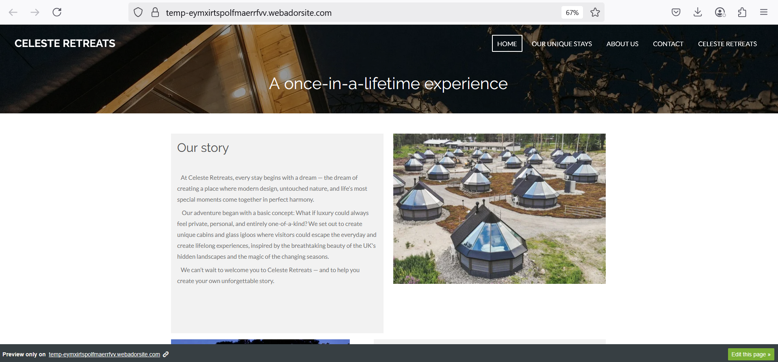
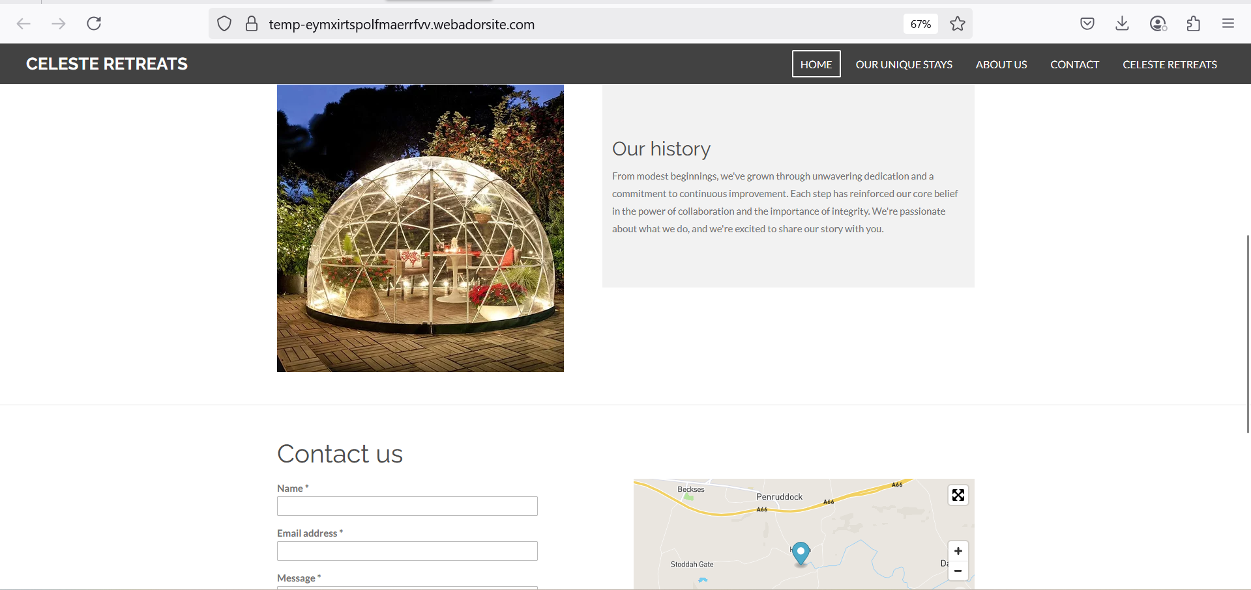
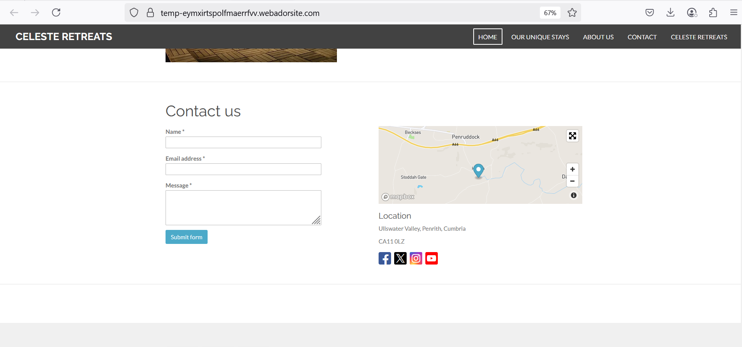
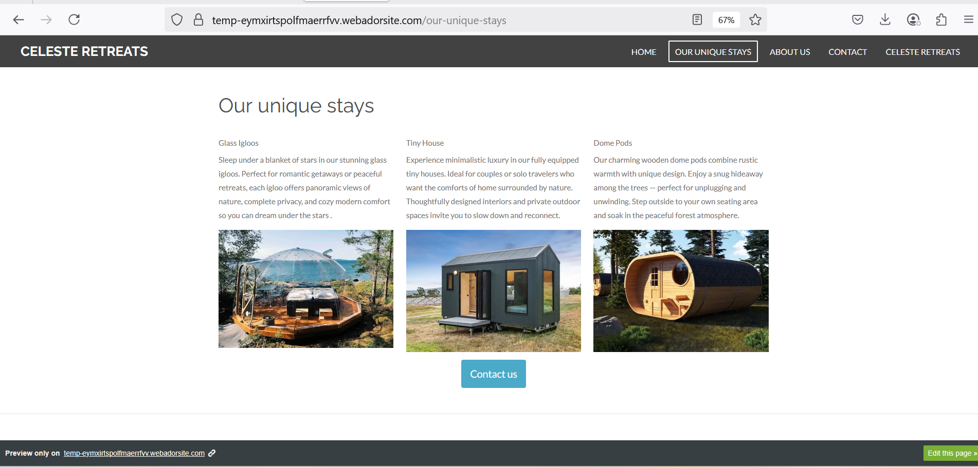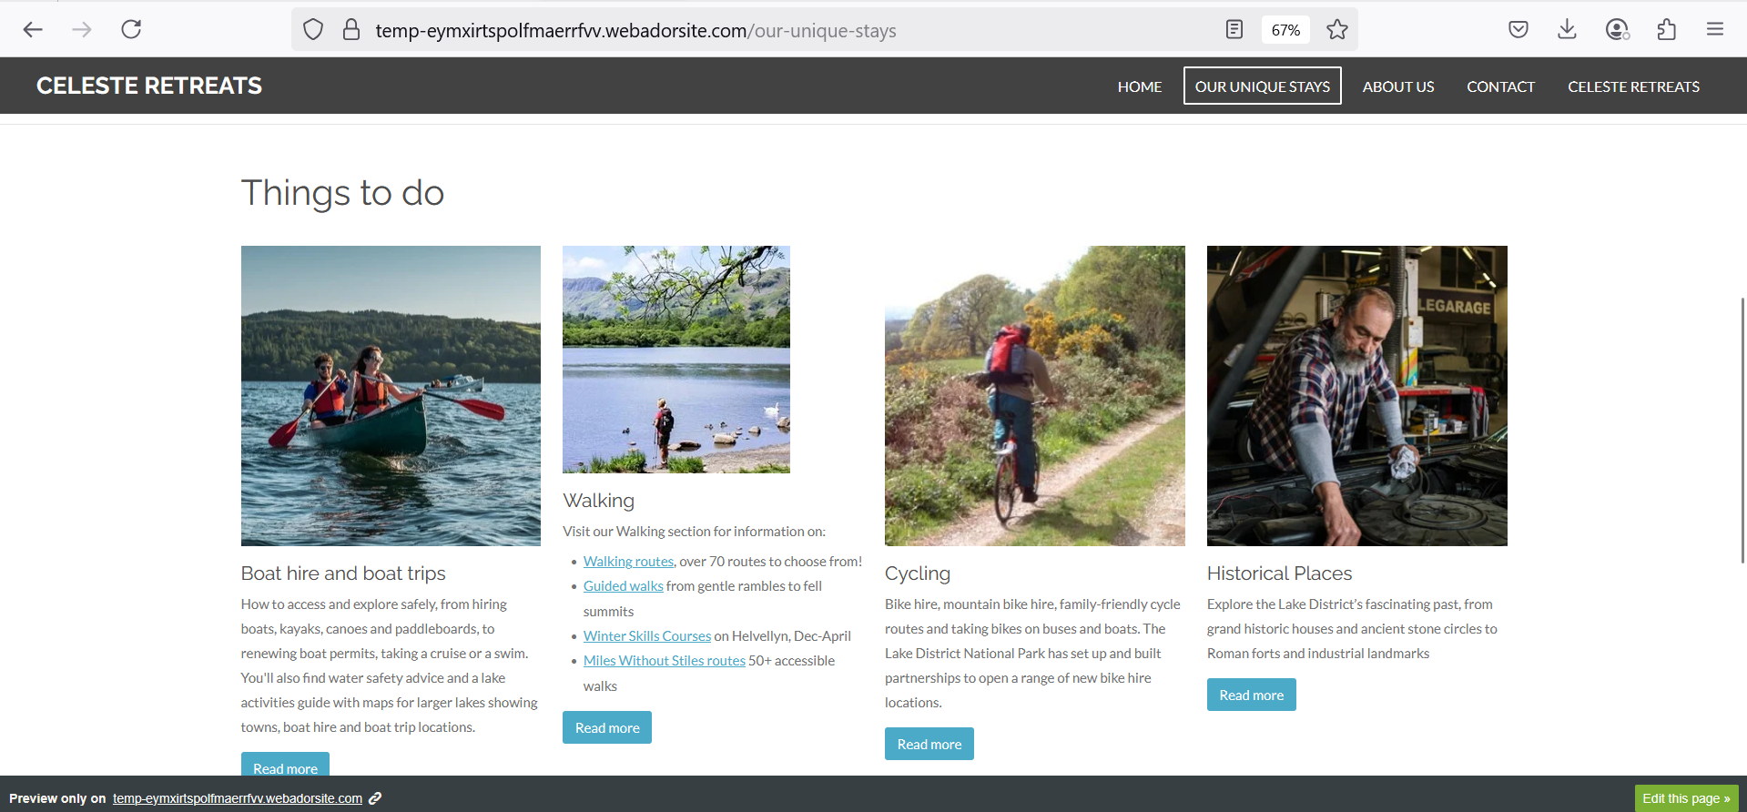
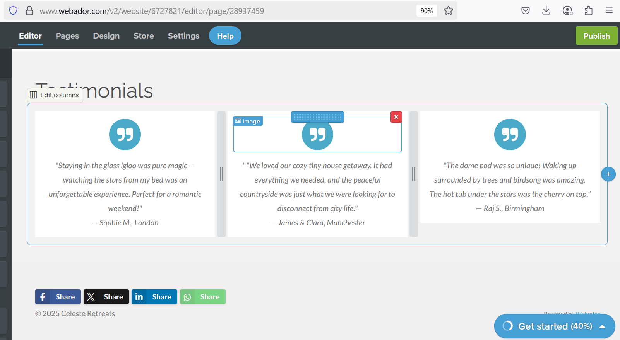

Celeste Retreats questionnaire:
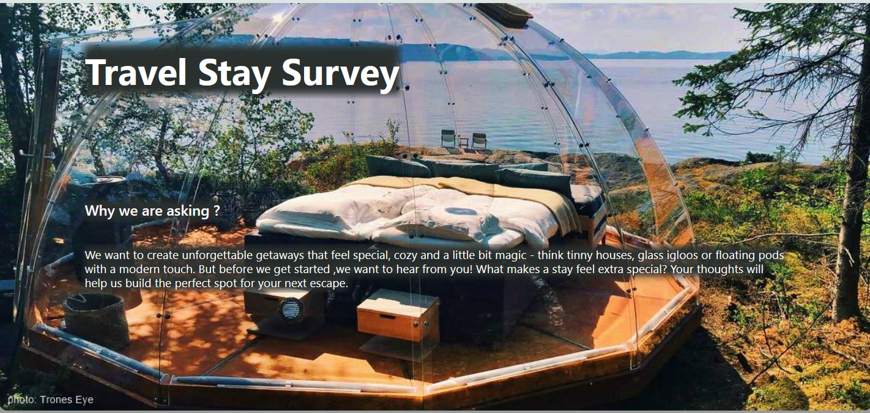
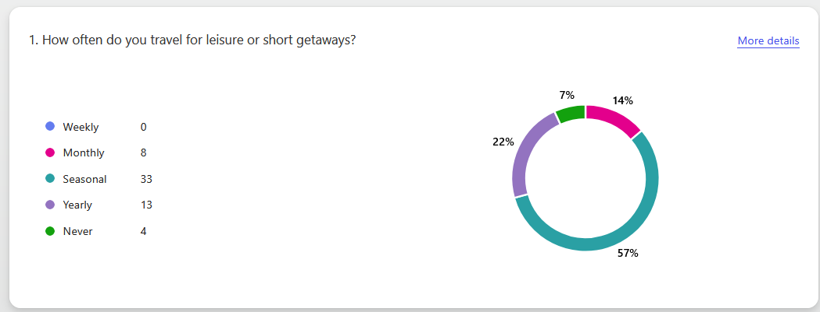
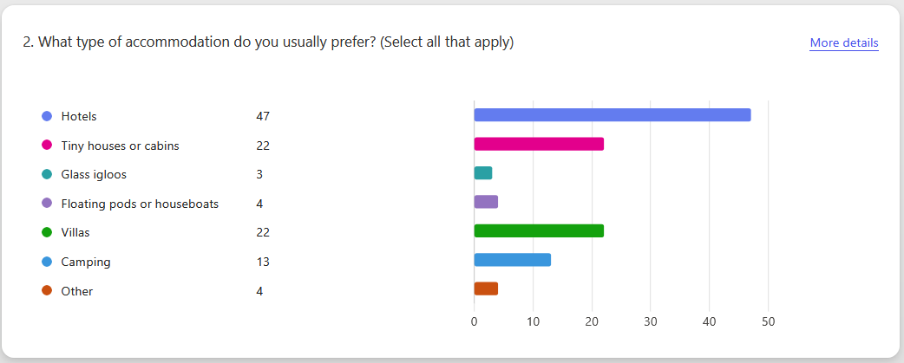

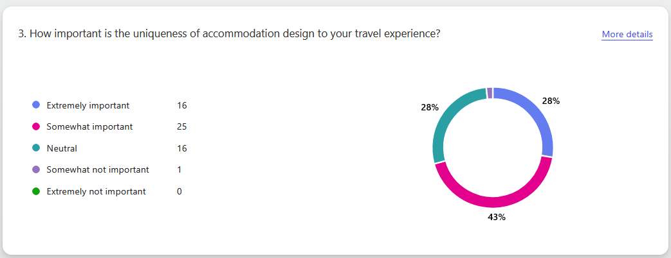

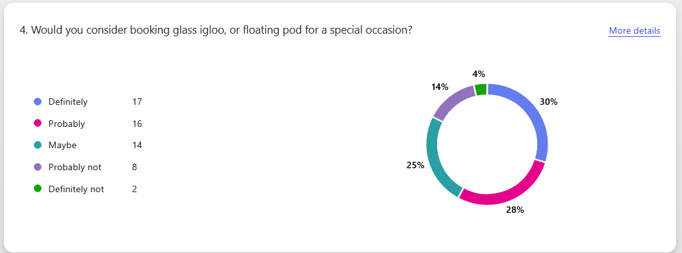

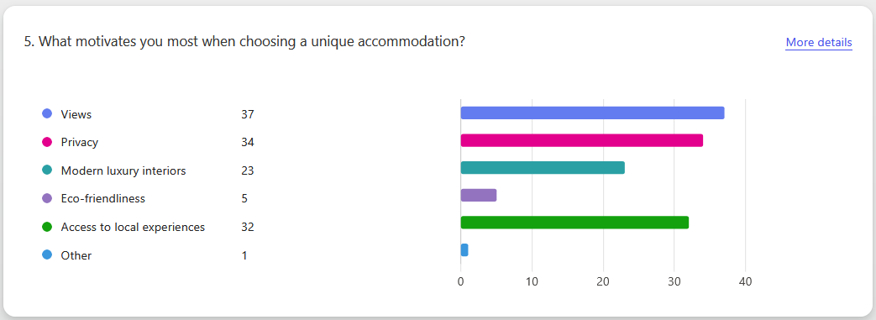
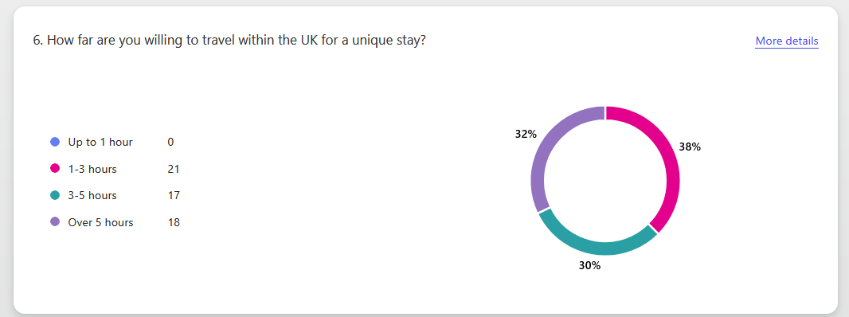

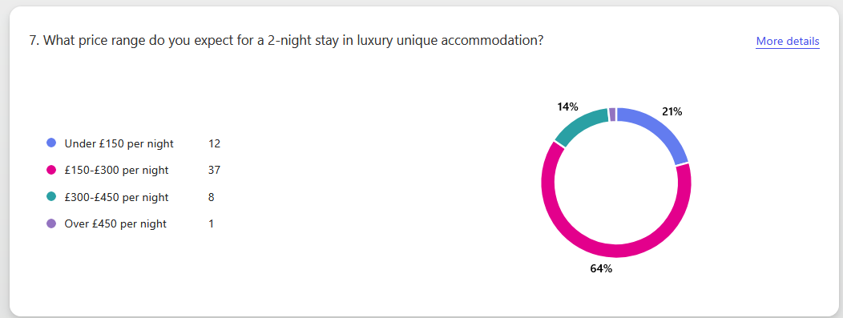

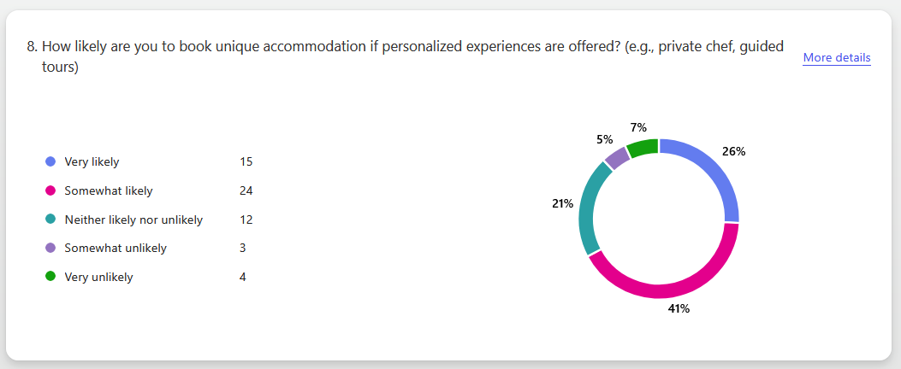

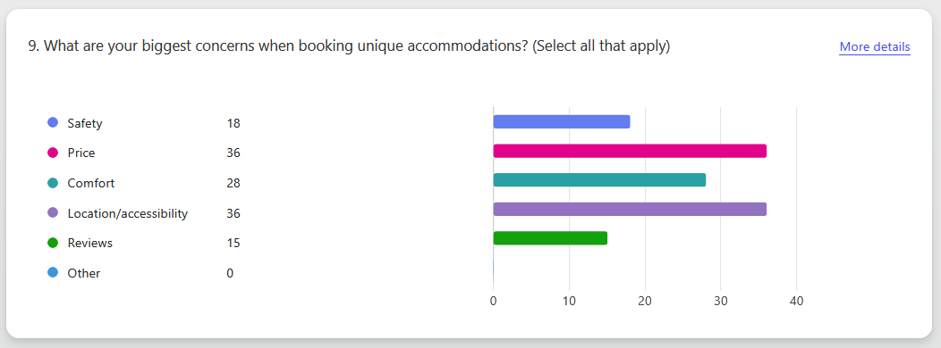

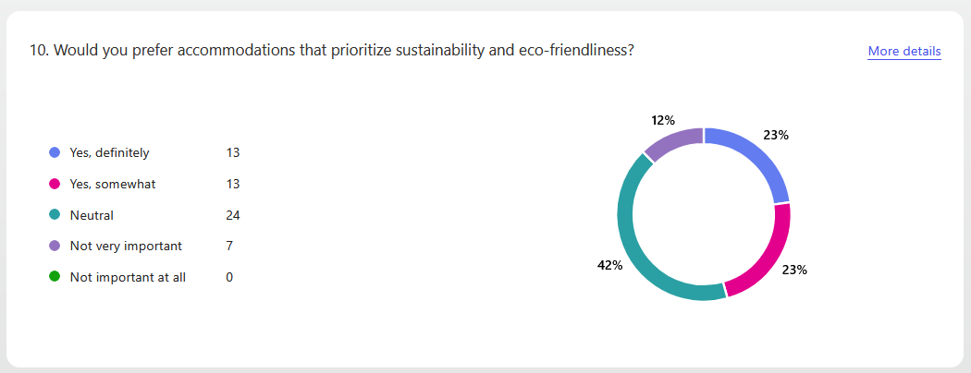

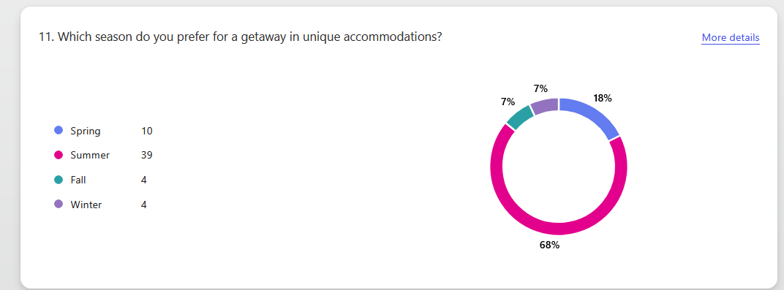

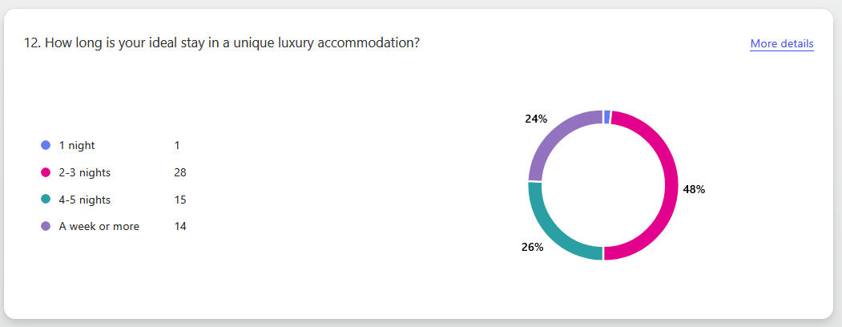

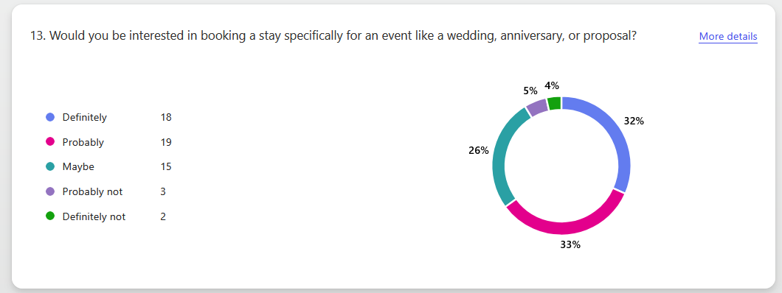

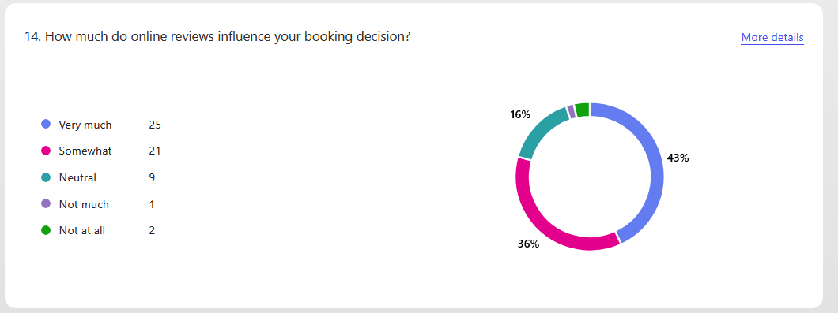

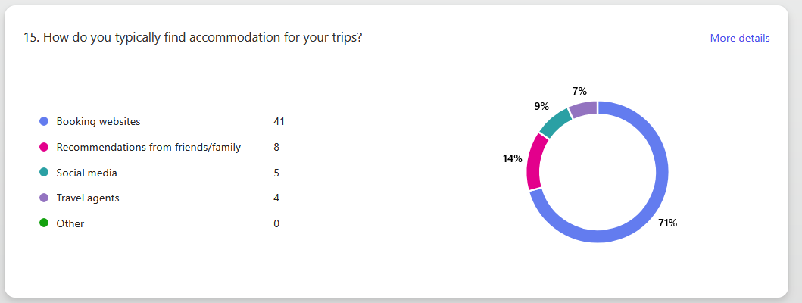

Marketing Materials:

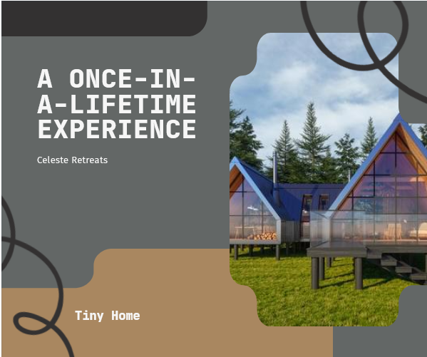

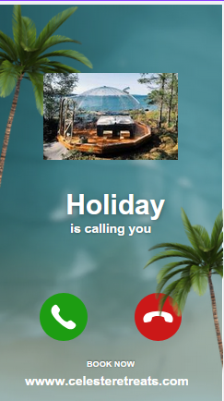

The importance of Excel in the digital era

Businesses of all sizes and in every industry need to be ready to navigate and comprehend data successfully in the fast-paced digital world of today. Microsoft Excel is still one of the most used and efficient software programs for managing, analysing, and making decisions out of all the tools available. For Celeste Retreats, a luxury hospitality business offering modern, unique experiences such as glass igloos and designer cabins in the UK, Excel plays a vital role in supporting day-to-day operations and long-term growth.
“Various surveys of companies across different industries show that over half use Excel spreadsheets for forecasting, and most combine this with other forecasting software tools” (Russell & Taylor, 2023). Excel offers a comprehensive suite of features including advanced formulas, powerful charting capabilities, data analysis tools, and visualization options. It also supports macros, another automation and customization features (Rosener, 2024). The management and employees at Celeste Retreats can remain organised and confidently make well-informed decisions. The continued emergence of hospitality and tourism technologies (HTT) has reshaped the industry by enhancing customer experience (Fan and Mattila, 2021) and improving operational efficiency (Law et al., 2022).
Excel supports Celeste Retreats in a few important areas, including financial management. Construction, maintenance, luxury guest amenities, and seasonal employment are all expensive aspects of operating a luxury retreat. “Business analytics skills and knowledge are undeniably important to organizations at both a strategic and operational level”. (Grenci,2022). Excel is also essential for analysing reservations data and figuring out customer preferences. Reservations are managed by an online booking system, but deeper insights into customer behaviours are accessible once this data is exported to Excel. With this information, the business can create packages that meet client expectations, modify rates during off-peak hours, and create special offers. “Excellent hospitality operations management will lead to better services and experiences for customers and staff, which will further the goal of business success”. (Szende, Dalton & Yoo, 2021). For instance, the company may decide to buy more glass igloos or provide winter-specific packages with extras like hot chocolate or stargazing tours if the data indicates that the igloos are generally in great demand during the winter months.
Excel is useful for everyday operational activities in addition to finances and consumer data. For instance, managing inventory is essential for a luxury retreat that offers exclusivity and comfort. Operating unique accommodations often means dealing with specialized equipment and supplies, such as bedding for igloos, eco-friendly cleaning products, and local food items for guest welcome baskets. Excel spreadsheets can help monitor stock levels, automate reordering schedules, and manage supplier contact lists, ensuring smooth day-to-day operations. “The rapid and disruptive technological innovations have significantly transformed the hospitality and tourism industry, which has traditionally emphasised the value of human touch” (Ozdemir et al., 2023).
Additionally, Celeste Retreats can transform unprocessed booking or financial data into understandable, useful graphics by using Excel's data visualization features, which include conditional formatting, sparklines, and pivot charts.
For example, the manager can rapidly create pie charts that break down expenses to identify areas of overspending or occupancy heat maps. Excel has an important yet indirect effect on marketing. Whether it's Instagram advertising showing off the glass igloos under the stars or collaborations with local influencers promoting romantic holidays, Excel can be used to collect data on customer preferences, seasonal trends, and booking sources to determine which marketing channels generate the biggest returns. Celeste Retreats may use this information to target high-conversion platforms, alter its marketing budget, and create deals that truly attracts guests. According to Brannan (1998), the consumer must be in the centre of the strategic thinking from beginning to end. If the organisation understands consumer’s wants, needs and motivation and identifies what differentiates the organisation from competitors, it more likely establishes a meaningful positioning.
Excel is helpful for long-term business expansion as well. For instance, Excel can assist in comparing possible sites by collecting important information on land costs, accessibility, local competition, and predicted occupancy if Celeste Retreats chooses to grow by adding more locations in other attractive regions of the UK. Instead of depending only on intuition, this logical approach to expansion planning reduces risks and encourages evidence-based choices.
To sum up, Excel is still one of the most effective tools available in the digital age, particularly for small businesses like Celeste Retreats. It is essential for managing a well-organized, data-driven, and customer-focused retreat because of its many uses in financial planning, inventory control, booking administration, and performance monitoring. Celeste Retreats is capable of maintaining operational excellence, provide guests with experiences they are going to never forget, and expand progressively in the highly competitive hotel industry by being proficient in Excel. “The hospitality industry must harness data analytics to personalize guest experiences and gain a competitive advantage in the digital marketplace” (Ali and Frew, 2021).

References:

Fan, A. and Mattila, A.S. (2021) ‘Touch versus tech in service encounters’, Cornell Hospitality Quarterly, 62(4), pp. 468–481.
Grenci, R.T. (2022) ‘Introducing business analytics in context: An Excel project to analyze product and sales data for inventory purchase decisions’, Decision sciences journal of innovative education, 20(4), pp. 190–200.
Law, R., Ye, H. and Chan, I.C.C. (2022) ‘A critical review of smart hospitality and tourism research’, International Journal of Contemporary Hospitality Management, 34(2), pp. 623–641.
Brannan T. (1998). A Pratical guide to Integrated Marketing Communications: Planning and Developing a Strategy. London: Kogan Page Limited
Ali, A. and Frew, A.J. (2021) ‘Information and communication technology (ICT) and hotel performance: a critical review of literature’, Tourism Management Perspectives, 38, p. 100812.
Ozdemir, O. et al. (2023) ‘A critical reflection on digitalization for the hospitality and tourism industry: value implications for stakeholders’, International journal of contemporary hospitality management, 35(9), pp. 3305–3321.
Rosener, W.J. (2024) ‘Comparative Analysis of Google Sheets and Microsoft Excel: A Discussion Case in Spreadsheet Software’, Journal of cases on information technology, 26(1), pp. 1–21.
Russell, R. S., & Taylor, B. W. (2023). Operations and Supply Chain Management (11th ed.). John Wiley & Sons, Incorporated.
Szende, P., Dalton, A. N. and Yoo, M. (eds) (2021) Operations Management in the Hospitality Industry. Bingley, England: Emerald Publishing.

Excel Spreadsheet

