

LCMB7001-MARKETING MANAGEMENT -A1

Student Name: Ibrahim Hazrat Ali Sardar
Student ID: 2215769
Lecturer Name: Tushara Balendran
Submission Date:30/08/2023
Table of Contents
Introduction 3
About the company 3
Definition of communication 4
A Diagram and a brief explanation of a communication model 4
A Definition of Integrated Marketing Communications 5
New promotional strategies that the company can use to raise awareness of the brand 6
A definition of branding and brand equity 8
Explanation and relate Keller’s Brand Equity model to the company 9
The customer journey and customer touch points of the organisation 11
Explanation and critical analysis of a customer journey map for the company 12
The Total Engagement Model could be explained and related to the company 13
Conclusion 16
References 17

Introduction
In this study, the company which has been chosen is Gucci. The report shall focus on providing a background of the organisation along with explanation communication, integrated marketing communication, branding and brand equity. In addition to evaluating the need to create innovative strategies of marketing for raising brand awareness as well as managing and evaluating the customer journey across a variety of communication channels to ensure current and future stakeholders shall be evaluated. In addition, the way the brand equity model is related to the company shall also be evaluated.

About the company
Gucci is a well known name among the top luxury brands which are known for its innovative, Italian-crafted leather goods, apparel and accessories for men and women. Founded in 1921 by Guccio Gucci, the famous Italian businessman and fashion designer Gucci is one such brand that forges towards continuing for redefining luxury while celebrating creativity, Italian craftsmanship, and innovation. The mission statement of Gucci is to become the top leader in the market of luxury globally (Gucci, 2023). The brand's vision statement is “to reinvent a wholly modern approach to fashion” Gucci is well known for its innovative approach to continuing its business unifying the principles they uphold and the actions they pursue to treat the world and each other better, for the collective future. As per 2022 reports, the net worth of the company is 18.1 billion U.S. dollars with revenue generation of €10.49 billion (Statista, 2022). Gucci believes in inclusivity, diversity and equality with the purpose of creating a global community that is authentic, unique and diverse selves.
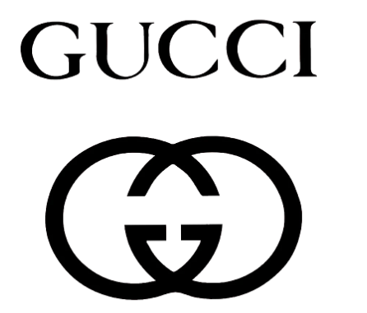
Figure 1: Gucci
(Source: Gucci, 2023)

Definition of communication
The concept of communication can be defined as a two-way process that is followed during the transfer of information from one person to another. Viswanathan and Mogensen (2020) stated that communication plays an important part in accessing management. The transmission and exchange of information which takes place in terms of sharing facts, opinions, views, and beliefs are termed together as communication. Communication can be of four types, verbal, nonverbal, written and visual. Different types of communication are used for different purposes to accomplish goals. For accomplishing objectives, communication plays an important role. Effective communication includes the communicator encoding the required information in such a way that the receiver can input and decide the information properly. As opined by Holzinger et al. (2021), communication is one such essential factor that contributes towards positive human interaction where individuals are allowed to connect, interact, collaborate and express one another for better social, personal and professional interactions.

A Diagram and a brief explanation of a communication model
A communication model is a common way of evaluating communication processes through simplified representations. Different communication models are used by businesses among which The Shannon-Weaver Model of Communication is the most common yet effective.
The Shannon-Weaver Model of Communication model focuses on evaluating the communication process that happens between a sender and a receiver. The model is used as there are several benefits where it emphasises information transmission through technical aspects of communication.
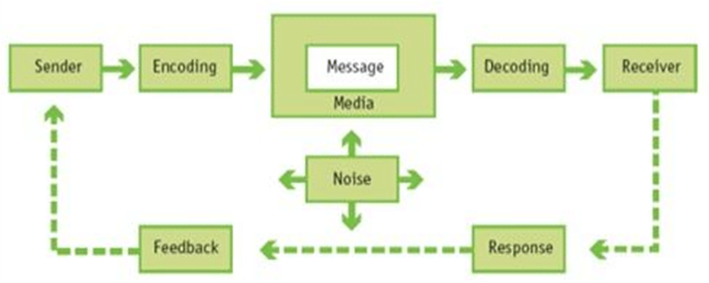
Figure 2: Marketing Management, Global Edition, 15th edition
(Source: Pearson, 2020)
From the above figure, it can be evaluated that there are several key components of the Shannon-Weaver Model, those are:
Sender: It is the main source of information generator that is responsible for sending and initiating the communication process.
Encoder: The prime role of the encoders is to focus on converting the information into a suitable format so that the receiver is capable of understanding. The encoder is the one who converts the information into symbols, voices, words or images.
Channel: It is the channel that works as a medium where the transmitted message is sent to the receiver from that of the sender (Kiranmayi et al. 2022).
Noise: IT can be defined as the interference which occurs when a message is being transmitted. It is the prime reason why messages get distorted and it affects the accuracy.
Decoder: It is the medium which is used for deciding the message tio such a form so that the receiver can understand the information.
Receiver: It is the receiver who receives the message sent by the sender. The receiver is responsible for decoding the message (Kuznar et al. 2020).
Feedback: IT can be said that feedback is the response received where it is conveyed whether the information that has been received is clear or not.

A Definition of Integrated Marketing Communications
Integrated Marketing Communications (IMC) can be defined as the process that is used for unifying a company’s messaging for making it consistent across all media regarding the brand used to reach its target audience. As opined by Das (2021), the prime goal of IMC is to take part in analysing all the aspects of a brand's marketing and work well to deliver cohesive and compelling messages to its target market. It can be said that with the use of IMC by companies, they can track and recognise customers being exposed to several promotional messages through various communication channels. The stages of IMC include defining the audience to be targeted, setting the promotional objectives, setting the promotion budget, designing the promotion mix and evaluating the results. These promotional messages work as interconnected elements that contribute towards gaining customer attention and also help in contributing to brand perception (Rachmawati and Afifi, 2022). There are key principles of IMC, those are consistency, coordination, customer-centric approach, channel integration, message clarity, measurement and analysis, feedback loop and long-term perspectives.
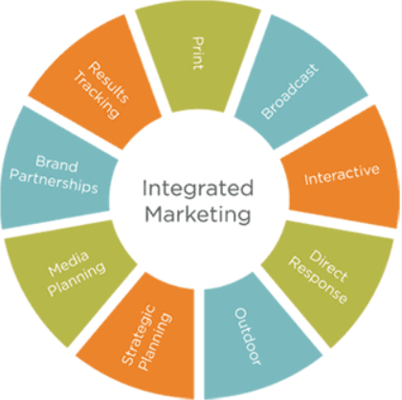
Figure 3: Integrated Marketing Communications
(Source: Das, 2021)

New promotional strategies that the company can use to raise awareness of the brand
Gucci is one of the top luxury brands globally and is already known to millions of people. But to increase its brand awareness following are the new promotional strategies that can be adopted:
- Collaborations with influencers and different artists
Influencer marketing is one of the most effective promotional strategies that can be used by organisations. Campbell and Farrell (2020) stated that influencer marketing is the process which is adopted by businesses that partner with social media influencers to market their products and services. Gucci can take the initiative in working more on collaborating with influencers as influencers have become big names in the world of social media. Currently, thousands of people use social media daily and Gucci using it as a promotional medium is best for evaluating its marketing. Presently, it has been seen that Miley Cyrus who is a popular singer has collaborated with Gucci and has made its presence in Gucci's FloraFragrance in June 2021 (Grazia Magazine, 2022).
- Diversification of product offerings
Product diversification is an important strategy which is used by organisations for promotional purposes. Oladimeji and Udosen (2021) stated that Product diversification is the procedure where the development and offering of new lines of products and services are provided which helps the organisation's survival and expansion. With the increased competition in the luxury market, survival has become essential as well as difficult because of the variety of options available to the customers. Because of that, companies like Gucci can take part in product diversification which can help in gaining new customers as well as contribute towards reducing the likelihood of industry collapse.
- UGC campaigns
User-generated content also known as UGC campaigns is original, brand-specific content created by customers and published on social media or other channels. This can be astrology where Gucci can encourage customers to create their content based on the brand's products. This is an essential step towards positive promotion as it helps organisations in building customer confidence (Mou, 2020). It is an effective strategy as it influences its audience and also converts them into buyers. It happens when the audience sees people just like them wearing or using a product, it feels more relatable and helps influence them to purchase.
- Sustainability Initiatives
It can be said that Sustainability Initiatives can be adopted by Gucci to increase its promotion aspects. It is an approach that is adopted by organisations where they aim to create long-term value through business strategy implementation using ethical, social, cultural, environmental and economic conditions (Brewer, 2019). Gucci takes part in highlighting their sustainability efforts through several workshops and campaigns which can contribute towards gaining more customers. These initiatives can be done through showcasing eco-friendly activities by Guicci, evaluating ethical production and others.
- Storytelling
For making a marketing campaign successful, storytelling can be one of the best strategies that can be adopted by brands. Michael and Fusté‐Forné (2022) stated that Storytelling marketing is the process that is used as a narrative for communicating a message. This process involves sugaring the history of the brand along with how the craftsmanship meaning of the products started. The storytelling process can help Gucci attract more customers and clients after knowing its history and the way the brand developed. This creates a stronger emotional connection with that of the customers.
- Virtual Personal Shopping
This is another essential strategy that can be adopted by Gucci for raising brand awareness. A virtual personal shopper is a person who is a virtual stylist who helps clients in defining their personality through styling. The virtual personal stylist helps the customers select clothing and accessories that go perfectly with the client's personality, body type, and preference as well as within their acquired budget (Xue et al. 2020). Gucci can offer these benefits to the customers where personalisation is available and can also help them create intimate connections with the brand.

A definition of branding and brand equity
Branding can be defined as the process of creating the brand identity of a particular company. As opined by Savitri et al. (2022), the overall process of branding includes research, development and application of the brand identity towards an organisation so that customers can associate with the organisation through their products and services. The process of creating a unique identity helps the organisation attract customers and understand the products wisely. Several attributes contribute towards successful branding; those are name and logo which are needed to be memorable and attractive, and visual identities using certain colours, typography or images which help the brand in better representation. In addition, messaging and posturing include the development of clear and concise messages to the customers along with attaining a good vision and mission. Customer experience is an important attribute that focuses on ensuring better customer interactions (Han et al. 2022). Lastly, emotional connection with customers and maintaining consistency across marketing materials, packaging, delivery, social media etc is a part of branding.
Brand equity is the value premium that a company generates from a product with a recognisable name when compared to a generic equivalent. Haudiet al. (2022) stated that the representation of a brand's worth and strength. It can be said that brand equity is the final result of the branding efforts that are done by the company through improving its experience and altercations with that of the customers. Different components contribute towards successful brand equity; those are Brand Awareness of customers recognizing the brand, Brand Association that the customers make with the brand, Perceived Quality in comparison to other brands, Brand Loyalty of customers, Brand Personality creation within the customers, Differentiation in comparison to other competitors, Market Position concerning other brands and Emotional Connection of customers with the brand (Marketing Evolution, 2023).
For example: In 2022, Gucci was valued at approximately 18.1 billion U.S. dollars which can be considered as 2.5 billion dollars more than 2021.
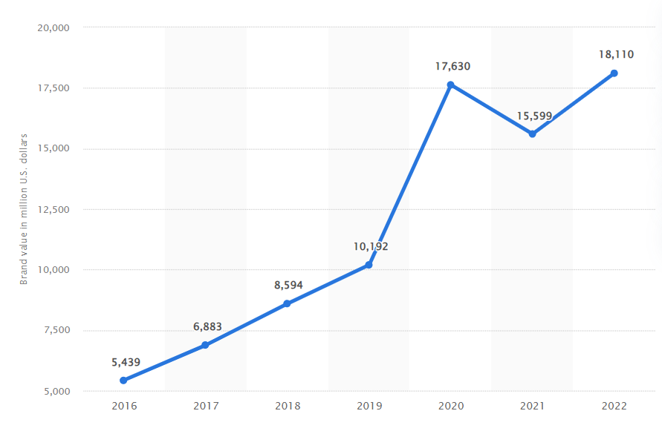
Figure 4: Brand equity of Gucci
(Source: Statista, 2022)

Explanation and relate Keller’s Brand Equity model to the company
The Keller’s Customer-Based Brand Equity (CBBE) model takes the shape of a pyramid, and that pyramid has four levels. The four levels include Identity, Meaning, Response and Relationships. Within identity, the brand salience is described. Within meaning, performance and imagery are defined. Response describes the brand's judgement and feelings while the relationship shows resonance (Mumford and Duhm, 2021).
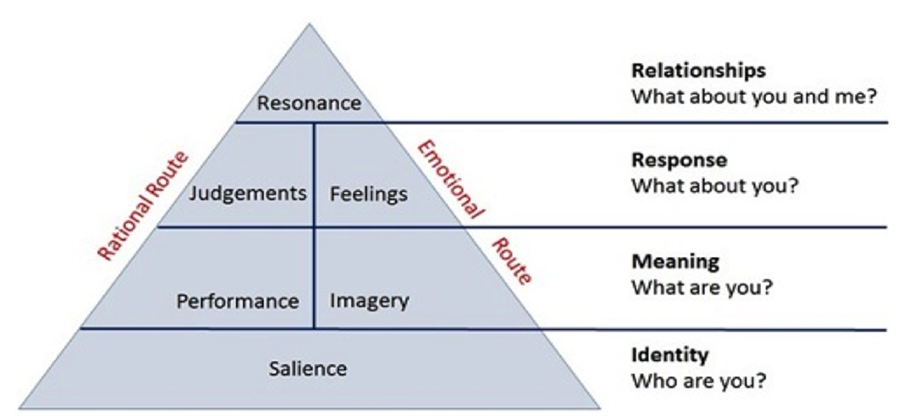
Figure 5: The Keller’s Customer-Based Brand Equity (CBBE) model
(Source: Mumford and Duh, 2021)
The following is the way Keller’s Brand Equity model can be related to Gucci:
Brand Salience
It is the first part of the CBBE model which identifies the brand. Brand salience or brand awareness focuses on how the brand is being perceived by the customers. How are the customers feeling about the brand and also their feelings accurate and justified? Based on Gucci's current population, it is on customer's top of their minds. Gucci has the most recognisable fashion logo which indicates a double G interlocked together demonstrates luxury (Micco, 2021). In addition, the "made in Italy" slogan also indicates the origin of the brand.
Brand Performance
Brand performance shows the aspects of how well the brand has performed in the market. It also shows how all the brands were capable of satisfying the customers. Based on Gucci's performance, certain functional benefits are achieved by customers, those are exclusivity, quality, Italian craftsmanship, unparalleled design and top-end price ranges (Ho et al. 2021). In addition to that, Gucci has been successfully offering customers top-notch quality luxury and thus contributes towards earning a strong performance reputation.
Brand Imagery
Brand Imagery refers to the Brand's social currency which shows the way the brand appears to its potential customer and the way they talk about it. It can be said that Gucci has very powerful and iconic imagery. This is because Gucci has made its preference clear to its customers and it provides services that reflect its heritage, modernity and prestige. Duality has been presented based on Gucci’s brand positioning of pairing with modernity and heritage (Hagan, 2021). In addition, its collaboration with celebrities also shows a prestigious presence.
Brand Judgements
Brand Judgments indicate the way customer judge the brand based on its qualities or services. Based on Gucci’s overview, it can be evaluated that the customers almost make positive judgments regarding the quality, services, design, and prestige of Gucci. It has been seen that Gucci was judged based on its most expensive pair of jeans which was sold for $3134 in 1998 (Forbes, 2005). The craftsmanship and the luxury materials that are used reinforce Gucci's judgments.
Brand Feelings
Brand Feelings also come under the response of the customer which shows what is being felt by the customer regarding the brand. Based on customer's feelings for Gucci, they believe Gucci contributes towards psychological empowerment, brand experience, high prestige and energising customers. Gucci is the brand that brings the feeling of luxury, pride and excitement (Placella, 2020). It also creates a sense of achievement and pride for customers when a Gucci product is owned by them.
Brand Resonance
Brand resonance sits on the top of the pyramid and is considered the most difficult to achieve. Brand resonance can be defined as the way a customer identifies themselves with the help of the brand. This indicates that the brand built a relationship with the customers. Gucci's brand resonance depends on engagement and community. Providing measuring clothing lines, single-day delivery and complimentary gifts on every purchase indicates high brand resonance. Available social media sites and loyal customers creating blogs with Gucci products help in brand resonance.

The customer journey and customer touch points of the organization
An organisation like Gucci, a high-end brand, passes through various phases in the customer journey, each of which is critical for establishing and preserving connections with clients.
Awareness: Potential clients will learn about Gucci in this manner for the first time.
Consideration: At this time, prospective clients started to think about Gucci as a possibility for their high fashion requirements.
Decision: At this point, clients decide whether or not to purchase Gucci goods.
Retention: Building customer loyalty and ensuring that they are happy with the product and the entire experience are the objectives after a purchase (Silva et al., 2020).
Advocacy: Customers who are happy with a brand become brand ambassadors and tell others about their favourable experiences.
Without question, consumer contact points play a significant role in determining how a customer feels about the brand and their entire experience.
Online store and website: Customers may explore the whole line of items offered by the company on the official Gucci website, which is a crucial point of interaction.
Social media: Instagram, Facebook, Twitter, and YouTube are just a few of the social media channels where Gucci is active.
Physical store: Gucci's physical storefronts are designed to provide an opulent and rewarding experience (Le Xuan, 2019).
Fashion shows and events: Gucci communicates with industry insiders, celebrities, influencers, and the media at key touchpoints by taking part in fashion weeks and events.
Advertising campaigns: The advertising efforts for Gucci, whether in print, online, or via other media, generate touchpoints that are seen by a large audience (Rana et al. 2021).
Influencer collaboration: The high fashion and pop culture realms are brought together via partnerships with influencers, celebrities, and artists.

Explanation and critical analysis of a customer journey map for the company
Noel, a social studies major from New York, is 22 years old. She has never given much thought to goods prices since she hails from a wealthy, tiny household.
 | Awareness | Consideration | Decision | Retention | Advocacy
Actions | Noel looked up several high-end companies online and discovered what they have to offer.  She goes to the Gucci website, looks over their merchandise, and selects a few items she likes. | For the official club opening, Noel realised she required a new costume. | From friends and vendors, she was able to obtain immediate feedback. | Noel picked up her belongings, collected her receipt for the transaction, and walked out of the shop. | Noel recalled her visit to the Gucci shop as being so wonderful that she only opted to purchase furs there and even talked about her experience on Facebook.
Effects | She sought advice from her friends and their preferred retailers of premium brands. | She recalls that she enjoys investing in pricey Gucci products to distinguish out. | Throughout her shopping trip, a salesperson assisted Noel and gave her a tour of the facility. She adores it and thinks this shop is virtually unique. | They provided her with a complimentary hair wash after the sale. | It was a wonderful experience for Noel.
Feelings |  | 
Final Assertion | This trends on social media

Figure 6: Customer journey map
(Source: Self-Created)

The Total Engagement Model could be explained and related to the company
It can be said that for a business to be successful, it is important to understand and focus on how customers decide to purchase its products. It can be evaluated by the fact that organisations are more likely to focus on customer engagement by tracking their product purchases and evaluating their needs and requirements. But if the organisation starts taking steps to encourage customers to engage in their brand by making one-off purchases rather than attempting to create engaged customers, it is more likely to observe that business performance increases and this is the main aim of the Total Engagement Model (Batidzirai et al. 2021). Based on the requirement, there are key strategic elements that need to be designed for creating engaged customers. Customer value proposition, Branding, Internal culture elements and Customer experience are the strategic elements.

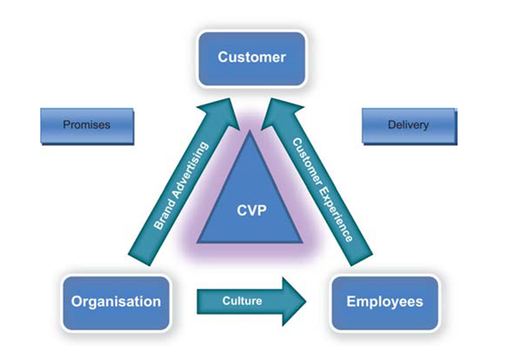
Figure 7: The Total Engagement Model
(Source: Batidzirai et al. 2021)
Customer value proposition
The Customer value proposition can be defined as the marketing statement that describes the reason behind customers buying a product or taking a service. As opined by Sheth (2019), the customer value proposition focuses on targeting the customers who are loyal or rather the potential customers who are willing to take up the service. Gucci's customer value proposition surrounds exclusive, regal and timeless. It is a symbol of status for customers who want luxury items in their collection (Hatton-Jones, 2020). The products' positioning, pricing, presentation, distribution and packaging along with fine customer service at their stores create an experience and connection to the brand that distinguishes them from their competitors.
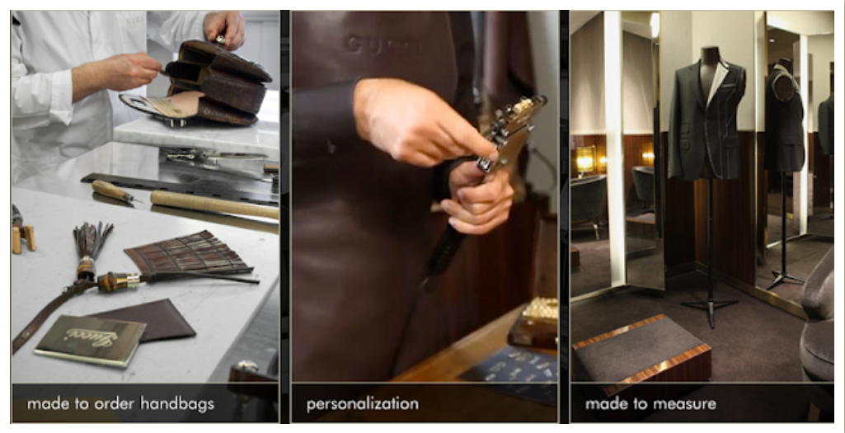
Figure 8: Gucci Value Proposition
(Source: Gucci Ppr.blogspot, 2023)
Branding
Branding can be defined as the total of who the brand is and what it stands for. It can be said that the tidal agent model identifies branding as an important factor where customers tend to know about the brand and its importance. There are certain aspects that Gucci highlights while branding, those are expansion of the target market, caring about the customers adopting marketing techniques ranges, focusing its brand positioning and strategic orientation and code of business conduct. By taking part in creation of a unique and recognisable brand identity, Gucci can use branding in the crowded luxury market to create loyal followers (Epiprodux, 2023).
Internal culture elements
The Internal culture element can be stated as "the way brands do things around" and also focuses on internal organisation aspects like its goals, values and internal behaviour. As per the brand, Gucci focuses on achieving significantly higher organisational effectiveness, because the people feel valued and part of a positive environment. In addition to that, some of their cultural elements include, being respectful, being the change makers, being trustworthy, being inclusive and daring and being responsible (Equilibrium. Gucci, 2022).
Customer experience
Customer experience refers to the combination of physical and emotional elements that are felt by the customer's interaction with the brand. It is one of the most important factors that contribute towards customer engagement as better customer experience leads to higher sales. Gucci has always been leading the way in putting the customer first (Vue.ai, 2021). Their main focus has always been on customer happiness, personalization and the last mile.

Conclusion
Gucci's marketing tactics, brand principles, and consumer interaction are the main topics of the research. Italian creativity and craftsmanship are the cornerstones of Gucci's mission to reinvent luxury. Along with the concepts of integrated marketing communications, the Shannon-Weaver communication model is examined. Influencer collaborations, product diversification, UGC campaigns, sustainability programmes, and storytelling are all part of Gucci's new advertising approach. In connection with Keller's CBBE model, brand equity and image are investigated. The Gucci customer journey consists of phases for awareness, contemplation, choice, retention, and advocacy, all of which are influenced by touchpoints, including online and physical shops, social media, associations, and partnerships with influencers. The entire engagement strategy has a focus on corporate culture, brand image, and customer experience.

References
Batidzirai, B., Trotter, P.A., Brophy, A., Stritzke, S., Moyo, A., Twesigye, P., Puranasamriddhi, A. and Madhlopa, A., 2021. Towards people-private-public partnerships: An integrated community engagement model for capturing energy access needs. Energy Research & Social Science, 74, p.101975.
Brewer, M.K., 2019. Slow fashion in a fast fashion world: Promoting sustainability and responsibility. Laws, 8(4), p.24.
Campbell, C. and Farrell, J.R., 2020. More than meets the eye: The functional components underlying influencer marketing. Business horizons, 63(4), pp.469-479.
Das, S., 2021. A systematic study of integrated marketing communication and content management system for millennial consumers. In Innovations in digital branding and content marketing (pp. 91-112). IGI Global.
Epiprodux, 2023. How Does Gucci Do It: Unpacking the Brand's Strategies. Available at: https://epiprodux.com/blog/how-does-gucci-do-it-unpacking-the-brands-strategies-for-success/#:~:text=By%20creating%20a%20unique%20and,strong%20bond%20with%20its%20customers. [Accessed on: 26.8.2023]
Equilibrium.gucci, 2022. Our Corporate Culture.
Available at: https://equilibrium.gucci.com/our-corporate-culture/ [Accessed on: 26.8.2023]
Forbes, 2005. The Most Expensive Jeans. Available at: https://www.forbes.com/2005/11/29/most-expensive-jeans-cx_sy_1130feat_ls/ [Accessed on: 26.8.2023]
Grazia Magazine, 2022. Miley Cyrus Honors Late Grandmother With Gucci Campaign. Available at: https://graziamagazine.com/us/articles/miley-cyrus-honors-grandmother-gucci-campaign/ [Accessed on: 26.8.2023]
Gucci Ppr.blogspot, 2023. Gucci Value Proposition.
http://guccippr.blogspot.com/p/gucci-value-proposition.html [Accessed on: 26.8.2023]
Gucci, 2023. About Gucci. Available at: https://www.gucci.com/us/en/st/about-gucci [Accessed on: 26.8.2023]
Hagan, S., 2021. Fashion Benefaction: Luxury and Brand Heritage in the Eternal City. CLARA, 8.
Han, D.I.D., Bergs, Y. and Moorhouse, N., 2022. Virtual reality consumer experience escapes: preparing for the metaverse. Virtual Reality, 26(4), pp.1443-1458.
Hatton-Jones, S., 2020. Luxury Brand Charisma (Doctoral dissertation, Curtin University).
Haudi, H., Handayani, W., Musnaini, M., Suyoto, Y., Prasetio, T., Pitaloka, E., Wijoyo, H., Yonata, H., Koho, I. and Cahyon, Y., 2022. The effect of social media marketing on brand trust, brand equity and brand loyalty. International Journal of Data and Network Science, 6(3), pp.961-972.
Ho, F.N., Wong, J. and Brodowsky, G., 2023. Does masstige offer the prestige of luxury without the social costs? Status and warmth perceptions from masstige and luxury signals. Journal of Business Research, 155, p.113382.
Holzinger, A., Malle, B., Saranti, A. and Pfeifer, B., 2021. Towards multi-modal causability with graph neural networks enabling information fusion for explainable AI. Information Fusion, 71, pp.28-37.
Kiranmayi, M.S., Mrudula, C.O., Thripureswari, P., Rao, K.R., Ragini, K. and Swamy, N.N.K.K., 2022. A Pragmatic Study On The Application Of Different Technical Communication Models Seen In English Literature. Journal of Positive School Psychology, pp.6949-6957.
Kuznar, L.A., Yager, M. and Joint Staff J39, Strategic Multi-layer Assessment Washington, DC United States, 2020. The Development of Communication Models, Quick Look. Joint Staff J, 39.
Le Xuan, T., 2019. Digital marketing strategies of luxury fashion brands in China: The Gucci brand.
Marketing Evolution, 2023. Brand Equity: What it Is & Why It's Key to Your Business. Available at: https://www.marketingevolution.com/marketing-essentials/what-is-brand-equity-marketing-evolution [Accessed on: 26.8.2023]
Micco, M.D., 2021. Can the strategy of the Italian fashion luxury brand Gucci sustain the brand´ s middle term future among its target? (Doctoral dissertation).
Michael, N. and Fusté‐Forné, F., 2022. Marketing of luxurious gastronomic experiences on social media: The visual storytelling of luxury hotels. International Journal of Tourism Research, 24(6), pp.827-838.
Mou, J.B., 2020. Study on social media marketing campaign strategy--TikTok and Instagram (Doctoral dissertation, Massachusetts Institute of Technology).
Pearson, 2020. Marketing Management, Global Edition, 15th edition. Available at: https://www.pearson.com/en-gb/subject-catalog/p/marketing-management-global-edition/P200000004661. [Accessed on: 26.8.2023]
Placella, S.A., 2020. Sustainability in fashion luxury: an atypical paradox evolving into reality: Gucci wallet case study.
Rachmawati, M.A. and Afifi, S., 2022. The integrated marketing communication in digital environment: a case study of local radio in Yogyakarta. The Indonesian Journal of Communication Studies, 14(2), pp.105-119.
Rana, J., Gaur, L., Singh, G., Awan, U. and Rasheed, M.I., 2021. Reinforcing customer journey through artificial intelligence: a review and research agenda. International Journal of Emerging Markets, 17(7), pp.1738-1758.
Savitri, C., Hurriyati, R., Wibowo, L. and Hendrayati, H., 2022. The role of social media marketing and brand image on smartphone purchase intention. International Journal of Data and Network Science, 6(1), pp.185-192.
Sheth, J.N., 2019. Customer value propositions: Value co-creation. Industrial marketing management, 87, pp.312-315.
Silva, S.C., Duarte, P. and Sundetova, A., 2020. Multichannel versus omnichannel: a price-segmented comparison from the fashion industry. International Journal of Retail & Distribution Management, 48(4), pp.417-430.
Statista, 2022. Brand value of Gucci worldwide from 2016 to 2022. Available at: https://www.statista.com/statistics/980720/gucci-brand-value-worldwide/#:~:text=In%202022%2C%20the%20Gucci%20brand,than%20in%20the%20previous%20year. [Accessed on: 26.8.2023]
Statista, 2022. Gucci: brand value worldwide 2016-2022 - Statista. Available at: https://www.statista.com/statistics/980720/gucci-brand-value-worldwide/#:~:text=Global%20brand%20value%20of%20Gucci%20from%202016%20to%202022&text=This%20statistic%20presents%20the%20brand,approximately%2018.1%20billion%20U.S.%20dollars. [Accessed on: 26.8.2023]
Uford, I. and Duh, H.I., 2021. Measuring the Sources and Outcomes of Customer Based Brand Equity in a Service Industry. African Journal of Business & Economic Research, 16(2).
Viswanathan, H. and Mogensen, P.E., 2020. Communications in the 6G era. IEEE Access, 8, pp.57063-57074.
Vue.ai, 2021. Here's Why I Thoroughly Enjoyed Shopping Online At Gucci. Available at: https://vue.ai/blog/retail-voices/gucci-online-digital-shopping-experience/[Accessed on: 26.8.2023]
Xue, L., Parker, C.J. and Hart, C., 2020. How to design fashion retail's virtual reality platforms. International Journal of Retail & Distribution Management, 48(10), pp.1057-1076.

