

Methods and Search Strategy Academic Poster

Student name: Noreen Akhtar
Student ID: 2246135
Module name: Independent Project
Module code: BMHP6020
Lecturer: Chloe Harries

The Differential Impact of Specific Types of Adverse Childhood Experiences (ACEs) on Mental Health in Young Adults (15–30) in the UK

01 Introduction and Research Aim
A methods chapter explains how the study was done so readers can judge credibility and, if needed, repeat the process. This poster summarises the secondary-research method used: database searching, screening, validation, and thematic analysis. Aim: To examine how physical abuse versus parental separation differentially affect mental health (depression, anxiety, PTSD/trauma symptoms, self-harm, substance use) among UK young adults aged 15–30, and to draw implications for trauma-informed screening and care.

03 Searching for Information

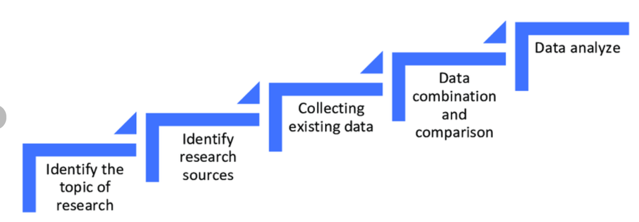

02 Search Strategy
A search strategy is a planned, systematic approach for locating relevant literature using defined keywords, databases, and limits. For this dissertation, search terms were built from the title and objectives, then applied consistently across databases to reduce selection bias and improve transparency.

Desk research method process (Turon and Kubik, 2021)
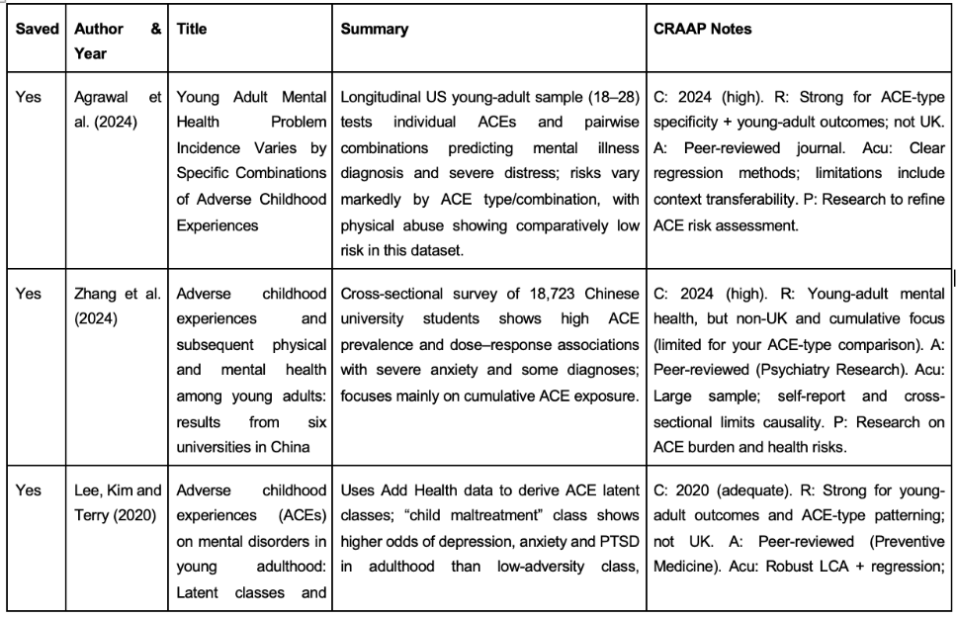

05 Research Validation and Analysis
Validation in secondary research is checking that sources are credible, relevant, and methodologically sound. Sources were checked using rapid skimming (methods/results first) and the CRAAP criteria (Currency, Relevance, Authority, Accuracy, Purpose). Analysis: included studies were synthesised using thematic analysis (coding repeated patterns, grouping codes into themes, maintaining an auditable coding trail) to compare mechanisms, outcome patterns, and moderators.

Inclusion Criteria | Exclusion Criteria
Peer-reviewed articles and credible reports | Non-scholarly sources
UK-focused (or clearly transferable to the UK context) | Studies using only cumulative ACE scores with no separate ACE-type results
Outcomes for ages 15–30 (or extractable subgroup data) | Non-extractable age groups
Distinct reporting of physical abuse and/or parental separation | Outcomes unrelated to mental health
Mental health outcomes aligned to the study aim | Unclear methods or insufficient reporting
Accessible full text | —

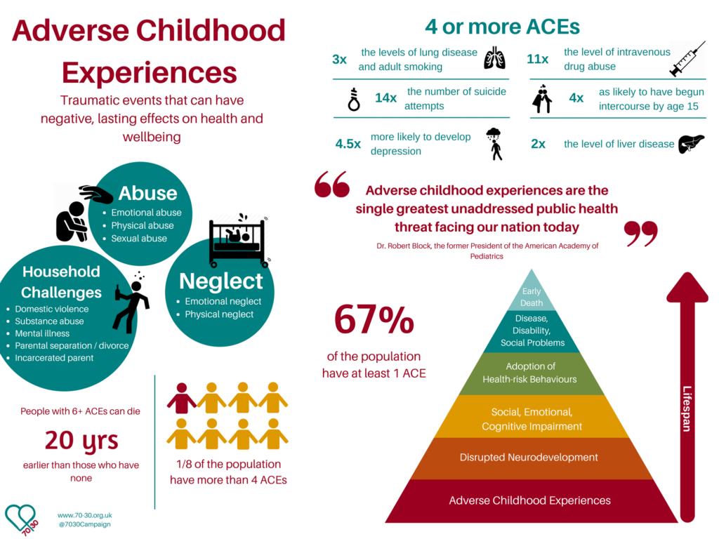
ACE and their Impacts (Hans, 2021)
References
Bramer, W.M. et al. (2017) ‘Optimal Database Combinations for Literature Searches in Systematic reviews: a Prospective Exploratory Study’, Systematic Reviews, 6(1), p. 245. Available at: https://doi.org/10.1186/s13643-017-0644-y.
Braun, V. and Clarke, V. (2006) ‘Using Thematic Analysis in Psychology’, Qualitative Research in Psychology, 3(2), pp. 77–101. Available at: https://doi.org/10.1191/1478088706qp063oa.
Gupta, S. et al. (2018) ‘Systematic Review of the Literature: Best Practices’, Academic Radiology, 25(11), pp. 1481–1490. Available at: https://doi.org/10.1016/j.acra.2018.04.025.
Hans, L. (2021) Can Childhood Adversity Cause Anxiety?, Laura Hans Therapy. Available at: https://laurahanstherapy.co.uk/mental-health/can-childhood-adversity-cause-anxiety/ (Accessed: 4 February 2026).
Kalidas, A.J. (2021) ‘The Effectiveness of CRAAP Test in Evaluating Credibility of Sources’, International Journal of TESOL & Education, 1(2), pp. 1–14.
Turoń, K. and Kubik, A. (2021) ‘Business Innovations in the New Mobility Market during the COVID-19 with the Possibility of Open Business Model Innovation’, Journal of Open Innovation: Technology, Market, and Complexity, 7(3), p. 195. Available at: https://doi.org/10.3390/joitmc7030195.

