Alessandro Dallavalle

P151936

Motorsport/Automotive Engineering

Electronic Ignition & Fuel Injection Systems

Lecture Andrew Gibson

Contents page

Introduction 3

Methodology 4

Task 2 5-15

Task 3 16

Task 4 17

Task 5 18

Graphs 19-37

Conclusion 38

Reference 39

Introduction

With the report I will be looking at two different engines and I will compare them with one another by comparing the results, I will do this by firstly testing each engine by using various different types of equipment. I will then create graphs and charts to use to compare the two engines. Then I will go on to say which type of modification can be done to one of the engines, so that the engine would perform better and be more efficient.

Methodology

First of all we went through health and safety practice, like do not put your fingers in the engine when the engine is running, the lecturer Andrew Gibson used an exhaust suction system and open the door just in case we would breathe in any toxic fumes from the engine exhaust system. Personal protective equipment was worn; I wore Steel toe cap boots and a overall to protect me from any dangers like a heavy object falling on my foot and say oil that would go on the overalls rather than my clothes.

The two engines were on rigs which made it much easier to test as they were modified by our lecturer Andrew Gibson so that we could probe the engine pin points in one location. We tested the engine when the ignition was on and off with Bosch diagnostic system and a digital multi-meter.

The reason why I chose to use the Bosh diagnostic kit was because firstly it is highly accurate and it also gives you the readings on the screen in graph form. I chose the digital multi-meter because it is not as accurate as the Bosh diagnostic kit but still reliable as it is easy to use and move around.

Task 2

Results from tests from Metronic:
A graph for metronic
 | Ohms | Volts | Ohms | Volts | charcoal solenoid 5 | lambda 28
20 | 1442 | 3 | 0 | 45% | Off | Off
30 | 1090 | 2.6 | 3.3 | 43% | Off | Off
40 | 712 | 2.1 | 3 | 43% | Off | switching between 40degrees and 45 %
50 | 472 | 1.7 | 2.8 | 45% | on at 50 - 55 degrees
60 | 0 | 0 | 0 | 0%
70 | 264 | 1.1 | 3 | 44%
80 | 246 | 0.8 | 2.7 | 45%%

NTC1

20 | 3.8
80 | 3.7

Injection on time
Temperature | resistance | volts | ms | %
60 | 266 | 1.1v | 2.8 | 41%

The fan was turned on at 60 degrees to 80 degrees because the fan is on and also uses electrical power.

Resistance o injector valves
1 | 16 ohms
2 | 16 ohms
3 | 16 ohms
4 | 16 ohms

ht leads
1 | 1990 ohms
2 | 1750 ohms
3 | 1500 ohms
4 | 2140 ohms

King lead
broken

primary windings and secondary windings
primary | 0.6 ohms
Secondary | 9720 ohms

Throttle potentiometer
resistance between 1 And 2 throttle closed | 2000 ohms
resistance between 1 and 3 throttle open | 2549 ohms

air flow sensor
resistance between 4 and 2 | 329 ohms
resistance between 4 and 3 | 536 ohms
resistance between 4 and 1 | no pin 1

air temperature
resistance between 4 and 5 cold engine temp | 2690 ohms
engine temp 80 degrees | 246 ohms

pin number | ignition off | ignition on
1 | 0 | 12.31
2 | 0 | 0.03
3 |  | 12.2
4 | 0 | 9.85
5 | 0 | 12.18
6 | 0 | 11.48
7 | 0 | 0.21
8
9
10 | 0 | 0
11
12 | 0 | 5.07
13 | 0 | 10.23
14 | 0 | 0.02
15
16 | 0 | 12.18
17 | 0 | 12.18
18 | 1254 | 12.16
19 | 0 | 0.02
20
21
22 | 0 | 0.91
23
24 |  | 0.03
25
26 | 0 | 0.05
27 | 0 | 12.28
28 | 0 | 0.46
29
30
31
32 | 0 | 11.46
33
34
35
36 | 12.21 | 0.28
37 | 0 | 12.18
38
39
40 | 0 | 0.05
41 | 0 | 0.05
42 | 0 | 0.03
43
44 | 0 | 3.7
45 | 0 | 3.9
46 | 0 | 5.07
47
48 | 0 | 0.05
49 | 0 | 0.09
50
51
52
53 | 0 | 0.62
54
55 | 0 | 11.15

LE3 data:

 | ignition ecu |  | fueling ecu
pin | ignition off | ignition on | ignition off | ignition on
1 | 0 | 0.07 | 0 | 0.32
2 | 0 | 0.17 | 0 | 12.3
3 | 0 | 12.24 | 0 | 0
4 |  |  | 0 | 0.02
5 | 0 | 0.1 | 0 | 0.03
6 | 0 | 0.02
7 | 0 | 1.32
8 | 0 | 1.2 | 0 | 0.82
9
10 | 0 | 0.18 | 0 | 0.15
11 | 0 | 0.12
12 | 0 | 0.18 | 0 | 12.35
13 | 0 | 0.26
14 | 0 | 5.01 | 0 | 5.02
15 | 0 | 0.16 | 0 | 0.02

ntc 2 | ohms | volts | Ms
 | 8 | 8 | 3
20 | 1822 | 1.5 | 4.7ms
30 | 1049 | 0.1 | 3.3
40 | 749 | 0.8 | 3.2
50 | 538 | 0.6 | 2.9
60 | 401 | 0.6 | 2.7
75 | 552 | 0.6 | 2.5
Ht leads
pin
1 | 8560 ohms
2 | 8500 ohms
3 | 7460 ohms
4 | 5070 ohms

Graph 1

This graph above compares NTC2 volts with Metronic and Le3 engines.

Graph 2

This graph above compares the NTC2 ohms of the Metronic and Le3 engines.

Task 3
Compare
If you look at my graph 1 NTC2 voltage, you will notice that Metronic and LE3 the voltage starts high then drops in voltage as the engine increases temperature. This is due to the engine needing less voltage as the engine gets warmer because ignition becomes easier to induce. When the sensors reads up that the engine is getting hotter than the fan turns on to cool the engine back down again. In our team we noticed that the fan turn around at 60 degrees. I have noticed in the graph 1 that LE3 has lower voltage than the metronic because it is an older engine and the age of the wiring could have reduced the voltage.

In the second, graph 2, you can notice that the ohms is similar to each other in both engines. The Metronic engine has a lower resistance than the LE3. When the engine is cold the resistance is high but the resistance decreases as the engine warms up, once the engine has got to running temperature the resistance is low.

The LE3 engine the voltage is less than the Metronic engine because the LE3 has an on and off switch, because it doesn’t need that much voltage for the thermostat. I believe that Metronic system has a bigger voltage than the LE3 because It has a input and a return signal.

Task 4
The differences between the two engines are:
The metronic engine has a sequential direct injection, this is where the injectors are above the cylinder and spray fuel directly into the cylinders 1,2,3,4 at different times. The Metronic engine also has a lambda sensor, the sensor reads the fuel once its burned and then can alter the amount of fuel that is injected into the engine depending if the engine is running lean or rich, the air mass meter is in control of the amount of air that goes into the engine and can alter the amount of air that goes in. a EGR valve is also used this controls when the engine is idle and keeps the engine running.

The LE3 doesn’t have a direct injection, but it does inject fuel. The injector is located behind the intake valve so as the valve opens it injects fuel and draws air in at the same time. This system injects two injectors at the same time which happens every 180 degrees rotation. The air mass meter has an electronically controlled flap. The LE3 is not fitted with a catalytic converter.

Task 5
I would improve the LE3 because it’s an old engine that can be improved. Firstly I would:
- improve the LE3 by changing the injectors to sequential which would improve the delivery of fuel and not waste as much fuel because the sequential injectors only operate when told by the system.
- I would also have modern temperature sensors which would detect when the engine is over-heating faster than the old one and turn on the cooling system to cool down the engine quicker.
- I would recommend putting in a direct coil pack, which would mean that it gives a better spark.
- Put in direct injection which would mean that the engine would have a better fuel injection as when its sprayed into the cylinder its accurate and does not dripple.
- I would put in a catalytic converter and a lambda sensor as this would mean that the engine would become more fuel efficient as the lambda sensor reads the amount of burnt fumes and can then judge how much fuel to put in or air by communicating with ecu.

Graphs
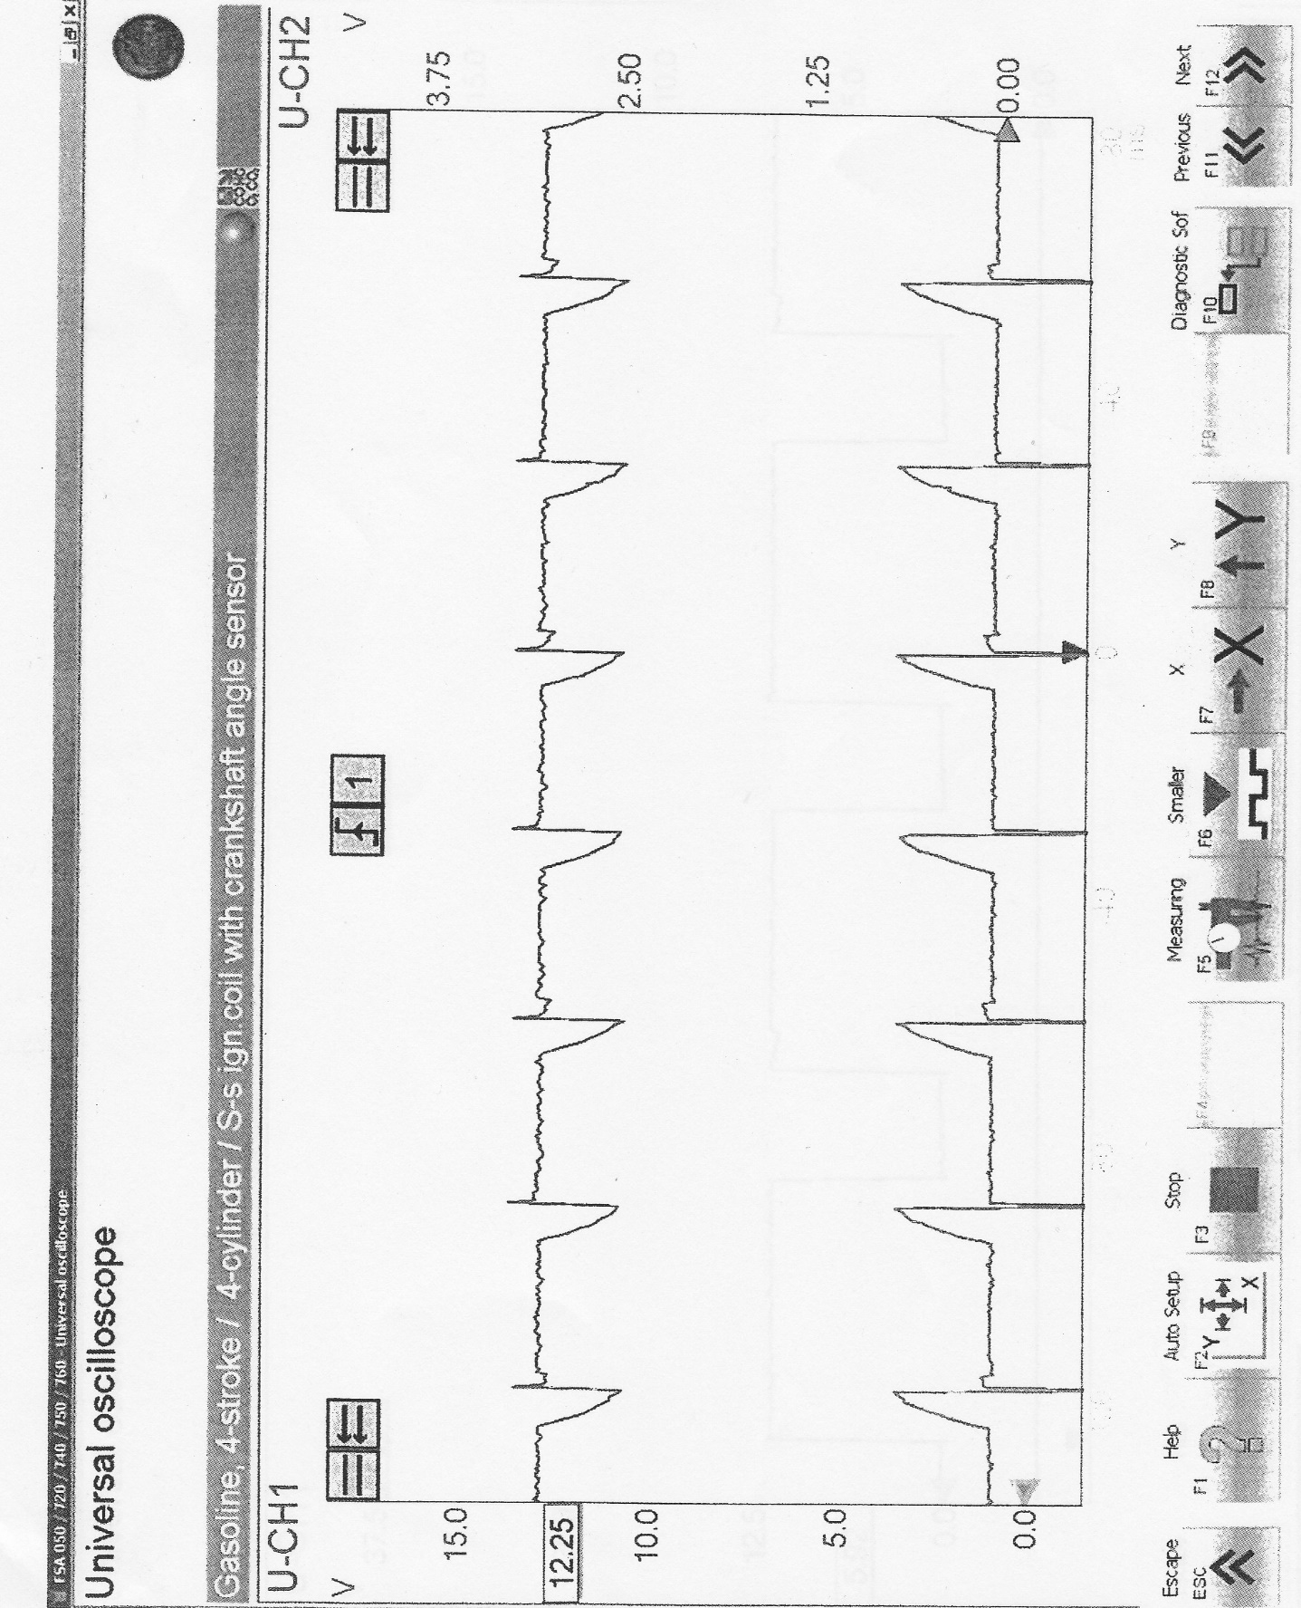
This graph above shows the supply pin 3 and earth pin 2. If you look carefully at the graph it shows on the top line the voltage drops where it is grounded which means it is on for a short time then off. The bottom one earth, what is happening is that the current is being grounded.

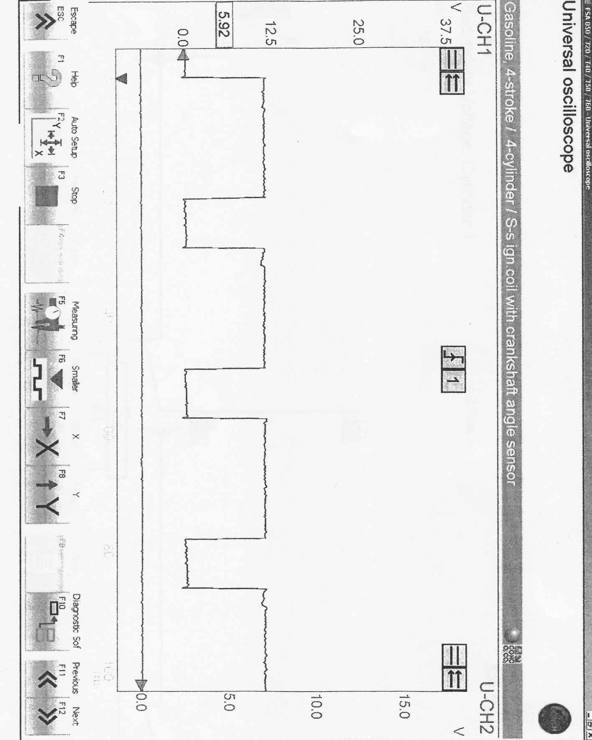

Speed reference for fuel graph pin 5
This graph is showing grounded, on, off for speed reference. For fuel, it uses a road speed sensor.

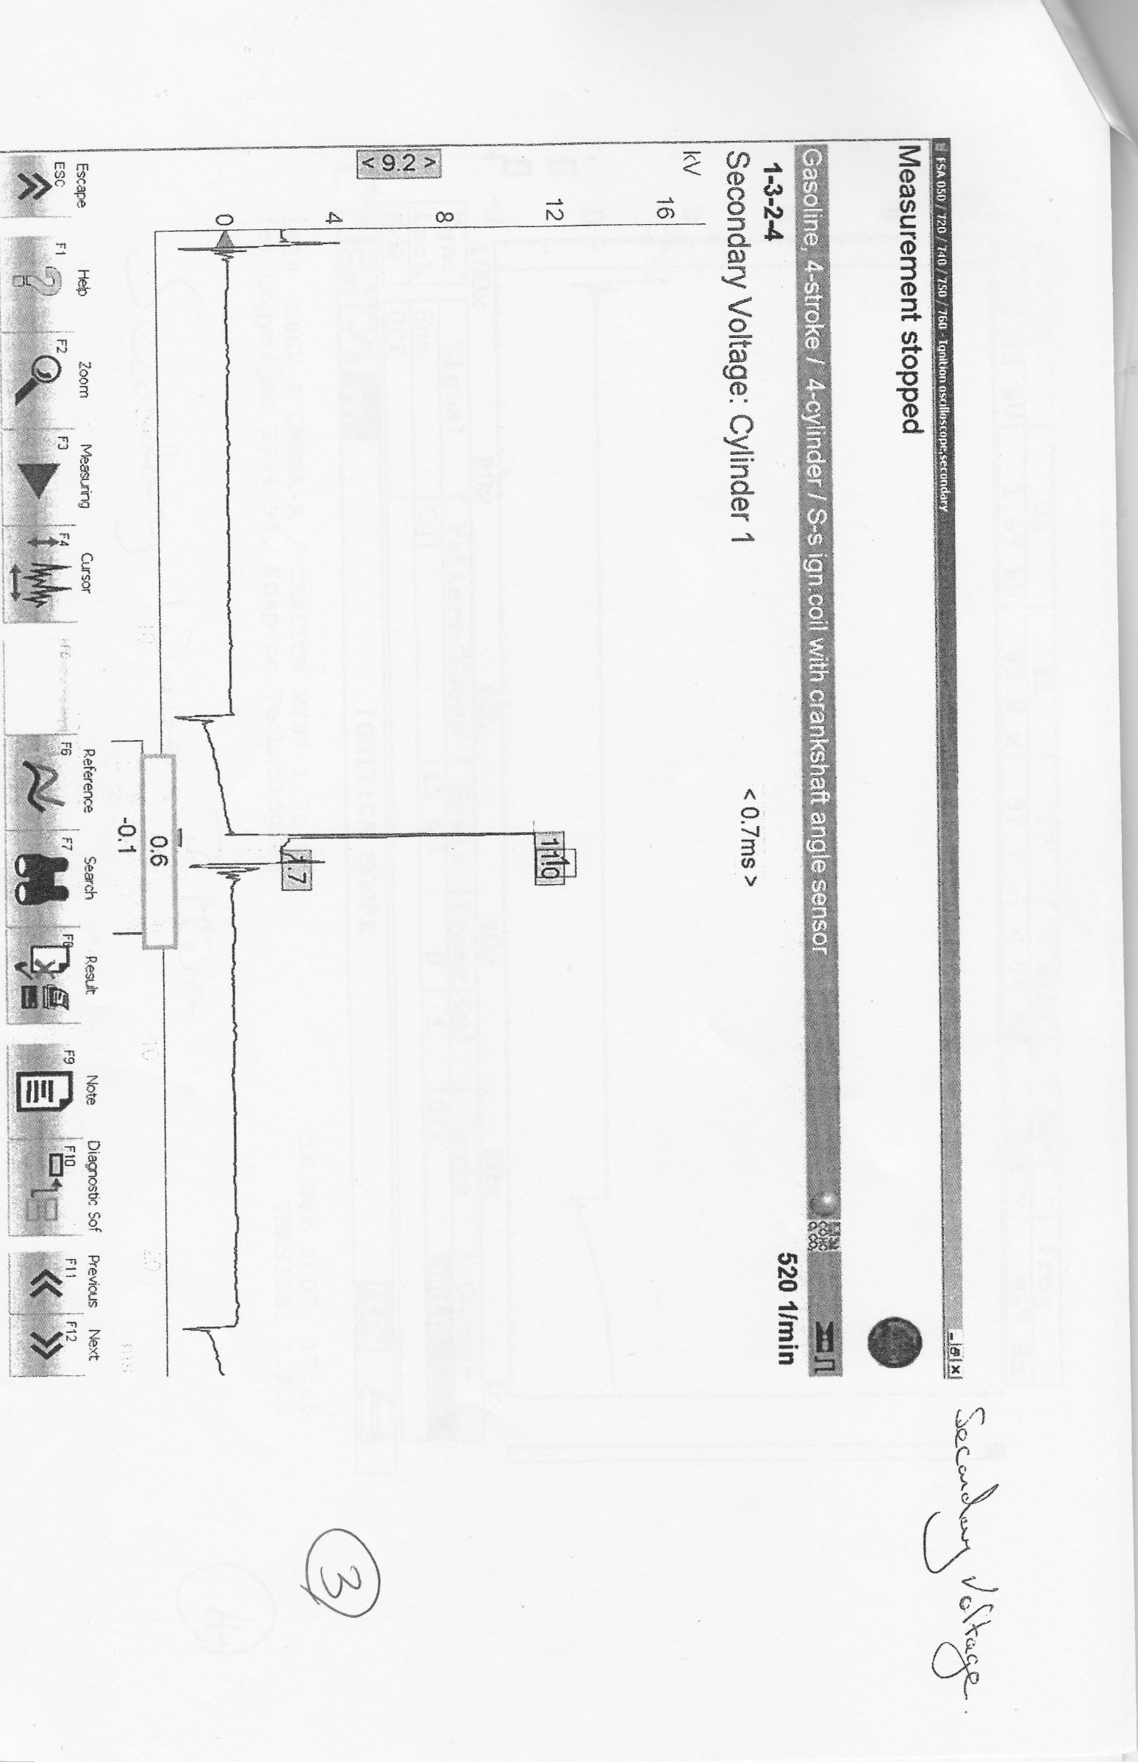

This chart above shows the scope pattern of Secondary voltage.
The first bit that happens in this graph is that before the voltage drops it has a magnetic field then after that a dwell, then a spark firing voltage and back EMF, then you can see end of spark.

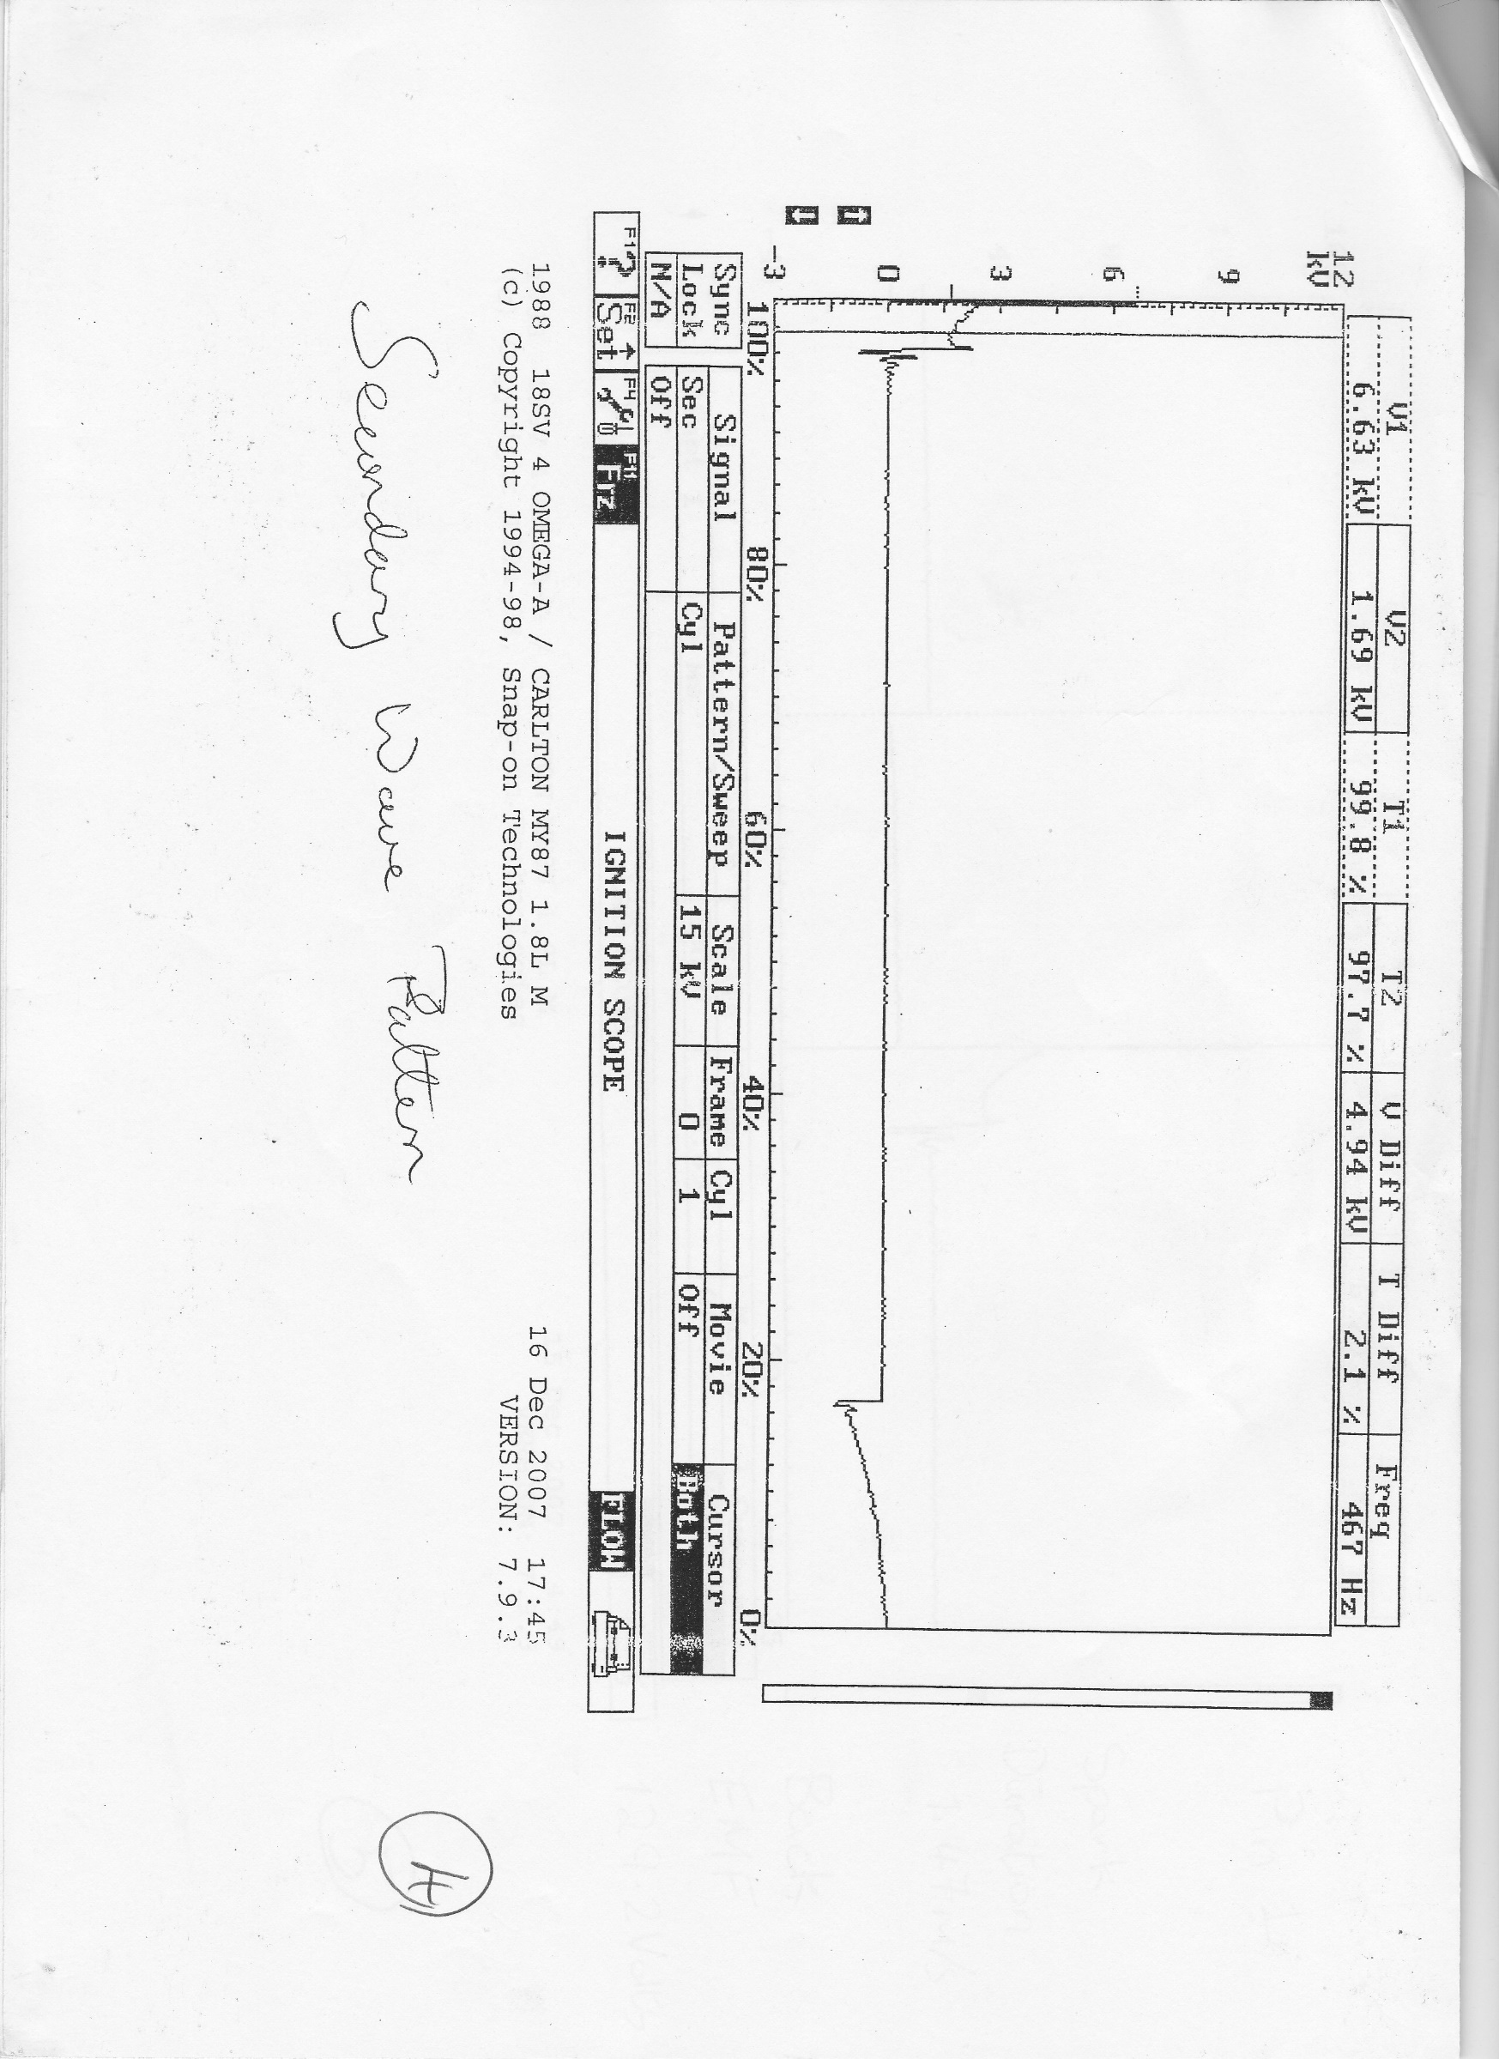
This graph above is the secondary wave pattern. This graph shows the dwell time.
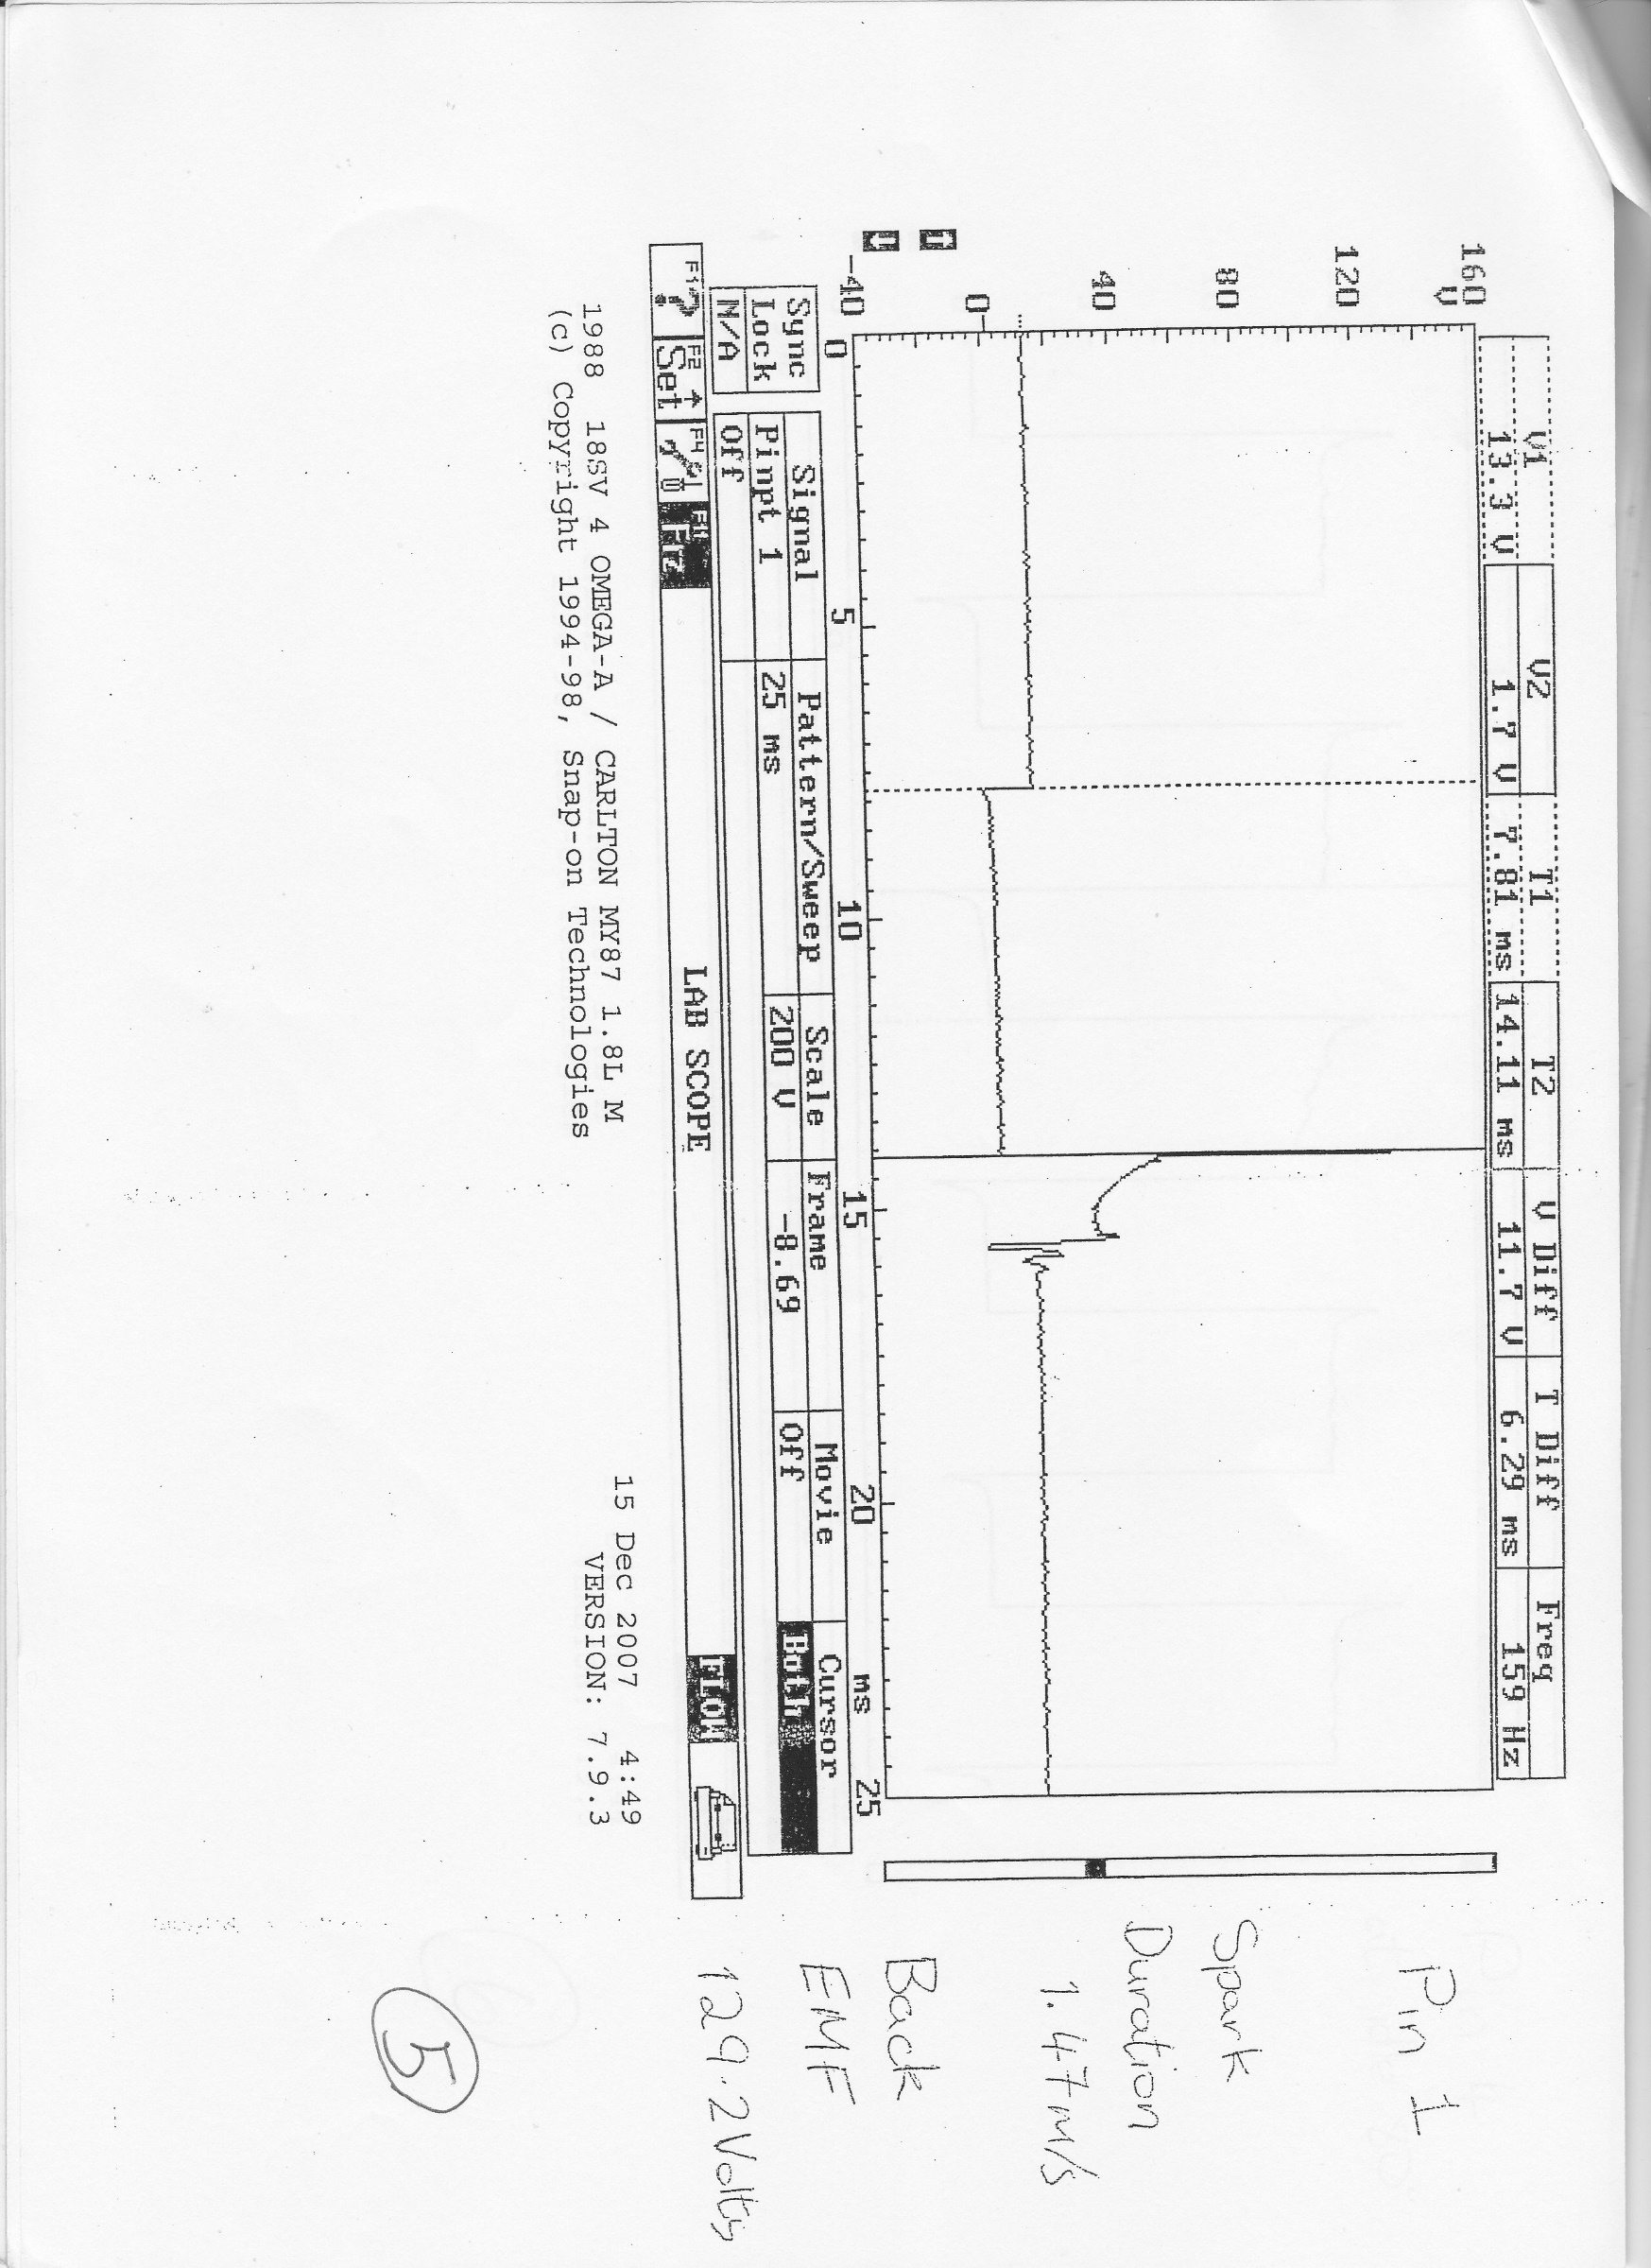
Pin 1
it shows back EMF 129.2 volts then it shows the burn time and spark time 1.47m/s, this is the negative side of coil.

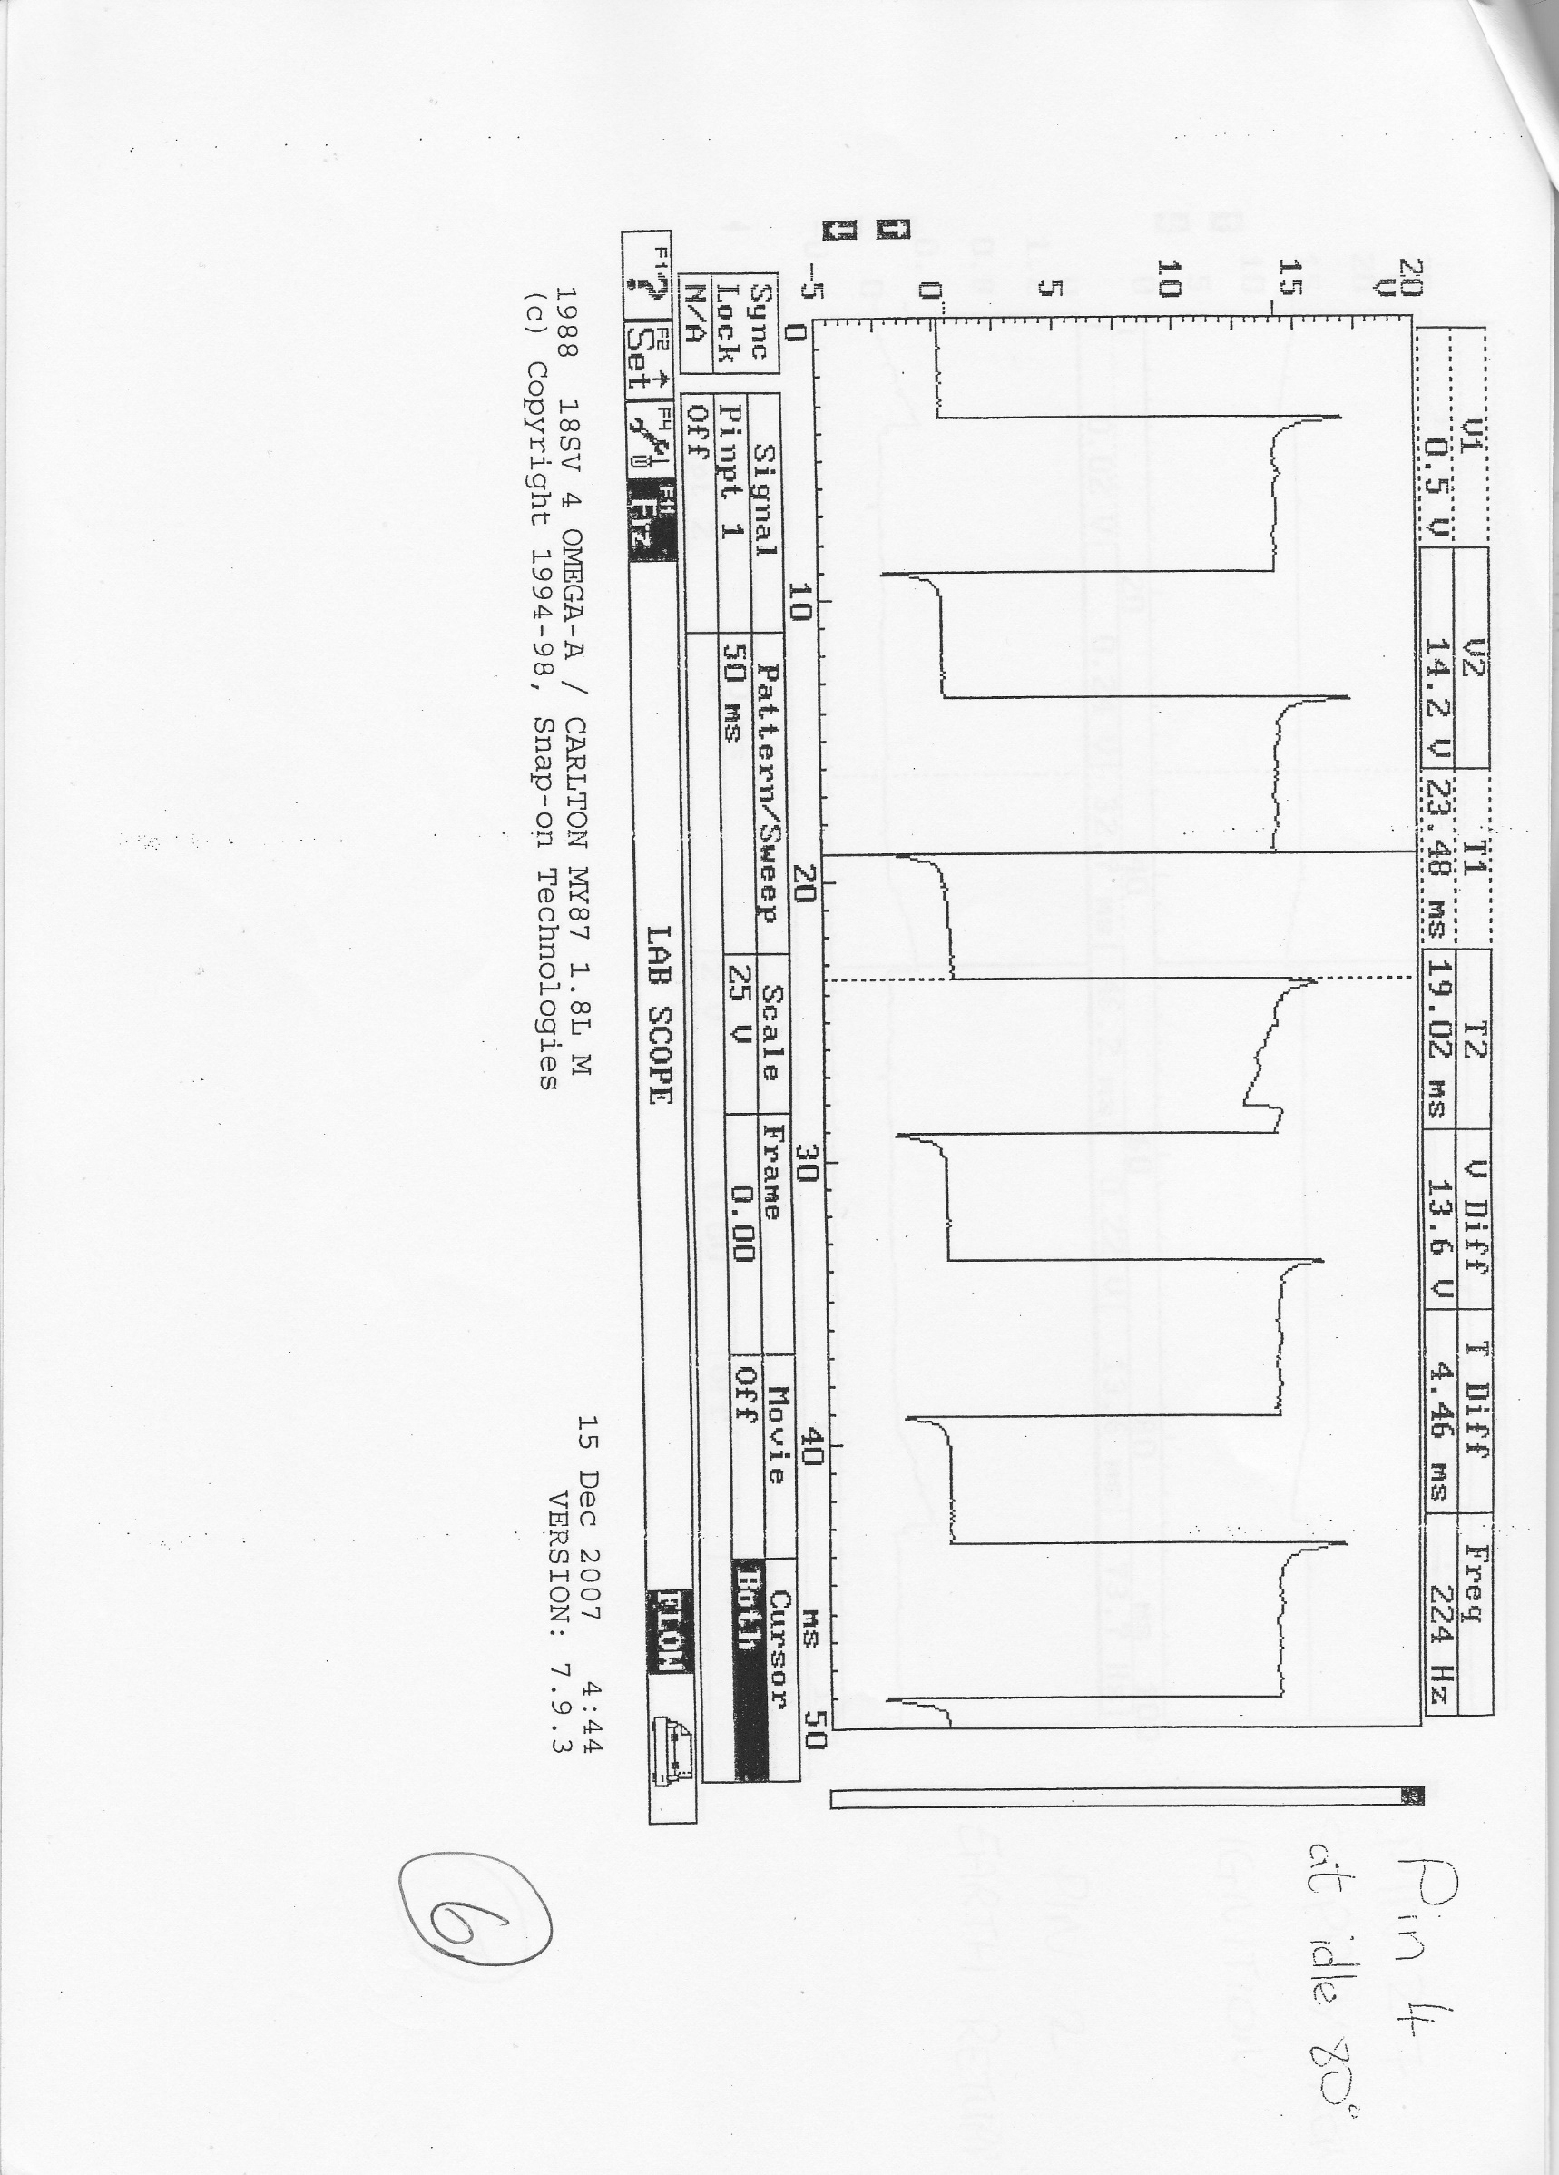
Graph above shows Pin 4 at idle 80 degrees
The graph shows when it spikes it’s the on time and when I spikes down is the off time.

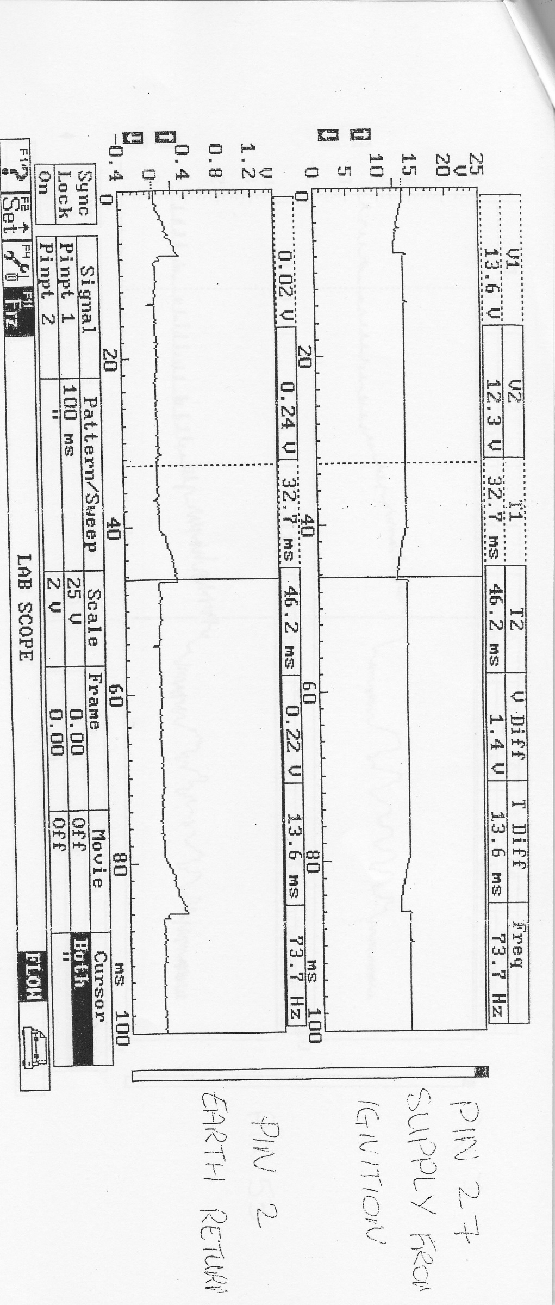
This graph shows Pin 27 (ignition) and pin 2 Earth return
The top graph shows when ignition is off and grounded. The bottom graph then shows when the ignition is on and has the current supply.
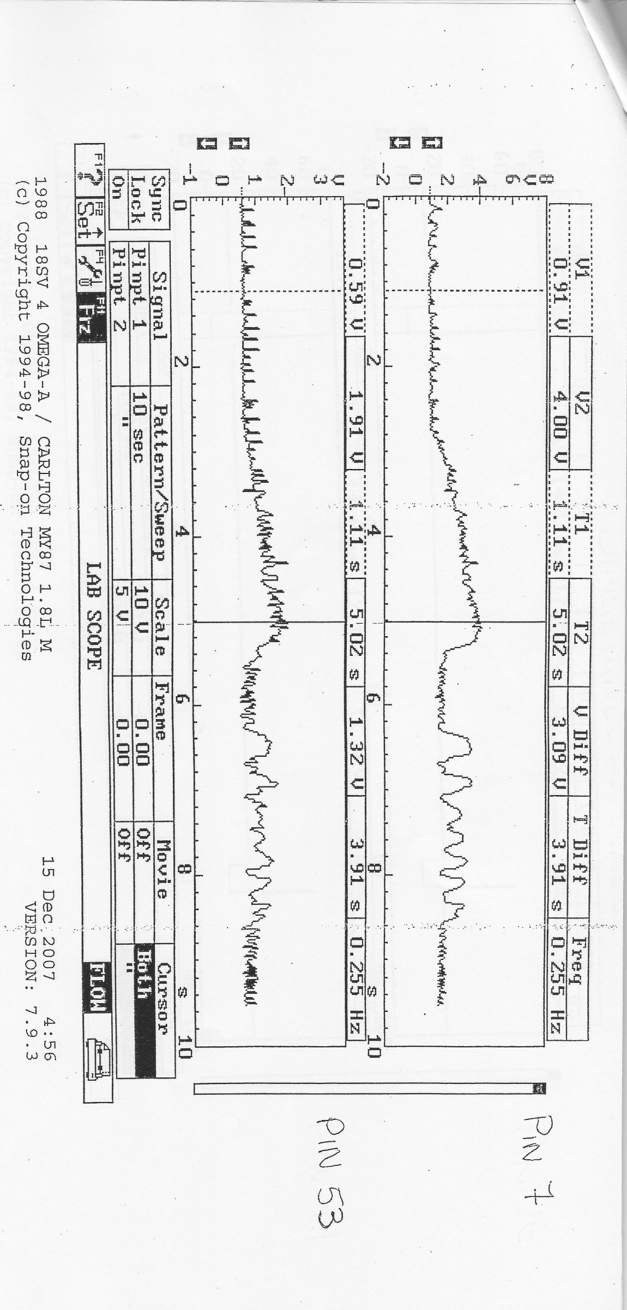
The graph above shows Pin 7 and 53 First of all pin 7 shows the load signal from the air-flow meter and also the idle and acceleration. Pin 53 the throttle potentiometer.

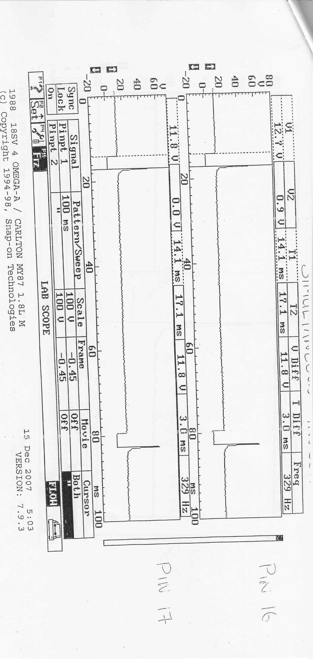
This graph above shows Pins 16 and 17
These two pins show pulsed side of injectors, in graph it shows the injection on time and the duration of the pulses.

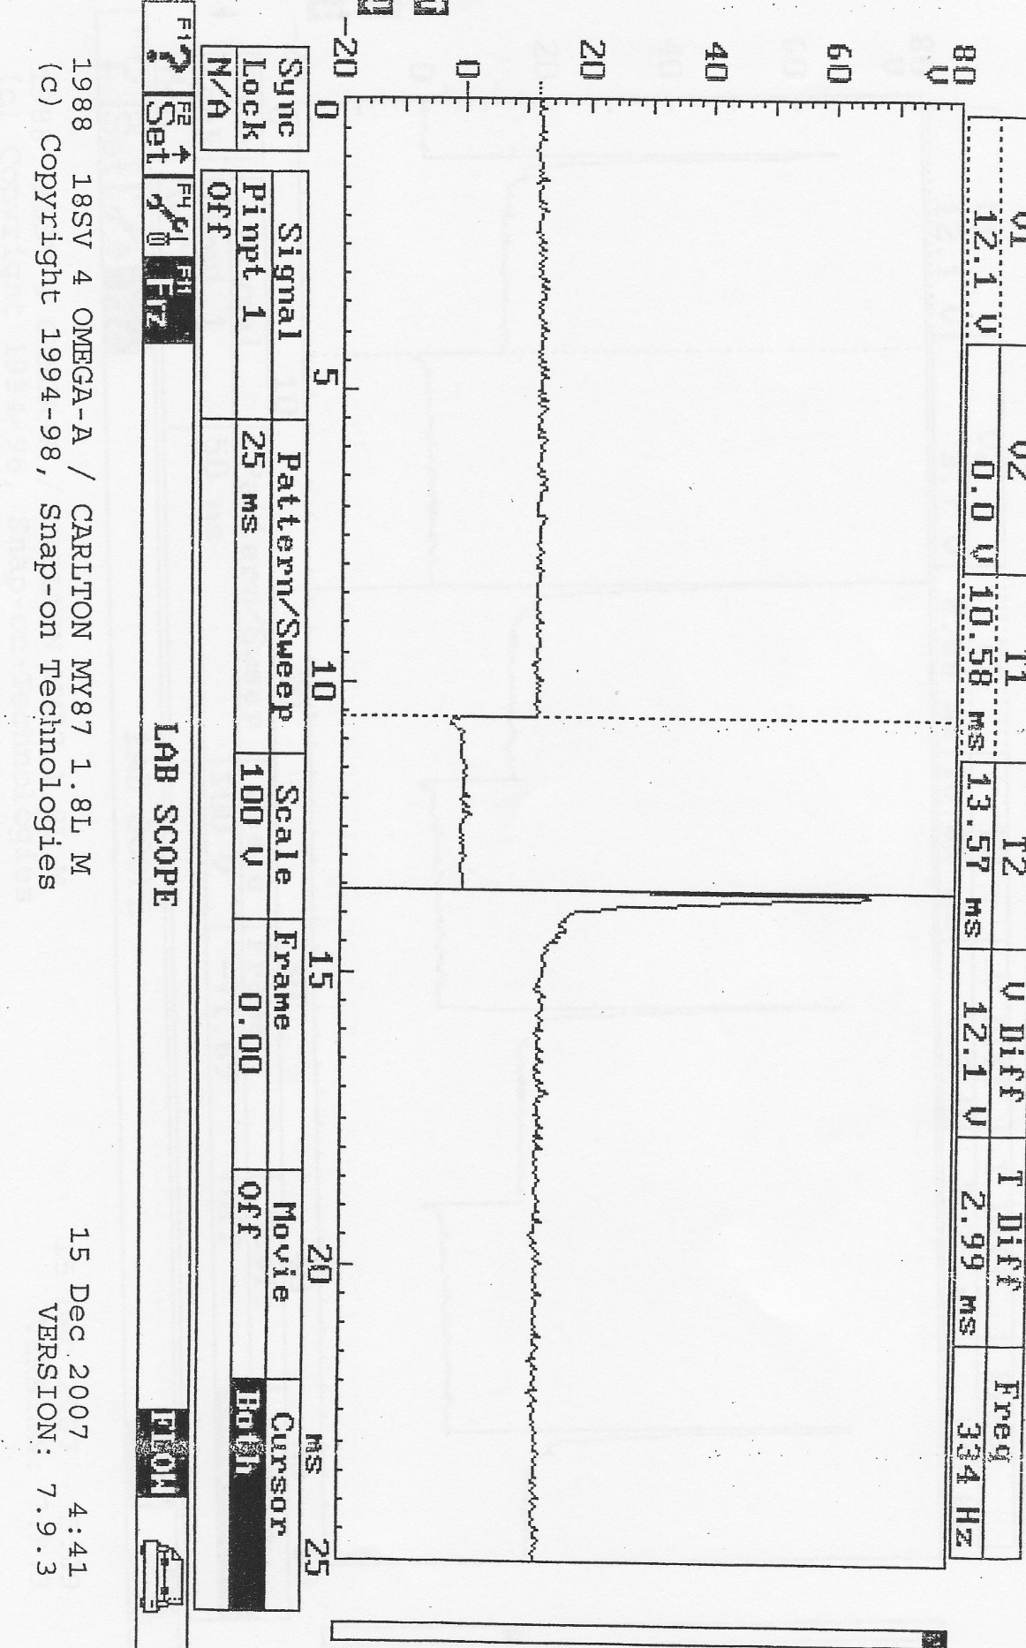
This graph shows Pin 16
The injector on time at 80 degrees.

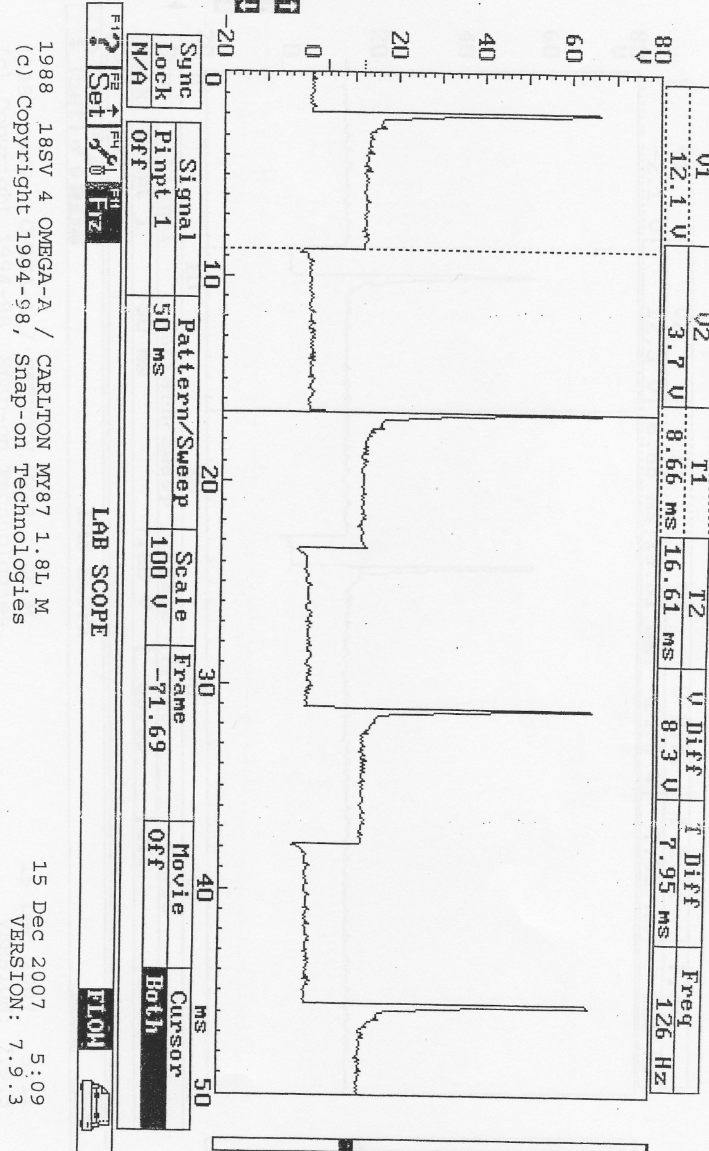
This graph shows in 16 Accelerating

Load signal output from air flow meter shows the acceleration, this means that the injectors is injecting more fuel due to it having more air.

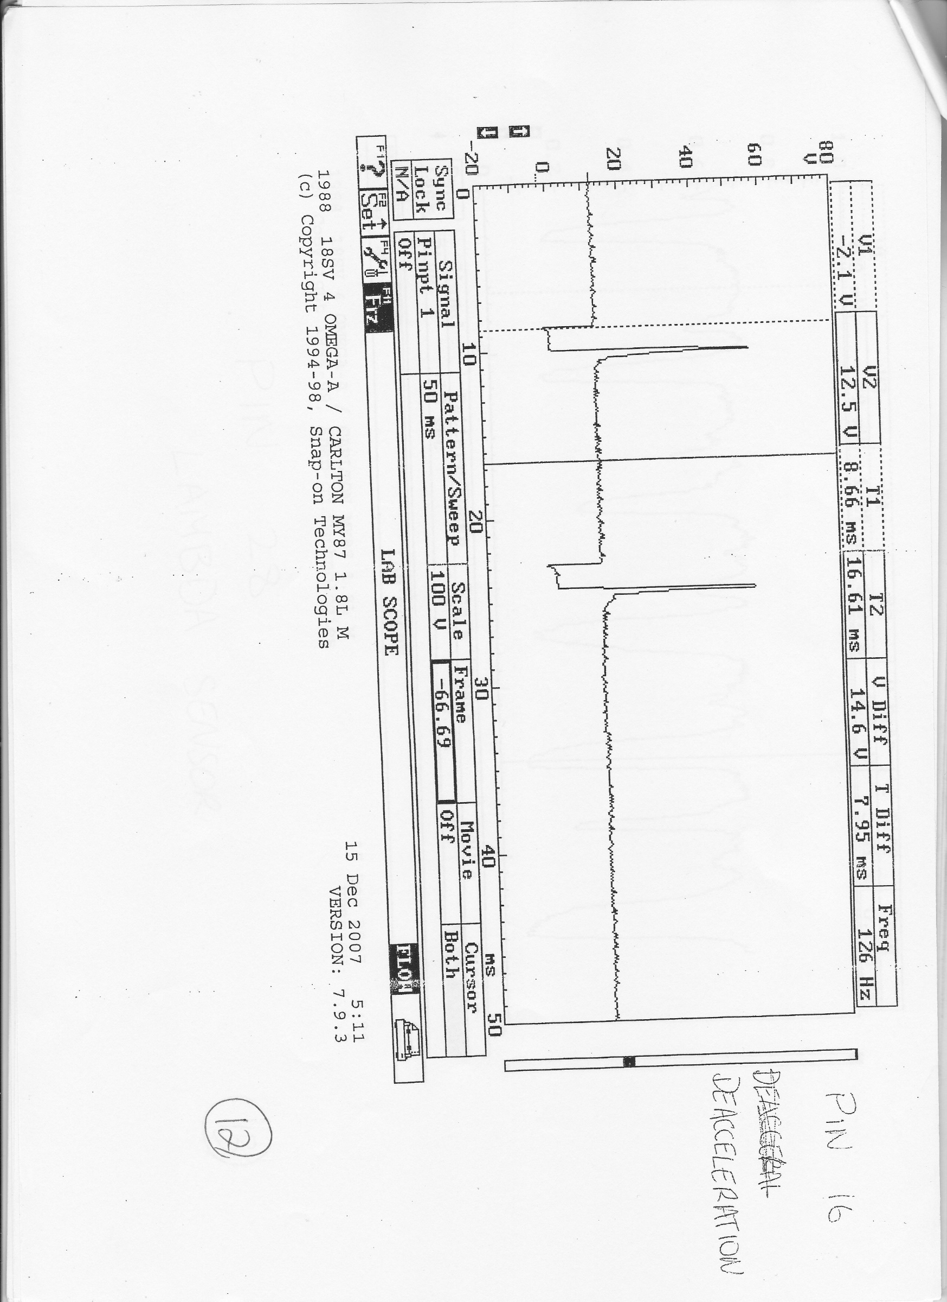
Graph above shows Pin 16 – De-accelerating
The pulsed injector in the graph is small because the engine is slowing down, it then goes in to overrun which means the injector does not need to pulse.

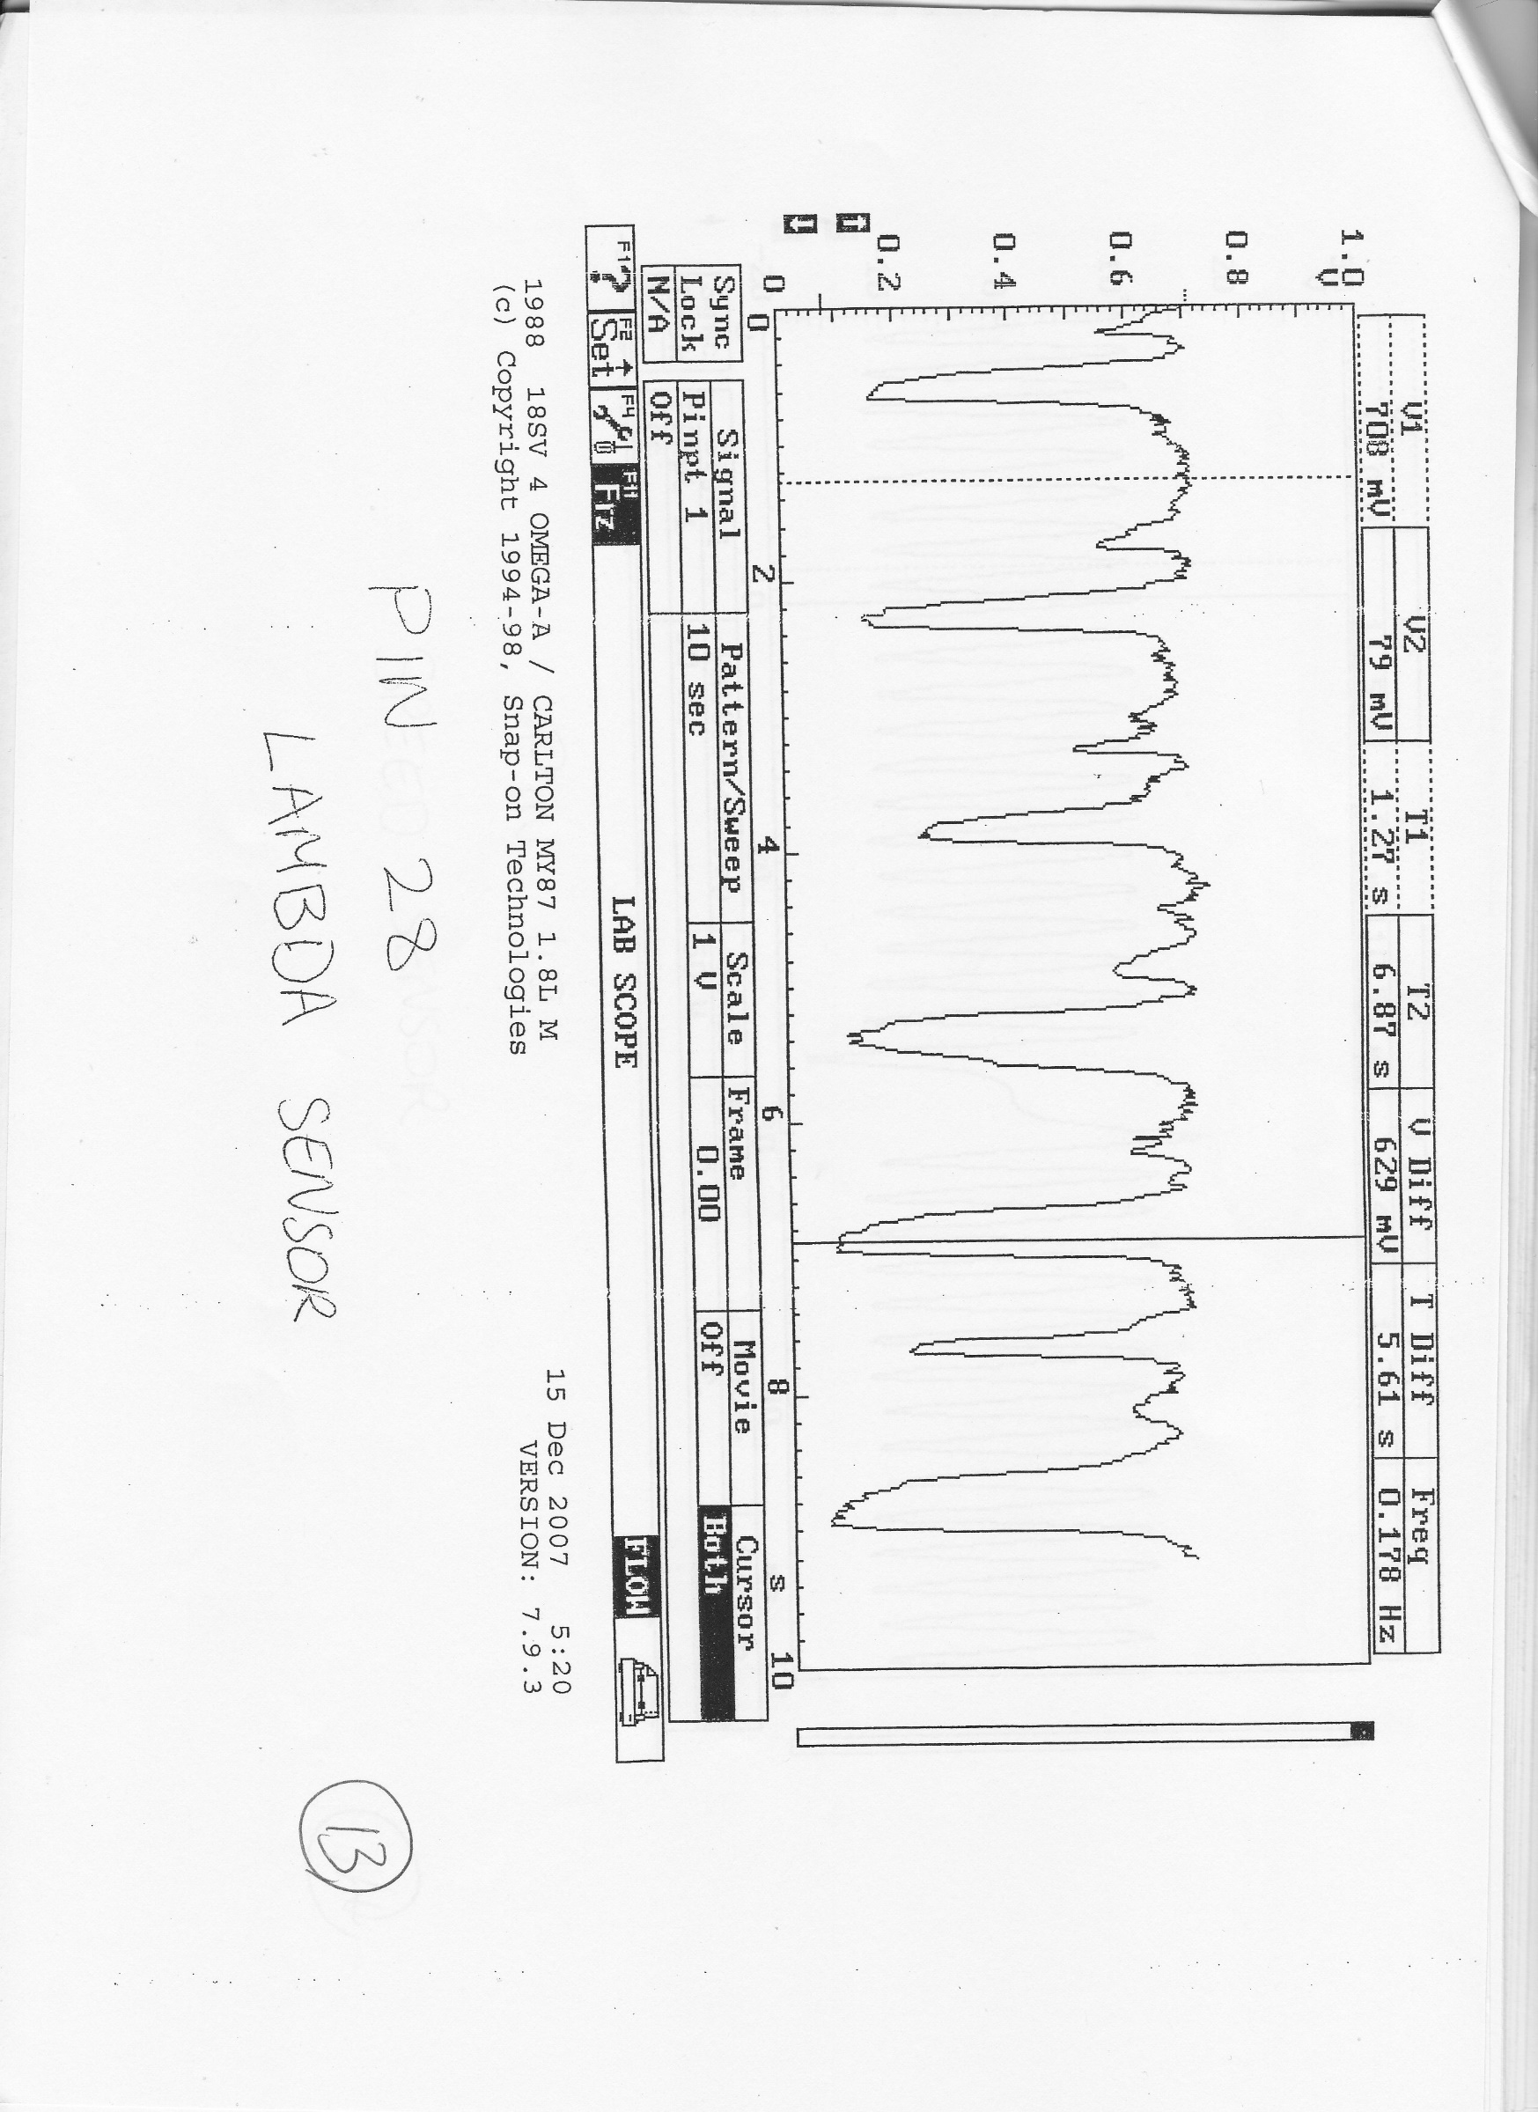
This graph above is pin 28 Lambda sensor.
This is the Lambda sensor which reads the exhaust emissions and It reads lean to rich and carries on like that until the gases come out of the exhaust.

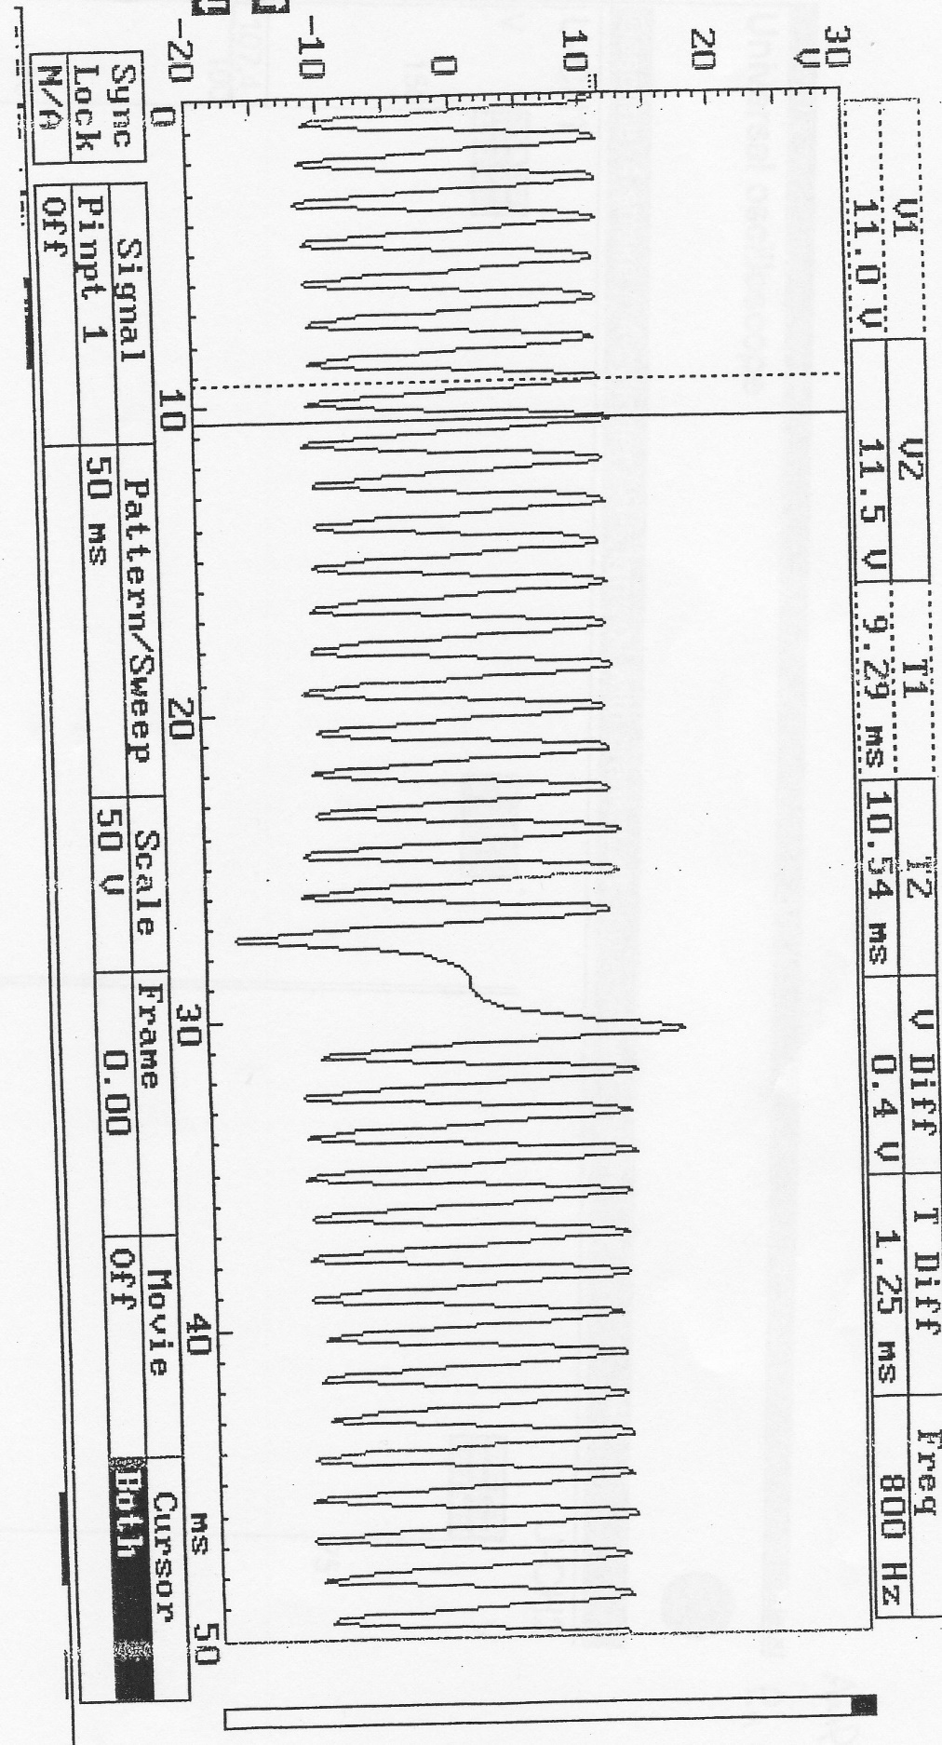
This graph shows Pin 49 which is the speed sensor.

The speed sensors output from crankshaft sensor saying to the engine when to inject the fuel. The graph shows negative at the bottom and positive at the top.

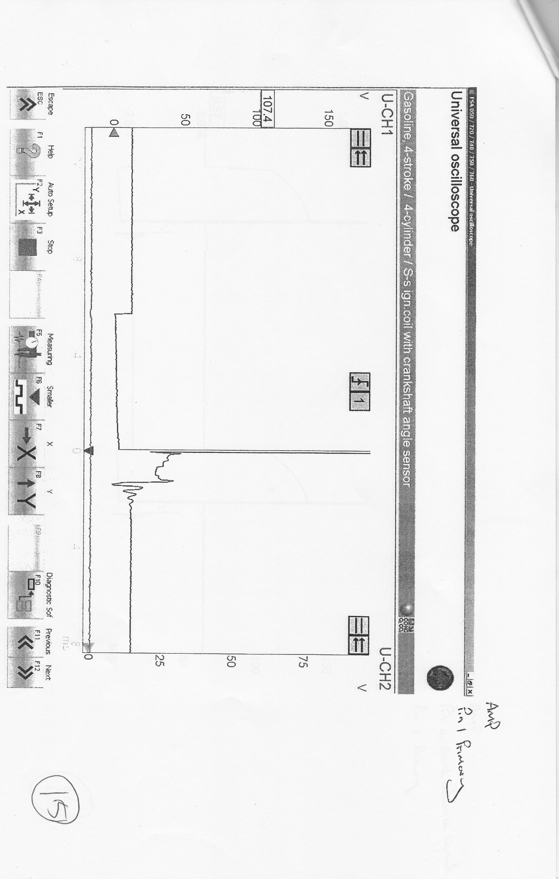
This graph shows Pin 1 , primary

If you look at the graph carefully. When the voltage drops it is called dwell on time after dwell on time it goes up (spikes) then you get back EMF, when the spike drops you get spark time and then burn time.

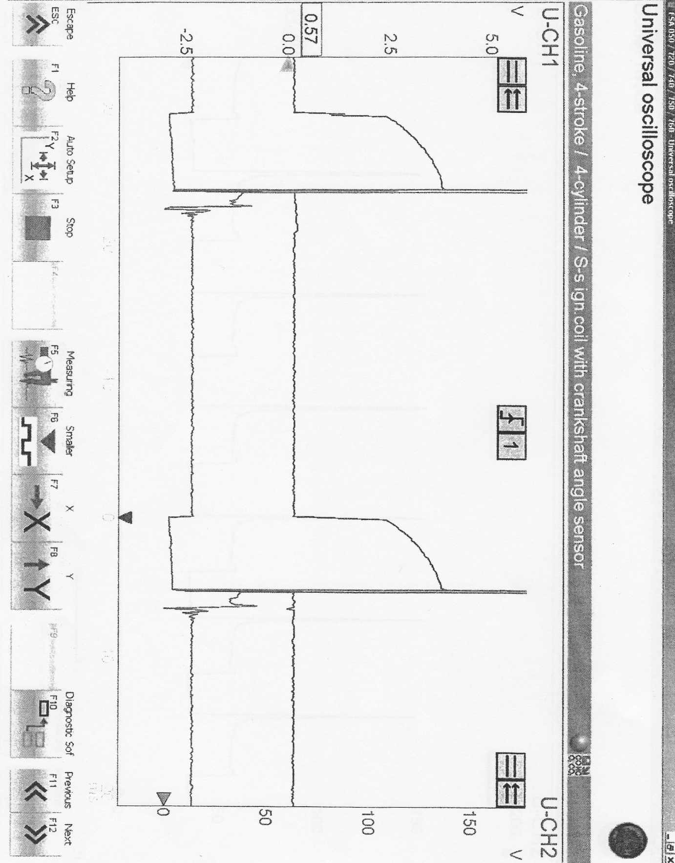

The graph shows pin 4 spark advance signal and pin 1 primary.

Firstly the chart drops this is dwell on time, then it spikes which is called EMF and then the graph drops again which is sparks time.

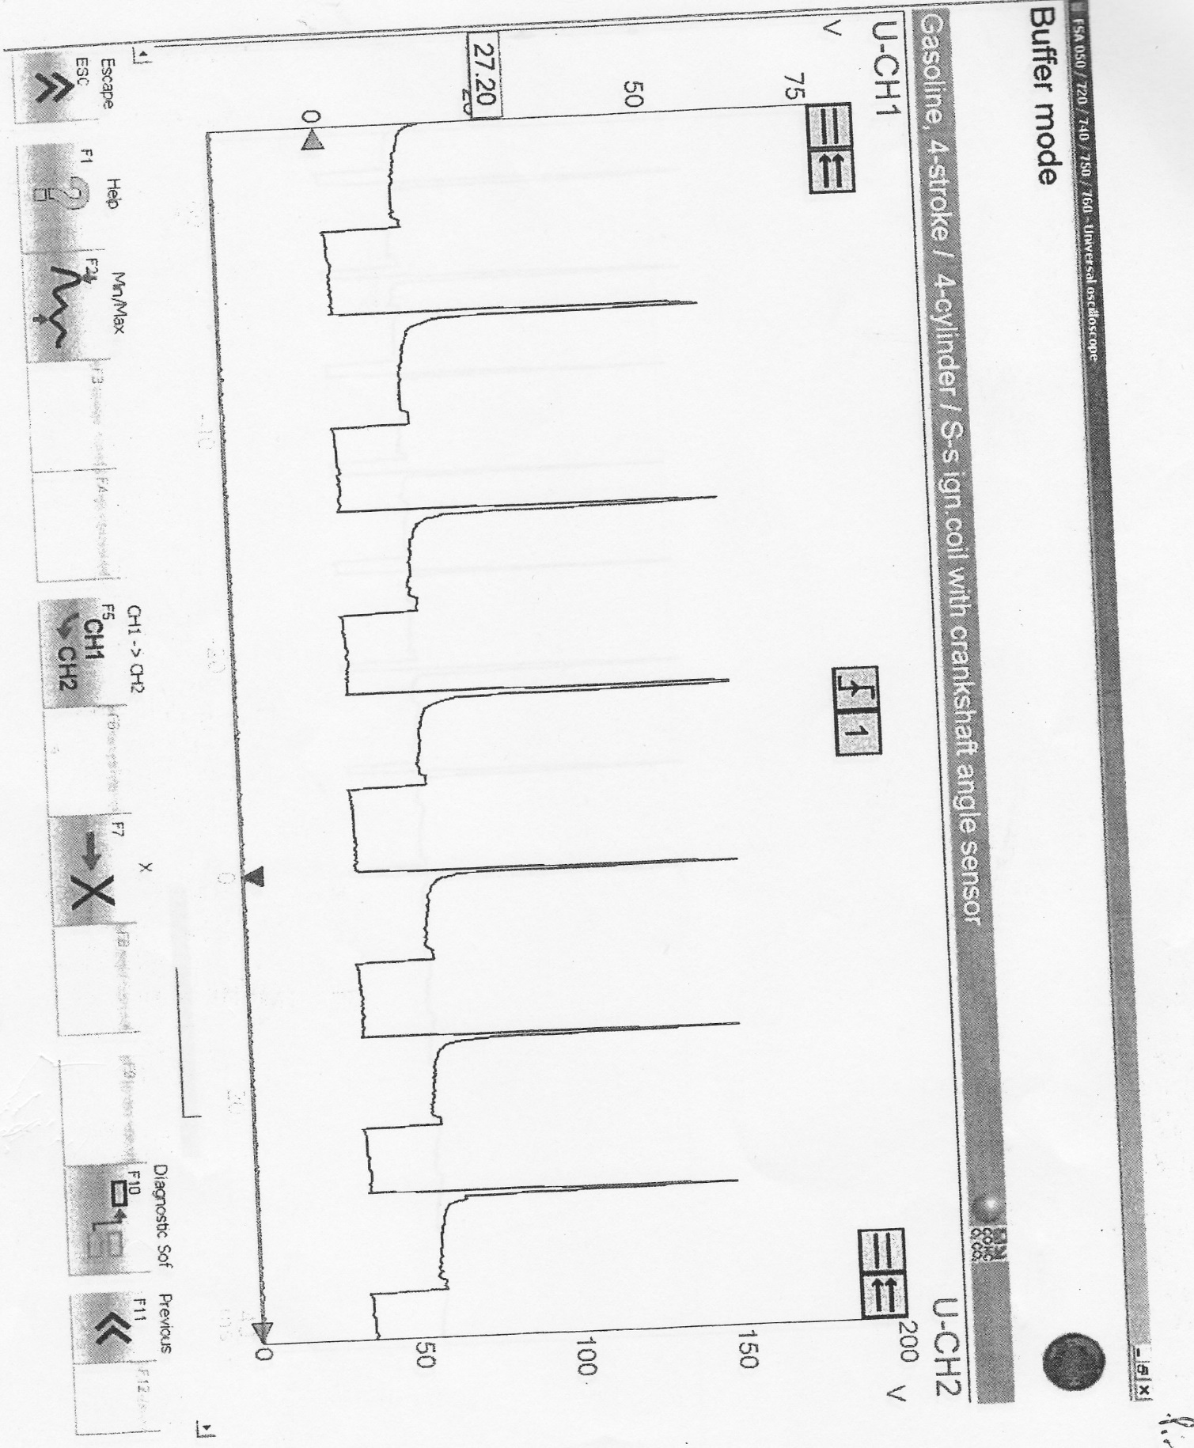

This graph is on Pin 3, Acceleration
This graph shows firstly a voltage spike then it drops its called a voltage supply which then becomes injection on time, the injection on time is so frequent because the engine is accelerating.

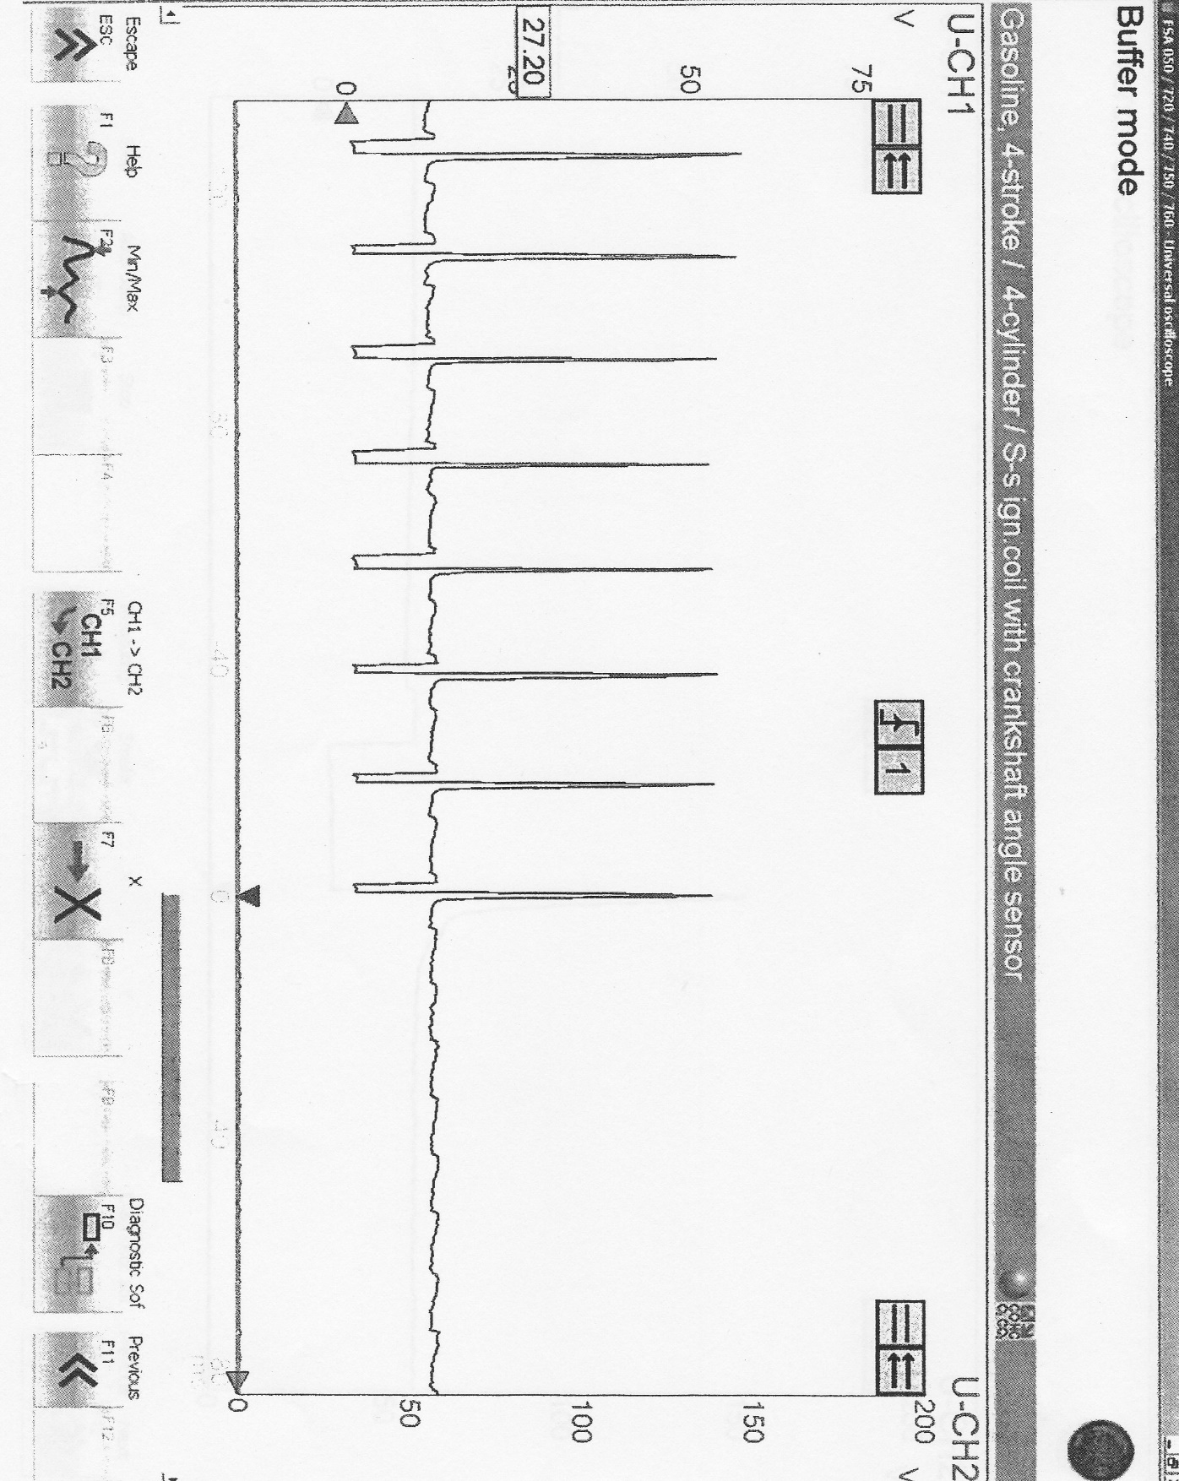
This graph shows pin 3 de acceleration
If you look at the graph you can see that the injection on time is small, this is because the engine is slowing down and the line that is almost flat in the graph is the over run.

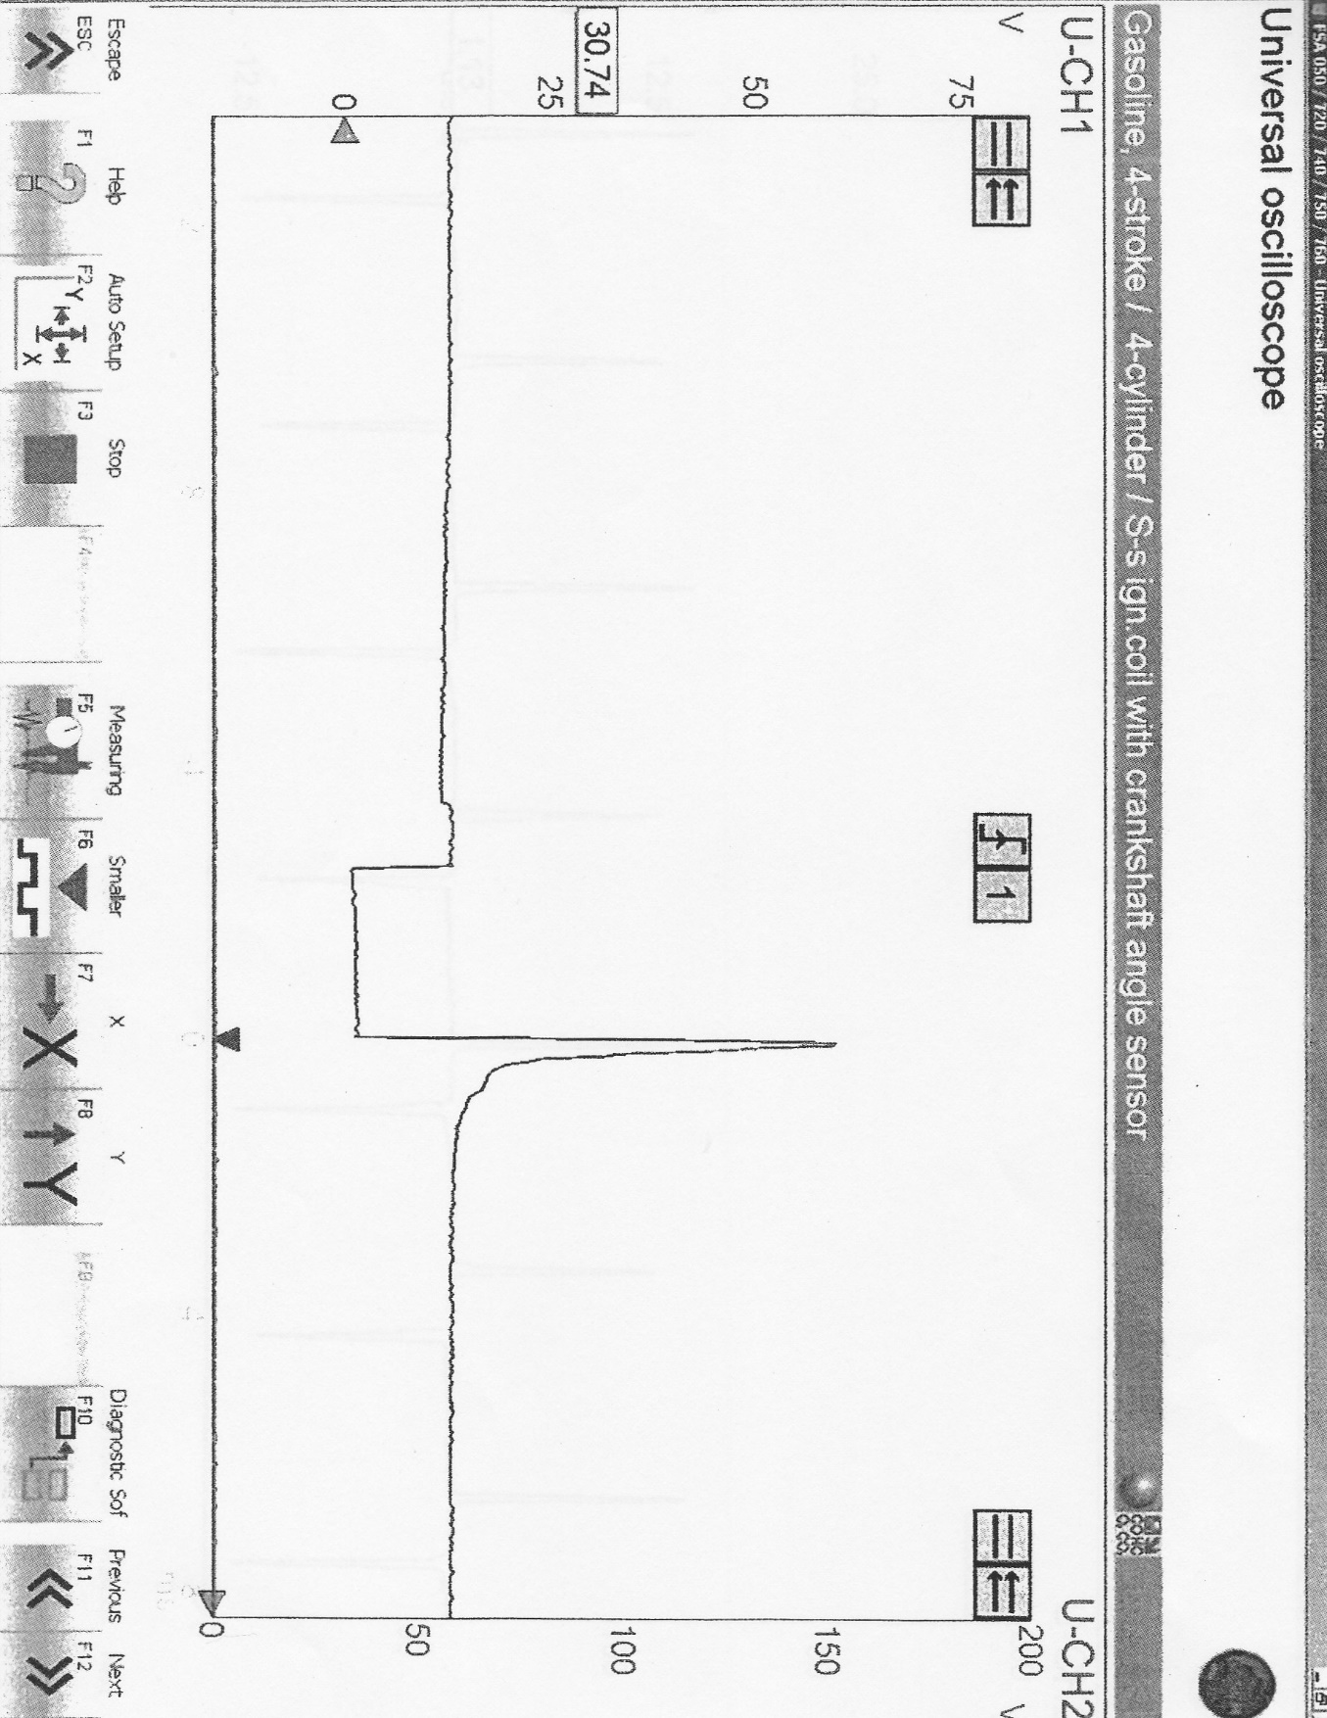
Pin 3 injector idle
Firstly you have a supply voltage then its injection on time, after the spike the injection closes.
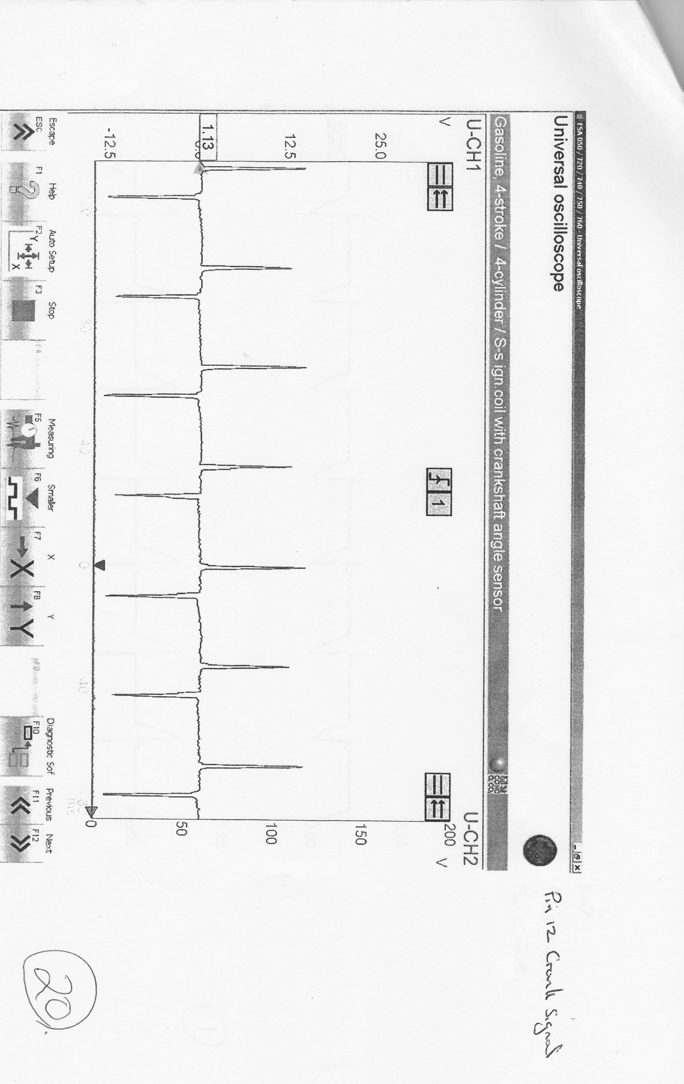
Pin 12 Crank signal
As you can see, firstly you have a spike going up this is positive voltage and then you can see we have a spike going down this is negative voltage.

Conclusion
I felt with the test was well structured.
The team worked well together and that there was a high accuracy with the data.
If the test was re-identified I would expect the same results as there hardly any errors done.
The team felt that the test went very well and that everyone got together and that communication was good tasks were well shared.
The Metronic engine was far better than the LE3 because it was more efficient and more modern. The main improved that I suggested that on the LE3 is that it would definitely, improve the engine and make it better than the Metronic engine if emission system was fitted the voltage was less variable improving combustion.
It would be good in the future as a work programme to fit the upgrades that I suggested onto the LE3 then test the LE3 against the Metronic engine. just to see whether there was an improvement with the LE3 engine. I would perform an assessment between the two engines.
I found the health and safety was brilliant because everyone understood the health and safety regulations and why they were in place and that everyone wore the right gear into the workshop and no one got injured.

References

Bosch, R (1995). Gasoline Fuel - Injection System L - Jetronic.

Andrew Gibson nots that he gave me.

Smith, C. (2018). New catalytic converter could cut fuel consumption and car manufacturing costs | Imperial News | Imperial College London. [online] Imperial News. Available at: https://www.imperial.ac.uk/news/141089/new-catalytic-converter-could-fuel-consumption/ [Accessed 12 Apr. 2018].

Smith, C. (2018). New catalytic converter could cut fuel consumption and car manufacturing costs | Imperial News | Imperial College London. [online] Imperial News. Available at: https://www.imperial.ac.uk/news/141089/new-catalytic-converter-could-fuel-consumption/ [Accessed 22 Apr. 2018].

