The future of hospitality and is it profitable to be green?

By Waheed Farid
Module Title- BMIH5006 Sustainable Hospitality & Tourism Management
Lecturer Name- Ruth Taylor Davies
Contents Page

- Introduction

- Is this relevant today?

- Is finance important in the hotel industry/

- Are businesses responsible for being environmentally sound or is it consumer driven?

- Can the hospitality industry truly ever be green?

- Is financial resiliency key to sustainability?

- Recommendation

- Reference list

1.0 Introduction
This report will look into the future of hospitality and whether its profitable to be green? In recent years the concept of sustainability and environmental responsibility has gained significant attention across various industries, including the hospitality sector. As concerns about the climate change and resource depletion continue to grow, it becomes crucial to examine the future of hospitality. Also look in to whether its profitable to adopt green practises, this report will also explore the hotel industry today and how important finance is in driving certain green practises. One of the key questions will be whether business in the hospitality industry should prioritise financial gains over the importance of the environment? However, as finance is of the utmost importance but it’s important to strike a balance between financial success and sustainable success. Furthermore, this report will investigate the responsibility of hotels in being kind to the environment. Are consumers looking to inherit responsibility of the environment or do they demand businesses to be solely driven to be sustainable? Understanding the motivations and adoptions of green practises in hotels will determine whether the future in the hotel industry is driven by sustainability. Lastly the report will cover whether the future of the hotel industry can truly ever achieve a green future. With the industries heavy reliance on resources and energy is it feasible of implementing sustainable practises. Ultimately this report will shed light on the future of hospitality and its profitability in adopting green practises. By analysing the relevance of sustainability today, the role of finance, the responsibility of businesses, and the potential of a green future.

2.0 Is this relevant today?
Businesses are putting more and more emphasis on social responsibility, whether it is by defending the rights of women, preserving the environment, or working to eradicate poverty on a local, national, or international scale. Adopting socially conscious strategies helps businesses draw in and keep consumers, which is crucial for long-term success (Murphy, 2022). Furthermore, a lot of people are willing to pay more for things if they are aware that a portion of the revenues will go towards causes close to their hearts in the community. Businesses that are dedicated to helping the community may also see an increase in foot traffic. Either or the consumers do find social responsibility relevant today as everyone is more aware of what happening in the world and furthermore, they are starting to understand how important it for a business to corporate social responsibility within their company. As big hotels and organisations have a lot of consumers come in and out their doors to stay whether that’s short stays or long, which brings in high energy consumptions, or food waste or even just general use in higher volumes. As you can see on the following graph the csr in the hotel industry has taken off but it’s still trying to get use to certain aspects of grasping in completely.

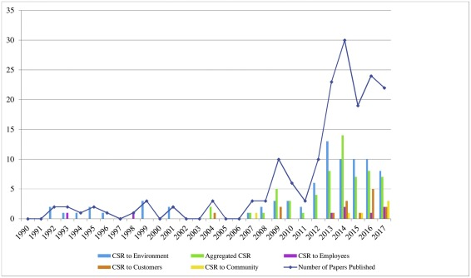
(Rhou and Singal, 2020)

3.0 Is finance important in the hotel industry?
Financial stance is important in any organisation as this is where it any industry begins, it’s where a business begins and can start to plan the process of investing, plans of renovation or even buying. Finance is where the business will begin to understand where the money is coming from and will be able to manage it accordingly. Without keeping an eye on the financial side of the hotel, the hotel would never be able to keep track of their profits and losses. According to this definition, finance is significant since it involves the inflow and outflow of substantial sums of money within the hospitality sector. An industry wouldn't know where money is going, how to balance it, or what areas to use the revenue for without the role of finance. The company's functions, advantages, and expansion may become more stable, but the negative aspects of finance's position in the hospitality sector also exist (www.bartleby.com, n.d.). So, if the hotel was to have a firm view of their finances to see whether they were running in losses or profits they could equally spread the cost out on sustainable goods and then measure to see whether its profitable or not. Financial status is always going to be important for a hotel as it gives them the status amongst competitors as well as knowing which areas they are lacking in and how and what they can do to improve. Financial management success is all about collecting and analysing high quality information, once this is collected and utilised the hotels can then go on to making offering such as discounts or any promotions and will the also be able to work out how to compete with other brands to what their offering (NetSuite.com, 2022).

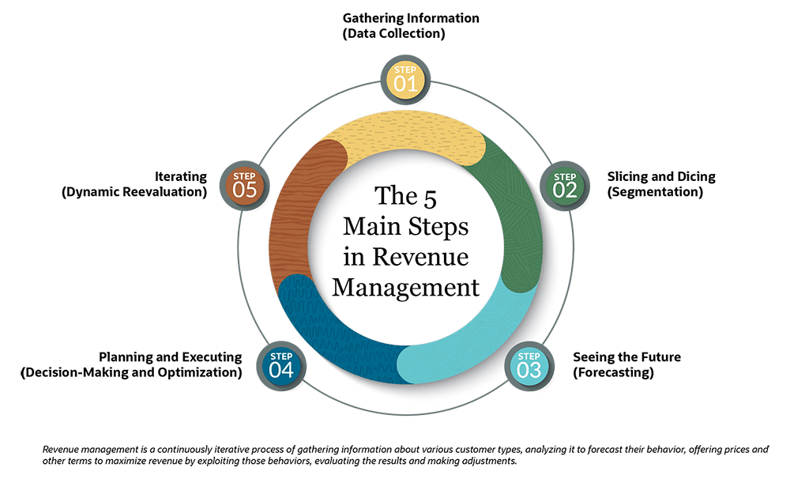
(NetSuite.com, 2022).
4.0 Are businesses responsible for being environmentally sound or is it consumer driven?
Consumer demands for Corporate Social Responsibility (CSR) must be addressed, according to the Model of Consumer-Driven Corporate Responsibility (CDCR), for businesses to continue making money (Claydon, 2013). As a result, the business experiences cyclical patterns of behaviour that lead to profitability and other favourable results. By acting in an environmentally and socially responsible manner, the business can improve its standing in the public eye. This leads to an increase in its clientele, comprising a greater number of individuals who anticipate socially and ecologically conscious actions from the business. To draw in additional clients and increase its profitability, the corporation thus keeps integrating CSR into its fundamental business strategy.

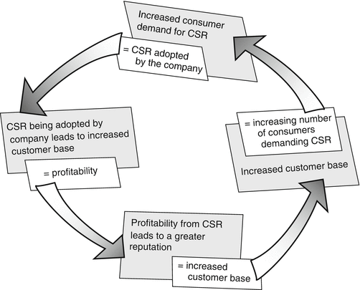
(Claydon, 2013)

Doxey’s Irridex model and its importance in environmental sustainability.
Established by Doxey in 1975, the Doxey’s Irridex model, sometimes known as the "Irridex," is based on a knowledge of how locals' attitudes towards tourists change as tourism develops at different stages of a destination's life cycle. Doxey created this system, which is often referred to as the Irridex, in 1975. It is predicated on comprehending the attitudes of locals towards tourists and the evolution of tourism over the many phases of a destination's life cycle, for example, and how those attitudes have changed over time (tourismteacher.com, 2022). In simpler terms it was a four-step timeline as follows;
- Euphoria
- Apathy
- Annoyance
- Antagonistic

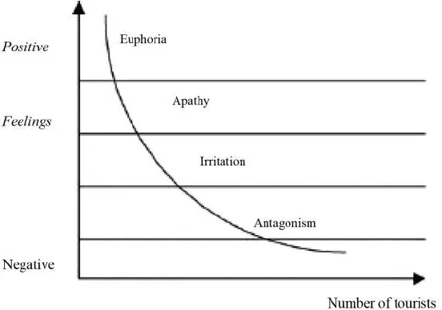
(tourismteacher.com, 2022)
So as you can see on the measuring scale on bottom line is tourist numbers and upper scale is feelings, so positive feelings will be higher up then negative at the bottom. So how this model links to the future of hospitality is that these kind of positive or negative impacts do take a toll through consumers and their needs and what they see or feel. So euphoria is the first stage as to where the population will start feeling europhic a positive feeling with seeing tourism in the area as this somewhat suggests development in the area, second stage is apathy which is still a rather positive feeling where residents will see a source of both income and development of the area. Thirdly is annoyance where resident will start getting annoyed as they will start accusing the tourist of littering or any increase in traffic in the area and at this stage, they will start feeling like the hotel is not really investing locally more for their own benefit. Finally, is antagonism where resident or local population will start showing there annoyed at the tourist and hotels and accuse them of any sort of issues that are arising in the local region. So, with this theory in mind hoteliers must be mindful of a lot of things as they don’t want to upset locals or be viewed negatively or even have a negative impact on the local people. Word spreads and if it’s a negative one then it will take a toll on revenue or even visitors coming through their doors. Hotels showing and proving sustainability and being public about is a positive way so striking the balance of increasing revenue and staying sustainable to improve the environment is at the utmost importance.

5.0 Can the hospitality industry truly ever be green?
The hospitality sector can be as green as it can. As sustainability now is on the rise and the local public all around the world are more conscious about littering and keeping the planet clean and green its vital that hotels implement a certain structure. As stated by authors and researchers’ tourism is a two-way tool and is capable of offering benefits to the local population as well offering the visitor the enjoyment of the destination (Vânia Gonçalves Costa and Costa, 2022). This two-way tool is only going to be ever respected and made full use of by the hotels and local public when the see hotels are benefitting the environment and economy. For hotels and hospitality sector they need to push forward to be more sustainable as it’s a benefit to them more then it’s a benefit for the environment, as it reduces waste, energy consumption and recycling more means better use of resources. Hotels also need to involve opinions of local stakeholders and the policies of tourism implemented in the local vicinity need to follow governing policies, only then hotels can change the trend and tourism can be developed in an integrated manner (Vânia Gonçalves Costa and Costa, 2022). Perfect example is Accor hotel groups who have thrived with sustainability and profits and are continuing to grow by implementing new policies across the globe across all their brands. By integrating sustainable development (Human and Nature) into the core of its business strategy, Accor has advanced even further. By 2030, the Group will have accomplished its lofty goals according to the new sustainable strategy, which is founded on science (SBT) and addresses the full customer journey—stay, eat, and explore (ACCOR, 2019).

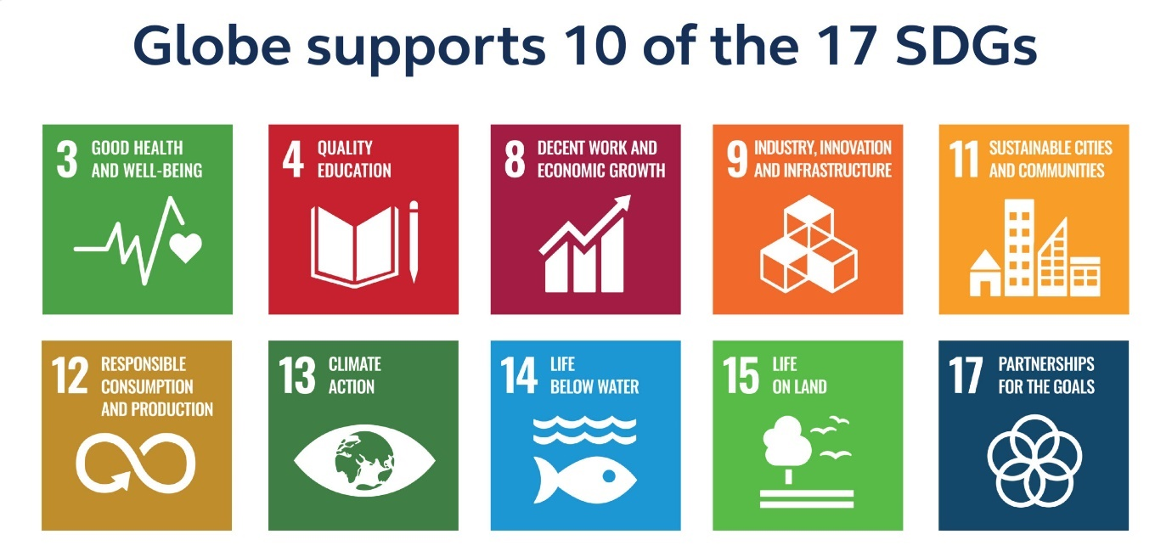
(Delle, 2020)

6.0 Is financial resiliency key to sustainability?
The transition to sustainability for hotels does require huge investments but the cost savings and environmental benefits would make up for the initial financial investments (Hlatky, 2023). Hotels that prioritise sustainability can reduce their operational cost by up to 30%, they can save on energy bills, waste disposal costs as they would be implementing the use of recyclable materials and improved employee productivity as they would not be using up time doing things that are not sustainable (Hlatky, 2023). This in hand would save the hotels a lot of money which would be a profit as they would be operating more sustainably and not wasting any resources or materials. As years go by specially from the pandemic it is made clear that normal is constantly and rapidly redefined. New boundaries are always being set and its not a stable market anymore unless hotels go above and beyond their current approaches. Economic uncertainty has dramatic effects on hotels, but these uncertain times can be seen as game changers as hotels are pushed and made willing to change their strategies and policies to benefit themselves the environment and the population around them (Raluca and Igi Global, 2022). So sustainable hotels can collaborate with certain strategies which in return boost their profit margins through utilities, future proof investment strategies and also ensure a long-term sustainable energy supply which is only few of the benefits for stakeholders in hotels (Miguel Angel Gardetti and Ana Laura Torres, 2017).

7.0 Recommendations

Hotels can be even more successful and more resourceful if they find the balance of sustainability along with increasing revenue. This report has spoken a lot about how it can be done but if hotels were to implement the biggest change of all which is cutting down cost of utilities and resource materials, they will see a dramatic change in profits. If they introduced more recycling and thought of installing solar panels to create electricity also made sure all rooms were appropriately insulated this will in return, see a drastic change. Also educating the staff on certain aspects of energy saving practises such as switching off lights if not in use, which in return the staff can educate guests on appropriate usage. Saving energy is not only good for the environment but also for the financial side of things.

8.0 Reference list
www.bartleby.com. (n.d.). Financial Role Of The Hospitality Industry - 2011 Words | Bartleby. [online] Available at: https://www.bartleby.com/essay/Financial-Role-Of-The-Hospitality-Industry-P3C6V7Q3FT85.
Murphy, C. (2022). Why Is Social Responsibility Important to a business? [online] Investopedia. Available at: https://www.investopedia.com/ask/answers/041015/why-social-responsibility-important-business.asp.
Claydon, J. (2013). Consumer-Driven Corporate Responsibility. Encyclopedia of Corporate Social Responsibility, pp.444–450. doi:https://doi.org/10.1007/978-3-642-28036-8_694.
Rhou, Y. and Singal, M. (2020). A review of the business case for CSR in the hospitality industry. International Journal of Hospitality Management, 84, p.102330.
tourismteacher.com. (2022). What is Doxey’s Irritation Index and how does it work? - Tourism Teacher. [online] Available at: https://tourismteacher.com/doxeys-irritation-index/#:~:text=Also%20known%20as%20the%20Irridex [Accessed 16 Nov. 2022].
Claydon, J. (2013). Consumer-Driven Corporate Responsibility. Encyclopedia of Corporate Social Responsibility, pp.444–450. doi:https://doi.org/10.1007/978-3-642-28036-8_694.
Vânia Gonçalves Costa and Costa, C. (2022). Sustainability and competitiveness in the hospitality industry. Hershey Pa: Business Science Reference.
tourismteacher.com. (2022). What is Doxey’s Irritation Index and how does it work? - Tourism Teacher. [online] Available at: https://tourismteacher.com/doxeys-irritation-index/#:~:text=Also%20known%20as%20the%20Irridex [Accessed 16 Nov. 2022].
Hlatky, P. (2023). Building Green and Resilient Hotels: Investing in our Planet. [online] EDGE Buildings. Available at: https://edgebuildings.com/building-green-and-resilient-hotels-investing-in-our-planet/ [Accessed 6 Nov. 2023].
Raluca, C. and Igi Global (2022). COVID-19 pandemic impact on new economy development and societal change. Hershey, Pennsylvania (701 E. Chocolate Avenue, Hershey, Pennsylvania, 17033, Usa): Igi Global.
Vânia Gonçalves Costa and Costa, C. (2022). Sustainability and competitiveness in the hospitality industry. Hershey Pa: Business Science Reference.
Hlatky, P. (2023). Building Green and Resilient Hotels: Investing in our Planet. [online] EDGE Buildings. Available at: https://edgebuildings.com/building-green-and-resilient-hotels-investing-in-our-planet/ [Accessed 6 Nov. 2023].
Miguel Angel Gardetti and Ana Laura Torres (2017). Sustainability in Hospitality. Routledge.
NetSuite.com (2022). Revenue Management Defined: Ultimate Guide for 2022. [online] Oracle NetSuite. Available at: https://www.netsuite.com/portal/resource/articles/financial-management/revenue-management.shtml.
ACCOR (2019). Accor - Worldwide hospitality leader. [online] Accor.com. Available at: https://group.accor.com/.
NetSuite.com (2022). Revenue Management Defined: Ultimate Guide for 2022. [online] Oracle NetSuite. Available at: https://www.netsuite.com/portal/resource/articles/financial-management/revenue-management.shtml.
Delle, C. (2020). Globe encourages suppliers to adopt sustainable practices | Read now! [online] Trade & Travel Journal. Available at: https://tradetraveljournal.com/globe-encourages-suppliers-to-adopt-sustainable-practices/ [Accessed 6 Nov. 2023].

