Mental Health and Well-being is not necessarily ‘breaking news’ anymore, however it is still a ‘hot topic’ of discussion, research, debate etc. For me personally, having worked with young people over a period of fifteen years, from a range of backgrounds, I can certainly say that the shift in focus, understanding and ‘openness’ to discuss Mental health and well-being, is a breath of ‘fresh air’. I think for society as a whole, it is crucial to have an increased awareness of our mental state, especially considering that despite massive economic growth, people are no happier now than during the 1950’s (Williams, 2018). Townsend (2018) quoted Javed Khan, chief executive of Britain’s largest children’s charity, in an article from The Guardian, ‘that young people’s mental health had never been worse in the organisation’s 152-year history’. Sadly this is still the reality today despite the fact that in 2006 the Prime Minister, David Cameron, made a commitment to broadening our understanding and measurement of the nation’s well-being. He stated that

It’s time we admitted that there’s more to life than money and it’s time we focused not just on GDP but on GWB – general wellbeing. Wellbeing can’t be measured by money or traded in markets. It’s about the beauty of our surroundings, the quality of our culture and, above all, the strength of our relationships. Improving our society’s sense of wellbeing is, I believe, the central political challenge of our time.’ (Guardian, 2006)

This was an instrumental and bold statement that still applies today. It has increasingly more so come to my knowledge and depth of understanding, the importance of fostering and harnessing relationships in youth work practice. This means working with young people from ‘whatever point they are in their lives’ as noted in The principles of Youth Work in Wales (2013). Also one of the major findings noted by Ungar et al, (2013, cited in Williams, 2018) from ‘Pathways to Resilience’ is that ‘positive experiences facilitate resilience processes, which in turn leads to functional outcomes for young people’. This translates the relevance youth work practice has in today’s society. In this practice log I will be exploring ‘why there is a lack of resilience in young people today’ and the role youth work has to play in this growing issue. Frude (2016, cited in Williams, 2018, p. 21) noted that truly effective ‘non-formal’ education can help young people to become ‘better able to understand and manage their emotions; more hopeful and optimistic; stronger and more resilient; happier and less impulsive’.

What is ‘resilience’? Masten and Yates (2004, cited in Williams, 2018, p. 10) defines resilience as ‘the human capacity to face, overcome and ultimately be strengthened by life’s adversities and challenges’. Rutter (1985, cited in Public Health Wales, 2018, p. 34) simply states it as the ‘ability to cope, adapt positively and to recover from adversity’. So what has been the major drive to finding out more about young people’s ‘resilience’? A huge amount of research has been conducted to evidence that feelings, therefore ‘subjective well-being’, can be measured and has been used to inform policy making. (The Children’s Society, date unknown). In The Children’s Society report on Promoting positive well-being for children (date unknown) it is noted that
Subjective well-being focuses on how people are feeling, whereas objective well-being focuses on the conditions which affect those feelings, such as health or education. Both of these perspectives are valuable for understanding children’s well-being. (Unknown author, cited in The Children’s Society report, date unknown, p. 3)

UNICEF noted that children in the UK have lower subjective and objective well-being than any other developed country. This was backed up by further research in 2011 comparing the well-being of children in the UK, Sweden and Spain (UNICEF, 2011).
But where does it all stem from? Research found that children who are ‘securely attached’ as infants tend to develop stronger self-esteem and are more resilient (Cherry, 2018). But what about those that are in-securely attached, or has ‘attachment disorder’ or ‘disorganised attachment’? These are to mention only a few. The Children’s Society noted in Promoting Positive well-being for children that

Relationships are at the heart of children’s well-being. When children talk about what is important in their lives, they highlight their need for love, support, respect, fairness, freedom and safety – concepts that are central to what it means to be human, social beings. Children list these qualities primarily in relation to family and friends, but they value them in all of their relationships, in their homes, schools, communities and beyond. (The Children’s Society, date unknown, p.13).

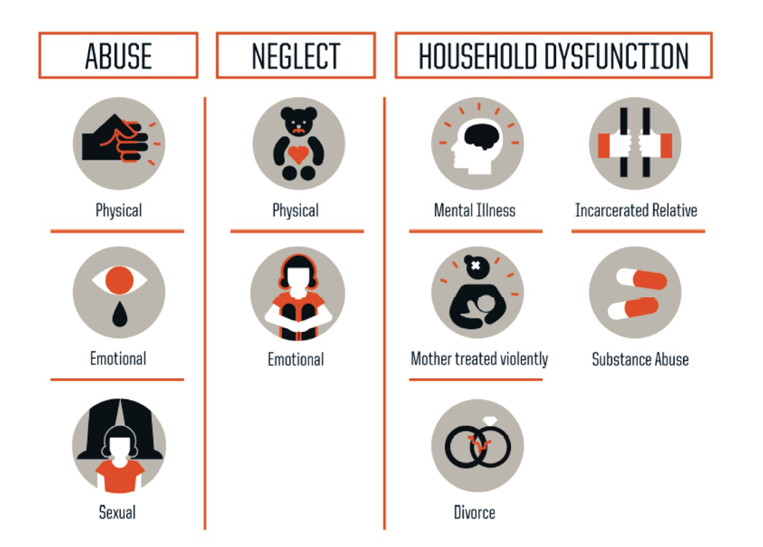
So what if these relationships are absent, distorted, unreliable, erratic, violent, abusive, irregular or posing danger? NHS Health Scotland (2017, p. 3) noted that Adverse Childhood Experiences (ACE’s) refer to ‘stressful events occurring in childhood (between 0 – 18 years)’. The Robert Wood Johnson Foundation’s (2013, cited in NHS Health Scotland, 2017, p. 3) graphic, states these experiences include:

Coupar and Mackie (2016, cited in NHS Health Scotland, 2017, p.5) notes that
Adverse childhood events can create dangerous levels of stress and derail healthy brain development, which can result in long-term effects on learning, behaviour and health. Neurobiological research indicates that the ‘toxic stress’ (defined as prolonged activation of stress response systems in the absence of protective relationships) associated with ACEs can lead to physical changes in the way the brain develops and propensity to experience future stress, adopt health-harming behaviours and develop mental and physical illness. (2016, cited in NHS Health Scotland, 2017, p.5).

Research have proved that this does not mean that the brain is not able to be re-wired, in fact positive psychological experiences can re-vert and re-wire the brain as well as during adolescence when the brain further develops (McEwan, 2015 cited in NHS Health Scotland, 2017). Hence why youth work practice in adolescence can have a massive impact for a young person’s future general well-being. Public Health Wales (2018, p. 9) states that there is a robust link of
Adverse Childhood Experience (ACE) and poor health across the life course. Including increased risk of health- harming behaviours (Bellis et al, 2015), low mental well-being (Ashton et al, 2016a) and early development of chronic disease (Ashton et al, 2016b). (Public Health Wales, 2018, p. 9).

Does ACE’s therefore stem from the initial ‘attachment theory’? Brennan (YoungMinds, date unknown, p. 5) states that
Psychological trauma is the emotional response children and young people can have to experiencing distressing, adverse experiences. Importantly, trauma does not always result from a single, identifiable traumatic event or life adversity. The cumulative impact of adverse environments, events and relationships can have a traumatic impact on the development of a child or young person.

Personally I don’t know the answer and have found little research that refers to this link of ‘attachment theory’ and ACE’s directly, however in my own mind and opinion, I do feel there can be a strong link. However NHS Health Scotland notes that
Recent research has led to a greater understanding of how this early adversity affects brain development. Our brains are shaped by the relationships we have had from birth and therefore impact on our future emotional health and wellbeing. Children and young people who have experienced ACEs and who may not have received the emotional comfort for a healthy start in life will develop ways to respond and cope. (NHS Health Scotland, 2017, p.9).
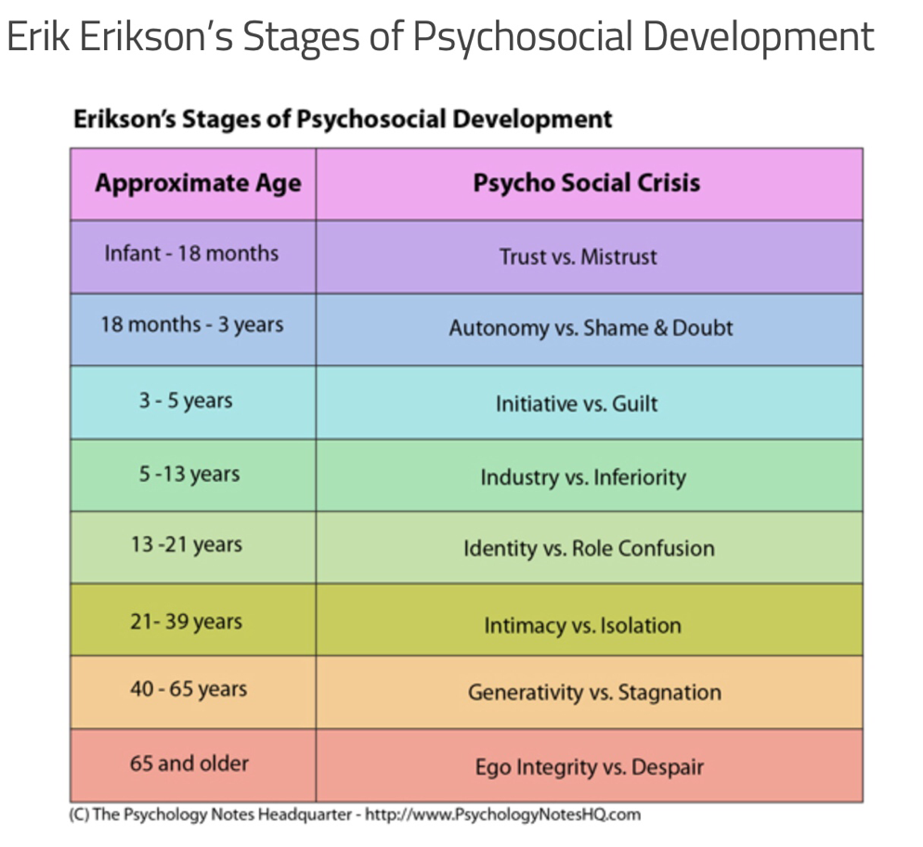
Just thinking of Bronfrenbrenner’s Ecological Systems Model clearly notes the strong correlation of how the different systems interlink with each other and how this affect the development of a person, from infancy to adulthood (Enoch, 2017). As well as Psychology Notes HQ (2017) of Erik Erickson’s (1963) stages of psychosocial development illustrated here:
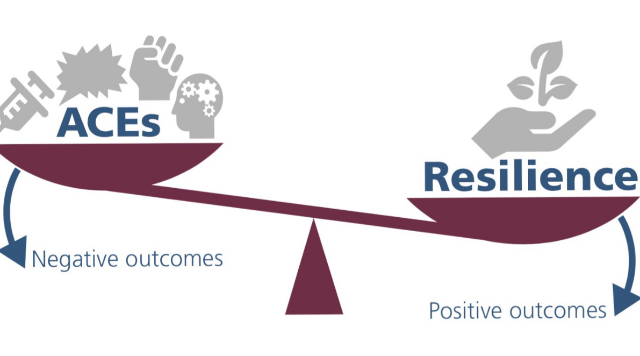
Evidence has been shown that one stable, caring and supportive relationship between a child and an important adult in their life can help individuals develop resilience (National Scientific Council on the Developing Child, 2015). The values at the core of youth work is to build relationships and engage young people with the local community, and building working relationships and networks (LSIS, 2012). Welsh Government policy, Taking Wales Forward 2016-2021 (Welsh Government, 2016a, cited in Public Health Wales, 2018, p. 9) sets out a national ambition for a Wales which is ‘prosperous and secure, healthy and active, ambitious and learning, united and connected’. Also the Well-being of Future Generations (Wales) Act (2015, p. 6) who insists on building happier young people will contribute to ‘a resilient Wales; a healthier Wales; a more equal Wales; a Wales of cohesive communities…’ Creating ACE- awareness in public services in Wales, supports the prevention of ACEs along with the development of resilience in children and young people (Welsh Government, 2017). Therefore the youth work sector have an essential role to play in creating opportunities for young people affected by ACEs to develop personal and relationship skills as well as positive friendships (LSIS, 2012 & YWRG, 2013). This figure as adapted from the Center on the Developing Child, notes how protective resources such as personal skills, positive relationships and community support can counterbalance the heavy burden imposed by ACEs (Public Health Wales, 2018).

Having worked in outdoor education as a tool in youth work for fifteen years, I have personally experienced the positive affect participation in sport, adventure, nature and the ‘wilderness’ can have on young people’s well-being. Opportunities created to take young people on residential where they are taken out of their natural environments, that are potentially ‘stressful’, and creating experiences that are challenging yet positive, developing resilience by focusing on young people’s strengths, qualities and values in the outdoors through outdoor activities. Using outdoor activities as a tool, links with the five pillars of youth work which are; participative; empowering; inclusive; expressive and educative (YWRG, 2013). Having experienced and seen the impact the outdoors have had on a range of young people, I can agree with the evidence from research identifying the benefits of sports participation to mental health, both in childhood and adulthood (Eime et al, 2013, cited in Public Health Wales, 2018). Public Health Wales stated that
Among those with four or more ACEs, the adjusted proportion reporting current mental illness fell from 25% of those who did not regularly participate in childhood sports to 19% in those who did. It is not possible from this survey to explore whether participation in sports builds resilience in children or whether children with greater resilience are more attracted to sports. (Public Health Wales, 2018, P. 35).

The Public Health Wales (2018, p. 35) reports that it is ‘suggested that sports participation should be further explored as a means of developing resilience and protecting mental health’. This to me is not ‘rocket science’ and I am quite shocked that it is not a ‘known’ fact already. Especially considering the long history of evidence and impact that various youth work organisations have had on young people’s mental health and well-being for example the ‘Scouts’ and ‘Duke of Edinburgh Award’ schemes that are directly linked with using sports activities. This is quoted by Julius Irungu Krush, a Gold Award holder of the Duke of Edinburgh Award Scheme on how this valuable youth work organisation impacted his life:
The Award came into my life when I had almost lost all hope...I had low self-esteem and regarded myself as unfortunate, desperate, hopeless and unworthy. I thought that I would never be able to make it in life an attempted to commit suicide...By the time I completed my Award, I had reaped a lot of benefits and had achieved so much. Honestly, my life changed – I was able to deal with my issues, this saved my life. (The Duke of Edinburgh’s International Award, 2014).

As a youth worker it is vital to also understand your limitations, boundaries, roles and responsibilities. I am thankful that these are becoming more clearly defined in organisations job descriptions and confidentiality policies. Experience in various organisations safeguarding and confidentiality policies, provides a solid understanding of safe working practice. Also drawing upon experience of personal ethics, values and beliefs enhances knowing when to seek appropriate support. Stanton-Salazar (2011) defines the roles of Youth Work as an institutional agent, I have highlighted in BOLD what I think I am personally doing or have done through youth work practice, and the rest is what I believe I can further develop in.

Direct Support | Integrative  Agent | System Developer | System Linkage & Networking support
Resource agent  Knowledge Agent  Advisor  Advocate | Integrative support  (Coordinating young people’s integration and participation in networks and professional venues)  Cultural Guide  (Guides young people through new social situations in a particular cultural sphere) | Program developer  Lobbyist  Political advocate | Recruiter  Bridging Agent  (Introduces young people to institutional agents, knows what key players do)  Institutional broker  (Knows what resources are available and who controls or possesses them  Coordinator  (Assesses young people’s needs and identifies resources and ensures young person utilities resources.

It is vitally important for a youth worker to know what they are doing and ‘can do’ and what they are ‘not doing’ or ‘not supposed to do’. This can be discussed through supervision from line-management in line with the job description and confidentiality policies of an organisation. If these roles are not clearly defined, outside supervision can be a helpful tool to access. Especially considering the era we are in and its statistics regard mental health and wellbeing issues, where recent data collected by NHS Digital, showed that there were 344,000 children and young people referred to either CAMHS or adult mental health services in May 2017 (Children and Young people Now, 2018). A great example of ‘different avenues’ that has been set up and run by The children’s Society, is a project called ‘PAUSE’. This is a drop-in centre space in Birmingham city centre, for young people and families, to walk in without an appointment to talk to therapists, youth workers, volunteers, and get immediate help and support without waiting. It was commissioned and designed to deliver services with a wider age range in mind than the Child and adolescent mental health services (CAMHS) that was set for birth to 18 year olds. This idea of extending eligibility was to avoid a cliff-edge for young people moving from child mental health services to adult mental health services. Rob Willoughby (CYPNOW, 2018, p. 38) stated that ‘the transfer from one service to another was poor’, and that ‘we are giving young people help to prevent higher needs developing’. The young people noted that they wanted the service to feel like a mix between Costa coffee and an Apple Store – modern, bright, with IT and self-help points, as well as being welcoming and spacious. PAUSE has had 10,000 visits over only 2 years. They noted that on average, each young person felt their ability to cope with their presenting need increased by four points on a scale of one to 10 (Puffett, CYPNOW, 2018). This is a great indication therefore about the importance of connectedness and trusting relationships. As illustrated through research in Public Health Wales (2018, p. 35) is that ‘at least one trusted, stable and supportive relationship with an adult is emerging in international literature as one of the most important aspects of childhood’.
Strategies to build individual and community resilience would support mental health, however building resilience may help to protect those who suffer ACEs, it cannot be expected to completely offset them and Public Health Wales strongly suggests preventing ACEs must be the main focus. They have also noted that working on identification of interventions to build resilience is key, as well as creating effective programmes alongside primary prevention which include, positive parenting schemes (Public Health Wales, 2018). The challenge remains to engage hardest to reach young people in resilience-building activities, hence why peer support, how to access community support, and more importantly personal trusting relationships with young people through youth work remains key. The prevention of all ACEs will remain a long-term goal, therefore developing resilience in society is important to protect those experiencing ACEs from their long term mental health and well-being consequences that can be debilitating (Public Health Wales, 2018).
In the Public Health Wales (2018) report conclusion it is noted how
Public sector support for social and emotional skills development, activities that create connectedness to schools, sign-posting children to available help, opportunities for creating friendship networks, and occasions to engage in cultural traditions should be considered investments in children’s lifelong mental health. While more information is required on the cause and effects of these resources on mental health, reductions in provision of these community facilities may have long-term repercussions for population mental health and especially affect those with high levels of childhood trauma. (Public Health Wales, 2018, p. 37).

The youth work sector are by and large ticking all these elements and requires Government to take notice. Youth work practice needs to be recognised by Government and have adequate funding implemented to support the valuable role youth work has to play in building resilience in young people and therefore society as a whole. I like how Williams (2018) noted that it is important for young people to know that
The key way to survive and thrive is not striving to be happy all the time - which is unrealistic. It is about learning to cope with pain and misery, to bounce back from difficulties and to accept yourself for who you are. (Williams, 2018, UWTSD lecture notes, p. 24).

Bibliography

Brennan. S. (date unknown) Young Minds, Beyond Adversity: Addressing the mental health needs of young people who face complexity and adversity in their lives. https://youngminds.org.uk/media/1241/report_-_beyond_adversity.pdf (Accessed 17 May 2018).

Cameron, D. (2006) The Guardian, 22 May, [Online]. Available at: www.guardian.co.uk/politics/2006/may/22/conservatives.davidcameron
(Accessed: 10 May 2018).

Cherry, K. (2018) What is attachment theory, https://www.verywellmind.com/what-is-attachment-theory-2795337 (Accessed: 15 May 2018).

Children and Young People Now. (2018) Special Report Policy: Children’s Mental Health, Journal, February 2018.

Enoch, A. (2017) UWTSD: lecture notes Adolescence.

Frude, N. (2016). Keynote Speech at Investors in Families Conference, Cardiff: UWTSD.
Learning and Skills Improvement Service (2012) National Occupational Standards for youth work. Coventry: LSIS.

National Scientific Council on the Developing Child (2015). Supportive Relationships and Active Skill-Building Strengthen the Foundations of Resilience: Working Paper 13; 2015. [Online] Available at: http://www.developingchild. harvard.edu (Accessed 15 may 2018).

NHS Health Scotland. (2017). Tackling the attainment gap by preventing and responding to Adverse Childhood Experiences (ACEs). [Online] Accessed at: http://www.healthscotland.scot/media/1517/tackling-the-attainment-gap-by-preventing-and-responding-to-adverse-childhood-experiences.pdf (accessed: 15 May 2018).

Psychology Notes HQ (2017) Erik Erickson’s Theory of Psychosocial Development https://www.psychologynoteshq.com/erikerikson/ (Accessed: 17 May 2018).

Public Health Wales (2018) Sources of resilience and their moderating relationships with harms from adverse childhood experiences. Report 1: Mental illness, Welsh Adverse Childhood Experience (ACE) and Resilience Study. NHS Wales. Wrexham. [Online]. Available at: http://www.wales.nhs.uk/sitesplus/documents/888/ACE%20&%20Resilience%20Report%20 (Eng_final2).pdf

Stanton-Salazar, R.D. (2011) A Social Capital Framework for the Study of Institutional Agents and Their Role in the Empowerment of Low-Status Students and Youth. Youth & Society, 43 (3) 1066-1109
The Children’s Society (date unknown) The Good Childhood Report, promoting positive well-being for children. London: The Children’s Society. [Online] Available at: https://www.childrenssociety.org.uk/sites/default/files/tcs/promoting_positive_well-being_for_children_final.pdf (Accessed: 10 May 2018)

The Duke of Edinburgh’s International Award (2014) Supporting Youth with Mental Health Conditions. http://www.intaward.org/news/supporting-youth-mental-health-conditions (Accessed: 17 May 2018).

Townsend. M. (2018) ‘Some children reach brink of suicide before getting help with mental health, charity warns’, The Guardian. 5 May. [Online]. Available at: www.theguardian.com/society/2018/may/05/children-denied-help-mental-health-attempt-suicide-self-harm-barnardos-local-authority-funding (Accessed: 10 May 2018).

Ungar, M., Liebenberg, L., Armstrong, M., Dudding, P., and Van de Vijver, F. (2013). Patterns of Pscycosocial Service Use: Individual Contextual Risk factors, and resilience among adolescents using multiple services. Child Abuse and Neglect, 37, 150-159.

UNICEF, (2011) Child Well-being in the UK, Spain and Sweden. UNICEF: Florence

Wellbeing of Future Generations Act (2015). http://gov.wales/topics/ people-and-communities/people/future-generations-act/?lang=en. Cardiff: Welsh Government
Welsh Government. Taking Wales Forward 2016-2021 (2016a). http://gov.wales/docs/strategies/160920-taking-wales-forward-en.pdf. Cardiff: Welsh Government.

Williams, D. (2018) UWTSD fieldwork lecture notes: Well-being, resilience and happiness, (01/02/2018).

Youth Work in Wales Review Group. (2013) Youth Work in Wales: Principles and Purposes, Cardiff: Youth Work in Wales Review Group.

