How to use Axon Capture to take photos and then upload them to evidence.com via your mobile phone.

Axon Capture is the new way to upload your photographic evidence, via evidence.com
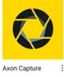
Select the Axon Capture App

Make sure you are logged in using the i icon (top left)

Log in details
Agency = demsc.uk.evidence.com
Press Continue
Enter your evidence.com username and password

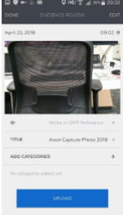

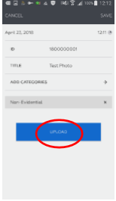

How to upload a single/multiple photos.

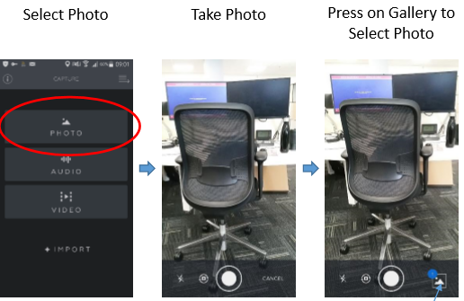

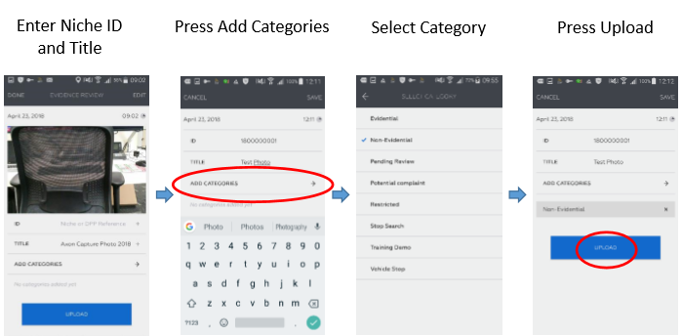
Press skip if you want to view the photo’s first

Once uploaded the picture will be removed from your phone.

To select multiple photo’s tick the boxes of those you wish to use
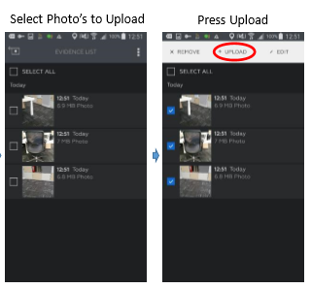

If you did not upload any photo’s because you do not wish to use them:
Select the photo
Press Remove from device

All photos will now be available to view on Evidence.com
This can be accessed via your browser on your phone by typing in:
Demsc.uk.com
Log in and use as you usually would for evidence.com

