Report for Community Engagement Assignment 2 2018 – Problem Solving



May 2018

MODULE NAME: Community Engagement
Project Name: Problem Solving
Name: Lucy Crocker
Student Number: 1701540

Table of Contents

1. EXECUTIVE SUMMARY 3
2. Introduction 4
2.1 Report Remit 4
2.2 Brief background TO the organisation 4
2.3 The problem 5
3. Problem solving techniques 6
3.1 Solving the problem 7
4. Conclusion 12
5. References 14

EXECUTIVE SUMMARY
This report contains an insight into the author’s chosen problem, which is the continuous increase of unemployment amongst young people and how organisations like Down To Earth can contribute to solving the problem. Down To Earth are a not for profit social enterprise that specialise in organising activities in aid of vulnerable and disadvantaged people. Their activities are solely based upon skills development through the aid of construction. Down To Earth have encouraged vulnerable and disadvantaged young people to become more involved within their local community by building various structures which both aid the community and develop their personal skills. The problem the author has identified is the continuos increase in the unemployment rates for young people, a solution to this would be to introduce schemes where individuals can develop their experience skills through participating in tasks in order to develop their confidence and experience before applying for a role within the workplace. There are five main problem solving techniques which are the 5m’s, the 8p’s, the 5s’s, the 5 why’s and the Ishikawa Diagram. The author has chosen the 5 why’s and the Ishikawa diagram as the techniques to solving the problem. The 5 why’s are consistent of why are young people not in education or training , why do young people fear of being discriminated, why is the unemployment rate for young people continuously increasing, why are older people working past retirement and why is unemployment for young people such a problematic issue. In relation to solving the problem, the two solutions that were considered to be the most successful was the career days scheme, where indivduals would attend lectures and workshops based upon developing work critical skills and attending scheduled days where individuals could go to a organisation of their choice to complete tasks in order to develop their experiences. The second solution that was considered succesfull was the discrimination awareness, where a series of lectures would be presented in schools and town centres in order to raise awareness of discrimination and also educate others on the various types of discrimination.

Introduction
The problem that the author has decided to research for this report, is the continuous rise of unemployment amongst young adults within the UK, with particular reference to unemployment within the South Wales region, and how Down To Earth, a Swansea based not for profit social enterprise, contributes to decreasing these levels by providing crucial skills development for young people, which in due course can be valuable for their future profession and general employment prospects. The author has decided that this topic is particularly relevant to the experience they received during their time with the organisation Down To Earth, due to the invaluable insight received into the organisations projects and the positive effects they have had on the lives of those who have participated in these projects.

Report Remit
In this report the author will be reviewing the numerous problem- solving techniques utilised by Down to Earth and relating them to their project experience with the organisation, which was completed during the authors first semester project at University of Wales Trinity St David.

Brief background TO the organisation
The Down To Earth Project is a not for profit, social enterprise based on two seperate sites known as Little Bryn Gwyn and Murton on the Gower Peninsula, Swansea. The Down To Earth Project specialises in organising numerous team building projects for vulnerable and disadvantaged young people within their local community. The organisation’s projects to date, include sustainable construction, which helps young people to develop various skills that can be beneficial for their future careers (Down To Earth A, 2018). Down To Earth achieves this by specialising in various adventure days,which include a number of different activities for example, climbing, abseiling and coasteering (Down To Earth B, 2018), activities that many young disadvantaged and vulnerable people may not get the opportunity to experience, as well as eco building, which includes sustainable building training by developing structures through the use of timber building, straw bale building and dry stone walling (Down To Earth C, 2018). Down To Earth have supported vulnerable and disadvantaged young people by encouraging them to become more involved within their local community by building numerous structures based upon their training, for example the ORACLE at Swansea University was developed in order to provide research opportunities for students, a setting for lectures and also as a setting for relaxation for both students and staff members (Swansea University, 2018).

The problem
The problem the author has identified in relation to their project experience with the social enterprise Down To Earth, is unemployment figures amongst young adults within the UK. According to research briefings by Parliament UK 538,000 young people aged 16-24 were unemployed in November 2017- January 2018, 15,000 more than the previous quarter (Parliament UK, 2018). In relation to South Wales in particular, which is the primary focus for the work of Down to Earth, the unemployment rate in Wales for 19 -24 year olds for young people who are not in education, employment or training (NEET) is 18.5% as of 2016 (Welsh Government, n.d.). Statistics show that at the end of 2017, Wales has a higher rate of 19-24 year olds not in employment or training (Welsh Government, n.d.) (Department For Education, 2017).Down To Earth have taken these statistics into consideration and continue to provide essential skills development and training through the use of construction and building development for individuals who are not in employment, education and training. A solution to this problem would include introducing schemes where individuals who are unemployed can increase their knowledge and experience before applying for jobs.

Problem solving techniques
There are five main problem- solving techniques which are known as the Ishikawa Diagrams, The 5m’s, The 8P’s, The 5s’s and the 5 Why’s. The Ishikawa Diagram was developed by Kaoru Ishikawa in the late 1960’s, his diagram is known as “the fishbone diagram” which is used within organisations in order to explore inputs that would explain outputs (Best & Neuhauser, 2008, p. 150).
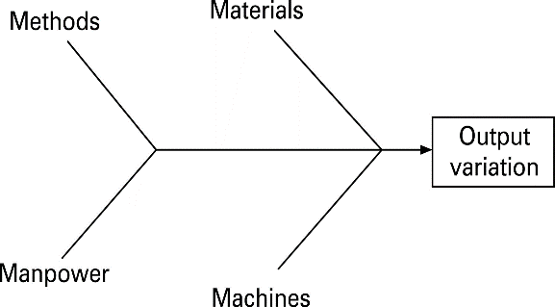
The Ishikawa Diagram is used to encourage participations from an organisations employees, but also it increases the understanding of processes and is used to identify the main cause of defects and problems and identify key areas for the collection of data (Best & Neuhauser, 2008).
Figure 1: Ishikawa Diagram (Best & Neuhauser, 2008)
The second problem solving technique is the 5m’s, which is commonly found in the manufacturing industry (Hughes, 2018). This model consists of 5 factors which are known as machine, method, material, man power and measurement (Managment Mania, 2016).
The third problem solving technique is the 8P's, which are of use in Marketing. This model consists of 8 factors, which include, the product or service, price, place, promotion, people/personnel, process, physical evidence and packaging (Hughes, 2018).
The fourth problem solving technique is the 5S’s, which are used within the service industry. This model consists of 5 factors, which are known as, the organisations surroundings, suppliers, systems, standard documentation skills and scope of work.

The final problem- solving technique is know as the 5 Why’s, which is used within organisations in order to “resolve simple or moderately difficult problems” (MindTools, 2018). There are five key steps to this model which consists of, assembling a team, define the problem, ask the first “why?”, ask “why?” another four times and the final step is to know when to stop (MindTools, 2018) (Bermingham, 2013). The 5 why’s technique was developed by Sakichi Toyota, who is the founder of Toyota Corporation, and this theory is still used within the corporations manufacturing methods. It is still considered to be a critical component for problemsolving at Toyota (Bermingham, 2013).
The problem- solving techniques the author has decided upon in relation to their chosen problem are the Ishikawa diagram and the 5 why’s.

Solving the problem
The first problem solving techniques the author will use in order to solve the problem of rising unemployment rates amongst young people in the UK, will be the Ishikawa Diagram.
Throughout the analysis of this problem a recurring theme through the 5 why’s and the Ishikawa Diagram, the main problems that were identified to have occurred more than once were lack of work experience, lack of qualifications, lack of interest and confidence issues. The solution to these problems would include introducing career days, which would include a day of work experience with an organisation of choice,for example , the career day with British Gas would include experience either within the call centre environment or provide a more engineering based experience, the time limit can also be adjusted if the individual would like to gain more experience over the course of a week. Another option would be workshops,lectures and presentations from organisations such as HSBC, John Lewis and Virgin about the job application process, CV writing workshop, general advice for when individuals apply for jobs and also the opportunity to apply for career roles. This solution will decrease the problems listed above by ensuring that young people develop their confidence for job applications, providing and developing an important skill that many disadvanted young people miss out on.
In relation to the author’s problem of unemployment rates in young adults, one of the main factors in relation to the issue of young adults not being in employment and training is a fear of being discriminated within the workplace either due to a disability or other causes.
There are numerous organisations including Down To Earth who specialise in providing crucial skills development for young people who may feel this threat of discrimination, or actual discrimination itself, through various activities, an example of which is an organisation called Bikeworks, who are a bike selling and repair shop based in London (Bikeworks, N.D). Bikeworks are a not for profit social enterprise who specialise in skills developing through the use of bikes, in may different ways. The organisation sell bikes within their shop but also repair and provide skills teaching and training, which in due course will help individuals improve their skills base. The activities Bikeworks offer include maintenance courses, teambuilding schemes, cycle training, cycling for health, cycling for schools and an employment programme which offer critical skills development opportunities for people of all ages (Bikeworks, N.D).
According to Gov.uk, in 2008, 19% of people with disabilities experienced unfair treatment at work compared to 13% of non-disabled people (Gov.uk, 2014). The second problem solving technique the author will use in relation to solving the discrimination of young people within the workplace, is the 5 why’s. The process is simply asking the question why five times. Let me provide you an example of only getting to the symptom of a problem.

The first element of the 5 why’s in relation to the author’s problem is, “why are young people not in employment or training?”. The most common reason that young people feel uneasy with the process of getting employed, is the fear of being discriminated, amongst other various reasons. According to The Independent, “a survey of 1,400 employees found that over half of 18 year olds feel as if they are not being taken seriously at work” (The Independent, 2017).
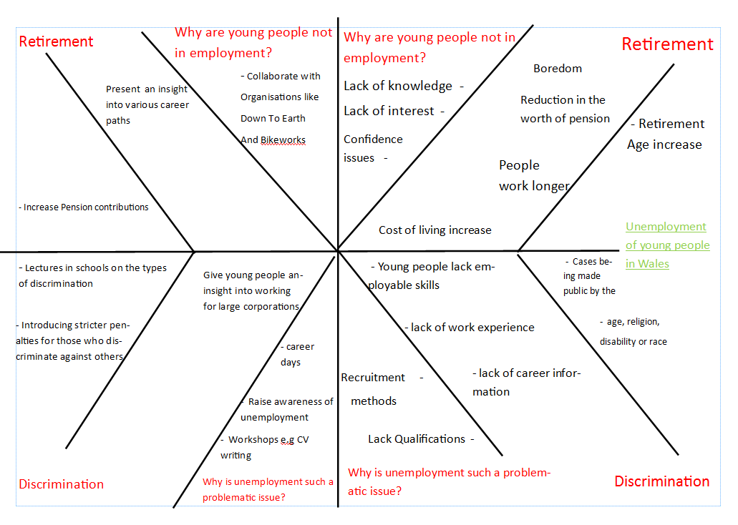
The first solution to this element will include supporting and encouraging the work of charitable enterprises similar to Down To Earth and Bikeworks, who encourage young people to develop their crucial career skills through a variety of challenges, in the examples mentioned above this would be through either construction or biking. The second solution to this element will include raising awareness of discrimination and the different types of discrimination, in order to decrease the fear of being discriminated against within the workplace.

The second element of the five why’s problem solving technique is “Why do young people fear being discriminated against?”. The reasoning for this question would include the lack of role models for young adults, but also the cases of those discriminated within the workplace being made pubic by the media. An example of this includes Starbucks, where an employee with dyslexia was discriminated against after being accused of falsifying documents (BBC News, 2016). The first solution to this element will include decreasing the fear and lack of support from organisations and the government by introducing stricter penalties to those who discriminate others and also register any complaints made against an individual commiting a discriminatory offense within the UK. An example of this solution currently being in use is within the government of the Netherlands (Government of the Netherlands, N.D.), in order to attempt to decrease the increasing youth unemployment level.

The third element of the five why’s problem solving technique is “why is the unemployment rate in young adults continuously increasing?”. The youth unemployment rate has been described by the Guardian as “its worst for 20 years ” (The Guardian, 2015), and has been an “ escalating problem for the UK since 2005” (Youth Employment UK, 2018) . There are numerous factors which contribute to the continuous rise of youth unemployment, these factors include, failure to address previous high levels of youth unemployment by governments. The first solution to this element of the 5 why’s will include decreasing the retirement age in order to increase positions within the workplace for young individuals. According to the Guardian, figures published by the National Office for Statistics show that 15.5% of men and 11.3% of women are still in employment past the traditional retirement of 70 in 2016 (The Guardian, 2017).

The fourth element of the five why’s technique in relation to the author’s problem is “why are older people working past retirement?”. Retirement has been defined by Simon de Beauvoir as a “ radical break” into ones life after they are cut off from their past, this can bring many advantages for individuals which include leisure and rest (Fineman, 2011) . The retirement age varies in many continents, for example, the retirement age in the Uk for men is 65 but is increasing from 60 to 65 for women (Age UK, 2017), the retirement age in Spain is currently 65 (ExpactFocus, 2017) and the retirement age in China is 60 for men and 50 for women . There are numerous reasons as to why people continue to work past retirement, for example, employees being passionate about their career and also increase their pensions worth. One possible solution for this problem will be to increase pension contributions, this solution will open up more career experiences for young people as older people wouldn’t have to work during their retirement period.

The fifth and final element of the five why’s technique in relation to the problem is “Why is unemployment for young people such a problematic issue?”. According to Youth Employment UK, there are various factors which increase the levels of unemployment, these factors include, young people that lack skills which are required within the workplace, Down To Earth specialise in organising skills development for young and disadvantaged people in order to develop their confidence and skills building for future careers. Other factors which increase unemployment include employment legislation, lack of qualifications or appropriate qualifications for specific careers, but also some employers preference to employ staff with numerous career experience backgrounds (Youth Employment UK, 2018).

3.2 PROBLEM SOLVING IMPLEMENTATION

The first solution to this element will include introducing career days within schools and institutions in order for young people to gain various experiences before applying for higher jobs. This example has been introduced in Bulgaria and includes days where organisations such as financial institutions, IT, bank, production along with public administration structures offer internships and CV building workshops in order to decrease the levels of unemployment, but also to increase young people’s confidence whilst applying for a career (Job Tiger, 2017). Of the solutions presented within the above solving the problem section, the first solution the author will discuss in greater detail is the career days solution. This solution scheme will be presented to schools and institutions for young people, in order to gain intrest within the world of work which will be beneficial in due course. This experience will ensure that young people can develop various critical skills for future careers and gain experience of completing tasks within a working environment, increase their confidence and discover new opportunities that may have not been considered. The opportunity to attend will be accessable to pupils completing GCSE’S and A-Levels but also to those who are claimants of Jobseekers Allowance, this experience will broaden their knowledge of the various career paths available. The scheme will include workshops with the opportunity of internships, apprenterships, CV building and general advice for the career application process. It will be hosted by a variety of corporations for numerous intrests ,for example, The Armed Forces, Childcare Professionals, Catering and Hospitality, General Business, Medical Proffession, Teaching Industry, Emergency Services and Construction. A similar solution has been introduced in Bulgaria where it has been successful in decreasing unemployment (Job Tiger, 2017). The scheme will be advertised on social media platfforms such as Facebook, Twitter and Instagram but also in poster form to be presented within schools and job centres.
The second solution that the author will examine in greater detail is raising the general public’s awareness of discrimination and the many different types of discrimination. This solution will be presented in the form of lectures that will take place in schools and institutions on certain occasions, for example, the topic will be introduced during lectures based on applying for roles within the workplace. This scheme will include valuable information about discrimination and advice should individuals feel as if they are being discriminated either due to disability, religion or any other circumstances. The scheme will be advertised on posters in schools and local town centres where members of the public can attend.

Conclusion

In conclusion to bring this report to a close, there are various solutions to the author’s chosen problem of the increasing unemployment rates within the UK and specifically within the South Wales region, through the use of the 5 why’s and the Ishikawa Diagram, which include raising awareness of discrimination, suitable payment options for pension schemes, career days and also introducing penalties for those who discriminate against others. The two most successful solutions have been acknowledged before and have proven to have been successful in other continents, for example, the career days in Bulgaria.

References
Age UK, 2017. State Pension Age. [Online]
Available at: https://www.ageuk.org.uk/information-advice/money-legal/pensions/changes-to-state-pension-age/
[Accessed 01 05 2018].
BBC News, 2016. Starbucks Employee Wins Dyslexia Discrimination Case. [Online]
Available at: http://www.bbc.co.uk/news/uk-35521061
[Accessed 30 04 2018].
Bermingham, J. A., 2013. BUSINESS DEVELOPMENT - The 5 Whys. Drug Development & Delivery, 02 October, Issue Sep 2013, p. N.P.
Best, M. & Neuhauser, D., 2008. Kaoru Ishikawa: From Fishbones To World Peace. s.l.:BMJ Publishing Group LTD.
Bikeworks, N.D. Homepage. [Online]
Available at: https://www.bikeworks.org.uk/
[Accessed 29 04 2018].
Department For Education, 2017. NEET Statistics Quaterly Brief. [Online]
Available at: https://assets.publishing.service.gov.uk/government/uploads/system/uploads/attachment_data/file/683881/SFR13-2018_NEET_Statistics_Quaterly_Brief_Q4-2017.pdf
[Accessed 03 05 2018].
Down To Earth A, 2018. Events. [Online]
Available at: https://www.downtoearthproject.org.uk/events/#sidewidgetarea
[Accessed 15 04 2018].
Down To Earth B, 2018. Adventures. [Online]
Available at: https://www.downtoearthproject.org.uk/adventures/
[Accessed 15 04 2018].
Down To Earth C, 2018. Eco Building. [Online]
Available at: https://www.downtoearthproject.org.uk/ecobuilding/
[Accessed 15 04 2018].
ExpactFocus, 2017. Spain Retirement. [Online]
Available at: https://www.expatfocus.com/expatriate-spain-retiring
[Accessed 01 05 2018].
Fineman, S., 2011. Organising Age. Oxford: Oxford Scholarship Online.
Gov.uk, 2014. Disability Facts and Figures. [Online]
Available at: https://www.gov.uk/government/publications/disability-facts-and-figures/disability-facts-and-figures
[Accessed 23 04 2018].
Government of the Netherlands, N.D.. Government measures to combat discrimination. [Online]
Available at: https://www.government.nl/topics/discrimination/government-measures
[Accessed 30 04 2018].
Hughes, G., 2018. Ishikawa Problem Solving Powerpoint. [Online]
Available at: https://moodle.uwtsd.ac.uk/course/view.php?id=2021
[Accessed 15 04 2018].
Job Tiger, 2017. Career Days. [Online]
Available at: https://careerdays.bg/en/national-careerdays
[Accessed 01 05 2018].
Managment Mania, 2016. 5M Method. [Online]
Available at: https://managementmania.com/en/5-m-method
[Accessed 15 04 2018].
MindTools, 2018. 5 Whys. [Online]
Available at: https://www.mindtools.com/pages/article/newTMC_5W.htm
[Accessed 16 04 2018].
Parliament UK, 2018. Youth unemployment statistics. [Online]
Available at: https://researchbriefings.parliament.uk/ResearchBriefing/Summary/SN05871
[Accessed 16 04 2018].
Swansea University, 2018. ORACLE in the Botanical Garden. [Online]
Available at: http://www.swansea.ac.uk/sustainability/oracle/
[Accessed 13 04 2018].
The Guardian, 2015. Youth Unemployment. [Online]
Available at: https://www.theguardian.com/society/2015/feb/22/youth-unemployment-jobless-figure
[Accessed 25 04 2018].
The Guardian, 2017. Number of women working past 70 in UK doubles in four years. [Online]
Available at: https://www.theguardian.com/money/2017/mar/22/number-of-women-working-past-70-in-uk-doubles-in-four-years-retirement
[Accessed 01 05 2018].
The Independent, 2017. Majority of UK workers say age discrimination is common at work. [Online]
Available at: https://www.independent.co.uk/news/business/news/uk-workers-age-discrimination-common-workplace-office-young-majority-a8103511.html
[Accessed 25 04 2018].
Welsh Government, 2018. Unemployment rate. [Online]
Available at: http://gov.wales/statistics-and-research/key-economic-statistics/?lang=en
[Accessed 29 04 2018].
Welsh Government, n.d. [Online]
Available at: https://gov.wales/statistics-and-research/young-people-not-education-employment- training/?lang=en
Youth Employment UK, 2018. Youth Unemployment. [Online]
Available at: https://www.youthemployment.org.uk/youth-unemployment/
[Accessed 26 04 2018].

