EMERGENT LEADERSHIP SKILLS IN THE WORKPLACE

BA (Hons) Leadership & Management Skills for the Workplace

Name: Jane Nakitto

SID: 2008466

Word Count: 4500/UWTSD

Table of Contents
Introduction 3
Main Body 4
Background of chosen business 4
Key leadership theories/models/approaches/styles that this research will use 5
Apply discussed theories/models/styles and approaches within chosen business 7
Different leadership approaches and styles 10
Current leadership strategies in Sainsbury’s 12
Recommendations 13
Task 2: Reflective Summary 14
Problem solving skills 14
Leadership skills 15
Management skills 15
Description 16
Feelings 16
Evaluation 16
Conclusion 17
Action plan 17
References 17

Introduction

This report is divided into two part where in the first part the field of study will apply leadership and academic management models, theories and methods to explore the key responsibilities of leadership within the workplace as well as scrutinise critical importance of the objective’s analysis of personal limitations and strengths. In this part taking Coronavirus into consideration researcher will execute what emergent leadership skills might be effective for the leader via taking an organisation as a case study. Hence, the chosen business for this report is J Sainsbury’s PLC and by choosing this organisation researcher will assess and analyse strategies to make decision amid uncertainty caused via ongoing economic uncertainty.

The second part of the report is reflective essay where the field of study will outline the learning and acquired skills from this module with the help of samples which can be used for employment entailing the exercises of personal responsibilities as a leader as well as decision making via getting into depth of internal and external business environment. All the data gathered within this report will be referenced accordingly to avoid collusion and plagiarism as per the university guidelines.

Main Body

Background of chosen business

J Sainsbury’s PLC is one of the best fast paced retail which is second largest chain of Supermarkets in the UK that was established back in 1869 by John James Sainsbury with very first shop located in Drury Lane, London. Since then, the business was largest UK retailer of groceries for most of the 20th century. The company currently split into three division Sainsbury’s Supermarket, Sainsbury’s Bank, ARGOS and Habitat. As of 2021 the largest shareholder of the business is Qatar that holding 14.99% of the company. The business is listed on the London Stock Exchange and it’s a constituent of FTSE 100 Index (Sainsbury’s, 2022). During the time of Coronavirus which poses extraordinary demands on leaders due to outbreak, economic uncertainty, political instability Leaders of Sainsbury’s effectively handled the situation with distinctive strategy where effective control and balance was on place. Because of this being an essential grocer of people needs even though the business sales were booming during the pandemic still it has face £261m loss due to spending £485m on Covid related costs. Reason being, Sainsbury’s has always been ethical retailer where health and safety of consumers and colleagues are the priority (Simson, 2021).

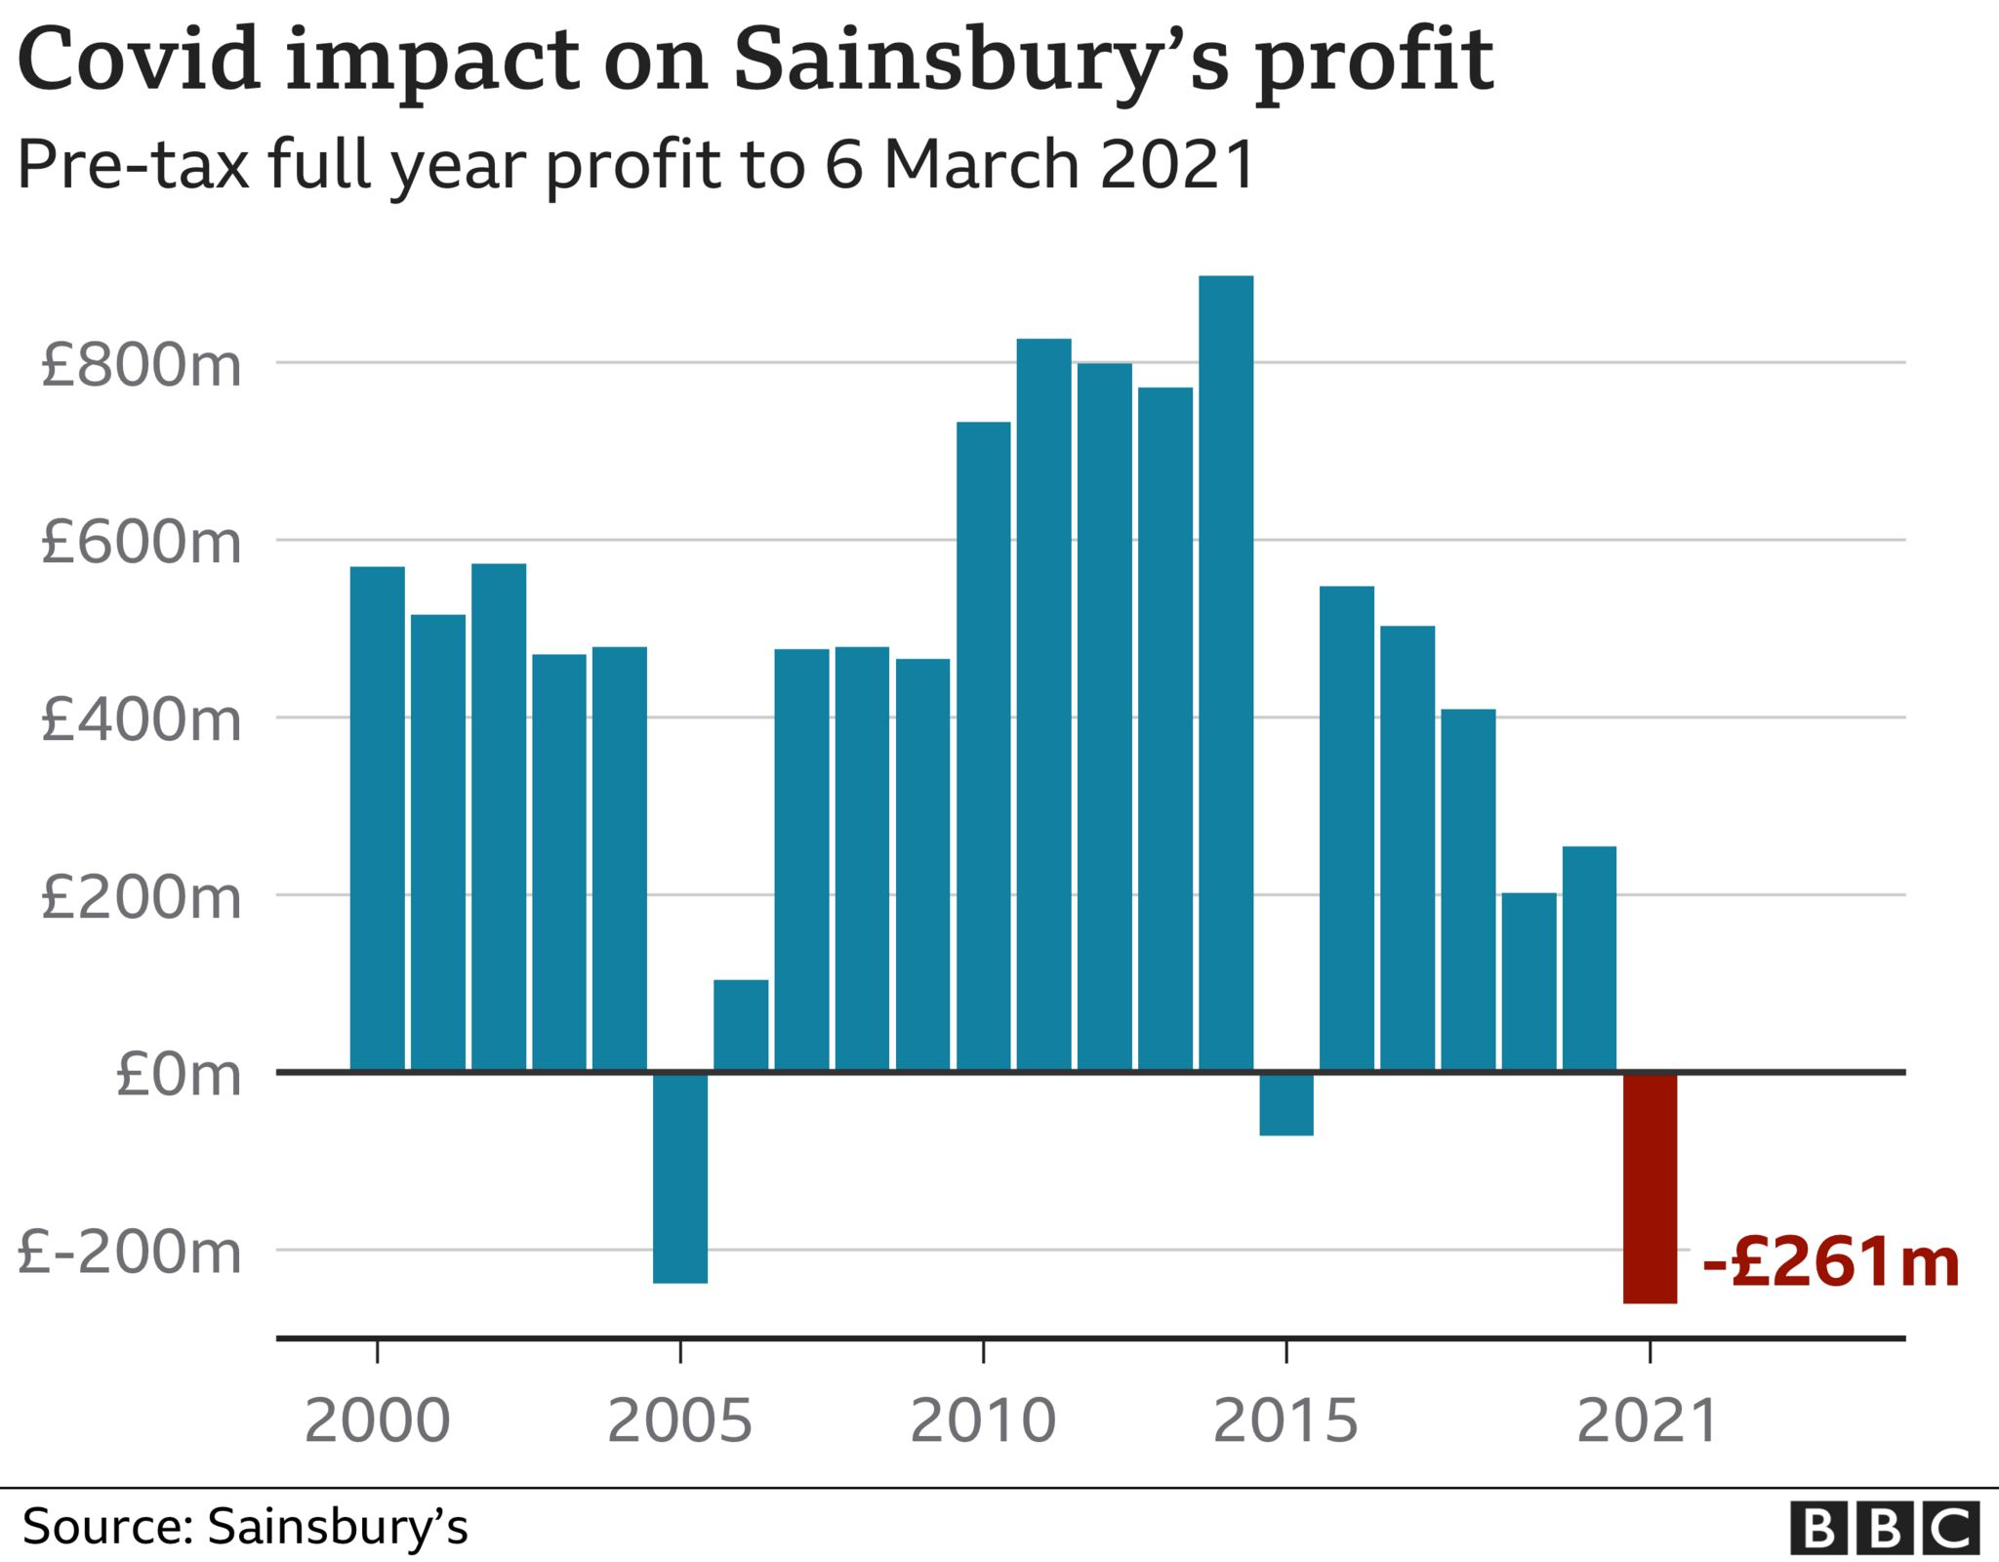

Figure: Covid impact on Sainsbury’s Profit (Source: Sainsbury’s, 2022).

Despite having the loss, the CEO of the business added “our effort was heroic where thousands of staff keep up with business going during the time of pandemic” (Simpson, 2021).

Key leadership theories/models/approaches/styles that this research will use

The leadership study can be trace back to the ancient Egyptian such as Socrates, Pluto and Aristotle however the overall importance and understanding of the leadership has been emerged within the early stage of the 20th century since then leadership tuned into a most written phenomenon of all time (Grint, 2022). At the end of 20th century various attempt was made to understand leadership where various leadership theories, models, styles and approaches has been developed to aid large scale of leadership tactics that can be adopted by various leaders to get a fruitful outcome (McElroy, 2019).

As per the theory this report will use transformational theory, as per the style researcher will use democratic leadership style, as per the approached research will use integrated psychological approach and finally as per the model researcher will use team oriented model which are effectively adopted by chosen business over the time specially in the scenario of Covid.

Transformational leadership theory: this sort of leadership raise the consciousness of the followers via appealing towards moral values and ideals rather than to materialistic desires or negative emotions. With the help of agreements leaders incorporate the followers within the process of activities in organisation to achieve common goals as well as return distinguishes transformation leadership from other previous and contemporary theories (Northouse, 2016). This theory support followers to achieve their commitment as well as reintroduce them. Here, the leader inspires, motivate and transforms followers to perform while exceeding self-interest for the organisational improvements. This type of leadership motivates followers to go and achieve goals beyond their individual interest for the benefit of the business. Leaders also use this style as part of a process where followers engage with others in a way which in turn raise their morality and motivation (Lussier and Achua, 2019).

Democratic leadership style: through this leadership style, leader make decentralised decision where leaders includes their followers within the process of decision making along with planning and execution. This style is highly effective that enable leaders to maintain and encourage group effectiveness and support followers to express their ideas to accomplish the goals. In compare to bureaucratic leadership style this style stimulates more organisational citizenship behaviour among the workers as bureaucratic leaders tend to believe in process and policies. However, in democratic leadership style, leaders discuss with followers before implementing such process and policies (Malloy, 2019).

Integrated Psychological approach: this approach of leadership is effective attempt to integrate the overall strengths of the older theories such as leadership styles, traits, behaviour, functional and situation while pinpointing the limitations via introducing a new element such as developing effective leadership presence, attitudes towards followers, behavioural flexibility, practicing psychological mastery etc. (Northouse, 2016). Integrated psychological approach started grabbing attention after the James S (2011) published three levels of leadership model where the author argued older theories, models, approaches offers limited assistance in developing person’s abilities to lead efficiently. Hence, through integrated psychological approach leaders can positively correlated emotional, mental, physical and relational wellbeing for business success.

Team oriented model: this model of leadership emphasises the experiences, skills as well as personal strengths of the individual as a collective over the power of leaders. This sort of leadership model promotes effective collaboration along with offer opportunities for leaders and workers to achieve full potential. This model sets positive example via creating collaborative team environment that focus over nurturing the individual strengths of each group member, motivating them to reach their high potential as an individual as well as a team via collaboration (Clark and Hazen, 2017).

Apply discussed theories/models/styles and approaches within chosen business

When it comes to implement all the theories/models/styles and approaches discussed above, researcher would be able to gain new heights in leadership with the help of transformational, democratic, team oriented and integrated psychological leadership tactics as it would allow researcher to convince team and motivate them simultaneously when new issue arise. Further, as the chosen business all the discussed theories/models/styles has effectively been adopted by J. Sainsbury’s leaders as part of their distinctive strategy to make decision amid uncertainty cause by COVID-19 and ongoing economic uncertainty.

Transformational leadership: J Sainsbury’s PLC consider as most popular as well as traditional supermarket chain shop which is successfully operating its business since 1922. Since then, over different era the business has went through transformation and change its management and leadership style to make better business decision (Sainsbury’s 2022). As part of that, the business where it used to follow autocratic leadership before pandemic adopted transformation leadership to deal with uncertainty cause by COVID-19 and ongoing economic chaos. Henceforth, the business use transformation leadership theory to initiate big changes and to ensure it, Sainsbury’s delegated it high performers as well as dedicated team to do that (Sainsbury’s, 2022). As a result, management team of the business at store level always communicate with their employees in prior to take any decision to manage the overall operation. Majority of the store management team discuss with their workers to collect information to make decision such as “We are listening surveys” and Great place to work representative participation. Through we are listening survey, all the management workers and employees fill up their survey with various feedback where head office-based leader review it and make decision because of this during post pandemic the business invested £100m in colleagues pay and 3% rise in management pay to motivate their employees to cope with cost of living (BBC, 2023). On the other hand, every store has great place to work representative and through monthly team call all the area-based management and GRTW representative come up with various initiatives to fulfil the desire of workers. Because of this, the business has come up with colleague food where store depending upon the size will get £50-£200 weekly payment to ensure colleagues are getting free food such as milk, bread, butter, nuts, chocolate, fruits etc. which effectively helped colleagues to cope with cost of living. Apart from that, the business at the store level always arrange staff meetings with their colleagues and discuss about various business changes (Sainsbury’s 2023).

Democratic management/leadership style: the most common management style used by many businesses within the UK is democratic management style. Through this management style store level management are often delegated by upper leaders to consult with employees in prior to make any decision (Pascal, 2017). Through this style, Sainsbury’s ensure high employee motivation and retention. As a result, within a store level the business has introduced effective HR policies and trained all managers to support colleagues extensively to ensure low employee turnover. The interactive HR module enable all the managers to understand value of each employee where Sainsbury’s lose £11000 pound by losing an experienced colleague. Due to that effective democratic management style is in place where employees get 26 weeks of long sick pay, maternity and paternity leave, career break after working one year, 15% discount on every weekend and 10% on daily basis. Further, the business also allows colleague to have certain type of healthy meal which are available in the canteen all day long. The holiday payments, wellbeing support, free valedium mental health doctor, cycle to work, loan, share investment, pension and so on where colleagues are exited and motivated to work (Sainsbury’s, 2023).

Integrated Psychological approach: when it comes to this leadership approach Sainsbury’s has effective wellbeing commitment where every colleague has access to mental health as well as wellbeing support via different tools and other resources which in turn enable them to make proactive and positive choices to thrive within all aspects of life (Sainsbury’s, 2023). To ensure integrated psychological approach the business has adopted a holistic approach towards wellbeing which includes three pillars, physical, mental and financial wellbeing (Christos, 2023) With the help of these pillars, Sainsbury’s focus highly on education, awareness, support via different tools and resources which enable their colleague to adopt proactive and positive choices to thrive within all aspects of life. Apart from that, the business also holds various wellbeing campaign throughout the year to minimise the stigma as well as create a culture of openness towards physical, mental and financial wellbeing. Such as Validium, loan, salary finance to leverage the colleague’s expertise. Apart from that, Sainsburys also have internal social media called Viva Voce (Yammar) we all the leader and team members drumbeat communication daily regarding health and wellbeing (Sainsbury’s, 2023).

Some of the major example of the undertaken campaigns are; during 2022 Sainsburys has carried out Mental Health Awareness week, Suicide prevention week, make you money count financial wellbeing campaign to support colleague to deal with rising cost of living. All of the campaigns are supported via Sainsburys company wide network of over 1500 wellbeing champions. The wellbeing champion the business are the colleagues who has volunteered to help other team members via supporting them with right resources (Sainsbury’s, 2023).

Team oriented model: to help the team to a greater extent, the business earlier this year has delegated essence to support single minded digital marketing strategy where the business has gone through huge digital transformation and bring all the employees of Sainsburys under one roof (Shin, Kim and Lee, 2016). The business through digital transformation has invested Sainsburys SharePoint where colleague can get all their required training available in audio and video along with book holiday, check schedule, check health and wellbeing support, sickness pay and so on. Due to the digital transformation the digital side of the business now accounts £6bn of the groups £32bn sales performance where highly trained and dedicated team members are the key to success (Sainsbury’s 2023).

Different leadership approaches and styles and identify the personal ability of a leader to fulfil key responsibilities of the leadership role within the context of established leadership styles.

All the above discussed leadership style, theory, model and approach are highly effective within the scenario of Sainsburys as through effective adaptation of these leaders of the business embed the leadership fundamentals within their day to day management of the team. Through leadership strategy Sainsburys focus on their team’s best performance where managers are key to drive the performance of the team via engaging them, supporting them and offer best tolls and resources. Then area managers go through area-based meetings where GPTW representative nominated by the store are gathered together and share their views how managers are and to what extent are supporting them. Once the meeting is finished area manager go through all the store managers to allocate them with feedback and improvements to pursue better outcome from the team. Apart from that, the business has Right line assistance where vulnerable colleagues can call anonymously to get the high authority involvement and attention to sort out the problem (Sainsbury’s 2023).

Here, through leadership strategy, approach, model and theory are designed in a way to achieve the leadership fundamental that includes; build relationships, enable the basics, communicate, appreciate and drive performance. As far as personal ability of a leader to fulfil the key responsibility is concern Sainsburys always prioritise its leadership fundamentals side by side it also build habits of reminder through email and text, relies on simple visual cues such as what leaders should consider and what would works for them, make it simple such as setting up SMART goal and making small changes step by step and finally plan to fail where Sainsburys allows its leader to learn from the mistakes (Sainsbury’s 2023).

Further, in the light of leadership fundamental Sainsburys allows its leader to judge their personal ability via self-reflection activity where different small changes can ensure big impact. The self-reflection activity includes;

- What is my goal? What I want to achieve in the next week.
- What is the reality? What is happening now? Do you have everything in hand to achieve the goal?
- What is my obstacle and opportunities? What stopping you to doing this? What is in and out of the control?
- What I will commit to? What are the available options? Convert these into action to think forward (Sainsbury’s 2023).

As per Sainsburys (2023) “our approach enables all colleague to be the best they can be and offer them autonomy to develop” by doing it the business focus on career progression of exiting colleague to get the best leader possible who are expert within their role. That’s how Sainsburys boost personal ability via leadership approach, model, theory and style as well as let them use personalised content, network of mentors, programs, skills one need to be a better version of themselves. With the help of identifying best potential within the business Sainsburys flourish new leaders within their role within the context of established leadership styles. Once offering all the required aspects Sainsburys focus over additional investment within a more personalised approach to develop and retain new leaders to maximise their potential. Daily feedback in this stage in place regarding development to support leader with their performance as well as achieve career aspirations is key un-locker for the business as this in turn help business to ensure work at pace, build strong relationships, drive innovation and so on (BBC, 2023).

The past years in post pandemic time and current economic uncertainties to boost the overall skills of leaders Sainsburys went through massive switch to digital activities as well as ways of working. Numerous learning materials are added for leaders to support colleagues within this transition. Some of the support materials are user guides, digital learning platform, online live class, short videos for leader to train current and new team members (BBC, 2023) Sainsbury’s continue to review the impact of these materials as well as use the principle to shape the effective future learning platform for all leaders and colleagues wherever they are based. Along with these, the business is evolving apprenticeship offer to support business needs where the business has leading profession, specialist knowledge within the area of delivery. As part of it Sainsburys work with British Retail Consortium, Institute of Grocery Distribution and support leader’s development (Spyridonidi, 2022). The business also works closely with ifAET team as well as skills development Scotland to help the development of future apprenticeship program which will deliver skills leader required. Sainsburys also work with different trailblazer groups and retail skill quality food to offer what leaders need for effective delivery. As per Simon Roberts (2023) CEO of the business “to tackle economic uncertainty we continue to strengthen our partnership with suppliers by offering free digital learning where leaders have access to 20 on demand modules that ensure we are aligned with our key process, system and ways of working where we can collaborate and work together for better”.

Current leadership strategies in Sainsbury’s by extracting information from the recent annual report of the company and published newspapers.

Current leadership strategy of Sainsbury’s largely influenced by digital providers that open door for fast paced retailer like Sainsbury’s to acquire new consumer, offer better service towards consumers, minimise cost of operation, maximise employee motivation that has positive outcome on revenue and margin perspective. Sainsbury’s leadership is based on board which is chaired by Martin Scicluna, who along with his fellow board members are responsible to set up long term strategy for the group. They act better in the interests of colleagues, shareholders, customer and stakeholders, ensuring delivery on promises (Sainsbury’s 2023). On the other hand, Simon Roberts, CEO of the board focus on daily management process and their role to execute the strategy set via the board. Further, Lesley chaired for Sainsbury’s bank who is independent member of the Moody investor services and non-executive director of money supermarket (BBC, 2023).

The chairman of the company Martin, ensure valuable knowledge and skills in evaluating leadership strategy and developing strategy as well as financial services. He is the one who delegate leaders in different region with training facilities and mostly the training available digitally. The democratic leadership is current view of the business and the CEO of the business Simon Roberts check through Area managers to ensure store based managers are following it (Sainsbury’s 2023). if there is any complain from store colleague, CEO take it very seriously and retrain the managers through different workshops to ensure business process and management style are handled with care. As per Sainsbury’s (2020) we stay connected with colleague through different wellbeing questions without our CE survey, the non-executive director and operation board ensure regular listening sessions throughout the year to understand colleagues mind. The business national and local GPTW groups are also active to offer new opportunity for colleague to understand the mind and feelings (Sainsbury’s 2023).

Recommendations

The overall market, consumer demand and preferences has change unimaginably due to pandemic, Brexit, cost of living hit as a result many people within the UK are struggling to fulfil their basic needs. To deal with that Sainsbury’s as a responsible retailer has come up different strategies to support their consumers such as winning in food, 100 price match with Aldi, Nectar discount, discount on smart app shopping and so on. But still the business is facing huge competition with its rivals hence there are some major weakness the field of study has scrutinised that ought to be acquired by the business as well as leaders to ensure change-emergent leadership skills are implemented. The key recommendations are;

- UK life turned very expensive because of that many consumers wants to pay less one their grocery and household shopping. There are few retailers are offering best prices than Sainsbury’s such as Lidl, Aldi, Asda, Iceland etc. hence to stay competitive within the emergent market leaders need to create unique selling point by minimising price of the products. Hitherto, to ensure this cost leadership skills the business need to cut cost from another sector and use modern and better the to reduce the price of the product.

- The business is very successful due to its brand image and quality hence, leaders of the business to cope with economic certainty should open more branch in different location to ensure more profitability within the market.

- Regarding the decision making the business is maintaining power culture however the leaders of the business during this economic uncertain time need to use role culture instead to make effective decision within quicker times.
- Majority of the stores are instructed to adopt democratic leadership tactics however in the store level there are various store leaders are still following autocratic leadership style which maximising high employee turnover hence top leaders need to ensure store leaders are using either democratic or participative management style leadership.

Task 2: Reflective Summary

By carrying out the module and Task 1, I have access various leadership tactics, styles, approach, models, theories that boost my skills which can be used in future to exercise my personal ability as a leader to make decision via getting knowledge about internal and external business environment. Discussion of various skills is following;

Problem solving skills

The in-depth analysis of leadership, how leaders adopted change management during the time of pandemic helped to understand how problem solving skill is necessary to resolve any type of issues in efficient way. Which is highly important for my career progression individually and professionally.

Leadership skills

This skill is highly important as it would help me to accomplish my goal within a group or team. An objective of individual can easily get fulfilled while engaged within a group. I have poor knowledge about leadership before doing this research however this module acted as a blessing for me via improving my knowledge as well as inner leadership responsibility.

Management skills

Management skills enable one to solve critical issues which I had poor knowledge about and often used to get left behind of the allocated tasks. Hence, through this module I have acquired knowledge that will help me to manage my tasks without any delays and how to manage myself individually and professionally during unprecedented time.

Further, as part of the reflection I will use Gibbs reflective cycle which is highly effective for me to learn through the experiences. Through this cycle I can develop sense of situation to do better in future. Gibbs Reflective cycle comprises 5 stage such as description, feelings, evaluation, conclusion and finally action plan (Mindtools, 2022). Hence, through this cycle I will evaluate my personal and professional learning which this module have contributed immensely towards my learning under the 5 categories (Fergusson et al, 2019).

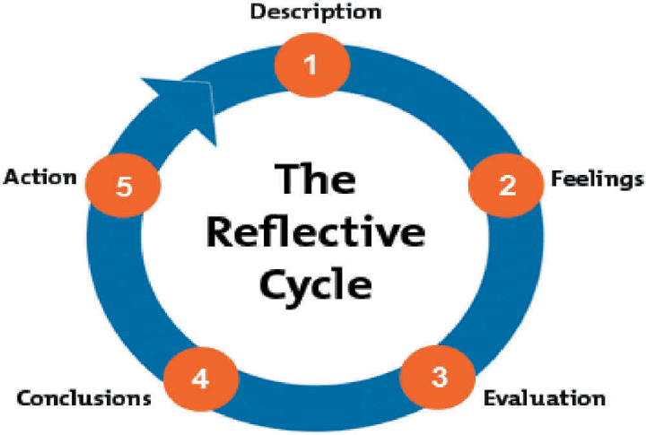

Figure: Gibbs reflective cycle (Mindtools, 2022).

Description

This cycle introduced within the paper to develop solution to mitigate issues while achieve richer understanding on leadership, change management, Corona virus challenges that retail has faced and all these elements were detrimental for me to resolve various issues in effective way. Hence, through this I have identified various leadership models, theories, approaches, styles and how to implement in challenging situation to get fruitful outcome (Gibbs et al, 2018).

Feelings

In this stage, my overall creative thinking flourished and recognised by me my strength and limitation regarding democratic, autocratic, transformational, integrated psychological approach, team oriented model etc and how these can be implemented to ensure best out of the employee during post pandemic era. Hence, this cycle is highly effective to resolute issues effectively (Gibbs et al, 2018).

Evaluation

At this stage, my inner skills are judged in oppose to theoretical and practical expertise as a result I am now fully capable to implemented new ideas and materials to ensure good outcome for large number of team such as increased safety, increased protection, high acceptance, values, ethics, new pricing for consumer, fulfilling changing demand and so on (Ellison, 2018).

Conclusion

In this stage its evident that, implementation of Gibbs reflective cycle catalyst for me as its amplified inner knowledge and skills how to manage team through effective leadership. With the help of this cycle, I can now follow step by step process to identify the issues mitigating the corporate growth (Fergusson et al, 2019).

Action plan

Through this cycle I have made myself capable to implement an effective action plan regarding leadership styles. Hence, my focus here, is to become more proactive while dealing with various situation, simplify problems, minimise potential challenges through various mode of leadership communication (Ellison, 2018).

References

BBC (2023). Sainsbury’s to raise pay to at least £11 per hour. (2023). BBC News. [online] 4 Jan. Available at: https://www.bbc.co.uk/news/business-64164486.

Clark, T. and Hazen, B. (2017). Business models for teams : see how your organization really works and how each person fits in. New York: Portfolio/Penguin.

Christos Pezirkianidis, Anastassios Stalikas and Panagiotis Parpottas (2023). An Integrated Positive Psychology Approach Into Counseling in Different Settings. Frontiers Media SA.

Ellison, C.M. (2018). Reflective make‐and‐take: a talent quest reflective practice teacher model. Reflective Practice, 9(2), pp.185–195.

Fergusson, L., van der Laan, L. and Baker, S. (2019). Reflective Practice and work-based research: a Description of micro- and macro-reflective Cycles. Reflective Practice, [online] 20(2), pp.289–303.

Gibbs, T., Brigden, D. and Hellenberg, D. (2018). Encouraging reflective practice. South African Family Practice, 47(7), pp.5–7.

MindTools (2022). Gibbs Reflective Cycle. [online] www.mindtools.com. Available at: https://www.mindtools.com/ano9qiu/gibbs-reflective-cycle. [Accessed 23/04/2023].

Grint, K. (2022). Leadership, incrementalism and the repetition of history: A Ukrainian tragedy in four acts. Leadership, Pp.17-19

Lussier, R.N. and Achua, C.F. (2019). Leadership : theory, application & skill development. 6th ed. Boston, Ma, Usa: Cengage Learning.

McElroy, J.C. (2019). Attribution Theory: A leadership Theory for Leaders. Leadership & Organization Development Journal, 3(4), pp.27–30.

Malloy, T. (2019). Nursing leadership style and psychosocial work environment. Journal of Nursing Management, 18(6), pp.715–725.

Northouse, P. (2016). Leadership: Theory and Practice. 9th ed. Los Angeles: Sage Publications.

Simpson, E. (2021). Sainsbury’s: Cost of Covid has been high. BBC News. [online] 28 Apr. Available at: https://www.bbc.co.uk/news/business-56912064. [Accessed 1 Sep. 2023].

Sainsbury's (2022). Our purpose. [online] about.sainsburys.k.u. Available at: https://about.sainsburys.kw/about-us.[Accessed 1 Sep. 2023].

Sainsbury's (2023) Colleague mental health and wellbeing. [online] Available at: https://www.about.sainsburys.co.uk/sustainability/plan-for-better/our-stories/2022/colleague-mental-health-and-wellbeing#:~:text=We%20adopt%20a%20holistic%20approach%20to%20wellbeing%2C%20centred [Accessed 1 Sep. 2023].

Pascal Pfähler (2017). Leadership Style and Communication. The Example of Larry Page. GRIN Verlag.

Sainsbury's (2023). Benefits. [online] Sainsbury’s Careers. Available at: https://sainsburys.jobs/working-for-us/benefits/. [Accessed 1 Sep. 2023].

Shin, Y., Kim, M. and Lee, S. (2016). Positive Group Affective Tone and Team Creative Performance and Change‐Oriented Organizational Citizenship Behavior: A Moderated Mediation Model. The Journal of Creative Behavior, 53(1), pp.52–68.

Spyridonidi, J. (2022). UNPRECEDENTED LEADERSHIP : learning to lead in turbulent times. S.L.: Springer Nature.

www.about.sainsburys.co.uk. (2023). Wellbeing Champion. [online] Available at: https://www.about.sainsburys.co.uk/sustainability/plan-for-better/our-stories/2021/wellbeing-story-esg.

www.about.sainsburys.co.uk. (2023). Sainsbury’s dials up digital, doubling capacity and extending delivery times. [online] Available at: https://www.about.sainsburys.co.uk/news/latest-news/2020/28-09-20-sainsburys-dials-up-digital.

