The Importance of Critical Thinking

https://uowtsd.sharepoint.com/teams/ECES4012SecuringSuccessfulStudySkills-SwanseaCohort_GRP-ScottRoberts/Shared%20Documents/Recordings/New%20channel%20meeting-20231024_162529-Meeting%20Recording.mp4?web=1

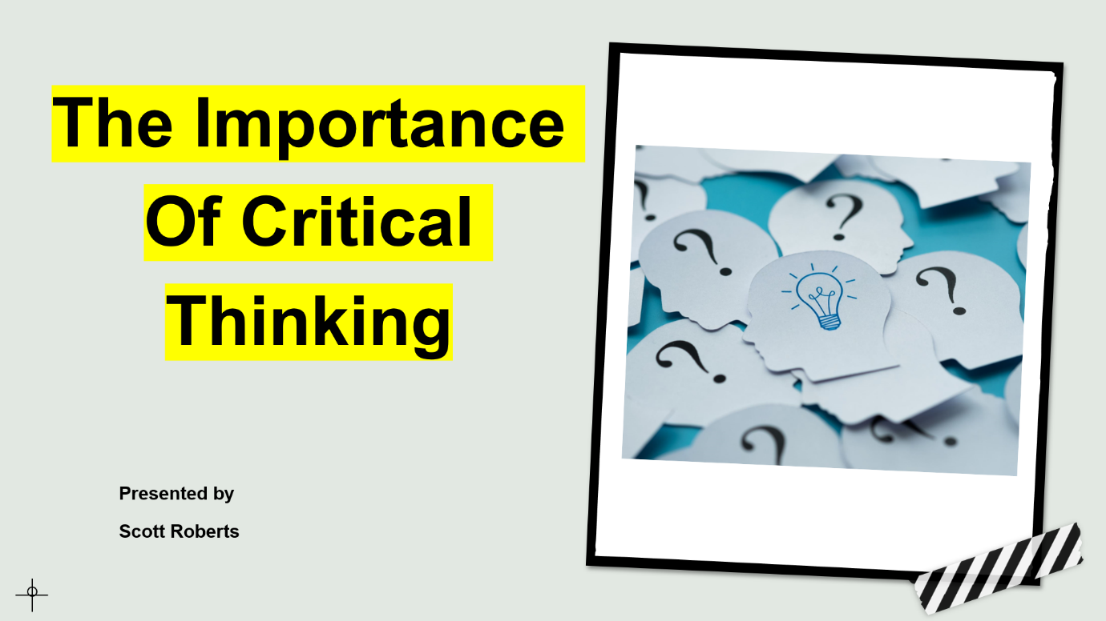

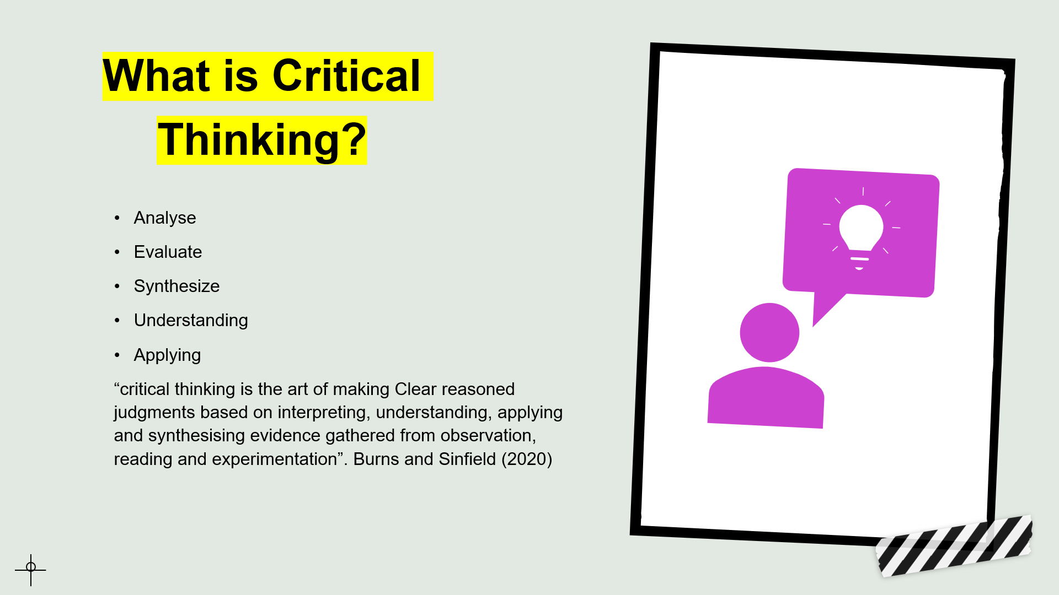
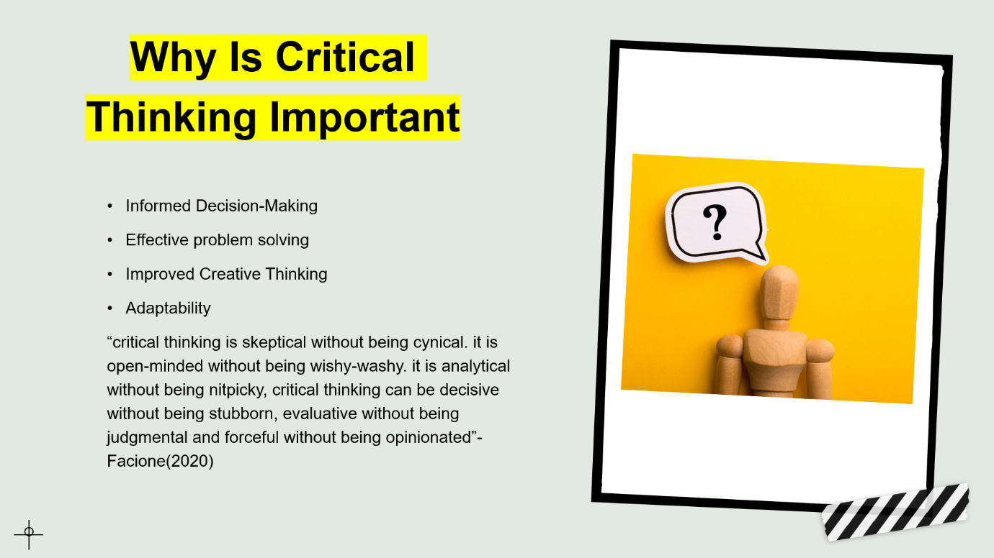

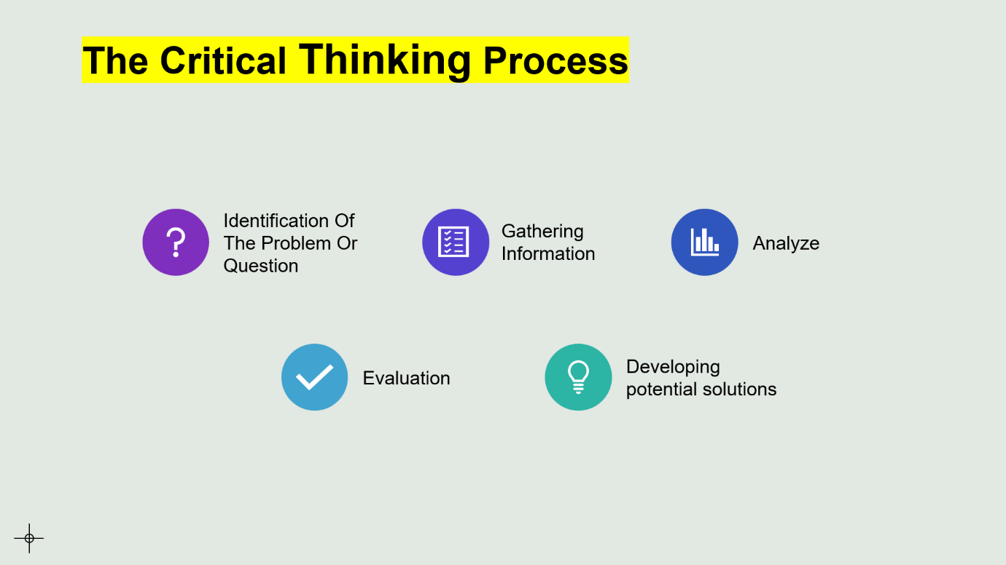
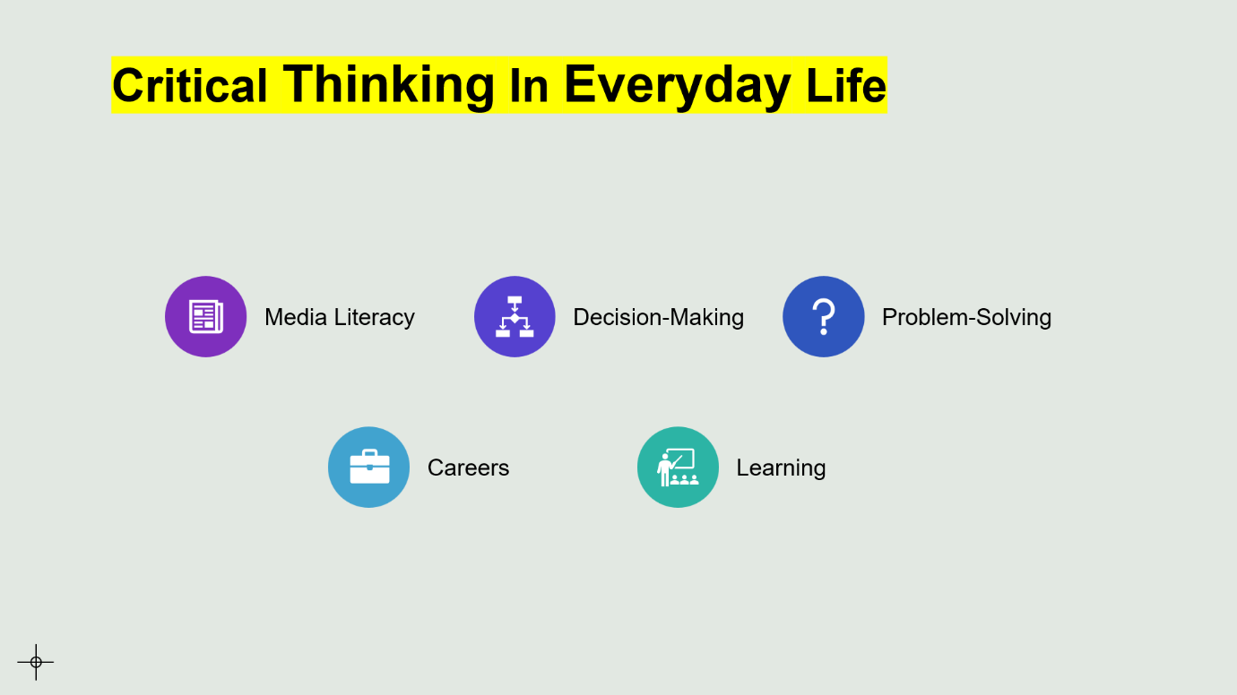

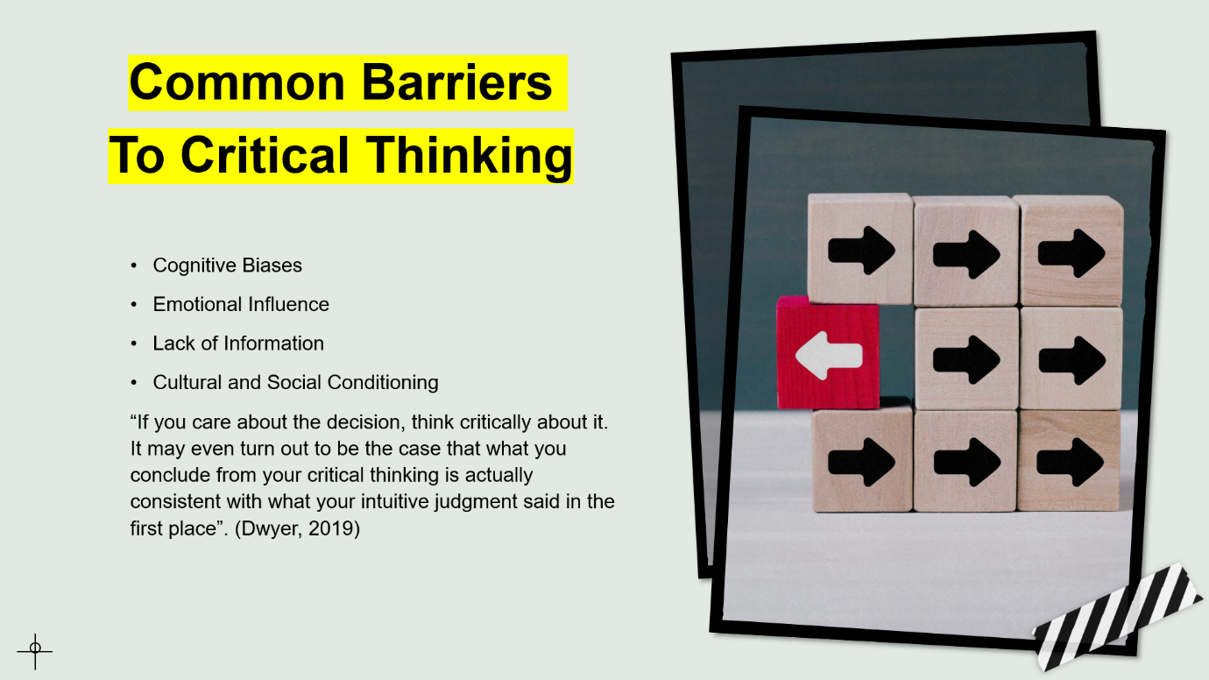
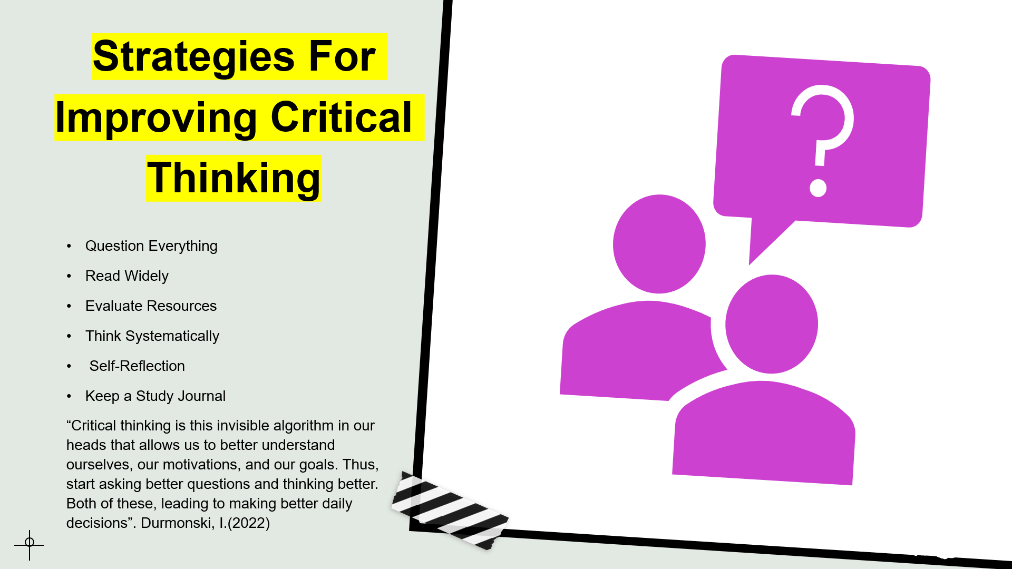

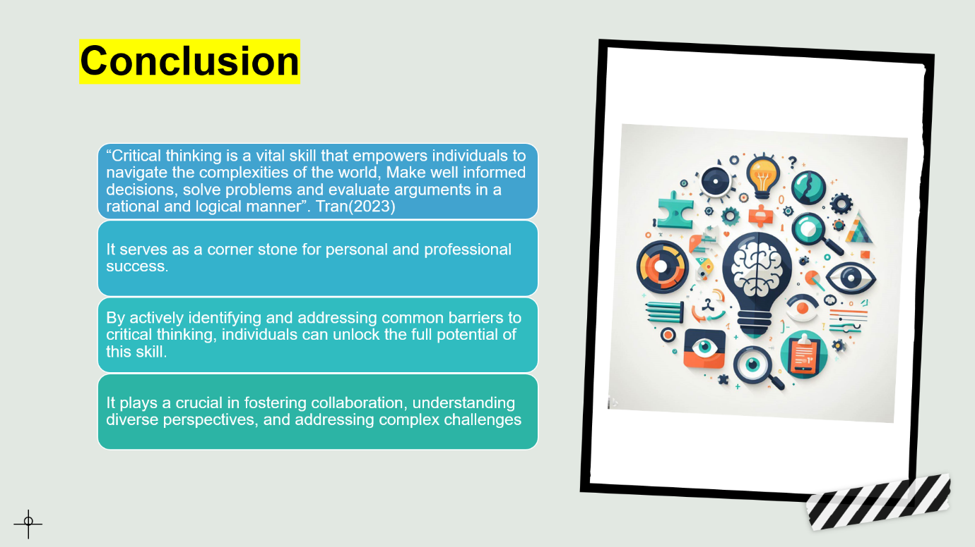
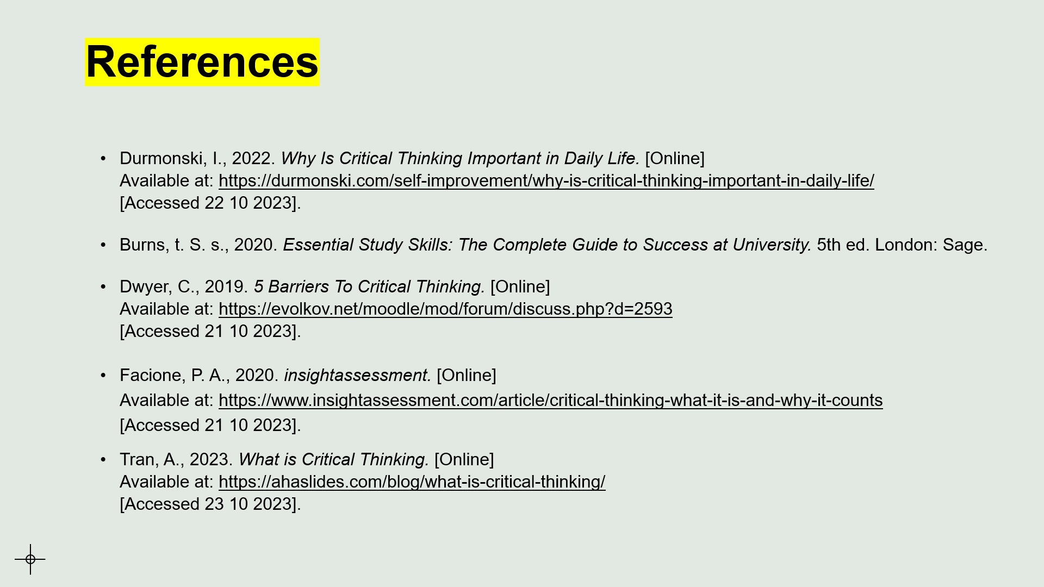

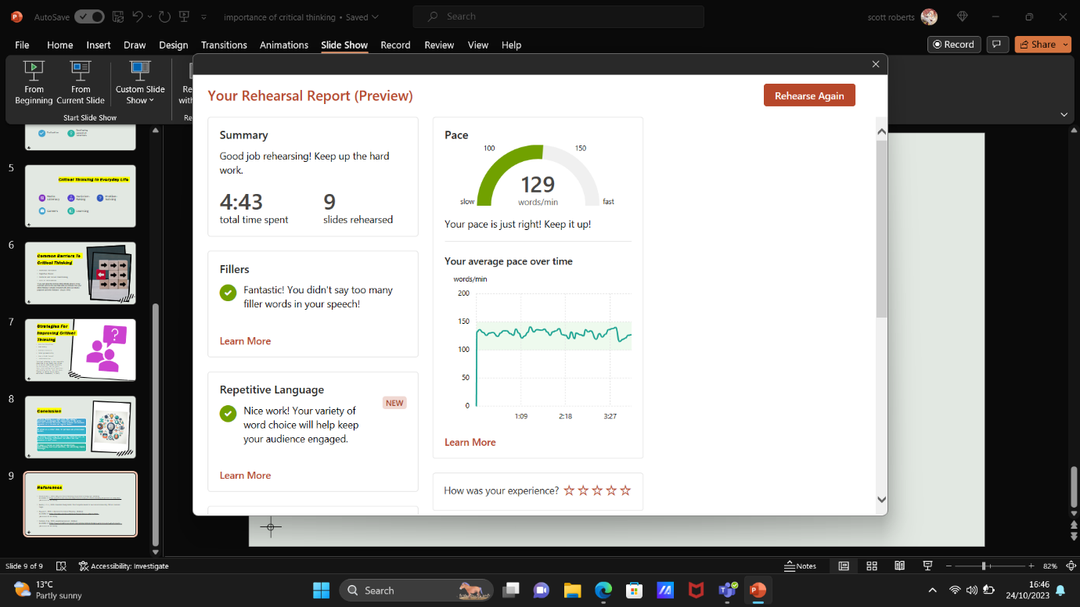
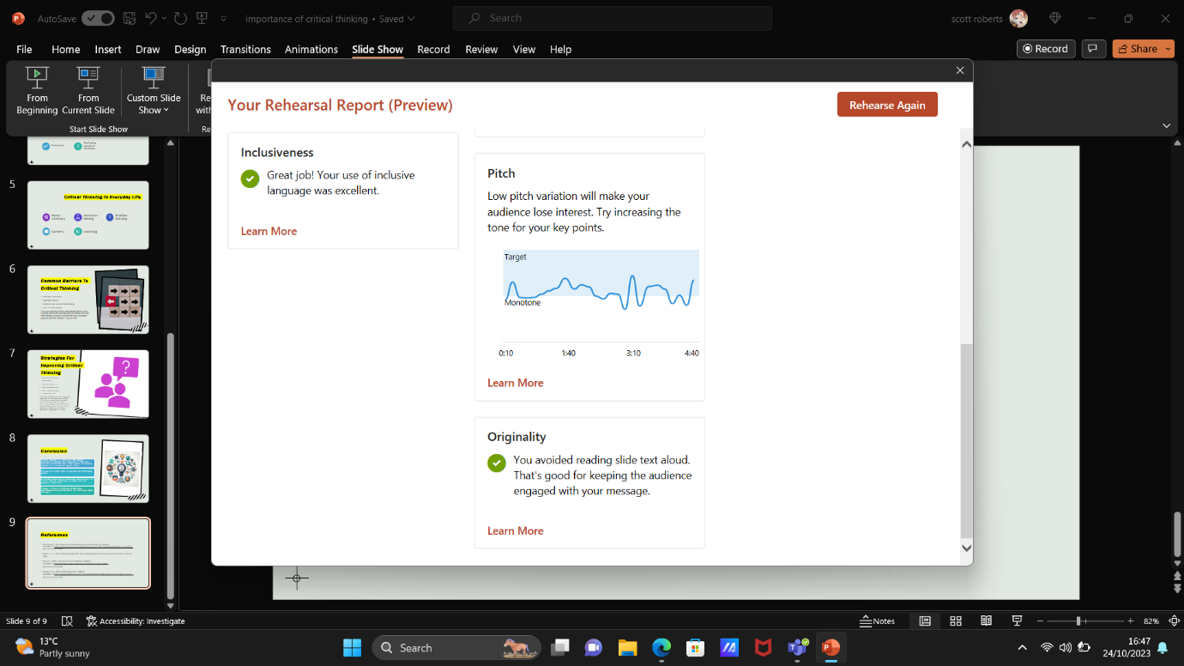

Reflective Piece

Critical thinking, the foundation of insightful decision-making and problem-solving, is a skill that carries immense importance in our daily lives. I recently had the opportunity to present a 5-minute PowerPoint presentation on the significance of critical thinking. While the content was clear in my mind, I faced numerous challenges during the process. In this reflective piece, I will delve into my journey of preparing and delivering this presentation, highlighting areas where I faced difficulty, anxiety, and room for improvement.
You can focus on areas for growth and progress by evaluating your strengths and shortcomings, as well as what you did well and poorly (Gupta, 2023).
Before diving into the presentation itself, it's essential to address the difficulties I encountered during the preparation phase. I found that organizing my thoughts and putting them into coherent sentences proved to be more challenging than I had anticipated. The large amount of information on critical thinking made me feel overwhelmed, causing some initial confusion. To tackle this issue, I decided to create a structured outline that helped me organize my ideas effectively. However, the initial struggle left me feeling anxious and somewhat apprehensive about my ability to convey the message clearly.
Periodically reflecting on ourselves is an essential aspect of our journey, allowing us to determine whether or not we are genuinely happy and pleased with our life, and if not, knowing that we can always take action to change that (Rebecca, 2023).
One of the key issues that hindered my performance during the presentation was nervousness and anxiety. Public speaking can be a daunting task, especially when discussing a subject as vital as critical thinking. The fear of judgment and the pressure to articulate my ideas clearly weighed heavily on me. These emotions led to a level of discomfort and anxiety that I had not anticipated. To overcome this challenge, I focused on implementing relaxation techniques, such as deep breathing and visualization, in the days leading up to the presentation. These practices helped me manage my anxiety to a certain extent.
It might be somewhat unsettling to speak in front of an audience. If you approach the exercise with the intention of giving, you'll become more relaxed, enjoy yourself, and influence your audience to the fullest. As is the case with anything, your presenting muscles will grow stronger the more speaking practise you receive. You'll soon be able to channel your nervousness into enthusiastic energy that will enable you to engage your audience in meaningful conversation (Riaz Meghji, 2021).
Additionally, I also encountered difficulties in maintaining a consistent and confident pitch throughout the presentation. It was clear to me that my nervousness had an impact on the tone and pacing of my speech. At times, I found myself speaking too quickly, trying to get through the material as fast as possible, while at other times, I would slow down, which could cause the audience to lose interest. Achieving a balanced, engaging pitch was indeed a challenge. One of the techniques I adopted to address this issue was rehearsing my presentation multiple times, focusing on the pacing and tone of my speech. Although I improved over time, it was evident that there was room for further growth.
Another significant challenge was the issue of stiffness. I realized that I appeared stiff and less engaging, which would make it difficult for the audience to connect with me and the topic. I needed to work on being more open and expressive, which would enhance the overall quality of my presentation. To counter this, I tried practicing in front of a mirror, trying to maintain a relaxed posture, maintain eye contact with my reflection, and use hand gestures to emphasize key points, but I found I was still lacking in being approachable and confident, I also found it difficult to use the hand gestures during the presentation because I had to change the slides whilst presenting my presentation.
Stumbling over words was yet another challenge that persisted throughout my preparation process. It was frustrating to practice and constantly get stuck on particular words or phrases. To overcome this, I focused on rehearsing with a trusted friend or family member, seeking their feedback and support. This external perspective was invaluable as they could point out areas where I stumbled and help me practice until I achieved fluency.
Despite these challenges, there were significant takeaway from this experience. The process of preparing and delivering this presentation allowed me to develop not only a deeper understanding of critical thinking but also valuable life skills such as resilience and perseverance. I learned that preparation and practice are the keys to combating anxiety and stumbling over words.
To become more educated in our decision-making and to enhance practise are the goals of reflection. In general, we desire to become more capable and productive in what we do. A lot of reflection is done to make sense of specific events - important experiences, perplexing situations - but contemplation can also begin with the desire to acquire a deeper understanding of ourselves (University of Edinburgh, 2019).
In conclusion, the journey of preparing and delivering a presentation on critical thinking was a personal growth experience. It highlighted my initial struggles with organizing my thoughts, managing anxiety, maintaining a confident pitch, and overcoming stiffness and word stumbling. While these challenges were real, they provided me with opportunities for self-improvement and learning. By addressing these difficulties head-on and utilizing effective strategies, I can continue to grow as a presenter and communicator. Public speaking remains a formidable challenge, but it is one that I am determined to conquer, thanks to this reflective journey.
You can see it more clearly and consider it from all angles, including advantages, disadvantages, and other crucial information that will enable you to reasonably decide what, if anything, you want to alter about it (Phillips-Waller, 2023).

References

Edinburgh, T. U. O., 2019. Reflectors Toolkit. [Online]
Available at: https://www.ed.ac.uk/reflection/reflectors-toolkit/self-awareness [Accessed 27,10,2023].

Gupta, S., 2023. The Importance of Self-Reflection: How Looking Inward Can Improve Your Mental Health. [Online]
Available at: https://www.verywellmind.com/self-reflection-importance-benefits-and-strategies-7500858 [Accessed 26,10,2023].

Meghji, R., 2021. Don't Let Anxiety Sabotage Your Next Presentation. [Online]
Available at: https://hbr.org/2021/07/dont-let-anxiety-sabotage-your-next-presentation [Accessed 28,10,2023].

Phillips-Waller, S., 2023. What is Self-Reflection And Why is it Important? [Online]
Available at: https://www.aconsciousrethink.com/10258/self-reflection/ [Accessed 26,10,2023].

Rebecca, 2023. 15 Essential Ways to Practice Self-Reflection. [Online]
Available at: https://www.minimalismmadesimple.com/home/self-reflection/ [Accessed 26,10,2023].

