Faculty of Applied Design

and Engineering

GROUP PROJECT BRIEF

Programme: | HND Motorsport/ Automotive Engineering
Module/Unit: | GROUP PROJECT
 |  | Lecturer: | Tim Tudor | Internal Verifier: | R. Dowden, A. Summerfield

Project Title: | MCR Front Suspension : Redesign

 | Grading Criteria
Pass: | Each objective has been satisfied reflecting the overall purpose of the skill areas and intended outcomes, and showing some ability to transfer knowledge within a skill area.
Merit: | All the specified objectives and out comes have been satisfied and some are well exceeded. The evidence reflects an ability to transfer skills knowledge and understanding to new situations with limited support.
Distinction: | All the specified objectives and out comes have been satisfied and the majority have been well exceeded. The evidence demonstrates extensive transfer skills knowledge in producing original and creative solutions to the tasks undertaken, with minimal tutor input and support.

- The MCR race car is being actively developed for the Sports 2000 race series.
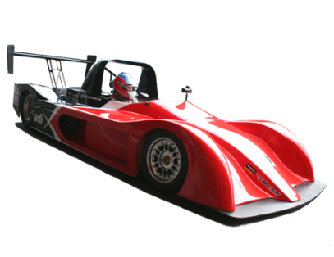
- Currently the car’s front suspension is difficult to adjust and access the dampers. The longitudinal rigidity of front suspension is also poor.

- The brief is that in groups of 5 students you are to:

- Research suspension layouts and requirements, and then critically review the current suspension system on the MCR race car.

- Redesign the front suspension to improve access and adjustability, whilst trying to reduce overall mass. You should also review the wishbone geometry to increase longitudinal ridgidity.

- Document and justify the project and designs

- The project/solution should:

  - Include a detailed time plan with tracking
  - Be designed to integrate with the chassis behind the front bulkhead (you may make significant modifications to the chassis forward of this bulkhead but only minor modifications rearward of this point, such as suspension mounts.)

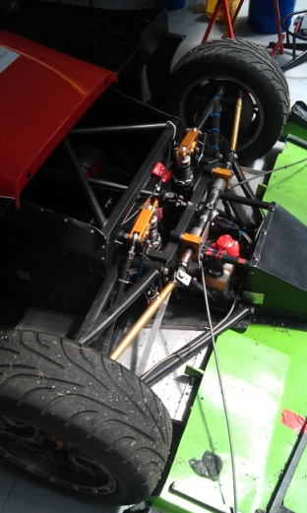
Front bulkhead

  - Be designed to complement the rear suspension system’s geometry
  - Be structurally sound given the car will corner at a maximum lateral acceleration of 2.0G. Proof calculations required.
  - Include justification of chosen geometry.
  - Include detailed designs for each component in the system along with manufacturing drawings.
  - Include a 3D assembly model to show the installed system. A 2D assembly drawing is also required.
  - Include material specifications and justifications for each component.
  - Include costings for the suspension system components and required modifications
  - Include a physical model (balsa wood or welding rod) of the suspension system.

- A more ambitious project may include:

  - An investigation into the effects and implications of rising/falling rate suspension and their influence on the overall vehicle balance.
  - An investigation into ways to make the suspension system adjustable so handling and/or tyre usage can be tuned. (e.g. adjustable Camber, Castor and roll centre)
  - Specification of spring and ARB rates, given a maximum body roll angle of 1 degree/G of cornering. You should aim for an initial load split balance of 50% but have the ability to alter this as track testing indicates.

- Each group will be allocated a project supervisor who you should meet with weekly.

- The groups should also meet without the supervisor at least once a week where minutes should be taken and progress reviewed.

- Assessments:

  - Initial Oral examination Viva 1 (10%) 5/12/2012
  - Initial Report (20%) 7/12/2012
  - Final Oral examination Viva 2 (20%) 10/5/2013
  - Final Report (50%) 17/5/2013

