Student Name: IANINA MARIA PANAITE

Student ID number: 2434312

Lecture name: ROOPA ARUVANAHALLI NAGARAJU

Module ENTERPRISE & ENTREPRENEURSHIP

Module code: LCLM 4006

Assignment title: BUSINESS PLAN COMPONENT 1

BUSINESS PLAN – ROMANIAN MINI-BAKERY

1. Executive Summary
The business plan is the development of a Romanian halal mini bakery within the city of Birmingham, UK. The proposed business, THE GRANDMOTHERS' BREAD, will focus on the traditional Romanian bakery products and deal in fresh bread, pretzels, and various sweet and savoury pastries. The products will be made daily and on site using original recipes and halal-certified ingredients. The bakery will take the form of a sole proprietorship, which will be run under the sole proprietorship of the owner. The proposed business will cater to the expanding Romanian and Eastern European community in Birmingham and the general population that values artisanal and halal products of the bakery. One of the impressive features of the business is its great social purpose: delivery of fresh bread to a hospital orphanage in the town every day. This project will enhance the relationship with the community and decrease food waste.
It is estimated that start-up capital of approximately £20,000-£25,000 will be needed, which will cover equipment rent, licences, initial inventory, and marketing. It will be funded using personal savings as well as a business bank loan. The business is hoping it will be stable in its operations in the first year and hopes to break even in 12-18 months.
The competitive strengths of the company are product authenticity, freshness of goods every day, halal status, and community involvement. The bakery has great prospects of long-term sustainability and slow growth with proper fiscal management and strategic marketing.

Table of Contents

- Executive Summary
- Overview of the Business Idea
- Market Research (PESTEL and Competition)
- Marketing Communications Strategy
- Financial Plan (Including CASH FLOW)
- Conclusion
- Reference List

2.Overview of the Business Idea

Name of the business: THE GRANDMOTHERS' BREAD.
The business proposed is a Romanian halal mini-bakery, which will be a small-scale production and sale unit in Birmingham. The principal idea is to merge the original tradition of Romanian baking with the halal-compatible kitchen practices that would provide high standards of fresh bread and pastries offered to the multicultural clientele. Besides running the business, the business will donate fresh bread every day to a local hospital or/and/or orphanage in Birmingham. This program will be included as part of the corporate social responsibility of the bakery on a long-term basis.
The donation programme will have various intentions. To begin with, it will help vulnerable people and make a positive impact on the local community. Secondly, it will help avoid waste of food by making sure that the future bread that is left after each production day is shared with people instead of being thrown away.
This social responsibility is in line with the current consumer demands, whereby customers are becoming more supportive of businesses that act ethically and have a sense of community. Since its inception, the bakery has positioned itself as a socially responsible local company.

The company's idea will be founded on three main pillars:
- A real Romanian halal bakery.
- Fiscal sustainability by institutional funding and cost management.
- Community assistance in the form of bread donations to the local institutions daily.

It is through the ability to combine the economic viability with the values created socially that the bakery will build a strong and ethical base on which long-term success can be built.

Products and Services
- Salt, Sesame, and Poppy Seed Pretzels.
- Romanian pastry: dessert and savoury pastry, croissants, and cake of the season.
- Events and holiday speciality and custom orders.
- Cheese or vegetable savoury pastries.

Management Structure:
- Management Structure:
- Firstly, there is a sole proprietorship where all the management is done by the owner.
- Functionalities: sales, customer service, production, and social donations.
- Potential future workforce: workers, part-time bakers, or delivery assistants, with a rise in demand.
- Legal Format
- It will be a sole-trader company.
This is a proper structure due to the following reasons:
- Simplicity of registration
- Fewer administrative tasks.
- Direct control over profits
- Reduced legal complexity

Management Structure
The business will be owner-managed in the initial stages. Responsibilities will include:
- Production management
- When the company expands, it could be a good time to shift into a limited company to minimise personal liability and the expansion.
Social Mission:
- The bakery will also deliver fresh bread to a local hospital or orphanage in Birmingham each day, which will enhance communication with the community and enhance corporate social responsibility.

Supplier negotiations
Financial planning
Marketing activities
Customer service
Part-time employees can be hired when the revenue stabilises. The initial cost control will be achieved by maintaining a lean organisational structure.
3. Market Research
The Eastern European and Romanian population of Birmingham is rather high, and it is one of the most diverse cities in the UK. The Romanian community is a solid niche market that demands home-based traditional products.

At present, the Romanian products are sold in mini-ethnic grocers primarily, although there are a few dedicated Romanian bakeries that are currently selling freshly made delicacies day in and day out. This presents an obvious gap in the market. Also, the British consumers are more and more interested in international cuisine, and that provides an opportunity outside of the Romanian community.

The compliance with food safety regulations, economic stability in daily food consumption, increasing interest in halal and authentic products, social media marketing, sustainable packaging, and legal food labelling standards are being pointed out in the PESTEL analysis.

Environmental Analysis (PESTEL)
Political: Adherence to the UK regulation of food, licensing by the Food Standards Agency, and hygiene inspections, as well as halal certification standards.
Economic: Birmingham is a diverse city whose demand for artisanal and ethnic food has expanded. The market potential is supported by increased consumer expenditure on speciality bakery products.
Social: There is an increasing demand for healthy, culturally authentic, and halal-certified products. The target consumers will be Romanian and Eastern European expatriates and the general community that will be interested in high-quality breads and pastries.
Technological: The promotion of products and contacting customers will be efficient with the help of social media sites, online ordering systems, and delivery apps.
Environmental: Sustainable practices involve packaging products in the most eco-friendly way, as well as minimising food waste by making social donations.
Laws: Compliance with food labelling laws, disclosure of allergens, employment laws (during the hiring process), and halal certification.

Competition Analysis
The competitors include big supermarkets and local artisan bakeries. Nevertheless, there are not many that sell true Romanian halal products.
Big chains of supermarkets – Tesco, Sainsbury's, and Lidl – sell mass-produced bakery products, but without Romanian flavour.
Local handcrafted bakeries specialise in British bread types: sourdough and baguettes; very few offer Romanian or halal products.
Competitive Advantage: Authentic Romanian recipes, halal-certified products, fresh daily production, and a social mission of giving out bread.
Supermarkets are price competitors, which are not authentic. Independent bakeries do not necessarily specialise in Romanian or halal products. This gives a niche opportunity.

.

4. Marketing Communications Strategy.
The bakery will be located as follows:
Residents
Families
Working professionals
Elderly customers
Nearby businesses
The brand image will be associated with Romanian culture and attract a multicultural audience.
Promotion Strategies.
Social media marketing (Facebook, Instagram) – Advertising in Romanian communities in Birmingham.
Cultural Branding – The focus on traditional Romanian identity in the branding, packaging, and store design.
Introduction of the Promotion – Discounts will be made in the first week.
Word-of-Mouth Marketing -Promotions to get customers to refer friends who are satisfied with the bakery.
Community Involvement – Publicity on daily bread donations to a hospital orphanage.
In the first step, low-cost digital marketing will be given priority in order to manage the spending.

Customer Relationship Strategy.

- Customer relationships will be developed by:
- In-store interaction with friends.
- Loyalty discounts
- Special holiday products

5. Financial Plan
5.1 Start-up Investment Requirements
Total funding required: £ 20,000 - £ 25,000
Funding Sources
- Personal saving
- Family support
- Small business loan if needed

Startup Costs (estimated)
Bakery oven and equipment £ 8,000
Rent deposit £ 3,000
Initial ingredients £ 2,000
First month rent £ 1,200
Licenses & insurance £ 1,000
Utilities setup £ 500
Marketing £ 500
Emergency reserve £ 4000

TOTAL £ 20,200

5.2 Monthly Operating Costs (estimated)
Rent £ 1,200
Utilities £ 400
Ingredients £ 2,000
Salaries ( 1 employee) £ 1,500
Insurance £ 150
Marketing £ 200
Miscellaneous £ 300
Donation cost £ 500
TOTAL £ 6,250

5.3 Estimated Monthly Revenue
Assumptions:
- Average of 120 customers per day
- Mean customer expenditure: £4.00.
- 30 days per month
Daily revenue: 120x £ 4=£ 480
Monthly revenue: £ 480x 30=£ 14,400

Monthly Profit Estimate
Monthly Revenue: £ 14,400
Monthly Expenses: £ 6,250

Estimated Gross Profit:
£ 14,400 - £ 6,250 = £ 8,150

5.4 Cash Flow (Table)
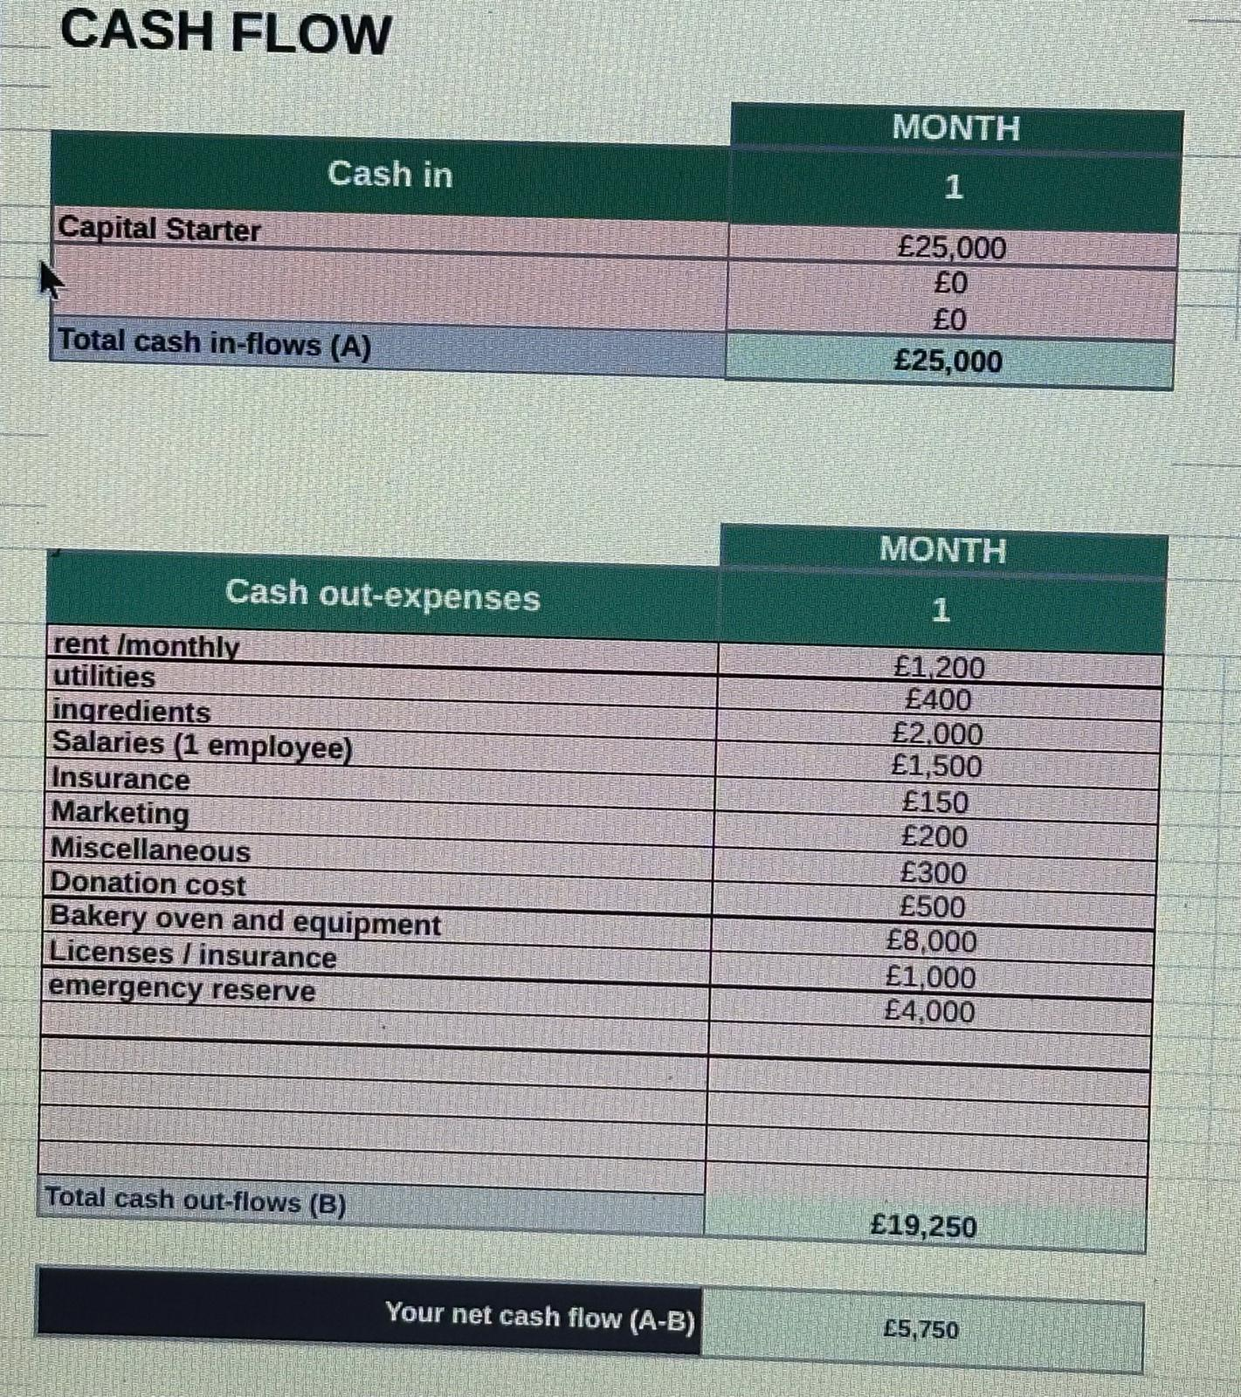
5.5 Cash Flow Forecast (first 6 months)
Month | Revenue (£) | Expenses (£) | Net cash Flow (£)
Month 1 | 10.000 | 7.000 | 3.000
Month 2 | 12.000 | 6.500 | 5.500
Month 3 | 14.000 | 6.250 | 7.750
Month 4 | 14.400 | 6.250 | 8.150
Month 5 | 15.000 | 6.500 | 8.500
Month 6 | 16.000 | 6.800 | 9.200

6.Social Responsibility Integration
The ethical positioning of the bakery is reinforced by the fact that they donate fresh Romanian bread on a daily basis. This initiative:
Reduces waste
Develops a good community image.
Enhances brand trust
Promotes loyalty among customers.
The social investment of the estimated monthly contribution of the donation cost of £500 is a strategic one.

Conclusion
The Romanian mini bakery in Birmingham is a viable, culturally differentiated business opportunity and a socially responsible business. This is an effective way of filling the gap in the market since the business targets original Romanian products and community outreach.
Having a startup capital of between 20.000 and 25.000 pounds, structured cost management, and steady demand among the Romanian population, the company can be said to have a high sustainable profitability potential.
The fusion of cultural integrity, quality services, and everyday charitable donations makes the bakery economically sustainable and socially influential in the economic context of the diverse marketplace in Birmingham.
Altogether, the combination of economic feasibility, cultural authenticity, and social impact shows that the Romanian mini bakery can be turned into a stable and reputable local business by means of financial control and attention to the quality of the products provided, as well as adherence to the mission that embraces the local community. This level of profitability and social responsibility makes the bakery a viable business enterprise and a significant member of the Birmingham community.
To look further past the establishment phase, the long-term development potential of the Romanian traditional mini bakery in Birmingham is still high. When brand recognition has grown and customer loyalty has been established, the business can consider strategic growth opportunities, such as product expansion, catering services at cultural events and communal gatherings, or the provision of Romanian grocery stores and local restaurants.

Reference List
Birmingham City Council (2024). Register a food business.
Food Standards Agency (2024). Food hygiene business.
Kotler, P. and Keller, K.L. (2016) Marketing management. 15 th edition
Mintel (2023) market report: UK bakery.
Porter, M.E. (1980). Competitive strategy: Industries and competitor analysis techniques. New York: Free Press.
Bakery products market revenue in the United Kingdom
The UK Government (2024) started as a sole trader

