Maurice Diakite
Student number : 2515416

Table of Contents

Abstract

1. Introduction

2. Company Overview

3. Threat Identification

4. Security Policies

5. Mitigation Measures

6. Network Monitoring and Incident Response

7. Staff Training and Awareness

8. Recommendations

9. Conclusion

References

Appendices

ABSTRACT

This report examines the cybersecurity risks affecting SteelForm Manufacturing Ltd, a medium-sized manufacturing company using IoT devices, automated machinery, and cloud-based systems.

The company manufactures components for the automotive and aerospace sectors. To improve its productivity, the company has adopted modern technologies such as the Internet of Things (IoT), automated machinery, and a cloud-based production management system.

However, this digital transformation has also increased the risk of cyberattacks. The company has recently faced several security incidents, including malware infections, phishing campaigns targeting procurement department staff, and unauthorised access attempts to the production network.

The objective of this report is to identify the main internal and external threats, assess the risks to which the company is exposed, and propose a comprehensive cybersecurity policy. The report also presents appropriate protection measures, an incident monitoring and response plan, as well as an employee awareness programme.

The implementation of these recommendations will strengthen the confidentiality, integrity, and availability of information systems while reducing the risks of production disruptions and data loss.

- INTRODUCTION

Cybersecurity has become one of the most important challenges facing modern organisations. The rapid adoption of Industry 4.0 technologies, including cloud computing, the Internet of Things (IoT), automation, and connected manufacturing systems, has significantly improved productivity and operational efficiency.

However, these technologies have also increased the number of cyber threats targeting industrial organisations.

Manufacturing companies are increasingly exposed to cyberattacks such as ransomware, phishing, malware infections, and unauthorised access. Successful attacks can interrupt production, compromise confidential information, damage an organisation's reputation, and cause significant financial losses.

This report focuses on SteelForm Manufacturing Ltd, a medium-sized manufacturing company that has recently experienced several cybersecurity incidents.

The purpose of this report is to identify the internal and external threats affecting the organisation, propose appropriate cybersecurity policies, recommend practical mitigation measures, develop a monitoring and incident response plan, and establish a staff training programme to improve the organisation's overall security posture.

- Company overview

A : Introduction To SteelForm

SteelForm Manufacturing Ltd is a medium-sized industrial company specialising in the production of custom metal components for the automotive and aerospace industries. To remain competitive and boost productivity, the company is actively investing in modern technologies that automate part of its manufacturing processes and enhance the overall quality of its services.

B : technologie in use

To modernise its operations, SteelForm relies on connected sensors (IoT), automated machinery, and a cloud-based production management system. These technologies enable real-time machine monitoring, fast information sharing across departments, and improved overall performance. However, this high level of connectivity also increases the company's exposure to cyberattacks, making robust security measures essential.

C : criticcal assets

SteelForm's key assets include its servers, employee workstations, production data, technical blueprints, industrial machines, IoT systems, cloud-based production management platform, as well as sensitive information about customers and suppliers. Protecting these assets is vital to ensure uninterrupted production, safeguard confidential information, and maintain the trust of business partners.

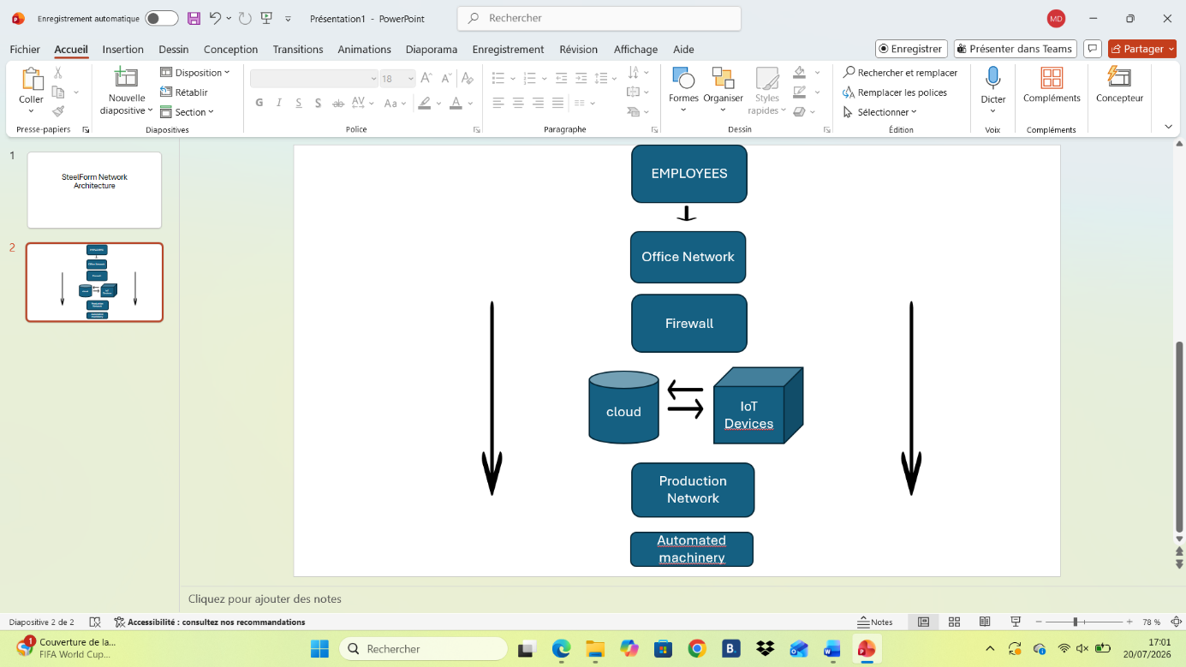

3. Threat Identification

3.1 Internal Threats

Internal threats often stem from within the organisation and can be just as damaging as external attacks

3.1.1 Human Error

Employees may inadvertently click malicious links, misconfigure systems, or share sensitive data. This is risky because even well-intentioned staff can create entry points for attackers, potentially leading to data leaks or system downtime that halts production lines at SteelForm

3.1.2 Weak Passwords

Simple or reused passwords make accounts easy to compromise. Consequences include unauthorised access to production controls or customer data, resulting in theft of blueprints or operational sabotage.

3.1.3 Malicious Insiders

Disgruntled employees or contractors with access could deliberately leak information or introduce malware. For SteelForm, this might mean the theft of proprietary manufacturing processes, causing competitive disadvantage.

3.1.4 Excessive Privileges

Users with more access rights than necessary increase the blast radius of any compromised account. A single breach could allow lateral movement across networks, disrupting automated machinery.

3.1.5 Misconfiguration

Incorrectly set up IoT devices or cloud services can expose systems. This could lead to unplanned downtime or data exposure in SteelForm’s connected production environment.

3.1.6 Unauthorised USB Devices

Plugging in personal or infected devices can introduce malware directly into the network, bypassing perimeter defences and potentially encrypting critical production files.

3.2 External Threats

3.2.1 Phishing

Attackers send deceptive emails to trick users into revealing credentials or downloading malware. Impact on SteelForm includes compromised executive accounts or initial access to OT systems.

3.2.2 Malware

Malicious software designed to damage or gain control of systems. It can spread rapidly through connected devices, disrupting automated production.

3.2.3 Ransomware

Encrypts data and demands payment. For a manufacturer, this could stop production lines, leading to missed deadlines and substantial revenue loss

3.2.4 Denial of Service (DoS)

Overwhelms systems with traffic. This could make cloud production platforms unavailable, halting order processing.

3.2.5 Industrial Espionage

State-sponsored or competitor-driven attacks aimed at stealing blueprints and processes. SteelForm could lose its technological edge.

3.2.6 Supply Chain Attacks

Compromising third-party vendors to infiltrate SteelForm’s network via trusted connections.

3.2.7 Cloud Attacks

Exploiting misconfigurations in cloud services to access production data.

3.2.8 IoT Attacks

Targeting vulnerable devices to gain footholds in OT networks, potentially manipulating machinery.

3.2.9 Brute-Force Attacks

Systematically guessing credentials, especially on remote access points or IoT interfaces.

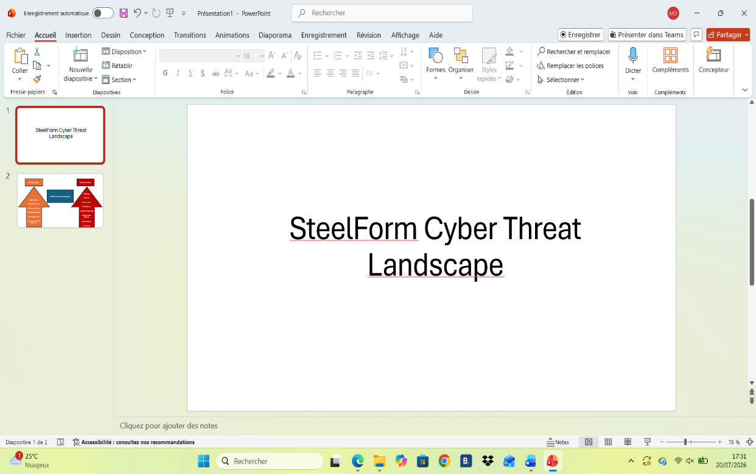

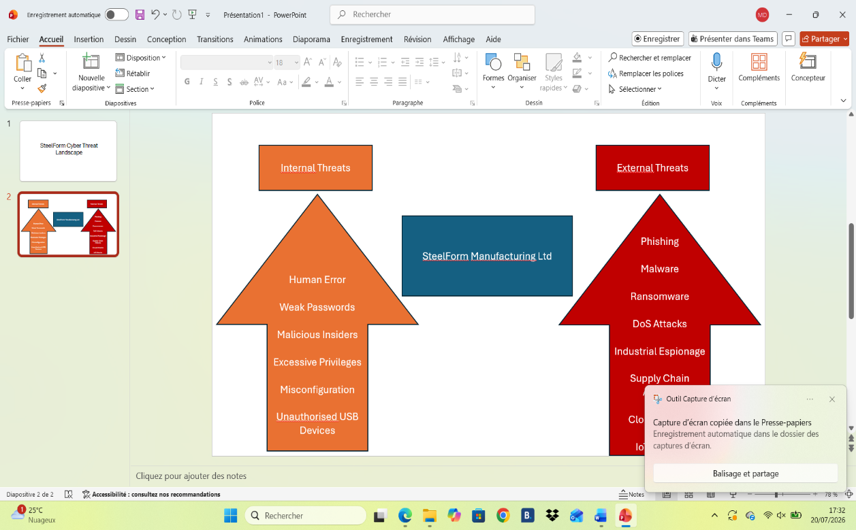

4.Security Policies

SteelForm should adopt the following policies: Password Policy Objective: Ensure strong, unique authentication. Importance: Weak credentials are a primary attack vector. Application: Enforce complexity, regular changes (or preferably passphrases), and lockouts after failed attempts; mandate password managers. Access Control Policy Objective: Limit access to the principle of least privilege. Importance: Reduces insider and lateral movement risks. Application: Role-based access (RBAC), regular reviews, and immediate revocation upon role changes. Acceptable Use Policy Objective: Define responsible use of company resources. Importance: Prevents accidental or intentional misuse. Application: Clear guidelines on internet use, USB devices, and personal software, with monitoring and disciplinary measures. Backup Policy Objective: Ensure data recoverability. Importance: Critical for ransomware recovery. Application: Regular automated offline and offsite backups with testing. Patch Management Policy Objective: Keep systems up to date. Importance: Closes known vulnerabilities quickly. Application: Scheduled testing and deployment, with emergency procedures for critical patches. Email Security Policy Objective: Protect against phishing and malware. Importance: Email remains the top delivery method for attacks. Application: Advanced filtering, user training, and reporting mechanisms. Remote Access Policy Objective: Secure connections from outside the office. Importance: Protects against external exploitation. Application: VPN with MFA and strict controls. Incident Response Policy Objective: Provide a structured response to incidents. Importance: Minimises damage and recovery time. Application: Defined roles, communication plans, and regular testing. Data Protection Policy Objective: Safeguard sensitive information. Importance: Ensures compliance and confidentiality. Application: Classification, encryption, and secure handling procedures.

5. Mitigation Measures

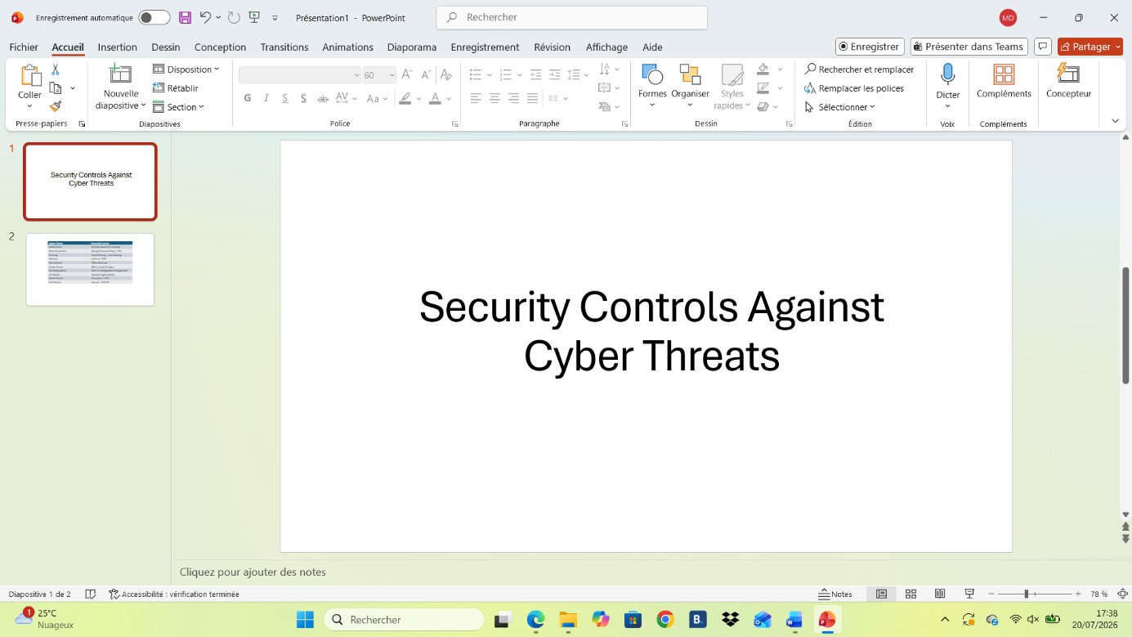

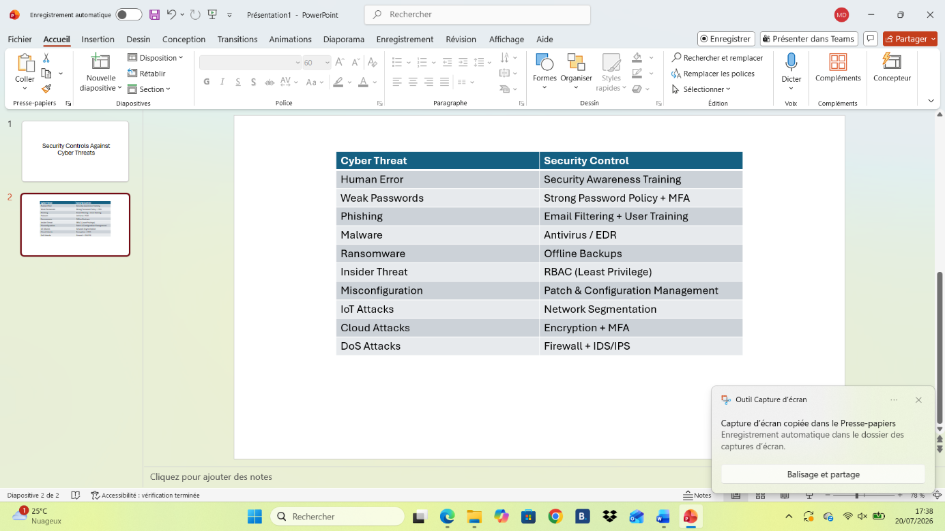

6. Network Monitoring and Incident Response

Effective monitoring is essential for early detection in a complex Industry 4.0 environment. Monitoring Tools:
• SIEM (Security Information and Event Management): Centralised log analysis.
• IDS/IPS (Intrusion Detection/Prevention Systems): Real-time threat detection.
• Firewall logs and Endpoint monitoring.
• Network monitoring tools tailored for OT/IoT traffic. Incident Response Process (can be visualised as a flowchart in Word):
Threat Detected → Alert Generated → Incident Analysed → Containment → Eradication → Recovery → Lessons Learned This cyclical process ensures rapid response and continuous improvement.

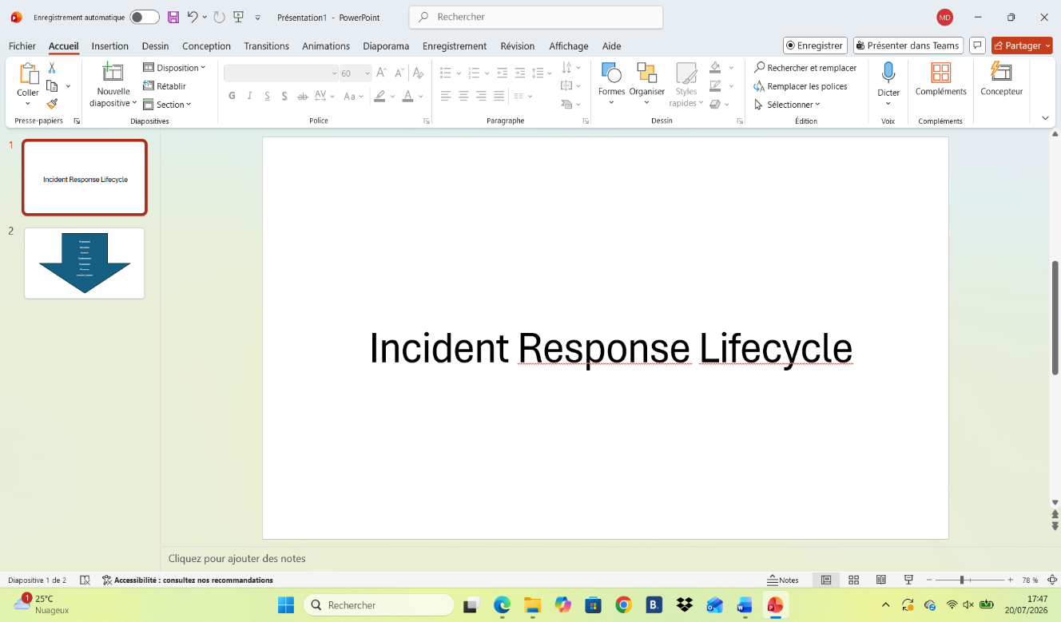

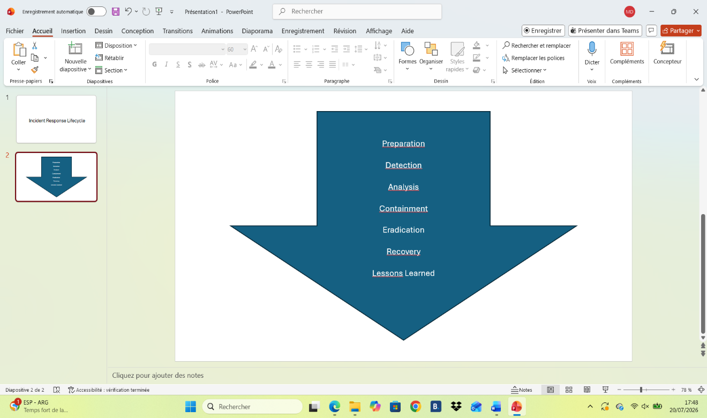

7. Staff Training and Awareness

A robust annual programme should include:

• New employees: Mandatory induction covering basic cybersecurity, strong passwords, and phishing recognition.
• Every 6 months: Simulated phishing exercises with feedback.
• Annually: Comprehensive refresher training.
• Ongoing topics: USB device policy, incident reporting procedures, data protection best practices, and secure remote working. Training should be engaging, with metrics to measure effectiveness.

8. Recommendations

1. Implement MFA across all accounts and systems.
2. Deploy a SIEM solution for centralised monitoring.
3. Establish secure offline backup procedures.
4. Segment IT and OT networks.
5. Roll out regular staff awareness programmes.
6. Enforce timely patch management.
7. Pursue ISO 27001 certification.
8. Regularly test and update the incident response plan.

9. Conclusion

SteelForm is vulnerable primarily because its adoption of interconnected Industry 4.0 technologies has outpaced its security controls, creating an expanded and complex attack surface involving IoT, cloud, and OT systems. The proposed policies and measures reduce risks by addressing both technical vulnerabilities and human factors through layered defences, proactive monitoring, and cultural change. These initiatives directly support the CIA Triad:
• Confidentiality via encryption and access controls.
• Integrity through monitoring and patch management.
• Availability via backups, segmentation, and incident response. By investing in these areas, SteelForm will not only protect its operations but also enhance resilience, regulatory compliance, and stakeholder trust, ensuring long-term business continuity and competitive strength in the digital manufacturing landscape. References

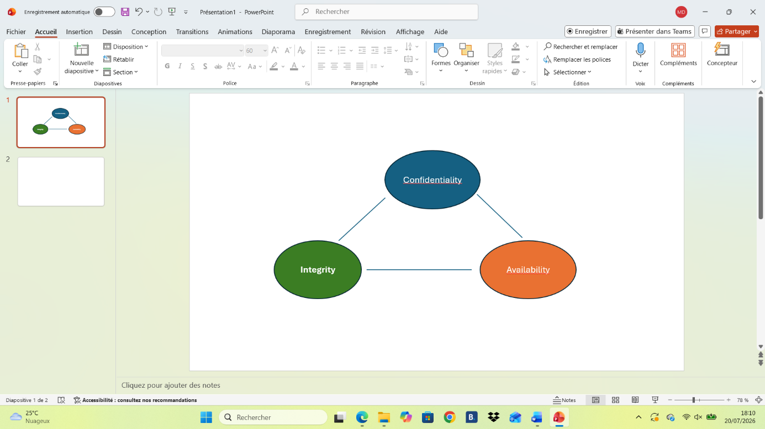

• NIST Cybersecurity Framework (various versions).
• ISO/IEC 27001:2022.
• NCSC (UK) Guidance on Phishing and Ransomware.
• CISA Industrial Control Systems Cybersecurity Resources.
• Additional academic and industry sources from Microsoft Security, Cisco, and recent publications on OT/IoT security. Appendix Include screenshots or exported slides from your 10-minute PowerPoint presentation here (e.g., threat overview, mitigation table, incident response flowchart, and training timeline). Ensure the slides are clean, visual, and support the key points of the report.

