Gao Yuxiang 2200441
ACCA7002 DATABASE SYSTEMS
Database Systems Course Report 2
Content
Abstract 2
1.0 Introduction and Development Status of NoSQL 3
1.1 Comparison of the different types of NoSQL databases 3
1.2 Document 3
1.3 Graph 4
1.4 Key-value 5
1.5 Wide column 6
2.0 NoSQL and traditional RDBMS database 6
3.0 Relational Database Implementation 7
3.1 SQL 7
3.2 JSON 13
4.0 Conclusion 18
Reference 20

Abstract
In this paper, four different NoSQL databases were compared, analyzing their data storage methods and characteristics, and listing some typical products. Furthermore, the characteristics of NoSQL and traditional RDBMS were compared from several perspectives, and the suitable scenarios for each were summarized. Finally, a relational database was implemented using SQL based on the business scenario, and a document database was implemented using JSON.[1]

Introduction and Development Status of NoSQL

1.1 Comparison of the different types of NoSQL databases
NoSQL (Not only SQL) refers to a class of database management systems that deviate from the traditional relational databases. In a broader sense, any database that does not follow the relational model can be categorized as NoSQL.[2]
NoSQL databases are designed with a focus on specific data models and have a flexible architecture to facilitate the development of modern applications. They employ various data models to access and manage data. These databases are optimized for use in applications that demand high data volumes, low latency, and flexible data models.[3] They achieve this by relaxing some of the data consistency constraints of other databases. This paper aims to compare four types of NoSQL databases: Document, Graph, key-value and wide column.[4, 5]

1.2 Document
Document-oriented databases are similar to relational databases in some ways. Data is stored in documents, which are similar to tables, and different types of documents can be stored in a single database or in a table-like structure within a database. Document-oriented databases can be schema-less, such as CouchDB and SimpleDB, or they can have flexible schemas, such as MongoDB.
Document-oriented databases store data in JSON or XML format. Different documents are organized in different ways, with some organizing them in collections, similar to how relational database tables organize rows into unordered sets. However, this is different from relational database tables, as rows in a relational table must have the same structure, while documents in a collection can have different structures.[6]
MongoDB is a document-oriented database system that shares some similarities with relational databases but not all features. MongoDB provides support for indexes and has its own query optimizer but does not support joins or ACID transactions. Similar to BigTable, writes on a document are atomic, akin to writes on a row in a relational database. MongoDB uses a publisher/subscriber architecture and employs range partitioning to horizontally scale.
In MongoDB, a document corresponds to a row in a relational database table and consists of many fields, which can be thought of as columns. Collections are groups of documents and are conceptually equivalent to tables in an RDBMS, but without enforcing a schema. Multiple collections are contained within a single database. The figure below illustrates the elements of an RDBMS structure and their counterparts in MongoDB.
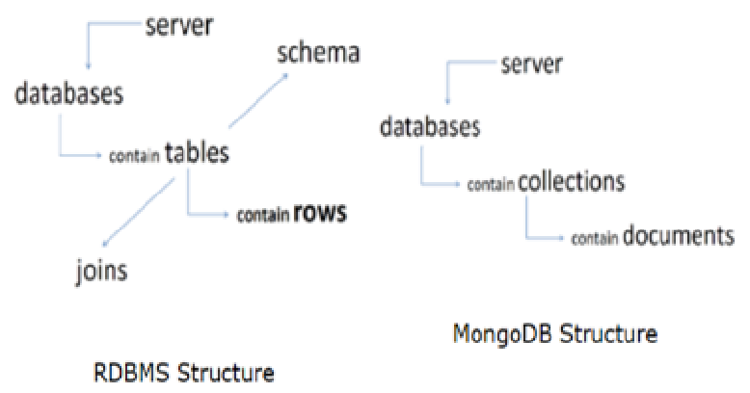
In a typical relational database management system (RDBMS) structure, a database consists of tables that contain rows. Tables implement a schema, which requires every row to contain the same fields with identical data types. When a value for a specific field is missing, NULL values may be inserted. A field in a row can only contain a single value, and joins can be used to locate data more efficiently.
In contrast, in the MongoDB structure, a database contains collections that store documents. Unlike RDBMS, MongoDB does not enforce a schema and allows for dynamic updates to fields within a document in a collection. This means that new fields can be added to a document without affecting the entire collection.

1.3 Graph
A graph database consists of nodes and relationships. Relationships are the core of a graph database and much of the value of a graph database comes from relationships. Graph databases use nodes to store data entities and use edges to store relationships between entities. Edges always have a start node, an end node, a type, and a direction, and edges can describe many kinds of relationships. A node can have an unlimited number of relationships. Social networks are a common example of a graph database, and the following diagram shows an example of a social network graph.[7]
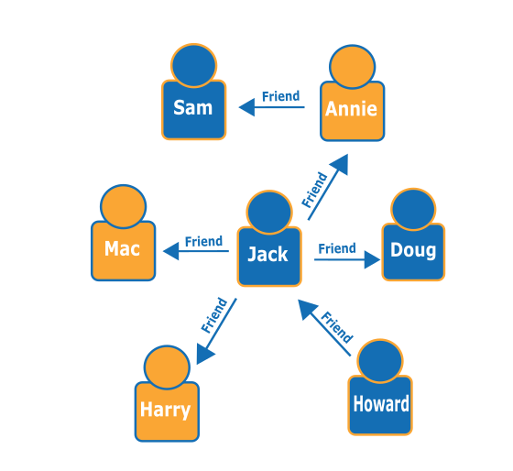
Graph databases are another recommended use case for applications. With a graph database, graph relationships can be stored between categories of information such as customer interests, friend recommendations, and purchase history. This allows for the provision of product recommendations to users or the identification of shared friends and offering friend recommendations.

1.4 Key-value
Key-value databases are a type of non-relational database that uses a simple key-value approach to store data. Data is stored as a collection of key-value pairs, where the key serves as a unique identifier. Both keys and values can range from simple objects to complex composite objects. Key-value databases are highly partitionable and allow for horizontal scaling at a scale that other types of databases cannot achieve. In the current application domain, the most popular product based on a key-value structure is Amazon's DynamoDB.
The following image shows an example of key-value structure in DynamoDB.
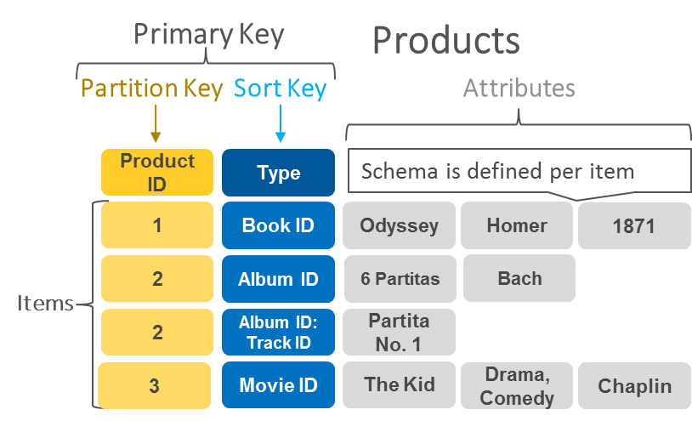
Key-value databases are commonly used for session storage, which is a classic use case. Session-based applications, such as web applications, start a session when a user logs in and keep it active until the user logs out or the session times out. During this time, the application stores all session-related data in main memory or a database. Session data may include user profile information, messages, personalized data, and themes, among others. Each user session has a unique identifier. Other than the primary key, no other key can query session data, making fast key-value storage more suitable for session data. Generally, key-value databases may incur less overhead than relational databases.

1.5 Wide column
Column-oriented data storage, also known as columnar DBMS or columnar database management system, stores data in columns instead of rows. This means that data from a certain column of all rows is stored together.
Columnar databases are capable of handling large amounts of data queries and are highly scalable. They are popular in big data analytics and data warehousing. A typical product for columnar storage databases is Apache Cassandra.

2.0 NoSQL and traditional RDBMS database
After analyzing and comparing the characteristics of NoSQL and relational databases, it is apparent that they have different data structures.
- Relational databases have a fixed structure, consisting of two-dimensional tables for data storage, where each table requires pre-defined rows and columns.
- In contrast, NoSQL databases have flexible data structures, such as graph relationships, node structures, key-value, document, and wide columns.
Due to the differences in data structure, data querying methods also differ. Relational databases utilize SQL language to query data, while NoSQL databases support their corresponding query language or API interfaces to query data.
Regarding data integrity and consistency, relational databases support transactions and have ACID properties, ensuring data consistency. In contrast, NoSQL databases generally only support CAP properties and do not support transactions, thus cannot guarantee data integrity and consistency.
In terms of processing large-scale data, relational databases have a challenging scaling process, resulting in potential performance bottlenecks when dealing with large amounts of data. NoSQL databases have strong scalability, allowing for efficient read/write and storage of large amounts of data through horizontal scaling.[8]

3.0 Relational Database Implementation

3.1 SQL
drop table if exists regUser cascade ;
drop table if exists assetAuthor cascade;
drop table if exists assetGenre cascade;
drop table if exists discountCodes cascade;
drop table if exists digitalAsset cascade ;
drop table if exists userTransaction;

create table regUser(
userId serial primary key,
userFname varchar(25),
userLname varchar(25),
userAddr varchar(145),
telNumber varchar(12),
joinDate date
);

create table assetAuthor(
authorId serial primary key,
authorFname varchar(25) not null,
authorLname varchar(25) not null
);

create table assetGenre(
genreId serial primary key,
genreName varchar(35) not null
);

create table discountCodes(
discountCode varchar(2) primary key,
discount numeric(5,2)
);

create table digitalAsset(
assetId serial primary key,
assetTitle varchar(55) not null,
authorId int,
genreId int,
publisher varchar(30),
releaseDate date,
originalPrice numeric(8,2),
stockAmt int,
blob text
);

create table userTransaction(
userId int,
assetId int,
discountCode varchar(2),
purchaseDate date,
primary key (userId, assetId)
);

alter table digitalAsset add constraint fk_authorid foreign key (authorId) references assetAuthor(authorId);
alter table digitalAsset add constraint fk_genreid foreign key (genreId) references assetGenre(genreId);
alter table userTransaction add constraint fk_userid foreign key (userId) references regUser(userId);
alter table userTransaction add constraint fk_assetid foreign key (assetId) references digitalAsset(assetId);
alter table userTransaction add constraint fk_discount foreign key (discountCode) references discountCodes(discountCode);

-- every user has a unique telnumber, so create an unique index
create unique index uni_telphone on regUser(telNumber);

-- create unique index on assetgenre
create unique index uni_genre on assetGenre(genreName);

-- create unique index on discountcodes
create unique index uni_discount on discountCodes(discount);

-- create index on usertransaction
create index index_purchase on userTransaction(purchaseDate);

insert into reguser values (1, 'domingus', 'Cotton', '1010 Street London', '18911663172', '2013-02-01');
insert into reguser values (2, 'jehiah', 'Macadam', '1002 Street New York', '13552466268', '2014-02-01');
insert into reguser values (3, 'ashleigh', 'Clinton?', '1202 Street Oxford', '4009607969', '2015-02-01');
insert into reguser values (4, 'fentress', 'George', '2000 Limbaugh Blvd Childersburg', '66583002', '2016-02-01');
insert into reguser values (5, 'forgione', 'Rodriguez', '101 Street New York', '4513517024', '2017-02-01');
insert into reguser values (6, 'exner', 'Miller', '123 Street Oxford', '4517438291', '2018-02-01');
insert into reguser values (7, 'mcgarvey', 'Rodriguez', '201 Street New York', '64165678091', '2019-02-01');
insert into reguser values (8, 'delaura', 'Garcia', '131 Street London', '64104068711', '2020-02-01');
insert into reguser values (9, 'mehrtens', 'Brown', '129 Street Boston', '17050269478', '2021-02-01');
insert into reguser values (10, 'hilmoe', 'Williams', '1024 Street New York', '85268895823', '2022-02-01');

insert into assetauthor values (1, 'Mark ', 'Twain');
insert into assetauthor values (2, 'Leo ', 'Tolstoy');
insert into assetauthor values (3, 'Victor ', 'Hugo');
insert into assetauthor values (4, 'Charles ', 'Dickens');
insert into assetauthor values (5, 'Charlotte ', 'Bronte');
insert into assetauthor values (6, 'Emily ', 'Bronte');
insert into assetauthor values (7, 'Jane ', 'Austen');
insert into assetauthor values (8, 'Thomas ', 'Hardy');
insert into assetauthor values (9, 'Alexandre Dumas ', 'Pere');
insert into assetauthor values (10, 'Alexandre Dumas ', 'fils');
insert into assetauthor values (11, 'Lewis ', 'Carroll');
insert into assetauthor values (12, 'Daniel ', 'Defoe');
insert into assetauthor values (13, 'Theodore ', 'Dreise');
insert into assetauthor values (14, 'Emile ', 'Zola');
insert into assetauthor values (15, 'Jack ', 'London');
insert into assetauthor values (16, 'Nathaniel ', 'Hawthorne');
insert into assetauthor values (17, 'Robert Louis', 'Stevenson');
insert into assetauthor values (18, 'Jules ', 'Verne');
insert into assetauthor values (19, 'James ', 'Joyce');

insert into assetgenre values (1, 'Science');
insert into assetgenre values (2, 'Math');
insert into assetgenre values (3, 'Economic');
insert into assetgenre values (4, 'Novel');
insert into assetgenre values (5, 'Classic');
insert into assetgenre values (6, 'Horror');
insert into assetgenre values (7, 'History');
insert into assetgenre values (8, 'Children');
insert into assetgenre values (9, 'Work');
insert into assetgenre values (10, 'Speeches');

insert into digitalasset values (1, 'The Adventures of Tom Sawyer', 1, 3, 'HarperCollins Publisher', '2021-01-01', '39.80', 200, NULL);
insert into digitalasset values (2, 'War And Peace', 2, 3, 'Associated Book Publisher', '2008-02-01', '42.88', 200, NULL);
insert into digitalasset values (3, 'Les Miserables', 3, 4, 'Longman Group Ltd', '2017-07-01', '29.99', 200, NULL);
insert into digitalasset values (4, 'A Tale of Two Cities', 4, 7, 'Macmillan Publisher', '2020-02-01', '33.44', 200, NULL);
insert into digitalasset values (5, 'Jane Eyre', 6, 5, 'Oxford Press', '2022-10-01', '40.80', 200, NULL);
insert into digitalasset values (6, 'Wuthering Heights', 8, 6, 'New York Publisher1', '2015-05-01', '28.98', 300, NULL);
insert into digitalasset values (7, 'Pride And prejudice', 9, 2, 'National Publisher', '2008-08-01', '35.55', 100, NULL);
insert into digitalasset values (8, 'Tess of the D''Urbervilles', 5, 1, 'Centre Publisher', '2005-05-01', '43.43', 100, NULL);
insert into digitalasset values (9, 'The Count of Monte Cristo', 9, 8, 'Macmillan Publisher', '2012-12-01', '29.09', 200, NULL);
insert into digitalasset values (10, '?Robison Crusoe', 4, 9, 'Centre Publisher', '2004-04-01', '38.83', 200, NULL);

insert into discountcodes values ('C1', '0.90');
insert into discountcodes values ('C2', '0.85');
insert into discountcodes values ('C3', '0.80');
insert into discountcodes values ('C4', '0.78');
insert into discountcodes values ('C5', '0.50');
insert into discountcodes values ('C6', '0.66');
insert into discountcodes values ('C7', '0.60');
insert into discountcodes values ('C8', '0.55');
insert into discountcodes values ('C9', '0.99');
insert into discountcodes values ('C0', '1.00');

insert into usertransaction values (1, 2, 'C3', '2023-02-04');
insert into usertransaction values (2, 4, 'C6', '2023-02-08');
insert into usertransaction values (3, 6, 'C9', '2023-02-19');
insert into usertransaction values (4, 8, 'C2', '2023-02-16');
insert into usertransaction values (5, 1, 'C5', '2023-02-05');
insert into usertransaction values (6, 3, 'C1', '2023-02-01');
insert into usertransaction values (7, 5, 'C7', '2023-02-17');
insert into usertransaction values (8, 7, 'C4', '2023-02-24');
insert into usertransaction values (9, 9, 'C8', '2023-02-18');
insert into usertransaction values (1, 8, 'C5', '2023-02-10');
insert into usertransaction values (2, 3, 'C2', '2023-02-05');
insert into usertransaction values (3, 7, 'C9', '2023-02-07');

3.2 JSON
{
"digits_assets": [

{
"asset": {
"assetid": "1",
"assettitle": "The Adventures of Tom Sawyer",
"authors": [

{
"authorid": "1",
"authorfname": "Mark ",
"authorlname": "Twain"
},
{
"authorid": "2",
"authorfname": "Leo ",
"authorlname": "Tolstoy"
}
],
"genre": "Science",
"publisher": "HarperCollins Publisher",
"releasedate": "1/1/2021",
"originalprice": "39.8",
"stockamt": "200",
"blob": "",
"users": [{
"userid": "1",
"userfname": "domingus",
"userlname": "Cotton",
"useraddr": "1010 Street London",
"telnumber": "18911663172",
"joindate": "1/2/2013",
"purchasedate": "4/2/2023"
}, {
"userid": "2",
"userfname": "jehiah",
"userlname": "Macadam",
"useraddr": "1002 Street New York",
"telnumber": "13552466268",
"joindate": "1/2/2014",
"purchasedate": "4/2/2023"
}]
},
"discountcode": "C3"

},
{
"asset": {
"assetid": "4",
"assettitle": "A Tale of Two Cities",
"authors": [{
"authorid": "5",
"authorfname": "Charlotte ",
"authorlname": "Bronte"
}],
"genre": "Economic",
"publisher": "Macmillan Publisher",
"releasedate": "1/2/2020",
"originalprice": "33.44",
"stockamt": "200",
"blob": ""
},
"users": [{
"userid": "2",
"userfname": "jehiah",
"userlname": "Macadam",
"useraddr": "1002 Street New York",
"telnumber": "13552466268",
"joindate": "1/2/2014",
"purchasedate": "8/2/2023"
}],
"discountcode": "C6"

},
{

"asset": {
"assetid": "7",
"assettitle": "Pride And prejudice",
"authors": [{
"authorid": "1",
"authorfname": "Mark ",
"authorlname": "Twain"
},
{
"authorid": "2",
"authorfname": "Leo ",
"authorlname": "Tolstoy"
}
],
"genreid": "Children",
"publisher": "National Publisher",
"releasedate": "1/8/2008",
"originalprice": "35.55",
"stockamt": "100",
"blob": ""
},
"users": {
"userid": "3",
"userfname": "ashleigh",
"userlname": "Clinton?",
"useraddr": "1202 Street Oxford",
"telnumber": "4009607969",
"joindate": "1/2/2015",
"purchasedate": "19/2/2023"
},
"discountcode": "C9"
},

{
"asset": {
"assetid": "10",
"assettitle": "Robison Crusoe",
"authors": [{
"authorid": "5",
"authorfname": "Charlotte ",
"authorlname": "Bronte"
}],
"genreid": "Speeches",
"publisher": "Centre Publisher",
"releasedate": "1/4/2004",
"originalprice": "38.83",
"stockamt": "200",
"blob": ""
},
"user": [{
"userid": "5",
"userfname": "forgione",
"userlname": "Rodriguez",
"useraddr": "101 Street New York",
"telnumber": "4513517024",
"joindate": "1/2/2017",
"purchasedate": "5/2/2023"
},
{
"userid": "6",
"userfname": "exner",
"userlname": "Miller",
"useraddr": "123 Street Oxford",
"telnumber": "4517438291",
"joindate": "1/2/2018",
"purchasedate": "5/2/2023"
}, {
"userid": "4",
"userfname": "fentress",
"userlname": "George",
"useraddr": "2000 Limbaugh Blvd Childersburg",
"telnumber": "66583002",
"joindate": "1/2/2016",
"purchasedate": "5/2/2023"
}
],

"discountcode": "C5"

}

]

}

4.0 Conclusion
Relational and non-relational databases are two different types of databases with some differences between them.
Relational databases use tables to organize data and use SQL (Structured Query Language) to query and manipulate data. Their data models are very normalized and have an enforced schema, which makes them great for working with structured data and dealing with relationships between data. Relational databases usually have stricter consistency and transaction guarantees to ensure data consistency and reliability. However, they can have performance bottlenecks when handling large data volumes and are difficult to scale to multiple nodes.
Non-relational databases (NoSQL) use different data models, such as document type, graph type, key-value type, wide column type, etc. These databases can better handle unstructured and semi-structured data, have better scalability and performance, and are therefore ideal for handling large-scale data. However, the query languages of NoSQL databases are usually more complex and may not have the strict consistency guarantees associated with ACID transactions, which means that in some cases there may be a risk of data inconsistency.[9]
In general, both relational and non-relational databases have advantages and disadvantages, and which one to choose depends on the needs of the application. If the application needs to process large amounts of structured data and requires strict consistency guarantees, a relational database may be a better choice. And if the application needs to process large amounts of unstructured data and requires better scalability and performance, a non-relational database may be a better choice. When choosing a database, developers should make an informed decision based on the needs of their application, taking into account the various advantages and disadvantages.

Reference
[1] S. Liu and X. Ma, Advanced Hybrid Information Processing: 5th EAI International Conference, ADHIP 2021, Virtual Event, October 22-24, 2021, Proceedings, Part II. Springer Nature, 2022.
[2] A. Di Meglio and M. Manca, "From big data to big insights: The role of platforms in healthcare IT," in New Perspectives in Medical Records: Springer, 2017, pp. 33-47.
[3] N. Phaphoom, X. Wang, and P. Abrahamsson, "Foundations and technological landscape of cloud computing," International Scholarly Research Notices, vol. 2013, 2013.
[4] C. Ji et al., "Big data processing: Big challenges and opportunities," Journal of Interconnection Networks, vol. 13, no. 03n04, p. 1250009, 2012.
[5] M. S. Punia, K. Malik, and V. K. Garg, "Partitioning based multi-persistence model for multi-paradigm database," Measurement: Sensors, vol. 25, p. 100594, 2023.
[6] X. Deng et al., "Geospatial big data: New paradigm of remote sensing applications," IEEE Journal of Selected Topics in Applied Earth Observations and Remote Sensing, vol. 12, no. 10, pp. 3841-3851, 2019.
[7] H. Han and P. Zhang, "Construction of Machine News Production System Based on Graph Database and Natural Language Generating Technology," in 2018 5th International Conference on Information Science and Control Engineering (ICISCE), 2018: IEEE, pp. 171-175.
[8] K. Wang and J. Bruch Jr, "A SOR iterative algorithm for the finite difference and the finite element methods that is efficient and parallelizable," Advances in Engineering Software, vol. 21, no. 1, pp. 37-48, 1994.
[9] S. HENDRIANI, "Turnitin World Journal on Educational Technology: Current Issues," 2022.

