
public health policy bmhp5013_birm
COVID-19 Report

NAME: FERDOWS JAHAN JESI
STUDENT NUMBER: 1810819
TUTOR NAME: BESTY JOSE

Contents
Introduction 2
Model and Theory of health behaviour change 2
Health Belief Model 2
COVID-19 3
Symptoms 3
How to protect yourself from COVID-19 3
COVID-19 Issues Identified on BAME Group 3
Public Health Strategies for surveillance 4
COVID-19 Policy 6
National Lockdown 6
Social distancing 6
Closing certain business and venues 6
Impact of the policies 7
Prominent Clinical potential vaccines 7
Recommendations 8
Conclusion 8
References 9

Introduction
This assignment will give a brief about COVID-19 and its effects on the public health. Model of the health behaviour change, Health Belief Model, and the people responses of using this model in COVID-19. This report will give a description about some issues we Identified in the group presentation. In this report there will be some strategies that used to monitor, measure and control COVID-19 and its effects. This report will also, explain few public health policies which will help to reduce the effects of COVID-19, how to control the infection rate and how these policies are changes people lifestyle. The impact of law and policies on our chosen group which is BAME group. How UK government is helping and supporting to control the effects on COVID-19 research. To control COVID-19 effects on public health which protuberant vaccines trials recently conducted in the UK. To improve how to control the COVID-19 effects, there will be few recommendations on our target group addressing health and well-being and a brief conclusion of whole this report.

Model and Theory of health behaviour change

Health Belief Model
Since the 1950s the Health Belief Model (HBM) became one of the most extensively recognized theoretical outlines of health behaviour, concentrating on behavioural and social change at the particularized level. The model implies that decision-makers create a psychological calculus about whether the advantages of an indorsed behaviour change overshadow its realistic and psychological and mental difficulties or problems. The model suggests six concepts predict health behaviour such as, risk severity, risk susceptibility, self-efficacy, benefits or advantages to action, barriers or obstacle to action, and cues or sign to action. The conception of self-efficacy, or the perceived capability to really take an optional action, was later knew as a valuable component or issue (Champion & Skinner, 2008).
COVID-19 presents a big exclusive challenge to public health. The Health Belief Model (HBM) is a model that has been expended to investigation behaviours related to avoiding or mitigating disease. It theorises beliefs about illness as existence included of the awareness of the threat as severe and pertinent, the perception of advantages of and obstacles to acting, and the insight of one's essential capability to act. As trusteed, group facing healthcare specialities, pharmacists are exclusively capable to bring about change in patient performances and behaviours. Community pharmacists using HBM to support COVID-19 mitigation behaviours and action should properly highlight the severity and susceptibility of the danger, emphasize obstacles to acting, help patients recognise methods to overcome obstacles to acting, and strengthen and support self-efficacy beliefs. It is also indistinct if the Health Belief Model (HBM) applies straight to an attempt as well-built as the ones self-militarised to fight COVID-19 (Science Direct, 2020).

COVID-19
COVID-19 is a latest strain of coronavirus that has not been before recognised in people. WHO was notified on 31 December 2019, of cases of pneumonia of unidentified cause in China from Wuhan City. Coronaviruses (COV) are a big family of viruses that produce disease reaching from the usual cold to more cruel illnesses such as Middle East Respiratory Syndrome (MERS) and Severe Acute Respiratory syndrome (SARS). Since December 2019, new cases have been recognised in a growing number of countries. The novel virus was later identified the “COVID-19 virus” (WHO, 2020).

Symptoms
Coronavirus symptoms might seem 2-14 days after contact. The covid-19 symptoms that are presently being seen are, fever, headache, cough, loss of taste and smell, recurrent shaking with chills, painful or Sore throat, Muscle pain, Shortness of breath etc (WHO, 2020).

How to protect yourself from COVID-19
To help stop the spread of infection and germs, you should, always wash your hand with antibacterial soap and water 20 seconds at least, Avoid touching your nose, mouth, and eyes, without washed hands, Avoid close interaction and contact with people who are ill, use hand sanitizer with 60% alcohol in it, stay home until you free of fever, cough and all the other symptoms and request medical care if you have coronavirus or flues (DC, 2020).

COVID-19 Issues Identified on BAME Group
Some strong evidence shows that COVID-19 does not affect all population groups similarly. Numerous analyses presented that senior age, male sex, ethnicity, and physical areas relate to the possibility of getting the disease, facing more harsh symptoms and higher rates of death. When compared to White British people, people of Indian, Chinese, Pakistani, Caribbean, Other Asian, and Other Black ethnicity had 10 to 50% higher risk of death. The current investigation from the UK proposes that both groups and income disparity are independently related with COVID-19 mortality (Razaq, et al. 2020). Old historic discrimination and poorer knowledges of health care or at work may mean that people in BAME groups are less likely to seek care when wanted or as NHS worker are less likely to speak out when they have worried about PPE (Personal Protective Equipment). BAME ethnicity lean to have poorer socioeconomic conditions which lead to poorer health results. The PHE and the ONS analysis presented the convincing association between financial difficulty and COVID-19 analyses, occurrence, and severe illness. Economic difficulty is also intensely related with the occurrence of smoking, diabetes, obesity, high blood pressure which all increase the possibility of illness. This might be the result of issues related with groups such as, population density, occupation, profession, usage of public transportation, housing circumstances and household (NHS, 2020).

Public Health Strategies for surveillance
The main target of the Public Health Strategy is to improve the public health and security. The intention of public health is to support and protect health and stop illness and injury. The strategy will bring systems to help, support and allow the important policy and operational and active goals set out in Healthy People, Healthy Lives and the following Update and Way Forward, creating best usage of modern technology and the communication presented by Public Health England (department of health, 2020). The Power of Information, the Information Strategy, defines several goals to understand the potential advantages of data and information to improve our health and care outcomes. Strong surveillance methods will be vital to producing this vision. Surveillance, as function of a big knowledge and information purpose that will be produced by Public Health England (GOV UK, 2019).
Surveillance is an important function of the public health toolkit, mainly in the Health Protection field, though it also, has importance in the other area of public health. But it is often described as a ‘secondary use’ of data. It is a clear public health action for example, in the health protection area, it obliges a great level of skilled specialists’ effort into the real-time examination and risk assessment of information. Because surveillance can measure directly actually what is happening in the population, it is helpful both for measurement the essential for involvements and for straight measure the special effects of interventions. The intention of surveillance is to inspire decision makers to lead and achieve more successfully by delivering timely, helpful, and beneficial indication (Birkhead, 2000).
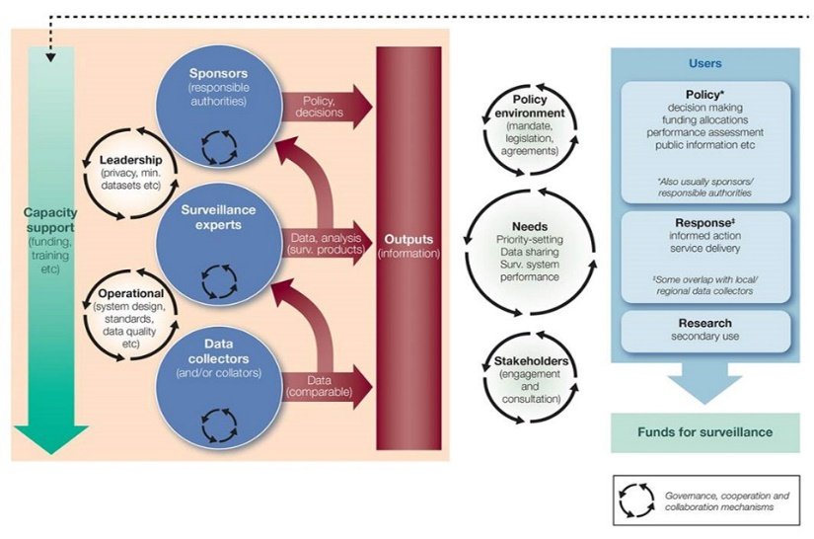
A general model for health surveillance
https://www.gov.uk/government/publications/public-health-england-approach-to-surveillance
This report summarises the data from the surveillance methods which are consumed to monitor and check the COVID-19 pandemic in England. Some surveillance signs show that there have been increases in COVID-19 action at a nation-wide through week 36. Case findings in England augmented in week 35 from 7,955 to 12,217 in week 36. North West, Humber and Yorkshire Case rates were highest. Case rates and incidence was highest in Bolton at a local authority level. in the age group of 20-29-year Incidence rates continued to be highest. In all age category positivity rates have increased and areas with a mainly steep upsurge in positivity seen in age group 85+ olds tested through Pillar 2. There has been a change in the demographic of cases in recent weeks between young adults from the highest incidence rates between those in the maximum deprived groups near those in the smallest deprived bands (WHO, 2020).

Under Pillar 1 and 2, Laboratory confirmed COVID-19 cases tested built on test week with general positivity for Pillar 1 and 2 (%)

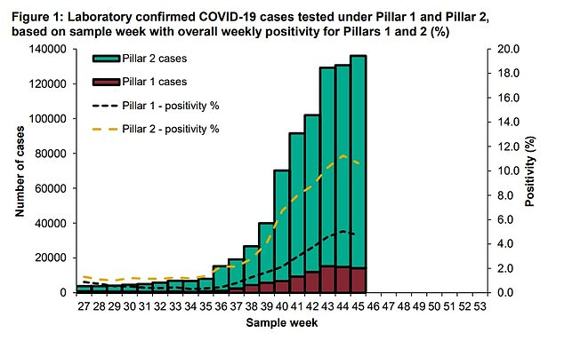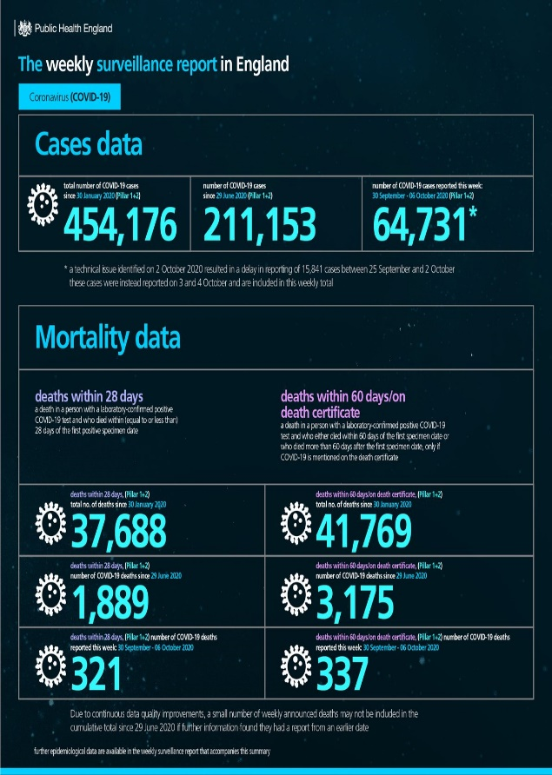

https://www.dailymail.co.uk/
https://twitter.com/PHE_uk/status/1314236841328103425

On September 8, 2020, in England under Pillar 1 and 2 a total of 304,269 positive cases have been confirmed for COVID19. Overall, in week 36, in both Pillar 1 and 2, positivity and case numbers increased with most cases reported from Pillar 2. In the age group of 15-44-year olds the highest case was seen. in 15-44-year olds the positivity was highest in Pillar 1 and in 85+ year olds in Pillar 2. in the North of England positivity and cases rates continue to be highest.

COVID-19 Policy
There have been many policies introduced by the UK government to help keep the public safe and stop the spread of from COVID-19. Reduce contact with other people, will reduce the spread of the disease. That is why the government has presented three new measures. except for important reasons, requiring people to stay at home, preventing gatherings of more than two people in public, closing certain businesses and places. These events will help control the spread of COVID-19 and will reduce the impact on the NHS and save lives. The most vital action can take to control and fighting coronavirus, is to stay at home to protect the NHS and save lives (GOV UK, 2020).

National Lockdown
The national lockdown policy started on 16th of March 2020 to reduce the spread of corona virus. The government advice people they must stay at home and require some business to close for the health and safety of the nation. On 16 March government announced there is clear evidence to support additional social distancing measures be introduced as soon as possible. The same day, a new plan updated the House of Commons on the governments to fight the virus. This included if you or a member of your family has symptoms, you have to self-isolate for two weeks and advice avoid all unnecessary social contact with people. People should work from home if possible and can avoid going out. On 23rd March, another announcement was made from Mr Johnson he said, to the British people gave instruction “you must stay at home.” This instruction included for which people were only allowed to leave their homes for necessary shopping , who are need to exercise a day or people who could not work from home only they can travelling to work, and forbidden meetings more than two people from different households in public. School, college, and all the other education centres must close. Community occasions including weddings were stopped. Non-essential stores were told to close, and government advised the police could enforce the laws (FULL FACT, 2020).

Social distancing
To reduce spreading and the risk of catching coronavirus, UK government has provided a law of social distancing. The social distancing policy is you should reduce spending time outside your home, and should stay two metres apart from other people, confirm that you are not in your support bubble or household. Social distancing is fundamental to prevent the spread of the infection, as it is more possibility to spread when people are close together. People who are infected can pass the virus even if they do not have any signs, through breathing, talking, sneezing, or coughing. Some physical contact such as, being close and face-to face should also avoid preventing the spread of virus. Avoid crowded places with many peoples and touching things that other people have touched should also avoid. you should stay more than 1 metre apart where you can’t stay 2 metres apart and take extra steps to stay safe. Such as, face covering is compulsory by law on public transportation and in namouras indoor places, shops, and other outdoor areas. You should try to maintain and continue social distancing to help to reduce the spread of the virus (GOV UK, 2020).

Closing certain business and venues
The UK government has introduced another policy to the public to prevent the spread of virus and social contact is certain businesses and venues will close for public. These include cinemas, pubs, and theatres, hair, beauty and nail salons, electronics and clothing stores, and indoor and outdoor marketplaces, community and party centres, libraries, and youth centres, public places within parks, such as sports courts, playgrounds and outdoor gyms leisure facilities (indoor and outdoor) such as, arcades, bowling alleys, and soft play facilities, places of worship excluding funerals. Hostels, bed and breakfasts, hotels, sites, boarding houses, and caravan parks, for business/vacation use, without use by those who live in them permanently and who are incapable to return home. Food stores and markets, hardware stores and certain other essential stores and facilities can remain open. Some other companies can stay open for their workers because they cannot work from home so their worker can travel to work (GOV UK, 2020).

Impact of the policies
All these covid-19 policies have had a huge effect on the life of the public. Due to national lockdown children in schools had to stay at home which has a massive impact on their future results. also, exams had to be cancelled. The closure of business effect peoples lively hood and some business had to close permanently. Gym, restaurant, public houses, and leisure centres are places were people go to socialise with these premises being closed it has an impact on the public and the business owners.
The policy’s introduced had a massive impact on the BAME community as they were most at risk of getting covid-19. Research shows that The BAME community have struggled with lockdown due to low income, living with more people in a house especially elderly people who are a high-risk patient. Some BAME people even lost their job as they were not able to attend work due to children being off school. BAME NHS staff have also been affected due to lack of PPE and Covid-19 testing. (NHS, 2020).

Prominent Clinical potential vaccines
The UK government have been supporting Covid-19 research by giving funding and support to the pharmaceutical companies and science labs to come up with a vaccine. The government has agreed to trial the following vaccines. The vaccines are,
- AstraZeneca
For covid-19 treatment an agreement for one million units of neutralising antibodies to protect those who are vulnerable and can’t receive vaccines such as immunocompromised patients and cancer patients.
- BioNTech/Pfizer
The company Pfizer have an agreed and secured a deal with the UK government to supply, the UK with 30 million doses.
- Valneva
The UK government have an agreement in place for 60 million doses of this vaccine. the government has an option to get a further 40 million units if the vaccine is proven safe and effective (GOV UK, 2020).

Recommendations
For BAME staff the government should provide more psychological support. BAME staff working in the NHS should be tested more often and given more support with Covid-19. The government should engage more with the BAME staff for a better understanding of the impact of COVID-19 on NHS workers and their families. For BAME families the government should provide more financial support to help stop the spread of the virus to family members living in the same households. Government should give priority for BAME elderly people in GP and hospital appointments. The NHS should focus on vitamin D screening to help BAME group and give supplements to boost vitamin C and D levels.

Conclusion
From this report I have concluded that Covid-19 is a very serious virus which as effected the whole world. Covid-19 has had a huge impact on the lives of whole nation specially on the BAME community. Covid-19 has affected people livelihood, businesses, education, socialisation, weddings, and events. This virus has affected the way of life as we knew mentally and physically. The UK government have taken drastic measures to help combat spread of this virus. The information gathered through surveillance monitoring the rise of covid-19 cases across the UK lead to the government issuing national lockdown. The government have implemented many policies to keep nation safe such as, 2m space rule, face covering, social distancing, track and trace and decreasing the number of people in one group. The government have been working towards finding a vaccine to eradicate covid-19.

References
Bandura, A., et al. (1977). Social learning theory (Vol. 1). Englewood Cliffs, NJ: Prentice hall.
Champion, V. et al. (2008). The health belief model. Health behaviour and health education: Theory, research, and practice, 4, pp.45-65.
DC, (2020). https://coronavirus.dc.gov/page/what-covid-19 (accessed on 2nd November 2020)
Fishbein, et al. (1975). Belief, Attitude, Intention and Behaviour: An Introduction to Theory and Research. Reading, MA: Addison-Wesley.
Gov UK. (2020) Coronavirus Act 2020, Legislation.gov.uk, Queen's Printer of Acts of Parliament, available at: https://www.legislation.gov.uk/ukpga/2020/7/contents/enacted (accessed 24 October 2020).
GOV.UK. (2020). https://www.gov.uk/government/news/millions-could-be-vaccinated-against-covid-19- (accessed on 4th November 2020)
McQuillan R, et al. (2020). What is the evidence on ethnic variations in COVID-19 incidence and outcomes? Edinburgh: UNCOVER (Usher Network for COVID-19 Evidence Reviews).
National Institute for Health and Care Excellence. NICE, (2013). BMI: preventing ill health and premature death in black, Asian, and other minority ethnic groups. London.
NCBI, (2020). https://www.ncbi.nlm.nih.gov/pmc/articles/PMC7363169/ (accessed on 7th November 2020)
NHS Confederation BME Leadership Network, (2020). The impact of COVID-19 on BME communities and health and care staff. London: NHS Confederation.
Platt L, et al. (2020). Are some ethnic groups more vulnerable to COVID-19 than others? London: Institute for Fiscal Studies.
Razaq A, et al. (2020). BAME COVID19 Deaths - What do we know: Rapid data and Evidence Review: 'Hidden in Plain Sight'. Oxford: Oxford Centre for Evidence-Based Medicine.
Samuelson, M. (1998). Stages of change: From theory to practice. The Art of Health Promotion, 2(5), pp.1-7.
Science Direct, (2020). https://www.sciencedirect.com/science/article/pii/S155174112030293X? (accessed on 5th November 2020)
WHO, (2019). Ethical issues in global health, World Health Organization, World Health Organization, available at: https://www.who.int/ethics/topics/en/ (accessed on 1st November 2020)
World Health Organisation, (2020). https://www.euro.who.int/en/health-topics/health-emergencies/coronavirus-covid-19/novel-coronavirus-2019-ncov (accessed on 2nd November 2020).
Department of health, (2020). https://www.gov.nu.ca/health/information/health-strategies-0 (accessed on 2nd November 2020).
GOV.UK. (2020). https://www.gov.uk/government/publications/coronavirus-covid-19-meeting-with-others-safely-social-distancing/ (accessed on 1st November 2020)
Birkhead, G. S., et al. (2000). "State and Local Public Health Surveillance." In Principles and Practices of Public Health Surveillance, ed. S. M. Teutsch and R. E. Churchill, 270. New York: Oxford University Press.
Dean, A. D. (2000). "Computerizing Public Health Surveillance Systems." In Principles and Practices of Public Health Surveillance, ed. S. M. Teutsch and R. E. Churchill, 229–52. New York: Oxford University Press.
GOV.UK. (2019) https://www.gov.uk/government/publications/phe-strategy-2020-to-2025 (accessed on 7th November 2020)
World Health Organization. (2020). Operational considerations for COVID-19 surveillance using GISRS: interim guidance, 26 March Geneva: WHO; https://extranet.who.int/iris/restricted/handle/10665/331589. 2.
World Health Organization. (2020). Global surveillance for COVID-19 caused by human infection with COVID-19 virus: interim guidance, 20 March Geneva: WHO; https://extranet.who.int/iris/restricted/handle/10665/331506.
FULL FACT. (2020). https://fullfact.org/health/coronavirus-lockdown-hancock-claim/ (accessed on 7th November 2020)

