
Programme: BA (Hons) Business Management
Module: Management Economics
Module code: LCBB5008
Student Name Bogdan Pacuraru
Student ID 2245496
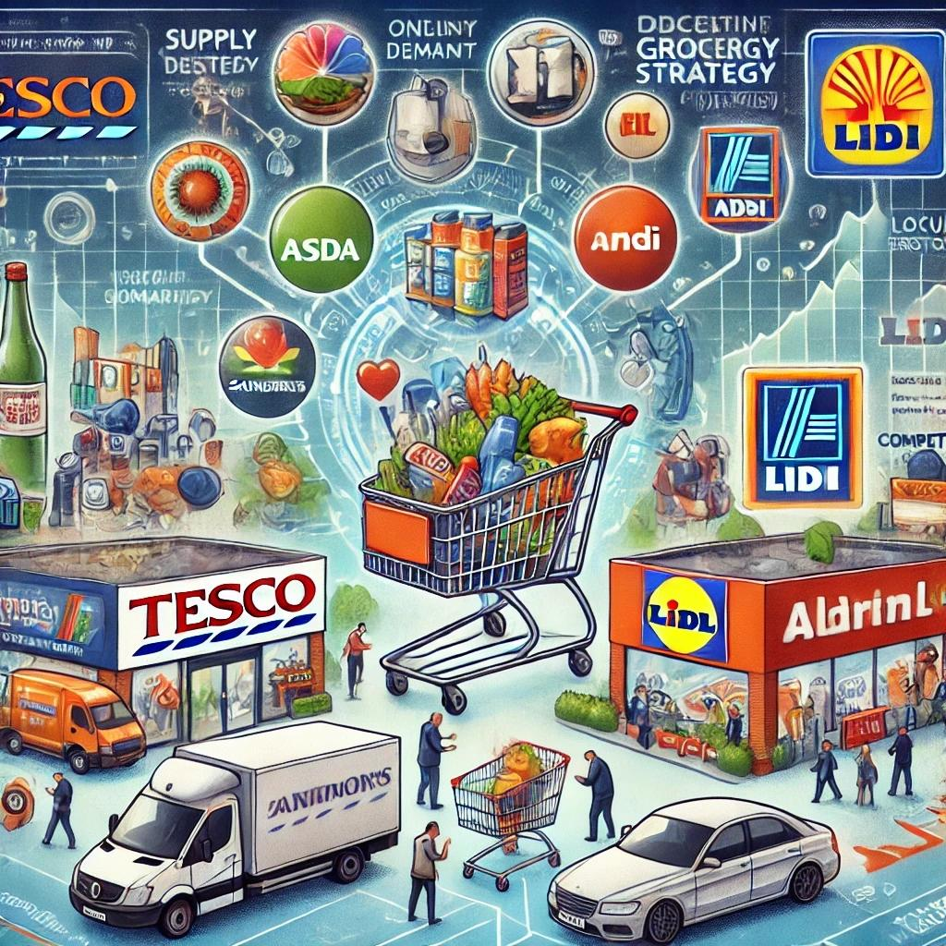
The market structure, supply and demand analysis, and sustainable growth plans of the UK supermarket industry

This picture depicts the UK supermarket sector, competition among huge merchants, and economic concepts like supply and demand.
1.Introduction

The UK supermarket industry is one of the most competitive and dynamic retail sectors, with leading market players and shifting consumer preferences. In 2021, the whole grocery market was estimated to be worth £211.9 billion, with supermarkets accounting for £91 billion (Statista, 2024).
Economic issues like customer demand, supply chain dynamics, and competitive pricing strategies have a big impact on this industry.
Factors such as the post-COVID-19 economic recovery, rising acceptance of online grocery shopping (from 5.4% in 2018 to 9% in 2024), and the persistent cost-of-living problem have all shifted the competitive environment.Although household budgets were stretched and food costs rose as a result of the 2023 inflation peak, recent economic developments have enabled consumers to spend more (ONS, 2024). Price-sensitive consumers still choose private label and bargain stores over name-brand goods in spite of this.
Historically, the business has been controlled by the „Big Four” supermarkets: Tesco, Sainsbury’s, Asda, and Morrisons. However, discount stores like Aldi and Lidl have increased their market share dramatically through aggressive pricing techniques. Rising inflation and the cost of living crisis have further impacted consumer purchasing habits, making discount stores more popular.
This essay looks at the industry’s competitive tactics, supply and demand dynamics, and market structure. Furthermore, it offers suggestions for long-term expansion by evaluating the state of the market using economic theories like supply and demand analysis and the theory of the firm.
2.Utilizing economic theory
Theory of market structure and the company
The UK supermarket sector operates under an oligopolistic market structure, with a few powerful companies dominating, while independent grocers and bargain stores compete, characterized by various features.
The Big Four’s domination
Tesco, Sainsbury’s, Asda, and Morrisons have historically dominated the UK grocery industry, together accounting for a sizable market share. Tesco continues to be the market leader in 2024, with a share of approximately 27%, followed by Sainsbury’s (15.2%), Asda (14.4%), and Morrisons (9.1%). These businesses benefit from economies of scale, which enable them to provide reduced pricing while being profitable (Sloman et al., 2022).
The growth of discount stores
Since the 2008 financial crisis, the big four have lost market share to Aldi and Lidl’s rapid expansion, with Lidl and Aldi holding 7.7% and 9.9% market shares respectively as of 2024.
Reduced operational expenses as a result of streamlined supply chains and a more constrained range of products (Mintel, 2023). Aggressive pricing tactics that frequently result in competitors being undercut by 15–30% (BBC, 2024). Reliance on national brands is decreased by their robust private label products, which make up more than 90% of their stock (Financial Times, 2023).
Digital change and the internet
Statista reports a significant increase in online grocery sales from 5.4% in 2018 to 9% in 2024, with Tesco and Sainsbury’s dominating the market due to their robust supply chains.
Time savings and convenience for consumers (ONS, 2024). Innovations in technology, like AI-powered suggestions and quick delivery services (Deloitte, 2023). Online-only merchants that prioritize high-end and quick delivery choices, such as Amazon Fresh and Ocado, are competitors (The Guardian, 2023).
Loyalty tactics and priceless competition
Because of the fierce rivalry, UK supermarkets employ non-price competitive tactics to keep their customers loyal, such as:
Loyalty programs like Tesco Clubcard and Sainsbury’s Nectar offer discounts and rewards, while sustainability goals involve minimizing plastic waste and introducing green products. Premium store brands like Tesco Finest help supermarkets compete with high-end food shops.
Premium differentiation: Marks & Spencer and Waitrose target wealthy customers with premium branding and high-quality products.
In addition to price rivalry, businesses invest in non-price competition, such as improving customer experience, increasing convenience through online buying, and diversifying their product offerings. For example, Sainsbury’s ‚Food First’ strategy stresses fresh and sustainable food products, making it appealing to environmentally aware customers (Financial Times, 2024).
Businesses are interdependent:
When one firm makes adjustments to its pricing or marketing, it affects the strategies of its rivals, intensifying the competition.
The impact of rules and impediments to market entry
The structure of supermarkets is influenced by various government laws and regulations, including
The Competition and Markets Authority (CMA) regulates pricing practices, focusing on predatory pricing, while high capital investment, broad distribution networks, and brand loyalty pose significant barriers to new competitors.
The widespread popularity of convenient internet purchasing has become increasingly popular.
Lidl and Aldi have revolutionized the market by utilizing cost-cutting techniques and effective supply networks, offering superior private label goods that compete with branded products.
The market structure’s direction is being analyzed.
The UK grocery industry is experiencing a rise in diversity, with anticipated trends including:
Increased rivalry between local stores and individual merchants (ONS, 2024). Other innovations in technology include automated warehouses and cashierless retail (BBC, 2024). Carbon-neutral supply chains and ethical sourcing are examples of sustainability-driven developments (IGD, 2023).
3.Analysis of supply and demand
Demand-influencing factors in the UK grocery sector
There are numerous important elements that impact demand in the grocery sector:
1.Price elasticity of demand: The demand for essential foods is inelastic, meaning that price changes have little effect on the quantity that is sought. But luxury or branded products are more elastic, so when costs go up, buyers will move to less expensive options (Fernie &amp; Sparks, 2019).
2. Consumer trends and preferences: Supermarkets are expanding their selections of „free” and plant-based items due to the growing demand for organic food, ethical sourcing, and health-conscious buying (Wrigley &amp; Lowe, 2020).
3. Technological influence: As e-commerce and smartphone apps have grown in popularity, consumers’ convenience has increased, leading to a shift in demand for home delivery services and online shopping.
Invest in fast delivery services such as partnerships with Amazon Fresh and Uber Eats Open multiple store formats such as Tesco Express and Sainsbury’s Local.
Elements that affect supply
Supermarkets encounter a number of supply-side difficulties, such as:
a.Cost increases: The cost of operations has increased as a result of supply chain interruptions and inflation. Fresh fruit supply has also been impacted by trade constraints due to Brexit (ONS, 2024).
b. Supplier relationships: Big grocery stores have a lot of negotiating power with suppliers, which affects stock availability and costs (IGD, 2023).
c. Pressures on sustainability: Environmental concerns and regulatory rules are pressuring supermarkets to implement more environmentally friendly supply chain procedures, like purchasing locally made goods and minimizing plastic packaging (Competition and Markets Authority, 2024).
Supermarket prices, product availability, and general customer pleasure are determined by the intersection of these elements.
Government rules and demands for sustainability
The industry is facing increasing pressure from the UK government to:The goal is to decrease food waste, achieve sustainability goals, and uphold fair trade regulations to ensure ethical sourcing, while enhancing the pay and working conditions of supply chain workers.
Retail technology advancements Technology is being used more and more by supermarkets to increase productivity, including:
AI-based self-checkout systems and customer support are being implemented in supply chains to streamline replenishment and customize advertising based on consumer purchasing patterns.
4.Suggestions for long-term expansion in the UK grocery sector
Economic uncertainty, heightened competitiveness, environmental demands, and shifting consumer preferences are some of the growing issues facing the UK grocery industry. Supermarkets must implement strategic steps to boost productivity, preserve competitiveness, and encourage sustainable growth in order to secure long-term success. Here are 12 specific suggestions to help you reach these objectives.
1.Improve the digital and internet services.
Online grocery shopping has become an important component of the retail landscape, with e-commerce grocery sales increasing from 5.4% in 2018 to 9% by 2024 (Statista). Supermarkets ought to invest in:
AI-based recommendations are integrated into mobile apps, enhancing collaborations with Uber Eats, Deliveroo, and Just Eat for expedited delivery and inventory tracking for efficient order fulfillment.
Supermarkets may improve customer convenience and compete with online-only merchants like Ocado and Amazon Fresh by bolstering their digital capabilities (Mintel, 2023).
2.Create tactics for competitive pricing.
The issue with living expenses has forced people to purchase on a tight budget. Supermarkets must improve their pricing tactics by:
Granting individualized savings via loyalty schemes (e.g., Tesco Clubcard, Sainsbury’s Nectar). Applying dynamic pricing schemes that take into account current market demand. Price matching and incentives for larger purchases are two ways to keep price-conscious clients.
Price wars are becoming a crucial component of competition, especially when it comes to Aldi and Lidl, whose low-cost business methods are continuing to increase their market share (BBC News, 2024).
3. Expand the range of private label products.
Over 50% of supermarket sales in the UK are made up of private label (own brand) goods (IGD, 2024). The supermarkets ought to:
More affordable, medium-priced, and high-end private brands should be available. To compete with national companies, enhance your branding and sense of quality. By utilizing recyclable packaging and components that are acquired responsibly, you can emphasize sustainability.
Tesco’s Finest and Sainsbury’s Taste the Difference show how premium private label brands may compete with big food manufacturers (Kantar, 2023).
4. Increasing ethical and sustainable sourcing
According to Deloitte (2024), more than 70% of UK consumers increasingly prioritize sustainability when making purchases. The supermarkets ought to:
Implement net-zero carbon methods in your supply chain, increase fuel stations and paper-based alternatives, and ensure fair trade and ethical sourcing in product purchasing to reduce plastic waste.
Tesco, as per its 2023 Annual Report, sets a goal to become carbon neutral by 2035, a standard that all retailers must adhere to.
5. Consider investing in automation and AI technology.
Automation and artificial intelligence (AI) can increase productivity and save operating expenses. Important investments consist of:
Amazon’s Just Walk Out utilizes a cashierless system and self-checkout, while AI predicts demand to maximize stock levels and automated warehouses streamline logistics.
Ocado’s AI-powered fulfillment centers demonstrate how automation will significantly transform grocery store operations (Financial Times, 2024).
6. Make customer loyalty programs better.
Tesco Clubcard and Sainsbury’s Nectar dominate the market, making loyalty programs crucial for customer retention. Enhancing these programs can be achieved through various tactics.
The company is implementing data-driven hyper-personalization to offer personalized discounts, reward tiers, and financial services integration, including cashback on supermarket-affiliated credit cards.
Mintel (2023) reports that Tesco Clubcard members spend 12% more than non-members due to loyalty schemes enhancing customer retention and basket size.
The goal is to enhance the visibility of the department store.
The need for smaller local businesses has grown as a result of changing lifestyles. In order to profit from this trend, supermarkets ought to:
Expand urban store concepts like Tesco Express and Sainsbury’s Local, offer ready-to-eat meals and healthy snack alternatives, and enhance micro delivery centers for faster local deliveries.
According to Statista (2024), the UK’s convenience store sales are predicted to increase by 7% a year, indicating significant room for supermarket growth in this sector.
8.The goal is to enhance collaborations with regional vendors.
Supporting regional farmers and suppliers can boost community involvement and sustainability. Supermarkets should:
Grow fresh regional cuisine from nearby farms, utilize targeted marketing for seasonal products, and collaborate with independent British brands to differentiate yourself from competitors.
Morrisons is a pioneer in local sourcing, sourcing over 70% of their fresh produce from British farms (Morrisons, 2023).
9.The goal is to improve training and staff well-being.
A motivated team enhances customer satisfaction and operational effectiveness, which supermarkets should strive to achieve.
Increase pay for skilled personnel, offer job development opportunities like retail management apprenticeships, and provide digital training to help employees adapt to AI-powered operations.
Retailers like Waitrose are implementing mental health support programs to boost job happiness, as they believe employee well-being is linked to increased productivity.
10. Concentrate on health and wellness products.
Health-conscious customers are driving the demand for organic, plant-based, and low-calorie solutions, prompting supermarkets to adapt accordingly.
The restaurant is introducing freshly prepared vegan and gluten-free options, health-focused meal kits, and nutritional information through digital menus and mobile apps.
Deloitte’s 2024 report shows a 20% increase in sales of plant-based foods due to a shift in customer preferences.
11. Spread out your sources of revenue.
Supermarkets should explore alternative income sources beyond traditional grocery sales, such as:
Insurance services are increasingly being offered through subscription-based food models, with financial organizations providing these services in-store, utilizing retail media advertising to target promotions.
Tesco Bank and Sainsbury’s Bank are leveraging targeted advertising campaigns and diverse services to generate substantial earnings (The Grocer, 2024).
12. Adhere to laws and corporate social responsibility programs.
Supermarkets are required to adhere to UK government regulations and corporate social responsibility (CSR) objectives.
The country is aiming to achieve carbon neutrality goals, reduce food waste through collaboration with nonprofits like FareShare, and offer discounted critical goods programs to low-income households.
The UK Plastic Pact, enacted by Gov.uk in 2024, is a legislation that aims to encourage retailers to actively reduce plastic pollution.
The future of supermarkets in the UK
Technological advancements, shifting consumer expectations, and regulatory changes will all influence the industry’s future. Supermarkets will continue to have a competitive edge if they can effectively strike a balance between cost, convenience, and sustainability.
5.Conclusion
The UK supermarket industry remains competitive due to evolving consumer preferences, technological advancements, and economic volatility, with online shopping, convenience retailers, and discounters vying for dominance.
Economic theories like supply and demand analysis reveal key industry determinants like rising costs, supply chain limitations, and changing consumer behavior.
Supermarkets must adopt sustainable growth strategies, price adjustments, digital expansion, and environmental initiatives to ensure future success.
UK supermarkets must adopt digital transformation, sustainability, pricing competition, and consumer-focused innovation for long-term success. Implementing these 12 strategic recommendations will enable them to adapt to changing consumer behavior, regulatory challenges, and market changes.
6.Reference
Books and journals for academics Burt, S. And Sparks, L. (2022) Retail in the United Kingdom: shifts and obstacles. Routledge, London. In 2020, Wrigley, N. And Lowe, M. A Geographical View of Retail and Consumption Spaces: Reading Retail. Oxford University Press, Oxford. Varian, H. (2021). Microeconomic evaluation. Third Edition. W.W. Norton &amp; Co., New York.
Reports from Government and Industry In 2024, the Competition and Markets Authority, the Retail Competition Situation in the UK. You can access it at [www.gov.uk/cma].(CMA: https://www.gov.uk) [As of January 28, 2025]. In 2024, the Office for National Statistics Retail Sales Index: 2024 Food Trends. Accessible at the following link: [www.ons.gov.uk](https://www.ons.gov.uk) [retrieved January 28, 2025].
Online sources and news 9. BBC News, ‚UK Supermarket Competition Heats Up as Discounters Gain Ground’ (2024). You can get it at [https://www.bbc.co.uk/news].This link: https://www.bbc.co.uk/news [As of January 28, 2025]. 10. ‚Tesco and Sainsbury’s Use Price Cuts to Fight Aldi and Lidl,’ Financial Times, 2024. It is accessible via [https://www.ft.com].Ft.com [As of January 28, 2025]. 10. ‚UK Grocery Prices and the Cost of Living Crisis,’ The Guardian (2024). [https://www.theguardian.com/business] is the URL to consult.This link: https://www.theguardian.com/business [As of January 28, 2025]. 12. Analysis of UK Food Market Share by Kantar (2024). You can access it at [https://www.kantar.com].(From https://www.kantar.com) [As of January 28, 2025].
National Statistics Office (ONS). *UK Retail Sales Report 2024*. 2024. You can access it at [https://www.ons.gov.uk].Go to https://www.ons.gov.uk.
Authority for Competition and Markets (CMA). (2023). Market Research Report on Food Retail. You can access it at https://www.gov.uk/cma.
(2024) Statistician. Market share of UK supermarkets in 2024. The URL is https://www.statista.com.
BBC News, 2024. Supermarket Pricing Strategies in the United Kingdom. https://www.bbc.co.uk/news is the online address.
Mind. (2023). UK Grocery Retail Market Report, 2023. Available at https://www.mintel.com.
Financial Times, 2024. How the UK supermarket business is being disrupted by inexpensive retailers. On the internet at https://www.ft.com
BBC, 2024. Supermarket Pricing Strategies in the United Kingdom. Accessible via the Competition and Markets Authority (CMA) news website: https://www.bbc.co.uk. (2023). Market Research Report on Food Retail. You can access it at https://www.gov.uk/cma.

