Guidebook for making the most of your retirement
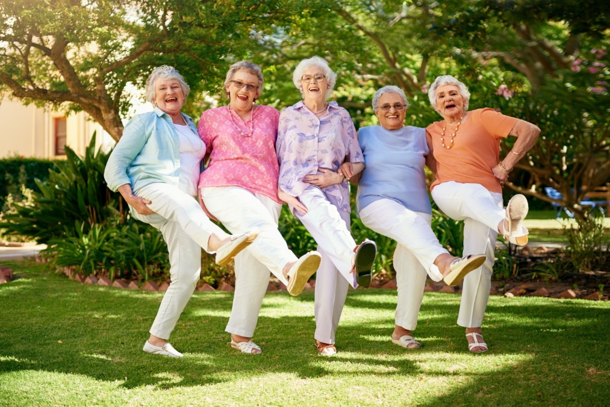
Image 1
Changes which happen in later life can leave people vulnerable to loneliness, isolation and social exclusion in older age (Newall and Menec, 2017).
People may lack access to basic services, and social participation. Changes in roles from employed to unemployed, spouse to widowed and provider to dependant are all experiences which older people are more prone to encounter (Victor, Scambler and Bond, 2009)
In many cases,as people age they begin to slowly distance themselves from society and disengage from social life (Zhang, 2008).
This does not have to be the case and it is also suggested that staying active in old age and engaging with others can maintain and even improve physical and mental health and well-being (Med fit network,2017).
Retiring from work is one of the biggest life course transitions you are likely to face in later life.
In the UK today retirement is seen as an exiting new chapter where you should be looking forward to exploring and doing the things you love.
It might be the first time in a long time that you can do as you please and have more time to spend with family and friends.
With an ageing population we are living longer and healthier lives therefore it could be the perfect opportunity to start ticking things off your bucket list (Sunlife, 2020).
Feelings About Retirement…
Even if you have been looking forward to retirement it is still advisable to be aware of some common feelings people often experience when the time comes. If you have recently retired, or are coming up to retirement it is very likely that you will be experiencing a range of emotions (Age uk, 2020b).
Your work may be a large part of your identity, and retiring may make you feel like you have lost a part of your identity.
It is also likely that you will miss the routine and start to question your purpose in life (Osborne,2012).

Socialising is usually part of the natural environment if most work places. where people enjoy social interaction in their daily routine, without the need to make any special arrangements.
This is the aspect that most retirees report to miss the most, especially as a new retiree (Moore and Rosenthal, 2018).
Social interaction does not have to decline in events such as retiring or being widowed, and keeping an active social life can help you adapt successfully to retirement improve your life satisfaction and assist you to age successfully and well (Nusbaum,Pecchioni and Robinson,2007).

Image 2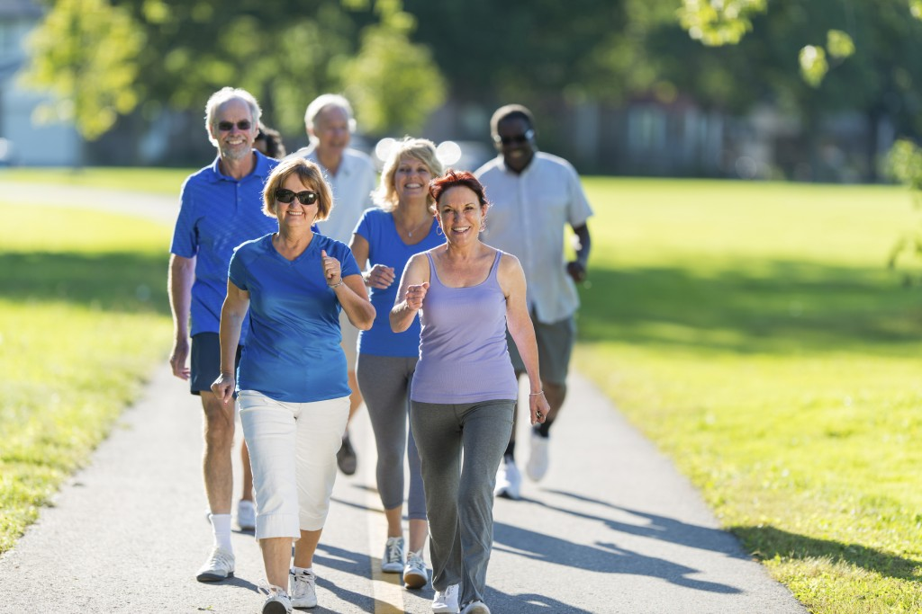

- Physical Activity
- Reduces risk of chronic diseases such as cancer, heart disease, stroke and diabetes by 50%
- Reduces risk of early death by 30%
- Improves mental health
- Makes you feel good! (NHS, 2018).

Other Benefits of Physical Activity Include…
- Preventing falls by improving strength, balance and flexibility. When you are older it can take much longer to recover from falls, therefore avoiding them is important (Kandel and Adamec, 2003).
- Social engagement. Offers opportunities to meet people through exercise through fitness classes, walking clubs, leisure centres and many others (Ehrman, Gordon and Visich, 2009).
- Improved cognitive function. Exercising can help keep thinking and learning skills sharp and healthy, and improve memory
(Alzheimer’s association,2021).

Volunteering
Volunteering is a great way to gain a sense of purpose and feelings of fulfilment. Below is a list of how you could benefit mentally and physically, from taking up a volunteering role-
- Getting involved in something you are passionate about
- Making new friends
- Making a difference to others
- Using your skills or learning new skills
(Smith, 2019).
There are plenty of opportunities available for volunteering, and more than 10,000 people over 50 volunteering with the volunteering matters charity.
If you feel that the well-being of your community could benefit from certain activities, you could get support from the retired and senior volunteer programme (RSVP) To take the lead role in organising activities.
For more information on how to find a suitable volunteering role visit the website on https://volunteeringmatters.org.uk/pillars/older-people/ (Volunteering matters, 2016).

Memory Function
Forgetting things from time to time is usually nothing to worry about and a normal part of ageing, but 19 0ut of 20 people with dementia are over 65, therefore it is a good idea to be aware of the following symptoms.
- Forgetting recent events
- Struggling to follow conversations on tv
- Forgetting names of people you are close to
- Getting lost on familiar journeys
- Feeling confused
- Others noticing your forgetfulness (Alzheimer’s society, 2021).
- Socially inappropriate behaviour
- Mood swings
- Personality change
If you experience one or more of these symptoms, you should discuss it with your GP (Dementia.org, 2021).
There is growing evidence that certain lifestyle changes can reduce cognitive decline
- Having regular exercise
- Learning and attending classes improves cognitive function.
- Stopping smoking
- Healthy eating
- Keeping your heart healthy can help your brain
- Getting enough sleep
- Staying social
- Avoiding head injuries (Alzheimer’s association, 2021).

Finances
As you approach retirement you may be concerned about your finances. You may not have a private pension and will have to rely on state pension (Smith, 2019).
Most people over 65 can claim the basic state pension.The maximum amount you can get is £134.25, and to be eligible you will need to have either paid or received National insurance contributions.
If you choose to carry on working, it will not effect your state pension,but it can effect other benefits such as pension credit or council tax reduction (Citizens advice, 2021).
Your income may also be topped up to £173.75 by the pension credit scheme. You can claim up to four months before you reach retirement age.
To find out if you are eligible and to begin your claim please visit https://www.gov.uk/pension-credit/how-to-claim or call 0800 99 1234 (Gov uk, 2021).
Age UK can provide you with information on benefits that you are entitled to. You can use the benefit calculator on their website on https://www.ageuk.org.uk/information-advice/money-legal/benefits-entitlements/benefits-calculator/
Alternatively if you want to speak to somebody lines are open 365 day a year between 8 am and 7pm on 0800 055 6112 (Age UK, 2020a).

Image 3
Technology and Retirement
sites and apps Computers are not just for young people, and has a lot to offer older people (Lifeline 24, 2021).
Learning how to use a computer and getting online can be physically and mentally challenging for older people who are not familiar with doing so.
Some barriers may include viual impairment problems, co-ordination issues due to illnessesses such as arthritis, memory problems and many other issues (Adapt-it, 2017).
Some other common factors that may prevent older people to get online is low confidence,believing they are not capable and fear of doing something wrong.
Some may also be unable to afford to pay for the internet to get online. Over 55’s are the most digitally excluded category making age the biggest indicator (Centre for Ageing better, 2020).
Being computer literate can give you many social and day to day convenience benefits.
Contemporary technology is full of opportunities for people to keep involved with family and friends through social networking
(Cherepanova, Tukhvatulina and Mirza, 2016).
Getting online can help maintain independence in daily routines such as banking,shopping and sending e-mails.
It is becoming increasingly common for health care physicians to communicate with patients online (Czaja and Sharit, 2016).
In the government’s adult learning policy, digital literacy remains a priority to give individuals the skills needed to access information and services online (Welsh government,2020).
Age Uk provides Information Technology lessons in over 6000 centres around the Uk.
For more information and find the nearest centre to you call Age UK on 08006781602 (Age UK, 2020c).

Loss and Bereavement
Losing a loved one is always a painful process and it can take a long time to adust to the loss and understand how you are feeling.
Being familiar with the grieving process and grief cycle can be extremely helpful when feeling intense feelings of grief (Mind, 2021).
Not everyone will go through all of these emotions, and some will go through each stage in a different order (Kubler-Ross and Kessler, 2014).

Image 4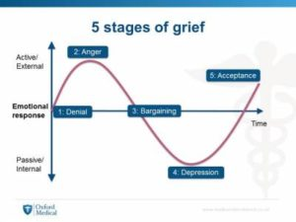
The loss of your spouse can be one of the most intense losses you may encounter, and brings with it many changes to the life you once knew.
- You may feel your identity has changed.
- Future dreams have been lost
- You my feel lonely and isolated
- Financial loss
- Becoming solely responsible for family and household duties
There are things you can do to help deal with the grief .
- Talking about your feelings ,
- Allowing yourself to remember and aknowledge your patner in different ways.
- Plan ahead how you want to cope with difficult days such as anniversaries.
- Remember to take care of yourself and disscuss any issues with a health professional.
Professional support for dealing with grief is available fom Curse helpline on 0808 808 1677 (Curse bereavement care).
Loneliness and isolation
, If you ever feel you are becoming lonely and isolated, there are some simple steps that may help you overcome these issues.
- Make and effort to re-connect with old friends.
- Join groups based on your hobbies to make new connections.
- Make small steps to interact with people around you. Good relations with neighbours can help make you confident when socialising, and friendships could be formed.
- Make the most of technology to keep in touch and engage with people (Campaign to end loneliness,2020).
If you feel you need support in tackling loneliness there are many formal organizations such as Silver line which could help. Silver line helpline 0800 470 80 90 (Silver Line, N.D).
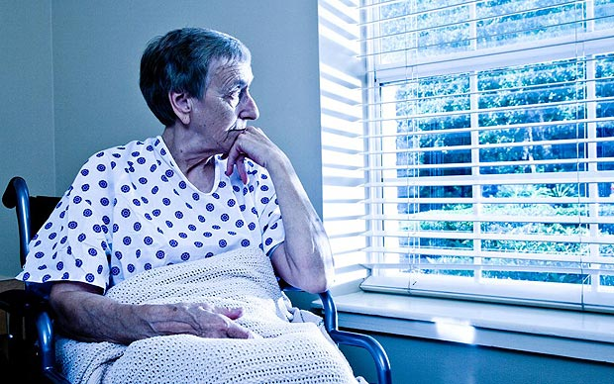
Image 5

Mental health in later life
Events which can trigger poor mental health can happen at any stage of life,but the majority of these events are more common in later life, such as the ones discussed in this booklet.
Other factors which are more common in older age such as decreased mobilisation,chronic pain and other health problems can also contribute towards poor mental health (World Health Organization).
Although Depression is one of the most common mental illness in older adults,it is very treatable if it gets diagnosed.
However, many cases are left undiagnosed and untreated due to symptoms being assumed as a normal part of the ageing prossess, resulting in patients not self-reporting they’re symptoms (Wiesel,2011).
You may also find it difficult to discuss your mental health due to it being seen as a a stigmatised topic in the past (Nationa health executive).
It is important to understand that poor mental health is not a sign of weakness, or a character flaw or failing. They are conditions which can effect an individuals mood and way of thinking.
Medication is not always the necessary way to treat symptoms. Sometimes adjusting your daily routine and making some changes to circumstances can improve your mental health without medication (Bursack, 2020).

Remember how much you have to offer
Retirement does not mean that you are no longer a valued member of society, and there are plenty of opportunities for you to contribute and be active members, making a positive difference in your community and other people’s lives, helping you have a happy fulfilling retirement (Cook,2011).


Image 6
Rationale
This booklet will explore the barriers people may face as they approach retirement age, and what steps can be taken to overcome these barriers and help in successful ageing. The average age people report a disability which interferes with daily life is 62. Small changes can help towards staying healthier,happier and more independent for longer (Giles, 2019).
The disengagement theory suggests that as people get older, they experience a decrease in interaction with others and reduced activity. As a result, they may seek more passive roles and become more occupied with their inner-self (Zhang, 2008).This is a mutual activity between the elderly and society where they disengage with each-other with the older person distancing themselves from emotional ties and social activity (Larkin,2009).
On the other hand the activity theory disagrees that the disengagement theory is not inevitable and proposes that older adults are happier when they remain active with a lot of social interaction. Some ways to help make this possible is recommended(Nusbaum,Pecchioni and Robinson, 2007).
Physical exercise is promoted in this booklet, because changes which occur when people age, mimic changes which are seen in people who are too inactive and sedentary. A large amount of changes which limit an older persons functioning are due to a lack of exercise. Physical exercise can be seen as a fountain of youth for ageing people by reversing and preventing the effects of ageing (Sullivan and Pomidor,2015).
It also improves mental health Ten minutes of exercise can result in feeling more content, awake and calm. It relieves stress, increases self-esteem and self worth as well as reducing symptoms of Anxiety and Depression. (Mental health foundation, 2021).
Regardless of how Socially connected someone may be,ageing usually brings a change in Social Networks. Friends and family may move away or die , marriages dissolve,and rifts arise bringing with it a arisk of loneliness. Those who are lonely and isolated are more likely to behave in health harming ways such as smoking and drinking. It can also have a detrimental effect on Mental and physical well-being (Kaye and Singer, 2018).
Hopefully being made aware of mental illness can help people identify if they need help. Approximately 15% of adults over 60 suffer from a mental disorder. The most common mental health illnesses in elderly people are depression and dementia. Depression is very treatable, therefore getting a diagnosis is vital (World Health Organization, 2017).
An important part of talking about mental health in this booklet was explaining that mental health should be discussed openly. Due to being brought up in a time when mental health was seen as a weakness, some of the beliefs and behaviours associated with mental health are engrained in the behaviour of older people disencouraging them to seek help (National Health Executive, 2017).

Many people worry about they’re finance in retirement and are unaware of what they are entitled to, which is why it is important why people need to know where to go to for advice. Currently up to £3.5 billion of housing and pension credit goes unclaimed ( Age UK,2020). Contact details for many organizations are provided to make it easier to find any support the reader may need, as it is stated in the care act that local authorities should make people aware of what services are available to them, and how they can access the services (Care act, 2014).
People tend to think of mobility, and physical issues when considering the problems associated with the elderly. However, there are many social issues which are often faced while ageing such as loneliness, financial issues and feeling inadequate after retiring from work. Therefore this leaflet is focused on those issues, to hopefully prepare people approaching retirement , or be available for people who are currently facing one or more of these issues to relate to and discover ways to approach the issues (The live-in care hub, 2019).
Reference list
Image 1
Retirment living guide (2013).https://www.bethesdahealth.org/wp-content/uploads/2018/01/iStock-680410722-1400x1008.jpg
Image 2 Aging Mastery, (2016). Healthy aging. [image] Available at: <https://www.ncoa.org/healthy-aging/aging-mastery-program/aging-mastery-program-core-curriculum/> (Accessed: 12 February 2021).
Image 3 London and partnership,( 2012). British money. [image] Available at: <https://www.bing.com/images/search?view=detailV2&ccid=VzHpIrqk&id=CB20EEA460D6E875204882EC4CFFCD3B04551FDB&thid=OIP.VzHpIrqkgmSnOEO4VmJ8zgHaEK&mediaurl=https%3A%2F%2Fth.bing.com%2Fth%2Fid%2FR5731e922baa48264a73843b856627cce%3Frik%3D2x9VBDvN%252f0zsgg%26riu%3Dhttp%253a%252f%252fcdn.londonandpartners.com%252fvisit%252fgeneric%252fobjects%252f76659-640x360-british-money-coins-640.jpg%26ehk%3DHW0HcVbmAz81%252bAnKm7KjhJoWWm54ZL%252f2e1lbQl8luKE%253d%26risl%3D%26pid%3DImgRaw&exph=360&expw=640&q=pictures+of+coins+uk&simid=607989575293011323&ck=C9346C627BF3B4058B17F895F4D2E40F&selectedindex=7&form=IRPRST&ajaxhist=0&vt=0> [Accessed 13 February 2021].
Image 4 Oxford Medical (2015). 5 stages of grief. Available at: https://www.medicalinterviewsuk.co.uk/2015/09/09/kubler-ross-doctors-and-the-7-day-nhs/ (Accessed: 8 February 2021).

Image 5 The daily Telegraph ( 2013). Toll of loneliness. Available at https://www.telegraph.co.uk/news/health/elder/9953019/Toll-of-loneliness-isolation-increases-risk-of-death-study-finds.html. (Accessed: 13 February 2021).
Image 6 Amentorp (2013). Old woman relaxing on beach. Available at: https://pixfeeds.com/images/retirement/1280-485630241-old-woman-relaxing-on-the-beach.jpg. Accessed 13 February 2021).
Oxford Medical (2015). 5 stages of grief. Available at: https://www.medicalinterviewsuk.co.uk/2015/09/09/kubler-ross-doctors-and-the-7-day-nhs/ (Accessed: 8 February 2021).
Adapt-it(2017). Computers for Elderly users, seniors and Silver surfers). Available at: https://www.adapt-it.co.uk/how-adapt-it-can-help/disabled-individuals/computers-for-elderly-users/#:~:text=Adapt-IT%20supplies%20computers%20for%20elderly%20users%20to%20benefit,button%20keyboards%2C%20trackball%20mice%2C%20screen%20magnifiers%20and%20more.( Accessed 9 February 2021).
Age UK a (2020) Benefits and Entitlements. Availablehttps://www.ageuk.org.uk/information-advice/money-legal/benefits-entitlements/ (Accessed: 7 February 2021).
Age uk b (2020) Preparing emotionally for retirement. Available at: https://www.ageuk.org.uk/information-advice/work-learning/retirement/preparing-emotionally-for-retirement/(Accessed: February 12 2021).
Age UK c (2020) IT training. Available at: https://www.ageuk.org.uk/services/in-your-area/it-training/ (Accesed: 7 February 2021).

Alzheimer’s association (2021) 10 ways to love your brain. Available at: https://www.alz.org/help- support/brain_health/10_ways_to_love_your_brain (Accessed: 5 February 2021).
Alzheimer’s society (2021) Worried about memory problems. Available at: https://www.alzheimers.org.uk/memoryproblems (Accessed : 7 February 2021).
Bursack, C (2020). Understanding mental health issues in seniors. Available at: https://www.who.int/news-room/fact-sheets/detail/mental-health-of-older-adults.( Accessed: 10 February 2021).
Campaign to end loneliness (2020).I feel lonely, What can i do? Available at: https://www.campaigntoendloneliness.org/feeling-lonely (Accessed 9 February 2021).
Centre for Ageing better (2020). Bridging the digital divide.Available at: https://www.ageing-better.org.uk/sites/default/files/2020-08/bridging-digital-divide-infographics.pdf. (Accessed 9 February 2021).
Cherepanova, N., Tukhvatulina, L. and Mirza, N., 2016.’ Social networks of older people in contemporary society’. SHS Web of Conferences, 28, p.01120.
Citizens advice (2021). State pension. Available at:https://www.citizensadvice.org.uk/debt-and-money/pensions/types-of-pension/state-pension/.(Accessed: 13 February 2021.
Cook, J., (2011). ‘The socio‐economic contribution of older people in the UK’. Working with Older People, 15(4), pp.141-146.
Cruse bereavement care (2020) Coping with the death of a partner. Available at: https://www.cruse.org.uk/get-help/about-grief/coping-death-partner.( Accessed 8 February 2021).
Czaja, S and Sharit,J. (2016). Designing training and instructional programs for older adults. Boca Rotan: Taylor & Francis.
Dementia.org (2021) Symptoms of Dementia. Available at : https://www.dementia.org/symptoms (Accessed: 7 February 2021).

Ehrman,J. Gordon, P and Visich,P.(2009) Clinical exercise physiology. Leeds: Human Kinetics.
Giles,A. (2019) We must give future generations the gift of healthy ageing. Available at: https://www.bing.com/search?q=www.ageing-better.org.uk/blogs/we-must-give-future-generations-gift-healthy-ag%E2%80%A6&form=IPRV10. (Accessed 15 February 2021).
Care Act 2014,c.4. Available at: https://www.legislation.gov.uk/ukpga/2014/23/part/1/crossheading/general-responsibilities-of-local-authorities/enacted (Accessed 16 February).
Gov uk, (2021) Pension credit. Available at: https://www.gov.uk/pension-credit/how-to-claim. (Accessed 13 February 2021).
Kandel,J. and Adamec,C. (2003). The encyclopedia of Senior health and well-being.New York: Facts on file.
Kaye, L. and Singer, C.,(2018). Social isolation of older adults. New York: Springer.
Kubler-Ross,E. and Kessler,D. (2014). On Grief and Grieving: Finding the meaning of grief through the five stages of loss.New York: Scriber.
Larkin,M. (2009) Vulnerable groups in Health and Social care. London: Sage publications Ltd.
Lifeline 24 (2021). How technology can improve the life of older people. Available at: https://www.bing.com/search?q=www.lifeline24.co.uk/technology-for-older-people/&form=IPRV10 (Accessed 13 February 2021).
Mental health foundation (2021) Mental health foundation. Available at : https://www.mentalhealth.org.uk/publications/how-to-using-exercise (Accessed : 6 February 2021).
Mind (2021). Bereavement. Available at: https://www.mind.org.uk/information-support/guides-to-support- and-services/bereavement/about-bereavement/ (Accessed:10 February 2021).

Moore,S. and Rosenthal,D. (2018) The psychology of retirement.Abingdon: Taylor and Francis.
National health executive (2017). Stigma leading older people to not seek help for MH problems,charity warns. Available at : https://www.nationalhealthexecutive.com/Health-Care-News/stigma-leads-older-people-to-not-seek-help-for-mh-problems. (Accessed: 12 February 2021).
National Health Service (2018). Physical activity guidelines for older adults. Available at : https://www.nhs.uk/live-well/exercise/exercise-health-benefits/(Accessed: 06 February 2021).
Newall,N.G. and Menec,V.H.( 2017). ‘Loneliness and social isolation of older adults: Why it is important to examine the social aspect together. Journal of social and personal relationships,36(3),pp. 925-939.
Nussbaum,L.,Pecchioni,L. and Robinson (2000) Communication and Aging. Oxon: Routledge.
Osborne,J.(2012). ‘Psychological effects of the transition to retirement’.Candian journal of counselling and psychotherapy. 46(1),pp 45-58.
Smith, A. (2019). The Good Retirement Guide 2019. London: Kogan page.
Sunlife.(2020). How to have a happy retirement. Available at https://www.sunlife.co.uk/articles-guides/your-life/happy-retirement/ (Accessed 10 February 2021).
Sullivan,G,M. and Pomidor,AK. (2015). Exercise for ageing adults A guide for practitioners. London:Springer.
The live-in care hub (2019). A guide to issues affecting the elderly. Available at: https://www.liveincarehub.co.uk/guide-to-issues-affecting-the-elderly/ (Accessed February 17 2021).
The Silver line (N.d). Telephone friendship services. Available at: https://www.thesilverline.org.uk/what-we-do/telephone-friendship-service/(Accessed: 9 February 2021).
Victor,C.,Scambler,S. and Bond,J. (2009).The Social world of older people. Berkshire: University press.
Volunteering matters (2016).Older people. Available at: https://volunteeringmatters.org.uk/pillars/older-people/ (Accessed 12 February 2021).
Welsh government (2020). Age friendly Wales: Our strategy for an ageing society. Available at: https://www.liveincarehub.co.uk/guide-to-issues-affecting-the-elderly/https://www.liveincFebruary 2021).
Wiesel, B., 2011. ‘Geriatric depression: The use of antidepressants in the elderly’. BC Medical Journal, 53(47), pp.341-347.
World Health Organization (2017). Mental health .Available at: https://www.who.int/news-room/fact-sheets/detail/mental-health-of-older-adults. Accessed 10 February 2021.
Zhang,T. (2008). Elderly entrepreneurship in an aging US economy: It’s never too late. Hackensack:World scientific publishing.

